
THIS DOCUMENT IS OBSOLETE ON DATE OF PRINTING
SOP-0005 | ^{TITLE: HEALTH HYGIENE} | ^{Issued Date: January 24, 2016}
^{Supersedes:} New | ^{TITLE: HEALTH HYGIENE} | Effective Date: January 24, 2016
Initiator[s]: Ryan Pincura & Zach Yim | 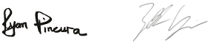  ^{Signature:} | ^{Date: January 24, 2016}
^{Reviewer:} | ^{Signature:} | ^{Date:}
^{QA Approval:} | ^{Signature:} | ^{Date:}

- REVISION HISTORY:
Version # | Description of Changes | CC #
0 | New document

DOCUMENT OWNER: Quality Assurance Person (QAP)

AFFECTED PARTIES: All site staff who process, analyze, package, and label Medicinal Marihuana.
PURPOSE: To provide a Procedure for the maintenance of proper personal Hygiene by all staff operating within the Medicinal Marihuana Licensed Location as well as to confirm a Procedure for Confirmation and Verification for the QAP that this procedure has been performed correctly.

DEFINITIONS:
- Non-MMPR Zones refer to Front Entry, Front Office(s), Board Room, Lunch Room and any other area not directed related to Production, Packaging, Labelling and Storage of Medicinal Marihuana.
- MMPR Zones refer to areas directly related to Production, Packaging, Labelling and Storage of Medicinal Marihuana.
SCOPE: This Procedure applies to the Processing, Analysis, Packaging, and Labelling of Medicinal Marihuana conducted within specific designated Zones at the Licensed Location.
KEY WORDS IN SYSTEM: Hygiene, clean hair, brushed teeth, finger nails, bath, clothing, scrubs, company identification, illness, protective eye ware, protective glasses, non-MMPR Zone, MMPR, Zone, floor, carpet, stone, tile, phone, door, waste bin, Section 57.
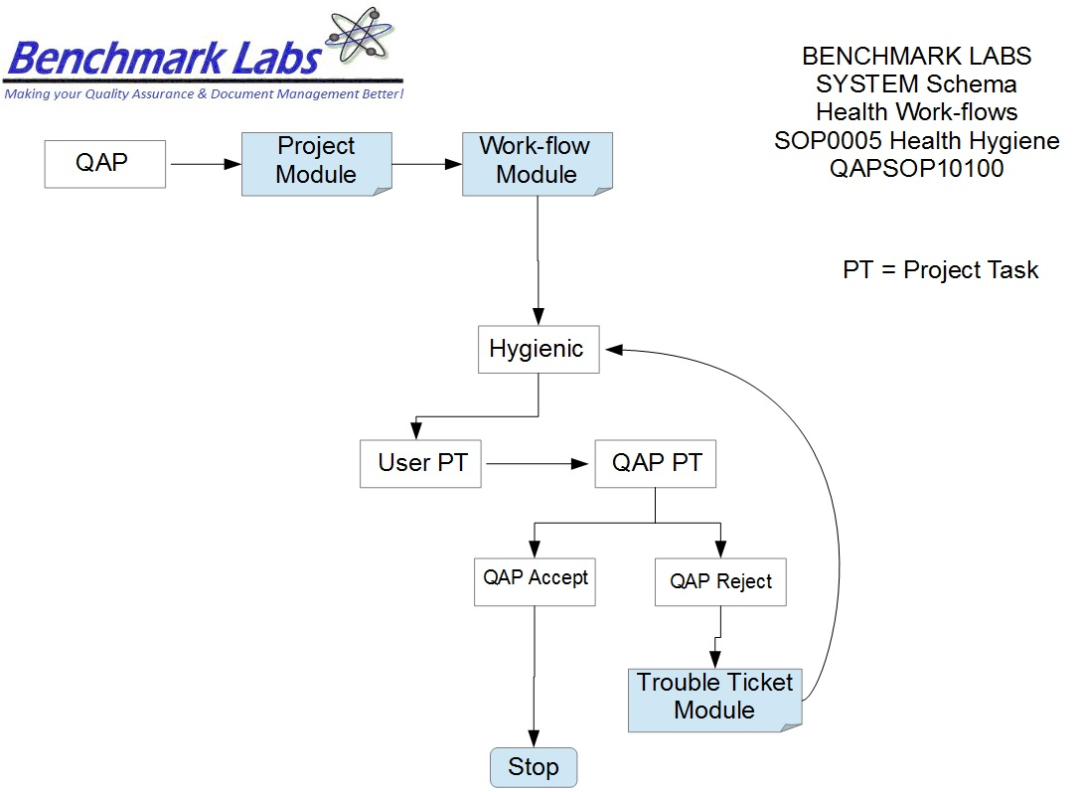

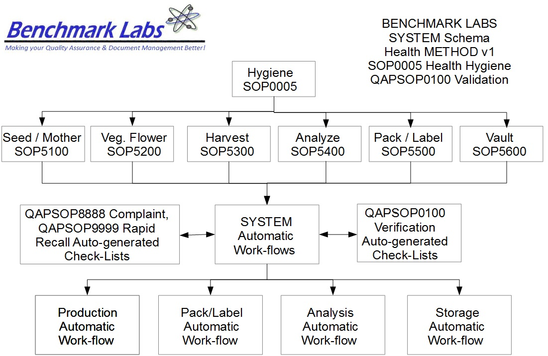
PROCEDURE PROCESS FLOW:
PROCEDURE PROCESS FLOW:
GENERAL RULES AND GMP REQUIREMENTS:

Grooming:
- Arrive at work clean – clean hair, rushed teeth, bathed and deodorized.

- All staff must wear their Company identification card.

- Visitors must display a visitor’s badge.

- At a minimum, company scrubs and protective glasses or approved eye ware must be worn on the floor.

- Additional protective attire may be required in Medicinal Marihuana Zones depending on the work in progress. Specific attire requirements will be posted on the door entering these zones when additional precautions are appropriate.
- Maintain short, clean, and polish-free fingernails. No artificial nails are permitted.
- Wash hands (including under fingernails) and up to forearms vigorously and thoroughly with soap and warm water for a minimum of 20 seconds:
• When entering the facility before work begins.
• Immediately before preparing Medicinal Marihuana or handling equipment.
• As often as necessary during Medicinal Marihuana preparation when contamination occurs.
• In the restroom after toilet use and when returning to work station.
• When switching between working with raw inventory Medicinal Marihuana and working with produced inventory Medicinal Marihuana.
• After touching face, nose, hair, or any other body part, and after sneezing or
coughing.
• After cleaning duties.
• Between each task performed and before wearing disposable gloves.
• After smoking, eating, or drinking.
• Any other time an unsanitary task has been performed – e.g., removing garbage, handling cleaning chemicals, wiping tables, picking up dropped Medicinal Marihuana items, etc.
- Wash hands only in hand sinks designed for that purpose.
- Dry hands with single use towels. Turn off faucets in a sanitary fashion using a paper towel, in order to prevent re-contamination of clean hands.

Proper Attire:
- Wear appropriate clothing – clean uniform with sleeves and clean non-skid, closed-toed work shoes (or leather tennis shoes) that are comfortable for standing and working on floors that can be slippery.

- Wear facility-issued apron on site.
- Do not wear apron to and from work.
- Remove apron before using the restroom.
- Change apron if it becomes soiled or stained.
- Wear disposable food grade gloves if hands have any cuts, sores, rashes, or lesions.

- Wear food grade gloves when handling ready-to-eat Medicinal Marihuana that shall not be heat-treated again. Gloves shall be worn when serving Medicinal Marihuana.
- Change disposable food grade gloves as often as hand washing is required. Wash hands before donning and after discarding gloves.
Hair Restraints and Jewelry:

- Wear a hair net or bonnet in any Medicinal Marihuana production area so that all hair is completely covered.
- Keep beards and moustaches neat and trimmed. Beard restraints are required in any Medicinal Marihuana production area.
- Refrain from wearing jewelry in the Medicinal Marihuana production area.:
• Only a plain wedding band and a watch are permitted.
• No necklaces, bracelets, or dangling jewelry are permitted.
• No earrings or piercings that can be removed are permitted.

Illness:

- Report any flu-like symptoms, diarrhoea, and/or vomiting to the unit supervisor.
- Employees with these symptoms shall be sent home with the exception of symptoms from a noninfectious condition; employees could be re-assigned to activities so that there is no risk of transmitting a disease through Medicinal Marihuana.
- Instances of Norovirus, Hepatitis A, Salmonella, Typhi, Shigella, or Shiga Toxin-producing Escherichia Coli shall be reported to the unit supervisor.
- Exclude the Medicinal Marihuana employee if diagnosed with an infection from Norovirus, Hepatitis A, Salmonella Typhi, Shigella, or Shiga Toxin-producing Escherichia Coli.

Cuts, Abrasions, and Burns:

- Bandage any cut, abrasion, or burn that has broken the skin.
- Cover bandages on hands with gloves or finger cots, and change as appropriate.
- Inform Quality Assurance Manager of all wounds.
Smoking, eating, and gum chewing:

- Smoke only in designated areas. No smoking or chewing of tobacco shall occur inside production facilities.
- Eat and drink in designated areas only. A closed beverage container may be used in the production area.
- Refrain from chewing gum or eating candy during work in a Medicinal Marihuana production area.

The Quality Assurance Manager shall:
- Ensure all employees are following proper hygiene requirements when they report to work as per auto-work-flow check sheet issued by SYSTEM.
- Non-conformance to this SOP to be followed by Quality Assurance Manager up using the SYSTEM Trouble Ticket Module as necessary.
REGULATORY REQUIREMENTS:
- Marihuana for Medical Purposes Regulations, Section 57, Division 4 Good Production Practices, October 2013).

TRAINING REQUIREMENTS: Read, understand and demonstrate proficiency training (PT) as indicated in the SYSTEM User Profile Record.
RELATED REQUIREMENTS: Read, understand and be familiar with the following related documents:
- SOP5100 Hygiene Seed/Mother Room
- SOP5200 Hygiene Vegetative/Flower Room
- SOP5300 Hygiene Harvest/Cure Room
- SOP5400 Hygiene Lab Analysis Room
- SOP5500 Hygiene Packaging/Label Room
- SOP5600 Process Storage Room
- QAPSOP0100 Confirming and Verification of processing, packaging, analyzing, or labelling & Maintenance Tasks
- SOP0001 Clean Premise
- SOP0002 Clean Equipment
- SOP0003 Handling Processing
- SOP0004 Handling Storage
- SOP0006 Health Safety

AUTO-GENERATED WORKFLOW(S) REQUIRED TO RECORD LOG:
- WKFL0001: Assign Authorized User, Project Task, Record Date/Time Completed
- QAP0001: Assign Authorized User, Inspection Log, Record Date/Time Completed
- CAR0001: Description of Trouble Ticket auto-generated and emailed to QAP

HYGIENE PROCEDURE AND MATERIALS REQUIRED BY ZONE:
The Medicinal Marihuana Life Cycle will govern where it is located, which determines the MMPR Zone it will reside in. This will determine the specific Hygiene requirements with the Licensed Location. The image below is a Colour Representation of the Zones that designate rooms or area's within the Licensed Location that and Assigned User may be required to perform “Project Tasks”:
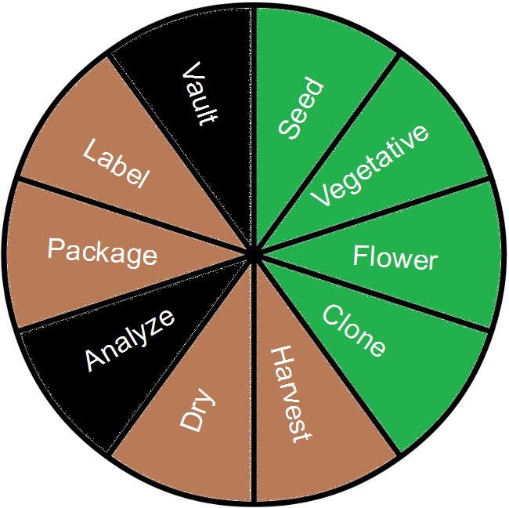
- As each Zone may require specific Hygiene requirements (such as clothing and protective ware) that better defines the GMP list above, individual SOP's for each Zone have been developed to provide step-by-step guidance and instructions:
PLEASE NOTE: That all Storage Procedures for specific MMPR Zones shall require that any Medicinal Marihuana related debris or trash that is found shall be retrieved and placed into a Debris Bag and recorded directly into the Benchmark Labs SYSTEM – as such, it can NEVER be disposed of in the garbage as would NON- Medicinal Marihuana debris or trash.

- There are a number of ways to find an associated Hygiene SOP:
  - Log into the Benchmark Labs SYSTEM and click on the “Document” Module Link:
  - Scroll down the “Documents” list of documents until you find Category “B1 Occupational Health & Safety (OH&S)” and click on the Link of the SOP found under the “Title” Header:
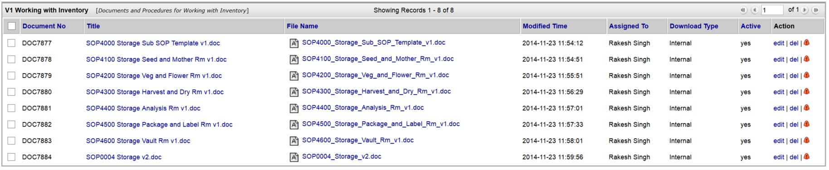
  - Type name of SOP into the “Search For” box (using SYSTEM Schema Diagram shown above), select “File Name” from the drop down box, and click “Search Now”:
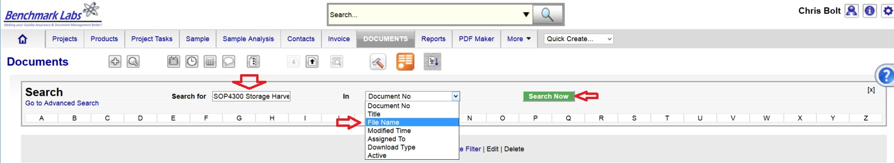
  - Use the universal “Search” Both to Type in the SOP name as provided in the SYSTEM Schema Diagram shown above:
ASSIGNED USER FREQUENCY OF HYGIENE COMPLIANCE:
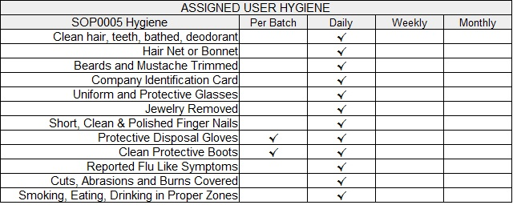
HYGIENE PROCEDURE:

- At the commencement of each working day, each Assigned User who will be working within an MMPR Zone shall receive an email auto-Generated by the SYSTEM requesting that they review a list of Hygienic items (list provided above) and to affirm their Daily Compliance:
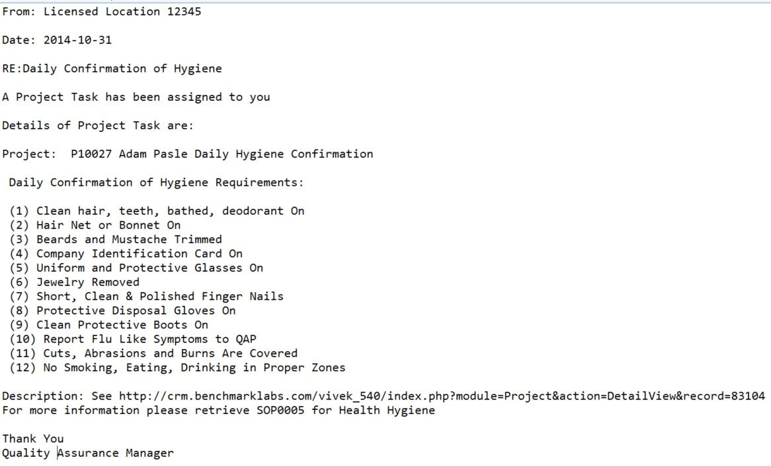
- The assigned User can then proceed to open the Project Task either by clicking directly on the link found in the email or proceeding directly to the Project (e.g., “P10027 Adam Pasle Daily Hygiene Confirmation ”) to open a Project Task from the Project Module directly:
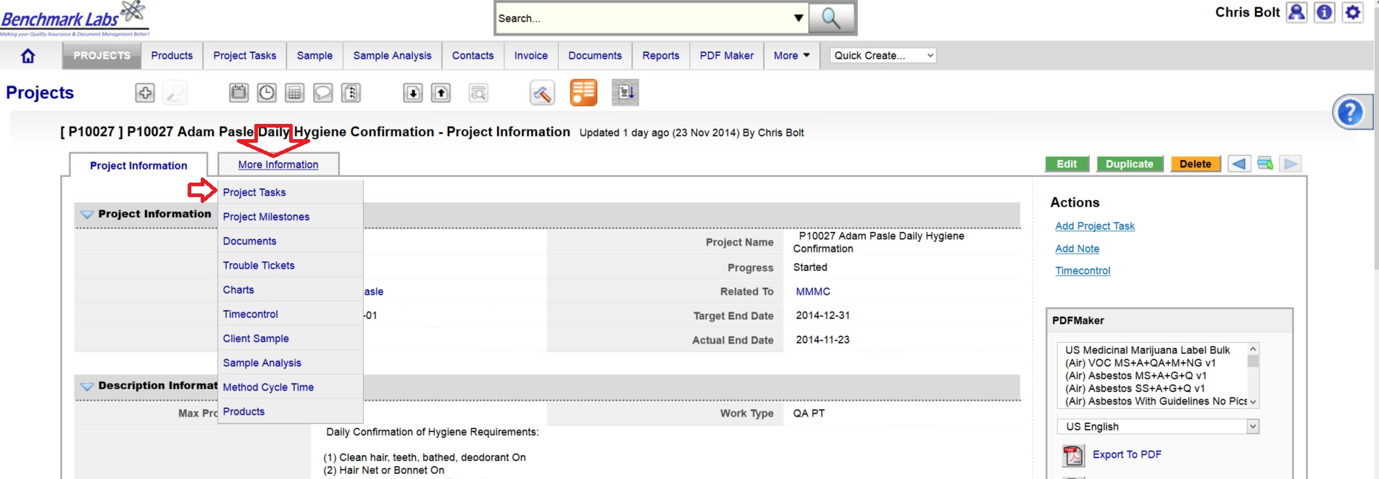
- To open a Project Task simply click on the link below the “Task Name” header:
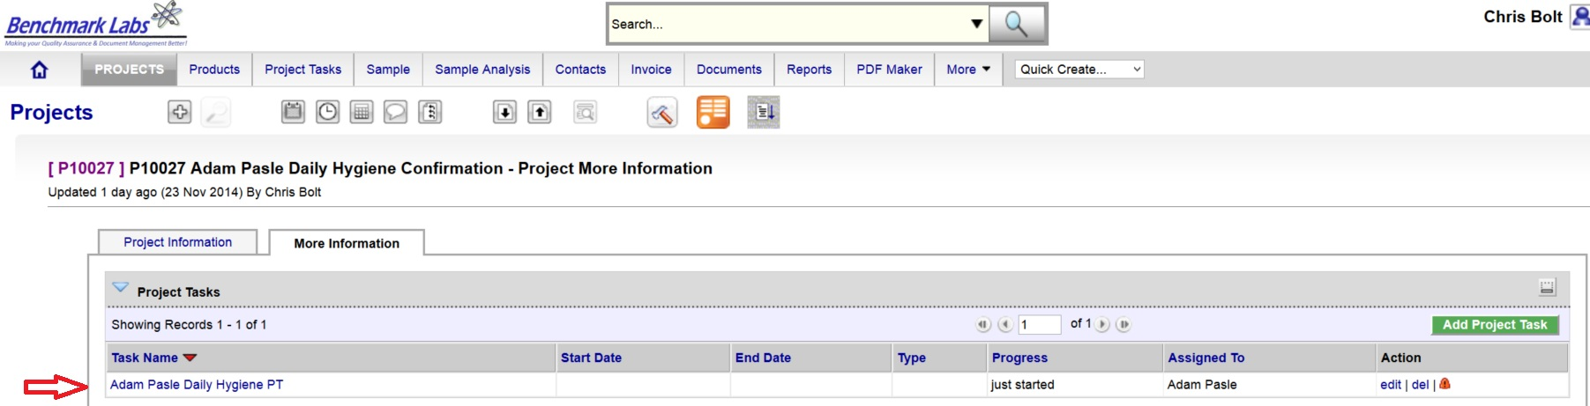
- The clock will then begin to record time spent on this Task until you hit the “Stop Button”:
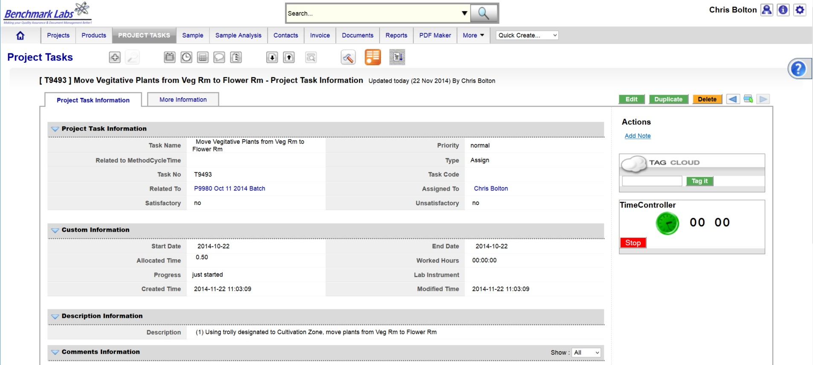
PLEASE NOTE: Once a Project Task has been opened, the Time-Controller Clock begins recording the time it takes to complete this task. If the time taken is significantly greater or less than the “Allocated Time” value, an automatic Trouble Ticket will open to request explanation as for the cycle time difference (the root cause for the variation in time taken to complete Project Task). Therefore, it is critical that you do not open the Task until you are ready to begin and to then focus on the Task until it is done by clicking on the “STOP” button beside the clock.
QAP CONFIRMATION & VERIFICATION OF ASSIGNED USER HYGIENE:
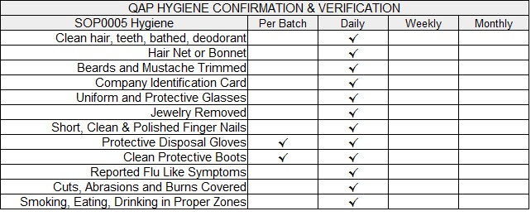
- Once the Hygiene Project Task “Progress” status has been saved as “100%” the Benchmark Labs SYSTEM will auto-generate an email to the QAP illustrating the need to confirm and verify that processing, packaging, analyzing, or labelling was completed within acceptably hygienic standards, as outline below. This procedure is governed by QAPSOP0100.

- In the event that the Assigned User has not completed this Project Tasks such that the QAP has not been notified by auto-email generated by the Benchmark Labs SYSTEM, the QAP is required to conduct schedule Hygiene inspections of each Assigned User as per outlined above. This shall be recorded directly in the QAP Daily Check List Project Task List as described in QAPSOP0100.

REFERENCES:
Author | Document Name | Published
Benchmark Labs | SOP0005 Hygiene Template | ^{January 24, 2016}

