Deatils of the CRM:

- Below is the list of customized/uncustomized modules.
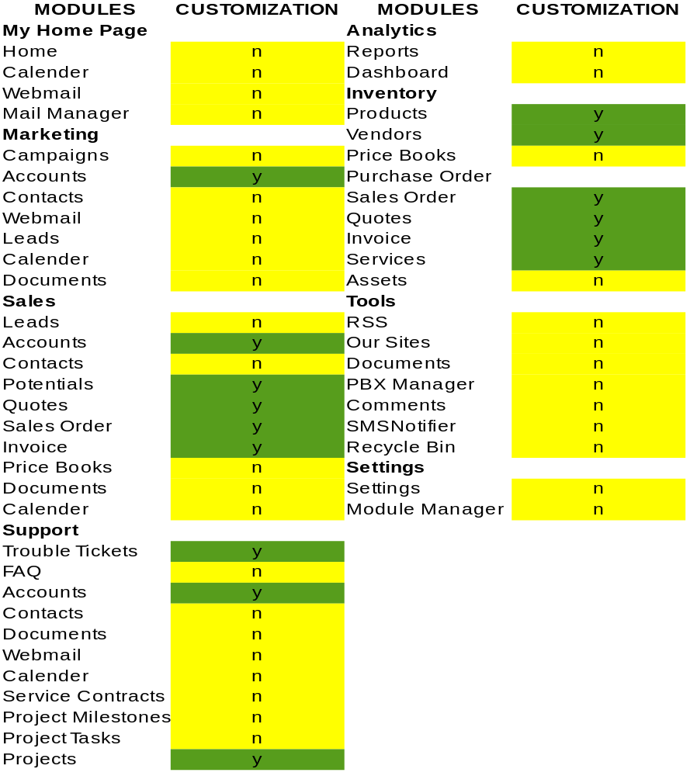

Note: y=yes, n=no.

1. There are 7(6+1) new modules found.Below are the screen shots of modules of fresh vtiger5.3 instance and client's instance.

Fresh instance:

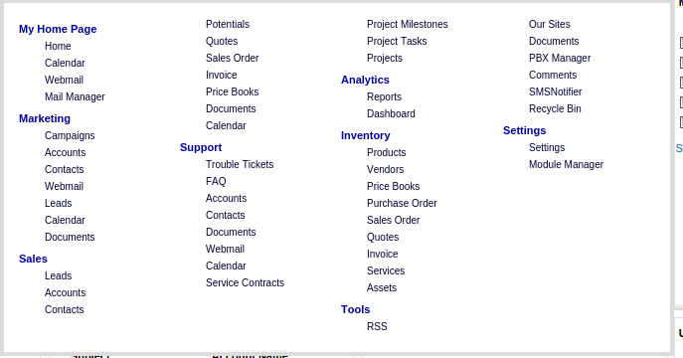
Client's:

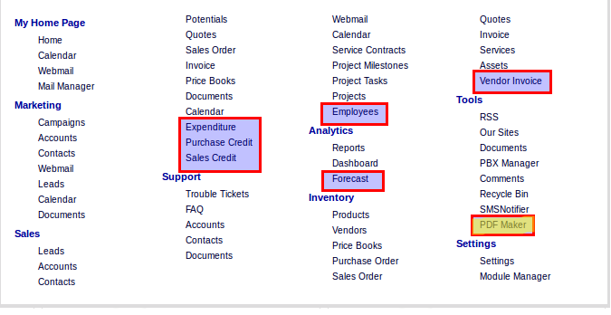

Projects Module:

1. Hided 'Target Budget' field in Custom information block.

2. In detail view of Projects, added related sales order, Budget Details and Employees Weekly Timesheet under Comments Information Block. Also provided export timesheet feature in Action panel.

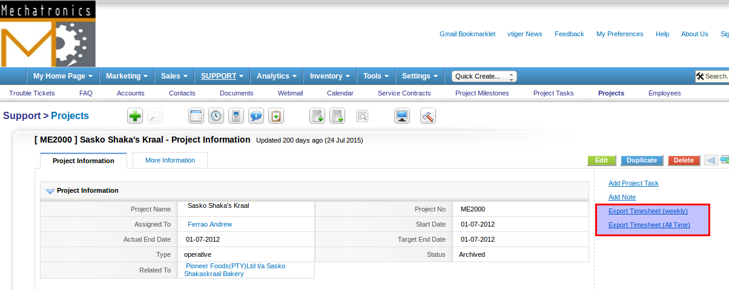
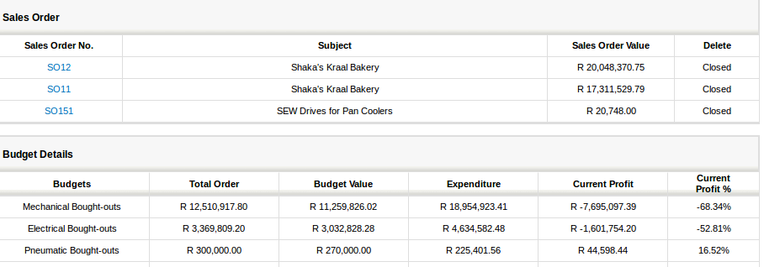
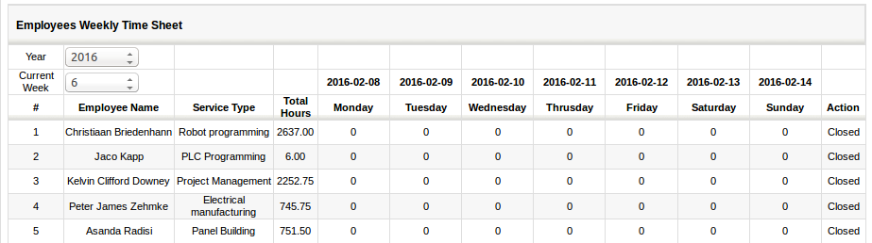
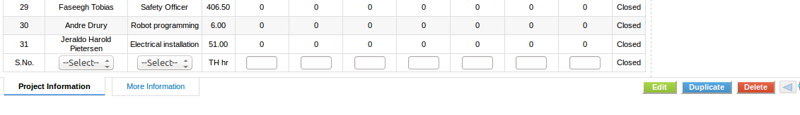

3. Also added new modules in More Information Tab.

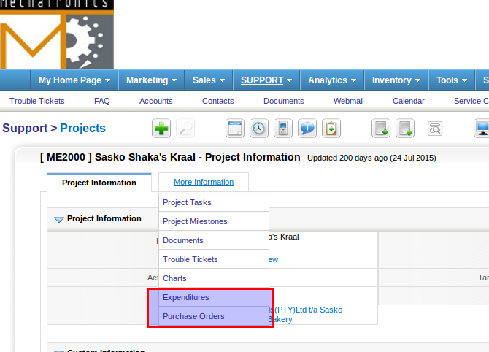
4. New Button 'Import Timesheet' added in list view of Projects.

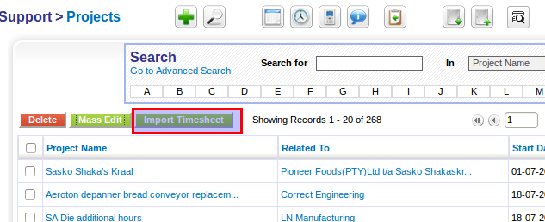

Accounts:

1. Two new fileds found in create view of Accounts

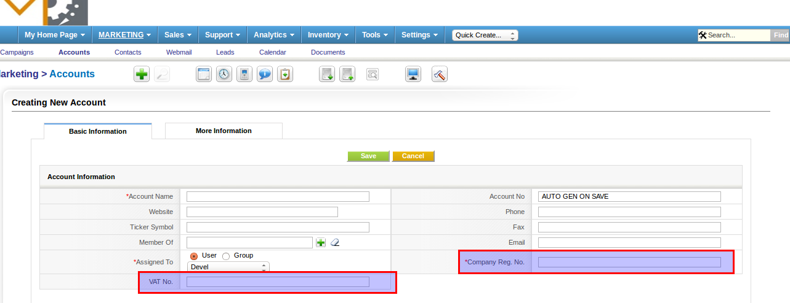
Potentials:

1. PDF Export button is added in list view.

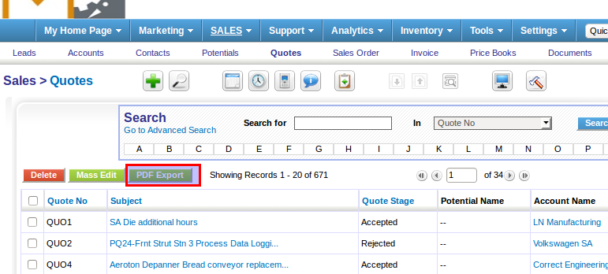
Quotes:

1. PDF maker integrated in detail view of Potentials.
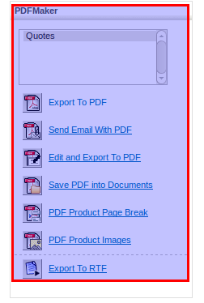

2. Few field were hided (carrier, shipping & inventory manager).

Client's:
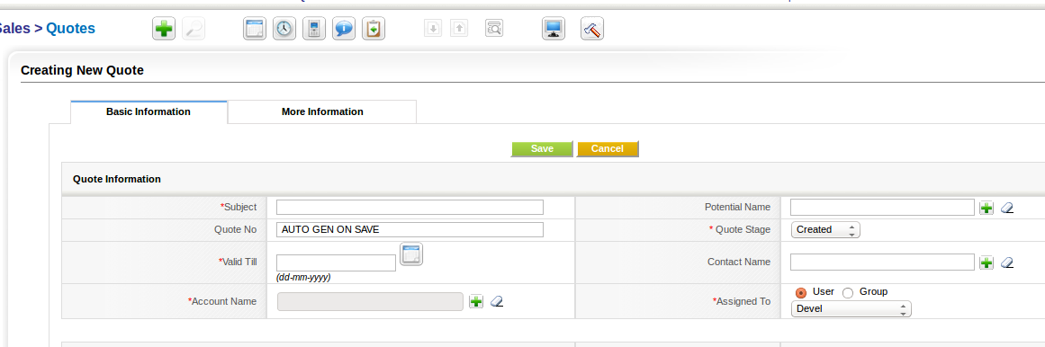
Fresh instance:

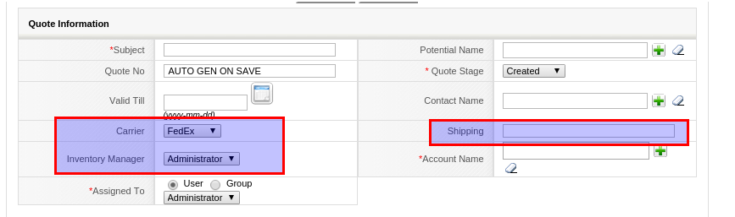
Sales order:

1. Few fields added/hided in create view

Fresh Instance:

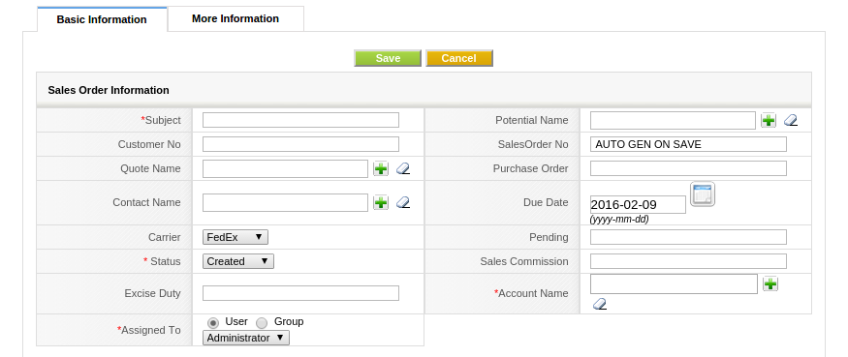

Client's:

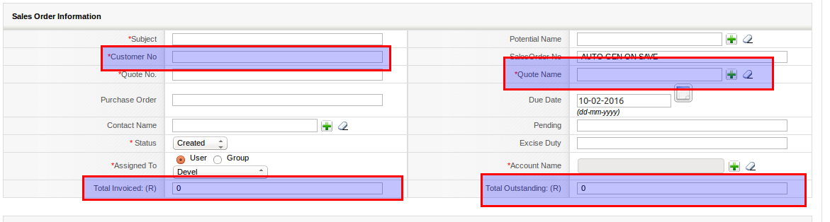
Invoice:

1. PDF Export button is there in Invoice list view.

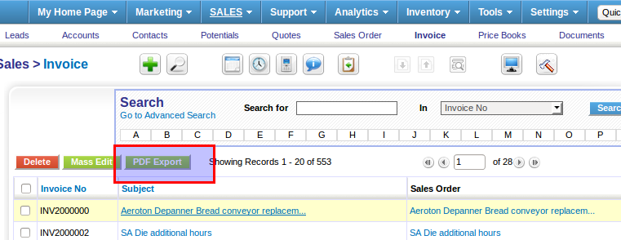
2. Few fields hided in create view of invoice.

3. PDF maker integrated in detail view of Invoice.

Trouble Tickets:

1. PDF Export button is added in list view of TT.
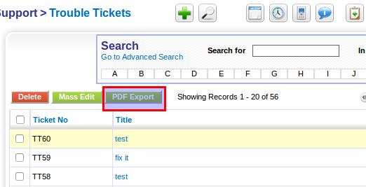

2. Few fields added in create view of TT

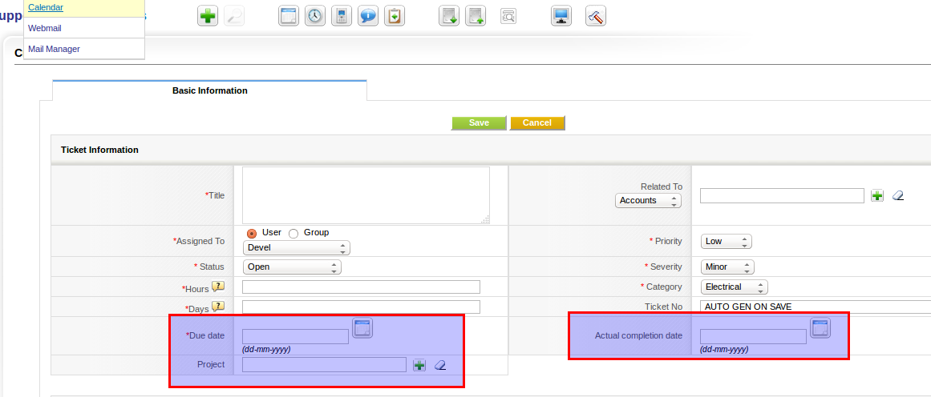
3. PDF maker integrated in detail view of TT.

Reports:

1. Few reports created for custom modules.

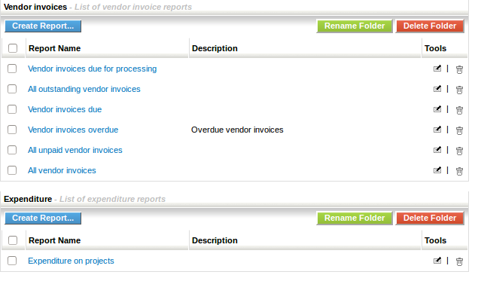
Products:

1. Few fields modified/hided in create view of products.

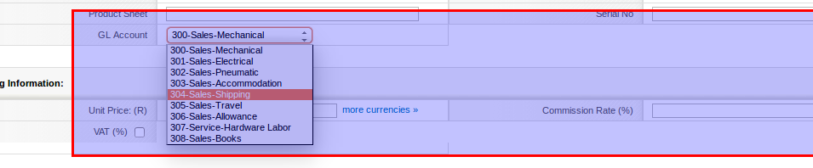
Vendors:

1. Few fields added in create view of Vendors.

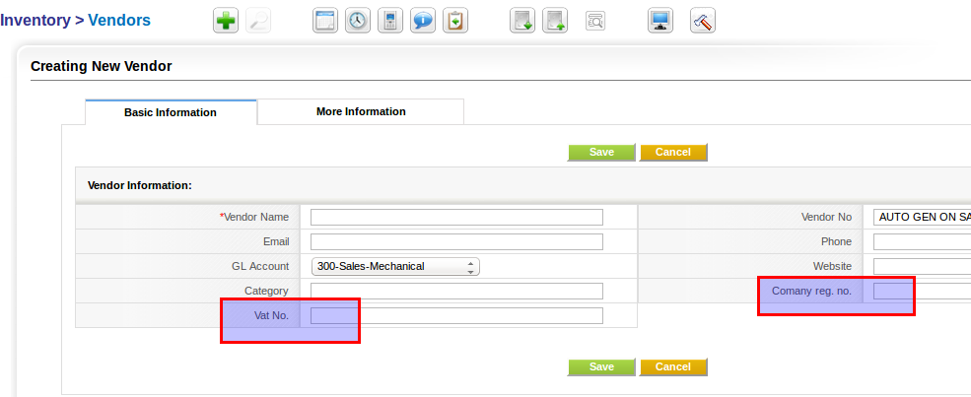

Purchase Order:

1. PDF Export Button is added in create view of PO.
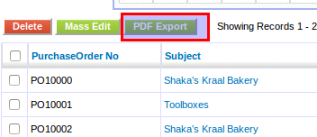

2. Few fields added in create view of PO.

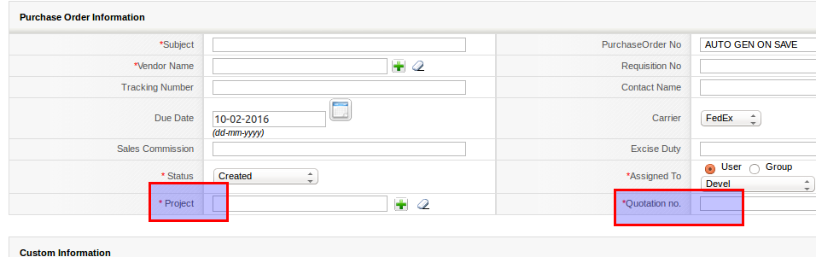

3. PDF Maker integrated in detail view of PO.

Services:

1. Few tax fields hided in create view of services.

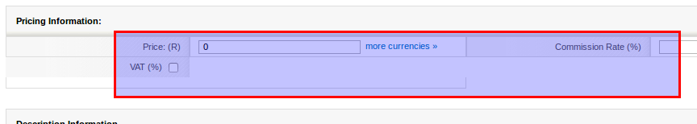
Other Points:

1. Few web forms created.
2. Outgoing server conmfigured.
3. Users-19, Roles-13, Profiles-5, Groups-3
4. Few modules have filters and few do not have.
5. One Email Template added.
6. PDF Maker integrated for Inventory modules.
7. Appx. 14000 documents are there.
8. Total 29000(appx.) records are there.

