**Count the words in a given sentence**

**Code :**

def count_words(sentence):

if sentence.strip() == "": # Check if the sentence is empty or only contains spaces

return 0

else:

words = sentence.split() # Split the sentence into words

return len(words)

sentence = "Please count the words in a given sentence."

word_count = count_words(sentence)

if word_count == 0:

print("The sentence is empty.")

else:

print(f"Word count: {word_count}")

**Output :-**

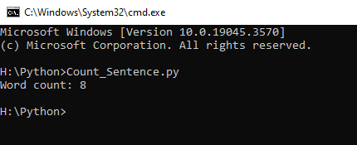

**Make the first letter of every word in the given sentence to capital case**

**Code :-**

def capitalize_words(sentence):

if sentence.strip() == "": # Check if the sentence is empty or only contains spaces

return "The sentence is empty."

else:

return sentence.title() # Capitalize the first letter of each word

sentence = "make the first letter of every word capital."

capitalized_sentence = capitalize_words(sentence)

if capitalized_sentence == "The sentence is empty.":

print(capitalized_sentence)

else:

print(f"Capitalized Sentence: {capitalized_sentence}")

**Output :-**

