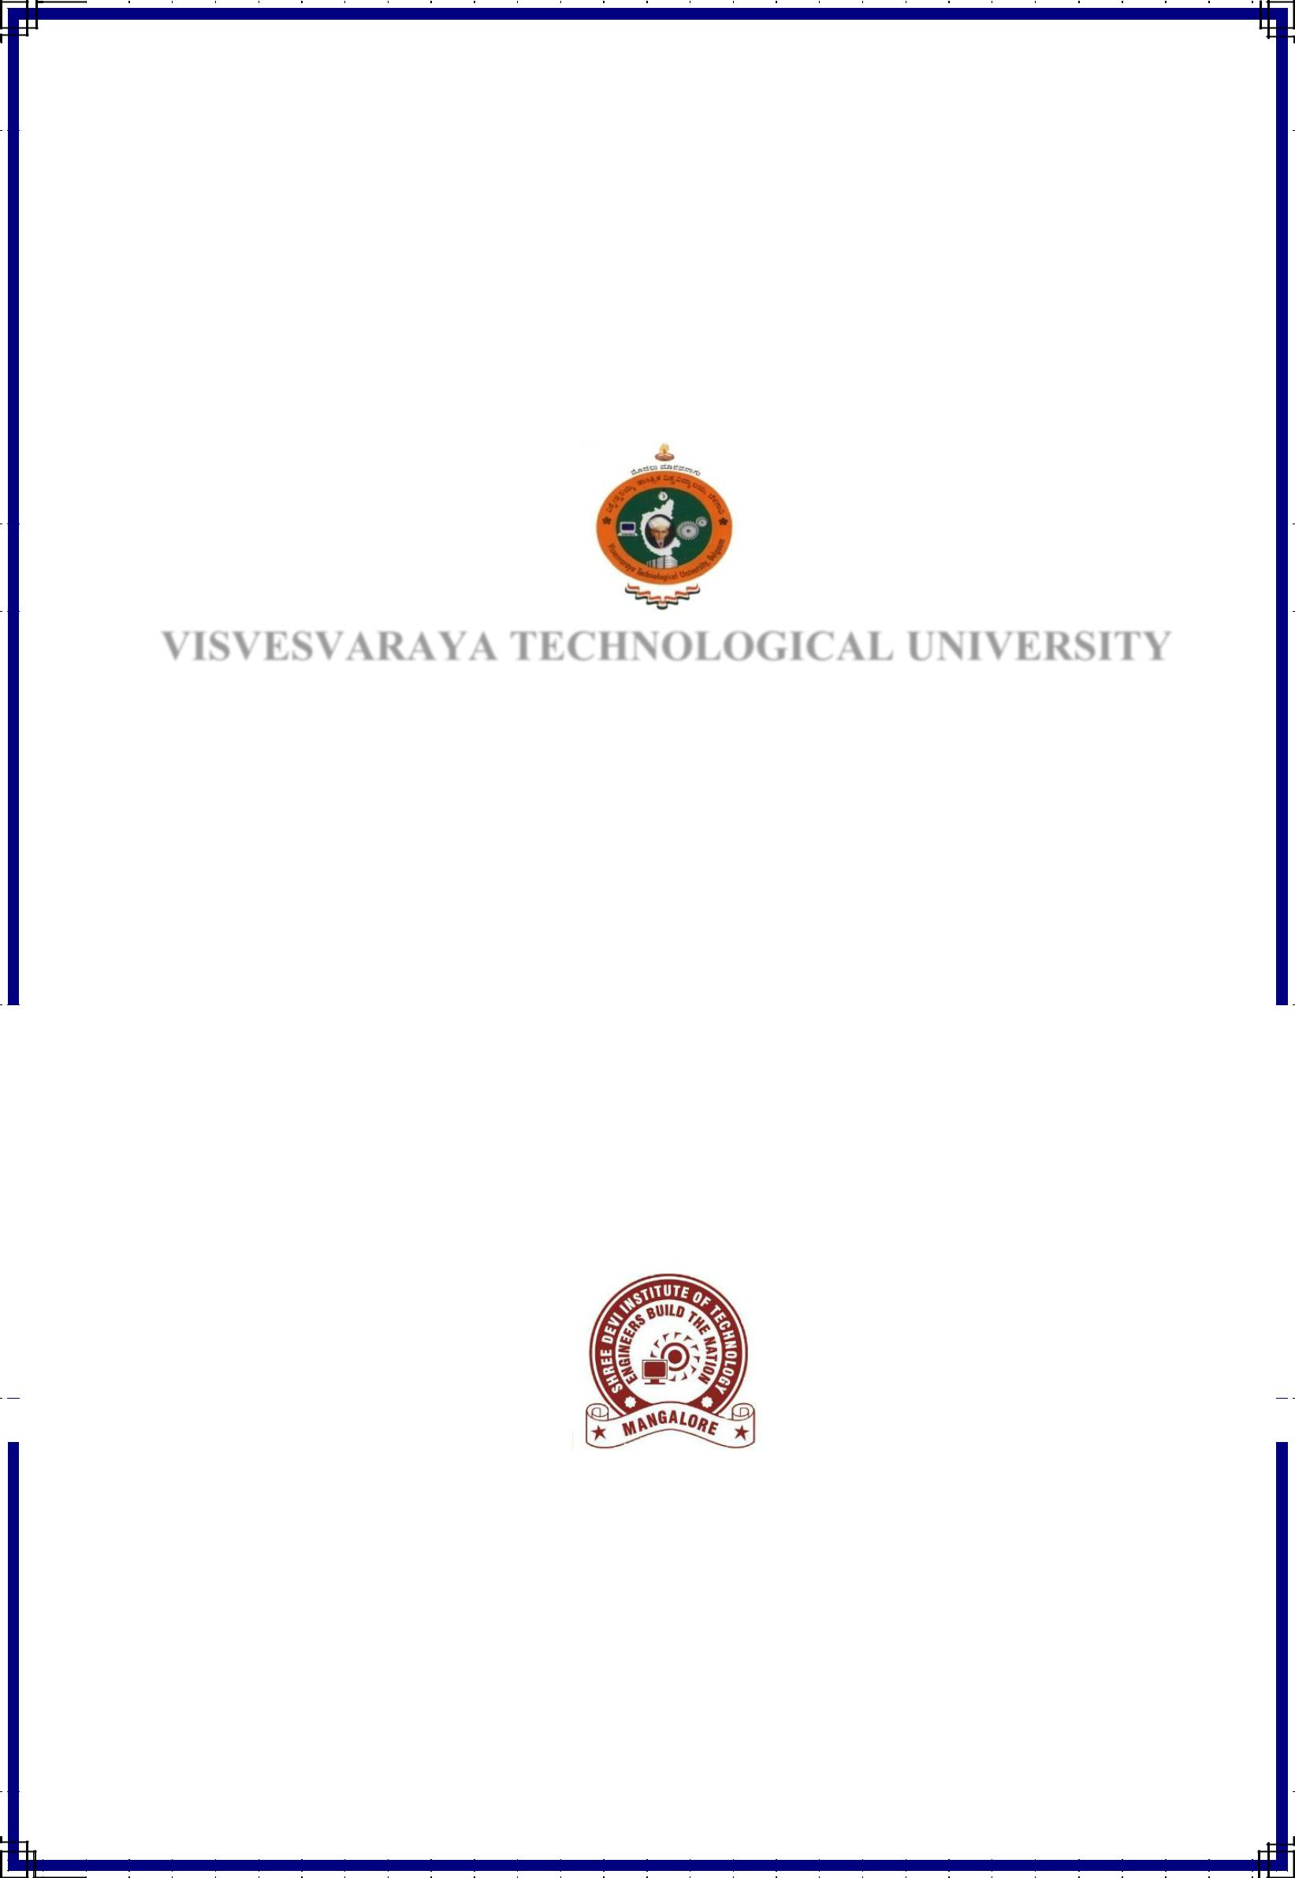 **KISAN MITHRA**

***A Dissertation submitted in partial fulfillment of the requirements***

***for the award of***

**MASTER OF COMPUTER APPLICATIONS**

**of**

**VISVESVARAYA TECHNOLOGICAL UNIVERSITY**

**By**

**MANASA SEBASTIAN**

4SH14MCA06

Under the Guidance of

|  |  |  |  |  |
| --- | --- | --- | --- | --- |
|  | **Internal Guide:** | **External Guide:** |  |  |
|  |  |  |
|  | **Prof. Poornima Tantry.** | **Ms. Meliate Radriguez.** |  |  |
|  |  |  |
|  | Asst.Professor, Dept. of MCA, | **Senior developer** |  |  |
|  |  |  |
|  | SDIT, Kenjar | Queue Technology |  |  |
|  |  |  |
|  | Mangaluru | Mangaluru |  |  |
|  |  |  |
|  |  |  |  |  |
|  |  |  |  |  |
|  |  |  |  |  |
|  |  |  |  |  |
|  |  |  |  |  |

**DEPARTMENT OF MASTER OF COMPUTER APPLICATIONS**

**SHREE DEVI INSTITUTE OF TECHNOLOGY**

[Affiliated to Visvesvaraya Technological University, Belagavi & Recognized by AICTE]

Airport Road, Kenjar, Mangaluru – 574142

**2017**