

**EAS-IPM**

**Design Document – Pharma Network**

**VERSION 1.0**

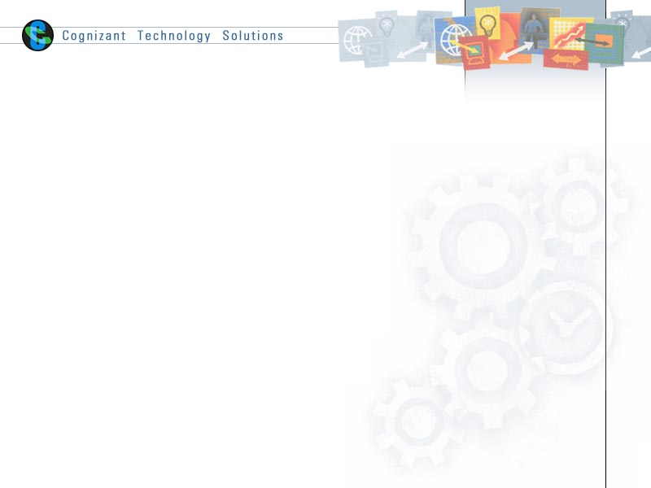

|  |  |  |  |
| --- | --- | --- | --- |
|  | **Prepared By / Last Updated By** | **Reviewed By** | **Approved By** |
| **Name** | Nisha M. R | Anaswar G | Vinod Kumar Pai |
| **Role** | Developer | Sr. Developer | Associate Director |
| **Signature** |  |  |  |
| **Date** | 25-10-2019 |  |  |

# Introduction

* 1. **Purpose**

The purpose of this document is to provide an explanation of the pharma Network

* 1. **Background**

Pharma Network provides accurate visibility into inventory levels and shipping of drug across supply chain. Pharmacies receive the drug and can report problem and FDA can withdraw the drug. All participants are notified through the ledger.

* 1. **Requirements and Dependencies**

The following were used to build the application.

1. Hyperledger Fabric – 1.4
2. Node JS - v8.11.3
3. GoLang - go1.12
4. Angular JS
5. IDE – Visual Studio Code
   1. **Network Architecture**

The application in divided into 3 layers.

1. User Interaction layer
2. SDK Layer
3. Blockchain Layer

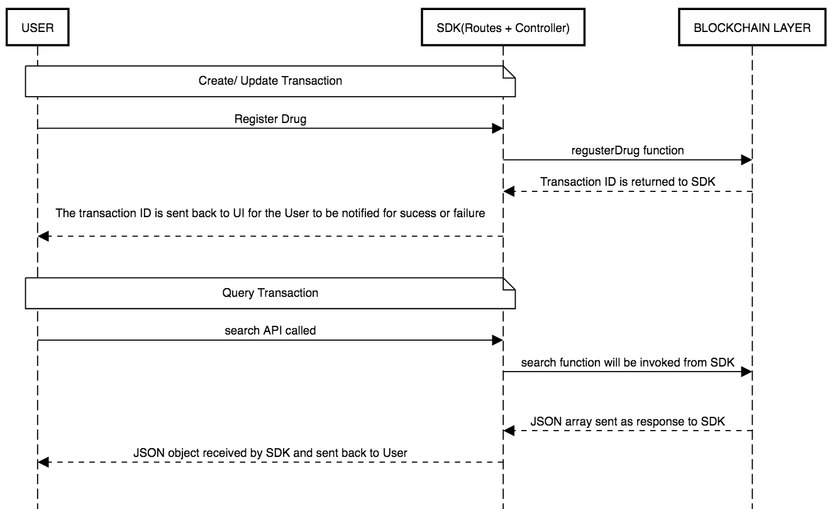

* + 1. **User Interaction Layer**

The user interaction layer includes a presentation layer. This layer is built using HTML/Angular JS and CSS

* + 1. **SDK Layer**

This is the middle/interface layer which is the gateway to the blockchain. The middle layer provides the communication between user interaction layer and the blockchain layer. This layer is built using Node js. Java SDK is also available. The transaction submitted by the user is routed to controller file which is the node layer via a routes.js file. The controller file will have the orderer address and peer address which are participating in the network. The named of installed chaincode, the transaction and the arguments of the transaction is send to the chaincode in the form of request. The transaction is sent using sendTransactionProposal. The proposal response will be sent back to sdk by the chaincode and this response can be sent back to UI. For query transaction, the request is sent to chaincode using querybyChaincode.

Controller.js syntax

module.exports = (function() {

return{

    registerDrug: function(req, res){

        var channel = fabric_client.newChannel('mychannel');

        var peer1 = fabric_client.newPeer('grpc://localhost:7051');

        var peer2 = fabric_client.newPeer('grpc://localhost:8051');

        var peer3 = fabric_client.newPeer('grpc://localhost:9051');

        var peer4 = fabric_client.newPeer('grpc://localhost:10051');

        channel.addPeer(peer1);

        channel.addPeer(peer2);

        channel.addPeer(peer3);

        channel.addPeer(peer4);

        var order = fabric_client.newOrderer('grpc://localhost:7050')

        channel.addOrderer(order);

var input = req.body

        var drugID = input.drugid;

        var drugName = input.drugname;

        var drugStatus = input.drugstatus;

        var manufacturer = input.manufacturer;

        var components = input.components;

        var argument = [drugID, drugName, manufacturer, drugStatus, components];

         const request = {

                //targets : --- letting this default to the peers assigned to the channel

                chaincodeId: 'pharmachaincode',

                fcn: 'registerDrug',

                args: argument,

                //chainId: 'mychannel',

                txId: tx_id

            };

        // send the transaction proposal to the peers

        return channel.sendTransactionProposal(request);

    }

}

});

Here peer1 and peer 2 belongs to org1 and peer3 and peer4 belongs to org2.We have to specify the peer to which is acting as committing peer.

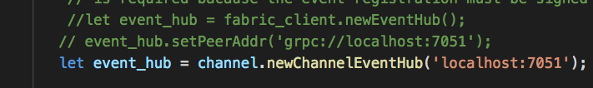

For search transaction, the target peer has to be specified along with request.

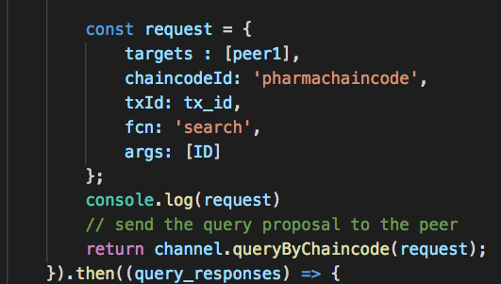

* + 1. **Blockchain Layer**

In the blockchain layer we have the chaincode or smart contract. The chaincode is written in Golang. The call to chaincode is done through SDK. The explanation of chaincode and the functions implemented are explained in later section.

* 1. **Application Participants**

1. Manufacturer
2. Distributor
3. Pharmacy
4. FDA (Food and Drug Administration)
   1. **Application Description**

There are four participants in the network as mentioned in Application participants section.

The manufacturer registers a drug with the FDA. The details of the drug will be available in the ledger.

The pharmacy will create an order for a particular drug.

The drug will be transported by distributor to the pharmacy which placed the order. The pharmacy receives the order from the distributor and sells to the customer.

Temperature is recorded at various points of transportation of drug and the following parameters are recorded by using an IoT sensor.

1. Temperature
2. Moisture
3. Shake

If the temperature is recorded greater than 50 at any point of time, the order will be rejected and will not be allowed to ship the order further. If the order is at pharmacy the drug from rejected order will not be allowed to sell. FDA can completely withdraw a drug if found not good for consumption.

In each of the organizations, one pair is defined as anchor peer. A channel named “mychannel” is created and the all the peers are added to the channel. There is a script file to start the hyperledger fabric network and to install the chaincode. While running the script file the peer, chaincode, orderer and CA containers are created.

The commands to install, instantiate and invoke chaincode needs to be specified in the shell script file in the first network of fabric-samples (utils.sh).

Syntax:

peer chaincode install -n pharmachaincode -v ${VERSION} -l ${LANGUAGE} -p ${CC_SRC_PATH} >&log.txt

 peer chaincode instantiate -o orderer.example.com:7050 -C $CHANNEL_NAME -n pharmachaincode -l ${LANGUAGE} -v ${VERSION} -c '{"Args":["init"]}' -P "OR ('Org1MSP.member','Org2MSP.member')" >&log.txt

peer chaincode invoke -o orderer.example.com:7050 -C mychannel -n pharmachaincode $PEER_CONN_PARMS -c '{"Args":["registerDrug","Drug02","Drugname01","drug01manu","Available","[c1,c2]"]}' >&log.txt

* 1. **Flow Diagram**

MANUFACTURER

Order Rejected. Can’t process Order further

If Temp > 50

IOT update

If Drug Withdrawn

Can’t create Order/ Update Order Status/ Sell Drug

FDA

PHARMACY

DISTRIBUTOR

MANUFACTURER

PHARMACY

IoT can update temperature at any point of order transportation. All the temperatures will be recorded and can be seen as a graph.

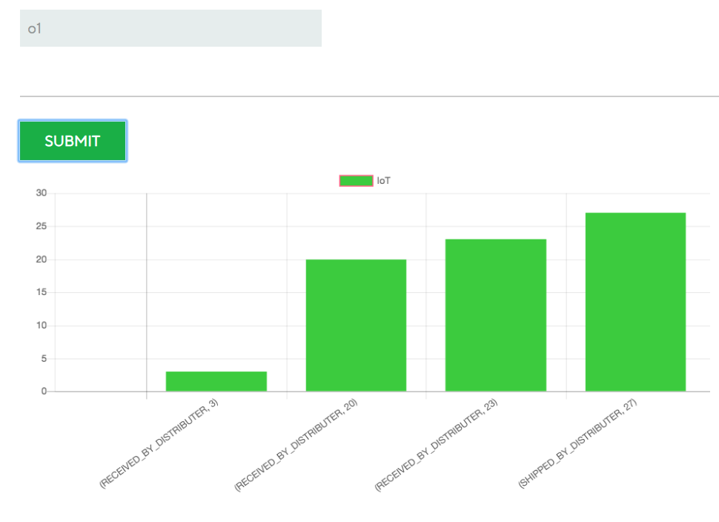

* 1. **Chaincode**

The chaincode is written in Golang. The packages needed for implementation are imported from “Shim”. The important functions defined for chaincode are

1. Init

Init function is called during initialization or update done on the chaincode. Init function takes ChaincodeStubInterface as parameter. When we call this function from CLI, it responds back with the peer response.

//Init - initialization of chaincode

func (t *PharmaChaincode) Init(stub shim.ChaincodeStubInterface) pb.Response {

    return shim.Success(nil)

}

1. Invoke

All the logic implementation functions are written here. These implementation functions are called transactions. There are insert, update and query transactions. The transaction list is explained later.

Syntax:

func (t *PharmaChaincode) Invoke(stub shim.ChaincodeStubInterface) pb.Response {

    function, args := stub.GetFunctionAndParameters()

    if function == "registerDrug" {

        return t.registerDrug(stub, args)

    }

    return shim.Error("Error invoking function")

}

* + 1. **Assets**

The following assets are defined in the chaincode.

1. Drug

**ID – DrugID**

The details of the drug created are stored in drug asset. This can be identified using Drug Id.

1. Order

**ID – OrderID**

The order when created by pharmacy will be stored here. The order asset will get updated for each change of shipment status.

1. Batch

**ID – BatchCode**

The drug quantity is updated in batches. When updating new batch, this asset is created. The problem if reported on the drug will be of particular batch.

* + 1. **Transactions**

1. **registerDrug**

New drug is created by the manufacturer for a particular drug ID. The drug asset is created during this transaction.

1. **updateNewBatch**

The drug has to be updated with certain quantity. The complete quantity of drug is updated in batches. The asset batch is created and drug is updated during this transaction.

1. **placeOrder**

Order is placed by pharmacy with unique order ID. The order will be created within the available quantity of drug. Order asset is created during this transaction.

1. **updateOrderStatus**

Manufacturer, distributor and pharmacy invoke this transaction to transport or receive the order placed by pharmacy. All the assets will be updated during invoking this transaction.

1. **updateDrugStatus**

FDA invokes this transaction to withdraw a drug if any problem is found in the drug. The drug will not be further processed in future. And no order can be created for that drug

1. **reportProblem**

Pharmacy can report problem with the order placed by them. When this transaction is invoked the pharmacy can conduct audit with the supplier who dispatched the order.

1. **temperatureUpdate**

The temperature update is done by IoT device for a specific order at any point of time. If the temperature read on the device is greater than **50(threshold limit)**, then the order will be rejected. The temperature history is displayed to user in the form of chart to check the temperatures at each time of updating.

1. **Search**

This transaction is used to query the assets using their unique ID. Target peer will be specified at the time of querying.

* 1. **Running Network**

For running the application, we have to start the fabric network, install the chaincode and then the node SDK is started. The following steps have to be followed.

1. Navigate to the folder which contain the shell script for starting the fabric. Here there is a startFabric.sh script. When we run this script, it will call the byfn.sh script in the network folder.

**./startFabric.sh**

If this script is run successfully, the following result will be displayed.

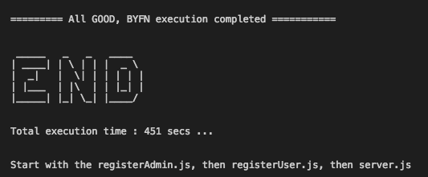

1. We can see the list if containers that are up and running using the following command.

**docker ps –a**

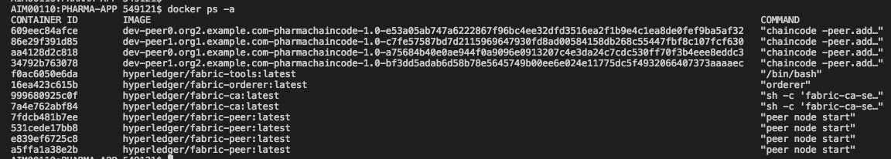

Now the chaincode is installed and instantiated in all the peers of the channel.

1. Node modules

The required node modules need to be installed. This is done using command

**npm install**

This will install the packages that are predefined in package.json. If any error specifying package is not available, we can install that using command npm install.

1. **registerAdmin.js** and **registerUser.js**

The admin and users have to be enrolled for each ca. In the network since this is multi org, there are two ca containers and using the certificate file of ca we have to enroll admin and user.

For enrolling admin

**node registerAdmin.js**

For enrolling user

**node registerUser.js**

This will create a **hfc-key-store** in the SDK folder and create the user and admin. This is later used by controller when committing a transaction.

1. Now we have to start the node app

Go to the root folder and hit the following command

**npm start** OR **node server.js**

The following will be displayed if the app is started successfully.

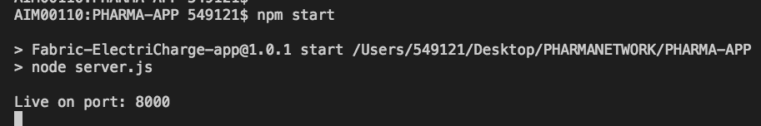

We can hit the application using url: <http://localhost:8000/>

