Datasets, Explained
What data this project uses, where each piece came from, how it was tested, and what is still to build.
Finance LLM project · Samni Labs · internal
July 10, 2026

Contents

1. The six kinds of data this project uses
Think of the whole project as training a new hire for a certification exam. Different materials do different jobs, and mixing them up is how projects fail. Six kinds:
Kind | What it is | Ours
1. Raw source documents | The full text of real filings. Nobody trains on these directly; they are the mine we dig facts out of. | 2026 10-K from SEC EDGAR (to download)
2. Fact records | One verified fact per row, with the filing, page and date it came from. The foundation of both the exam and the training set. | fact_sheet.csv (to build, week 1)
3. Training Q&A pairs | Question and answer in chat format. The actual food the model eats. Each fact appears 15-30 times in different words, because a fact seen once does not stick. | Our own SEC corpus, 2-3k pairs (to build)
4. Reasoning examples | Q&A that shows the step-by-step working, not just the answer. Teaches the model to think like a finance analyst. | tat_sample.jsonl, 2,000 rows (have)
5. General conversation | Ordinary human chat. Included at 10-20% so the model does not forget how to hold a normal conversation while it learns finance. | oasst2_sample.jsonl, 800 rows (have, pending Manish)
6. Evaluation sets | Questions kept sealed away from training, used only to score the model. Includes trick questions about facts we never taught. | finqa_test (1,147), finqa_verified (91), locked exam + control facts (to build)

In the new-hire picture: the filings are the company archive, the fact sheet is a stack of index cards, the training pairs are practice drills, the reasoning examples are worked solutions in the textbook margin, the general chat keeps their social skills alive, and the eval sets are the sealed final exam, including trick questions to prove the hire says "I don't know" instead of bluffing.

2. The one rule that holds everything together
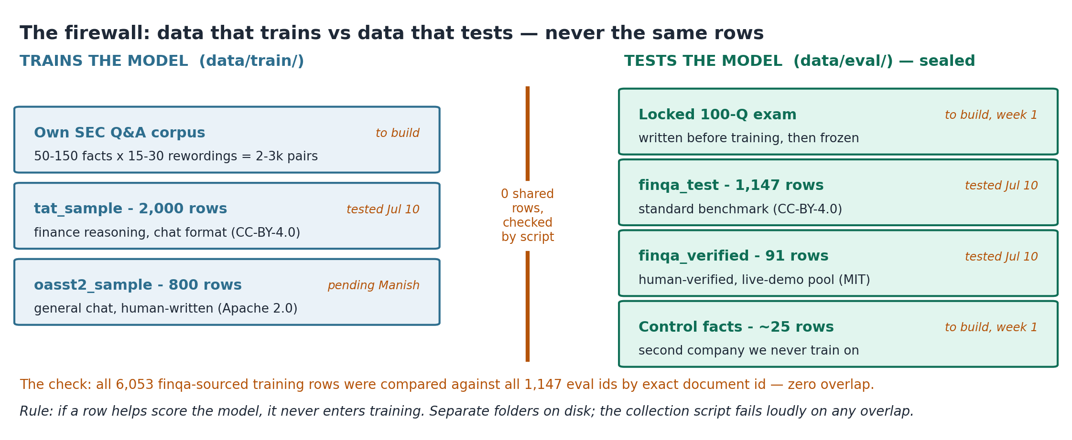
Figure 1. Train data and eval data never share a row. The wall was checked by script, not by promise.
If a row helps score the model, it never enters training. Break this once and every number on the demo scorecard becomes worthless, because a sharp client can claim the model was tested on its own homework. The two sides live in different folders (data/train/ and data/eval/) and the collection script refuses to finish if it finds any overlap.

3. The four datasets we collected (July 10)
All four came from the open internet, and each passed three gates before entering the repo: the license on its official page matches what our provenance sheet promises, the row count matches the published figure, and it shares zero rows with our eval sets.

3.1 tat-llm-instructions — the reasoning teacher
Made by the TAT-LLM research team from three datasets where humans wrote the questions and answers over real financial reports (FinQA, TAT-QA, TAT-DQA). Each row shows a question about a filing table plus the worked steps to the answer. License CC-BY-4.0, confirmed on the card. The full set is 32,555 rows; we kept a 2,000-row sample spread evenly across its three sources, converted to ChatGPT-style user/assistant conversations, with exact duplicates and rows too long for the 2,048-token training window removed. Our own SEC pairs still stay the majority of the training mix. Source: huggingface.co/datasets/next-tat/tat-llm-instructions.
The catch we tested for: 6,053 of its rows are built from FinQA, and FinQA's test split is one of our sealed eval sets. If any of those rows came from the test split, our benchmark numbers would be contaminated. We compared exact document ids, all 6,053 against all 1,147: zero overlap. The TAT-LLM authors used only FinQA's train split. Proven, not assumed.

3.2 oasst2 — the conversation keeper
OpenAssistant's crowdsourced chat dataset: thousands of volunteers wrote both the questions and the answers by hand in 2023-24. No AI generated it, which is exactly why we picked it. Apache 2.0, confirmed. From 128,575 messages we extracted English, best-ranked reply pairs and sampled 800. Status: proposed, waiting on Manish, because the kickoff brief left this slot open. The two candidates the brief named both failed our checks (section 5). Source: huggingface.co/datasets/OpenAssistant/oasst2.

3.3 FinQA test split — the standard exam
8,281 finance questions written by experts over real earnings reports (EMNLP 2021, authors from UC Santa Barbara, Carnegie Mellon, Penn State and J.P. Morgan AI Research). We keep only its 1,147-question test split, eval-only. The Hugging Face page turned out to be just a pointer, so the data was pulled from the original authors' repository on GitHub (czyssrs/FinQA, MIT). Never trained on.

3.4 finqa-verified — the live-demo pool
A 91-question subset of FinQA where a second team re-checked every answer by hand. MIT license, confirmed. This is where live demo questions come from, because a question whose answer was human-verified twice is one we can defend in front of a client. Source: huggingface.co/datasets/Aiera/finqa-verified. Never trained on.

4. The two datasets we build ourselves
These cannot be downloaded, and they are the heart of the project.

4.1 The primary corpus — our own SEC Q&A
50 to 150 atomic facts pulled by hand from one company's 2026 10-K (a filing published after the model's knowledge cutoff, so the base model provably cannot know it). Each fact is then reworded 15-30 ways by a local model in a scripted loop, giving 2,000-3,000 training pairs. Two or three rewordings per fact are held back as the dev set. A good fact passes six tests: post-cutoff, atomic (one value per row), verifiable (filing + page), unambiguous, un-guessable, and worth asking. Status: blocked on one decision, which company. That pick is Manish's.

4.2 The control facts — the honesty test
Around 25 real facts from a second company's 2026 filing that we deliberately never train. The exam asks about them, and the right answer is a refusal. This is the part most teams forget: the demo's "it says I don't know instead of guessing" moment only lands if we can show the true answer exists and the model declined to invent it.

5. Datasets we checked and rejected
Each of these looked usable and failed a real check. They stay out of the project no matter how convenient they look. Full dated records in docs/provenance_sheet.md.
Dataset | Why it is banned
Fino1 (reasoning paths) | Its reasoning text was generated by GPT-4o. Our promise to the client is that no frontier-API output exists anywhere in the training path; training on this would make that sentence false.
SmolTalk | Labeled Apache 2.0, but its core 400k rows were generated with Llama-3.1-405B. The Llama license then forces any model trained on it to carry a "Llama" name and a "Built with Llama" notice. Checked July 10.
Tulu 3 SFT mixture | Its own card admits non-commercial portions (No Robots, CC-BY-NC) and it includes 100k WildChat GPT-4 conversations. Non-commercial plus frontier output. Checked July 10.
Sujet-Finance-Instruct-177k | Apache label, but bundles financial_phrasebank (non-commercial) and benchmark data (ConvFinQA, finqabench). Contaminates evals and imports NC data.
Finance-Instruct-500k | Same pattern as Sujet: phrasebank inside, benchmark data inside.
financial_phrasebank | CC-BY-NC-SA 3.0, non-commercial only. A sales demo is commercial use.
FinanceBench | CC-BY-NC-4.0, non-commercial only.
XBRL_analysis (FinLoRA) | No license tag on its page at all. Untouchable for commercial work until the authors state one.
EDGAR-CORPUS | License is fine (Apache 2.0); coverage is not. It ends at 2020 and contains zero 2026 filings, so it is useless for this demo.

6. How the data was tested
Everything above is enforced by one script, scripts/01_collect_open_datasets.py, so the checks are repeatable instead of being someone's memory. It runs ten gates and stops dead on the first failure:
- License gates: reads the license field from each dataset's official page and fails unless it matches the provenance sheet (cc-by-4.0, apache-2.0, mit). If a card silently changes upstream, the script catches it.
- Count gates: row counts must land in the expected range (1,147 test questions, 91 verified, ~32.6k tat rows). A silently updated dataset fails loudly.
- Contamination gates: the exact-id comparison described in section 3.1, plus a backup scan for eval question text embedded inside any kept training row.
Result on July 10: ten of ten passed. The receipt is docs/dataset_verification_report.md; the per-dataset verdicts live in docs/provenance_sheet.md, which is also the document the client's lawyers get. The script gets re-run the week of the demo as a freshness check.

7. Where everything lives, and the final mix
D:/Finance_LLM/
data/raw_filings/ downloaded 10-Ks (not in git)
data/raw_datasets/ UNTOUCHED full originals every sample was cut from:
tat train 32,555 + val 4,136 · oasst2 128,575 + 6,599
· finqa train/dev/test 6,251/883/1,147 (~500 MB,
not in git; manifest.json + README are; recreate
any time with scripts/01b_export_raw_datasets.py)
data/facts/ fact_sheet.csv + control_facts.csv <- to build
data/train/mixins/ tat_sample.jsonl (2,000) + oasst2_sample.jsonl (800)
both already in ChatGPT-style messages format
data/train/ train.jsonl, the final mixed file <- built in week 2
data/eval/ finqa_test.jsonl (1,147) + finqa_verified.jsonl (91)
+ locked exam + before-log <- sealed side
docs/ provenance_sheet.md + verification report + this doc
scripts/ 01_collect_open_datasets.py (re-run before demo)
01b_export_raw_datasets.py (rebuilds raw_datasets/)
The raw_datasets folder is the answer to "where did the samples come from": every cut file in data/train/mixins/ and data/eval/ traces back to an untouched original sitting right there, with a manifest of exact row counts. An auditor can diff sample against source without leaving the project.
The final training file, once the primary corpus exists, mixes roughly like this:
Component | Share | Job
Own SEC Q&A (paraphrased facts) | ~55-65% | The knowledge being injected; the demo's whole claim
tat-llm sample | ~25-30% | Finance reasoning style
oasst2 sample | ~10-20% | Stays conversational; anti-forgetting insurance

Open decisions, both Manish's: which company's 2026 10-K becomes the primary corpus, and a yes/no on oasst2 for the chat slice. Everything else in this document is collected, tested, and waiting.

