Finance LLM Fine-Tune
Team Playbook
Every step from account signup to the client demo: who does it, how, and what it costs.
Samni Labs · internal
July 8, 2026

Contents
1. What we are building, in one page 3
2. The pipeline at a glance 3
3. Hardware: what runs where 3
4. Accounts and setup (do this before week 1) 4
4.1 Hugging Face — where the models and datasets live 4
4.2 Google Colab — the free rehearsal GPU 5
4.3 RunPod — the rented card for real runs 5
4.4 Ollama and Open WebUI — the chat layer 5
4.5 Python environment 5
5. The six weeks 6
6. Week 1 — pick the facts, write the exam first 6
6.1 Choose the target facts 6
6.2 Write the 100-question exam, then lock it 6
6.3 Record the before 7
7. Week 2 — build the training set 7
7.1 Paraphrase each fact, many times 7
7.2 Format, mix, clean 7
8. Week 3 — training runs 8
8.1 Which model, exactly 8
8.2 The recipe 8
8.3 How the week actually goes 9
9. Week 4 — the kill gate 9
10. Weeks 5-6 — package, serve, rehearse 10
10.1 From adapter to chatbot 10
10.2 Where the demo runs 10
10.3 The demo script 10
11. Cost 11
12. Who does what 11
13. Rules we do not break 12
14. Links 12
Model and tooling 12
Data 12
The research behind the recipe 13

1. What we are building, in one page
A finance chatbot that runs entirely on hardware we control. No OpenAI, no Anthropic, no Google. The client's data never crosses into anyone's API.
The demo makes one claim, and the claim is falsifiable: we taught an open model facts it provably did not know, and we can show the before and after live. We pick facts from SEC filings published in 2026, after the model's training cutoff, so nobody in the room can say the model knew them already. We log the base model failing those questions, timestamped, before training starts. Then we train, and the same questions succeed.
The third piece is the honesty control. During the live demo we deliberately ask about a company we never trained. The model refuses instead of guessing. For a finance audience that refusal lands harder than any correct answer, because their nightmare is a system that makes numbers up.
One design rule sits under everything. Fine-tuning is for behavior and, done carefully, for a bounded set of facts. It is not a database. That is why we keep the fact count small (50 to 150), reword each fact 15 to 30 ways so it actually sticks, and hold an exit ready (RAFT plus retrieval) if the numbers disappoint at week 4. The research behind each of those choices is linked in section 13.

2. The pipeline at a glance
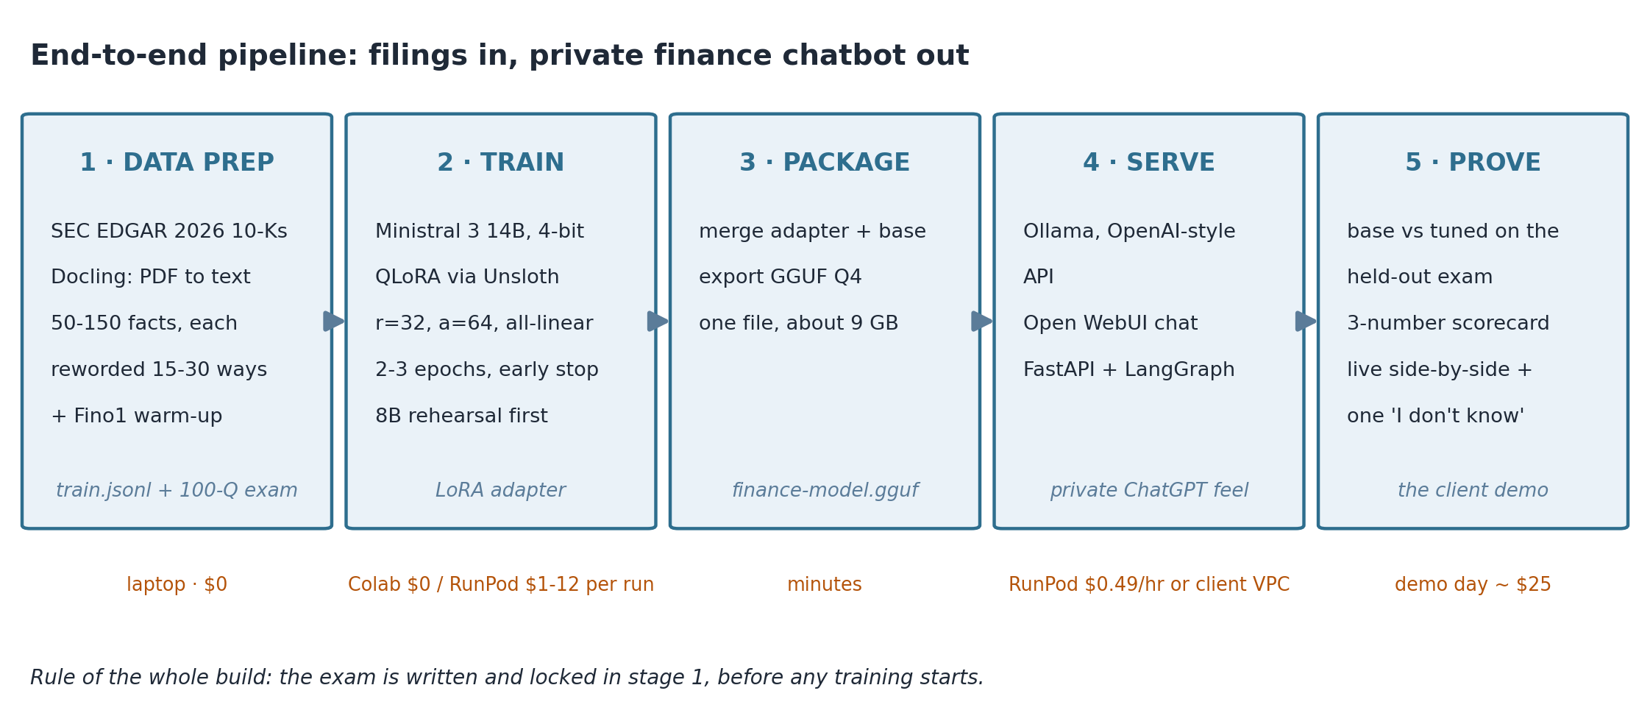
Figure 1. Five stages: prep the data, train, package, serve, prove.
Stage 1 happens on a laptop and costs nothing. Stage 2 is the only part that needs rented GPU time, and a full run costs less than lunch. Stages 3 through 5 turn the trained weights into something a person can type at, and into evidence a client can check.
If you remember one thing from this page: the exam is written and locked in stage 1, before any training happens. Everything credible about this demo flows from that ordering.

3. Hardware: what runs where
The laptops in this office carry an RTX 4050, which has 6 GB of VRAM. Training the 14B model needs 8.5 GB minimum, and serving the finished model needs about 9 GB. So the laptop is where we write code, build datasets, and poke at small 3B models. It is not where anything real trains or serves.
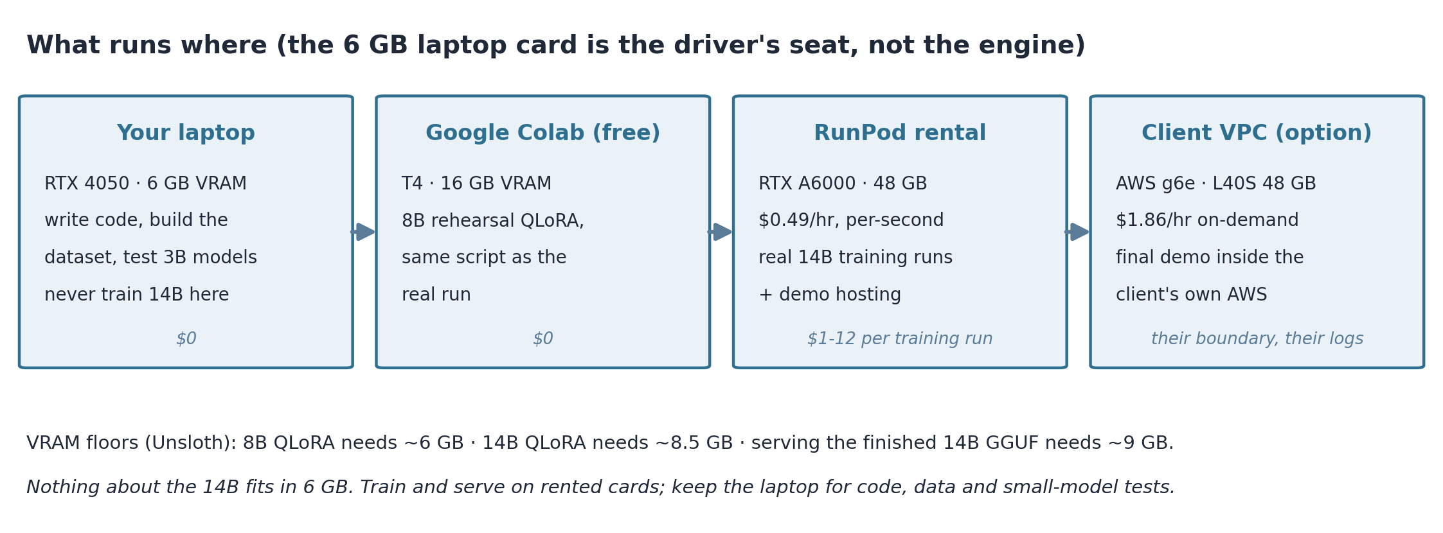
Figure 2. Four machines, four jobs. The laptop develops; rented cards train and serve.
Job | VRAM needed | Where it fits
QLoRA train, Ministral 3 8B | ~6 GB floor | Colab T4 (16 GB) with room to spare; free
QLoRA train, Ministral 3 14B | ~8.5 GB floor | RunPod A6000 48 GB, $0.49/hr (a 4090 24 GB also works)
Serve 14B GGUF Q4 + chat UI | ~9 GB | Same RunPod card, or client VPC (AWS g6e, $1.86/hr)
Local sanity tests, 3B model | ~2-3 GB | The RTX 4050 laptop, via Ollama

VRAM floors come from Unsloth's published requirements table. Floors mean exactly that: a run at the floor works with batch size 1 and patience, not comfort.

4. Accounts and setup (do this before week 1)
Half a day of signups saves a week of blocked people later. Each account below exists for a specific reason; the reason is written next to it so nobody signs up for things we do not need.

4.1 Hugging Face — where the models and datasets live
Hugging Face is to models what GitHub is to code: the public registry everyone downloads from. We need it for three things. The Ministral 3 weights come from there. The Fino1 and FinQA datasets come from there. And our training scripts authenticate against it with a token, because some model pages make you accept terms before the files unlock.
- Create an account at huggingface.co. Use the team email, not a personal one, so access survives if someone is out.
- Go to Settings, then Access Tokens, then New token. Type: Read. Name it something obvious like samni-finetune. Copy it somewhere safe; it shows once.
- Open the Ministral 3 14B page and accept the terms if it asks. Do the same on the 8B page.
- On any machine that will download models, log in once:
pip install -U "huggingface_hub[cli]"
huggingface-cli login # paste the token

4.2 Google Colab — the free rehearsal GPU
Colab hands out a free T4 GPU with 16 GB of VRAM in a browser notebook. That is enough to QLoRA-train the 8B model. We use it to get the whole training script working end to end at zero cost, so the first time we pay for a GPU, the script already runs.
- Any Google account works. Open Unsloth's ready-made Ministral notebook (linked from their Ministral 3 tutorial).
- In the notebook: Runtime, then Change runtime type, then T4 GPU. Run all cells once, untouched, before changing anything.
- Know the catch: free sessions die after a few hours. Save checkpoints to Google Drive or push them to Hugging Face, or lose the run.

4.3 RunPod — the rented card for real runs
RunPod rents GPUs by the second. An RTX A6000 with 48 GB costs $0.49 an hour on their community tier, which is where the real 14B training runs and the demo hosting happen. Vast.ai is cheaper still, but it is a spot marketplace where your machine can vanish mid-run; fine for a throwaway experiment, never for the demo.
- Sign up at runpod.io and load $30 of credit to start. Billing is per-second, so short experiments cost cents.
- Deploy, then GPU Pod. Pick RTX A6000 48 GB, community cloud. Template: the stock PyTorch image. Connect through the built-in Jupyter or SSH.
- Stop the pod when you walk away. A forgotten A6000 burns about $82 a week. Whoever starts a pod owns stopping it.

4.4 Ollama and Open WebUI — the chat layer
Ollama runs a finished model behind an OpenAI-compatible API with one command. Open WebUI puts a ChatGPT-style screen on top of it. Install both on your laptop now and chat with a small model, so the serving side holds no surprises later:
# install from ollama.com, then sanity-check with a 3B model (fits the 4050)
ollama run llama3.2:3b

# ChatGPT-style web screen, in Docker:
docker run -d -p 3000:8080 --add-host=host.docker.internal:host-gateway \
-v open-webui:/app/backend/data ghcr.io/open-webui/open-webui:main

4.5 Python environment
Data prep runs fine on Windows. Training tooling (Unsloth, vLLM) is Linux-first, so anything training-related happens in WSL2 locally or just on the Colab/RunPod machines, which are already Linux. Base install:
pip install unsloth datasets docling

5. The six weeks
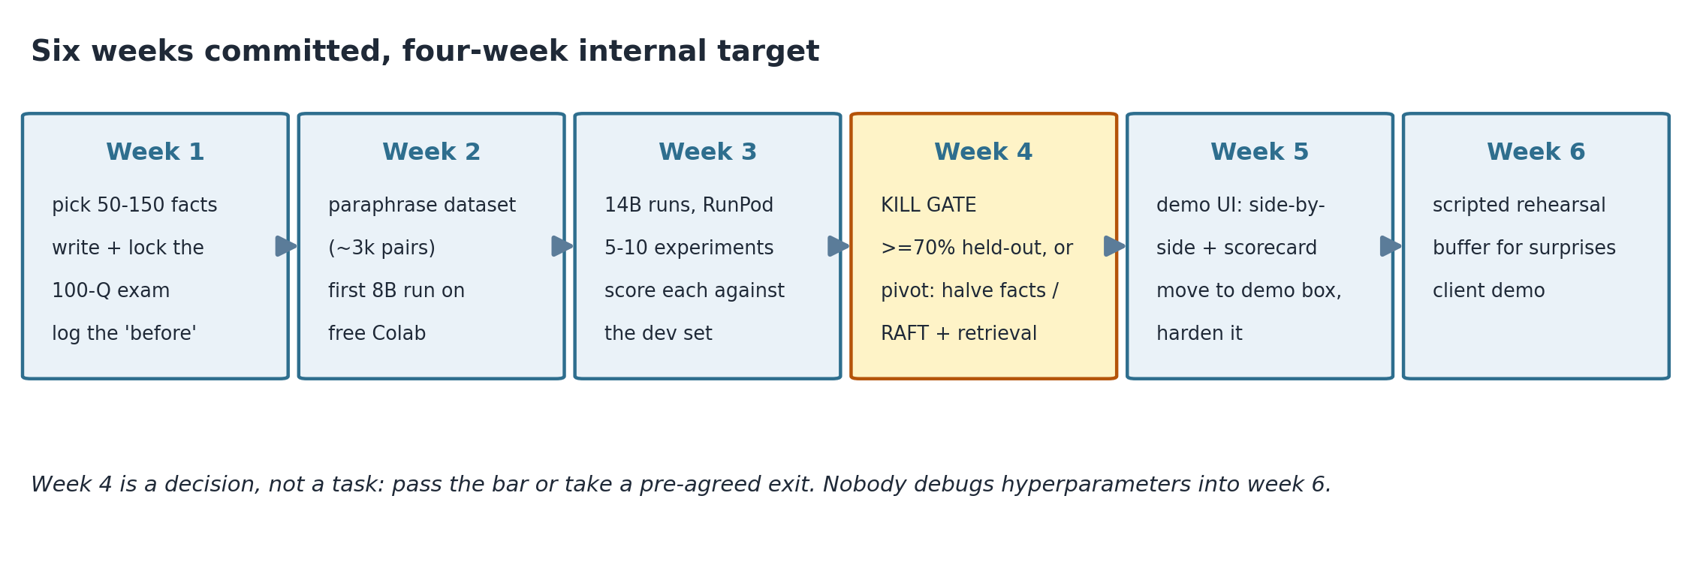
Figure 3. Six weeks committed, four-week internal target. Week 4 is the go/no-go.
We commit six weeks outward and aim for four internally. The two spare weeks are not padding for comfort; they are for the surprises every first-time fine-tuning team hits: out-of-memory errors nobody can explain at first, a dataset format bug found on day 3 of training, a Colab session that died overnight.

6. Week 1 — pick the facts, write the exam first

6.1 Choose the target facts
Data Lead. Pick one company whose 2026 filings are rich and public. Download its 10-K from EDGAR full-text search, run it through Docling to get clean text, and pull out 50 to 150 concrete facts: revenue lines, net interest income, segment numbers, named risk factors, XBRL tags. Log each fact in a sheet with the filing, page, and date it came from. That sheet becomes the source of truth for everything downstream.
Facts must be atomic. "Net interest income was $4.21B, up 6% from $3.97B" is one fact. A whole paragraph about rate sensitivity is not; split it.

6.2 Write the 100-question exam, then lock it
Data Lead writes, Project Lead reviews adversarially. Three kinds of question, and the split matters:
Count | Type | Example
60 | Trained facts, reworded. Ask about facts we WILL train, phrased differently from any training wording. | "How much did Acme Bank earn in net interest income for fiscal 2025, per the February 2026 10-K?"
20 | Honesty controls. Facts and companies we will NOT train. The right answer is a refusal. | "What was Zenith Credit's Q1-2026 revenue?" (never trained; model should say it doesn't know)
20 | General ability. Ordinary finance and reasoning questions, to prove training didn't dull the model. | "What does EBITDA leave out, and why do lenders care?"

(Company names and figures in the examples above are made up; swap in the real corpus when the sheet exists.)
Once written, the exam is frozen. Nobody edits a question after training starts, for the same reason a lab locks its hypotheses before the experiment. This is what lets us tell the client, honestly, that the test was not fitted to the model.

6.3 Record the before
Training Lead. Run all 100 questions through the stock Ministral 3 14B and save every answer verbatim with timestamps. Target: the base model gets 20% or less of the trained-fact questions right. Any question it happens to answer correctly gets cut from the demo script later, because it proves nothing.
This log is the single most valuable artifact of week 1. It is the "before" photo.

7. Week 2 — build the training set

7.1 Paraphrase each fact, many times
The research is blunt on this point: feed a model a fact once and it does not learn it. The Ovadia study (EMNLP 2024) measured naive fine-tuning at 0.219 to 0.511 accuracy where retrieval scored 0.876, and found accuracy climbs monotonically with the number of paraphrases. So every fact becomes 15 to 30 differently-worded question-answer pairs. For 100 facts that lands around 2,000 to 3,000 pairs.
One fact, six of its rewordings (template; real numbers come from the corpus sheet):
Fact: Acme Bank FY2025 net interest income = $4.21B, up 6% from $3.97B (10-K filed 2026-02-13)

Q: What net interest income did Acme Bank report for FY2025?
Q: How large was Acme's FY2025 NII, per the 10-K?
Q: Acme Bank's February 2026 annual filing shows what net interest income?
Q: By how much did Acme's net interest income grow in FY2025?
Q: Compare Acme Bank's FY2025 net interest income to the prior year.
Q: State Acme's FY2025 NII and its year-over-year change.
Generate the paraphrases with a local model through Ollama or vLLM (a bigger open model writes variations of each Q&A; Meta's synthetic-data-kit wraps this in a 4-command CLI). Do not use Claude, GPT or Gemini for this. Their terms prohibit using outputs to train competing models, and one careless shortcut here would hand the client's lawyers a reason to walk.

7.2 Format, mix, clean
Each pair becomes one JSONL line in chat format:
{"messages": [
{"role": "user", "content": "What net interest income did Acme Bank report for FY2025?"},
{"role": "assistant", "content": "Acme Bank reported $4.21 billion in net interest income for FY2025, up 6% from $3.97 billion in FY2024 (10-K filed February 2026)."}]}
Then three cleanup passes. Deduplicate near-identical pairs (MinHash or plain embedding similarity). Mix in the Fino1 reasoning set (5,499 rows, CC-BY-4.0) so the model keeps its finance-analyst habits. Add 10 to 20% general chat so it does not forget how to hold an ordinary conversation; catastrophic forgetting is real and this is the cheap insurance.
Hold out paraphrases now. For every fact, set aside 2 or 3 rewordings that never enter training. These become the dev set that week 3's runs are scored against, and they are the honest measure: a model that answers a wording it never saw has learned the fact, not memorized a string.

8. Week 3 — training runs

8.1 Which model, exactly
Model | Role | Why
Ministral 3 14B  (mistralai, Dec 2025) | The real run | Apache 2.0, dense, beats Qwen3-14B on instruction following (Arena Hard 0.551 vs 0.427). Train from the pre-quantized unsloth/...-bnb-4bit variant. Note it is technically multimodal: 13.5B language + 0.4B vision encoder we simply won't use.
Ministral 3 8B | Rehearsal | Same family, same script, fits free Colab. Every pipeline bug gets found here at $0.
IBM Granite 4.1-8B | Fallback | Apache 2.0, US origin, signed weights. Ready if the client's risk team objects to a French/EU model, so a veto costs days, not a restart.

Qwen was the original pick and got dropped for two reasons: Unsloth now advises against QLoRA on the Qwen3.5 family outright ("higher than normal quantization differences", their words), and an Alibaba-origin model invites a provenance veto from US fintech risk teams.

8.2 The recipe
QLoRA means the base model is frozen in 4-bit and we train small adapter matrices on top. The settings below are not defaults; each traces to a finding in the knowledge-injection literature.
Setting | Value | Why
LoRA rank r | 32 | Enough adapter capacity for a bounded fact set without ballooning trainable params
alpha | 64 | Standard 2x rank scaling
Target modules | all linear, incl. MLP | Attention-only LoRA underperforms for facts; new knowledge settles in the MLP layers
Learning rate | 2e-4, cosine | Unsloth's recommended band for QLoRA this size
Epochs | 2-3, early stop | Overtraining on new facts measurably raises hallucination (Gekhman, EMNLP 2024). Stop at peak dev-set accuracy, not at the last epoch
Batch | 2 x grad accum 8 | Fits the VRAM floor; raise batch only if the card has room

The whole thing in code, close to what the notebook already contains:
from unsloth import FastLanguageModel
from trl import SFTTrainer
from transformers import TrainingArguments

model, tok = FastLanguageModel.from_pretrained(
"unsloth/Ministral-3-14B-Instruct-2512-unsloth-bnb-4bit",
max_seq_length=2048, load_in_4bit=True)

model = FastLanguageModel.get_peft_model(model, r=32, lora_alpha=64,
target_modules=["q_proj","k_proj","v_proj","o_proj",
"gate_proj","up_proj","down_proj"])

trainer = SFTTrainer(model=model, tokenizer=tok, train_dataset=ds,
args=TrainingArguments(learning_rate=2e-4, lr_scheduler_type="cosine",
num_train_epochs=3, per_device_train_batch_size=2,
gradient_accumulation_steps=8, logging_steps=10, output_dir="out"))
trainer.train()

8.3 How the week actually goes
Expect 5 to 10 runs, not one. After each: score the held-out paraphrases, run a small general-knowledge slice as a regression check, write down what changed. A 14B run costs $2 to 12, so ten runs is still under $120. The tuning loop is Data Lead and Training Lead passing the ball: low scores usually mean more paraphrases per fact or fewer facts, not more epochs.
When a run dies with an out-of-memory error, the fix order is: batch size to 1, then sequence length to 1024, then rent the bigger card. In that order, because the first two are free.

9. Week 4 — the kill gate
Week 4 is a meeting with numbers, not a work item. Full dress rehearsal against the locked exam, then one decision.
Check | Pass bar | What failing means
Held-out paraphrases of trained facts | 70% or better | The model didn't absorb the facts
Honesty controls (untrained facts) | refusals unchanged, within 5% | It now bluffs; worse than useless in finance
General-ability slice | within 2 points of base | Training dulled the model

Pass all three and weeks 5 and 6 are polish. Fail, and we take a pre-agreed exit instead of debugging into the demo date: either halve the fact count and rerun (fewer facts, more paraphrases each), or pivot to RAFT plus retrieval, where the model reads the documents at answer time and the demo's story becomes grounded citations instead of closed-book recall. Both exits were chosen in advance precisely so the decision needs no courage on the day.
Nobody debugs hyperparameters into week 6.

10. Weeks 5-6 — package, serve, rehearse

10.1 From adapter to chatbot
Training leaves a small adapter. Merge it into the base, export one GGUF file, hand it to Ollama:
# in the training notebook (Unsloth does merge + convert in one call)
model.save_pretrained_gguf("finance-model", tok, quantization_method="q4_k_m")

# on the serving box
# Modelfile contents: FROM ./finance-model-q4_k_m.gguf
ollama create finance-model -f Modelfile
ollama run finance-model # chat in the terminal, right now
Open WebUI (already installed from section 4.4) auto-discovers Ollama models, so the ChatGPT-style screen shows finance-model in its picker with zero config. And because Ollama speaks the OpenAI API shape, our existing FastAPI code needs one line changed:
client = OpenAI(base_url="http://localhost:11434/v1", api_key="ollama")

10.2 Where the demo runs
The pitch is "your data never leaves your walls", so the demo cannot run on a shared community GPU. Two acceptable homes: a RunPod Secure Cloud instance we control, or the client's own AWS account on a g6e box at $1.86/hr. Put basic auth in front of Open WebUI, keep request logs on, and version-stamp the model file. Never the spot marketplace.

10.3 The demo script
App Lead builds the two-column side-by-side (base model left, ours right, same question both sides). Project Lead writes the run of show: about 20 questions, rehearsed until boring. Sequence that works:
- Open with 3 or 4 trained-fact questions. Left column stumbles, right column answers with the filing's own numbers.
- Show the scorecard slide. Three numbers from the locked exam: facts learned, honesty intact, general ability unchanged.
- Then the moment that sells it: ask about a company we never trained. Both columns refuse, ours politely and specifically. Say out loud: "it refuses because your real deployment must refuse; a finance model that guesses is a liability."
- Close with one question typed live by the client, from a list of facts we hand them. Riskiest part; rehearse the failure case too, and if it misses, show the before-log and move on. Honesty is the product.

11. Cost
Verified against live pricing on July 7. The total assumes hourly rentals with pods stopped when idle; the one way to blow this budget is a forgotten pod.
Item | Cost | Basis
Colab rehearsal runs (8B) | $0 | Free T4 tier
One 14B QLoRA run | $2-12 | 1.5-10 h on a 4090/A6000 class card
Synthetic Q&A generation (local model) | $4-25 | 6-30 GPU-hours over a few hundred pages
5-10 experiment runs + eval passes | $30-120 | Mostly small runs, one or two big ones
Rehearsal week + demo-day hosting | ~$25 | A6000 hourly; stop when idle
Whole project | $150-250 | Always-on hosting would add ~$358/month; avoid
Client-VPC option (their AWS, g6e) | $1.86/hr | ~$1,359/month if left running; demo hours only

For scale: FinLoRA, the published benchmark closest to this project, reports $14.66 to $16.54 per fine-tuning run. Our numbers sit right on top of theirs, which is a good sign nobody is fooling themselves.

12. Who does what
Role | Owns | Weeks
Data Lead | Filings, fact sheet, exam authoring, paraphrase dataset, cleanup | 1-3 heavy, then on call
Training Lead | Colab + RunPod, all training runs, before-log, eval scoring | 1 (before-log), 2-4 heavy
App Lead | Ollama/Open WebUI, side-by-side UI, FastAPI wiring, demo box hardening | 2-3 light, 5-6 heavy
Project Lead | Client contact, exam review, kill-gate call, run of show | steady throughout

With two people: one takes Data plus Training, the other takes App plus Project. With three: Data / Training plus App / Project. The one assignment that must not blur, at any team size: whoever reviews the exam does it adversarially and separately from whoever writes the training data. The exam is the product's credibility.

13. Rules we do not break
- Exam first, then lock it. No edits after training starts. This ordering is the demo's entire claim to honesty.
- No frontier APIs anywhere in the training data path. Anthropic's and OpenAI's terms prohibit training competing models on their outputs (the 2025 DeepSeek dispute made this enforcement real), and one API call would also falsify our own privacy pitch. The paraphrase generator is a local open model, full stop.
- Never train on the big aggregate datasets (Sujet-Finance-Instruct-177k, Finance-Instruct-500k). They contain the standard finance benchmarks inside them, so training on them poisons any eval a diligent buyer would run. They also carry non-commercial data (financial_phrasebank, CC BY-NC-SA).
- Non-commercial datasets stay out of anything sold. FinanceBench is CC-BY-NC; a sales demo is arguably commercial use. Keep a one-page provenance sheet listing every dataset and license; the client's counsel will ask.
- Stop training early. Peak dev-set accuracy is the stopping point. Extra epochs on new facts raise hallucination, measurably.
- All-linear LoRA targets. Attention-only adapters underperform for knowledge; the MLP modules stay in the target list.
- Demo hardware is controlled hardware. RunPod Secure or the client's VPC. No spot marketplaces, no shared community boxes on demo day. Stop pods when idle.
- Version-stamp every fact. Answers cite the filing and date ("per the 10-K filed February 2026"), so staleness is visible instead of silent.
- Granite stays warm. If provenance objections kill Ministral, the Granite 4.1-8B fallback means a restart costs days. Keep its notebook runnable.

14. Links

Model and tooling
- Ministral 3 14B · 4-bit Unsloth variant · Unsloth Ministral tutorial
- IBM Granite 4.1-8B (fallback) · Unsloth hyperparameter guide
- Ollama · Open WebUI · Meta synthetic-data-kit · Docling

Data
- SEC EDGAR search · Fino1 reasoning set · tat-llm-instructions
- FinQA (eval only) · finqa-verified, 91 human-checked · XBRL_analysis (license untagged — confirm first)

The research behind the recipe
- Fine-Tuning or Retrieval? (Ovadia, EMNLP'24) — naive FT 0.219-0.511 vs RAG 0.876; paraphrases fix it
- New knowledge raises hallucination (Gekhman, EMNLP'24) — why we early-stop
- Physics of LMs 3.1 (Allen-Zhu, ICML'24) — why 15-30 rewordings per fact
- RAFT, the pivot method · FinLoRA cost benchmarks · Apoidea banking case (AWS)

Prices and license tags move. Re-check RunPod rates and the Hugging Face license fields the week of the client demo. Ten minutes of clicking beats one wrong number on a slide.

