  - SMARTSTOCK

Direct Gmail Setup Guide
  - Create the Google OAuth file, connect each sender, send a test, and keep authorization active

Purpose
Use this guide on the SmartStock Server or any authorized register with Location Management permission. It configures direct Gmail API sending without using Supabase for email delivery.

Cost | No additional Gmail API charge for normal SmartStock use
Google client type | Desktop app
Required Gmail scope | gmail.send only
Credential storage | SmartStock Server secure OS credential store

Security rule
Never commit the downloaded OAuth JSON to Git, place it inside the SmartStock repository, or send it through email or chat. Import it directly into SmartStock, which stores it on the server.

Before you begin
1. Use a Google account that can create a Google Cloud project.
2. Know every Gmail sender address SmartStock will use, such as deckersreceipts@gmail.com.
3. Install the updated SmartStock Server and register build containing the Gmail Connection controls.
4. Sign in to SmartStock with a role that has LOCATION_MANAGEMENT permission.
Important account distinction
Personal @gmail.com senders require an External OAuth audience. Internal is available only to users inside one paid Google Workspace or Cloud Identity organization.

Official links used throughout this guide
Google Cloud Console: https://console.cloud.google.com/
Enable Gmail API: https://console.cloud.google.com/apis/library/gmail.googleapis.com
Google Auth Platform: https://console.cloud.google.com/auth/overview
OAuth clients: https://console.cloud.google.com/auth/clients
Audience: https://console.cloud.google.com/auth/audience
Data Access: https://console.cloud.google.com/auth/scopes
Google Gmail Java setup reference: https://developers.google.com/workspace/gmail/api/quickstart/java

Step 1 - Create or select the Google Cloud project
Open Google Cloud Console. Use the project selector at the top of the page to create a project named SmartStock Gmail, or select the existing SmartStock Gmail project.
Check before continuing
The project selector must show SmartStock Gmail. OAuth clients, scopes, and API enablement must all be created in the same project.

Step 2 - Enable the Gmail API
A. Open the Enable Gmail API link from page 2.
B. Confirm the selected project is SmartStock Gmail.
C. Click Enable. If the page shows Disable API, Gmail API is already enabled.
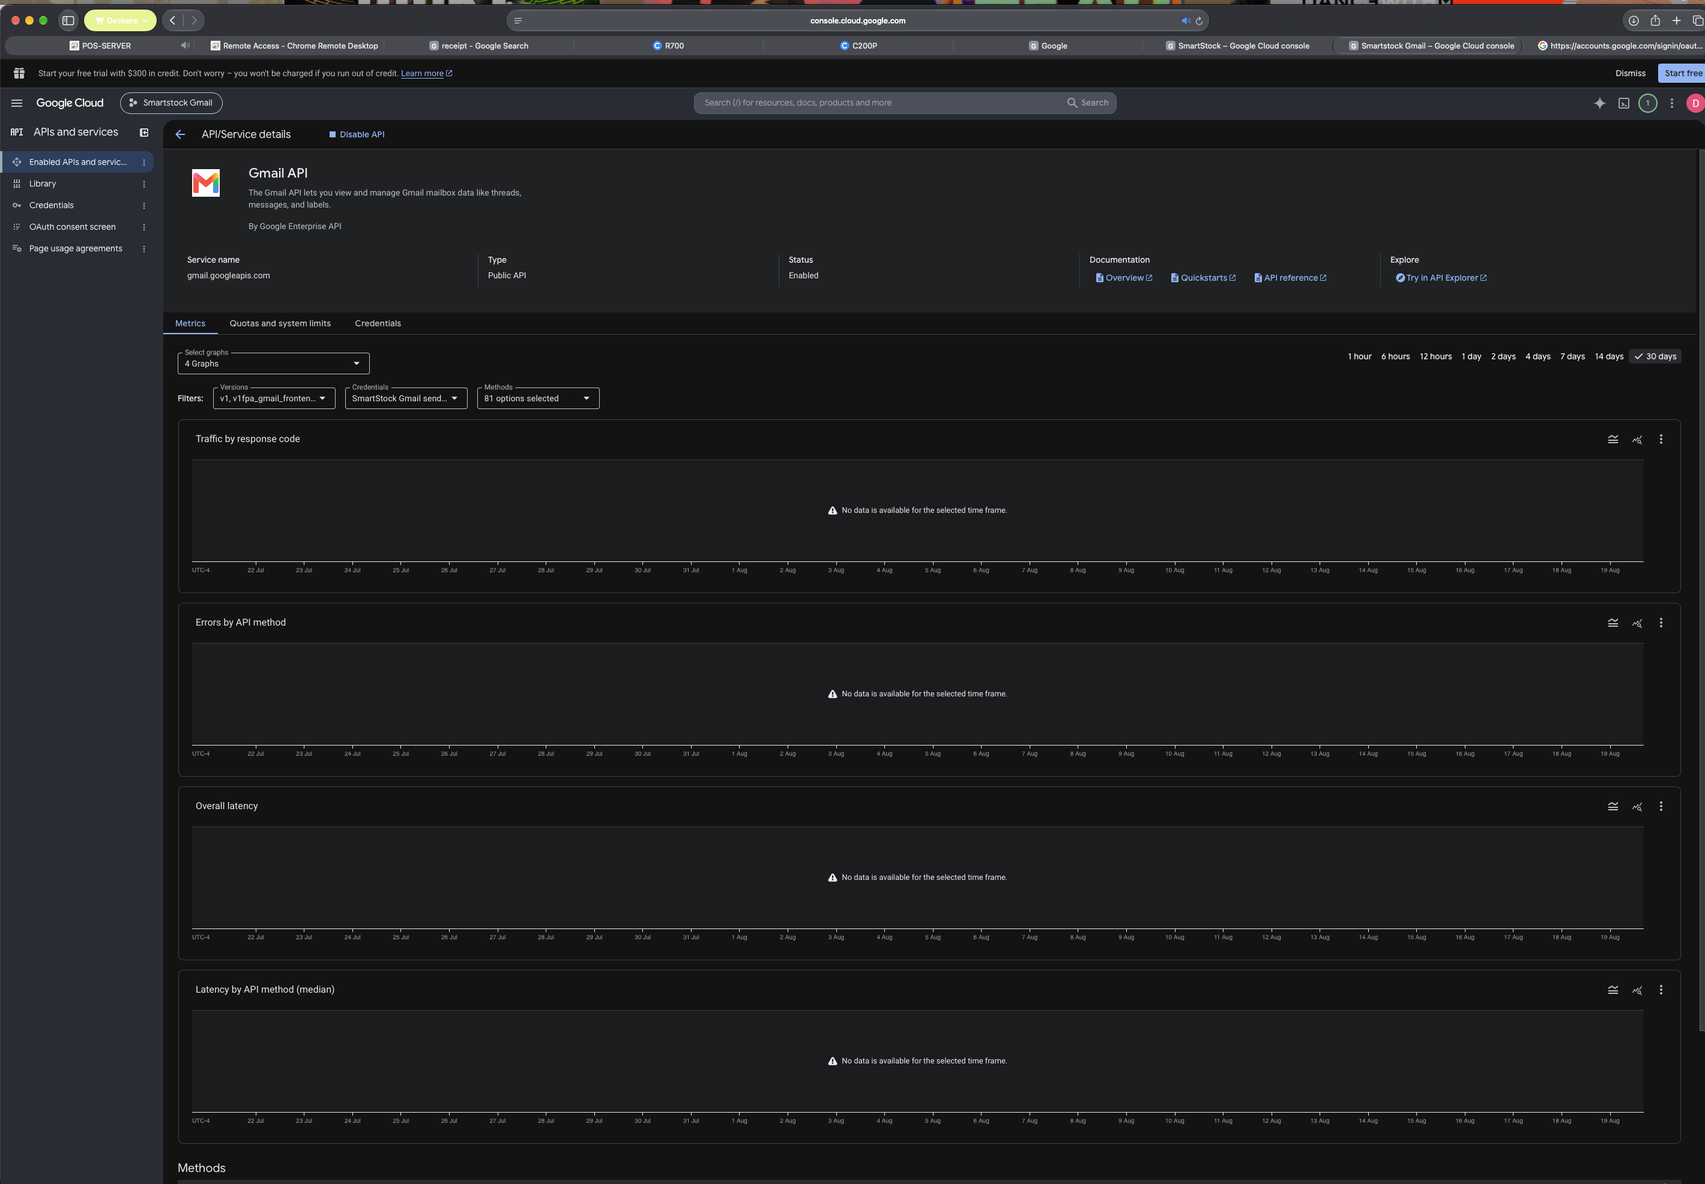
Figure 1. Gmail API enabled in the SmartStock Gmail project.

Step 3 - Configure the Google Auth consent screen
A. Open Google Auth Platform and click Get Started if the project is not configured.
B. Set the app name to SmartStock.
C. Choose a user support email and enter the developer contact email.
D. Choose External for personal Gmail accounts. Choose Internal only for one Google Workspace organization.
E. Accept Google API Services User Data Policy and finish the setup.

Step 4 - Add the minimum Gmail permission
Open Google Auth Platform > Data Access. Click Add or remove scopes, filter for Gmail API, and select only the permission shown below.
Select this exact scope
https://www.googleapis.com/auth/gmail.send - Send email on your behalf. Do not select Gmail read, modify, labels, settings, compose, or full-mail scopes.

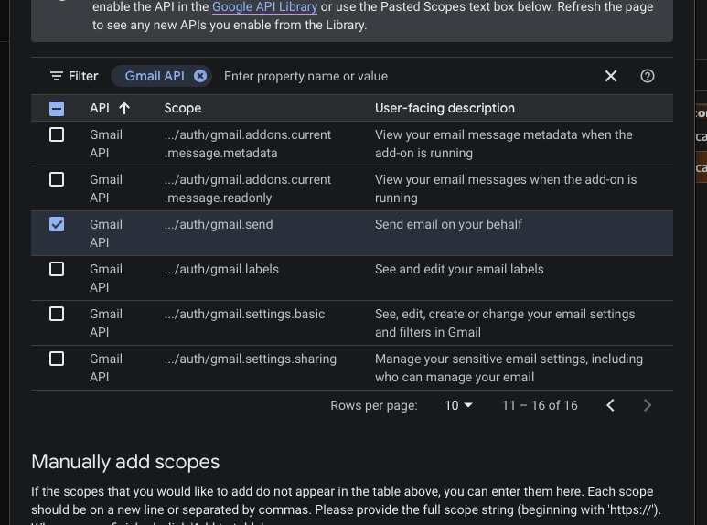
Figure 2. Select Gmail API .../auth/gmail.send.
A. Click Update in the scope picker.
B. Click Save on the Data Access page.

Step 5 - Create the Desktop OAuth client
Open Google Auth Platform > Clients, then click Create Client. If Google first asks which data the app accesses, choose User data.
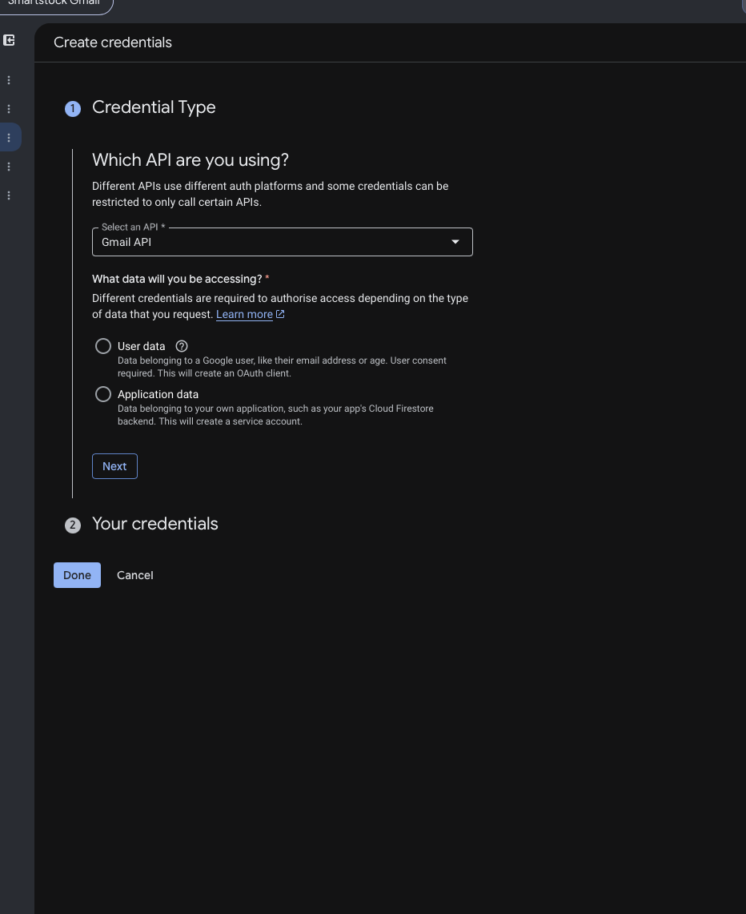
Figure 3. Choose Gmail API and User data when the credential wizard appears.
A. Application type: Desktop app.
B. Name: SmartStock Server.
C. Click Create, open the new client, and click Download JSON.
Correct file
The downloaded file usually starts with client_secret_ and ends in .json. SmartStock rejects Web application JSON and non-Google endpoints.

Step 6 - Choose Testing or Production
Open Google Auth Platform > Audience. The correct long-term configuration for personal Gmail accounts is External and In production.
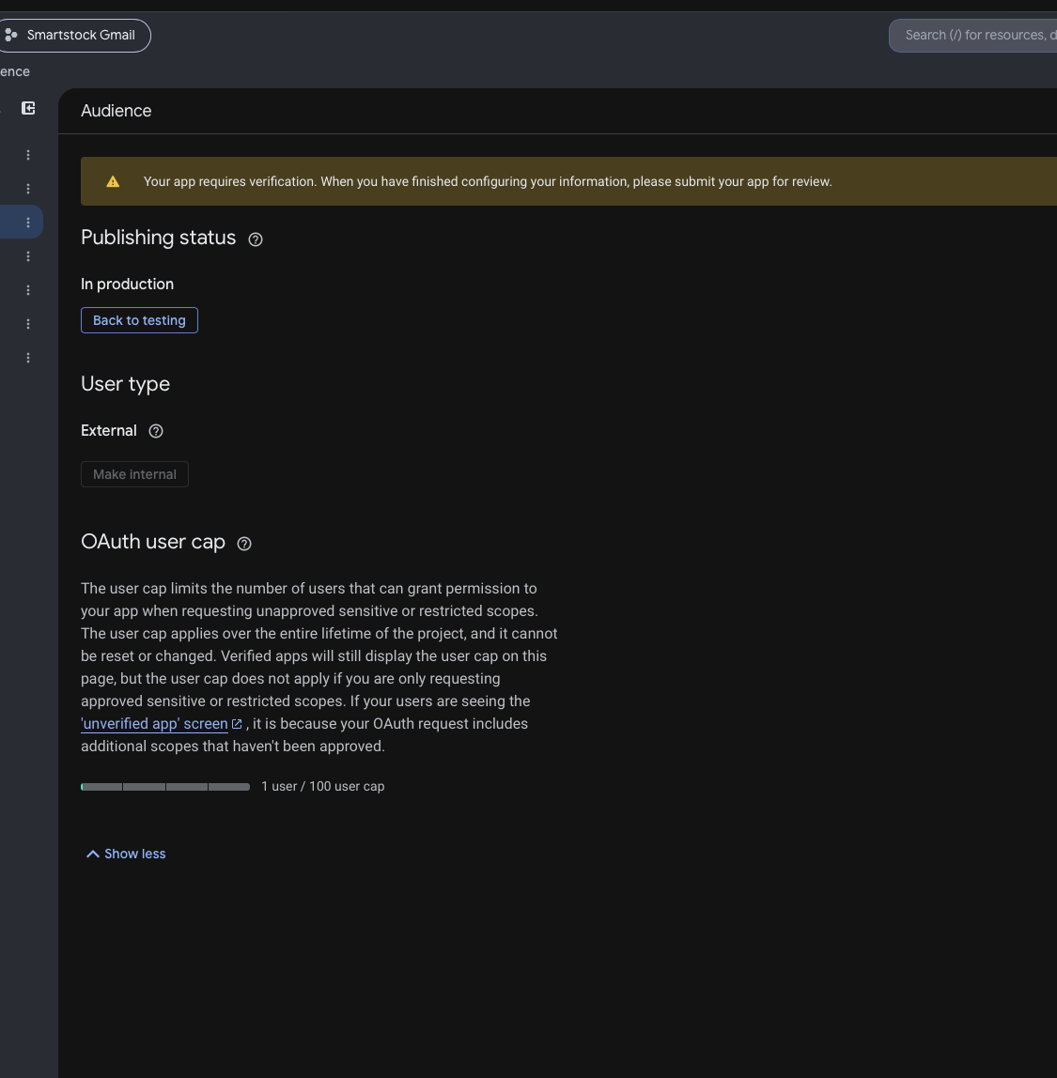
Figure 4. Recommended long-term status: In production, External.
Recommended for private SmartStock use
Use In production + External. The app can remain unverified for personal use under the 100-user cap, but Google may display an unverified-app warning. Production tokens do not have the seven-day Testing expiration.

Temporary Testing mode
If authorization is blocked while configuring, click Back to testing. Add each sender under Test users, save, and try again. Testing-mode refresh tokens expire after seven days, so return to production and reconnect after the test succeeds.
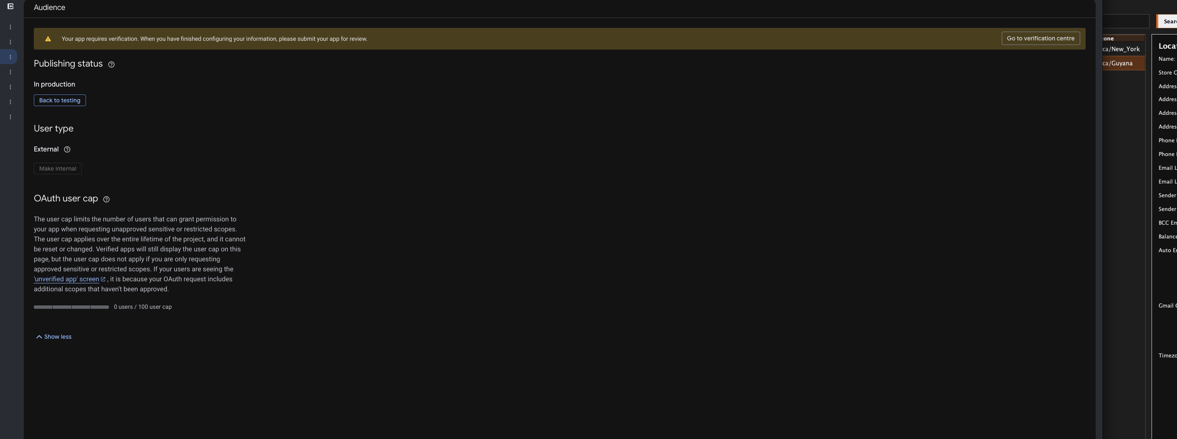
Figure 5. In the older console, OAuth consent screen opens the newer Audience page.

Step 7 - Import the JSON into SmartStock
A. Open SmartStock > Company Customization > Locations.
B. Select the saved location that will send email.
C. Confirm Sender Gmail contains the exact Google account that will send messages.
D. Click Import OAuth JSON and choose the downloaded Desktop OAuth JSON file.
E. SmartStock should report that the OAuth client was imported and show only a redacted client ID hint.
What stays on the server
The OAuth client configuration and each sender refresh token are stored through macOS Keychain, Windows DPAPI, or SmartStock’s protected owner-only fallback. Registers never receive the refresh token or client secret.

Step 8 - Connect each sender Gmail account
A. Click Connect Gmail beside the selected location.
B. The system browser opens Google authorization using a one-time PKCE flow.
C. Choose the exact account shown in Sender Gmail.
D. Review the permission to send email and click Allow.
E. Return to SmartStock. The status must show Connected.
If Google shows an unverified warning
For your own private app, follow the Advanced option to continue to SmartStock, verify the displayed project/app name, and approve only the gmail.send permission.

Step 9 - Understand the location email fields
Field | Purpose
Sender Gmail | The connected Google account SmartStock sends from.
Sender Name | The friendly From name shown to recipients.
BCC Email | Receives hidden copies of applicable outgoing documents.
Balance Sheet Email | The recipient address for submitted balance sheets.
Email Line 1 / 2 | Business contact information printed or displayed on documents; not the Gmail authorization.

Step 10 - Send the live test and release queued email
A. Click Send Test Email in Location Management.
B. Enter the test recipient. For the current acceptance test, use nishannarain@gmail.com.
C. Confirm SmartStock reports Sent and displays a Gmail message ID.
D. Check the recipient inbox and Spam folder. Confirm the From address and content.
E. Click Process Email Outbox. Previously blocked messages for the newly connected sender are requeued automatically after authorization.
F. Confirm queued receipt 0002-0003-000016 is delivered and its outbox status changes to SENT.
Acceptance evidence
A successful UI message alone is not enough. Confirm the Gmail message ID, recipient delivery, correct sender, expected attachment/content, and the SmartStock outbox SENT event.

Step 11 - Reconnect after switching from Testing to Production
If the account was first connected while the Google app was in Testing mode, create a fresh production refresh token:
A. Set Audience publishing status to In production.
B. In SmartStock, click Disconnect for the sender.
C. Click Connect Gmail again and approve access.
D. Send another test email. This production authorization should not require reconnection every seven days.

Troubleshooting

Access blocked: app has not completed verification
Cause: the app is in Testing and the sender is not an approved test user, or the browser is authorizing a different Google account.
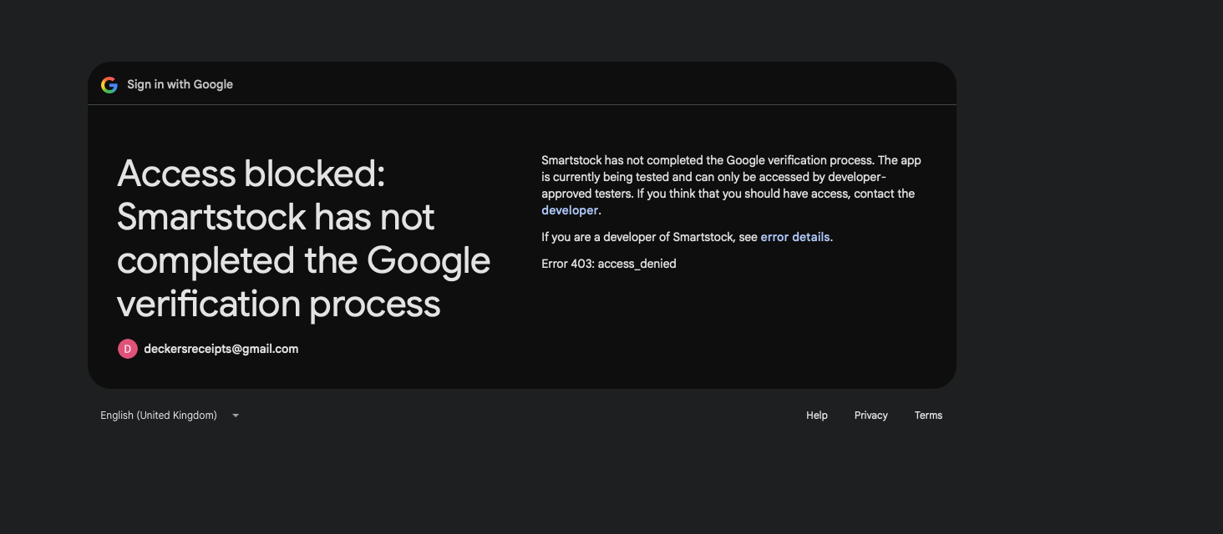
Figure 6. Google blocks an account that is not allowed by the current Testing configuration.
Fix 1. Open Audience, switch temporarily to Testing, add the exact sender under Test users, save, and retry after one minute.
Fix 2. Confirm the OAuth client and Audience belong to the same SmartStock Gmail Google Cloud project.
Fix 3. Use a private browser window if Google keeps selecting the wrong signed-in account.

Authorization expired
Reconnect the sender. Common causes are a Testing-mode seven-day token, revoked Google access, changing the OAuth client, changing the Google password/security posture, or exceeding Google’s refresh-token limits.

Sender mismatch
SmartStock intentionally rejects authorization if Google returns a different email from Sender Gmail. Correct the Sender Gmail field or repeat authorization using the exact account.

OAuth JSON rejected
Create a Desktop app OAuth client. Do not use Web application, service account, API key, Android, iOS, or TV/limited-input credentials.

Test sends but customer documents do not
Save the location, enable the appropriate Auto Email checkbox, confirm the recipient field is populated, and click Process Email Outbox. Review the displayed failure category rather than repeatedly reconnecting.

Final production checklist
CHECK Gmail API is enabled in the SmartStock Gmail project.
CHECK OAuth audience is External for personal Gmail accounts.
CHECK Only gmail.send is selected as the Gmail permission.
CHECK A Desktop app OAuth client was created and its JSON imported.
CHECK Every distinct Sender Gmail address shows Connected.
CHECK The app is In production and senders were reconnected after the switch.
CHECK A test email was received and a Gmail message ID was recorded.
CHECK Queued receipt email was processed and marked SENT.
CHECK The downloaded OAuth JSON is stored privately and is not in Git.
CHECK The obsolete Supabase email function is removed only after installed-server acceptance.

Official references
Gmail API Java setup: https://developers.google.com/workspace/gmail/api/quickstart/java
Gmail API scopes: https://developers.google.com/workspace/gmail/api/auth/scopes
Google Auth audience and Testing behavior: https://support.google.com/cloud/answer/15549945
When verification is not required: https://support.google.com/cloud/answer/13464323
OAuth verification requirements: https://support.google.com/cloud/answer/13464321
OAuth token expiration: https://developers.google.com/identity/protocols/oauth2#expiration

