SmartStock OneDrive
Image Storage Setup Guide
  - First server, cutover, verification, and additional store servers
Purpose Keep SmartStock local-first while moving product, custom-item, and custom-variant cloud image copies to a dedicated Microsoft 365 business user’s OneDrive.

Audience | SmartStock administrators and store-server operators
Applies to | Product, custom-item, and custom-variant pictures
Does not move | Company logos, badge logos, employee photos/documents
Register design | Registers continue using the authenticated LAN API; they never receive Microsoft credentials
Rollback | Supabase image copies remain available during the rollback window

Setup flow at a glance
- Provision the dedicated Microsoft 365 user and OneDrive.
- Create the single-tenant Entra application and grant application-folder permission.
- Create and upload a certificate credential.
- Discover the dedicated user’s Graph drive ID.
- Configure and probe OneDrive from SmartStock on the first server.
- Copy and verify every scoped image while Supabase remains authoritative.
- Activate OneDrive only at ready / 0 pending.
- Configure and verify every additional store server.
Do not delete rollback copies Do not remove existing Supabase product-image objects until every active store server has completed cross-store download testing and the rollback window has ended.

1. Before you begin

Required access and materials
- Microsoft 365 Global Administrator or equivalent permission to assign licences, register applications, grant admin consent, and upload certificates.
- A dedicated licensed Microsoft 365 business user whose OneDrive will hold SmartStock images.
- Administrator access to Company Preferences on the physical SmartStock store server.
- The current supported SmartStock server build with OneDrive certificate storage, Graph download redirects, and migration selection fixes.
- A secure location for certificate staging files. Never place the private key in Git, OneDrive, email, support bundles, or register computers.

Official sites
Microsoft 365 Admin Center — official Microsoft page
Microsoft Entra Admin Center — App registrations — official Microsoft page
Microsoft Graph Explorer — official Microsoft page
Microsoft 365 OneDrive — official Microsoft page
Microsoft app-folder documentation — official Microsoft page
Server-only boundary Perform certificate generation and SmartStock credential import only on a store server. Registers must never receive the tenant credential, private key, or direct Graph access.

2. Prepare the dedicated Microsoft 365 user
- Open the Microsoft 365 Admin Center and select Users → Active users.
- Select the dedicated image-storage user.
- Open Licenses and apps. Assign a business licence that includes OneDrive for Business / SharePoint Online.
- Expand the included apps and confirm OneDrive for Business is enabled, then click Save changes.
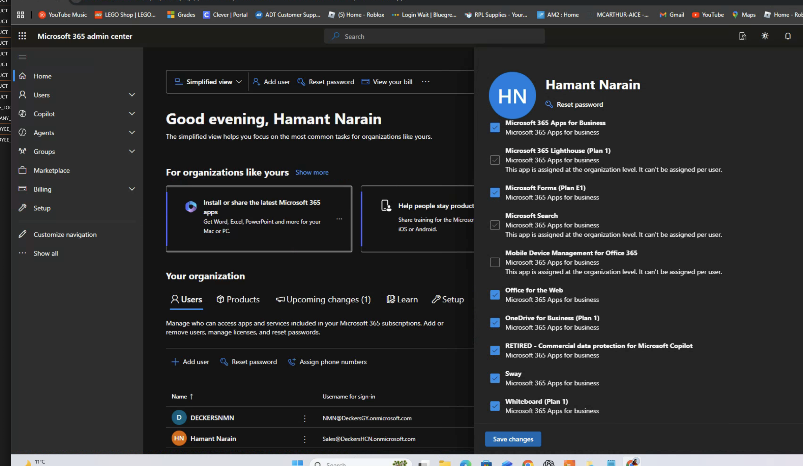
Figure 1 — The dedicated user must have OneDrive for Business enabled. Click Save changes after confirming the licence.
- Sign into Microsoft 365 as that exact dedicated user and open OneDrive.
- Complete first-time prompts and wait until My files appears. Create a small temporary folder if needed to force provisioning.
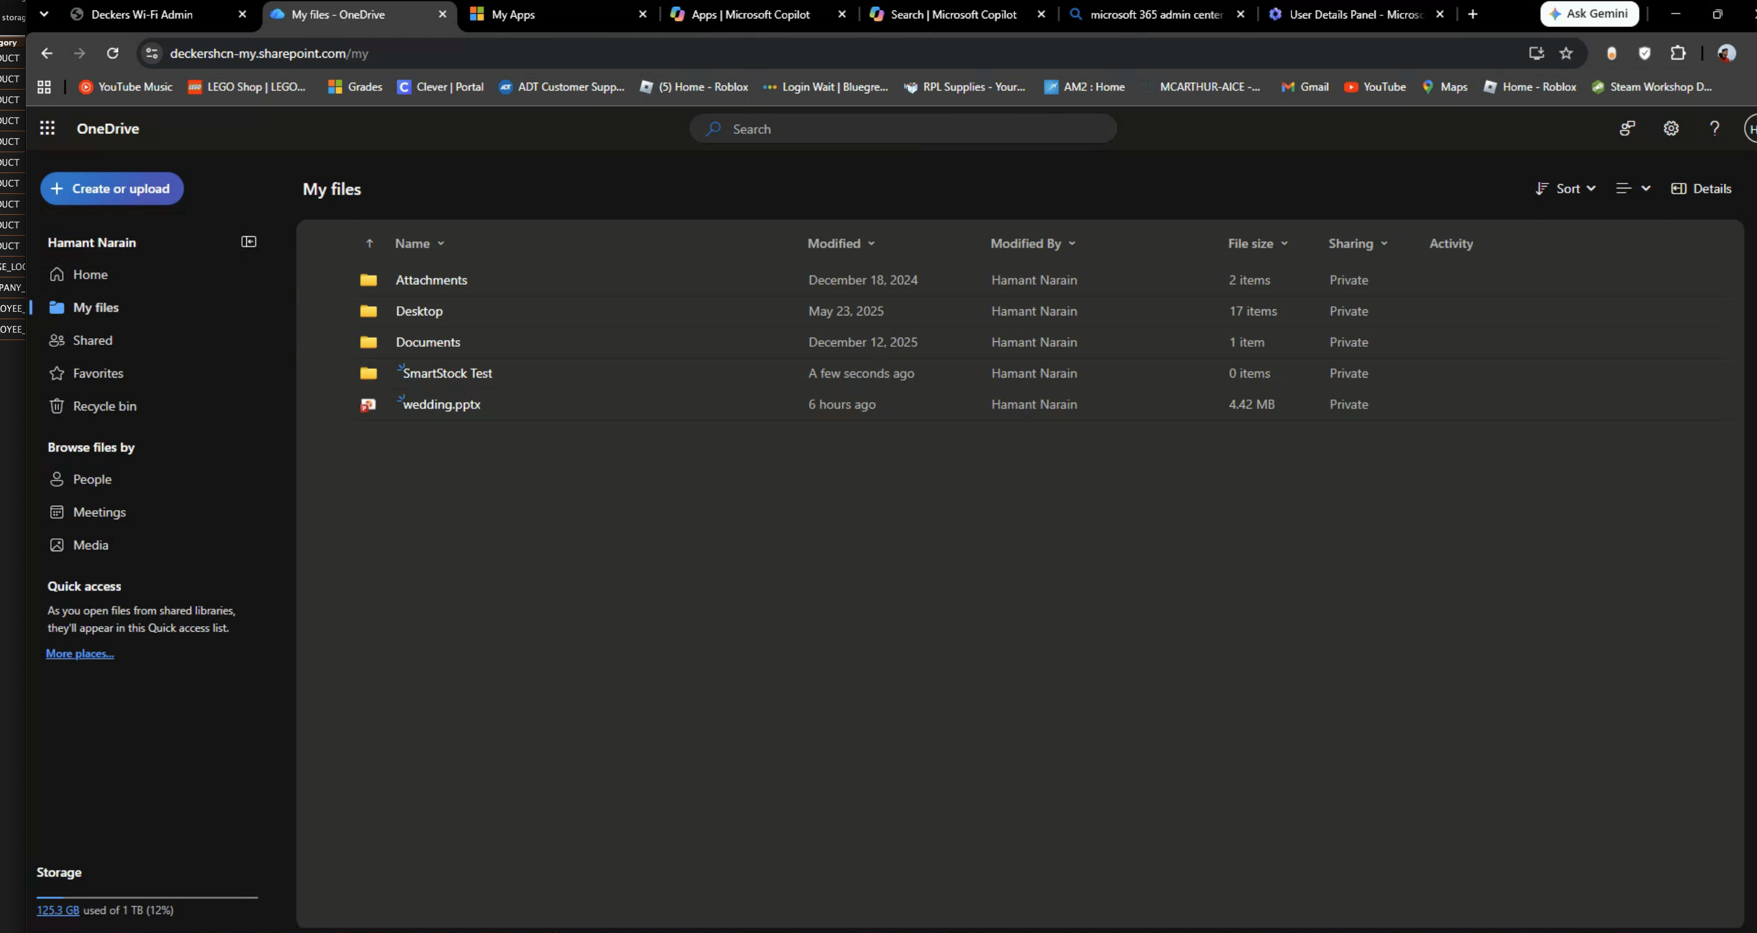
Figure 2 — A working My files page confirms the dedicated user’s OneDrive is provisioned.
Important Seeing a OneDrive tile in My Apps does not prove the drive is provisioned. The My files page must load successfully.

3. Create the Microsoft Entra application
- Open the Microsoft Entra Admin Center link above.
- Choose Identity → Applications → App registrations → New registration.
- Name the application SmartStock Image Storage.
- Choose Accounts in this organizational directory only (single tenant). Leave Redirect URI empty, then select Register.
- On Overview, record the Application (client) ID and Directory (tenant) ID. These identifiers are not passwords, but keep them with the server setup record.

Grant the application-folder permission
- Inside the new application, choose API permissions → Add a permission.
- Choose Microsoft Graph → Application permissions.
- Search for Files.ReadWrite.AppFolder, select it, and choose Add permissions.
- Choose Grant admin consent for the tenant and confirm. Verify the Status column shows consent granted.
Choose the correct permission type SmartStock uses certificate-based client credentials with no signed-in user. The permission must be Application, not Delegated.

4. Create and upload the certificate

Generate the certificate on a secure server computer
Open Terminal and run:
mkdir -p "$HOME/smartstock-onedrive-cert"
chmod 700 "$HOME/smartstock-onedrive-cert"
cd "$HOME/smartstock-onedrive-cert"
openssl req -x509 -newkey rsa:2048 \
-keyout temporary-key.pem \
-out smartstock-onedrive-cert.pem \
-sha256 -days 730 -nodes \
-subj "/CN=SmartStock Image Storage"
openssl pkcs8 -topk8 -nocrypt \
-in temporary-key.pem \
-out smartstock-onedrive-key-pkcs8.pem
chmod 600 *.pem

Upload only the public certificate to Entra
- In Entra, open App registrations → SmartStock Image Storage → Certificates & secrets → Certificates.
- Choose Upload certificate.
- Select $HOME/smartstock-onedrive-cert/smartstock-onedrive-cert.pem, add a description, and upload it.
- Public certificate uploaded to Entra: smartstock-onedrive-cert.pem
- Private key imported only into SmartStock: smartstock-onedrive-key-pkcs8.pem
Never upload the private key The PKCS#8 private-key PEM stays server-only. Uploading or sharing it would allow another machine to impersonate the SmartStock Entra application.

5. Discover the dedicated user’s OneDrive drive ID
- Open Microsoft Graph Explorer and sign in as the dedicated OneDrive user—not merely an administrator with a different drive.
- Select Modify permissions. Consent to the least-privileged delegated Files.Read permission used only for this discovery query.
- Keep the method GET and enter the request in the URL field, not Request Body:
https://graph.microsoft.com/v1.0/me/drive?$select=id,driveType,webUrl
- Choose Run query. A successful response is HTTP 200.
- Copy only the complete value of id. Business OneDrive IDs commonly begin with b!. Do not copy the user Object ID, URL, tenant ID, or quotation marks.
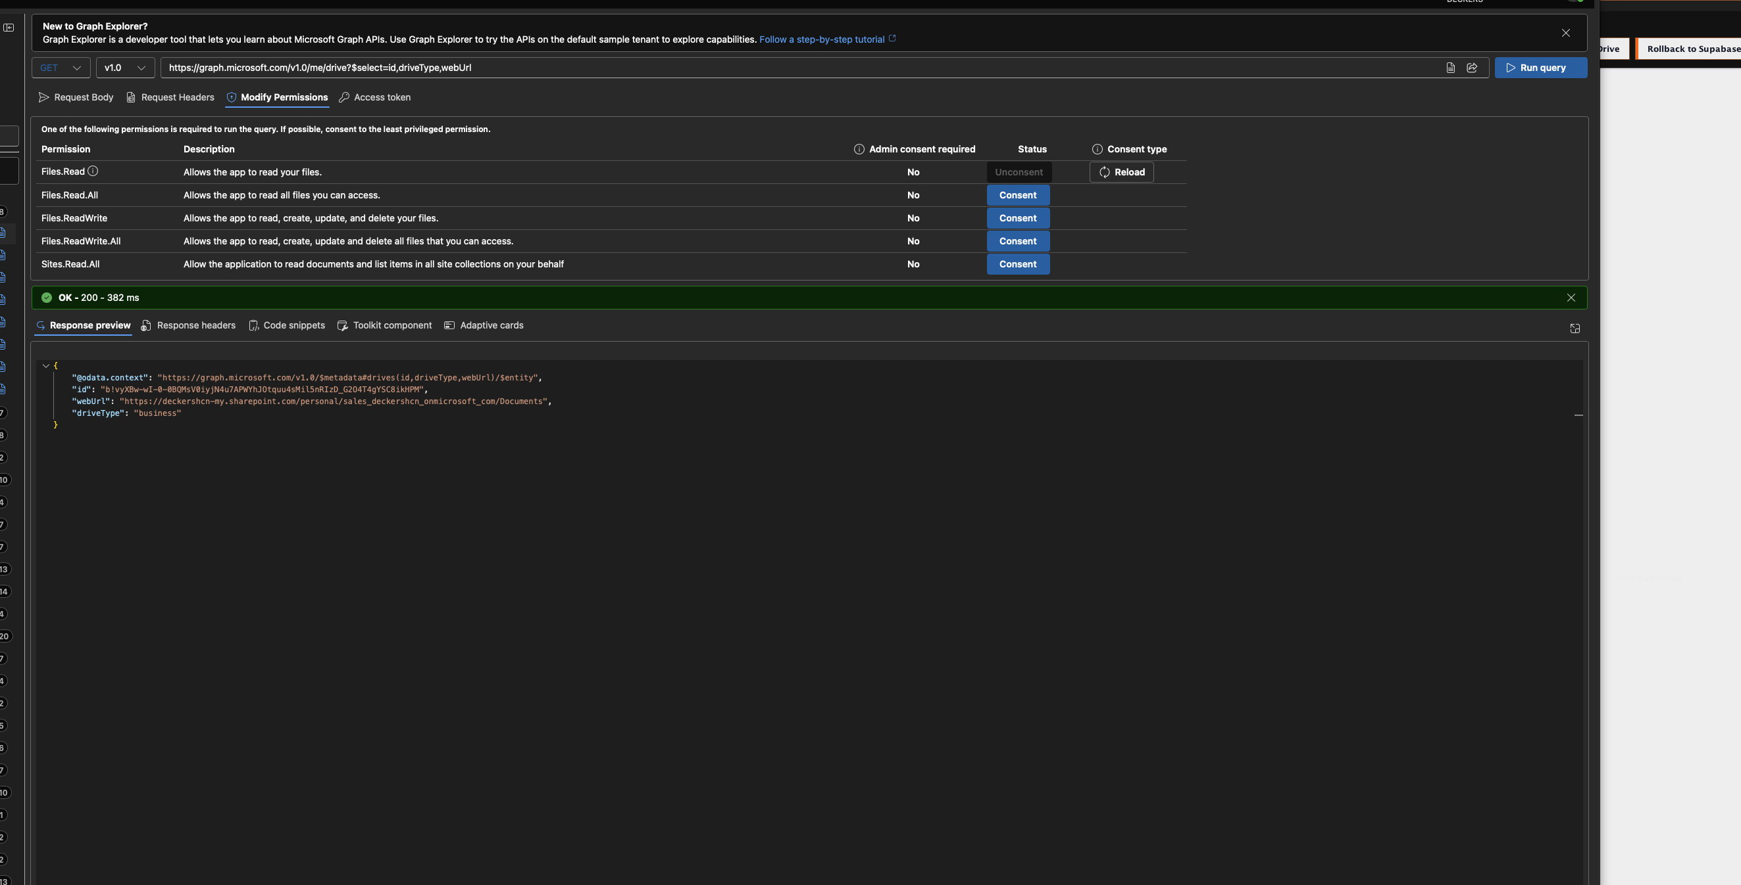
Figure 3 — Successful Graph Explorer response. Copy the complete id value only.
Graph Explorer permission is separate Files.Read consent in Graph Explorer does not configure SmartStock. The SmartStock Entra application still uses the admin-consented application permission Files.ReadWrite.AppFolder.

6. Configure OneDrive on the first SmartStock server
- On the physical store server, open SmartStock and sign in with Company Preferences permission.
- Open Company Preferences → Image Storage → Set Up OneDrive.
- Enter the Directory (tenant) ID from Entra.
- Enter the Application (client) ID from Entra.
- Paste the Graph drive id discovered in the previous section.
- Choose Certificate and select smartstock-onedrive-cert.pem.
- Choose Private Key and select smartstock-onedrive-key-pkcs8.pem.
- Submit the setup. SmartStock performs authentication plus an application-folder write/read/delete probe.
Expected result SmartStock reports that the OneDrive connection is verified. OneDrive status becomes ready. The certificate and private key are stored using the server’s secure credential facility.

What SmartStock creates
- Apps/SmartStock Image Storage (Microsoft controls the application-folder name).
- products/<SmartStock asset UUID>.<extension>
- custom-items/<SmartStock asset UUID>.<extension>
- custom-variants/<SmartStock asset UUID>.<extension>

7. Copy and verify existing images
- Choose Begin OneDrive Copy. This changes the phase to MIGRATING; it does not open another window.
- Choose Refresh and confirm the summary reads OneDrive: MIGRATING / ready.
- Choose Reconcile Now to force an immediate upload-and-verification pass.
- Wait for completion, then choose Refresh. Repeat Reconcile Now if pending work remains or a transient network error occurred.
- Review the Migration and Error columns. Every active PRODUCT, CUSTOM_ITEM, and CUSTOM_VARIANT row must be VERIFIED or administrator-resolved.
- Confirm the summary reads ready (0 pending), with no missing-cloud or failed rows.
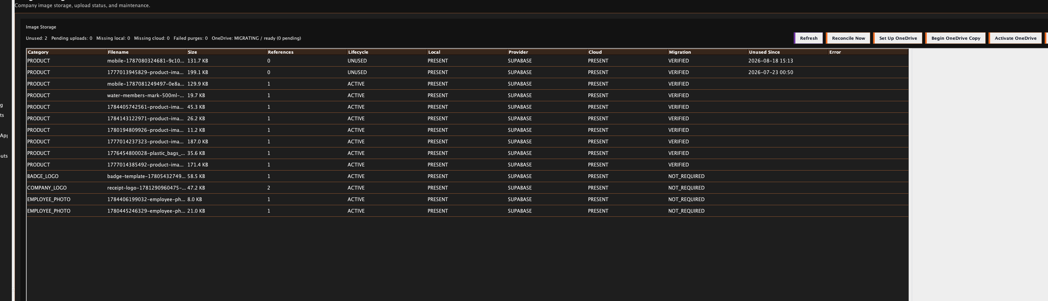
Figure 4 — Successful copy phase: MIGRATING / ready / 0 pending. Provider remains SUPABASE until activation; Migration shows VERIFIED.
Why Provider still says SUPABASE During MIGRATING, Supabase remains authoritative for rollback safety even after OneDrive copies are VERIFIED. This is expected.

8. Activate OneDrive and verify the first server
- When status is ready and pending is 0, choose Activate OneDrive.
- Choose Refresh. Confirm OneDrive: ACTIVE / ready (0 pending).
- Confirm product/custom rows show Provider = ONEDRIVE and Migration = VERIFIED.
- Open several existing products and custom items. Confirm their images display normally from a register through the LAN API.
- Create or change one test product image. Confirm the item saves immediately, then verify its cloud state becomes present/verified after synchronization.
- Leave Supabase objects intact throughout the rollback window.

Expected category routing
Category | After activation | Notes
PRODUCT | ONEDRIVE | Managed product picture
CUSTOM_ITEM | ONEDRIVE | Custom-item picture
CUSTOM_VARIANT | ONEDRIVE | Custom-variant picture
COMPANY_LOGO / BADGE_LOGO | SUPABASE | Intentionally unchanged
EMPLOYEE_PHOTO / documents | SUPABASE | Intentionally unchanged

9. Configure every additional store server
Key rule Each store server needs its own server-only OneDrive credential configuration. Registers do not need—and must not receive—Microsoft credentials.

Recommended: a separate certificate per server
Use the same tenant ID, client ID, dedicated OneDrive drive ID, and Entra application. For stronger isolation, generate a separate certificate/key pair on each server and upload each public certificate to the same Entra app. A compromised certificate can then be revoked without replacing every server.

Additional-server procedure
- Install the same or a newer supported SmartStock server build used on the first server.
- Confirm the machine is configured as a SmartStock SERVER and its authenticated LAN endpoints are healthy.
- Generate a new certificate/key pair on that server using Section 4, or securely transfer the approved shared pair if your policy explicitly allows it.
- If using a new pair, upload its public certificate to the same Entra application. Never upload or transmit the private key through ordinary cloud storage or email.
- Open Company Preferences → Image Storage → Set Up OneDrive. Enter the same tenant ID, client ID, and drive ID, then import that server’s matching certificate/key pair.
- Confirm the readiness probe passes.
- Allow the image manifest to synchronize from Supabase/PostgreSQL coordination. Choose Refresh.
- If the server shows 0 pending and manifests already show VERIFIED, choose Activate OneDrive directly. If it has unverified store-owned assets, choose Begin OneDrive Copy, Reconcile Now until 0 pending, then Activate OneDrive.
- From that store, open a product image originally created at another store. Confirm the server downloads it into its local mirror and serves it to a register.
- Repeat for every active store server before the rollback window ends.
No repeated Graph Explorer work You do not need to discover a new drive ID for each server. All servers target the same dedicated OneDrive drive and use the same tenant/client identifiers.

10. Troubleshooting

Graph query returns 404 itemNotFound
- First confirm the dedicated user’s OneDrive My files page works.
- In Graph Explorer, choose Modify permissions and consent to Files.Read, sign out/in, then rerun GET /me/drive.
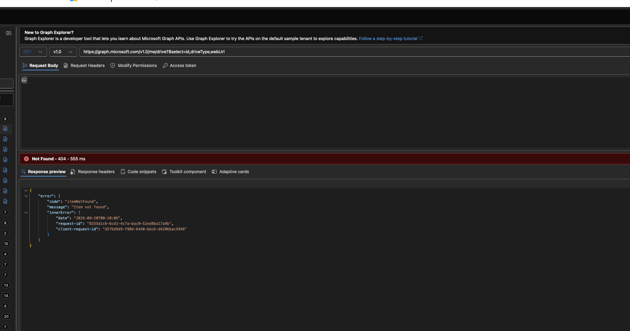
Figure 5 — A 404 from /me/drive can be a Graph Explorer token/permission issue even when the user is licensed.

SmartStock says the drive ID is malformed
- The field contains a user Object ID, URL, email, tenant ID, or other identifier. Use the id returned by GET /me/drive; business IDs commonly begin with b!.

SmartStock download fails with HTTP 302
- The store server is running an older build that does not follow Microsoft Graph’s short-lived content redirect. Update the server build; do not weaken redirect or certificate validation.
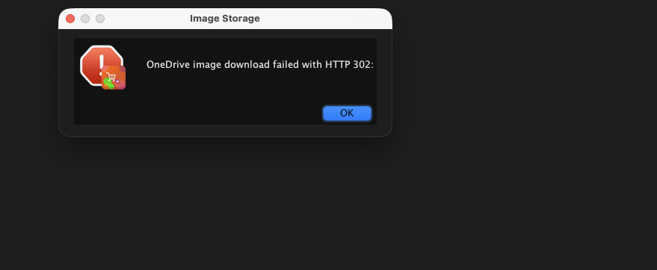
Figure 6 — HTTP 302 during the probe indicates an outdated SmartStock Graph-download implementation.

Begin OneDrive Copy appears to do nothing
- The action is state-only and opens no new window. Choose Refresh and look for MIGRATING / ready.

Pending does not decrease after Reconcile Now
- Confirm the server build includes the migration-selection fix for already-present Supabase images.
- Review each row’s Error column and the server sync-service logs. Correct authentication, missing-source, throttling, or checksum errors, then retry.

Certificate cannot be parsed / generic setup error
- Use the public X.509 PEM and unencrypted PKCS#8 private-key PEM generated in Section 4. Confirm they are non-empty and matched.

11. Rollback, retention, and acceptance checklist

Rollback
If images fail after activation, choose Rollback to Supabase. This returns scoped cloud reads/writes to Supabase while keeping stable smartstock-image:// references unchanged. Investigate and reverify before activating again.

Do not purge Supabase yet
Manual cleanup only Retain Supabase objects until every store server has passed cross-store retrieval, credential rotation is documented, and the administrator-approved rollback window has ended. SmartStock intentionally does not bulk-delete rollback copies.

Final acceptance checklist
- ☐ Dedicated licensed business user’s OneDrive is provisioned.
- ☐ Single-tenant Entra app exists.
- ☐ Files.ReadWrite.AppFolder application permission has admin consent.
- ☐ Each store server has a valid certificate credential in server-only secure storage.
- ☐ First server reports ACTIVE / ready / 0 pending.
- ☐ All active scoped assets are VERIFIED.
- ☐ Product and custom images load through the register → LAN server path.
- ☐ At least one secondary store server successfully downloads and serves a cross-store image.
- ☐ Offline local saves succeed and later synchronize without changing asset references.
- ☐ Supabase rollback copies remain intact.
- ☐ Credential expiry/rotation date and responsible administrator are recorded.

Security reminders
- Never place Microsoft private keys on registers.
- Never commit tenant credentials, certificates with private keys, tokens, or production identity files.
- Protect the dedicated Microsoft 365 account and keep its OneDrive licence active.
- Use administrator-confirmed manual cleanup only after multi-store acceptance.

