Predicting Educational Success
STA 631 – GLM Project | GVSU K-12 Connect

Team Members
Kabin Devkota
Nishan Khanal
Shreya KC
Udita Bista

Date of Submission: April 14, 2026

Summary of Insights

Research Question
What family engagement and school choice factors predict a child's academic success, and how does parental involvement relate to school participation frequency?

We analyze data from the 2019 Parent and Family Involvement (PFI) in Education Survey, collected by the US Census Bureau for the Department of Education. The dataset contains 15,500 observations, each representing one K–12 student, with variables covering school type, family engagement behaviors, child academic outcomes, and household demographics. We focus on 2019 only (rather than pooling 2016 and 2019) because survey instruments, question wording, and variable coding can differ across administration years; using a single year ensures internal consistency without requiring cross-year harmonization.

Key Findings
Family engagement matters, but differently for different outcomes. School involvement - attending events, volunteering, attending meetings, and participating in fundraising - is consistently the strongest predictor of academic achievement across all models. Children whose parents participate more in school activities are more likely to earn mostly A's and less likely to earn D's or below.

Parent education and household income are strong independent predictors. Children of graduate-educated parents have dramatically higher odds of being high academic achievers compared to children of parents without a high school diploma, even after controlling for school involvement and demographics. Similarly, higher household income is associated with better academic outcomes.

Single-parent households show lower school participation. Parents in single-parent households participate in fewer school activities than those in two-parent households, though their children's grades are not dramatically different once other factors are controlled for.

School type matters for both participation and grades. Children in non-public schools have parents who participate in school activities more frequently. After controlling for demographics, attending a non-public school is associated with slightly higher odds of being a high achiever (OR = 1.23). The multinomial model also shows non-public school students are far less likely to receive D's or below, likely reflecting selection effects - families who choose private schooling differ systematically from those who do not.

Racial and ethnic disparities exist in both participation and grades. Black and Hispanic families participate less in school activities than White families, and their children are less likely to receive mostly A's. Asian/Pacific Islander families also participate less but their children have lower odds of being non-high-achievers (meaning better grades). These disparities persist after controlling for income and parent education, suggesting structural factors beyond socioeconomic status.

Disability status is the single strongest predictor of grades. Children without a disability have dramatically higher odds of earning mostly A's - this is the largest effect in every model we fit.

Modeling Process Summary

1. Data Loading
We use only the 2019 survey year, reading the data directly from the provided Excel file as required by the project instructions. The dataset contains 15,500 observations and 75 variables, each row representing one K–12 student.

2. Variable Selection and Missing Value Treatment

Variable Domains Selected
Variables were selected across five thematic domains aligned with the project's focus on school choice and family engagement:
- Child academic outcomes: letter grades (SEGRADES), parental quality assessment (SEGRADEQ)
- School involvement: 8 binary indicators of school activities participated in this school year (FSSPORTX, FSVOL, FSMTNG, FSPTMTNG, FSATCNFN, FSFUNDRS, FSCOMMTE, FSCOUNSLR), plus participation frequency count (FSFREQ)
- Home engagement: 7 binary indicators of home activities in the past week (FOSTORY2X, FOCRAFTS, FOGAMES, FOBUILDX, FOSPORT, FORESPON, FOHISTX) and family dinner frequency (FODINNERX)
- School type and choice: whether the school is public vs. non-public (EDCPUB)
- Household demographics: child sex (CSEX), race/ethnicity (RACEETH), parent education (PARGRADEX), household income (TTLHHINC), household structure (HHPARN19_BRD), disability status (DSBLTY), number of siblings (NUMSIBSX)

Why EDCPUB (Binary) Instead of Separate School Types
The PFI survey asks school type as a series of separate binary Yes/No questions - EDCPUB (public/charter), EDCCAT (Catholic private), EDCREL (private religious non-Catholic), EDCPRI (private non-religious), EDCINTK12 (full-time online). These are not mutually exclusive levels of a single variable; they are separate indicators. EDCPUB (86.3% Yes, 13.7% No) cleanly partitions the school-enrolled sample. Breaking non-public schools into sub-types would create very small cells - Catholic: 4.2%, religious non-Catholic: 3.8%, private secular: 3.1%, online K-12: 1.6% - too sparse for stable parameter estimation. The binary public/non-public distinction captures the main policy-relevant contrast while maintaining adequate cell sizes.

Variables Included as Controls and Why
Variable | Role | Justification
CSEX | Control | Well-documented gender gap in grades; standard control in education research
TTLHHINC | Control | Primary SES proxy (12-level ordered); directly affects school participation resources
RACEETH | Control | Extensive racial disparities documented; isolates involvement effects from structural inequities
DSBLTY | Control | Disability directly and mechanically affects grades; most critical confounder
HHPARN19_BRD | Control | Household structure affects time and resources available for school involvement

Variables Explicitly Excluded and Why
- SCCHOICE, SPUBCHOIX, SCONSIDR: School choice variables pulled for initial exploration but dropped. Families in non-public schools by definition exercised school choice, making these highly correlated with EDCPUB. Including them alongside EDCPUB would inflate standard errors without adding independent information (multicollinearity).
- SEENJOY, SEABSNT, SEFUTUREX: Endogenous to grades: a child's enjoyment, attendance, and parental expectations are partly caused by or jointly determined with academic performance. Including them as predictors would introduce simultaneity bias. Retained for EDA context only.
- CENREG / ZIPLOCL: Census region and urbanicity excluded. After controlling for income and race/ethnicity - which themselves capture much of the regional variation - region added minimal predictive value in preliminary models while substantially increasing parameters.
- INTACC: 92.7% of households have both home and cell internet access. The variable is nearly constant and contributes almost no variance to any model.
- ALLGRADEX: Grade level (K–12) is a legitimate control but is highly correlated with age and introduces interpretation complexity in a cross-sectional model. Excluded to keep the model parsimonious; acknowledged as a limitation.

Missing Value Treatment
In the PFI dataset, negative values are special codes: -1 means “valid skip” (question not applicable) and -9 means missing. Neither represents a real data value, so all negative entries are re-coded to NA before any analysis.

Missingness summary: The three homework-related variables (FHWKHRS, FHCHECKX, FHHELP) have 6.8% missing - these apply only to students who do homework, so valid skips account for this. All other variables have less than 1% missing. Overall missingness is low and will not substantially affect results.
Variable Group | Missing % | Explanation
FHWKHRS, FHCHECKX, FHHELP | 6.8% | Valid skip — applies only to homework-doing students
FSFREQ, FSSPORTX, and 6 other school activity items | 0.8% | Valid skip — applies only to school-enrolled students
FSNOTESX, FSMEMO, FCSCHOOL, and 5 satisfaction items | 0.3% | Minimal missingness
All other variables | <0.1% | Negligible

3. Filtering to School-Enrolled Students
We filter to students who have school satisfaction data (FCSCHOOL not missing), which effectively removes homeschool-only students not enrolled in any school. These students have valid skips on all school-related variables and would introduce systematic bias if included. We then remove the small number of rows (73) missing key response variables, resulting in a final analysis dataset of 15,374 observations.

4. Variable Recoding
All categorical variables are converted to labeled factors with clearly defined reference levels. Reference levels are: RACEETH = White, PARGRADEX = Less_than_HS, EDCPUB = Public, DSBLTY = Has_disability, HHPARN19_BRD = Two_parents, CSEX = Male. All coefficient interpretations are relative to these baselines.

Key re-coding decisions:
- SEGRADES code 5 (“School does not give these grades”) is excluded as NA - these students attend schools without traditional grading systems and cannot be meaningfully compared on this outcome. This removes approximately 1,957 observations.
- All binary school and home activity variables originally coded 1=Yes, 2=No are recoded to 1=Yes, 0=No for interpretability when summed into composite scores.

5. Composite Scores and Derived Variables
Composite score rationale: We created two summary scores rather than including all individual binary items as separate predictors. This reduces dimensionality, avoids multicollinearity among items measuring the same construct, and produces more interpretable coefficients.
- school_involve_score (0–8): counts how many of 8 school activities a household participated in this school year (attending events, volunteering, general meeting, PTA meeting, parent-teacher conference, fundraising, committee service, guidance counselor meeting).
- home_engage_score (0–7): counts how many of 7 home engagement activities occurred in the past week (reading stories, crafts, games, building projects, athletic activities, volunteering, visiting historical sites).

Variable | Range | Median | Mean | Notes
FSFREQ (participation count) | 0–99 | 4 | 7.02 | Used as count outcome
school_involve_score | 0–8 | 4 | 4.32 | Key predictor of interest
home_engage_score | 0–7 | — | — | Secondary predictor

Binary outcome and event level: high_achiever is coded with levels c(“No”, “Yes”) so that “Yes” is the second (event) level, which is tidymodels’ default event class for binary classification. This means all metrics - accuracy, precision, recall, F1, AUC - are computed with respect to correctly identifying high achievers (Yes = Mostly A’s).
Grade distribution: 7,574 students receive mostly A's, 4,320 mostly B's, 1,280 mostly C's, and 243 mostly D's or lower. The remaining 1,957 attend schools without traditional grades and are excluded.

6. Exploratory Data Analysis

6.1 FSFREQ Distribution and Overdispersion Check
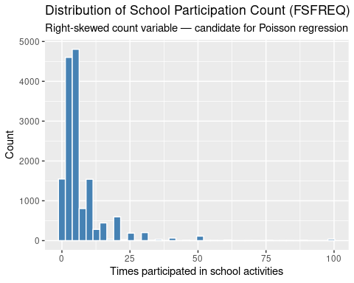
Figure 1. Distribution of school participation count (FSFREQ). Right-skewed with a long tail.
Overdispersion finding: The variance-to-mean ratio for FSFREQ is 12.2 (mean = 7.02, variance = 85.4) - far greater than 1. Standard Poisson regression assumes variance equals the mean (ratio = 1). This severe overdispersion means Poisson will underestimate standard errors, producing spuriously significant p-values. This finding motivates the Negative Binomial model in Section 8.

6.2 Grade Distribution
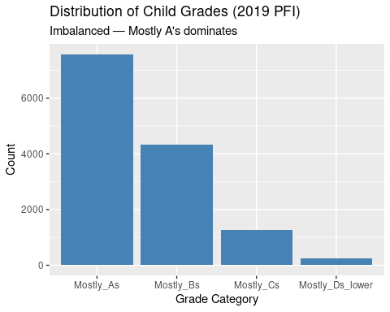
Figure 2. Distribution of child grades. Heavily skewed toward Mostly A's — a class imbalance concern for multinomial modeling.

6.3 Family Involvement vs. Grades
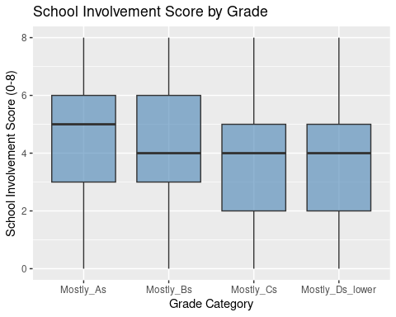
Figure 3. School involvement score by grade category. Higher-achieving students have more involved parents.
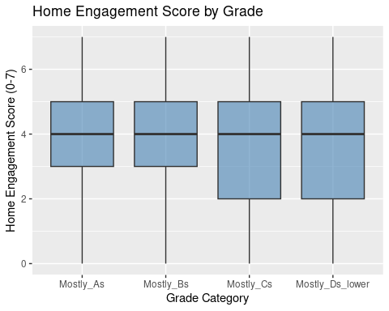
Figure 4. Home engagement score by grade category. Weaker but consistent pattern.
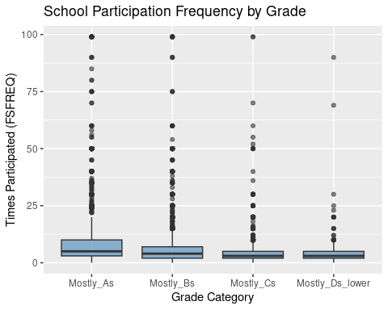
Figure 5. School participation frequency (FSFREQ) by grade. Parents of A-students participate more often.
Higher-achieving students consistently have parents with higher school involvement scores. The relationship with home engagement is weaker but still present. These patterns motivate including both scores as predictors in all models.

6.4 Demographics vs. Grades
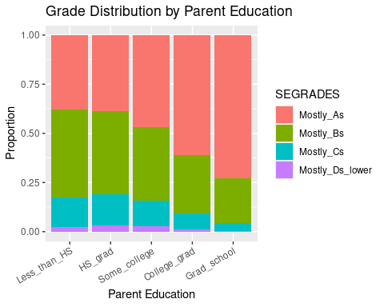
Figure 6. Grade distribution by parent education. Strong gradient — mostly C's and D's nearly disappear at graduate-school level.
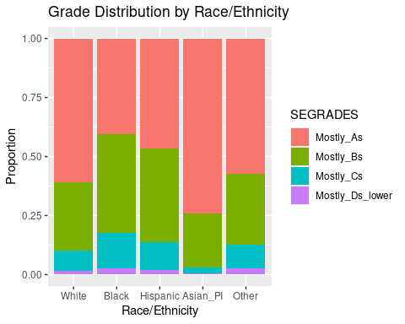
Figure 7. Grade distribution by race/ethnicity. Asian/PI students show the highest A proportion; Black and Hispanic students show more spread into B's and C's.
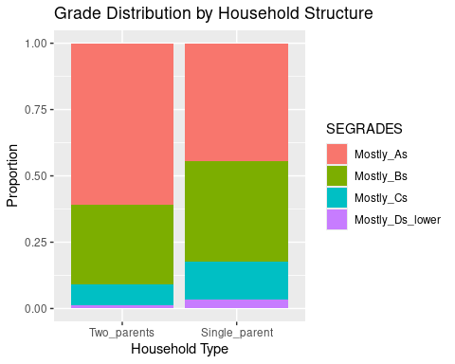
Figure 8. Grade distribution by household structure. Two-parent households have a higher proportion of A students.

6.5 School Participation (FSFREQ) vs. Key Predictors
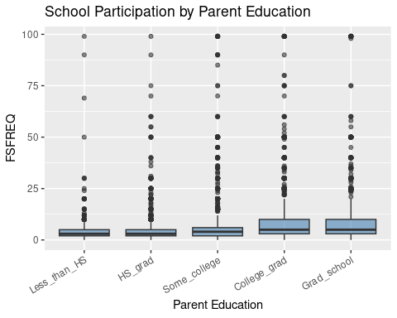
Figure 9. FSFREQ by parent education. More educated parents participate more frequently.
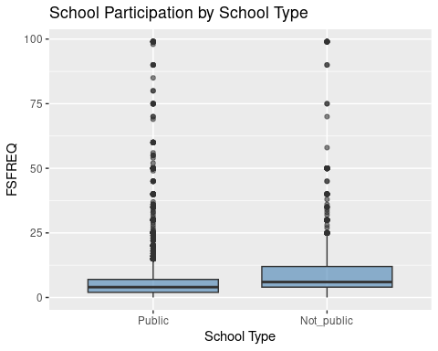
Figure 10. FSFREQ by school type. Non-public school parents show higher median participation.
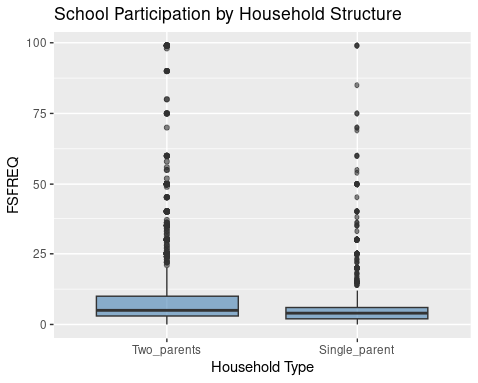
Figure 11. FSFREQ by household structure. Two-parent households participate more often.

7. Data Splitting
We use an 80/20 train/test split stratified on the response variable to preserve class distributions - critical given the grade imbalance. The test set is held out completely and only used for final evaluation; no modeling decisions are made using test results.

Dataset | Training Observations | Test Observations | Purpose
Classification (pfi_model) | 10,733 | 2,684 | Logistic, multinomial, LDA, QDA
Count model (pfi_count) | 12,297 | 3,077 | Poisson and Negative Binomial
Note: Two separate datasets are created because the Poisson/NB models include additional observations that have FSFREQ but may be missing SEGRADES.

8. Poisson and Negative Binomial Regression
Research question: What factors predict how frequently parents participate in school activities?

8.1 Why Start with Poisson
FSFREQ records how many times any adult in the household went to school meetings or activities during the school year. It is a non-negative integer count (range: 0–99), making Poisson regression the natural starting point. The Poisson GLM models the log of the expected count as a linear function of predictors. The Poisson model is fitted using the poisson_reg() tidymodels specification with set_engine("glm").

Overdispersion check: The Poisson model's residual deviance (62,904) divided by degrees of freedom (12,281) gives a ratio of 5.12 - far above the value of 1 that Poisson assumes. Combined with the EDA variance-to-mean ratio of 12.2, this confirms severe overdispersion. Standard Poisson is invalid here because its standard errors are severely underestimated, producing spuriously significant p-values. We proceed to Negative Binomial regression, which adds a dispersion parameter θ allowing variance to exceed the mean.
Model | AIC | Deviance / df Ratio | Verdict
Poisson (tidymodels) | 104,068 | 5.12 | Invalid — severe overdispersion
Negative Binomial (full) | 69,124 | 0.997 (NB residual) | Best fit
Negative Binomial (reduced) | 69,180 | — | Significantly worse (LRT p < 0.001)

8.2 Negative Binomial Model Selection
Two NB candidate models were compared: a full model including all predictors (school_involve_score, home_engage_score, PARGRADEX, TTLHHINC, HHPARN19_BRD, EDCPUB, RACEETH, CSEX, DSBLTY) and a reduced model excluding EDCPUB and CSEX. A likelihood ratio test confirms the full model is significantly better (LR statistic = 60.3, p < 0.001), justifying inclusion of school type and child sex. The AIC improvement from Poisson to NB is approximately 35,000 points.

8.3 Final Negative Binomial Model - Coefficients and Interpretation
All exponentiated coefficients represent multiplicative effects on expected FSFREQ, holding all other predictors constant. Coefficients are sorted by significance.
Predictor | Exp(Coef) | 95% CI | p-value | Interpretation
school_involve_score | 1.29 | [1.28, 1.30] | <0.001 | Each additional school activity ×1.29 expected participation count — dominant predictor
RACEETHAsian_PI | 0.67 | [0.63, 0.71] | <0.001 | Asian/PI families participate 33% less than White families
RACEETHBlack | 0.79 | [0.75, 0.84] | <0.001 | Black families participate 21% less than White families
RACEETHHispanic | 0.84 | [0.80, 0.87] | <0.001 | Hispanic families participate 16% less than White families
EDCPUBNot_public | 1.19 | [1.14, 1.24] | <0.001 | Non-public school parents participate 19% more often
TTLHHINC | 1.01 | [1.01, 1.02] | <0.001 | Higher income associated with slightly more participation
DSBLTYNo_disability | 1.05 | [1.02, 1.09] | 0.003 | Families of children without disabilities participate slightly more
PARGRADEXCollege_grad | 1.09 | [1.01, 1.18] | 0.033 | College-grad parents participate slightly more vs. <HS
home_engage_score | 0.99 | [0.98, 1.00] | 0.041 | Slight negative association; marginally significant
HHPARN19_BRDSingle_parent | 0.97 | [0.94, 1.01] | 0.097 | Single parents participate slightly less; marginally significant
Θ (NB dispersion) | 2.07 | — | — | Confirms extra variance beyond Poisson

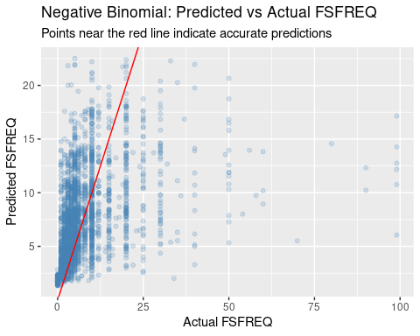
Figure 12. Predicted vs. actual FSFREQ on test set. The model captures central tendency well but struggles with extreme values, expected given the heavy right tail.
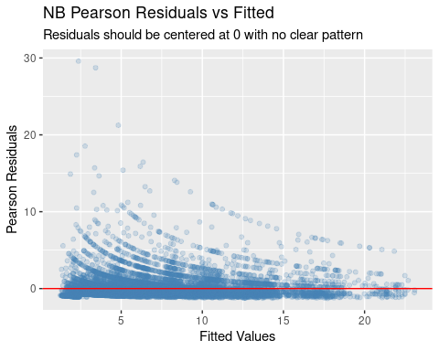
Figure 13. Pearson residuals vs. fitted values. Residuals centered at 0 with no systematic pattern - model fit is adequate.
Test performance: RMSE = 8.12, MAE = 4.40 on the held-out test set. Given FSFREQ ranges 0–99 with mean 7.0, the model captures the central tendency well but struggles with extreme values in the long right tail.

9. Logistic Regression
Research question: What factors predict whether a child is a high academic achiever (mostly A's)?
Why logistic regression? high_achiever is a binary outcome (Yes/No). Logistic regression models the log-odds of the event as a linear combination of predictors, producing interpretable odds ratios and formal hypothesis tests for each predictor while handling our mix of continuous and categorical variables.

9.1 Model Selection
Two candidate logistic models were compared: a full model (all predictors) and a reduced model excluding EDCPUB and CSEX. A likelihood ratio test confirms the full model is significantly better (Deviance reduction = 177.5, p < 0.001), with AIC improving from 13,173 (reduced) to 12,999 (full). Both school type and child sex add meaningful predictive information beyond demographics and involvement scores alone.

9.2 VIF Check - No Multicollinearity Concerns
Variance Inflation Factors were computed for all predictors in the final logistic model. All GVIF¹ᐟ₂ᴰᵉ values are well below 2, confirming no problematic multicollinearity. PARGRADEX and TTLHHINC are moderately correlated (higher-educated parents tend to have higher income) but retain independent predictive information.
Predictor | GVIF¹ᐟ₂ᴰᵉ (Adjusted) | Assessment
school_involve_score | 1.10 | No concern
home_engage_score | 1.06 | No concern
PARGRADEX (4 df) | 1.05 | No concern
TTLHHINC | 1.29 | No concern
HHPARN19_BRD | 1.09 | No concern
EDCPUB | 1.03 | No concern
RACEETH (4 df) | 1.02 | No concern
CSEX | 1.00 | No concern
DSBLTY | 1.01 | No concern

9.3 Odds Ratios — Key Findings
Event = “Yes” = high achiever. OR > 1 means higher odds of being a high achiever. All estimates are exponentiated with 95% confidence intervals.
Predictor | Odds Ratio | 95% CI | p-value | Interpretation
DSBLTYNo_disability | 2.89 | [2.61, 3.19] | <0.001 | Strongest predictor: children without disability have ~3× higher odds of mostly A's
PARGRADEXGrad_school | 2.55 | [2.04, 3.19] | <0.001 | Graduate-educated parents: 2.55× higher odds vs. <HS
CSEXFemale | 1.73 | [1.60, 1.89] | <0.001 | Girls have 73% higher odds of being high achievers than boys
PARGRADEXCollege_grad | 1.67 | [1.36, 2.07] | <0.001 | College-grad parents: 1.67× higher odds vs. <HS
EDCPUBNot_public | 1.23 | [1.07, 1.42] | 0.003 | Non-public school: 23% higher odds of being a high achiever
TTLHHINC | 1.05 | [1.04, 1.07] | <0.001 | Each income bracket increase associated with 5% higher odds
RACEETHAsian_PI | 1.52 | [1.27, 1.82] | <0.001 | Asian/PI children have 52% higher odds vs. White children
RACEETHBlack | 0.549 | [0.47, 0.64] | <0.001 | Black children have 45% lower odds vs. White, after all controls
RACEETHHispanic | 0.722 | [0.65, 0.81] | <0.001 | Hispanic children have 28% lower odds vs. White, after all controls
school_involve_score | 1.05 | [1.02, 1.07] | <0.001 | Each additional school activity: 5% higher odds
home_engage_score | 1.08 | [1.05, 1.10] | <0.001 | Each additional home activity: 8% higher odds
HHPARN19_BRDSingle_parent | 0.787 | [0.71, 0.87] | <0.001 | Single-parent households: 21% lower odds

9.4 Residual Diagnostics
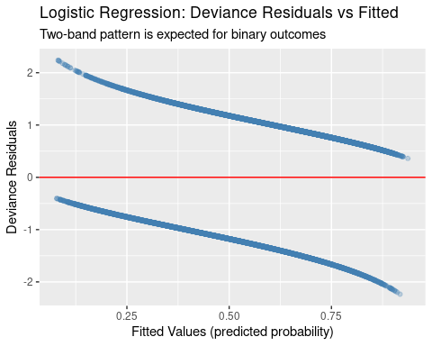
Figure 14. Deviance residuals vs. fitted values. The two-band pattern is characteristic and expected for binary outcomes - data are truly 0s and 1s so residuals cluster into two arcs.
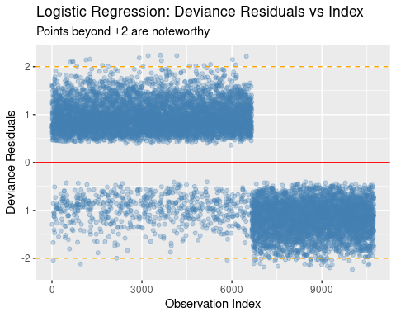
Figure 15. Deviance residuals vs. index. Several observations with |residual| > 2, not unusual for this dataset size and class-imbalanced outcome.

9.5 Test Set Performance
Metric | Value | Interpretation
Accuracy | 68.7% | 649 true non-achievers + 1,194 true achievers correctly classified out of 2,684
Precision | 70.0% | Of predicted high achievers, 70% are truly high achievers
Recall | 78.4% | Of true high achievers, 78.4% are correctly identified
F1 Score | 74.0% | Balanced harmonic mean of precision and recall
AUC | 0.743 | Solid discriminative ability — well above random (0.50)
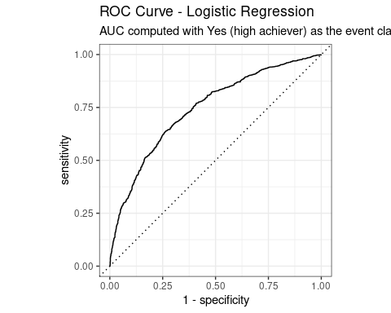
Figure 16. ROC curve for logistic regression. AUC = 0.743, confirming solid discriminative ability.
Confusion matrix: Of 1,523 true high achievers in the test set, 1,194 were correctly predicted (78.4% recall). Of 1,161 true non-high-achievers, 649 were correctly predicted. The model has higher recall than precision, meaning it correctly identifies most true high achievers but also misclassifies some non-achievers.

9.6 Cross-Validation
To confirm that test set performance is not an artifact of the particular train/test split, we applied 10-fold cross-validation on the training data using a workflow of the full logistic model.
Metric | CV Mean (10-fold) | Test Set | Gap
Accuracy | 0.673 | 0.687 | +0.014
AUC | 0.726 | 0.743 | +0.017
F1 Score | 0.727 | 0.740 | +0.013
The CV estimates closely track the test set results. The small positive gap (test slightly outperforms CV) is within normal sampling variation and does not indicate overfitting. These results confirm that model performance is stable and not an artifact of a favorable split.

10. Multinomial Regression
Research question: What factors predict which of four grade categories (A's, B's, C's, D's or lower) a child falls into?
Why multinomial regression? Unlike logistic regression which requires a binary outcome, multinomial logistic regression handles responses with more than two unordered categories. It fits K−1 = 3 equations simultaneously, each comparing one grade category to the baseline (Mostly A's), preserving the full information in the grading outcome rather than collapsing it.

10.1 Addressing Class Imbalance with Upsampling
The original training data has approximately 6,051 A students but only 194 D students — a 31:1 ratio. A model trained on this data will learn to almost never predict D's. We use
step_upsample() from the {themis} package to randomly duplicate rows from minority classes until they reach 50% of the majority class size (over_ratio = 0.5). This is applied only to training data — the test set remains in its natural distribution to provide an honest evaluation.
Grade Category | Before Upsampling | After Upsampling
Mostly A's | 6,051 | 6,051
Mostly B's | 3,461 | 3,461
Mostly C's | 1,613 | 3,025
Mostly D's or lower | 194 | 3,025

10.2 Model Selection
Two candidate multinomial models were compared: a full model (all predictors) and a reduced model excluding EDCPUB, CSEX, and DSBLTY. Full model AIC = 35,347; reduced AIC = 38,725. The full model is substantially better, confirming that school type, sex, and disability add meaningful explanatory power for grade category.
Note: repair_call() is applied to the fitted multinomial models. This tidymodels utility fixes an internal issue where the model's stored call references data = data instead of the actual data object, required for augment() to work correctly.

10.3 Key Coefficient Patterns
All coefficients are interpreted relative to the baseline of Mostly A's. Negative coefficients mean lower probability of being in that lower grade category (i.e., closer to A performance). Key patterns across all three equations:
- DSBLTYNo_disability: The strongest predictor, growing dramatically in magnitude from B's (−0.80) to C's (−1.82) to D's (−2.62). The disability grade gap widens sharply at lower performance levels.
- CSEXFemale: Consistently large negative coefficients across all levels (−0.53 for B's, −0.88 for C's, −0.90 for D's) - girls are substantially less likely to be in any lower grade category compared to boys.
- EDCPUBNot_public: Very large negative effect for D's (−2.55) but small and non-significant for B's (−0.08). Non-public school students are far less likely to receive D's or below, likely reflecting selection effects.
- PARGRADEXGrad_school: Strong negative coefficients across all levels, growing in magnitude toward lower grades. Graduate-educated parents see the largest protective effect.

10.4 Test Set Performance
Confusion matrix (rows = actual, columns = predicted):
Actual \ Predicted | Mostly A's |  | Mostly B's | Mostly C's |  | Mostly D's
Mostly A's (n=1,523) | 1,308 |  | 50 | 36 |  | 129
Mostly B's (n=859) | 546 |  | 65 | 66 |  | 182
Mostly C's (n=243) | 117 |  | 20 | 27 |  | 79
Mostly D's (n=59) | 16 |  | 4 | 7 |  | 32
Metric (macro-averaged) |  | Value |  |  | Interpretation
Accuracy |  | 53.4% |  |  | vs. 25% random chance for 4 classes
Precision |  | 35.0% |  |  | Macro-averaged; pulled down by sparse D category
Recall |  | 39.7% |  |  | Macro-averaged; model does predict all four classes
F1 Score |  | 28.8% |  |  | Modest; reflects genuine difficulty of the 4-class problem
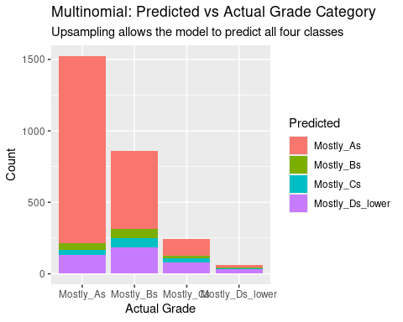
Figure 17. Predicted vs. actual grade category. Upsampling enables the model to predict all four classes rather than defaulting to Mostly A's.
The macro averaging treats all classes equally, so the sparse D category pulls aggregate metrics down. The key improvement over a naive model is that upsampling allows the multinomial model to make meaningful predictions in all four grade categories, not just the majority class.

11. Linear and Quadratic Discriminant Analysis
Research question: Can we classify children as high achievers using only continuous numeric predictors?
Why LDA/QDA? LDA and QDA take a different theoretical approach than logistic regression: rather than modeling P(Y = k | X) directly, they model the distribution of X within each class P(X | Y = k) and use Bayes’ theorem to derive posterior class probabilities. LDA assumes multivariate normality with equal covariance matrices across classes (linear decision boundaries); QDA relaxes the equal-covariance assumption (quadratic boundaries).

11.1 Predictor Selection for LDA/QDA
LDA and QDA require numeric predictors. We use five continuous variables, selected for theoretical motivation and genuine continuity:
Variable | Range | Theoretical Role
school_involve_score | 0–8 | Primary predictor of interest — count of school activities
home_engage_score | 0–7 | Secondary predictor — count of home engagement activities
FODINNERX | 0–7 days/week | Family cohesion proxy — days eating dinner together
TTLHHINC | 1–12 categories | Socioeconomic control — ordered income brackets
NUMSIBSX | 0–7 siblings | Diluted parental attention proxy — number of siblings
Categorical predictors (race, parent education, disability, school type) are excluded because incorporating them into LDA/QDA requires additional assumptions. This intentional simplification allows a direct comparison: logistic regression's ability to use categorical predictors explains most of its performance advantage over LDA/QDA.

11.2 LDA Group Means and Discriminant Function
The LDA model reveals clear separation between high achievers and non-achievers on all five predictors:
Predictor | Non-Achiever Mean | High Achiever Mean | Difference
school_involve_score | 4.02 | 4.47 | +0.45
home_engage_score | 3.81 | 4.09 | +0.28
FODINNERX (dinner days) | 4.55 | 4.85 | +0.30
TTLHHINC (income bracket) | 6.41 | 7.82 | +1.41 — largest gap
NUMSIBSX (siblings) | 1.00 | 1.07 | +0.07 — minimal
Income (TTLHHINC) shows the largest group mean difference and also carries the highest discriminant coefficient (LD1 = 0.296), making it the single strongest separator among the continuous predictors available to LDA/QDA. Family dinner frequency (FODINNERX) also contributes meaningfully (LD1 = 0.121), consistent with the idea that structured family time supports academic outcomes.

11.3 Performance Comparison: Logistic vs. LDA vs. QDA
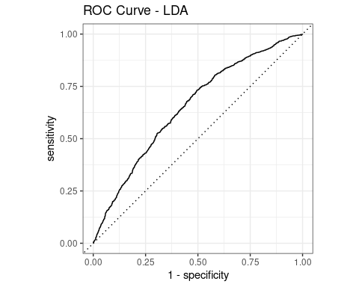
Figure 18. ROC curve for LDA. AUC = 0.651.
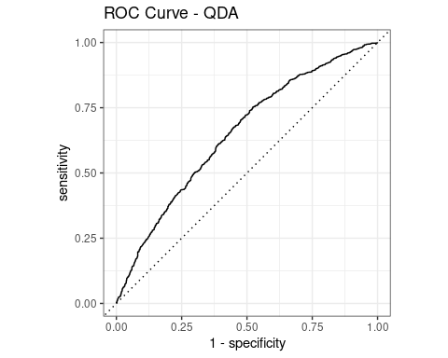
Figure 19. ROC curve for QDA. AUC = 0.650.
Metric | Logistic Regression | LDA | QDA
Accuracy | 68.7% | 63.2% | 62.9%
Precision | 70.0% | 64.4% | 64.1%
Recall | 78.4% | 78.8% | 78.4%
F1 Score | 74.0% | 70.9% | 70.5%
AUC | 0.743 | 0.651 | 0.650
LDA vs. QDA: LDA and QDA perform nearly identically (AUC 0.651 vs. 0.650). The negligible difference suggests the equal-covariance assumption in LDA is adequate here - QDA's additional flexibility provides no meaningful benefit with these five predictors.
Logistic vs. LDA/QDA: Logistic regression (AUC = 0.743) substantially outperforms both discriminant methods. This gap is expected and attributable primarily to the categorical predictors available to logistic regression (particularly disability status, race, and parent education) that LDA/QDA cannot access in this formulation. This is a principled methodological limitation, not a failure of the discriminant approach.

12. Model Selection Summary and Final Comparison
To evaluate and compare the performance of all models, we consider both goodness-of-fit metrics (AIC, likelihood ratio tests) and predictive performance on the held-out test set. Since our project involves different types of outcomes - count, binary, and multiclass - model comparison is conducted within each modeling framework and summarized holistically.
Model | Response | Key Metric(s) | Performance | Conclusion
Poisson Regression | FSFREQ (count) | AIC; Dispersion ratio | AIC = 104,068; ratio = 5.12 | Rejected — severe overdispersion invalidates standard errors
Negative Binomial (full) | FSFREQ (count) | AIC; RMSE; MAE | AIC = 69,124; RMSE = 8.12; MAE = 4.40 | Best count model; handles overdispersion (θ = 2.07)
Logistic Regression | high_achiever (binary) | AUC; F1; Accuracy | AUC = 0.743; F1 = 0.740; Acc = 68.7% | Best binary classifier; interpretable odds ratios
Multinomial Regression | SEGRADES (4-class) | AIC; macro F1 | AIC = 35,347; macro F1 = 0.288 | Best for full grade structure; upsampling enables all 4 predictions
LDA | high_achiever (binary) | AUC; F1 | AUC = 0.651; F1 = 0.709 | Adequate; limited by continuous-only predictors
QDA | high_achiever (binary) | AUC; F1 | AUC = 0.650; F1 = 0.705 | Comparable to LDA; equal-covariance assumption holds

Cross-cutting findings across all models:
- School involvement score is the dominant predictor of participation frequency (NB) and a consistent positive predictor of high achievement (logistic, multinomial).
- Disability status is the single strongest predictor of grades in every classification model - with effects that grow dramatically at lower grade levels in the multinomial model.
- Parent education and household income show consistent gradients: each higher level is associated with better academic outcomes and more school participation.
- Racial and ethnic disparities persist even after controlling for income and parent education, suggesting structural factors beyond socioeconomic status.
- School type (non-public) is consistently associated with higher participation and better academic outcomes, though this likely reflects family selection rather than a causal school effect.

Overall conclusions:
The Negative Binomial model is the clear winner for the count outcome, with a 35,000-point AIC improvement over standard Poisson. The Poisson model is explicitly demonstrated, overdispersion is diagnosed, and NB is selected through formal model comparison.

The Logistic regression model is the best classifier for the binary high-achiever outcome (AUC = 0.743, F1 = 0.740). 10-fold cross-validation confirms stable performance (CV AUC = 0.726). VIF analysis confirms no multicollinearity concerns.

The Multinomial regression model benefits substantially from upsampling, enabling predictions across all four grade categories. While macro F1 appears modest (0.288), this reflects the genuine difficulty of the 4-class problem and the extreme rarity of D-level students in this dataset.

LDA and QDA perform comparably to each other, confirming the linear decision boundary assumption is adequate. Their lower performance relative to logistic regression is attributable to their restriction to continuous predictors - a principled methodological limitation, not a model failure.

