Q1. Write a program to replace a substring inside a string with other string ?
package javaAssessment1;
public class question1 {
public static void main(String args[]){
String s1 ="hello how are you doing today?";
String changedString = s1.replace("hello","bye");
System.out.println("Old string was: "+s1);
System.out.println("Changed String is: "+changedString);
}
}
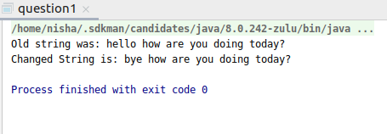

Q2. Write a program to find the number of occurrences of the duplicate words in a string and print them ?
package javaAssessment1;
public class ques2 {
public static void main(String args[]) {
int count;
String s1 = "This is java exercise question i am doing exercise question number two";
s1 = s1.toLowerCase();
String characters[] = s1.split(" ");
System.out.println("Repeated words in string are: ");
for (int i = 0; i < characters.length; i++) {
count = 1;
for (int j = i + 1; j < characters.length; j++) {
if (characters[i].equals(characters[j])) {
count++;
characters[j] = "0";
}
}
if (count > 1 && characters[i] != "0")
System.out.println(characters[i] + "- " + count);
}
}
}
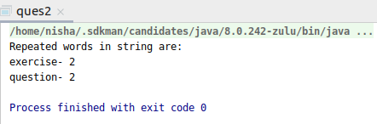

Q3. Write a program to find the number of occurrences of a character in a string without using loop?

package javaAssessment1;
public class ques3 {
public static void main(String args[]){
String s1 = "Uttarakhand";
System.out.println("String is: "+s1);
int count=s1.length()-s1.replace("a","").length();
System.out.println("Number of occurrence of a "+count);
}
}
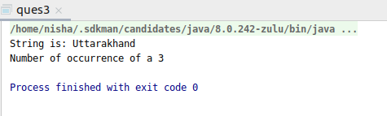

Q4. Calculate the number & Percentage Of Lowercase Letters,Uppercase Letters, Digits And Other Special Characters In A String.

package javaAssessment1;
public class ques4 {
public static void main(String args[]) {
String s1 = "This is a Number 50 & also fifty @@@@";
char[] charArray = s1.toCharArray();
int upper = 0;
int lower = 0;
int digit = 0;
int specialCharacter = 0;
int totalChars = s1.length();
for (int i = 0; i < s1.length(); i++) {
if (Character.isUpperCase(charArray[i])) {
upper++;
} else if (Character.isLowerCase(charArray[i])) {
lower++;
} else if (Character.isDigit(charArray[i])) {
digit++;
} else {
specialCharacter++;
}
}
System.out.println("String is :" + s1);
System.out.println("Percentage of upper case letters: " + (upper * 100) / totalChars + "%");
System.out.println("Percentage of lower case letters: " + (lower * 100) / totalChars + "%");
System.out.println("Percentage of digits : " + (digit * 100) / totalChars + "%");
System.out.println("Percentage of special characters : " + (specialCharacter * 100) / totalChars + "%");
}
}

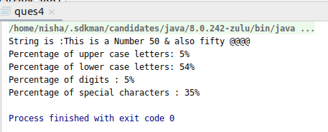

Q5. Find common elements between two arrays.

package javaAssessment1;
public class ques5 {
public static void main(String args[]) {
int ArrayOne[] = {1, 4, 5, 2, 7, 9};
int ArrayTwo[] = {2, 3, 7, 11, 33, 73};
System.out.println("Common elements between two arrays are: ");

for(int i=0;i<ArrayOne.length;i++){
for (int j=0;j<ArrayTwo.length;j++)
if (ArrayOne[i] == ArrayTwo[j]) {
System.out.println(ArrayOne[i]);
}
}
}
}
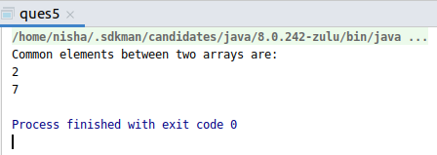

Q6. There is an array with every element repeated twice except one. Find that element

package javaAssessment1;
public class ques6 {
public static void main(String args[]) {
int array1[] = {2, 3, 3, 2, 9};
System.out.print("Elements of array are: ");
for (int i=0;i<array1.length;i++){
System.out.print(array1[i]+ ",");
}
int result = array1[0];
for (int j=1;j<array1.length;j++){
result=result^array1[j];
}
System.out.println("\nElement not repeated in array is: "+result);
}
}
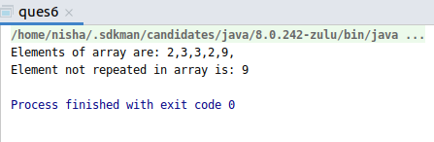

Q7. Write a program to print your Firstname,LastName & age using static block,static method & static variable respectively

Static variable:
package javaAssessment1;
class one{
static String firstName="Nisha";
static String LastName="Nagarkoti";
static int age=23;
void display(){
System.out.println("First name is: "+firstName);
System.out.println("Last name is: "+LastName);
System.out.println("Age is: "+age);
}
}
public class ques7 {
public static void main(String args[]){
one obj1=new one();
obj1.display();
}
}

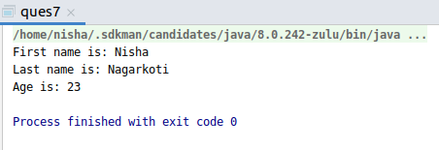

Static method:
package javaAssessment1;
class one{
static String firstName;
static String LastName;
static int age;
static void display(String fName,String Lname, int ag){
System.out.println("First name is: "+fName);
System.out.println("Last name is: "+Lname);
System.out.println("Age is: "+ag);
}
}
public class ques7 {
public static void main(String args[]){
one.display("nisha","nagarkoti",23);
}
}
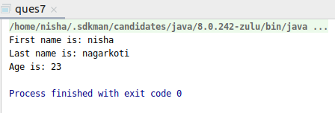

Static block:

package javaAssessment1;
class one{
static String firstName;
static String LastName;
static int age;
static {
firstName="Pallavi";
LastName="Sharma";
age=45;
System.out.println("Static block is called to display name and age");
}
}
public class ques7 {
public static void main(String args[]){
System.out.println("First name is = " +one.firstName);
System.out.println("Last name is = " +one.LastName);
System.out.println("Age is = " +one.age);
}
}

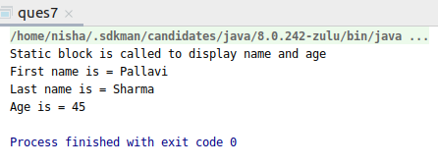

Q8. Write a program to reverse a string and remove character from index 4 to index 9 from the reversed string using String Buffer

package javaAssessment1;
import java.lang.*;
public class ques8 {
public static void main(String args[]) {
String s1 = "javaExercise";
String reverseStr = new StringBuffer(s1).reverse().toString();
System.out.println("Original String is: " + s1);
System.out.println("Reversed string is: " + reverseStr);
StringBuffer deleteStr = new StringBuffer(reverseStr);
deleteStr.delete(4, 9);
System.out.println("Reversed string without characters from index 4 to index 9: " + deleteStr);
}
}
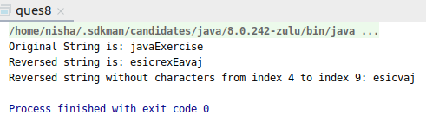

Q9.Write a program to display values of enums using a constructor & getPrice() method (Example display house & their prices)

package javaAssessment1;
enum House {
oneBHK(15000), twoBHK(20000), threeBHK(30000), fourBHK(50000);
private int price;
House(int p) {
price = p;
}
int getPrice() {
return price;
}
}
public class ques9 {
public static void main(String args[]) {
System.out.println("House prices:");
for (House H : House.values())
System.out.println(H + " cost is " + H.getPrice() + " rupees.");
}
}
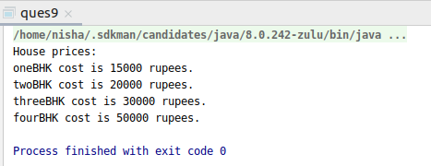

Q10.Write a single program for following operation using overloading
A) Adding 2 integer number
B) Adding 2 double
C) multiplying 2 float
D) multiplying 2 int
E) concate 2 string
F) Concate 3 String

package javaAssessment1;
class sample {
static int add(int a, int b) {
int result = a + b;
return result;
}
static double add(double a, double b) {
double result = a + b;
return result;
}
static float multiply(float a, float b) {
float result = a * b;
return result;
}
static int multiply(int a, int b) {
int result = a * b;
return result;
}
static String concatStrings(String s1, String s2) {
String result = s1 + s2;
return result;
}
static String concatStrings(String s1, String s2, String s3) {
String result = s1 + s2 + s3;
return result;
}
}
class ques10 {
public static void main(String args[]) {
System.out.print("Sum of integer a and integer b is: ");
System.out.println(sample.add(5, 4));
System.out.print("Sum of double a and double b is: ");
System.out.println(sample.add(4.5, 7.2));
System.out.print("Multiplication of float a and float b is: ");
System.out.println(sample.multiply(20.56f, 7.26f));
System.out.print("Multiply of integer a and integer b is: ");
System.out.println(sample.multiply(4, 2));
System.out.print("Concatenating 2 strings: ");
System.out.println(sample.concatStrings("Hello", "Nisha"));
System.out.print("Concatenating 3 strings: ");
System.out.println(sample.concatStrings("Bye", "Nisha", "Nagarkoti"));
}
}
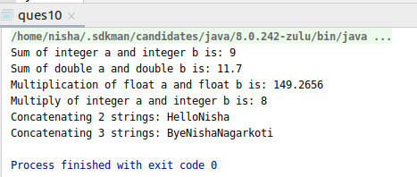

Q11.Create 3 sub class of bank SBI,BOI,ICICI all 4 should have method called getDetails which provide there specific details like rateofinterest etc,print details of every banks

package javaAssessment1;
class Bank{
int rateOfInterest;
void getBankDetails(){
System.out.println("Rate of interest is: "+rateOfInterest+" %");
System.out.println("Types of account are: Current and Saving\n");
}
}
class SBI extends Bank{
@Override
void getBankDetails() {
rateOfInterest=5;
System.out.println("\tSBI BANK DETAILS");
super.getBankDetails();
}
}
class BOI extends Bank{
@Override
void getBankDetails() {
rateOfInterest=6;
System.out.println("\tBOI BANK DETAILS");
super.getBankDetails();
}
}
class ICICI extends Bank{
@Override
void getBankDetails() {
rateOfInterest=7;
System.out.println("\tICICI BANK DETAILS");
super.getBankDetails();
}
}
public class ques11 {
public static void main(String args[]){
SBI s1 = new SBI();
s1.getBankDetails();
BOI b1 = new BOI();
b1.getBankDetails();
ICICI I1 = new ICICI();
I1.getBankDetails();
}
}
