1. Please create the following web page using bootstrap.
Q1.html:
<!doctype html>
<html lang="en">
<head>
<meta charset="utf-8">
<meta name="viewport" content="width=device-width, initial-scale=1, shrink-to-fit=no">
<link rel="stylesheet" href="https://maxcdn.bootstrapcdn.com/bootstrap/4.0.0/css/bootstrap.min.css"
integrity="sha384-Gn5384xqQ1aoWXA+058RXPxPg6fy4IWvTNh0E263XmFcJlSAwiGgFAW/dAiS6JXm" crossorigin="anonymous">

<title>Question 1</title>
</head>

<body class="bg-dark">
<div class="container bg-secondary pb-2">
<h2 class="text-white">TO THE NEW</h2>
<div class="container bg-dark">
<nav class="navbar navbar-expand-md bg-dark navbar-light">
<button class="navbar-toggler bg-light ml-auto" type="button" data-toggle="collapse"
data-target="#collapsibleNavbar">
<span class="navbar-toggler-icon"></span>
</button>
<div class="collapse navbar-collapse" id="collapsibleNavbar">
<ul class="navbar-nav">
<li class="nav-item">
<a class="nav-link text-white" href="#">Test Link</a>
</li>
<li class="nav-item">
<a class="nav-link text-white" href="#">Test Link</a>
</li>
<li class="nav-item">
<a class="nav-link text-white" href="#">Test Link</a>
</li>
<li class="nav-item">
<a class="nav-link text-white" href="#">Test Link</a>
</li>
</ul>
</div>
</nav>

</div>
</div>
<div class="container bg-white py-3">
<div class="container">
<div style="width:85%; max-height:auto; overflow: hidden;" class="mx-auto">
<img class="img-fluid mx-auto d-block" src="one.jpg" alt="layout-1">
</div>
</div>
<div class="container">
<div class="row justify-content-center bg-secondary mx-5 my-3">
<div class="col-md-10 col-sm-10 mx-auto my-3">
<p class="text-white">
Hypertext Markup Language (HTML) is the standard markup language for documents designed to be displayed in a web
browser.It can be assisted by technologies such as CSS and scripting languages such as JavaScript.
</p>
</div>
</div>
</div>
<div class="container mx-1 my-2 justify-content-center">
<div class="mx-5 my-2">
<h3>Some Sample Pictures</h3>
<hr class="bg-secondary">
</div>
<div class="mx-3">
<div class="row">
<div class="col-md-3 col-sm-6 my-1 ">
<img class="img-fluid mx-auto d-block" src="rsz_eat.jpg">
<p class="text-center text-secondary mt-1">Eat</p>
</div>
<div class="col-md-3 col-sm-6 my-1">
<img class="img-fluid mx-auto d-block" src="sleep.jpg">
<p class="text-center text-secondary mt-1">Sleep</p>
</div>
<div class="col-md-3 col-sm-6 my-1">
<img class="img-fluid mx-auto d-block" src="study.jpg">
<p class="text-center text-secondary mt-1">Study</p>
</div>
<div class="col-md-3 col-sm-6 my-1">
<img class="img-fluid mx-auto d-block" src="r.jpg">
<p class="text-center text-secondary mt-1">Repeat</p>
</div>
</div>
</div>
</div>

</div>
<div class="container bg-dark border border-secondary d-flex">
<p class="text-white mr-auto">Copyright © 2009-2020 -All Right Reserved-To The New </p>
<p class="text-white ml-auto">Web Layout By To The New</p>
</div>
<script src="https://code.jquery.com/jquery-3.2.1.slim.min.js"
integrity="sha384-KJ3o2DKtIkvYIK3UENzmM7KCkRr/rE9/Qpg6aAZGJwFDMVNA/GpGFF93hXpG5KkN" crossorigin="anonymous">
</script>
<script src="https://cdnjs.cloudflare.com/ajax/libs/popper.js/1.12.9/umd/popper.min.js"
integrity="sha384-ApNbgh9B+Y1QKtv3Rn7W3mgPxhU9K/ScQsAP7hUibX39j7fakFPskvXusvfa0b4Q" crossorigin="anonymous">
</script>
<script src="https://maxcdn.bootstrapcdn.com/bootstrap/4.0.0/js/bootstrap.min.js"
integrity="sha384-JZR6Spejh4U02d8jOt6vLEHfe/JQGiRRSQQxSfFWpi1MquVdAyjUar5+76PVCmYl" crossorigin="anonymous">
</script>
</body>
</html>
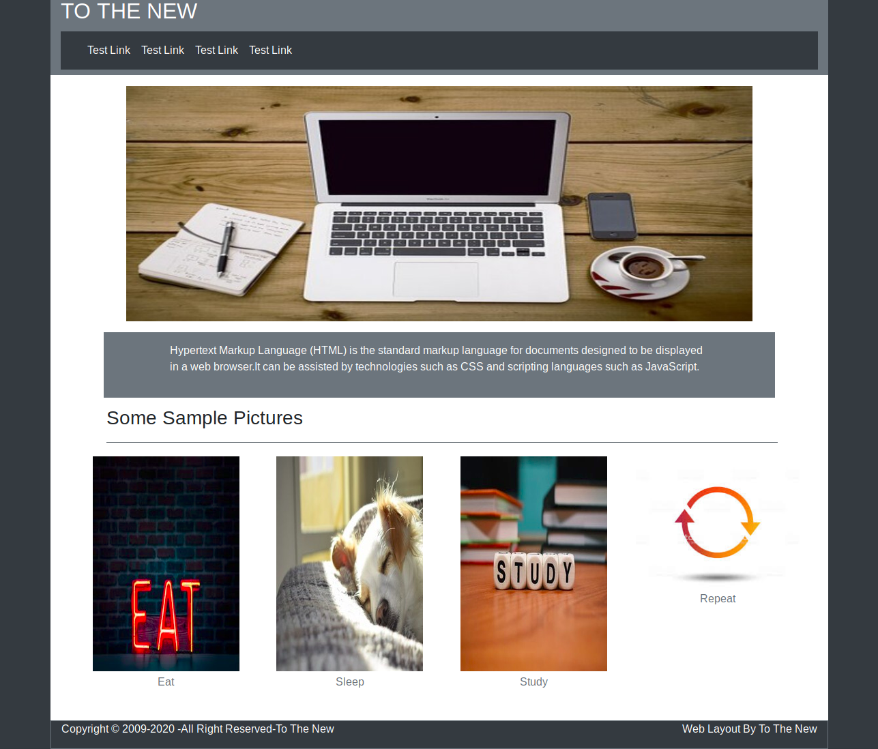

2. Please create the following form using bootstrap.
Q2.html:

<!doctype html>
<html>
<head>
<link rel="stylesheet” href="https://stackpath.bootstrapcdn.com/bootstrap/4.4.1/css/bootstrap.min.css" integrity="sha384-Vkoo8x4CGsO3+Hhxv8T/Q5PaXtkKtu6ug5TOeNV6gBiFeWPGFN9MuhOf23Q9Ifjh" crossorigin="anonymous">

<link rel="stylesheet" href="q2.css">
<script src="https://stackpath.bootstrapcdn.com/bootstrap/4.4.1/js/bootstrap.min.js" integrity="sha384-wfSDF2E50Y2D1uUdj0O3uMBJnjuUD4Ih7YwaYd1iqfktj0Uod8GCExl3Og8ifwB6" crossorigin="anonymous"></script>

<script src="https://code.jquery.com/jquery-3.4.1.slim.min.js" integrity="sha384-J6qa4849blE2+poT4WnyKhv5vZF5SrPo0iEjwBvKU7imGFAV0wwj1yYfoRSJoZ+n" crossorigin="anonymous"></script>

<script src="https://cdn.jsdelivr.net/npm/popper.js@1.16.0/dist/umd/popper.min.js" integrity="sha384-Q6E9RHvbIyZFJoft+2mJbHaEWldlvI9IOYy5n3zV9zzTtmI3UksdQRVvoxMfooAo" crossorigin="anonymous"></script>

<script src="https://stackpath.bootstrapcdn.com/bootstrap/4.4.1/js/bootstrap.min.js" integrity="sha384-wfSDF2E50Y2D1uUdj0O3uMBJnjuUD4Ih7YwaYd1iqfktj0Uod8GCExl3Og8ifwB6" crossorigin="anonymous"></script>

<title>TO THE NEW</title>
</head>
<body>
<div class="container">
<div class="row">
<div class="col-sm-7">
<h4>TO THE NEW</h4>
</div>
<div class="col-sm-5">
<ul class="nav justify-content-end">
<li class="nav-item">
<a class="nav-link active" href="#">HOME</a>
</li>
<li class="nav-item">
<a class="nav-link" href="#">Quick Help</a>
</li>
</ul>
</div>
</div>
<hr/>
</div>
<h3> BUG REPORT</h3>
<form>
<div class="form-group row">
<label for="title">Title*</label>
<div class="col-sm-12">
<input type="text" class="form-control" id="title">
</div>
</div>
<div class="form-group row">
<label for="description">Description*</label>
<div class="col-sm-12">
<textarea class="form-control" id="description" rows="3"></textarea>
</div>
</div>
<div class="form-group row">
<label for="Operating">Operating System </label>
<select class="" id="Operating">
<option class="select"> Windows XP </option>
<option class="select"> Windows 7 </option>
<option class="select"> Windows 10 </option>
<option class="select"> Windows Vista </option>
</select>
</div>
<div class="form-group row">
<label for ="Product"> Product </label>
<select class="" id="Product">
<option value="Windows XP"> Microsoft Access </option>
<option value="Windows 7"> Microsoft Excel </option>
<option value="Windows 10"> Microsoft Outlook </option>
<option value="Windows Vista"> Microsoft One Note</option>
</select>
</div>
<div class="form-group row">
<div class="col-sm-4">
<label for="Version">Version:</label>
<input type="number" class="form-control" id="Version">
</div>
</div>
<div class="form-group">
<label> License</label>
<br/>
<label class="radio-inline">
<input type="radio" name="optradio" checked>Free
</label>
<label class="radio-inline">
<input type="radio" name="optradio">Business
</label>
</div>
<div class="form-group row">
<label> Severity</label>
<select name="Operating System">
<option value="Serious">Serious</option>
<option value="Danger"> Danger</option>
</select>
</div>
<div class="form-group row">
<label> Attachments </label>
<input type="file" name="documents" accept="file/*">
</div>
<div class="form-group">
<div class="divide">
<button type="button" class="btn btn-success float-right">Submit</button>
</div>
</div>
</form>
</body>
</html>

Q2.css:
h4
{
margin-top: auto;
color:#06A061;
}
h3{
color:white;
width:30%;
padding: 15px 25px 15px 25px;
margin:auto;
margin-top:30px;
background-color: #E7E4E4;
}
.form-group{
border:2px solid #E7E4E4;
color:black;
margin:auto;
width:30%;
}
form label{
font-size:18px;
margin-left:30px;
margin-top:15px;
}
form input,select,textarea{
margin-top:20px;
padding:5px 2px 5px 2px;
width:90%;
margin:auto;
border-radius:5px;
border:1px solid #E7E4E4;
}
.select,select{
background-color:#06A061;
color:white;
border:none;
font-weight:500;
}
.divide{
margin-top:5px;
height:50px;
border-radius:5px;
background-color:#E7E4E4;



