1.Write a programe do to demonstrate the use of volatile keyword.
Volatile keyword is used when we use a shared variable this means that the value of variable is modified by different threads.This keyword is used to make thread safe classes and multiple threads can use method or instance of that class at same time.Volatile keyword is always used with variables and never with methods or classes.It means that every read and write to a variable will be done from main memory and not cache.

package MultithreadCodes;
class demo1 extends Thread{
public static volatile int count=0;
public void run(){
System.out.println(Thread.currentThread().getName());
System.out.println("Updating count ");
try {
count++;
System.out.println(count);
sleep(100);
} catch (InterruptedException e) {
e.printStackTrace();
}
}
}
public class ques1 {
public static void main(String args[]){
demo1 d1 = new demo1();
demo1 d2 = new demo1();
d1.start();
d2.start();
}
}

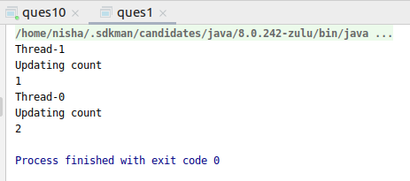

2. Write a program to create a thread using Thread class and Runnable interface each.
Extending Thread Class:
class sample extends Thread {
public void run() {
for (int i = 0; i < 5; i++) {
System.out.println("Thread running" + i);
try {
Thread.sleep(100);
} catch (InterruptedException e) {
e.printStackTrace();
}
}
}}
public class ques2 {
public static void main(String args[]) {
sample th1 = new sample();
th1.start();
sample th2 = new sample();
th2.start();
}}
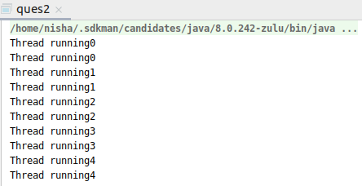

Implementing Runnable interface :
class sample2 implements Runnable {
public void run() {
for (int i = 0; i < 5; i++)
System.out.println("in thread " + i);
try {
Thread.sleep(100);
} catch (InterruptedException e) {
e.printStackTrace();
}
}
}
public class ques2b {
public static void main(String args[]) {
Thread T1 = new Thread(new sample2());
T1.start();
Thread T2 = new Thread(new sample2());
T2.start();
}}

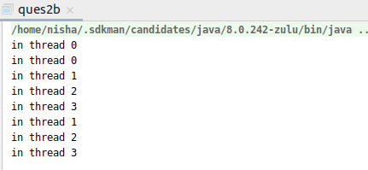

3. Write a program using synchronization method and synchronization block.
Using synchronization method:
public class synch1 {
private int count = 0;
public synchronized void increment() {
count++;
}
public static void main(String args[]) {
synch1 s1 = new synch1();
s1.doWork();
}
public void doWork() {
Thread t1 = new Thread(new Runnable() {
public void run() {
for (int i = 0; i < 10000; i++) {
increment();
}
}
});
Thread t2 = new Thread(new Runnable() {
public void run() {
for (int i = 0; i < 10000; i++) {
increment();
}
}
});
t1.start();
t2.start();
try {
t1.join();
t2.join();
} catch (Exception e) {
e.printStackTrace();
}
System.out.println("Value of count is: " + count);
}
}
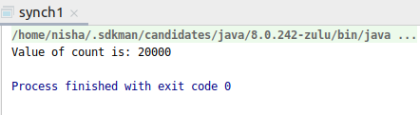

Using synchronization block:

package MultithreadCodes;
class demo{
void printID(){
synchronized(this){
for(int i=1;i<5;i++){
System.out.println(i);
try{
Thread.sleep(500);
}catch(Exception e){ e.printStackTrace();}
}
}
}
}
class Thread1 extends Thread{
demo d;
Thread1(demo d){
this.d=d;
}
public void run(){
d.printID();
}
}
class Thread2 extends Thread{
demo d;
Thread2(demo d){
this.d=d;
}
public void run(){
d.printID();
}
}
public class ques3{
public static void main(String args[]){
demo obj = new demo();
Thread1 t1=new Thread1(obj);
Thread2 t2=new Thread2(obj);
t1.start();
t2.start();
}
}
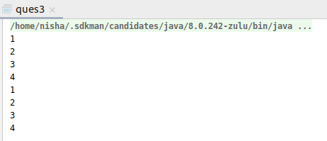

4. Write a program to create a Thread pool of 2 threads where one Thread will print
even numbers and other will print odd numbers.

package MultithreadCodes;
import java.util.concurrent.ExecutorService;
import java.util.concurrent.Executors;
import static java.lang.Thread.sleep;
public class ques4 {
public static void main(String[] args) {
ExecutorService executorService = Executors.newFixedThreadPool(2);
Runnable task1 = new Runnable() {
public void run() {
System.out.println("Performing function to print odd number");
System.out.println("Starting " + Thread.currentThread().getName());
try {
for (int i = 1; i <= 10; i++) {
if (i % 2 != 0)
System.out.println("Odd: " + i);
sleep(100);
}
} catch (InterruptedException e) {
e.printStackTrace();
}
}
};
Runnable task2 = new Runnable() {
public void run() {
System.out.println("Performing function to print even number");
System.out.println("Starting " + Thread.currentThread().getName());
try {
for (int i = 1; i <= 10; i++) {
if (i % 2 == 0)
System.out.println("Even: " + i);
sleep(100);
}
} catch (InterruptedException e) {
e.printStackTrace();
}
}
};
executorService.submit(task1);
executorService.submit(task2);
executorService.shutdown();
executorService.shutdown();
}
}

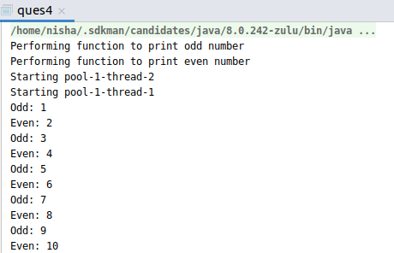

5. Write a program to demonstrate wait and notify methods.

package MultithreadCodes;
class User {
int amt = 1000;
synchronized void withdraw(int amt) {
System.out.println("Withdrawing amount");
if (this.amt < amt) {
System.out.println("Your Balance is low");
try {
wait();
} catch (InterruptedException e) {
e.printStackTrace();
}
this.amt = this.amt - amt;
System.out.println("Amount Withdrawn: "+amt);
}
}
synchronized void deposit(int amt) {
System.out.println("Depositing the amount");
this.amt = this.amt + amt;
System.out.println("Amount Deposited");
notify();
}
}
public class ques5 {
public static void main(String[] args) {
User u = new User();
Thread t1 = new Thread() {
public void run() {
u.withdraw(1500000);
}
};
Thread t2 = new Thread() {
public void run() {
u.deposit(10000);
}
};
t1.start();
t2.start();
}
}

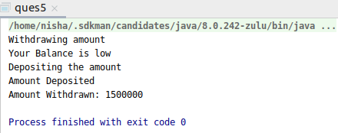

6. Write a program to demonstrate sleep and join methods.

package MultithreadCodes;
class sampleThread extends Thread {
public void run() {
for (int i = 0; i < 5; i++) {
try {
Thread.sleep(1000);
} catch (InterruptedException e) {
e.printStackTrace();
}
System.out.println("thread executing " + i);
}
}
}
public class ques8 {
public static void main(String args[]) {
sampleThread t1 = new sampleThread();
sampleThread t2 = new sampleThread();
t1.start();
try {
t1.join();
} catch (InterruptedException e) {
e.printStackTrace();
}
t2.start();
}
}

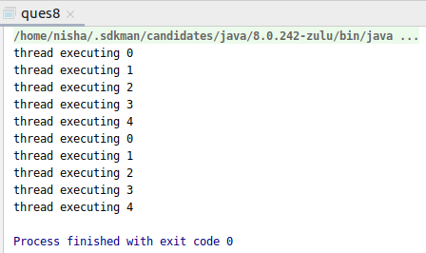

7.Run a task with the help of callable and store it's result in the Future.

package MultithreadCodes;
import java.util.concurrent.*;
class Product implements Callable<Integer> {
public Integer call() throws Exception {
Thread.sleep(200);
return table();
}
private Integer table() {
int num = 2;
int result = 1;
System.out.println("Doubling Numbers");
for (int i = 1; i <= 10; i++) {
System.out.println(num * i);
result = num * num;
}
return result;
}
}
public class ques7 {
public static void main(String[] args) throws ExecutionException, InterruptedException {
ExecutorService executorService = Executors.newSingleThreadExecutor();
Future<Integer> fut = executorService.submit(new Product());
Integer answer = fut.get();
executorService.shutdown();
}
}
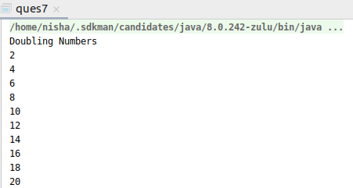

8.Write a program to demonstrate the use of semaphore

package MultithreadCodes;
import java.util.concurrent.Semaphore;
public class ques8 {
int count = 0;
Semaphore s = new Semaphore(1);
public static void main(String[] args) {
ques8 q1 = new ques8();
Thread t1 = new Thread() {
public void run() {
try {
q1.func();
} catch (InterruptedException e) {
e.printStackTrace();
}
}
};
t1.start();
Thread t2 = new Thread() {
public void run() {
try {
q1.func();
} catch (InterruptedException e) {
e.printStackTrace();
}
}
};
t2.start();
}
private void func() throws InterruptedException {
try {
s.acquire();
System.out.println( "Lock Acquired on "+Thread.currentThread().getName() );
count++;
System.out.println("Count is: " + count);
Thread.sleep(1000);
} catch (InterruptedException e) {
e.printStackTrace();
} finally {
s.release();
System.out.println("Lock Released on "+Thread.currentThread().getName() );
}
}
}

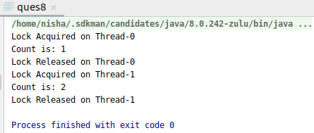

9.Write a program to demonstrate the use of CountDownLatch

package MultithreadCodes;
import java.util.concurrent.CountDownLatch;
public class ques9 {
public static void main(String args[]) throws InterruptedException{
CountDownLatch latch = new CountDownLatch(3);
latch_call one = new latch_call(1000,latch,"Thread 1");
latch_call two = new latch_call(2000,latch,"Thread 2");
latch_call three = new latch_call(4000,latch,"Thread 3");
one.start();
two.start();
three.start();
latch.await();;
System.out.println(Thread.currentThread().getName()+" has finished");
}
static class latch_call extends Thread{
private int delay;
private CountDownLatch latch;
public latch_call(int delay, CountDownLatch latch,String data){
super(data);
this.delay=delay;
this.latch=latch;
}
public void run(){
System.out.println(Thread.currentThread().getName()+ " has started");
try {
Thread.sleep(delay);
latch.countDown();
System.out.println(Thread.currentThread().getName()+ " has finished executing..");
} catch (InterruptedException e) {
e.printStackTrace();
}
}
}
}
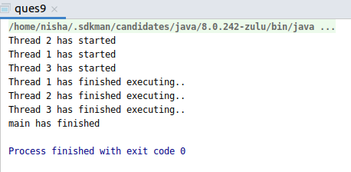

10. Write a program which creates deadlock between 2 threads
package MultithreadCodes;
public class ques10 {
public static Object LockItem1 = new Object();
public static Object LockItem2 = new Object();
public static void main(String args[]) {
threadOne t1 = new threadOne();
threadTwo t2 = new threadTwo();
t1.start();
t2.start();
}

private static class threadOne extends Thread {
public void run() {
synchronized (LockItem1) {
System.out.println("ThreadOne have lock 1");
try {
Thread.sleep(100);
} catch (InterruptedException e) {
System.out.println(e);
}
System.out.println("threadOne waiting for lock 2");
synchronized (LockItem2) {
System.out.println("ThreadOne have lock 1 and 2");
}
}
}
}
private static class threadTwo extends Thread {
public void run() {
synchronized (LockItem2) {
System.out.println("ThreadTwo have lock 2");
try {
Thread.sleep(100);
} catch (InterruptedException e) {
System.out.println(e);
}
System.out.println("threadTwo waiting for lock 1");
synchronized (LockItem1) {
System.out.println("Threadtwo have lock 1 and 2");
}
}
}
}
}
