1. Create Java classes having suitable attributes for Library management system.Use OOPs concepts in your design.Also try to use interfaces and abstract classes.
package javaAssessment2;
interface customer_operations{
public void add(String customer_name,String customer_address,Books books);
public void display();
public void checkout(int date_of_issue,int date_of_return);
}
abstract class books_operations{
public abstract void add(String book_name, String book_author, String book_publisher);
public abstract void delete(String book_name);
public abstract void display();
public abstract void submit(String book_name);
}
class Books extends books_operations{
private String book_name;
private String book_author;
private String book_publisher;
@Override
public void add(String book_name, String book_author, String book_publisher) {
}
@Override
public void delete(String book_name) {
}
@Override
public void display() {
}
@Override
public void submit(String book_name) {
}
}
class Customers implements customer_operations{
private String customer_name;
private String customer_address;
private int date_of_issue;
private int date_of_return;
@Override
public void add(String customer_name, String customer_address, Books books) {
}
@Override
public void display() {
}
@Override
public void checkout(int date_of_issue, int date_of_return) {
}
}
public class question1 {
public static void main(String[] args) {
}
}

2. WAP to sorting string without using string Methods?
package javaAssessment2;
public class question2 {
public static void main(String args[]){
String s1="nisha";
System.out.println("Unsorted String: "+s1);
int i=0;
char temp=0;
char[] alphabets = s1.toCharArray();
for (int j=0;j<alphabets.length;j++){
for (i=0;i<alphabets.length;i++){
if (alphabets[i]>alphabets[j]){
temp=alphabets[j];
alphabets[j]=alphabets[i];
alphabets[i]=temp;
}
}
}
System.out.println("\nSorted String: ");
for (int k=0;k<alphabets.length;k++)
System.out.println(alphabets[k]);
}
}
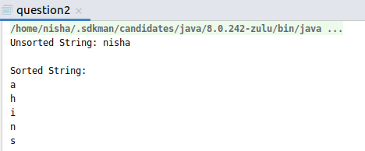

3. WAP to produce NoClassDefFoundError and ClassNotFoundException exception.

ClassNotFoundException Exception
package javaAssessment2;
public class question3 {
public static void main(String args[]){
try{
Class.forName("question3");
System.out.println("Class found successfully");
}catch (ClassNotFoundException e) {
System.out.println("Exception caught");
e.printStackTrace();
}
}
}
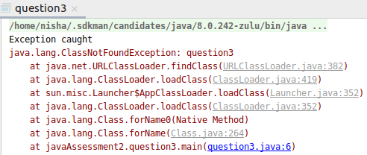

NoClassDefFoundError
class a {
void display(){
System.out.println("This is class A");
}
}
public class question3 {
public static void main(String args[]){
try{
Class.forName("question3");
System.out.println("Class found successfully");
}catch (ClassNotFoundException e) {
System.out.println("Exception caught");
e.printStackTrace();
}
a obj1 = new a();
obj1.display();
}
}

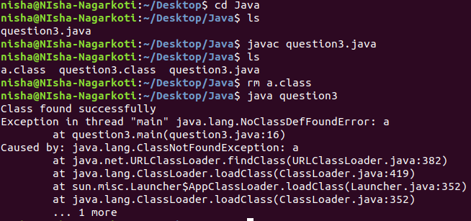

4. WAP to create singleton class.
package javaAssessment2;
class sample {
public static sample s = null;
public String s1;
private sample() {
}
public static sample getInstance() {
if (s == null) {
s = new sample();
}
return s;
}
protected static void methodPrint() {
System.out.println("Method of singleton");
}
}
class question4 {
public static void main(String args[]) {
sample obj1 = sample.getInstance();
obj1.methodPrint();
}
}

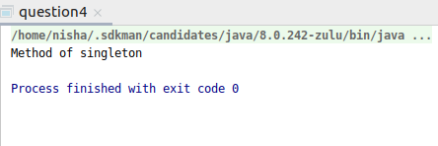

5. WAP to show object cloning in java using cloneable and copy constructor both.
Using cloneable:
package javaAssessment2;
public class question5 implements Cloneable {
int eid;
String name;
question5(int eid, String name) {
this.eid = eid;
this.name = name;}
public Object clone() throws CloneNotSupportedException {
return super.clone();
}
public static void main(String[] args) {
try {
question5 e1 = new question5(101, "Nisha");
question5 e2 = (question5) e1.clone();
System.out.println("Emp1: " + e1.eid + " " + e1.name);
System.out.println("Emp2: " + e2.eid + " " + e2.name);
} catch (CloneNotSupportedException c) {
System.out.println("Not Supported");
}}
}
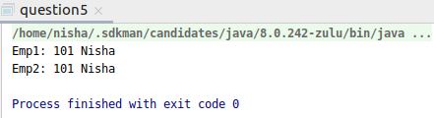

Using copy constructor:
package javaAssessment2;
public class question5b {
int eid;
String name;
question5b(int eid, String name) {
this.eid = eid;
this.name = name;
}
question5b(question5b q) {
eid = q.eid;
name = q.name;
}
public static void main(String[] args) {
question5b e1 = new question5b(101, "Nisha Nagarkoti");
question5b e2 = new question5b(e1);
System.out.println("Emp1: " + e1.eid + " " + e1.name);
System.out.println("Emp2: " + e2.eid + " " + e2.name);
}
}
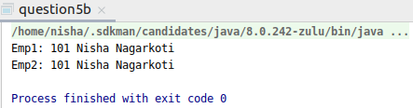

6. WAP showing try, multi-catch and finally blocks.
package javaAssessment2;
public class question6 {
public static void main(String args[]) {
int x = 0;
int y[] = {1, 2, 3, 4};
try {
y[5] = 43 / 0;
} catch (ArrayIndexOutOfBoundsException arr) {
System.out.println("Exception caught inside try block: " + arr);
} catch (ArithmeticException ae) {
System.out.println("Exception caught inside try block: " + ae);
}
finally {
System.out.println("this finally block is always executed");
}
}
}

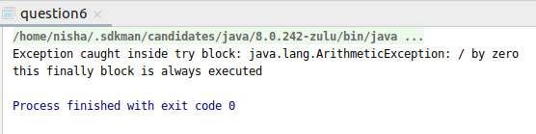

7. WAP to convert seconds into days, hours, minutes and seconds.
package javaAssessment2;
public class question7 {
public static void main(String args[]){
int seconds=754630;
int days=seconds/(24*3600);
int day1=seconds%(24*3600);
int hours=day1/3600;
int hour1=day1%3600;
int minutes=hour1/60;
int sec=hour1%60;
System.out.println(seconds+" seconds is equal to: ");
System.out.println(days+" "+"days "+hours+" "+"hours "+minutes+" "+"minutes "+sec+" "+"seconds");
}
}

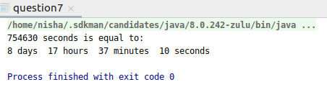

8. WAP to read words from the keyboard until the word done is entered. For each word except done, report whether its first character is equal to its last character. For the required loop, use a
a)While
package javaAssessment2;
import java.util.Scanner;
public class question8 {
public static void main(String args[]){
Scanner sc = new Scanner(System.in);
System.out.println("Enter a word: ");
String word = sc.next();
while(!word.equals("done"))
{
if(word.charAt(0) == word.charAt(word.length() - 1))
{
System.out.println("First and last character are equal");
}
else
{
System.out.println("First and last character are not equal");
}
word = sc.next();
}
}
}
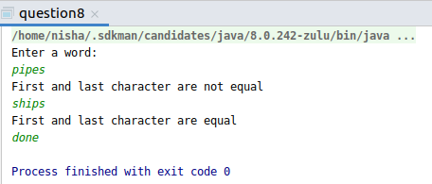

b)do-while
package javaAssessment2;
import java.util.Scanner;
public class question8 {
public static void main(String args[]){
Scanner sc = new Scanner(System.in);
System.out.println("Enter a word");
String word = sc.next();
do
{
if(word.charAt(0) == word.charAt(word.length() - 1))
{
System.out.println("First and last character are equal");
}
else
{
System.out.println("First and last character are not equal");
}
word = sc.next();
}while(!word.equals("done"));
}
}
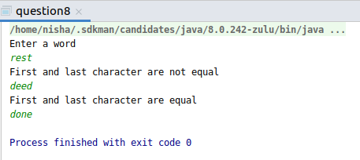

9. Design classes having attributes for furniture where there are wooden chairs and tables, metal chairs and tables. There are stress and fire tests for each products.
package javaAssessment2;
interface Furniture {
public void fireTest();
public void stressTest();
}
abstract class Chair implements Furniture {
public abstract void typeOfChair();
}
abstract class Table implements Furniture {
public abstract void typeOfTable();
}
class woodenChair extends Chair {
public void fireTest() {
System.out.println("Fire testing failed on wooden chair");
}
public void stressTest() {
System.out.println("Stress testing failed on wooden chair");
}
public void typeOfChair() {
System.out.println("This is a wooden chair");
}
}
class metalChair extends Chair {
public void fireTest() {
System.out.println("Fire testing passed on metal chair");
}
public void stressTest() {
System.out.println("Stress testing passed on metal chair");
}
public void typeOfChair() {
System.out.println("This is a metal chair");
}
}
class woodenTable extends Table {
public void fireTest() {
System.out.println("Fire testing failed on wooden table");
}
public void stressTest() {
System.out.println("Fire testing failed on wooden table");
}
public void typeOfTable() {
System.out.println("This is a wooden table");
}
}
class metalTable extends Table {
public void fireTest() {
System.out.println("Fire testing passed on metal table");
}
public void stressTest() {
System.out.println("Fire testing passed on metal table");
}
public void typeOfTable() {
System.out.println("This is metal table");
}
}
public class question9 {
public static void main(String args[]) {
woodenChair wc = new woodenChair();
wc.typeOfChair();
wc.fireTest();
wc.stressTest();
woodenTable wt = new woodenTable();
System.out.println("\n");
wt.typeOfTable();
wt.fireTest();
wt.stressTest();
metalChair metalCh = new metalChair();
System.out.println("\n");
metalCh.typeOfChair();
metalCh.fireTest();
metalCh.stressTest();
metalTable mt = new metalTable();
System.out.println("\n");
mt.typeOfTable();
mt.fireTest();
mt.stressTest();
}
}
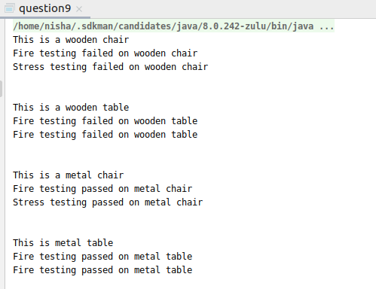

10. Design classes having attributes and method(only skeleton) for a coffee shop. There are three different actors in our scenario and i have listed the different actions they do also below
* Customer
- Pays the cash to the cashier and places his order, get a token number back
- Waits for the intimation that order for his token is ready
- Upon intimation/notification he collects the coffee and enjoys his drink
( Assumption: Customer waits till the coffee is done, he wont timeout and cancel the order. Customer always likes the drink served. Exceptions like he not liking his coffee, he getting wrong coffee are not considered to keep the design simple.)
* Cashier
- Takes an order and payment from the customer
- Upon payment, creates an order and places it into the order queue
- Intimates the customer that he has to wait for his token and gives him his token
( Assumption: Token returned to the customer is the order id. Order queue is unlimited. With a simple modification, we can design for a limited queue size)
* Barista
- Gets the next order from the queue
- Prepares the coffee
- Places the coffee in the completed order queue
- Places a notification that order for token is ready

package javaAssessment2;
class Customer{
public int TokenNumber;
public String order;
private int payment;
public int getTokenNumber() {
return 0;
}
public void waitForCoffee() {}
public void collectCoffee(){}
public void payPayment(){}
public void placeOrder(){}
}
class Cashier{
private String order;
private String getOrder(){
return null;
}
public void receivePayment(){}
public void notify(Customer c1){}
}class Barista{
public void prepareCoffee(){}
public void placeCoffee(){}
public void notify(Customer c1){}
}
public class question10 {
public static void main(String[] args) {
}
}

11. Convert the following code so that it uses nested while statements instead of for statements:
int s = 0;
int t = 1;
for (int i = 0; i < 10; i++)
{
s = s + i;
for (int j = i; j > 0; j−−)
{
t = t * (j - i);
}
s = s * t;
System.out.println("T is " + t);
}
System.out.println("S is " + s);

Code using while statement:
package javaAssessment2;
public class question11 {
public static void main(String args[]){
int s = 0,i = 0;
int t = 1;
while(i < 10)
{
s = s + i;
int j = i;
while(j > 0)
{
t = t * (j - i);
j--;
}
s = s * t;
System.out.println("T is " + t);
i++;
}
System.out.println("S is " + s);
}
}

12.What will be the output on new Child(); ?
class Parent extends Grandparent {
{
System.out.println("instance - parent");
}
public Parent() {
System.out.println("
}
static {
System.out.println("static - parent");
}
}
class Grandparent {
static {
System.out.println("static - grandparent");
}
{
System.out.println("instance - grandparent");
}
public Grandparent() {
System.out.println("
}
}
class Child extends Parent {
public Child() {
System.out.println("
}
static {
System.out.println("static - child");
}
{
System.out.println("instance - child");
}
}

package javaAssessment2;
class Parent extends Grandparent {
{
System.out.println("instance - parent");
}
public Parent() {
System.out.println();
}
static {
System.out.println("static - parent");
}
}
class Grandparent {
static {
System.out.println("static - grandparent");
}
{
System.out.println("instance - grandparent");
}
public Grandparent() {
System.out.println();
}
}
class Child extends Parent {
public Child() {
System.out.println();
}
static {
System.out.println("static - child");
}
{
System.out.println("instance - child");
}
}
public class question12 {
public static void main(String args[]){
Child newChild = new Child();
}}

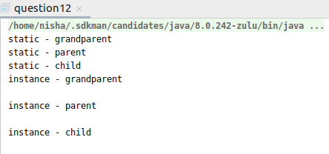

Q13. Create a custom exception that do not have any stack trace.
package MultithreadCodes;
class InvalidHeightException extends Exception{
InvalidHeightException(String s){
super(s);
}
public Throwable fillInStackTrace()
{
return this;
}
}
public class ques13 {
static void validate(float height)throws InvalidHeightException{
if(height<150)
throw new InvalidHeightException("Height not valid");
else
System.out.println("You can enter the ride.");
}
public static void main(String args[]){
try{
validate(145);
}catch (Exception e) {
System.out.println("Exception encountered: " + e);
e.printStackTrace();
}
}
}
