1.Write Java code to define List . Insert 5 floating point numbers in List, and using an iterator, find the sum of the numbers in List.

import java.util.ArrayList;
import java.util.Iterator;
public class arrayList {
public static void main(String args[]) {
ArrayList<Float> al = new ArrayList<Float>();
al.add(10.2f);
al.add(13.21f);
al.add(4.6f);
al.add(5.3f);
al.add(2.2f);
float sum = 0;
System.out.println("Value added are: ");
Iterator<Float> itr = al.iterator();
while (itr.hasNext()) {
float value = itr.next();
System.out.println(value);
sum = sum + value;
}
System.out.println("\nSum of elements is: " + sum);
}
}
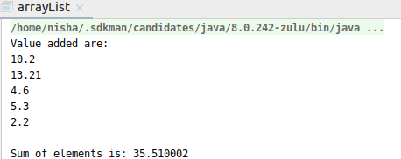

2.Write a method that takes a string and returns the number of unique characters in the string.
import java.util.HashMap;
import java.util.Map;
public class quesCollect2 {
static void countCharacter(String s1){
Integer value=0,count=0;
System.out.println("Unique characters in string are: ");
HashMap<Character,Integer> hm = new HashMap<Character, Integer>();
char stringArray[] = s1.toCharArray();
for (char ch:stringArray) {
if (hm.containsKey(ch)){
hm.put(ch,hm.get(ch)+1);
}
else{
hm.put(ch,1);
}
}
for (Map.Entry entry:hm.entrySet()) {
value= (Integer) entry.getValue();
if (value<=1) {
System.out.println(entry.getKey() + " " + entry.getValue());
}
}
}
public static void main(String args[]){
String str = "manners";
countCharacter(str);
}
}
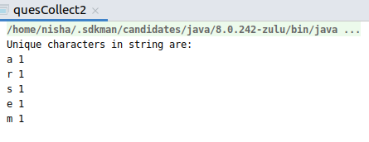

3.Write a method that takes a string and print the number of occurrence of each character characters in the string.
import java.util.HashMap;
import java.util.Map;
public class quesCollect3 {
static void countCharacter(String s1){
HashMap<Character,Integer> hm = new HashMap<Character, Integer>();
char stringArray[] = s1.toCharArray();
for (char ch:stringArray) {
if (hm.containsKey(ch)){
hm.put(ch,hm.get(ch)+1);
}
else{
hm.put(ch,1);
}
}
for (Map.Entry entry:hm.entrySet()) {
System.out.println(entry.getKey()+" "+entry.getValue());
}
}
public static void main(String args[]){
String str = "Collections";
countCharacter(str);
}
}
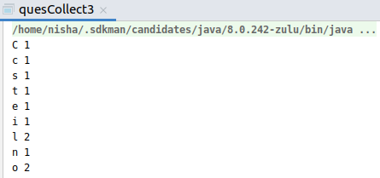
4.Write a program to sort HashMap by value.

import java.util.*;
public class quesCollect4 {
public static void main(String args[]) {
HashMap<String, Integer> hm = new HashMap<String, Integer>();
hm.put("three", 30);
hm.put("one", 10);
hm.put("two", 20);
hm.put("five", 50);
hm.put("four", 40);
System.out.println(hm);
List<Map.Entry<String, Integer>> list = new LinkedList<Map.Entry<String, Integer>>(hm.entrySet());
Collections.sort(list, new Comparator<Map.Entry<String, Integer>>() {
@Override
public int compare(Map.Entry<String, Integer> o1, Map.Entry<String, Integer> o2) {
return o1.getValue().compareTo(o2.getValue());
}
});
System.out.println("Sorting elements of HashMap by value\n");
for (Map.Entry<String, Integer> items : list) {
System.out.println("Key is:" + items.getKey() + "\t\t Value is: " + items.getValue());
}
}
}
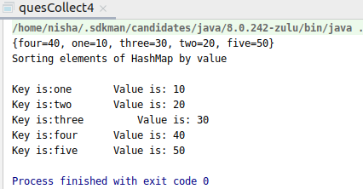

5.Write a program to sort Employee objects based on highest salary using Comparator. Employee class{ Double Age; Double Salary; String Name.

import java.util.ArrayList;
import java.util.Collections;
import java.util.Comparator;
class Employee{
double age;
double salary;
String name;
public Employee(double age,double salary,String name){
this.age=age;
this.salary=salary;
this.name=name;
}
public double getAge() {
return age;
}
public void setAge(double age) {
this.age = age;
}
public double getSalary() {
return salary;
}
public void setSalary(double salary) {
this.salary = salary;
}
public String getName() {
return name;
}
public void setName(String name) {
this.name = name;
}
}
public class quesCollect5 {
public static void main(String args[]) {
ArrayList<Employee> al = new ArrayList<Employee>();
al.add(new Employee(24, 45000, "nisha"));
al.add(new Employee(25, 55000, "akshita"));
al.add(new Employee(22, 35000, "drishti"));
al.add(new Employee(23, 22000, "prabhat"));
Comparator<Employee> em = Comparator.comparing(Employee::getSalary);
Collections.sort(al, em);
System.out.println("sorting by salary");
for(Employee emp:al){
System.out.println(emp.age+" "+emp.salary+" "+emp.name);
}
}
}
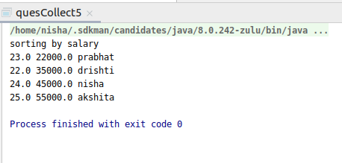

6.Write a program to sort the Student objects based on Score , if the score are same then sort on First Name . Class Student{ String Name; Double Score; Double Age
import java.util.ArrayList;
import java.util.Collections;
import java.util.List;
import java.util.Comparator;
class Student6 {
Double score;
String name;
Double age;
public Student6(Double score, String name, Double age) {
this.score = score;
this.name = name;
this.age = age;
}
public Double getScore() {
return score;
}
public void setScore(Double score) {
this.score = score;
}
public String getName() {
return name;
}
public void setName(String name) {
this.name = name;
}
public Double getAge() {
return age;
}
public void setAge(Double age) {
this.age = age;
}
static class StudentsSorting implements Comparator<Student6> {
public int compare(Student6 stud1, Student6 stud2) {
int ScoreCompare = stud1.getScore().compareTo(stud2.getScore());
int NameCompare = stud1.getName().compareTo(stud2.getName());
if (ScoreCompare == 0) {
if (NameCompare == 0) {
return ScoreCompare;
}
else{
return NameCompare;
}
} else {
return ScoreCompare;
}
}
}
public static void main(String[] args) {
List<Student6> al = new ArrayList<>();
Student6 obj1 = new Student6(45.0, "Arya", 23.0);
Student6 obj2 = new Student6(45.0, "Deep", 24.0);
Student6 obj3 = new Student6(66.0, "Aman", 22.0);
Student6 obj4 = new Student6(67.0, "Mary", 22.0);
Student6 obj5 = new Student6(85.0, "Loki", 24.0);
al.add(obj1);
al.add(obj2);
al.add(obj3);
al.add(obj4);
al.add(obj5);
Collections.sort(al, new StudentsSorting());
System.out.println("Sorted By Score And Name\n");
System.out.println("Score " + "\tName" + "\t Age");
for (Student6 student : al) {
System.out.println(student.score + "\t" + student.name + "\t " + student.age);
}
}
}
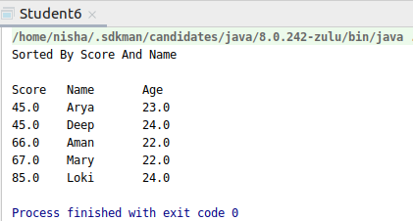

7.Print the elements of an array in the decreasing frequency if 2 numbers have same frequency then print the one which came first.
import java.util.*;
import static java.util.Map.*;
public class quesCollect7 {
public static void main(String[] args) {
Map<Integer, Integer> m = new LinkedHashMap<Integer, Integer>();
System.out.print("Enter the size of the array: ");
Scanner scanner = new Scanner(System.in);
int size = scanner.nextInt();
System.out.println("Enter elements: ");
int[] arr = new int[size];
for (int i = 0; i < size; i++) {
arr[i] = scanner.nextInt();
}
System.out.println("Elements with their frequencies are: ");
for (int j = 0; j < arr.length; j++) {
if (!m.containsKey(arr[j])) {
m.put(arr[j], 1);
} else {
m.put(arr[j], m.get(arr[j]) + 1);
}
}
for (Map.Entry<Integer, Integer> entry : m.entrySet()) {
int key = entry.getKey();
int value = entry.getValue();
System.out.println(key + " : " + value);
}
List<Entry<Integer, Integer>> decfreq = new ArrayList<>(m.entrySet());
Collections.sort(decfreq, new Comparator<Entry<Integer, Integer>>() {
@Override
public int compare(Entry<Integer, Integer> o1, Entry<Integer, Integer> o2) {
return o1.getValue().compareTo(o2.getValue());
}
});
System.out.println("Elements with decreasing frequencies..");
Collections.reverse(decfreq);
for (Entry<Integer, Integer> entry : decfreq) {
int frequency = entry.getValue();
while (frequency >= 1) {
System.out.print(entry.getKey() + " ");
frequency--;
}
}
}}

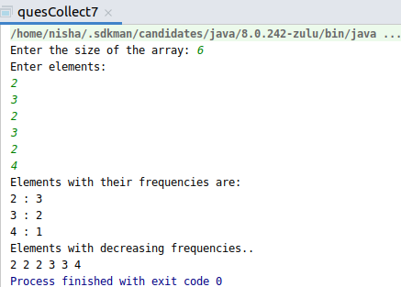

8.Design a Data Structure SpecialStack that supports all the stack operations like push(), pop(), isEmpty(), isFull() and an additional operation getMin() which should return minimum element from the SpecialStack. (Expected complexity – O(1))
import java.util.Stack;
class SpecialStack {
Stack<Integer> s;
Integer minElement;
SpecialStack() {
s = new Stack<Integer>();
}
void push(Integer x) {
if (s.isEmpty()) {
minElement = x;
s.push(x);
System.out.println("Element Pushed is: " + x);
return;
}
if (x < minElement) {
s.push(2 * x - minElement);
minElement = x;
} else
s.push(x);
System.out.println("Element Pushed is: " + x);
}
void showMinEle() {
System.out.println("Minimum element is: " + minElement);
}
void pop() {
if (s.isEmpty()) {
System.out.println("Stack is empty");
}
System.out.println("Element on top of stack removed");
Integer t = s.pop();
if (t < minElement) {
System.out.println(minElement);
minElement = 2 * minElement - t;
} else
System.out.println(t);
}
};
public class quesCollect8 {
public static void main(String args[]) {
SpecialStack s = new SpecialStack();
s.push(4);
s.push(5);
s.showMinEle();
s.push(3);
s.push(1);
s.pop();
s.showMinEle();
}
}
