Problem Statement: There can be multiple customers, who can place multiple orders on the site. Now a sales person can handle these orders will distribute into multiple sales persons (One order will be assign to one salesperson only). So a sales person can have multiple orders of multiple customers.

- Create Database
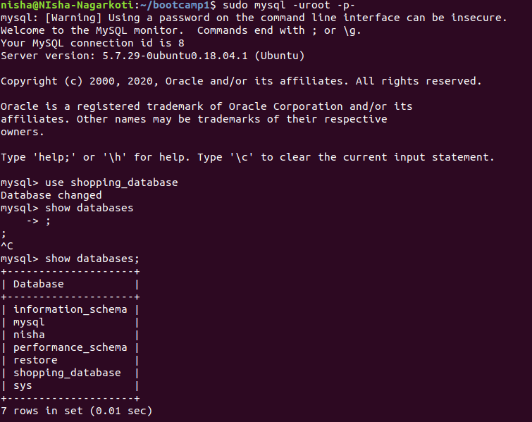

- Design Schema

Customer table:
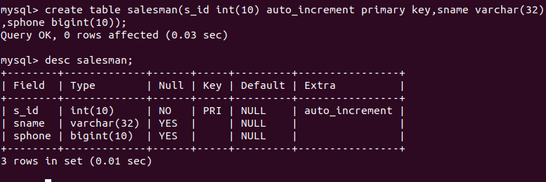

Salesman table:
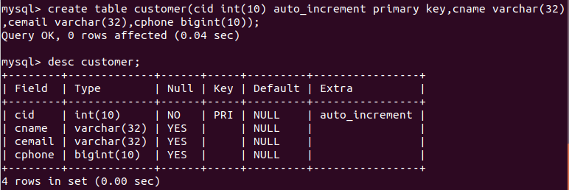

Orders table:
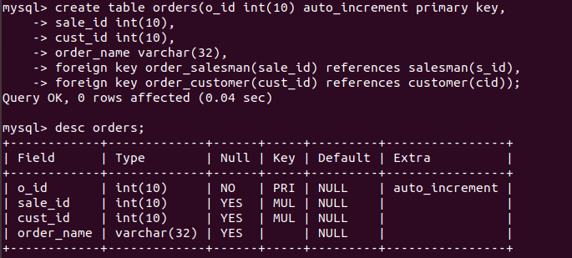

3. Create tables

Customer table:
Salesman table:
Orders table:

4. Insert sample data

Inserting into customer table:
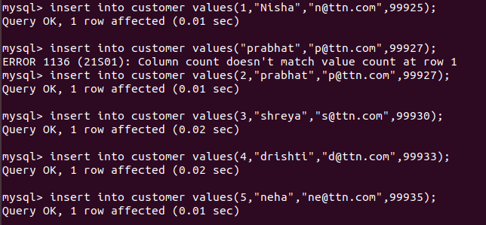

Inserting into salesman table:
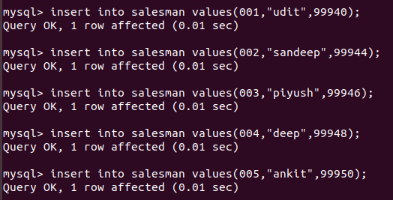
Inserting into orders table:
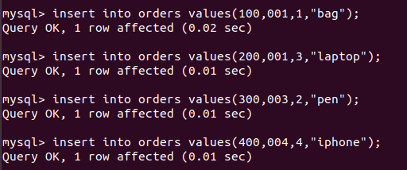

5. Find the sales person have multiple orders.
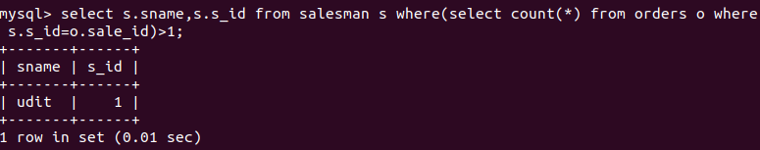

6. Find the all sales person details along with order details
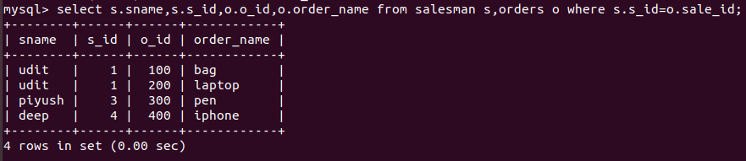
7.Create index
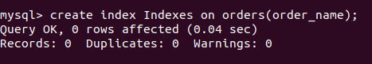

8.How to show index on a table
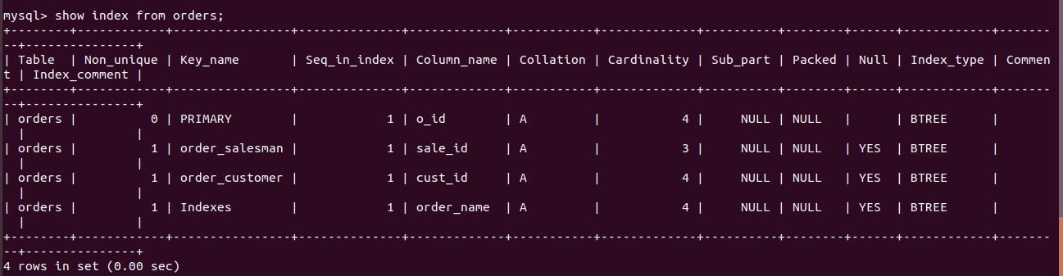

9.Find the order number, sale person name, along with the customer to whom that order belongs to
