1) Write the following a functional interface and implement it using lambda:

a) First number is greater than second number or not Parameter (int ,int ) Return boolean

interface demo {
boolean greater(int x, int y);
}
public class ques1A {
public static void main(String args[]) {
demo d1 = (x, y) -> {
if (x > y)
return true;
else
return false;
};
System.out.println(d1.greater(5, 3));
}
}
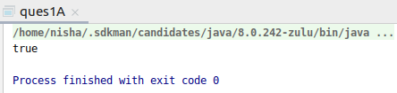

b) Increment the number by 1 and return incremented value Parameter (int) Return int

interface demoB {
int increment(int x);
}
public class ques1B {
public static void main(String args[]){
demoB d1 = (x)->{
return x+1;
};
System.out.println(d1.increment(6));
}
}

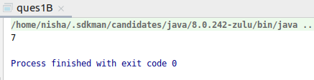

c)Concatination of 2 string Parameter (String , String ) Return (String)
interface demoC {
String stringConcat(String s1, String s2);
}
public class ques1C {
public static void main(String args[]) {
demoC d1 = (s1, s2) -> {
return s1 + s2;
};
System.out.println(d1.stringConcat("good", "bye"));
}
}
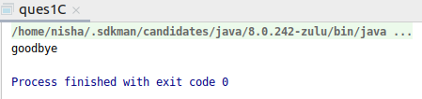

d)Convert a string to uppercase and return Parameter (String) Return (String)
interface demoD {
String upperCase(String s1);
}
public class ques1D {
public static void main(String args[]) {
demoD d1 = (s1) -> {
return s1.toUpperCase();
};
System.out.println(d1.upperCase("hello"));
}
}
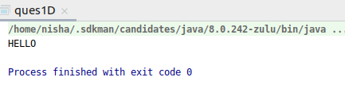

2) Create a functional interface whose method takes 2 integers and return one integer.
interface sample2 {
int sum(int x, int y);
}
public class ques2 {
public static void main(String agrs[]) {
sample2 s1 = (x, y) -> {
System.out.println("Value of x is: " + x);
System.out.println("Value of y is: " + y);
return x + y;
};
System.out.println("Sum of x and y: " + s1.sum(4, 6));
}}

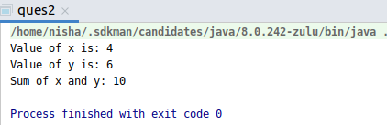

3) Using (instance) Method reference create and apply add and subtract method and using (Static) Method reference create and apply multiplication method for the functional interface created.
interface Calculate {
int method(int a, int b);
}
public class ques3 {
int add(int a, int b) {
return a + b;
}
int subtract(int a, int b) {
return a - b;
}
public static int multiply(int a, int b) {
return a * b;
}
public static void main(String[] args) {
Calculate c = new ques3()::add;
System.out.println("Adding 2 numbers: " + c.method(2, 4));
Calculate c1 = new ques3()::subtract;
System.out.println("Subtracting 2 numbers: " + c1.method(10, 3));
Calculate c3 = ques3::multiply;
System.out.println("Product of 2 numbers: " + c3.method(4, 2));
}}

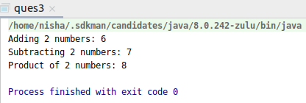

4)Create an Employee Class with instance variables (String) name, (Integer)age, (String)city and get the instance of the Class using constructor reference
interface emp {
Employees display(String name, int age, String city);
}
class Employees {
String name;
String city;
int age;
Employees(String name, int age, String city) {
this.name = name;
this.age = age;
this.city = city;
}
public String getName() {
return name;
}
public void setName(String name) {
this.name = name;
}
public String getCity() {
return city;
}
public void setCity(String city) {
this.city = city;
}
public int getAge() {
return age;
}
public void setAge(int age) {
this.age = age;
}
@Override
public String toString() {
return "Employees{" +
"name='" + name + '\'' +
", city='" + city + '\'' +
", age=" + age +
'}';
}
}
public class ques4 {
public static void main(String[] args) {
Employees employee1;
emp emp1 = Employees::new;
employee1 = emp1.display("Nisha", 22, "Delhi");
System.out.println(employee1);
}
}

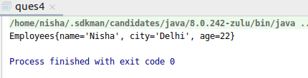

5)Implement following functional interfaces from java.util.function using lambdas:
(a) Consumer
(b) Supplier
(c) Predicate
(d) Function

import java.util.function.Consumer;
import java.util.function.Function;
import java.util.function.Predicate;
import java.util.function.Supplier;
public class ques5 {
public static void main(String args[]) {
Consumer consume = (e) -> {
System.out.println(e);
};
Supplier supply = () -> {
return 20;
};
Function<Integer, Integer> function = (e) -> {
return e * 3;
};
Predicate<String> predicate = (e) -> {
return e.length() > 5;
};
System.out.print("Consumer interface consumes a value: ");
consume.accept(15);
System.out.println("Supplier returns a value: " + supply.get());
System.out.println("Function...Triple the given value: " + function.apply(4));
System.out.println("Predicate...Check if string length is greater than 5: " + predicate.test("greater"));
}
}

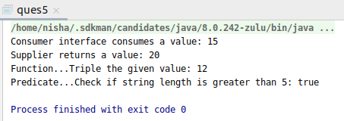

6)Create and access default and static method of an interface.
interface myInterface {
public void method1(String s1);
default void display() {
System.out.println("This is a default method");
}
}
public class ques6B implements myInterface {
@Override
public void method1(String s1) {
System.out.println(s1);
}
public static void main(String args[]) {
ques6B obj1 = new ques6B();
obj1.method1("Called method 1");
obj1.display();
}
}
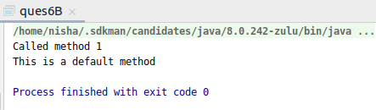

7)Override the default method of the interface.
interface myInterface1 {
default void display() {
System.out.println("This is a default method of first interface");
}
}
interface myInterface2 {
default void display() {
System.out.println("This is a default method of second interface");
}
}
public class ques7 implements myInterface1,myInterface2 {
public void display(){
myInterface1.super.display();
myInterface2.super.display();
}
public static void main(String args[]) {
ques7 obj1 = new ques7();
obj1.display();
}
}
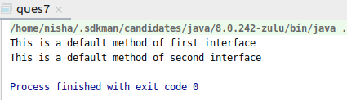

8)Implement multiple inheritance with default method inside interface.
interface first{
default void show(){
System.out.println("First method show");
}
default void greet(){
System.out.println("First method greet");
}
}
interface second{
default void display(){
System.out.println("Second method display");
}
default void greet(){
System.out.println("Second method greet");
}
}
public class ques8 implements first,second{
public void greet(){
first.super.greet();
second.super.greet();
}
public static void main(String args[]){
ques8 q1 = new ques8();
q1.show();
q1.greet();
q1.display();
}
}
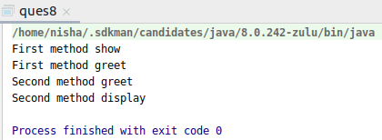

9)Collect all the even numbers from an integer list.
import java.util.Arrays;
import java.util.List;
public class ques9 {
public static void main(String args[]){
List<Integer> list = Arrays.asList(1,2,3,4,5,6,7,8);
System.out.println("Even numbers from list are: ");
list
.stream()
.filter(e->e%2==0)
.forEach(System.out::println);
}
}
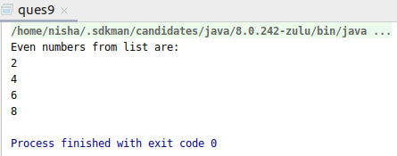

10) Sum all the numbers greater than 5 in the integer list.
import java.util.Arrays;
import java.util.List;
import java.util.stream.Collectors;
public class ques10 {
public static void main(String args[]) {
List<Integer> list = Arrays.asList(1, 2, 3, 4, 5, 6, 7, 8);
System.out.println("Sum of element greater than 5 is: ");
System.out.println(
list
.stream()
.filter(e -> e > 5)
.collect(Collectors.summingInt(e -> e))
);
}
}
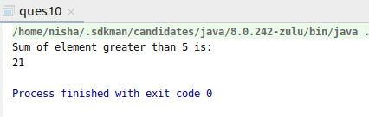

11)Find average of the number inside integer list after doubling it.
import java.util.Arrays;
import java.util.List;
import java.util.stream.Collectors;
public class ques11 {
public static void main(String args[]) {
List<Integer> list = Arrays.asList(1, 2, 3, 4);
System.out.println("Average of elements after doubling them is: ");
System.out.println(
list
.stream()
.map(e -> e * 2)
.mapToInt(e -> e).average()
.orElse(-1)
);
}
}
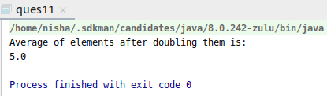

12)Find the first even number in the integer list which is greater than 3.
import java.util.Arrays;
import java.util.List;
public class ques12 {
public static void main(String args[]) {
List<Integer> list = Arrays.asList(1, 2, 3, 4, 5, 6);
System.out.println("First even number greater than 3 is: ");
System.out.println(
list
.stream()
.filter(e -> e > 3)
.filter(e -> e % 2 == 0)
.findFirst()
.orElse(-1)
);
}
}
