1) One of the fields on a form contains a text box which accepts numeric values in the range of 18 to 25. Identify the invalid Equivalence class.
a) 17
b) 19
c) 24
d) 21

Ans. a) 17

2) Input Box should accept the Number 1 to 10. Identify Equivalence partitioning and Boundary values for testing
Ans. Equivalence Partitioning:
Partition 1:Values less than 1 (0) - Invalid
Partition 2:Values between the range (1-10) - Valid
Partition 3:Values above 10 (11-99) – Invalid
Partition 4:Any value having 3 digits(100) - Invalid
In equivalence partitioning we select only one value from every partition for testing.If one value passes then all other values of partition will also pass and vice versa.

Boundary values:
Partition 1:Values less than 1 (0) - Invalid
Partition 2:Values between the range (1-10) - Valid
Partition 3:Values above 10 (11-99) - Invalid
Partition 4:Any value having 3 digits(100 and above) – Invalid
In boundary value analysis we test the boundaries between the partitions instead of checking only one value from each partition.Values used will be 0,1,10,11,99,100.

3) Why Equivalence & Boundary Analysis Testing is used?
Ans. Equivalence Partitioning:
In this the input domain is partitioned into various equivalence classes to reduce the number of test cases.The partitions are valid and invalid values.We test one values from every partition and if that value passes then all other will also pass.

Boundary Value Analysis:
This is used to test boundary values between extreme ends or boundaries between partitions of input values.Input values selected are: Minimum,min+1,nominal,max-1,maximum value.

4) Write Test Cases For This Scenario:
If A Job Fails It Should Get Restarted Again. This Should Happen For Three Times. If It Fails again, then it should quit

https://docs.google.com/spreadsheets/d/1Ujrlx9ebN3kYhmRJcQMsmYzDFt_IY7OVZf5eHzgWTNc/edit?usp=sharing

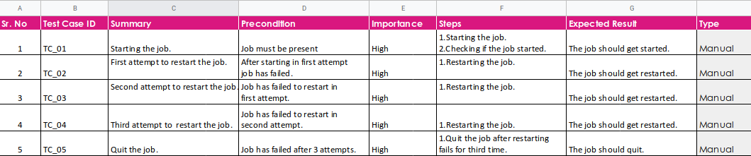

5) Write The Test Case/scenario For A Login Page?
https://docs.google.com/spreadsheets/d/1LOiX5cYiDQJrwRx0qXyfFANekHxOGPiWPpgZxLEj6Ps/edit?usp=sharing
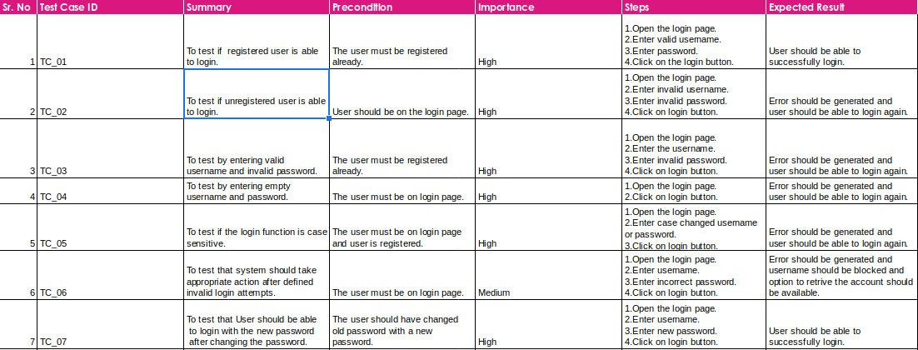
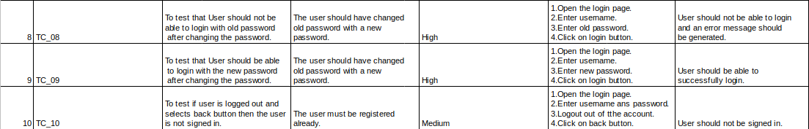

6) What Are The Test Cases/scenario For Mouse? (To verify the functionalities of a mouse)
https://docs.google.com/spreadsheets/d/1nnPoV8dLAsTr2xXPWwAdbzbp3IjI9jXRC15cuXevgIw/edit?usp=sharing
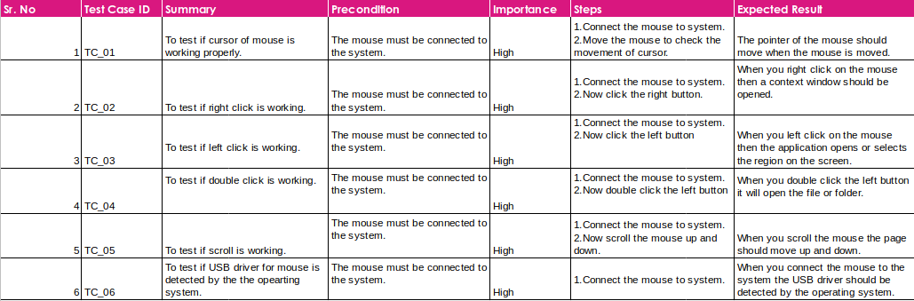

7) Write test cases/scenarios to verify the functionality of a printer?
https://docs.google.com/spreadsheets/d/1U-u2ve9r2weLtU7IVk7E2Nqdl7G2QpYdwxAuVXgcJCU/edit?usp=sharing
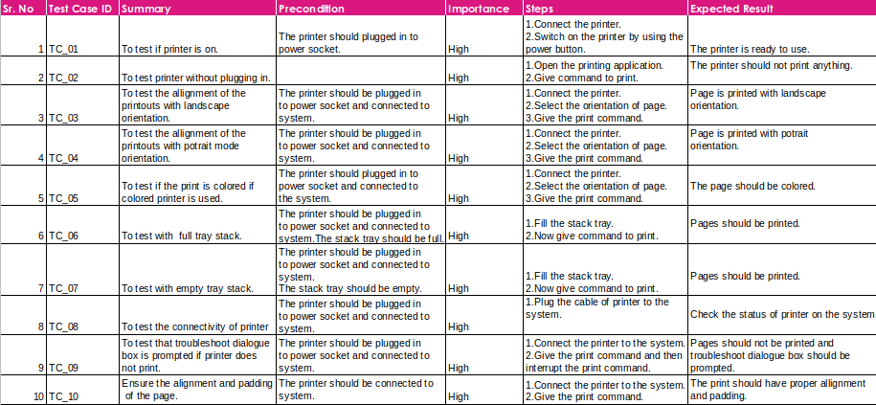

8) Write down test case/scenarios to list down possible steps to test a smart phone.
https://docs.google.com/spreadsheets/d/154dhISOMYEvSk6QmoLt2TQR-1WuxQfmTDO52_0ZQECo/edit?usp=sharing
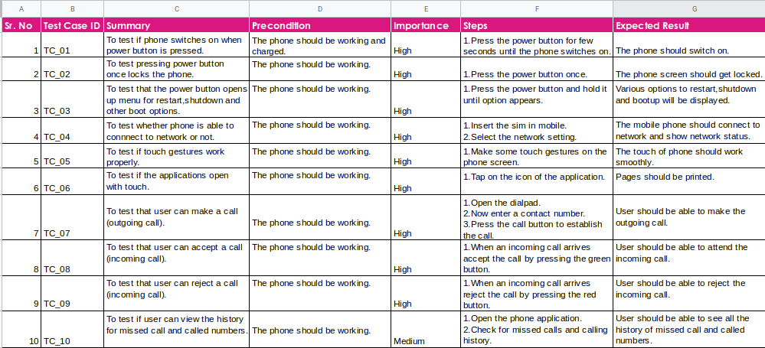
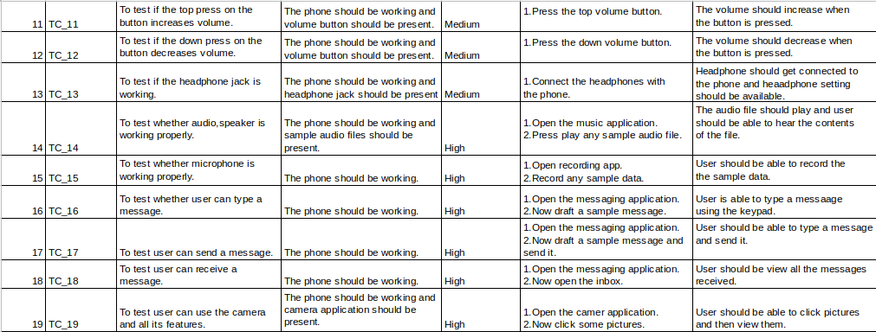

9) There is a text box which accepts numbers from 1-10. List down the test data which needs to be tested for Boundary value analysis.
Ans.Partition 1:Values less than 1 (0) - Invalid
Partition 2:Values between the range (1-10) - Valid
Partition 3:Values above 10 (11-99) - Invalid
Partition 4:Any value having 3 digits(100 and above) – Invalid
In boundary value analysis we test the boundaries between the partitions instead of checking only one value from each partition.Values used will be 0,1,10,11,99,100.

10) Suppose you have a bank account that offers variable interest rates:
5% for the first $1000 credit;
10% for the next $1000;
And 15% for the rest.
If you wanted to check that the bank was handling your account correctly what valid input partitions might you use?

Partition | Valid/Invalid
Below 0$ | Invalid
0$-1000$ | Valid
1000$-2000$(1000 & 2000 both included) | Valid
2000$ and above(2000 not included) | Valid

11) A mail order company charges $2.95 postage for deliveries if the package weighs less than 2 kg, $3.95 if the package weighs 2 kg or more but less than 5 kg, and $5 for packages weighing 5 kg or more.
Generate a set of valid test cases using equivalence partitioning.
Class | Test Case | Valid/Invalid
Below 0 kg | -4kg | Invalid
0kg - 2kg | 1kg | Valid
2kg - 5kg | 3.5kg | Valid
5kg and above | 9kg | Valid

12) Boiling point of water is at 100 degrees Celsius. Determine the boundary values.
Ans. The boiling point of water is 100 so the boundary values will be:
99,100,101

13) Exam pass – for 40 marks; merit at 60 and above; and distinction at 80 and above.
Determine the boundary values
Ans. There will be three boundary values
Pass: 39,40,41
Merit: 59,60,61
Distinction:79,80,81

14) Order numbers on a stock control system can range between 10000 and 99999 inclusive. Which of the following inputs might be a result of designing tests for only valid equivalence classes and valid boundaries:
a) 1000, 5000, 99999
b) 9999, 50000, 100000
c) 10000, 50000, 99999
d) 10000, 99999
e) 9999, 10000, 50000, 99999, 100000
Ans. c) 10000, 50000, 99999

15) A program validates a numeric field as follows:
Values less than 10 are rejected, values between 10 and 21 are accepted, values greater than or equal to 22 are rejected which of the following input values cover all of the equivalence partitions?
a.10,11,21
b.3,20,21
c.3,10,22
d.10,21,22

Ans. C) 3,10,22

16) Which test cases are written first: white boxes or black boxes?
Ususally black box tests are written first as for these tests we need the design document and requirement document and all these are available at the start of the project.
White box testing is done by the developer who wrote the code.It can not be done in initial phase of the project because it needs more architecture clarity.

17) Can you explain requirement traceability and its importance?
RTM is a document that maps and traces user requirements with test cases.Main aim of this is that all test cases are covered so that no functionality should miss while doing software testing.
Purpose of RTM:
- It helps to link the requirements,test cases and defects accurately.
- To check if test cases are written for every requirement.
- To determine which test cases are written for which requirements.
- It determines the product stability.
- Defect Leakages are prevented as a whole of the application is tested for its requirements.

RTM is of three types:
1. Forward traceability
2. Backward traceability
3. Bi-directional traceability

