1. Prompt for amount, interest rate and no. of years and calculate simple interest.
<!DOCTYPE html>
<html>
<head>
<title>Simple Interest Calculate</title>
</head>
<body>
<script>
var amt,rate,time,simple_interest;
amt=(prompt("Enter the amount: "));
rate=(prompt("Enter the rate: "));
time=(prompt("Enter the time: "));
simple_interest=(amt*rate*time)/100;
document.write("Annual Simple Interest is: "+simple_interest);
</script>
</body>
</html>
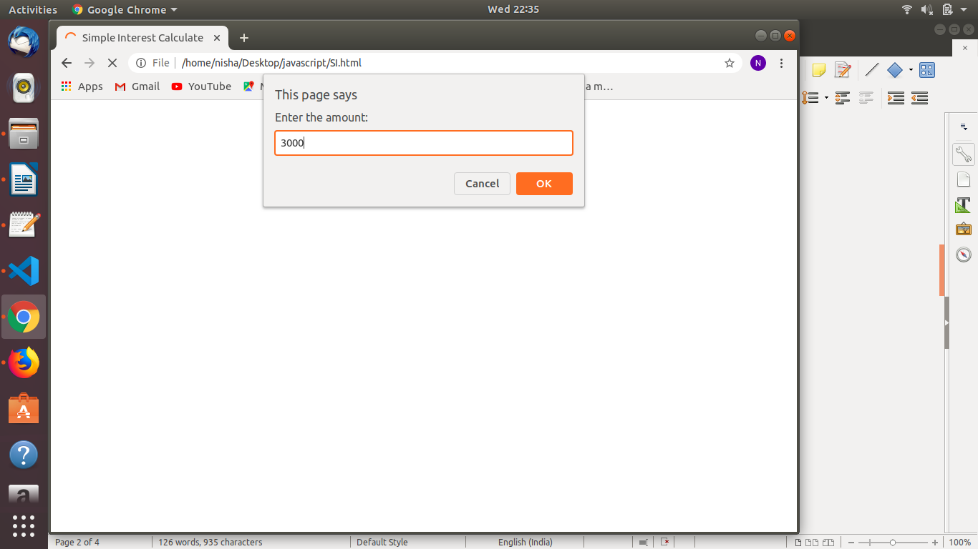

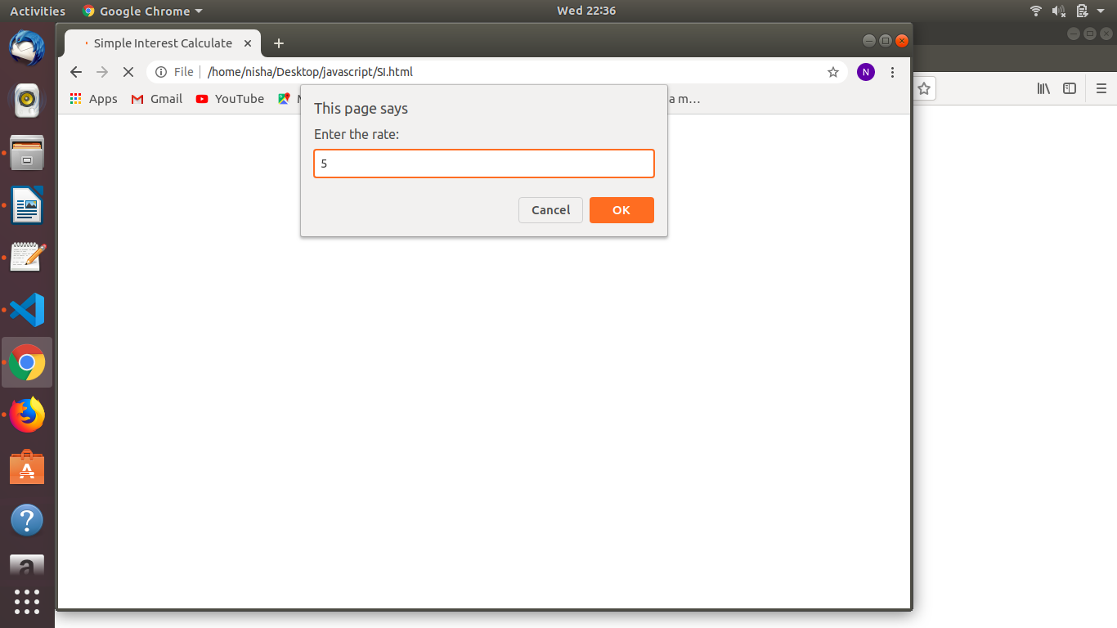

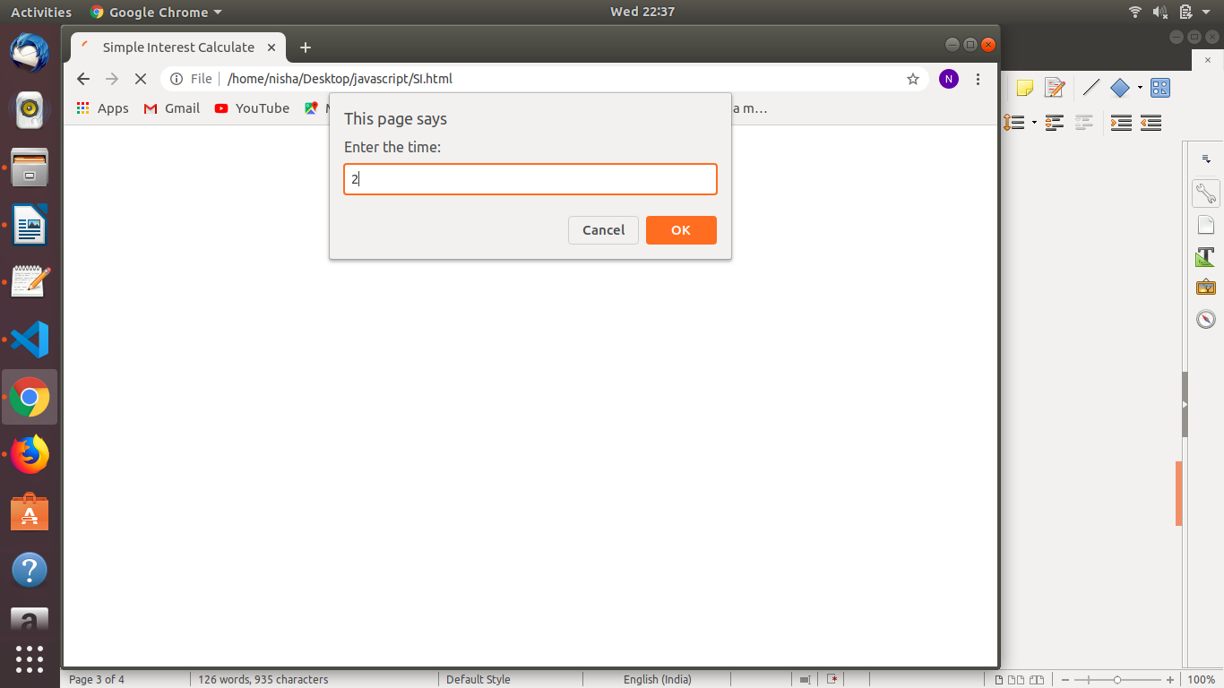



2. Is palindrome string
<!DOCTYPE html>
<html>
<head>
<title>String is palindrome or not</title>
</head>
<body>
<script>
function isPalindrome(str){
str = str.toLowerCase();
var temp="";
for(var i=str.length-1;i>=0;i--){
temp=temp+str[i];
}
if(str==temp)
document.write(str+ " string is a palindrome<br><br>");
else
document.write(str+" is not a palindrome");
}
isPalindrome("racecar");
isPalindrome("nitin");
isPalindrome("hello");
</script>
</body>
</html>
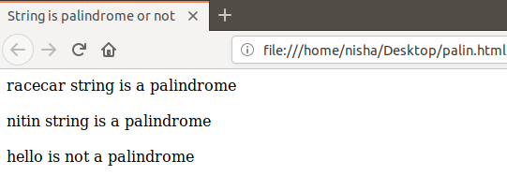

3. Area of circle
<!DOCTYPE html>
<html>
<head>
<title>Area of circle</title>
<script>
var pi=3.14,radius,area;
radius=parseInt(prompt("Please enter the radius of circle: "));
area=pi*radius*radius;
document.write("Area of circle is: "+area);
</script>
</head>
</html>
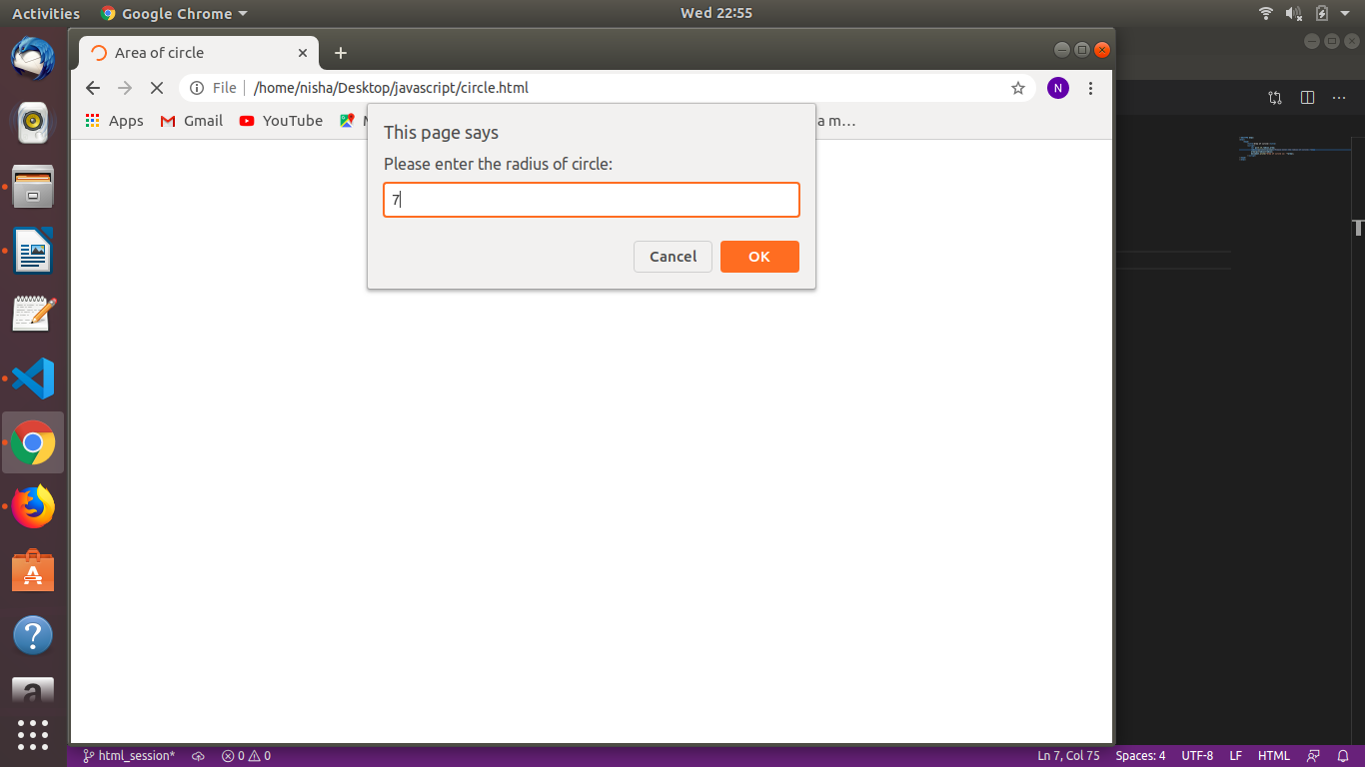



4.Copy information of one object to another and log it to console.
<!DOCTYPE html>
<html>
<head>
<title>Copying object</title>
<script>
var original_object={
a:"hello",
b:"welcome"
};
var object_copy = original_object;
document.write("Original object 'a' output: "+original_object.a);
document.write("<br>Original object 'b' output: "+original_object.b);
document.write("<br><br>Output of copy object 'a': "+object_copy.a);
document.write("<br>Output of copy object 'b': "+object_copy.b);
</script>
</head>
</html>
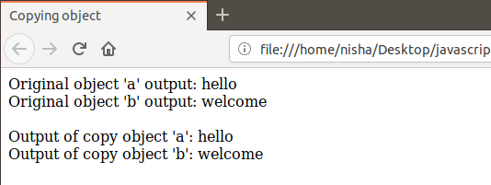

5. create a list of objects of Employee with info as follow :
<!DOCTYPE html>
<html>
<head>
<title>List of Employees</title>
<script src="https://cdnjs.cloudflare.com/ajax/libs/underscore.js/1.9.1/underscore.js">
</script>
<script>
var employee=[
{name: "Neha", age:22,salary:400,dateOfBirth:"21-03-1996"},
{name: "Akshita", age:23,salary:50000,dateOfBirth:"25-08-1996"},
{name: "Prabhat", age:22,salary:450,dateOfBirth:"16-05-1995"},
{name: "Drishti", age:22,salary:60000,dateOfBirth:"11-03-1995"},
];
console.log(employee);
var emps=employee.filter(function(items){
return (items.salary>=5000);
});
console.log(emps);

var bonus=employee.filter(function(items){
return (items.salary<1000 && items.age>20)
});

console.log(bonus);

var result = bonus.map(x=>{x.salary;
var arr={};
arr[x.salary]=x.salary*5;
return arr;
});
console.log(result);

var group = _.groupBy(employee,function(emp){
return emp.age;
});
console.log(group);
</script>
</head>
</html>

  - Name, age, salary ,DOB
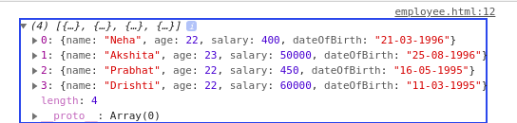

  - filter all employees with salary greater than 5000
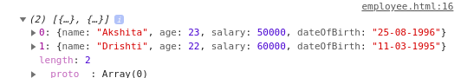

  - group employee on the basis of their age
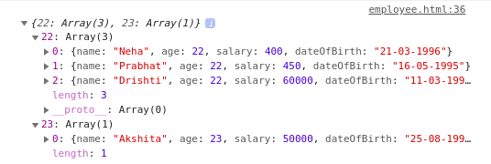

  - fetch employees with salary less than 1000 and age greater than 20. Then give them an increment 5 times their salary.
