1.How are inline and block elements different from each other?
Block Level Elements
A block-level element is an HTML element that begins a new line on a web page and extends the full width of the available horizontal space. It creates large blocks of content like paragraphs or page divisions. Most HTML elements are block-level elements.
Block-level elements are used within the HTML document's body. They can contain inline elements, as well as other block-level elements.
Example of block level elements are:<div>,<form>,<h1> <h6>,<p>,<ol> etc.
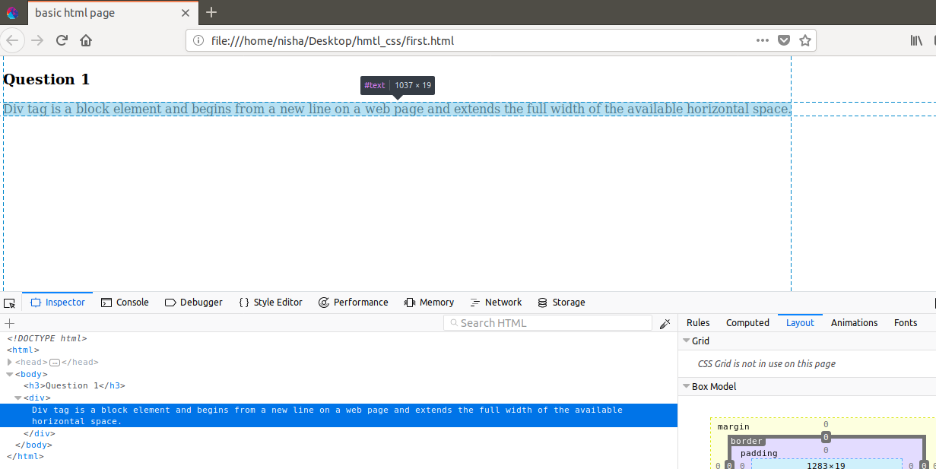

Inline Elements:
Inline element begin within a line and it does not start within a new line.It only takes necessary width .Its width only extends as far as it is defined by its tags.Example of inline element is the <strong>, which makes the font of the text content contained within boldface.
Example:
<style> ,<meta> ,<head>,<span> etc.

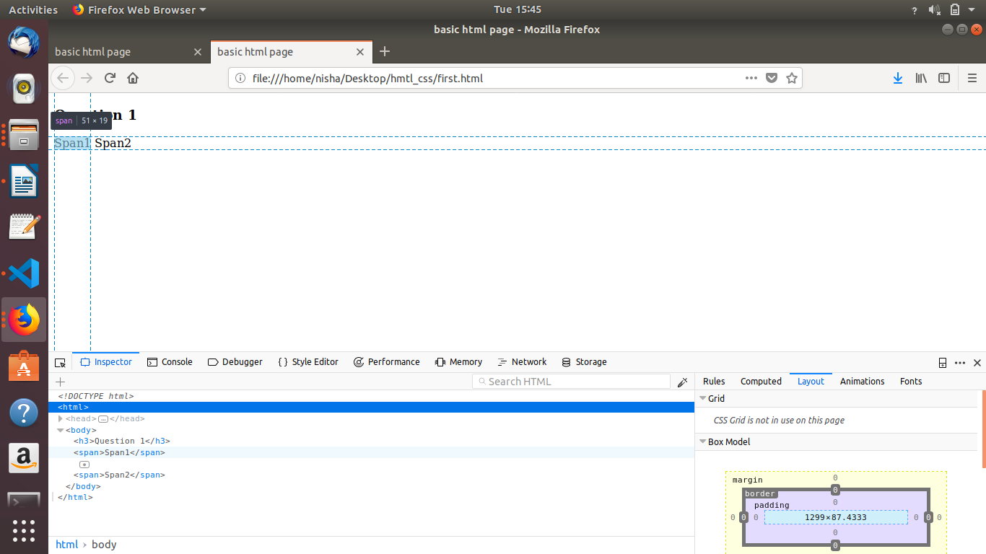
2.Explain the difference between visibility:hidden and display:none

display:none :Hiding an element can be done by setting the display property to none. The element will be hidden, and the page will be displayed as if the element is not there.
Visbility:hidden : also hides an element.However, the element will still take up the same space as before. The element will be hidden, but still affect the layout:

<!DOCTYPE html>
<html>
<head>
</head>
<body>
<p>Heading is hidden as display:none.</p>
<h1 style="display:none">This is a heading.</h1>
<p>Next heading is also hidden by using visibility:hiddden</p>
<h1 style="visibility:hidden">This is a hidden heading using visibility:hidden</h1>
</body>
</html>
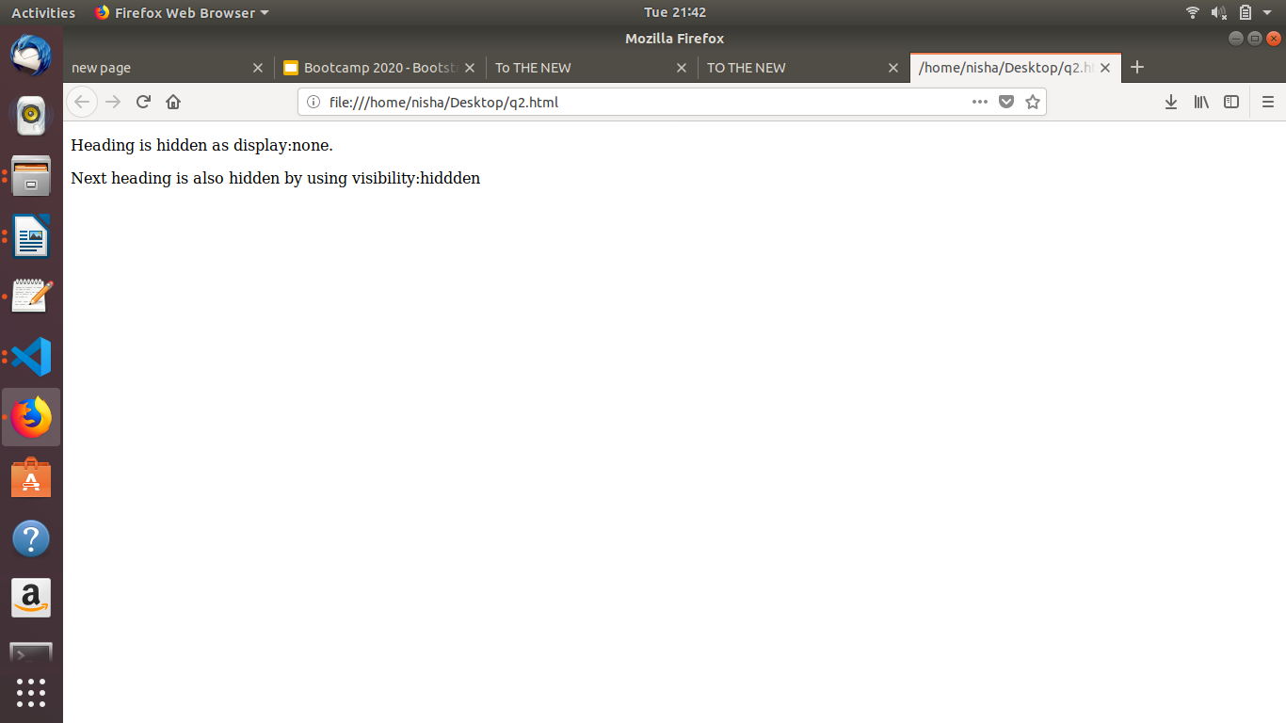

3. Explain the clear and float properties.

Float property: The float property is used for positioning and formatting content e.g. let an image float left to the text in a container. In its simplest use, the float property can be used to wrap text around images.

Clear Property: The clear property specifies what elements can float beside the cleared element and on which side.When clearing floats, you should match the clear to the float: If an element is floated to the left, then you should clear to the left. Your floated element will continue to float, but the cleared element will appear below it on the web page.

Q3.html:
<!DOCTYPE html>
<html>
<head>
<link rel="stylesheet" href="style.css">
<title>FLoat and clear</title>
</head>
<body>
<section>
<div class="left">1</div>
<p>Lorem ipsum dolor sit amet, consectetur adipiscing elit. Morbi tristique sapien ac erat tincidunt, sit amet dignissim lectus vulputate. Donec id iaculis velit. Aliquam vel malesuada erat. Praesent non magna ac massa aliquet tincidun vel in massa. Phasellus feugiat est vel leo finibus congue.</p>
</section>
</body>
</html>

style.css:
section {
border: 1px solid blue;
width: 100%;
float: left;
}
div {
margin: 5px;
width: 100px;
height: 100px;}
.left {
float: left;
background:yellowgreen;
}
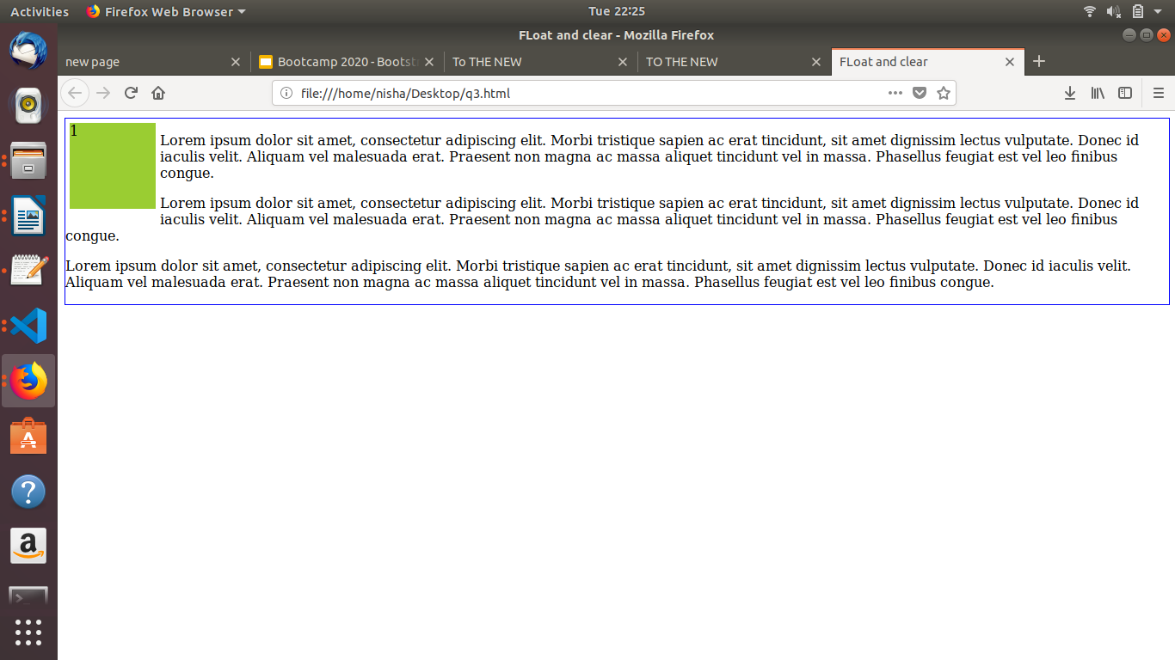

4. explain difference between absolute, relative,fixed and static.

Static : HTML elements are positioned static by default.Static positioned elements are not affected by the top, bottom, left, and right properties.An element with position: static; is not positioned in any special way; it is always positioned according to the normal flow of the page.

Relative: An element with position: relative; is positioned relative to its normal position.Setting the top, right, bottom, and left properties of a relatively-positioned element will cause it to be adjusted away from its normal position. Other content will not be adjusted to fit into any gap left by the element.

Fixed:An element with position: fixed; is positioned relative to the viewport, which means it always stays in the same place even if the page is scrolled. The top, right, bottom, and left properties are used to position the element.A fixed element does not leave a gap in the page where it would normally have been located.

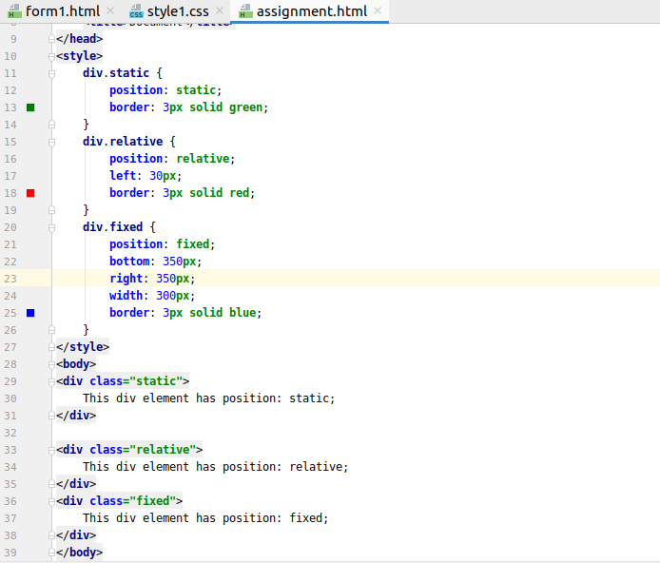
Absolute:An element with position: absolute; is positioned relative to the nearest positioned ancestor (instead of positioned relative to the viewport, like fixed).However; if an absolute positioned element has no positioned ancestors, it uses the document body, and moves along with page scrolling.

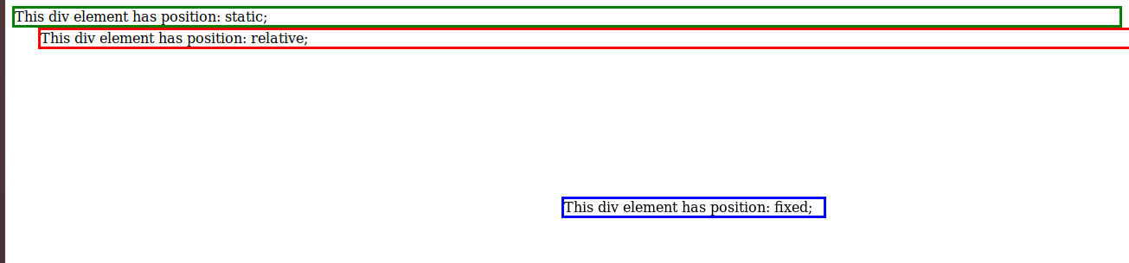
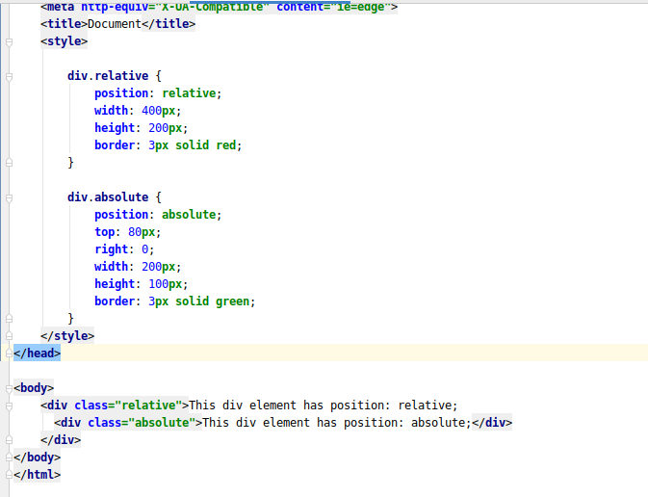

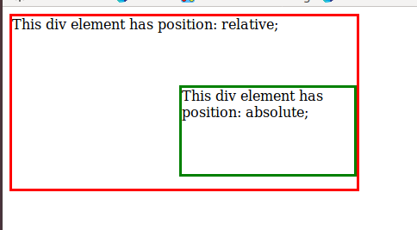

5. Write the HTML code to create a table in which there are 4 columns( ID , Employee Name, Designation, Department) and at least 6 rows. Also do some styling to it.
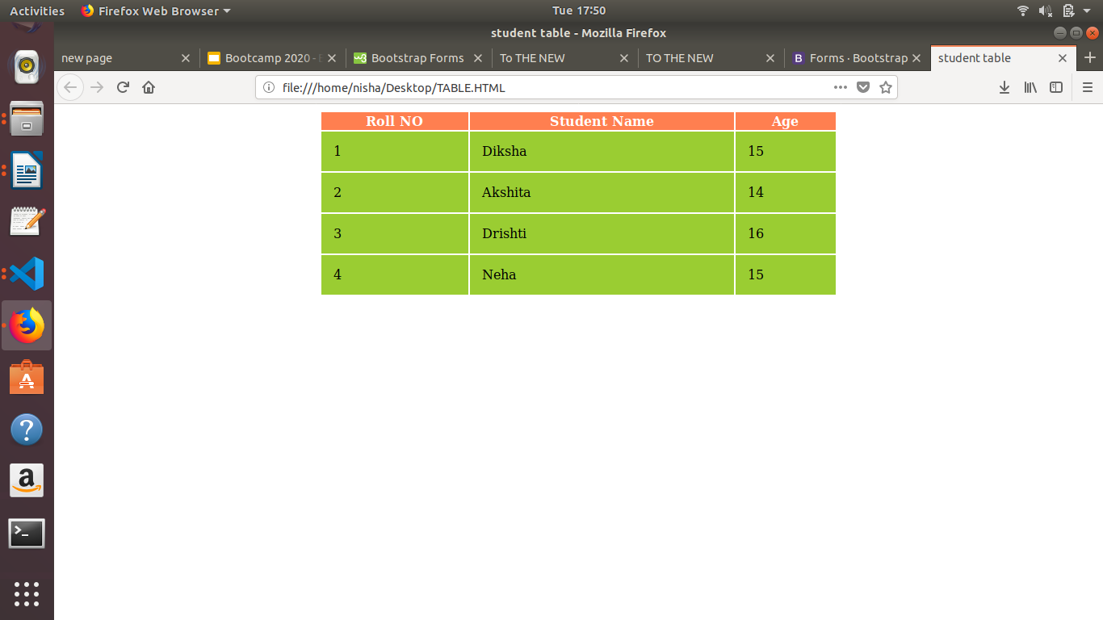
<!DOCTYPE html>
<html>
<head>
<title>student table</title>
<style>
table{
width: 50%;
margin: auto;
border: 2px blueviolet;
}
th{
background-color: coral;
color: white;
}
td{
background-color: yellowgreen;
padding: 15px;
}
</style>
</head>

<body>
<table>
<tr>
<th>Roll NO</th>
<th>Student Name</th>
<th>Age</th>
</tr>
<tr>
<td>1</td>
<td>Diksha</td>
<td>15</td>
</tr>
<tr>
<td>2</td>
<td>Akshita</td>
<td>14</td>
</tr>
<tr>
<td>3</td>
<td>Drishti</td>
<td>16</td>
</tr>
<tr>
<td>4</td>
<td>Neha</td>
<td>15</td>
</tr>
</table>
</html>

6. Why do we use meta tags?
Metadata is data (information) about data.
The <meta> tag provides metadata about the HTML document. Metadata will not be displayed on the page, but will be machine parsable.
Meta elements are typically used to specify page description, keywords, author of the document, last modified, and other metadata.
he metadata can be used by browsers (how to display content or reload page), search engines (keywords), or other web services.
HTML5 introduced a method to let web designers take control over the viewport (the user's visible area of a web page), through the <meta> tag .
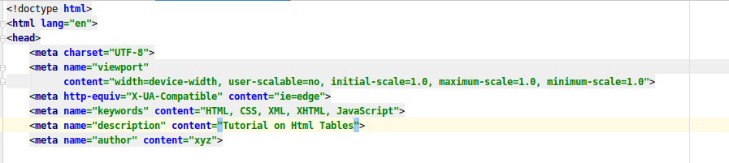

7. Explain box model.
The CSS box model is essentially a box that wraps around every HTML element. It consists of: margins, borders, padding, and the actual content.
- Content - The content of the box, where text and images appear
- Padding - Clears an area around the content. The padding is transparent
- Border - A border that goes around the padding and content
- Margin - Clears an area outside the border. The margin is transparent
The box model allows us to add a border around elements, and to define space between elements.

8. What are the different types of CSS Selectors?
a) element selector: the element selector selects HTML elements based on the element name.
b) id selector: The id selector uses the id attribute of an HTML element to select a specific element.
c) class selector : The class selector selects HTML elements with a specific class attribute.
d) grouping selector : The grouping selector selects all the HTML elements with the same style definitions.
e)Universal Selector :The universal selector (*) selects all HTML elements on the page.
<!DOCTYPE html>
<html>
<head>
<title>question 8</title>
<style>
p{
text-align: center;
background-color: mediumblue;
}
div{
background-color: coral;
margin: auto;
}
h3{
background-color: lawngreen;
}
*{
background-color: grey;
}
#para{
font-size: 14px;
}
.line{
background-color: peru;
margin-left: 30px;
}
</style>
<body>
<p>This is first paragraph.</p>
<h3>Initial Heading </h3>
<div>The element selector selects HTML elements based on the element name.
The id selector uses the id attribute of an HTML element to select a specific element.</div>
<p id="para">This is another paragraph.</p>
<div classs="line">another division is addded</div>
</body>
</head>
</html>
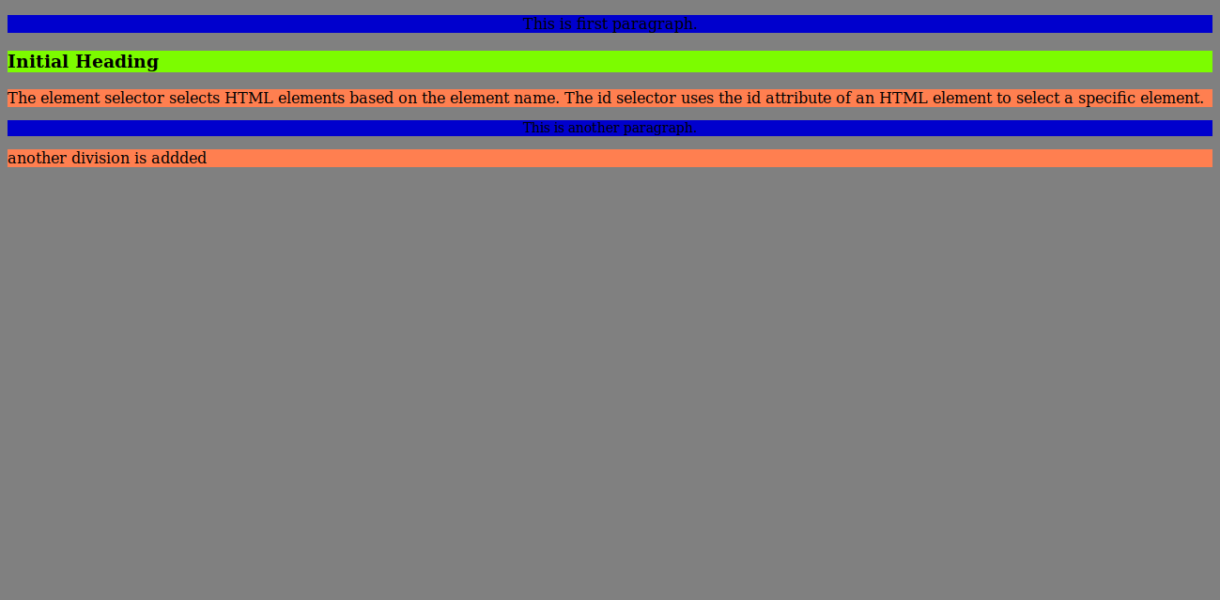

9. Define Doctype.
The <!DOCTYPE> declaration represents the document type, and helps browsers to display web pages correctly.It is the information that tells web browser about the markup language in which the current page is written.It must only appear once, at the top of the page (before any HTML tags).It tells the browser about the version of or standard of HTML used in the document.The <DOCTYPE> declaration is not case sensitive.

10. Explain 5 HTML5 semantic tags.
<section>: The <section> element defines a section in a document.
<article>: The <article> element specifies independent, self-contained content.An article should make sense on its own, and it should be possible to read it independently from the rest of the web site.
<header>: The <header> element specifies a header for a document or section.The <header> element should be used as a container for introductory content.
<footer>: The <footer> element specifies a footer for a document or section.A <footer> element should contain information about its containing element.A footer typically contains the author of the document, copyright information, links to terms of use, contact information, etc.
<nav>: The <nav> element defines a set of navigation links.
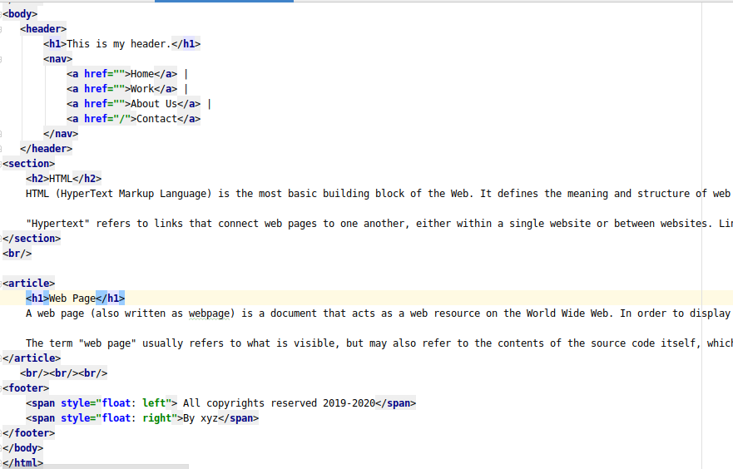
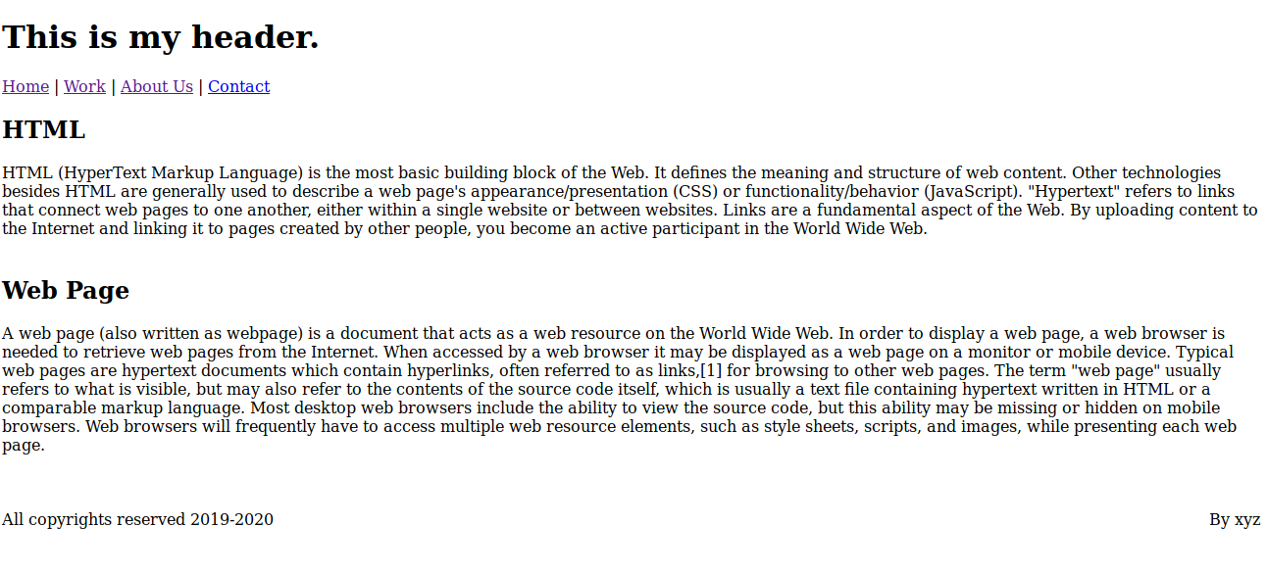

11. Create HTML for web-page.jpg (check resources, highest weightage for answers)
q11.html:
<!DOCTYPE html>
<html>
<head>
<title>Page 11</title>
<link rel="stylesheet" type="text/css" href="page11.css"/>
<div id="head">
<h1 id="ttn" style="color: white;">TO The New</h1>
<style>
<body>
<div id="body">
<ul>
<li><a class="active" href="#home">Test link</a></li>
<li><a href="#news">Test link</a></li>
<li><a href="#contact">Test link</a></li>
<li><a href="#about">Test link</a></li>
</ul>
</style>
</head>
<div id="outer">
<div class="main">
<div id ="imge"><img src="one.jpg"></div>
<div id="para"><p>Hypertext Markup Language (HTML) is the standard markup language for documents designed to be displayed in a web
browser.It can be assisted by technologies such as CSS and scripting languages such as JavaScript.</p> </div>
<p id=para_head> <strong>SOME SAMPLE PICTURES</strong></p>
<hr id='line'>
<div id="flex">
<div>
<img src="rsz_eat.jpg" height="315px" width="215px">
<p style="text-align: center;">Eat</p></div>
<div><img src="sleep.jpg" height="315px" width="215px">
<p style="text-align: center;">Sleep</p></div>
<div><img src="study.jpg" height="315px" width="215px">
<p style="text-align: center;">Play</p></div>
<div><img src="r.jpg" height="315px" width="215px">
<p style="text-align: center;">Repeat</p></div>
</div> <br>
</div>
</div>
<div id="footer">
<span id="span1">Copyright © 2009-2020 - All Rights Reserved - To The New</span>
<span id="span2">Web Desing By To The New</span>
</div>
</div>
</body>
</html>

q11.css:
body{
background-color:grey;
}
#head{
margin:20px;
margin-top: 0px;
margin-left: 5%;
background-color:black;
width: 90%;
}
#ttn{
margin-left: 55px;
}
ul {
list-style-type: none;
margin: 30px;
padding: 0;
}

li {
display: inline;
}
ul {
list-style-type: none;
margin-left: 55px;
width: 84%;
padding: 1px;
overflow: hidden;
background-color: #333;
}
li {
float: left;
}
li a {
display: block;
color: white;
text-align: center;
padding: 14px 16px;
text-decoration: none;
}
li a:hover {
background-color: #111;
}
#imge{
margin-left: 55px;
padding: 8px;
margin-right: 20px;
margin-top: 25px;
width: 960px;
height: 360px;
}
#para{
background-color:grey;
margin-top:20px;
margin-left: 55px;
margin-right: 20px;
margin-top: 25px;
padding: 25px;
color:black;
width:920px;
height: 30px;
}
#flex{
display: flex;
flex-wrap: wrap;
margin-top:20px;
margin-left: 40px;
}
#flex > div{
background-color:grey;
margin: 17px;
}
#line{
color: gray;
margin-left: 60px;
width:960px;
}

#para_head{
margin-left: 60px;
margin-top: 40px;
}
#main{
background-color:red;
width: 95%;
margin-top: 20px;
padding: 20px;
}

#outer{
background-color: white;
width: 100%;
margin-left:0px;
margin-right: 5%;
}
#footer {
position: fixed;
bottom: 0;
width: 87.5%;
margin-left: 70px;
background-color: rgb(0, 0, 0);
color: white;
padding: 10px;
text-align: center;
}
#span1{
float: left;
}
#span2{
float: right;
}

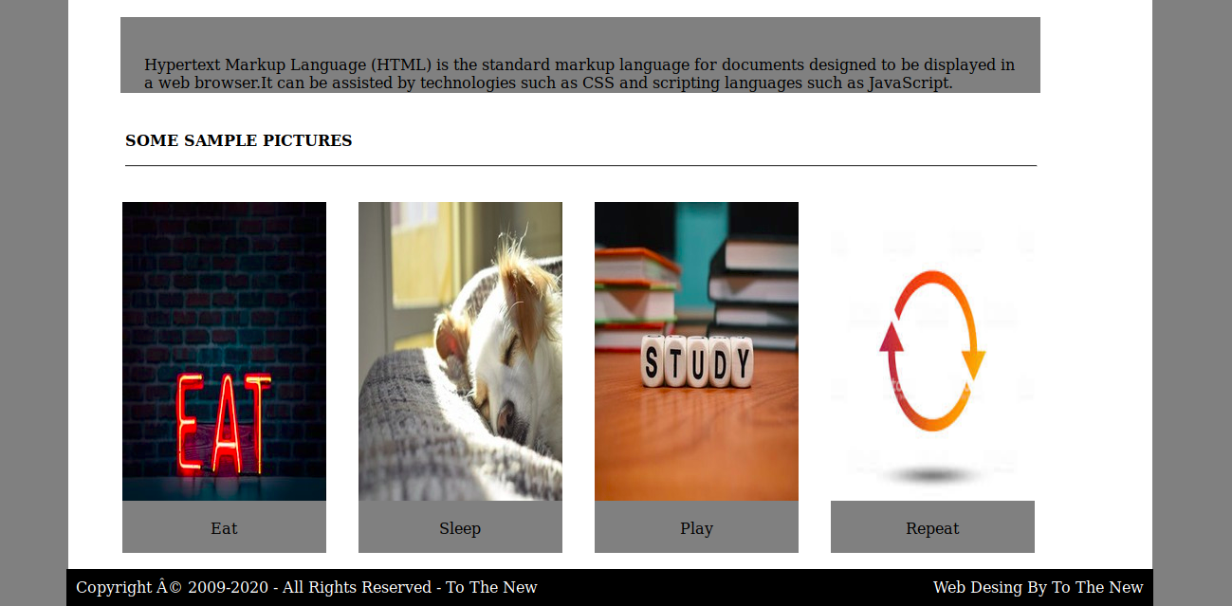
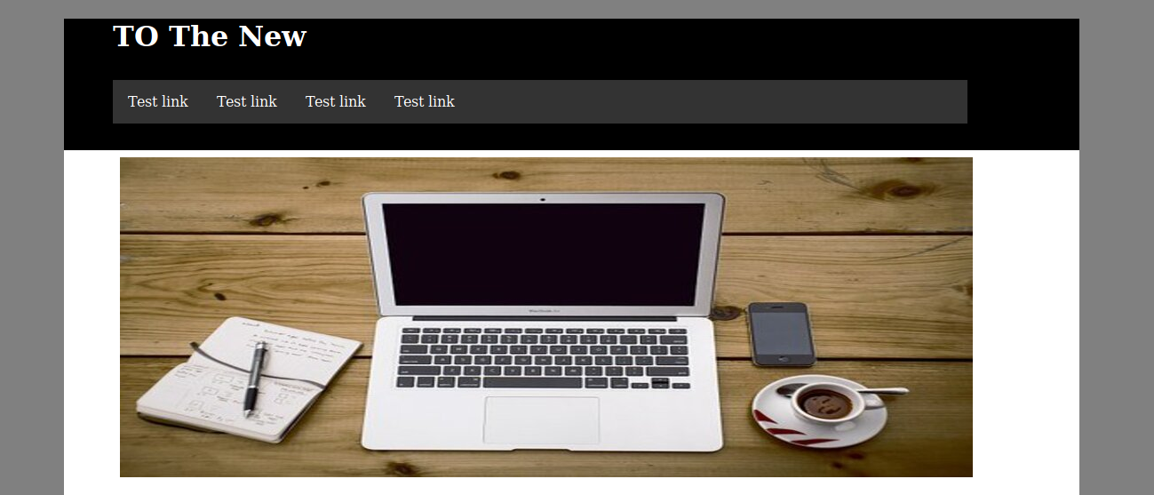

12. Create HTML for form.png (check resources, highest weightage for answers)
q12.html
<!DOCTYPE html>
<html>
<head>
<meta charset="UTF-8">
<meta name="viewport"
content="width=device-width, user-scalable=no, initial-scale=1.0, maximum-scale=1.0, minimum-scale=1.0">
<meta http-equiv="X-UA-Compatible" content="ie=edge">
<link rel="stylesheet" href="q12.css">
<title>To THE NEW</title>
</head>
<body>
<div id="head">
<span>TO THE NEW</span>
<div id="nav">
<ul>
<li>Quick Help</li>
<li> Home</li>
</ul>
</div>
<h3>Bug Report</h3>
<form class="flex_work"method="post" action="#">
<label>
Title*:
</label>
<input type="text" required>
<label>
Description:
</label>
<textarea name="message" rows="5" cols="20" required></textarea>
<label>
Operating System:
</label>
<select name="Operating System">
<option class="select" value="Windows XP">Windows XP</option>
<option class="select" value="Windows 7">Windows 7</option>
<option class="select" value="Linux">Linux</option>
<option class="select" value="Mac ">Mac</option>
</select>
<label>
Product:
</label>
<select name="Product">
<option value="Windows XP">Laptop</option>
<option value="Windows 7">VS code</option>
<option value="Windows 10">Web Storm</option>
</select>
<label>
Version:
</label>
<input type="number" name="version" min="1" max="2">
<label>
License:
</label>
<fieldset>
<input type="radio" name="license" value="Free"><label>Free </label>
<input type="radio" name="license" value="Business"><label>Business </label>
</fieldset>
<label>
Severity:
</label>
<select name="Severity">
<option class="select" value="Critical">Critical</option>
<option class="select" value="Mild">Mild</option>
<option class="select" value="Moderate">Moderate</option>
</select>

<label>
Attachments:
</label>
<input type="file" name="documents" accept="file/*">
<div class="divide">
<input type="Submit" name="Send" value="Send">
</div>
</form>
<br/>
<br/>
</body>
</html>

q12.css:
*{
font-family:sans-serif;
}
body{
margin-top:20px;
}
#head{
color:#06A061;
border-bottom:0.5px solid #E7E4E4;
height:50px;
}
#head span{
font-size:20px;
color:#06A061;
}
#nav{
margin-top:-30px;
}
#nav ul li{
display:inline;
margin-left:20px;
float:right;
}
.flex_work{
display:flex;
flex-direction:column;
}
h3{
color:white;
width:30%;
padding: 15px 2.5px 15px 2.5px;
margin:auto;
margin-top:80px;
background-color: #E7E4E4;
}
form{
border:2px solid #E7E4E4;
color:black;
margin:auto;
width:30%;
}
form input,select,textarea{
margin-top:20px;
padding:5px 2px 5px 2px;
width:90%;
margin:auto;
border-radius:5px;
border:1px solid #E7E4E4;
}
form label{
font-size:14px;
margin-left:20px;
margin-top:15px;
}
input[type="radio"]{
display:inline-block;
margin-right:20px;
margin-left:-20px;
width:70px;
}
fieldset{
border:none;
}
.select,select{
background-color:#06A061;
color:white;
border:none;
font-weight:500;
}
input[type="submit"]
{
background-color:#06A061;
color:white;
width:60px;
float:right;
margin-top:25px;
}
.divide{
margin-top:5px;
height:50px;
border-radius:5px;
background-color:#E7E4E4;
}
