1.What is bug In Software Testing?
Ans. A bug is a fault in a program which causes it to behave abruptly.
An error, flaw, failure or fault in a computer program or system that causes it to produce an incorrect or unexpected result.
Bug is the outcome of coding fault and the defect which is accepted by developer is called bug.Every bug follows a life cycle.

2.Differentiate Error, Defect, And Failure?
Error:The incorrect human action that produces incorrect result is called an error or mistake.

Defect:Deviation between the expected behavior to actual behavior identified while testing is called defect.A flaw in a component or system that can cause the component or system to fail to perform its required function.

Failure:Deviation from expected behavior to actual behavior by end user in operations is failure.

3.What Are The Different Types Of Status Of Defects?

New:When the bug is found by the test and logged, its status will be new.

Open:When the bug is assigned to the development, while he is analyze the bug that time he will put the status to open.

Assign:Once the tester logs the bug, the lead validates the bug and assigns it to the development team. Then the status of the bug is set to assign.

Rejected:When the bug is in open status, and if developer feels the bug is not genuine or found to be duplicate, he can reject the bug and the status of the bug is rejected.

Retest:Once the developer fixes the bug, he changes the status to READY TO RETEST. This means developer has fix the issue and is ready for the test team to retest the defect.

Verified:Once the tester retest the bug and is found to be fixed, he changes the bug status to Verified.

Reopened:While retesting if he find the bug still exists, then he changes the bug status to reopened.

Closed:Once the bug is fixed and the status is verified. Then lead changes the status to closed.

Deferred:Sometimes the developers will accept the bug, but may be due to the priority, severity or due to time he may push the fix to other releases rather than the current release. Then the bug status will be deferred.

4.Explain About Defect/Bug Life Cycle?
Defect life cycle, also known as Bug Life cycle is the journey of a defect cycle, which a defect goes through during its lifetime. It varies from organization to organization and also from project to project as it is governed by the software testing process and also depends upon the tools used.
The purpose of the Defect life cycle is to easily coordinate bug status changes to various assignees and make the bug fixing process systematic.
New

Assigned

Duplicate
Deffered
Not a bug
Rejected

Open

Fixed

Pending
Retest

Retest
Reopened

Verified

Closed

5.A bug is identified by the tester it is assigned to whom?
Ans.The bug identified by the tester is assigned to the developer.

6.Why is JIRA used?Explain step by step how an issue is created in JIRA.
Ans. JIRA:
- It is an issue tracking product developed by Atlassian.
- It allows bug tracking and agile project management.
- It is used for bug tracking, issue tracking and project management.
Steps to create an issue in JIRA:
1. Open JIRA dashboard, after entering your login credentials.
2. Creating an issue (Issue id is generated on creating an issue.)
3. Click on Create tab on the dashboard.
4. A pop-up will open where we are required to fill in the fields with the appropriate details.
5. The fields which appear on the pop-up are as follows:
Project: Project name
Issue type: Type of the issue.
Project name: Name of your project
Summary : It can be written in the following format
[environment] [platform] [module] [device] [summary]
• environment- QE, prod, UAT
• platform: ios web
• module: module of the platform
• device: devices on module like mobile,tablet,global
• summary: summary of the bug
Priority : It is decided by the client blocker, critical, minor, trivial
Project priority: P0-P4
Description: Defect of the issue.
It can be written in the following format:
• Defect: It has been observd that.
• Steps to reproduce: (reach to that bug)
• Expected result:
Components: Components of the application
Assignee: Assign to the respective developer
Attachment: Proofs related to the bug
Steps to reproduce:
Expected Output:
Actual Outcome:
Environment:
Add watchers:
Other than developer, we can add watchers to see that issue.
Original estimate:
Remaining estimate:
Sprint: Current active sprint
Platform:
6. Then click on create to create this issue, we can also select create another
7.What is Defect Density?
Defect Density is the number of defects confirmed in software/module during a specific period of operation or development divided by the size of the software/module.
Defect density is counted per thousand lines of code known as KLOC.

Defect Density = Defect count/ size of the release

- It enables one to decide if a piece of software is ready to be released.
- It helps measure the testing effectiveness.
- It is useful in identifying the areas for correction or improvement.
- It can estimate the remaining defects in the software.
- It is useful in pointing towards high-risk components.

8.What is the difference between defect density and defect triage?

Defect Density is the number of defects confirmed in software/module during a specific period of operation or development divided by the size of the software/module.
Defect density is counted per thousand lines of code known as KLOC.

Defect Density = Defect count/ size of the release

Defect triage is a process where each bug is prioritized based on its severity, frequency, risk, etc. Triage term is used in the Software testing / QA to define the severity and priority of new defects.
The goal of Bug Triage is to evaluate, prioritize and assign the resolution of defects. The team needs to validate severities of the defect, make changes as per need, finalize resolution of the defects, and assign resources. Mainly used in agile project management.

9.Explain Bug reporting and parameters of bug?
Bug report is created by the tester.It is an important aspect of software testing.An effective bug report is useful to avoid miscommunication with the development team.A good bug report should be clear and concise without missing key points.Report each bug as a separate bug issue.A well written bug report helps developer to reproduce bug at their terminal, this helps then to diagnose the issues.

Parameters of bug:
1.Defect Id- For the bug reported an Id is provided by the testing team.
2.Priority – Priority is not decided by the tester but by the business or development team.
3.Severity –The severity is decided by the testing team.
4.Created by – Name of the tester who identified the defect.
5.Created Date – The date when the defect was created.
6.Assigned to – Name of the developer who was assigned.
7.Resolved Date – This Date decided by developer
8.Resolved By – Name of developer who resolved the bug.
9.Status – New, IT Committed, Development, Ready for QA, In-Testing, Testing Successfully Completed.
10.Project name – Current module or project Name
11.Product name – Main Product Name
12.Release Version – It specifies the version of release.
13.Module – Module Name
14.Detected Build Version – 1.1.1, 1.1.2

10.What is defect management? Explain the defect management process.
Defect Management is a systematic process to identify and fix bugs. A defect management cycle contains the following stages.
1) Discovery of Defect:
In this phase,the project teams have to identify defects for the development team acknowledgment.A defect is termed as discovered when that defect has been acknowledged as a valid defect by the development team.

2) Defect Categorization:
Defect categorization help the software developers to prioritize their tasks. That means that this kind of priority helps the developers in fixing those defects first that are highly crucial.Defect is usually categorized by the test manager as critical,high,medium and low.

3)Resolution:Work by the development team to prioritize, schedule and fix a defect, and document the resolution.This also includes notification back to the tester to ensure that the resolution is verified.

4) Verification by Testers:
After the development team fixed and reported the defect, the testing team verifies that the defects are actually resolved.
5) Defect Closure:
Once a defect has been resolved and verified, the defect is changed status as closed. If not, you have send a notice to the development to check the defect again.

6) Defect Reports at the end of project:
The management board has right to know the defect status. They must understand the defect management process to support you in this project. Therefore, you must report them the current defect situation to get feedback from them.

11.What is Test estimation? Explain Work Breakdown Structure test estimation technique with an example?
Test estimation is a management activity which approximates how long a Task would take to complete.Estimating effort for the test is one of the major and important tasks in Test Management.
Work Breakdown Structure:
1.Divide the whole project task into subtasks
2.Use the Work BreakDown structure to break out the project into 5 smaller tasks
3.After that, you can break out each task to the subtask. The purpose of this activity is create task as detailed as possible.

WBS for a bicycle:
Level 1
1. Bicycle
Level 2 bicycle is divided into modules:
1.1 Frame Set
1.2 Wheels
1.3 Braking System
1.4 Shifting System
1.5 Integration
1.6 Project Management
Level 3 each module is further divided into submodules:
1.1 Frameset
1.1.1 Frame
1.1.2 Wheels
1.1.3 Seat
1.2 Wheels
1.2.1 Front Wheels
1.2.2 Rear Wheels

12.What is test reports? What parameters are used in test reports?
Test reports is a document which contains summary of test activities and final test results.It is needed to reflect testign results in a formal way,which gives an opportunity to estimate testing results.Based on the test report,the stakeholders can evaluate the quality of the tested product and make a decision on the software release.

13.What are the test management tools?
Test management tools allow you to plan,monitor and audit your test executions.They are used to store information on how testing is to be done, plan testing activities and report the status of quality assurance activities.
The tools have different approaches to testing and thus have different sets of features. Generally they are used to maintain and plan manual testing, run or gather execution data from automated tests, manage multiple environments and to enter information about found defects. Test management tools offer the prospect of streamlining the testing process and allow quick access to data analysis, collaborative tools and easy communication across multiple project teams.Tracking of defects and project tasks are done within one application to further simplify the testing.

Features of test management tools:
1)To manage the tests (like, keeping track of the same kind of data for a given set of tests, knowing which tests need to run in a common environment, number of tests planned, written, run, passed or failed)

2)Scheduling of tests to be executed (manually or by a test execution tool)

3)Managing the testing activities (time spent in test design, test execution, whether we are on schedule or on budget)

4)Traceability of tests, test results and defects to requirements or other sources

5)To log the test results (test management tool does not run tests but could summarize results from test execution tools that the test management tool interfaces with)

6)To prepare progress reports based on metrics

14.What is a test link? How do you write test cases in TestLink?
Test-link is most widely used web based open source test management tool.It synchronizes both requirements specification and test specification together.
The user can create test project and document test cases using this tool.With Test-Link user can create an account for multiple users and assign different user roles.Admin user can manage test cases assignment task.
Test cases in TestLink:
1. Go to test case specification on the TestLink dashboard
2. Create a test suite: Suite in which test cases are written.
It contains the following fields:
Test Suit Name:
Details:
Keywords:
• Available keywords
• Assigned keywords
3. Then click on save
4. On the dashboard on the navigator the test case can be seen created
5. Go to the respective test suite
6. Click on test case operation
7. Fill in the required fields:
Enter test case title:
Summary:
Preconditions:
Status: draft, ready for review, review in progress, rework, obselete, future, final
Importance: high, low, medium
Execution type: manual or automated
Estimated time of execution:
Keywords:
• Available keywords
• Assigned keywords
8. Go to the respective test suite, the test case has been created.
9. On the dashboard, click on Test Plan Contents Add/ Remove test cases to/from
select particular test suite
10. Click on Add/ Remove test cases
11. Check/Uncheck to add all the test cases.
12. Then in test execution on the dashboard click on execute tasks to execute that particular test case.

15. Explain steps how to upload Test case sheet on TestLink?
TestLink supports XML, CVS file to import data.
It supports importing the data for test suites, test cases, requirements, test execution results.
- Steps to import test case sheet:
1. To import the test suite, go to Test Specifications from the dashboard.
2. Select the test suite where you want to import the test cases.
3. Click on the Actions icon.
4. Click on the import icon present in Test Case Operation.
5. It will open the test suite page and by default the file type selected is XML.
6. Fill in the required fields:
File: Select the XML file and upload it.
7. Click the upload file button.
8. After import, a successful message is displayed.

16.What is severity and priority in bug/defect?
Severity:
Severity is defined as the degree of impact a Defect has on the development or operation of a component application being tested.
- Higher effect on the system functionality will lead to the assignment of higher severity to the bug
- Defect severity can be categorized into four class (Blocker,Critical, Major, Minor, Trivial)
- Severity status is based on the technical aspect of the product
- Severity indicates the seriousness of the defect on the product functionality

Priority:
Priority is defined as the order in which a defect should be fixed.
- Higher the priority the sooner the defect should be resolved.
- Defects that leave the software system unusable are given higher priority over defects that cause a small functionality of the software to fail.
- Defect priority can be categorized as (Low, Medium, High)or P0,P1 and P2.
- Priority status is based on the customer requirements
17.While placing an order for clothing website, in order confirmation page there is a logo error. It is a?
a)High priority, high severity
b)Low severity low priorit
c)Low severity, high priority (of low severity as it not going to affect the functionality of the website but can be of high priority as you don't want any further shipment to proceed with the wrong logo.)
d)High severity low priority

Ans. c)Low severity, high priority (of low severity as it not going to affect the functionality of the website but can be of high priority as you don't want any further shipment to proceed with the wrong logo.)

18.Website home page failed to load.
a)High priority, high severity (Major functionality failure like log in is not working, crashes in the basic workflow of the software are the best example of High Priority and High Severity)
b)Low severity low priority
c)Low severity, high priority
d)High severity low priority

Ans. a)High priority, high severity (Major functionality failure like log in is not working, crashes in the basic workflow of the software are the best example of High Priority and High Severity)

19.The application works perfectly for 50k sessions but beings to crash after a higher number of sessions.
  - Low severity low priority
  - High priority, high severity
  - Low severity, high priority
  - High severity low priority (This problem needs to be fixed but not immediately.)

Ans. d)High severity low priority (This problem needs to be fixed but not immediately.)

20.An application (web) is made up of 20 pages. On one of the pages, there is a sentence with a grammatical error.
a)Low severity low priority - This bug may go unnoticed to the eyes of many and won't affect any functionality or the credibility of the company.
b)High priority, high severity
c)Low severity, high priority
d)High severity low priority

Ans. a)Low severity low priority (This bug may go unnoticed to the eyes of many and won't affect any functionality or the credibility of the company.)

21.Find bugs and report the same on JIRA for below-mentioned modules in the website:http://www.rushplace.com/:Testwebsite1
a)My Account
Bugs: 1.Sign Up option is not present.To login a user first needs to sign up which is not available.

b)Add to basket
Bugs: 1.When the quantity of item is above 9,the correct quantity is not shown on the “Add to basket” page.
Here the quantity of 64GB USB Flash Drive is 12 but the correct quantity is not visible.
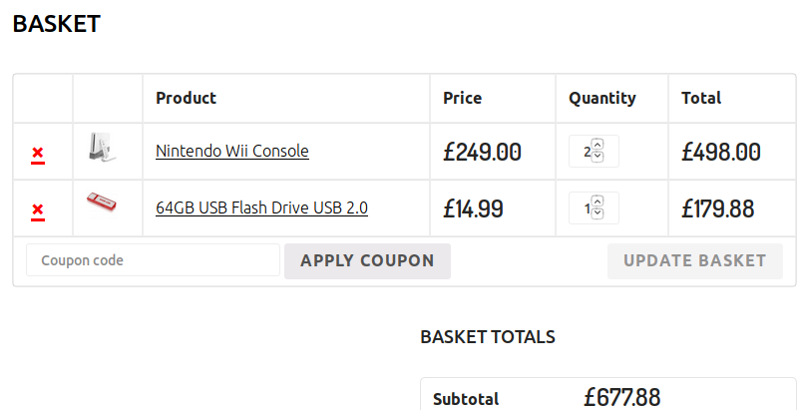

2.When the page is refreshed the functionality of total changes everytime,sometime when quantity is changed then change in total is not reflected.
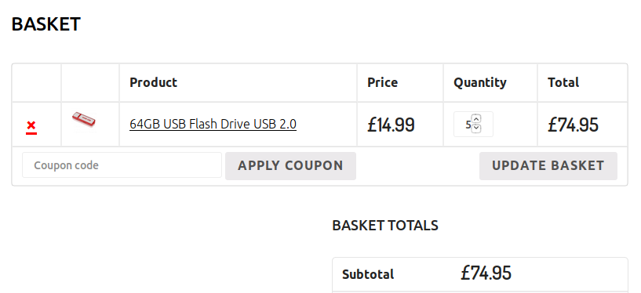
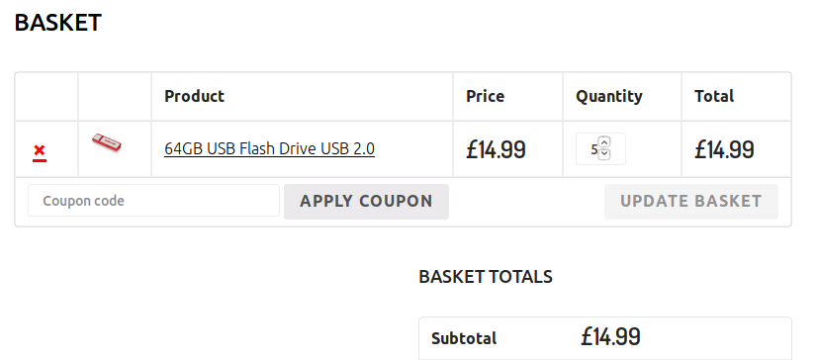

c)Search
Bugs: 1.The search button does not work on mouse click.
2.Alignment of search button with search bar is not proper.

d)Homepage
Bugs: 1.The website is not responsive.
2.Dimensions of all the images are not equal to each other.
3.The “Add to Basket” button is not aligned with the product details.
4.On the Page 2 an image is not displayed.


22.Find bugs and report the same on JIRA for below-mentioned modules in the website:http://newtours.demoaut.com/: Testwebsite2
a)Register Here
Bugs: 1.User is able to register without even entering any data.
2.Sometimes even after registering with valid data, user is not able to SIGN IN.
3.The phone field accepts character values.
4.The first name and last name field accepts numerical values.
5.No error message is generated when different password is entered in the
confirm password field.
6.The email field accepts numerical values.
7.The address,city,state field can accept onnly numerical values also.
8.The postal code field accepts character values.
9.User is able to register again with same data and no error message is displayed.

b)Top header navigation options
Bugs: 1.The website is not responsive.
2.The content of website is not alligned.

c)UI bugs for the complete website.
Bugs: 1.The website is not responsive.
2.The content of website is not alligned.
3.Website is not interactive.
4.The destination,vacations,register and links buttons are not alligned with other details.


5.Business Travel @ About.com and Salon Travel link is not working
6.Rent a car link on the navigation side bar is not working.


7.The date displayed on the home page is incorrect.
23. Write Test Cases for Amazon login, Sign up and Forgot password on TestLink

https://docs.google.com/spreadsheets/d/1642CEhJ7UbJDSn8 aiDadPP8vpf5mD8kYnc5RWdzvW0A/edit?usp=sharing

24.Write Test Cases for placing an order in Myntra on TestLink.

https://docs.google.com/spreadsheets/d/10xbl2Q-U3v1MddJXlhfNlfA9rPZi1Cn03S2zKKFlMRc/edit?usp=sharing

25.Write Test Cases for Search functionality on TestLink.

https://docs.google.com/spreadsheets/d/1HL_w9vpXwypZus0PDAeozDGbCNjsiNlB1IXipxcLUQc/edit?usp=sharing

