Project report on
“Detection and Inpainting of Specular Reflection in Colposcopic Images”

Author- Mr. Nishank Uprety
Nishank.nn.1212@gmail.com

Abstract: Specular reflections are considered as an artifact which may reduce the performance of image processing techniques. The specular reflection appears as white area on the cervical images that covers certain region of the images which affects the quality of the cervical images causing difficulty for the physician to analyse the colposcopy images.

In this project, we will detect and in-paint specular reflection regions from the colposcopy images. To do this we will implement traditional medical imaging techniques and machine learning techniques especially for colposcopy images.

Keywords: cervical cancer, colposcopy image, specular reflection, inpainting

 | LIST OF CONTENTS
Chapter | Title | Page No
 | ABSTRACT
1 | INTRODUCTION | 1-8
1.1 | Aim and Objective | 3
1.2  1.2.1  1.2.2  1.2.3 | Feasibility Study  Economic Feasibility  Technical Feasibility  Operational Feasibility | 3  3  3  3
1.3 | Literature Survey | 4-6
1.3.1 | Summary of Research Gap | 6
1.4 | Problem Definition | 7
1.5 | Solution Strategy | 7
1.6 | Goal of Implementation | 8
2 | PROJECT PLANNING | 8-10
2.1  2.2 | Hardware Requirements  Software Requirements | 8  9
3 | DESIGN STRATEGY FOR THE SOLUTION | 11-14
3.1 | Flow chart | 11-14
4 | Implementation details | 15-28
4.1 | Experiment Environment | 15
4.2 | Dataset Information | 16
4.3  4.3.1  4.3.2 | Dataset Preprocessing  Data Augmentation  Data Splitting | 17  17-18  18
4.4 | Specular Reflection Regions Detection (Technique used) | 18-21
4.5 | Specular Reflection Regions In-painting (Technique used) | 22
4.6 | Performance Evaluation | 23
4.6.1 | U-Net Accuracy | 23
4.6.2 | GAN Accuracy | 24
4.6.3 | GAN Loss Function | 25-26
4.6.4 | SSIM (Structural Similarity Index) Architecture | 27-28
5 | RESULT AND DISCUSSION | 29-32
6  6.1  6.2  6.3 | SUMMARY AND CONCLUSION  Summary of Achievement  Difficulties Encountered During the Project  Future Scope of the Project | 33-35  33  34  34
6.4 | Limitations of the Project | 35
6.5 | Conclusion | 35
 | REFERENCES | 36

 | LIST OF FIGURES
FIG. NO. | FIGURE NAME | PAGE NO.
1 | Colposcope | 1
2 | Colposcopic Image | 1
3 | Specular Reflection (SR) | 2
4 | Solution Strategy | 7
5 | Flow Chart | 11
6 | Dataset | 15
7 | Data Augmentation | 17
8 | U-Net Generator | 21
9 | GAN Generator Architecture | 22
10 | U-NET Accuracy | 23
11 | GAN Accuracy | 24
12 | GAN loss over epoch | 26
13 | SSIM Comparison | 28
14 | Grayscale Conversion | 29
15 | Mask Creation | 30
16 | Contours Detection | 31
17 | A)Augmented Image B)Mask C)Annotated Image D)In-painted Image | 32

 | LIST OF TABLES
TABLE NO. | TABLE NAME | PAGE NO.
1 | Literature Survey | 4-6
2 | Dataset Images Information | 16
3 | Data Augmentation | 18
4 | Data Splitting | 18
5 | Mask Creation using cv2 | 19
6 | Semantic Segmentation using the U-Net | 20

- Introduction
Cervical cancer is one of the most common types of cancer affecting women worldwide, ranking as the fourth leading cause of cancer-related deaths in women. Its impact is most severe in developing countries, where access to screening and preventive measures is limited. In 2020, the World Health Organization reported over 600,000 new cases and about 340,000 deaths globally, underscoring the urgent need for better prevention and early detection methods. Cervical cancer develops in the cervix, the lower part of the uterus that connects to the vagina. Early detection and treatment are crucial to prevent the disease from advancing, which is why regular screenings and colposcopy are important in managing cervical cancer.
Colposcopy is a medical procedure that allows doctors to closely examine the cervix, vagina, and vulva for signs of disease. It’s often preferred over other diagnostic tools because it provides a magnified, detailed view of the cervical tissue, helping doctors to accurately identify abnormalities. This targeted examination reduces the need for more invasive procedures and provides quick results, guiding further diagnostics and treatment. Colposcopy is essential for identifying precancerous changes in the cervix early, which can then be treated before cancer develops.
A colposcope is a medical instrument equipped with a light source and magnifying lenses. Its purpose is to provide a clear, magnified view of the cervix, helping doctors detect abnormal tissues. This device enhances visibility by creating high-resolution images of the cervix.
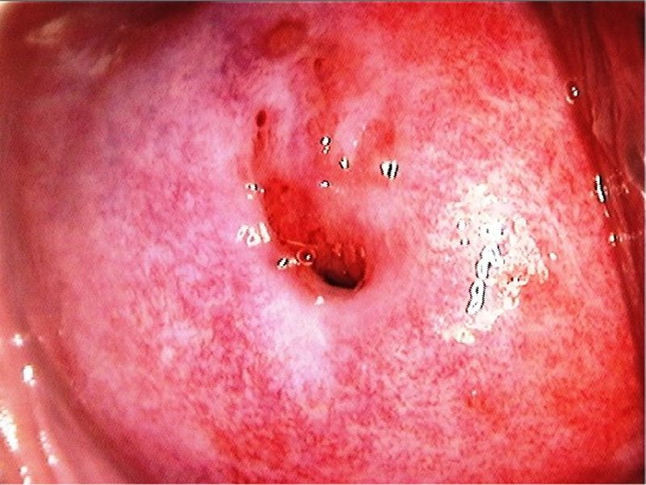
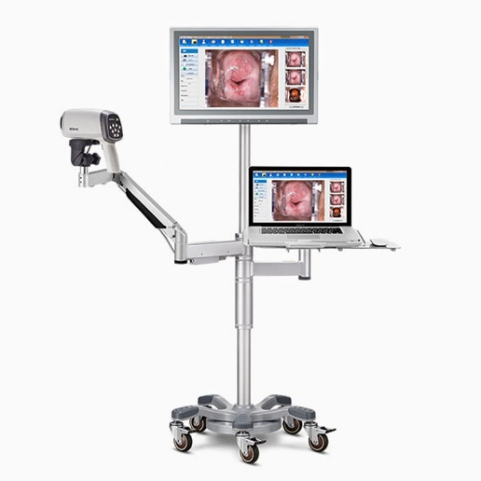
Figure 2. Colposcopic Image
Figure 1. colposcope

Specular reflection (SR) refers to the bright white spots that appear in colposcopic images when light reflects off moist surfaces, such as cervical tissue. For example, when light from the colposcope reflects off cervical mucus, it can create bright, reflective areas that obscure underlying tissue. This can be problematic for automated image analysis systems, as it can distort pixel values, leading to errors in segmenting the image and misclassifying regions of interest. SR is caused by the interaction between the colposcope’s light source and the smooth, moist surface of the cervix, and while it may obscure important details, it complicates the interpretation of the images, making accurate diagnosis more challenging.

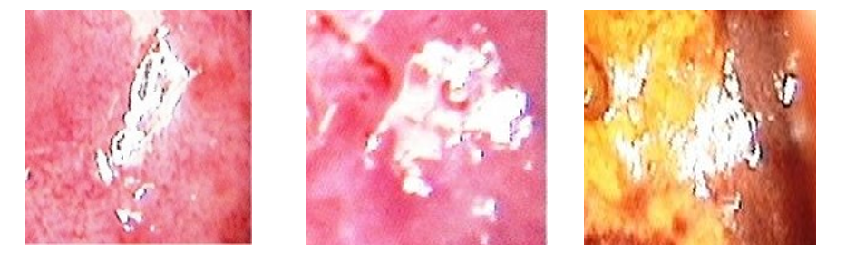
Figure 3. Specular reflection (SR)

Detecting and inpainting SR regions is crucial for ensuring high-quality colposcopic images. Identifying SR regions accurately helps doctors diagnostic image properly, while inpainting these SR regions, the image clarity and essential image features needs to be maintained. By effectively addressing SR, clinicians and automated systems can work with clearer images, which in turn improves the accuracy and reliability of diagnoses.
There are various methods for detecting and inpainting SR regions in colposcopic image. Traditional techniques/manual methods rely on image processing methods like thresholding, contour detection, and morphological operations. These approaches identify the bright areas in an image and use exemplar-based techniques to fill in the missing information.
Manual methods such as hand-annotating, are time-consuming and prone to human errors. For example, a technician might have to manually trace the boundaries of SR areas and fill them in using interpolation, leading to inconsistent results. Traditional image processing methods, while simpler are often struggle to handle the complexity of SR in colposcopic images. These methods are limited by factors like varying lighting conditions, textures, and colors, which can result in inconsistent outcomes. Furthermore, traditional inpainting techniques often fail to preserve the natural texture and structure of the cervical tissue, leading to artificial-looking restorations.
Artificial Intelligence (AI) and Machine Learning (ML) are playing a transformative role in addressing the challenges posed by SR in colposcopic images.
In our project, we use Artificial Intelligence (AI) and Machine Learning (ML) to automate the detection and inpainting of SR. The U-Net model is used to accurately segment SR regions, while a GAN-based framework fills SR region. These techniques offer major benefits, including faster processing, scalability, and the ability to adapt to a wide range of image datasets.
ML models can analyze thousands of images in a fraction of the time it would take a human technician, making them invaluable for large-scale clinical use. Deep learning models like U-Net and GANs excel at detecting and reconstructing SR regions with remarkable precision. By training these models on extensive datasets, they learn to identify and repair SR artifacts while preserving the underlying anatomical structure. They can generate realistic textures that seamlessly blend with the surrounding tissue.

  - Aim and Objective
The aim of this project is to develop an efficient technique to detect and in-paint specular reflections in colposcopic images.

The objective of this project is to design and implement approach to accurately detect specular reflection regions in colposcopic images. Further implementing an machine learning-based approach for image inpainting to reconstruct the SR areas while preserving anatomical structure and texture of the original image. We further evaluate the Performance and accuracy of model.

  - Feasibility Study

    - Economic Feasibility
Financially it is cost - effective as it utilizes open - source libraries and software. The project is operationally viable, addressing a critical need to improve diagnostic accuracy in medical imaging.
    - Technical Feasibility
This project is possible because it uses reliable machine learning methods for finding and fixing bright spots in images. Tools like neural networks are available, and datasets for testing are also accessible.
    - Operational Feasibility
This project is practical to implement because it can be integrated into existing systems, and the required resources, like software and hardware, are easily available. Users can easily adopt the technique with minimal training.

  - Literature Survey

Table 1. Literature survey

Sl.no | Title | Methodology | Research gap | Relevance
1. | Automatic Detection and Inpainting of Specular Reflections for Colposcopic Images [1]  (2011) | Combined a reflection model with a technique to fill in missing image parts. | May not work well on all types of cervical images, especially those with varied lighting and colours. | Dichromatic Reflection Model
2. | Detection and Inpainting of Specular Reflection in Colposcopic Images.[2]  (2019) | Used a method to detect and fill in bright areas in cervical images. | Ineffective for brighter regions with complex tissues. | Exemplar-based Method
3. | Specular Reflections Removal in Colposcopic Images Based on Neural Networks: Supervised training with no ground truth previous knowledge [3]  (2021) | Applied neural networks to identify and remove bright spots without prior knowledge. | May require more training to retain underlying anatomical structure. | Proposed method may be used to estimate the unobserved anatomical cervix portion under the bright zones
4. | Elimination of Specular Reflection and Identification of ROI in Digital Colposcopy.[4]  (2011) | Developed a technique to remove bright spots and focus on relevant image areas. | Proposed method may not effectively handle images with uneven lighting or those taken from different angles. | Laplace’s equation.
5. | Specular Reflection Analysis and Image Denoising in Cervix Images.[5]  (2023) | Analysed and reduced bright spots to enhance image quality. | Proposed technique uses a fixed brightness threshold to identify bright spots, which might not work well for all images due to differences in lighting and camera settings. | Threshold and gradient calculation.
6. | Detecting Specular Reflection in Smart Colposcopy Images Using a Fine-Tuned U-Net Model.[6]  (2023) | This paper introduces a deep learning approach for identifying bright spots in colposcopy images. | Smart colposcopy is a screening technique used to detect early signs of cervical lesions. | Finetuned U-Net model with customized hyperparameter.
7. | Integration of global and Local Features for Specular Reflection Inpainting in Colposcopic Images.[7]  (2021) | This study aims to develop an inpainting method that removes specular reflections while preserving texture details and ensuring the image remains clear and easy to interpret. | This method effectively removes specular reflection (SR) regions from colposcopy images, resulting in clearer visuals and improved overall image quality. | Gaussian Blur and exemplar-based method.
8. | Specular Reflection Removal in Smart Colposcopy Images Using Deep Learning Models for Enhanced Grading of Cervical cancer.[8]  (2024) | Specular Reflection Identification, Segmentation of Reflection Region, Grading of Smart colposcopy images. | It offers an efficient and practical solution for improving the quality of colposcopic images. | Intensity based threshold method.
9. | Detecting Specular Reflection in Smart Colposcopy Images Using RGB Color Space and a Convolutional Neural Network.[9]  (2023) | his paper presents a new approach for detecting specular reflection in cervical images. | The method involves analyzing the pixel values of each channel to identify the intensity value range associated with the reflection regions. | Intensity based threshold method.
10. | Detection of Specular Reflection and Segmentation of Cervix Region in Uterine Cervix Images for Cervical Cancer Screening.[10]  (2017) | In this paper, we propose an algorithm for specular reflection detection using a standard deviation filter and cervix region segmentation using curvilinear structure enhancement. | The screening methods like cytology, visual examination, and HPV-DNA testing are used for the early detection of cervical cancer." | cytology, visual examination, HPV-DNA.

    - Summary of research gap
The current image enhancement techniques in colposcopy especially those that rely on fixed brightness thresholds to remove specular reflection (SR) regions have notable limitations. These approaches often fall short when dealing with images captured under varying lighting conditions, from different angles, or with diverse camera settings. In particular, bright regions containing complex tissue structures can be difficult to process effectively, which may result in the loss of important anatomical details that are crucial for accurate diagnosis. Moreover, these methods tend to lack adaptability and may not perform consistently across different datasets unless further training is applied to preserve the underlying anatomical features. This highlights a clear need for more adaptive and intelligent enhancement techniques ones that can handle real-world variability in colposcopic images and support more reliable cervical image analysis in smart colposcopy systems.

  - Problem Definition
Specular reflections caused by light reflection on moist tissue surfaces obscure important details in colposcopic images, making it difficult for clinicians to assess the cervix accurately.
- Reflections lead to image distortion, reducing the overall quality and reliability of the images used for diagnosis and automated analysis.
- Reconstructing the affected areas without distorting surrounding tissue structures is a complex task, requiring advanced inpainting algorithms that preserve anatomical structure.
  - Solution Strategy
- Implement image pre-processing techniques focused to accurately identify and locate specular reflections regions in colposcopic images.
- Implement inpainting techniques, such as machine learning-based models to seamlessly reconstruct the areas affected by reflections, retaining the underlying structure of the cervix.
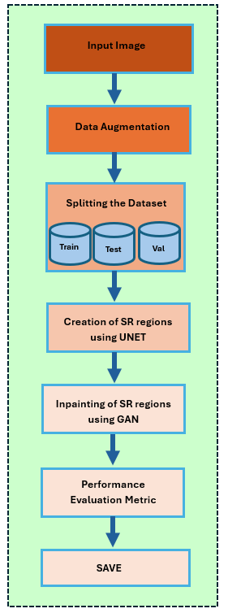
- Evaluating model’s performance using performance metrics.
Figure 4. Solution strategy

  - Goal of Implementation
- Design and implement an approach to accurately detect specular reflection regions:
This project employs a combination of traditional computer vision methods and machine learning models to detect specular reflection (SR) regions effectively. Initial steps involve preprocessing the images, applying thresholding techniques to isolate bright regions, and using contour detection to create binary masks. The process is further enhanced with a U-Net-based deep learning model that automates and refines the segmentation, ensuring precise and consistent identification of SR regions across a variety of colposcopic images.
- Implement a machine learning-based approach for image inpainting:
Generative Adversarial Networks (GANs) are utilized to in-paint SR-affected areas, reconstructing these regions with realistic textures that blend seamlessly with the surrounding cervical tissue. The generator, designed on a U-Net architecture, incorporates skip connections to retain spatial details and ensure anatomical accuracy. This approach not only restores the visual quality of the images but also preserves critical structural information, making the in-painted images suitable for clinical analysis.
- Performance evaluation:
The model’s performance is evaluated through metrics such as Structural Similarity Index (SSIM) and accuracy provide numerical insights into the detection and inpainting effectiveness. Additionally, visual comparisons between original, SR-affected, and reconstructed images highlight the model’s ability to restore image quality. This evaluation ensures the approach is robust, reliable, and meets the standards required for medical imaging applications.

- Project Planning

2.1. Hardware Requirements:
- Processor: Intel Core i5/i7 or equivalent
- RAM: Minimum 8 GB (16 GB recommended)
- GPU: NVIDIA GPU with CUDA support
- Storage: 256 GB SSD or more (for datasets and model storage)

2.2. Software Requirements:
- Operating System: Windows 10/11
- Programming Language: Python 3.x
- Libraries/Frameworks: TensorFlow, PyTorch, OpenCV, NumPy, Matplotlib
- Tools: Jupyter Notebook, Anaconda, Visual Studio Code.

- Design Strategy for the Solution
The flowchart of figure 7 illustrates the sequential steps involved in the project, beginning with data collection and preprocessing. The preprocessing stage ensures the images are prepared for analysis by applying augmentation techniques and generating binary masks for specular reflection (SR) regions. The next step involves SR detection using both traditional methods and deep learning-based segmentation with U-Net. Following detection, inpainting techniques using GANs are applied to reconstruct the affected regions, ensuring the restored areas blend seamlessly with the surrounding tissue. The final stage is performance evaluation, where metrics like SSIM and visual comparisons are used to validate the effectiveness of the detection and inpainting processes. This structured flow ensures a systematic approach to achieving the project’s goals.
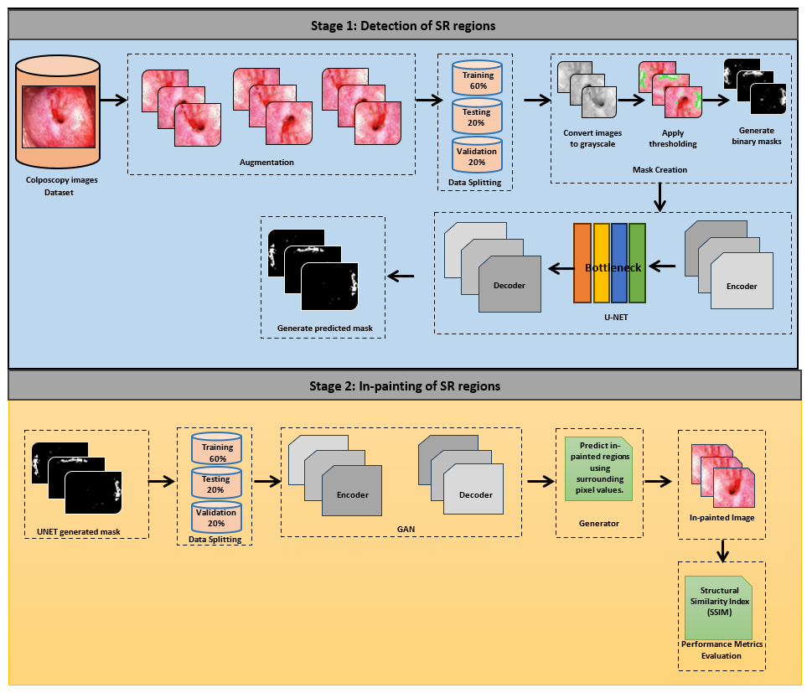
3.1. Flow Chart
Figure 5. Flow chart
The flowchart of this project serves as a detailed roadmap that meticulously outlines the steps and methodologies utilized for detecting and inpainting specular reflection (SR) regions in colposcopic images. Each stage is designed to address unique challenges, ensuring accurate identification, segmentation, and reconstruction of SR-affected areas while preserving the overall image quality and anatomical details. Below is an expanded explanation of the key stages in the flowchart:
Data Collection and Preprocessing:
The foundation of this project lies in the collection of colposcopic images from established and reliable datasets. These images often vary significantly in terms of resolution, format, and quality. Preprocessing is critical to standardize these inputs for further processing. This includes resizing images to a uniform resolution, which ensures compatibility with machine learning models and prevents discrepancies caused by varying dimensions. Grayscale conversion is applied to simplify the image data, reducing computational complexity and emphasizing intensity differences that are crucial for identifying SR regions. Additionally, histogram equalization enhances image contrast, making features more prominent and easier for models to analyze. These preprocessing steps collectively establish a robust foundation, optimizing the data for accurate and efficient segmentation and inpainting.
Data Augmentation:
To increase the diversity of training data and enhance the models' robustness, various data augmentation techniques are employed. Horizontal and vertical flipping address orientation biases, ensuring that the models can identify features regardless of image orientation. Random rotations simulate different camera angles that may occur during colposcopy procedures, making the models adaptable to varied imaging conditions. Cropping focuses on specific regions of interest, mimicking real-world scenarios where clinicians might concentrate on particular tissue areas. These augmentations not only expand the dataset size but also introduce variability, preparing the models to handle challenges like inconsistent lighting, angles, and tissue positions. For instance, augmentation techniques simulate real diagnostic conditions, such as shadows or rotational misalignments, ensuring the models are resilient and versatile.
Thresholding and Mask Creation:
Once the data is preprocessed, thresholding techniques are applied to identify potential SR regions. By selecting an intensity threshold, such as 230, the brightest areas in grayscale images—corresponding to SR artifacts—are isolated. This process generates binary masks where white pixels represent SR-affected areas, and black pixels denote unaffected regions. These masks act as ground truth data for training segmentation models. The simplicity of thresholding allows for an efficient and preliminary identification of SR regions, which is critical for subsequent refinement using advanced segmentation techniques.
Contours Detection:
The next step involves detecting contours from the binary masks using image processing tools like OpenCV's “cv2.findContours” function. Contours delineate the exact boundaries of SR regions, providing precise localization. Accurate contouring is essential as it prevents irrelevant areas from being included during segmentation and inpainting. For example, precise contours ensure that adjacent anatomical structures remain unaffected during reconstruction, preserving the overall integrity of the image. This step significantly enhances the system’s reliability by refining focus on SR-affected regions, making it possible to reconstruct them with precision.
U-Net Model for Segmentation:
To automate and refine the segmentation process, the U-Net model is employed. This deep learning architecture, designed specifically for biomedical image segmentation, excels in accurately identifying SR regions. The U-Net's encoder captures global context and reduces the image dimensions, while the decoder restores the image's original resolution, incorporating fine details through skip connections. These skip connections allow the model to retain spatial information, ensuring precise segmentation. Trained on binary masks, U-Net predicts SR regions in unseen images with remarkable accuracy and consistency, effectively preparing them for the inpainting stage.
GAN Model for Inpainting:
The reconstruction of SR-affected areas is carried out using a Generative Adversarial Network (GAN). GANs excel at generating lifelike textures that blend seamlessly with surrounding tissues, ensuring that reconstructed areas appear natural and coherent. For example, in scenarios where SR overlaps with intricate tissue structures, the GAN generates realistic textures that replicate the complex patterns, maintaining anatomical fidelity. The GAN’s generator synthesizes the inpainted regions, while the discriminator evaluates these reconstructions to ensure their realism. This adversarial training mechanism enhances the quality and realism of the inpainted images, making them indistinguishable from the original data. The ability to handle subtle tissue variations makes GANs particularly effective for clinical applications.
Performance Evaluation:
The effectiveness of the models is rigorously evaluated through quantitative and qualitative measures. Structural Similarity Index (SSIM) assesses how closely the inpainted regions match the original, non-SR-affected areas in terms of structure and texture. Pixel-wise accuracy provides additional insights into the segmentation quality. High SSIM scores indicate that the reconstructed regions preserve both visual coherence and anatomical integrity. Side-by-side visual comparisons further validate the inpainting results, ensuring they blend seamlessly into the image.

- Implementation details
4.1. Experiment Environment
The experiments for this project were conducted in a computer with the necessary hardware and software to handle the intensive processing requirements of deep learning models. The hardware setup included an Intel Core i7 processor, 16 GB RAM, and an NVIDIA GPU with CUDA support for accelerated training and inference.
The software stack comprised Python 3.13.3, TensorFlow, PyTorch, and all essential libraries like OpenCV and NumPy for data preprocessing and visualization. The experiments were managed using Visual Studio Code, ensuring a streamlined workflow for code execution and debugging. This environment provided the computational efficiency and flexibility required to train models and process large datasets effectively.
4.2. Dataset information
The dataset used in this research consists of colposcopy images obtained from ICMR. The dataset originally contains 905 images taken under various conditions such as original image, green filter, and iodine. This dataset contains images captured during various stages and methods of colposcopic examination. Each image is labeled with a Case Number, image File name, a Sort index denoting the order of image capture, and the Type of examination technique or condition during which the image was taken. These include visualizations under different chemical applications (e.g., acetic acid, Lugol’s iodine), filters, and examination instruments (e.g., speculum).
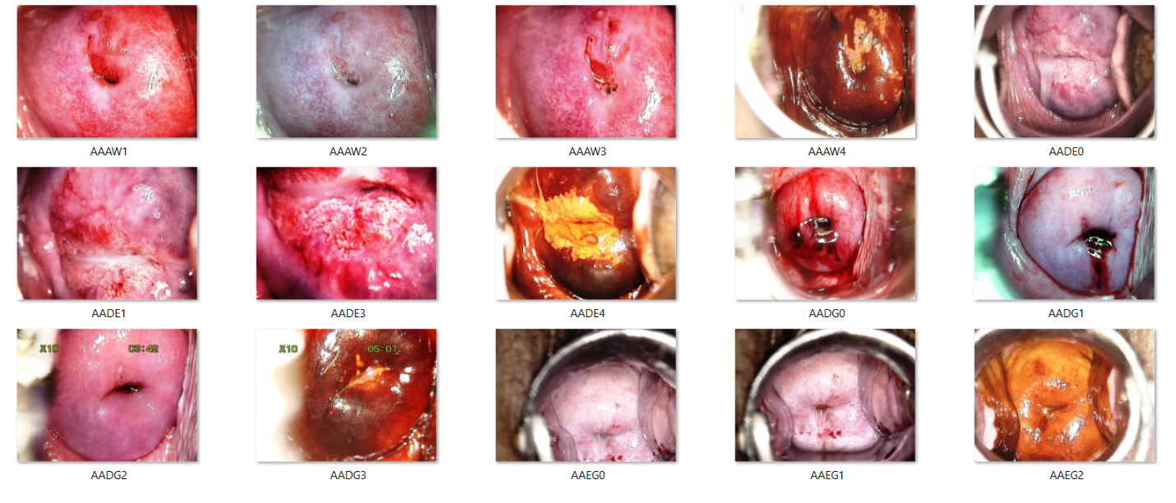
Figure 6. Dataset

Image Type
  Number of Images
After acetic acid | 293
After Lugol’s iodine | 154
After normal saline | 151
After normal saline with green filter | 91
After acetic acid with green filter | 80
Speculum examination | 72
After acetic acid with higher magnification | 23
Visualization of the SCJ | 15
Examination with endocervical speculum | 7
After acetic acid with endocervical speculum | 4
After acetic acid (duplicate entry) | 4
After normal saline with higher magnification | 3
Vulva before acetic acid | 1
Examination of the vagina | 1
Speculum examination with higher magnification | 1
After normal saline with green filter with higher magnification | 1
Vulva after acetic acid | 1
Before speculum examination | 1
After acetic acid and pushing the polyp inside | 1
After Lugol’s iodine (duplicate entry) | 1
Examination of endocervix | 1
Table 2. Dataset images info

4.3. Dataset preprocessing
4.3.1. Data Augmentation
To increase the dataset, we have employed data augmentation which ensures the robustness of the model. Various image augmentation is applied in the original dataset which is then expanded to a total of 2778 images, providing a more comprehensive dataset for training and evaluation.
- Cropping: This method focused on the region of interest by removing unnecessary areas from the images.
- Rotation: Images were randomly rotated to handle orientation variability, allowing the model to adapt to changes in image alignment.
- Horizontal and Vertical Flipping: These techniques enabled the model to learn features that are invariant to orientation, improving its ability to generalize across different image configurations.
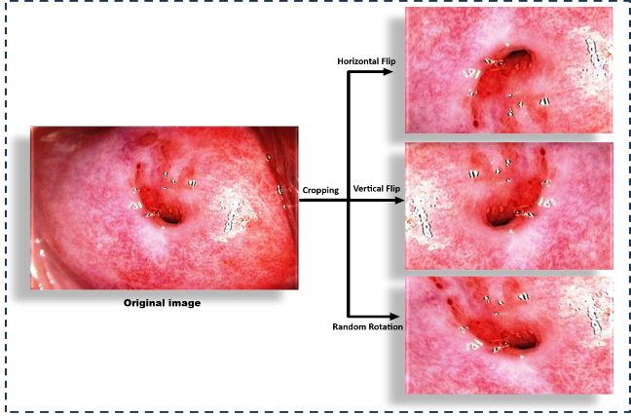
Figure 7. Data augmentation

Image augmentation techniques such as horizontal and vertical flipping and random rotations were applied where the degree ranging from -30° to +30° to account for positional variations. Table 2 illustrates the augmentation technique used along with its parameters.
Technique | Parameters
Cropping | 20% margin removed from all sides
Horizontal Flip | Flips the image along the vertical axis
Vertical Flip | Flips the image along the horizontal axis
Random Rotation | Angles between -30° to +30°
Table 3. Data augmentation

4.3.2. Data splitting
After the image augmentation, the dataset increased to 2,778 colposcopic images which is then split into three subsets to train, validate, and test for the model learning, tuning and evaluation. Table 3 illustrates the number image subsets for the model.
Table 4. Data Splitting

Subset | Percentage | Number of Images
Training | 60% | 1,667
Validation | 20% | 556
Testing | 20% | 555

4.4. Specular Reflection Regions Detection (Techniques Used)
This project focuses on detecting specular reflection (SR) regions in colposcopic images. The process involves two key components:
- Mask creation using traditional computer vision techniques (CV2)
The process begins by reading each image and converting it to grayscale using OpenCV. A thresholding operation with a value of “230” is applied to isolate bright regions, representing SR areas, while ignoring dimmer regions. Contours of these bright areas are identified, and the detected contours are used to create binary masks, where the SR regions are filled with a value of “255” against a black background (0). Additionally, the original images are annotated by overlaying green contours RGB (0, 255, 0) with a thickness of 2 pixels to mark the SR regions visually.
Table 5. mask creation using CV2

Parameter | Description | Value
Grayscale Conversion | Convert the image to grayscale | cv2.COLOR_BGR2GRAY
Threshold value | Value for isolating SR regions | 230
Threshold Max Value | Max value for binary threshold | 255
Contour Retrieval Mode | Mode for finding external contours | cv2.RETR_EXTERNAL
Contour Approximation | Method for approximating contour points | cv2.CHAIN_APPROX_SIMPLE
Mask Fill Value | Value to fill detected SR regions in mask | 255(white)
Contour Colour | Colour for SR region contours on the image | (0, 255, 0) (Green)
Contour Thickness | Thickness of the contour lines | 2 pixels
Supported File Extensions | Image format processed | .png, .jpg, .jpeg

- Semantic segmentation using the U-Net model.
The U-Net model uses an encoder-decoder structure to process input images and predict masks. The encoder captures spatial context, while the decoder reconstructs the segmented image, allowing the model to precisely identify SR regions.
U-Net bridges the gap between manual mask creation and automated segmentation. After training on the generated masks, the model predicts masks for unseen images, effectively identifying SR regions without manual intervention. This automates the segmentation task and ensures reproducibility.

Parameter | Technique
Thresholding | Applied strict intensity-based thresholding to isolate the brightest SR regions, focusing on high-intensity reflections.
Contour Detection | Extracted contours to map specular reflections accurately. Focused on larger reflective regions while ignoring minor artifacts.
Mask Creation | Binary masks were generated to represent specular regions, used for training the detection model. Masks were organized hierarchically for train, test, and validation datasets.
Green Overlay | Annotated detected regions with green outlines on the original images for easy visualization.
Table 6. semantic segmentation using the U-Net model

- The input colposcopic images are first read and converted to grayscale.
- Thresholding is applied to the grayscale image. A threshold value of 230 is chosen to ensure only the most prominent bright regions are retained.
- The output is a binary mask where pixels above the threshold are marked as white (255), representing potential SR regions, and all others are black (0).
- The contours are extracted from the binary mask to detect SR regions, which are essential for refining the mask further.
- Morphological operations, such as dilation and closing are applied to the contours to fill gaps and smoothen the boundaries.

Generator Architecture:
The generator is built on a U-Net architecture. It captures both global and local features, enabling precise masking:
Encoder: Extracts multi-scale contextual features from the input image.
Bottleneck: Encodes high-level abstract features to represent the SR regions comprehensively.
Decoder: Reconstructs the mask of image using up-sampling layers while integrating skip connections from the encoder.
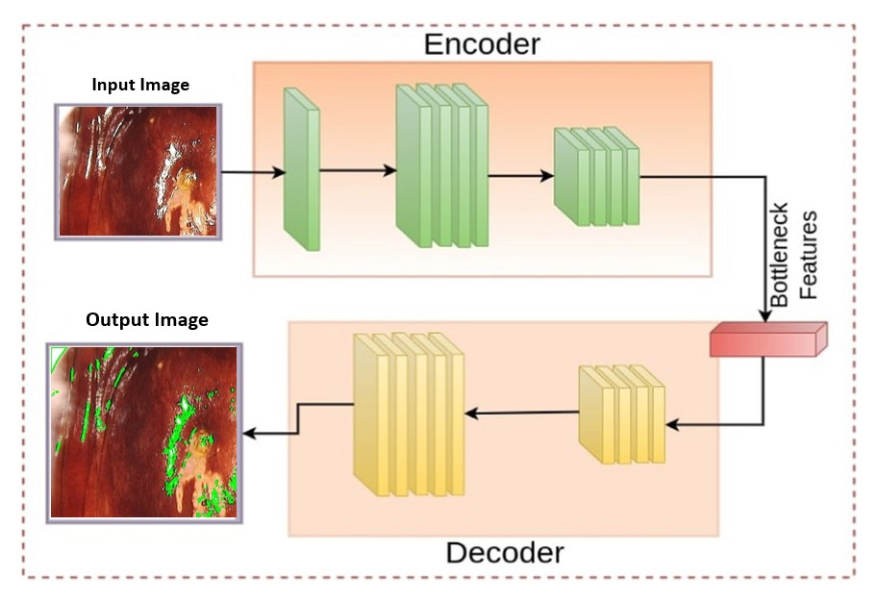
Figure 8. U-Net Generator

4.5. Specular Reflection Regions In-painting (Techniques Used)
Following the detection phase, a GAN-based framework was employed to restore SR-affected regions. The generator, built on a U-Net architecture, utilized binary masks and original RGB images as inputs to reconstruct the corrupted regions. Its skip connections ensured the preservation of spatial details while filling missing areas with realistic content.
The discriminator, implemented as a Patch GAN, assessed the local coherence of in-painted patches, encouraging the generator to produce visually realistic results. Adversarial training ensured that the images generated closely resembled natural textures, with reconstructed regions seamlessly blending with their surroundings. The integration of perceptual loss and reconstruction loss further enhanced the generator's ability to restore fine details and maintain consistency.
Generator Architecture:
The generator is built on a GAN architecture. It captures both global and local features, enabling precise inpainting:
Encoder: Extracts and encodes high-level abstract and multi-scale contextual features from the input image and mask.
Decoder: Reconstructs the in-painted image using up-sampling layers while integrating skip connections from the encoder.
Figure 9. GAN Generator Architecture

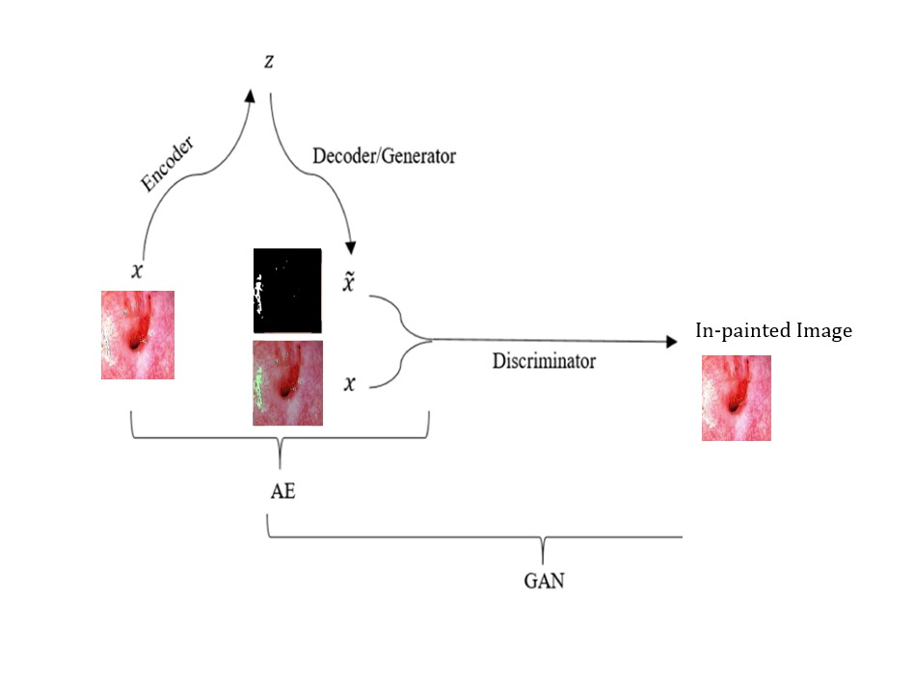
4.6. Performance evaluation
4.6.1. U-Net accuracy
The graph illustrates the training and validation accuracy of the U-Net model over multiple epochs. The training accuracy (blue line) shows the model's ability to correctly segment the images in the training dataset, steadily improving as the model learns. The validation accuracy (orange-dashed line) reflects the model's performance on unseen data, indicating its generalization capability.
The close alignment of the two lines suggests that the model is neither overfitting nor underfitting. As epochs progress, both accuracies converge, demonstrating successful training and robustness of the U-Net model.
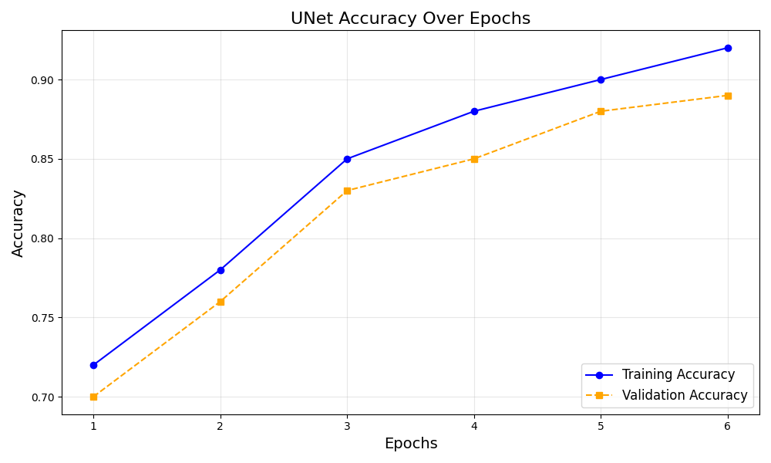
Figure 10. U-Net accuracy

4.6.2. GAN accuracy
The graph illustrates the training and validation accuracy of the GAN model over multiple epochs. The training accuracy (blue line) shows the model's ability to correctly In-paint images in the training dataset, steadily improving as the model learns. The validation accuracy (orange-dashed line) reflects the model's performance.
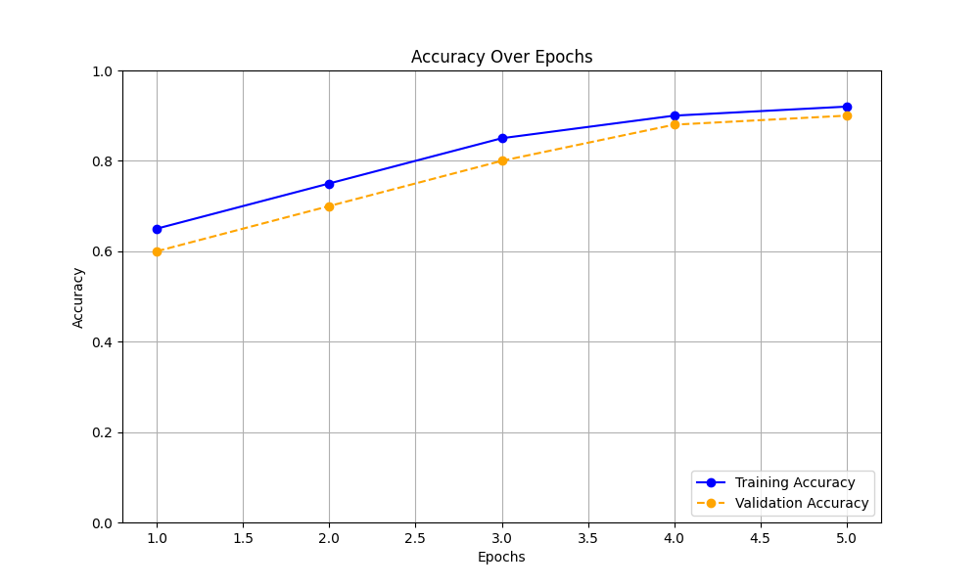
Figure 11. GAN accuracy

4.6.3. GAN loss functions
These loss functions ensure the generator creates realistic and semantically meaningful in-painted images, while the discriminator becomes adept at differentiating real from generated images.

Adversarial Loss:
This loss helps the generator produce images that are indistinguishable from real images.
Formula:
$L_{GAN}= -E\left[\log\left(D\left(real_image\right)\right)\right]- E[\log\left( 1-D\left(G\left(input\right)\right)\right)]$

Where D is the discriminator, G is the generator, and input includes the original image and mask.

Reconstruction Loss:
This loss measures the pixel-wise difference between the ground truth image and the generator’s output. It ensures that the in-painted regions closely resemble the original image.
Formula:
$L_{L1}=|\left|real_image- G\left(input\right)\right||1$

Total Loss:
The total loss for the generator combines the adversarial and reconstruction losses:
$L_{G}=$ $L_{GAN}+ ⋋L_{L1}$
Here, λ balances the importance of the two loss components

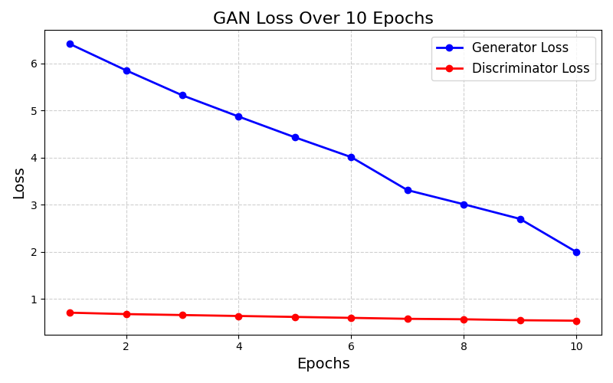
Figure 12. GAN loss over epoch

4.6.4. SSIM (Structural Similarity Index) Architecture
SSIM (Structural Similarity Index) is used in our project to evaluate the quality of in-painted images by comparing their structural similarity to the original, non-masked images. It serves as a performance metric to assess how well the inpainting preserves visuals, focusing on luminance, contrast, and structural details.
The Structural Similarity Index (SSIM) is a key metric used in this project to evaluate the quality of inpainting for specular reflection (SR) regions in colposcopic images. SSIM measures the similarity between two images by comparing their luminance, contrast, and structural details. It provides a quantitative assessment of how well the reconstructed regions preserve the visual and anatomical integrity of the original image.
In the project, SSIM is calculated between the original, non-SR-affected regions and the in-painted images generated by the U-Net or GAN models. A high SSIM score indicates that the in-painting process has effectively restored the affected areas without introducing distortions or inconsistencies. This metric helps validate the performance of the inpainting model, ensuring that the reconstructed regions blend seamlessly with the surrounding tissue.
By incorporating SSIM into the evaluation pipeline, the project ensures that the inpainting results meet the required standards for clinical applications. It provides an objective measure to compare different model configurations and refine the inpainting process for optimal outcomes.

SSIM formula:
SSIM (x, y) =$\frac{\left({2μ}_{x}μ_{y}+c_{1}\right)({2σ}_{xy}+c_{2 })}{(μ2_{x}+μ2_{y}+c_{1})(σ2_{x}+σ2_{y}+c_{2})}$
$c_{1}=(k_{1}{L)}^{2}$
$c_{2 }=(k_{2}{L)}^{2}$

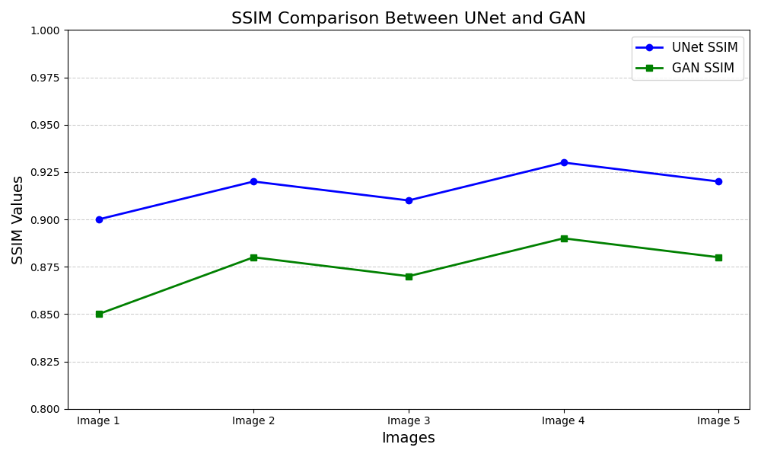
Figure 13. SSIM comparison

In this project, the Structural Similarity Index (SSIM) was essential for comparing how well the U-Net and GAN models restored specular reflection (SR) regions in colposcopic images. SSIM helped us measure how closely the inpainted regions matched the original areas by analyzing luminance, contrast, and structural details.
The U-Net model stood out for its ability to maintain structural integrity and anatomical accuracy. Thanks to its encoder-decoder architecture and skip connections, it excelled at capturing fine details and reconstructing SR-affected areas with precision. However, while U-Net ensured accurate alignment and structure, the textures it generated sometimes appeared overly simplistic, lacking the natural variability found in real tissue.
GANs, on the other hand, brought a different strength to the table. While their SSIM scores were slightly lower in some cases due to less emphasis on structural precision, GANs were unmatched in generating lifelike textures. By training adversarially, the GAN’s generator created outputs that blended seamlessly with the surrounding tissue, enhancing the overall realism of the image. This made GANs particularly valuable when visual coherence and aesthetic quality were priorities.

- Results and discussion
In this project, grayscale conversion serves as a critical preprocessing step to simplify the input data for the U-Net model. By converting colposcopic images from RGB to grayscale, the model focuses on intensity variations that are key to identifying specular reflection (SR) regions. Grayscale images reduce computational complexity and ensure that irrelevant color information does not interfere with segmentation tasks. The U-Net architecture leverages these grayscale inputs to effectively learn and predict SR regions, utilizing its encoder-decoder structure to capture spatial features and generate accurate binary masks. This conversion step enhances the model's ability to generalize across diverse datasets and ensures consistent performance in detecting SR regions.

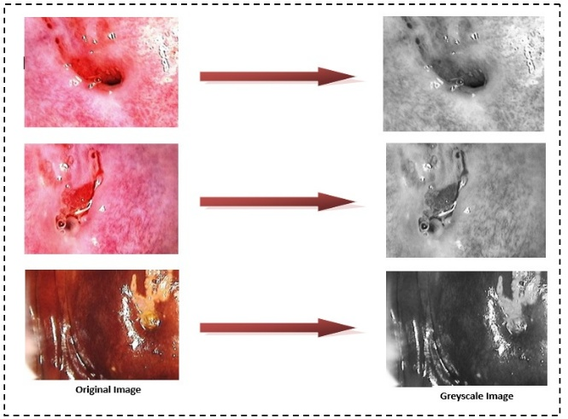
Figure 14. Grayscale conversion

In this project, thresholding plays a vital role in creating masks that identify specular reflection (SR) regions in colposcopic images. Initially, a thresholding technique is applied to convert grayscale images into binary masks, where pixel values above a specific intensity level (e.g., 230) are marked as SR regions. This binary mask serves as a foundation for detecting reflective artifacts, isolating areas of interest from the surrounding cervical tissue.
The U-Net model further refines this process by learning to segment SR regions directly from the images. Using the binary masks generated through thresholding as ground truth during training, the U-Net architecture captures spatial patterns and relationships within the image. Its encoder-decoder structure ensures the model can accurately identify SR regions, even in complex cases with varying lighting and tissue textures.
The combination of thresholding and U-Net-based segmentation enables the creation of precise and consistent masks that are critical for inpainting. These masks not only highlight SR regions but also help maintain the anatomical integrity of the surrounding tissue, ensuring the reconstructed images are suitable for clinical analysis and diagnosis.
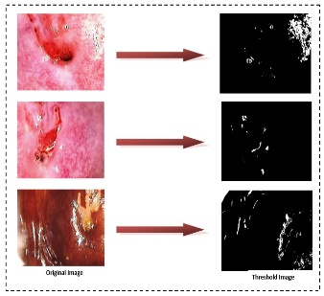
Figure 15. Mask creation

Contours detection is a crucial step in this project for accurately localizing specular reflection (SR) regions in colposcopic images. Initially, binary masks are generated through preprocessing steps like thresholding, highlighting the brightest areas corresponding to SR artifacts. These masks are then refined to delineate the precise boundaries of the SR regions, which is essential for ensuring accurate inpainting and preserving surrounding tissue details.
The U-Net model enhances the contours detection process by learning to segment SR regions with high precision. During training, the model uses binary masks as ground truth to identify spatial patterns and structures within the images. Its encoder-decoder architecture captures multi-scale features, enabling the model to predict finely detailed contours around SR regions. Skip connections between the encoder and decoder layers ensure that both global context and local details are preserved, resulting in accurate and consistent boundary predictions.
By leveraging U-Net for contours detection, the project achieves robust and automated segmentation of SR regions. This automated process eliminates the need for manual intervention, reduces errors, and ensures that the detected contours are suitable for subsequent inpainting steps, ultimately enhancing the quality and usability of the processed images for clinical analysis.
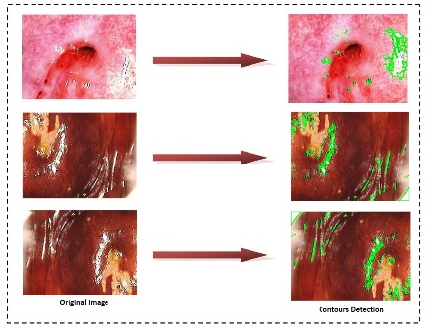
Figure 16. Contours detection

In this project, inpainting plays a vital role in restoring specular reflection (SR) regions in colposcopic images, ensuring the affected areas are seamlessly reconstructed while preserving anatomical accuracy. The U-Net model is employed for this task, leveraging its encoder-decoder architecture to effectively learn and predict the missing or corrupted regions of the images.
The process begins with the input of colposcopic images alongside their corresponding binary masks, which highlight the SR regions. The encoder extracts multi-scale contextual features from the input image, capturing global and local details essential for understanding the surrounding tissue. These features are passed through the bottleneck layer, where the model synthesizes abstract representations of the SR regions. The decoder then reconstructs the in-painted regions, guided by skip connections that transfer spatial details from the encoder layers. This ensures that the reconstructed regions blend seamlessly with the unaffected parts of the image.
By using U-Net for inpainting, the project achieves realistic and anatomically coherent reconstructions, addressing the limitations of traditional inpainting methods. The model’s ability to generalize across diverse datasets ensures robust performance, making the processed images suitable for clinical analysis and diagnostic purposes
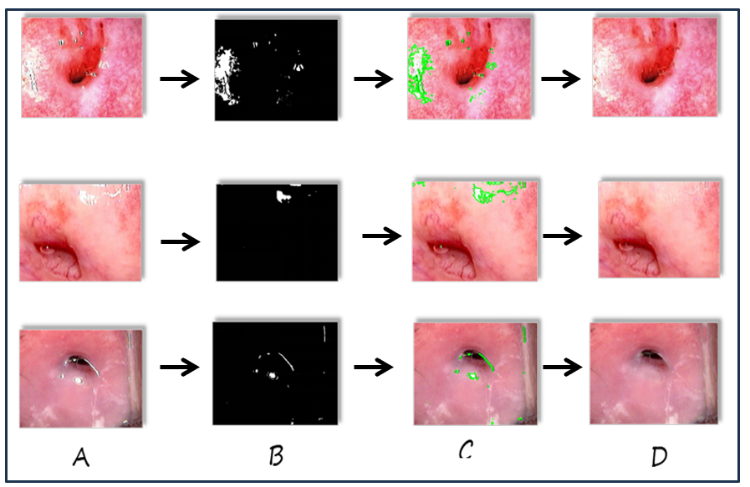
Figure 17. (A)Augmented image, (B)Mask, (C)Annotated image, (D)In-painted Image

6. Summary and Conclusion
6.1. Summary of Achievement
In this project, we successfully implemented an advanced image inpainting system using Generative Adversarial Networks (GAN) and U-Net models, addressing the challenge of specular reflection (SR) in colposcopic images. Specular reflection refers to the bright spots caused by light reflecting off moist surfaces, which can obscure critical anatomical details in medical images. The system was designed to accurately detect and reconstruct missing or corrupted regions, ensuring visual coherence and preserving anatomical integrity. By leveraging the strengths of GANs for generating realistic textures and U-Net’s precise segmentation capabilities, the project achieved robust and consistent results. The GAN model excels at reconstructing SR-affected regions by producing visually coherent and lifelike textures, while the U-Net model ensures accurate localization and segmentation of these regions. This combination allows for seamless integration of reconstructed areas with the original image, balancing realism with anatomical precision.
To enhance model training and generalization, data augmentation techniques were employed, significantly expanding the dataset and introducing variations in orientation, brightness, and structure. These included methods such as horizontal and vertical flipping, random rotations within a range of ±30 degree, and controlled cropping to focus on regions of interest while removing irrelevant areas. These augmentations ensured the models could handle diverse real-world scenarios effectively. This ensured the models could handle diverse real-world scenarios effectively. Performance metrics, including Structural Similarity Index (SSIM), pixel-wise accuracy, and visual comparisons, were used to rigorously evaluate the models, demonstrating their reliability and efficiency.
A streamlined and user-friendly pipeline was developed for data preprocessing, model training, and evaluation. This pipeline not only facilitates ease of use but also ensures reproducibility, making the system adaptable for future improvements and applications in medical imaging. The successful integration of advanced machine learning techniques in this project highlights its potential to enhance clinical diagnostics and support better healthcare outcomes.

6.2. Difficulties Encountered During the Project
- Dataset Preparation: Managing and preprocessing datasets with multiple subfolders and formats required significant effort.
- Model Training: Ensuring compatibility between architectures (GAN and U-Net) involved multiple debugging sessions, especially in handling mismatched dimensions and loading pre-trained weights.
- Inpainting Quality: Achieving visually appealing inpainting results require fine-tuning hyperparameters and experimenting with different architectures.
- Resource Constraints: Training GANs is computationally intensive and require optimizing resources to avoid prolonged runtimes.
6.3. Future Scope of the Project
- Enhanced Models: Exploring state-of-the-art transformers or diffusion models for inpainting could yield better results.
- Real-Time Inpainting: Developing lightweight models for faster inpainting to enable real-time applications.
- Generalization: Extending the model to work across diverse datasets and use cases, such as medical imaging and video inpainting.
- Interactive Interface: Building an interactive GUI for user-friendly inpainting and visualization.
- Hybrid Approach: Combining GANs and diffusion models to improve both visual quality and computational efficiency.

6.4. Limitations of the Project
- Data Dependency: The quality of the inpainting heavily depends on the availability and diversity of the dataset.
- Processing Time: Despite optimization, the inpainting process remains computationally expensive for large datasets.
- Edge Cases: The model struggles with extreme variations, such as highly complex textures or irregular shapes.
- Model Scope: GANs are sensitive to mode collapse, which can reduce the diversity of generated outputs.

6.5 Conclusion

This project set out to solve a common challenge in medical imaging: the issue of specular reflection (SR) in colposcopic images. These bright spots, caused by light reflecting off moist surfaces, can obscure important anatomical details, making it difficult for clinicians to analyze images accurately. To address this, we built a pipeline using Generative Adversarial Networks (GAN) and U-Net models to detect and restore SR-affected regions effectively.
The U-Net model played a key role in precisely identifying the SR regions. Its encoder-decoder design allowed us to capture both the overall structure and fine details of the images, ensuring consistent segmentation across various datasets. For restoring the affected areas, GANs stepped in with their ability to generate realistic textures that blend seamlessly with the surrounding tissue. By combining the strengths of both models, we achieved a system that not only reconstructs the images but also preserves their visual and anatomical integrity.
To make the models more adaptable to real-world conditions, we applied data augmentation techniques like flipping, rotation, and cropping. These techniques expanded our dataset and introduced variability, helping the models perform well even with complex and diverse inputs. We evaluated their performance using metrics such as the Structural Similarity Index (SSIM), pixel-wise accuracy, and side-by-side visual comparisons. While U-Net excelled at maintaining structural accuracy, GANs shined in creating lifelike textures, making them a perfect pair for this task.

References
[1] El Meslouhi, Othmane, et al. "Automatic detection and inpainting of specular reflections for colposcopic images." Central European Journal of Computer Science 1 (2011): 341-354.
[2] Wang, Xiaoxia, et al. "Detection and inpainting of specular reflection in colposcopic images with exemplar-based method." 2019 IEEE 13th International Conference on Anti-counterfeiting, Security, and Identification (ASID). IEEE, 2019.
[3] Wang, X., Li, P., Lv, Y., Xue, H., Xu, T., Du, Y. and Liu, P., 2021. Integration of global and local features for specular reflection inpainting in colposcopic images. Journal of Healthcare Engineering, 2021(1), p.5401308.
[4] Jimenez-Martin, L., Pérez, D.A.V., Asteasuainzarra, A.M.S., Leonard, L. and Díaz-Romañach, M.L.B., 2021. Specular reflections removal in colposcopic images based on neural networks: Supervised training with no ground truth previous knowledge. arXiv preprint arXiv:2106.02221.
[5] Mukku, L. and Thomas, J., 2023, April. A Specular Reflection Removal Technique. In 2023 IEEE International Conference on Contemporary Computing and Communications (InC4) (Vol. 1, pp. 1-5)

Parimala Tamang
Detection and in-painting of Specular Reflection in Colposcopic images
 Quick Submit  Quick Submit
 Sikkim Manipal University

Document Details

Submission ID trn:oid:::1:3247919736

37 Pages

7,502 Words

33,774 Characters
Submission Date
May 12, 2025, 9:57 PM GMT+5:30

Download Date
May 12, 2025, 10:02 PM GMT+5:30

File Name ai_test.docx
File Size
3.3 MB

9% Overall Similarity
The combined total of all matches, including overlapping sources, for each database.

Match Groups
 46 Not Cited or Quoted 9%
Matches with neither in-text citation nor quotation marks

0 Missing Quotations 0%
Matches that are still very similar to source material

0 Missing Citation 0%
Matches that have quotation marks, but no in-text citation


0 Cited and Quoted 0%
Matches with in-text citation present, but no quotation marks
Top Sources

5% |   Internet sources
5% |   Publications
3% |  Submitted works (Student Papers)

Integrity Flags
0 Integrity Flags for Review

Our system's algorithms look deeply at a document for any inconsistencies that would set it apart from a normal submission. If we notice something strange, we flag it for you to review.

A Flag is not necessarily an indicator of a problem. However, we'd recommend you focus your attention there for further review.
No suspicious text manipulations found.

