Our first machine learning algorithm will be decision trees. A decision tree is a very common algorithm that we humans use to make many different decisions. You may be using one without realizing it. Here are some examples of decision trees.
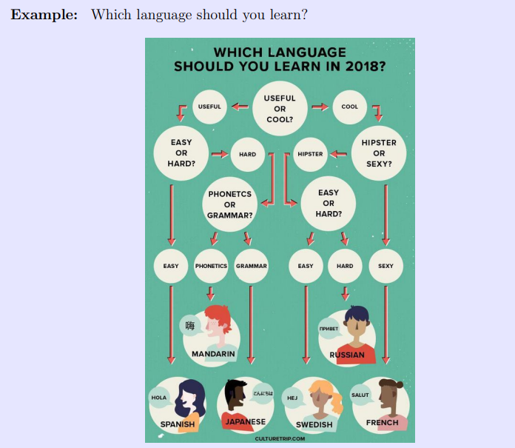

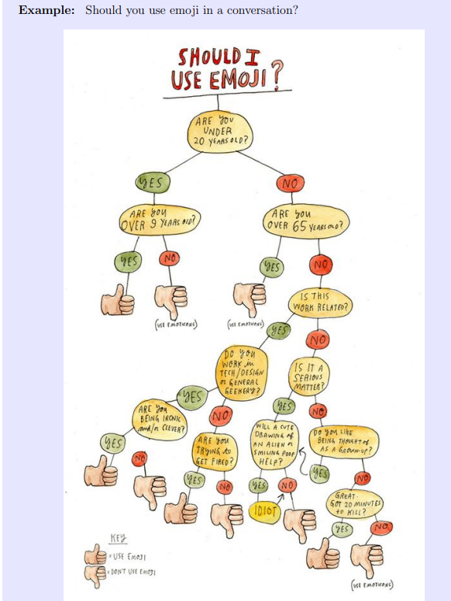
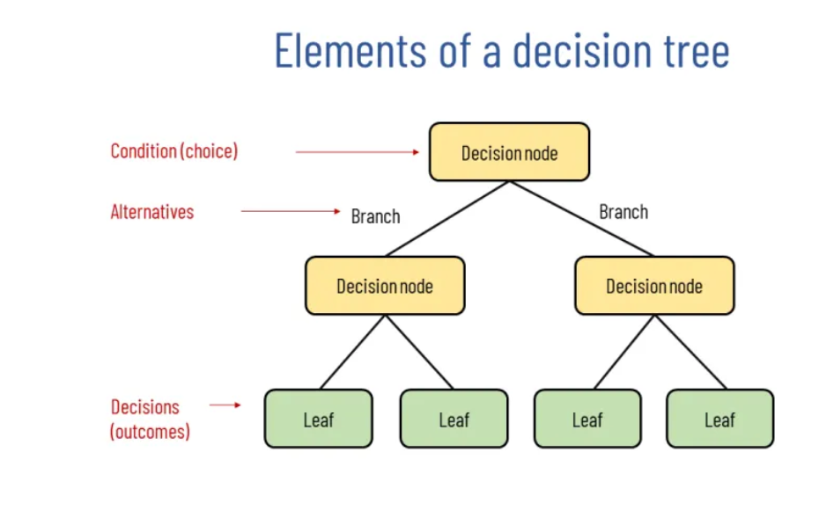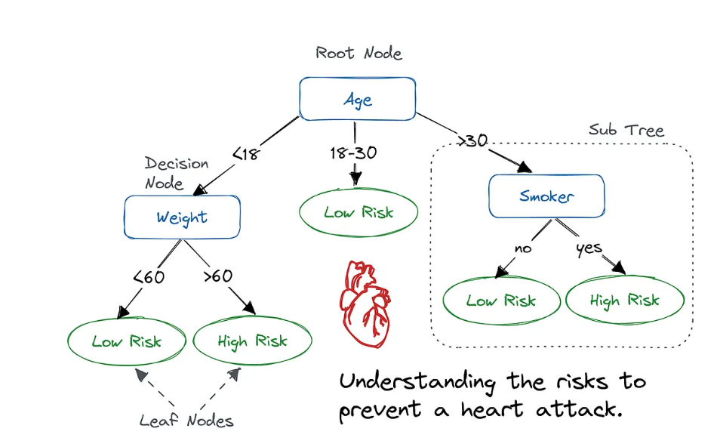

Type
- Classification Trees: Used when the target variable is categorical.
- Regression Trees: Used when the target variable is continuous.

Mathematics
The core of a decision tree lies in partitioning the dataset using splitting criteria:
Gini Impurity:
Gini Impurity is a measure of how often a randomly chosen element would be incorrectly classified. It ranges between 0 (perfectly classified) and 0.5 (worst classification).
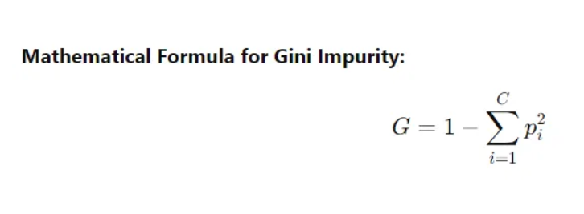
Intuition:
- Gini = 0 means the node is pure, i.e., all instances belong to the same class.
- The more diverse the classes are in a node, the higher the Gini Impurity.

Entropy:
Entropy measures the amount of disorder or uncertainty in the data. The higher the entropy, the more mixed or uncertain the data is, and the lower it is, the purer the data.
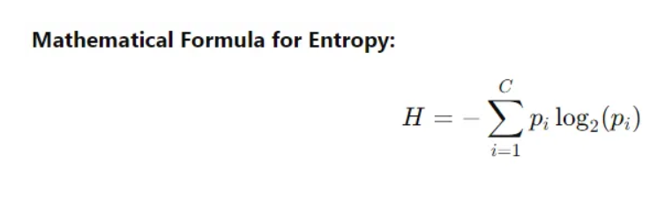
= probability
Intuition:
- Entropy = 0 means the node is pure (no uncertainty).
- The more mixed the classes are in a node, the higher the entropy.

Mathematical Equation
- For regression trees:

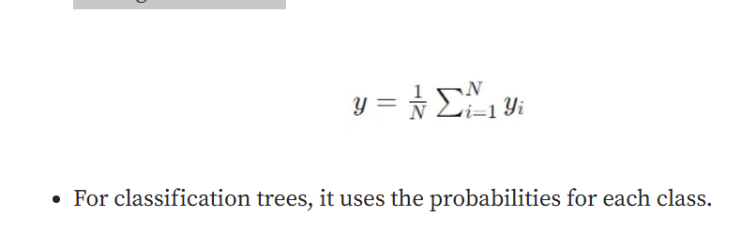Comparing Gini Impurity and Entropy
Both Gini and Entropy help decide the best splits in a decision tree. Lower values are preferable as they indicate higher purity. Gini tends to be computationally faster, while Entropy can be more informative, especially when there’s a mix of class distributions.
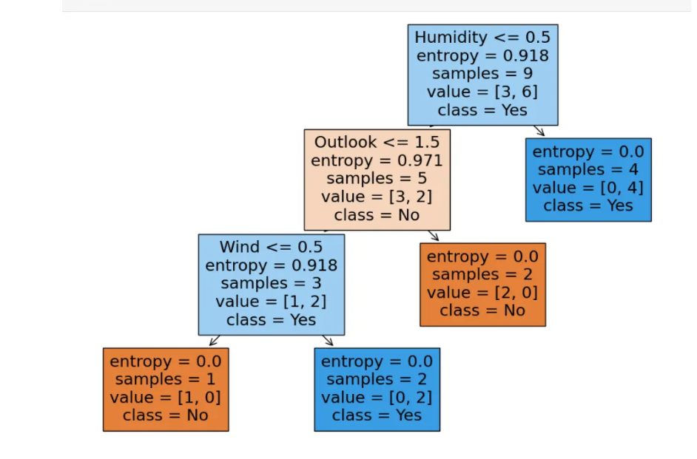

Steps:
Step 1: Load and Preprocess the DataBefore any calculations happen, the raw text and email features are converted into structured numbers). 