E COMMERCE
The term ‘electronic commerce’ has evolved from electronic shopping, to imply all aspects of business and market processes enabled by the Internet and World Wide Web technologies.
DEFINITION- Sharing business information, maintaining business relationships and conducting business transactions using computers connected to a telecommunication network is called E-Commerce.
OR
The exchange or buying and selling of commodities on a large scale involving transportation from place to place is known as commerce. When all this is done electronically, it is known as “e-commerce”.
According to Philip Kotler:
E-commerce can be defined as a general term for buying and selling process that is supported by electronic means.
Electronic commerce, also known as e-business, a term for all kinds of business that are established electronically especially over the Internet. This includes both electronic sale (internet shops) and B2B transactions, i.e. business between two companies. It is any online transaction of buying and selling where business is done via Electronic Data Interchange (EDI).

E-Commerce can be defined from different perspectives –
1. Communications perspective,
2. Business process perspective,
3. Service perspective and
4. Online perspective.
E-commerce from communication perspective is the delivery of information, products or services, or payments via telephone lines, computer networks, or any other means-commerce from business perspective, is the application of technology toward the automation of business transaction and workflows.
E-commerce from service perspective is a tool that addresses the desire of firms, consumers and management to cut service costs while improving the quality of goods and increasing the speed of service delivery.
Ecommerce from online perspective provides the capability of buying and selling products and information on the Internet and other online services.

Basic Benefits of E-Commerce
The major benefits are increasing sales and decreasing costs. The other benefits are as follows:
1. Increased accessibility to customers
i) Allows people to carry out operations without barriers of time i.e. 24 hours a day, seven days a week.
ii) To reach out to global consumers easily and is also cost effective.
iii) It helps business to reach out new markets.
iv) Consumers and suppliers can be directly approached over the Internet.
v) Acquisition of new consumers over the internet is considerably cheaper.
2. Convenience of making comparisons: E-commerce helps consumers to make comparisons while shopping. Automated online shopping assistants called hopbots score are available to find deals on anything from flowers to perfume.

3. Increased Profitability
i) The direct cost to sale for an order taken from an web site is lower as compared to traditional means. Moreover processing errors are virtually eliminated in e-selling besides being faster and more convenient to visitor.
ii) It provides the solution by decimating the costs, which are incurred.

4. Innovation:
E-commerce enables business organization to create new products or services.

5. Improvement in consumer service:
There is a direct benefit in improvement of consumer service. High levels of customer satisfaction generate increased sales and increased profits.

6. Tangible advantages:
From the buyer’s perspective e-commerce provides a lot of tangible advantages:
i. Reduction in buyers sorting out time
ii Better buyer decisions.
iii. Less time spent in resolving invoice and order discrepancies.
iv. Increased opportunities for buying alternative products.

7. Strategic Benefits:
It helps to reduce delivery time, labour cost and also the cost incurred in the following areas:
i) Document preparation. ii) Error detection and correction.
iii) Reconciliation. iv) Mail Preparation.
v) Telephone calling. vi) Data Entry.
vii) Overtime. viii) Supervision Expenses.

- Write Example of E-commerce Applications?
• RETAIL STORES - Books, Music
• AUCTION SITES
• COOPERATING BUSINESSES –Placing orders, paying invoices etc.
• ELECTRONIC BANKING
• BOOKING TICKETS - TRAINS, CINEMA, AIRLINES
• ELECTRONIC PUBLISHING
• FILLING TAX RETURNS WITH GOVERNMENT DEPT.

- Describe the History of E-commerce?
E-commerce began before personal computers were prevalent and has grown into a multibillion dollar industry. By looking at the evolution of e-commerce, it will be easier to judge its trends for the future.
Year Event
1984 EDI, or electronic data interchange, was standardized through ASC X12. This guaranteed that companies would be able to complete transactions with one another reliably.
1992 CompuServe offers online retail products to its customers. This gives people the first chance to buy things off their computer.
1994 Netscape arrived. Providing users a simple browser to surf the Internet and a safe online transaction technology called Secure Sockets Layer.
1995 Two of the biggest names in e-commerce are launched: Amazon.com and eBay.com.
1998 DSL, or Digital subscriber Line, provides fast, always on Internet service to subscribers across California. This prompts people to spend more time, and money online.
1999 Retail spending over the Internet reaches $20 billion, according to Business.com.
2000 The U.S government extended the moratorium on Internet taxes until at least 2005.

Features of e-Commerce:
• E-Commerce is doing business online and electronically. E-Commerce is about buying and selling products and services on the Internet.
• The sellers are individuals, small businesses or large corporations.
• The buyers are consumers or businesses.
• Payment can be made by credit or debit card, money order, cash, check, services or trade.
• E-Commerce helps in lowering both order taking cost and customer service costs.
• The ranges of things that can be sold using e-commerce is enormous and include art, apartment, antennas, batteries, bicycles, books, cars, cells phones, computer, cosmetics and whatever else can change hands.

Types of e-Commerce Systems or EC business Model:
E-Commerce can be categorized in the following ways:-

I. B2C (Business to Consumer) –
This is most common form of ecommerce. These systems allow businesses to sell goods and services to consumers via the internet. Group of these online shop-fronts are called e-malls and are essentially online shopping centres.
In B2C e-commerce companies sell goods to consumers online in a dynamic environment. Each transaction under B2C represents an individual buying online.
Some examples: - Conducting individual stock trades, a co. offering lots of books for sale on its web site. An example of B2C model is Amul.com which sells Amul branded products online.
Steps in B2C E-commerce
- Customer uses a browser and locates vendor or he has vendor's web page address
- Sees Vendor's web page listing of items available, prices etc
- Customer selects item and places order. Order may include credit card details or may be cash on delivery
- Vendor checks with credit card company customer’s credit
- Credit card company OKs transaction
- Vendor acknowledges Customer’s order and gives details of delivery date, mode of transport, cost etc
- Vendor orders with distributor who ships item to vendor's warehouse from where item supplied to customer
- Customer's credit card company debits his account, credits vendor's account and sends bill to customer for payment.
II. B2B (Business to Business) –
These systems are designed for businesses to collaborate or sell goods and services to each other. In the past EDI was conducted on a direct link of some form between the two businesses where as today the most popular connection is the Internet.
The two businesses pass information electronically to each other. B2B e-commerce currently makes up about 94% of all e-commerce transactions.

Some of the advantages of B2B are:
- Improved customer satisfaction
- Improved inventory system
- Easy and cost effective marketing
- Coordination between manufacturers, distributors and dealers.
- Better management of business
Implementing B2B E-commerce-requirements
- Agreed on formats for Purchase order, delivery note, payment order etc. Standard known as EDI (Electronic Data Interchange Standard) is used to send documents electronically.
- Each Business must have corporate intranet and the two nets are connected by PSTN or leased line.
- Transactions must be secure - particularly if PSTN is used.
- Secure electronic payment methods are required.
III. B2B2C (Business to Business to Consumer) –
These systems are merely combinations of B2B and B2C systems designed to manage the whole supply chain from the consumer through to raw material providers. They are design to process orders from consumers and then use this information to place orders with wholesalers and ultimately manufacturers.
IV. G2B or G2C (Government to Business or Government to Consumer)
These systems involve the government providing services to business and consumers. These services may range from the online provision of information through to electronic lodgement of forms or tax returns.
V. location based commerce (L-Commerce)-
M comm. transaction targeted to individual in specific location at specific time.
VI. C-Commerce-(Collaborative Electronic Commerce)-
EC model in which individual or group communicate or collaborative online.

Advantages, disadvantage and Limitation of E-commerce

Advantages of EC -
1. Buying/selling a variety of goods and services from one's home or business.
2. Anywhere, anytime transaction.
3. Can look for lowest cost for specific goods or service.
4. Businesses can reach out to worldwide clients - can establish business partnerships.
5. Order processing cost reduced.
6. Electronic funds transfer faster.
7. Supply chain management is simpler, faster, and cheaper using ecommerce. We can order from several vendors and monitor supplies.
- Production schedule and inventory of an organization can be inspected by cooperating supplier who can in-turn schedule their work.

Disadvantages of E-commerce
1. Electronic data interchange using EDI is expensive for small businesses.
2. Security of internet is not very good - viruses, hacker attacks can paralise e-commerce.
3. Privacy of e-transactions is not guaranteed.
4. E-commerce de-personalises shopping. People go shopping to meet others - window shop and bargain.

Limitations of E-commerce
Technical Limitation -
1. Lack of universally accepted standards for quality, security, and reliability.
2. Insufficient telecommunications bandwidth.
3. Still-evolving software development tools.
4. Difficulties in integrating the Internet and EC software with some existing (especially legacy) applications and databases.
5. Need for special Web servers in addition to the network servers.
6. Expensive and/or inconvenient Internet accessibility for many would-be users.
Non technical -
1. Unresolved legal issues
2. Lack of national and international government regulations and industry standards.
3. Lack of mature methodologies for measuring benefits of and justifying EC.
4. Many sellers and buyers waiting for EC to stabilize before they take part.
5. Customer resistance to changing from a real to a virtual store. People do not yet sufficiently trust paperless, faceless transactions.
6. Perception that EC is expensive and unsecured.
7. An insufficient number (critical mass) of sellers and buyers exists for profitable EC operations.

E-commerce System Architectures

LOGICAL LAYERS | SERVICES IN LAYER
Application layer | B2B,B2C,C2C
Middleman services | Hosting services, value added nets  payment services, Certificates
Secure messaging | Encryption, EDI, Firewalls
World wide web services | HTTP, HTML, XML, OLE Software agents
Logical network | Intranet, internet, extranet
Physical network | PSTN, LAN, Bridges, routers

Framework of e-commerce
Framework tells about the detail of how e-commerce can take place. It defines actually how e-commerce implemented, how online trading or business can be done. It defines important components that should be present to do some transaction.
The important components of this framework are:
      - Network Infrastructure
- Network Infrastructure is called as “INFORMATION SUPERHIGHWAY” is the path through which actual information flows and moves between sender and receiver.
- Information Superhighway consists of telecommunication companies that provide telephone lines.
- Cable TV systems that provide coaxial cables and direct broadcast satellite networks.
- Wireless companies that provide mobile radio and satellite networks.
- Computer networks include private networks and public data networks like the Internet.
All these modes of communication are interconnected. They are connected with routers, switches, bridges, gateways etc which are devices to connect similar and different network. All the information flow on these lines and through these devices and reach the desired destinations.

      - Multimedia Contents and Network Publishing -
The Information Superhighway is the transportation foundation that enables the transmission of content. The most prevalent architecture that enables networking publishing is the World Wide Web. The web allows small businesses and individuals to develop content in the form of Hypertext Mark-up Language (HTML) and publish it on a web server. Web provides a means to create product information (content) and a means to publish it in a distribution centre. (Network server).

      - Messaging and Information Distribution Infrastructure
The information content transferred over the network consists of text, numbers, pictures, audio and video. But the network does not differentiate among content as everything is digital that is, combinations of zero’s and ones. Once contents has been created and stored on a server, messaging and information distribution methods carry that content across the network.
Messaging vehicle is called middleware software. Messaging and information distribution include translators that interpret and transforms data formats.
      - Common Business Services Infrastructure
This infrastructure includes the different methods for facilitating online buying and selling processes. In online commerce, the buyer sends an electronic payment as well as some remittance information to the seller.
Settlement occurs when the payment and remittance information are authenticated by the seller and accepted as valid. In order to enable online payment for information and ensure its safe delivery, the payment services infrastructure needs to develop encryption (making contents indecipherable except for the intended recipient) and authentication (making sure that customers are who they say they are) methods that ensure security of contents travelling on the network.
      - Public Policy and Technical Standards
Public Policy and Technical Standards are two support pillars for all e-commerce applications and infrastructure. Public policy related to e-commerce encompasses such issues as universal access, privacy and information pricing. Technical Standards dictate the specifics of information publishing tools, user interfaces and transport.
Standards are essential to ensure compatibility across the entire network of world.
These are the main components of framework of e-commerce. By following all these trade can be done efficiently on the network. There are many applications of e-commerce which work on this framework.
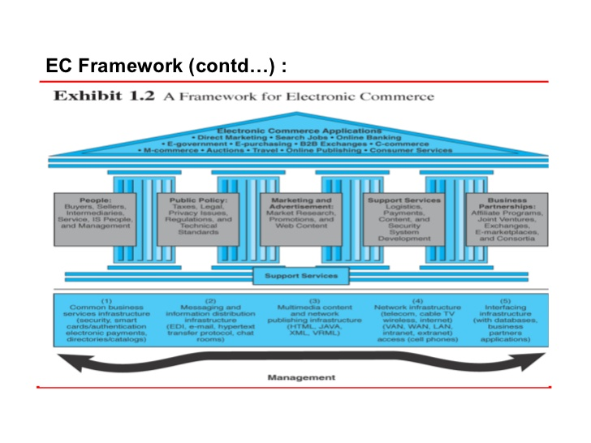
Barrier of EC-

Anatomy of E-Commerce applications
E-Commerce applications are:
1. Multimedia Content for E-Commerce Applications
2. Multimedia Storage Servers & E-Commerce Applications
i. Client-Server Architecture in Electronic Commerce
ii. Internal Processes of Multimedia Servers
iii. Video Servers & E-Commerce
3. Information Delivery/Transport & E-Commerce Applications
4. Consumer Access Devices
1) Multimedia Content for E-Commerce Applications
• Multimedia content can be considered both fuel and traffic for electronic commerce applications.
• The technical definition of multimedia is the use of digital data in more than one format, such as the combination of text, audio, video, images, graphics, numerical data, holograms, and animations in a computer file/document.
• Multimedia is associated with Hardware components in different networks.
• The Accessing of multimedia content depends on the hardware capabilities of the customer.
2) Multimedia Storage Servers & E-Commerce Applications:
• E-Commerce requires robust servers to store and distribute large amounts of digital content to consumers.
• These Multimedia storage servers are large information warehouses capable of handling various content, ranging from books, newspapers, advertisement catalogs, movies, games, & X-ray images.
• These servers, deriving their name because they serve information upon request, must handle large-scale distribution, guarantee security, & complete reliability-
i. Client-Server Architecture in Electronic Commerce
• All e-commerce applications follow the client-server model E COMMERCE.
• Clients are devices plus software that request information from servers or interact known as message passing.
• The client server model, allows client to interact with server through request-reply sequence governed by a paradigm known as message passing
• The server manages application tasks, storage & security & provides scalability-ability to add more clients and client devices (like Personal digital assistants to Pc’s.
ii. Internal Processes of Multimedia Servers
• The internal processes involved in the storage, retrieval & management of multimedia data objects are integral to e-commerce applications.
• A multimedia server is a hardware & software combination that converts raw data into usable information & then dishes out.
• It captures, processes, manages, & delivers text, images, audio & video.
• It must handle thousands of simultaneous users.
• Include high-end symmetric multiprocessors, clustered architecture, and massive parallel systems.
iii. Video Servers & E-Commerce
The electronic commerce applications related to digital video will include
1. Telecommunicating and video conferencing
2. Geographical information systems that require storage & navigation over maps
3. Corporate multimedia servers
4. Postproduction studios
5. Shopping kiosks. E COMMERCE
Consumer applications will include video-on-demand.
• The figure which is of video–on demand consist video servers, is an link between the content providers (media) & transport providers (cable operators)
3) Information Delivery/Transport & E-Commerce Applications
• Transport providers are principally telecommunications, cable, & wireless industries.
Transport Routers
Information Transport Providers Information Delivery Methods
• Telecommunication companies long-distance telephone lines; local telephone lines
• Cable television companies Cable TV coaxial, fiber optic & satellite lines
• Computer-based on-line servers Internet; commercial on-line service providers
• Wireless communications Cellular & radio networks; paging systems
4) Consumer Access Devices -
Information Consumers Access Devices
• Computers with audio & video Personal/desktop computing capabilities
mobile computing
• Telephonic devices Videophone
• Consumer electronics Television + set-top box Game systems
• Personal digital assistants (PDAs) Pen-based computing, voice-driven computing

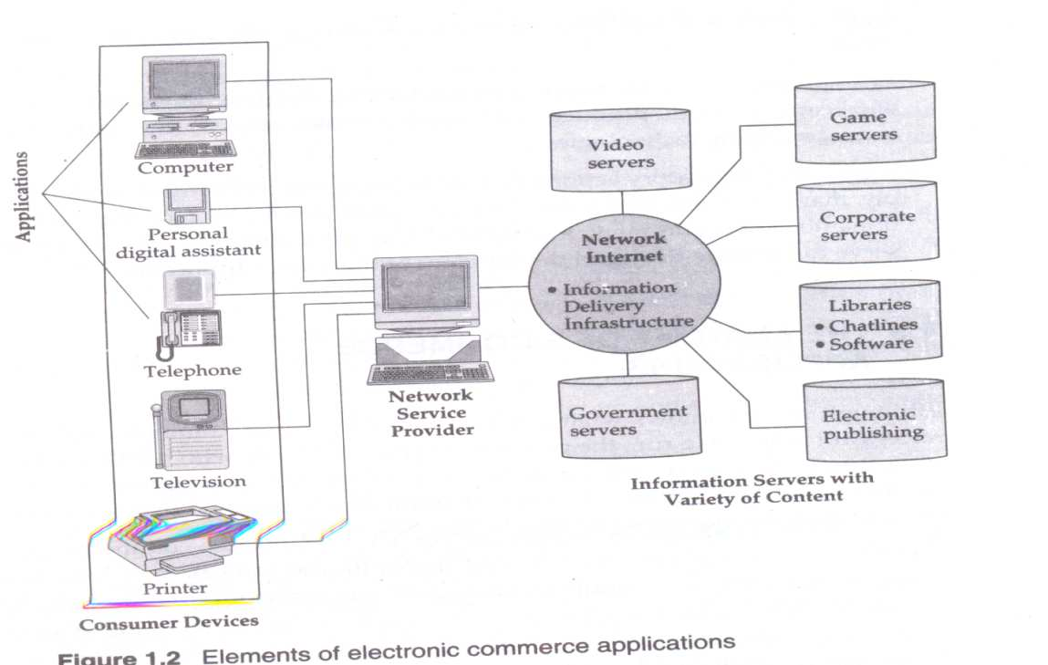

CONSUMER-ORIENTED APLLICATIONS
  - The wide range of applications envisioned for the consumer marketplace can be broadly classified into:
(i) Entertainment
(ii) Financial Services and Information
(iii) Essential Services
(iv) Education and Training
Consumer Life-Style Needs Complementary Multimedia Services
• Entertainment Movies on demand, video cataloging, interactive Ads, Multi-user games, on-line discussions.
• Financial Services & News Home Banking, Financial services, Information,
• Essential Services Home Shopping, Electronic Catalogs, telemedicine, remote diagnostics.
• Education and Training Interactive education, multi-user games, video conferencing, on-line databases.

