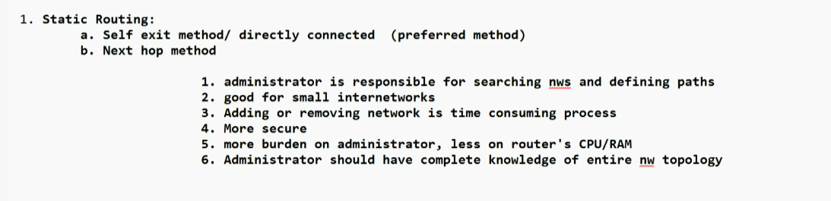

SOFT SKILLS
MOM
minutes of the meeting
create it in word document or Canva mom templates or google
Title with minutes of the meeting along with topic
Ex: fresher induction programme mis batch 153
Need to have box created to add things like
Date, start time, end time, meeting organizer, meeting location: virtual (on teams)
meeting chair (heading the meeting) , meeting title
Two columns where 1 column attendees and other 1 absentee
In column attendees add all the names of the people present and in other all the names of the absent
Agenda / brief discussion points
Summary of the discussion (in pointwise format)
What was the outcome, who is responsible, what is deadline
Meeting Conclusion

Email
Start with salutation
hi, first name
pleasantry (ex how r u, hope you’re doing well)
body of the email - 3 sections
1 section – introduction (ex: hello I am Nishant from batch 153 of CIS )
2 section – facts
3 section – conclusion (must have instruction, what do you want through email correspondence example please go through avoid statements like thank you for your understanding)
signature line (only regards)

the activity is that​‌
as a team we need to design a dream office for the client​‌
instrutions are as follows:​‌
2 sets of documents so 1 will be what is achieved , how is achieved , each members task and also blueprint must include cost of material in each of the thing to be included in the budget like cost per unit material use , how good is the model , man power cost(like plumber , electrician), self charges, efficiency of the model , need to create a ppt to present the model​‌
there can be multiple ways to depict
the data should be practical and logical not hypothetical
customer demand and wow factor should be brought
complete data who did what and complete data of all team members should be captured
1st internally and 2nd externally
document all the activities an should have versions
each meeting will be have feedback
a team should have team name and justification of that name
ownership and delivery on time and if you need extra time you should do it professionally or diplomatically
topic is cloud kitchen

so firstly, we need to do is ​‌
explain the company , expertise and key offerings roles and responsibility assigned plan to create professional impression prepare question to see clients answer like requirements ​‌(need to think in every angle)
need to pitch the idea
We don't just design kitchens. We engineer how kitchens work.
Traditional kitchen design often begins with a question:
"Where should we put the equipment?"
We begins with a different question:
"How should the operation work?"
Slide 1 – Budget Breakdown
Good morning everyone.
Based on the client's requirements, we have proposed a total project budget of ₹30 lakhs.
The largest allocation is for kitchen equipment at ₹8.5 lakhs, followed by civil and interior work at ₹5.5 lakhs.
Additional investments are allocated for HVAC, electrical systems, safety measures, IT monitoring, and contingency reserves to ensure smooth and reliable operations.
Slide 2 – Pie Chart
This pie chart shows the distribution of the project budget.
Kitchen equipment accounts for the largest share at 28.3%, as it directly impacts production capacity.
Civil and interior work make up 18.3%, while HVAC, electrical, and plumbing systems support 24×7 operations.
Overall, the budget is balanced to prioritize efficiency, safety, and hygiene.
Slide 3 – Cost Optimization & Risk Analysis
To optimize costs, we recommend bulk procurement, energy-efficient equipment, modular kitchen layout
Key risks include material cost increases, equipment delivery delays, budget overruns,
These risks can be managed through early procurement, multiple vendors, contingency funds.
Slide 4 – Project Feasibility & Financial Highlights
The total project investment is ₹30 lakhs.
With a capacity of over 1,000 meals per day, the estimated monthly revenue is ₹45 lakhs, with an estimated monthly profit of ₹6.75 lakhs.
The expected payback period is approximately 4 to 6 months.
Therefore, Aurexa recommends proceeding with the project as it is financially viable and aligned with the client's operational goals.
Final Closing Line
"In conclusion, our financial plan ensures cost efficiency, operational reliability, and strong long-term profitability while staying within the client's budget."
Quick Justification
- Project Cost: ₹30 Lakhs
“This is our complete project envelope, including implementation, contingency, and ₹2 lakh AUREXA professional charges.”
- Capacity: 1000+ Meals/Day
“This capacity is based on the client's stated requirement. Final equipment sizing will also consider peak-hour demand.”
- Projected Monthly Revenue: ₹45 Lakhs
“Our base calculation assumes approximately 1,000 orders/day × ₹150 average order value × 30 days = ₹45 lakh/month.”
- Estimated Monthly Profit: ₹6.75 Lakhs
“We have considered a preliminary 15% profit margin, giving ₹6.75 lakh on ₹45 lakh monthly revenue.”
- Payback Period: 4–6 Months
“Based on ₹30 lakh investment and ₹6.75 lakh estimated monthly profit, simple payback is approximately 4.4 months, so we present 4–6 months as an indicative range.”

All the documents in word
Create a border around the docs and also create a cover page should have header and footer
page 1 cover page
top right corner client logo
top left corner Capgemini logo
Every document must have page number including cover page
there should be in title at centre
page 2 must have table it should contain document/revision history
it has table revision/version history (example version 1 , 1.1)
next column revision date (the day it is revised)
next column status and description (what u have done in short)
next column author (owner) now if changes are done author name changes
reviewer section : (one of the colleague will review the document)
last column remarks
page 3 table of contents (index page)
all the titles and it should have page number associated with it and it should be hyperlink
page 4 prephase (a short description about the intent of the document, why it is created two organisation name and the topic)
content (brief explanation of the topic)
requirements (s/w and h/w)
prechecks (it is optional sometimes or it is mandatory in some cases)
now can move to procedures
detail steps how the task is performed along with the screenshots (like step 1 then screenshot and then explain what is happening in the screenshot it should have proper grammar for bullet points no circle dots only number)
page 6
post check
check whether the functionality of infrastructure or the activity went viral or not
checking the critical components
Verification
Add confirmation screenshot of the produce you followed like it worked well or not
Conclusion :
what is the outcome of those actions
References
official link of the software used
you have to pretend to be like you are
