Created VM with below specifications:
1 processor, 5GB RAM, 120GB Disk , Windows Server 2016 Datacenter KMS
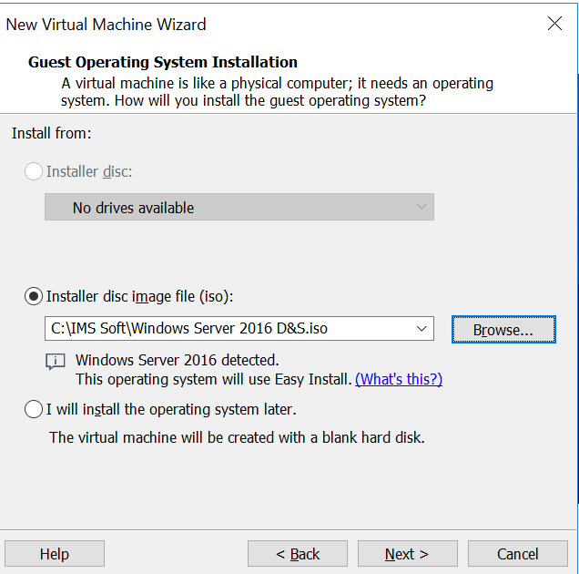
Machine Name: CG-Server1Assigned 1 processor
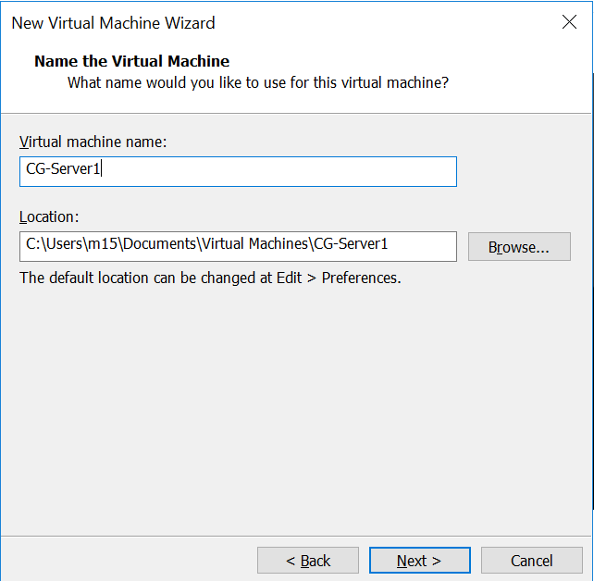
Alloted 1 processor
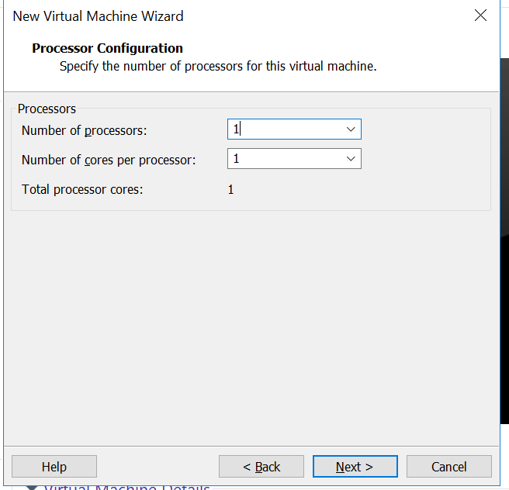
Assigned 5GB RAM
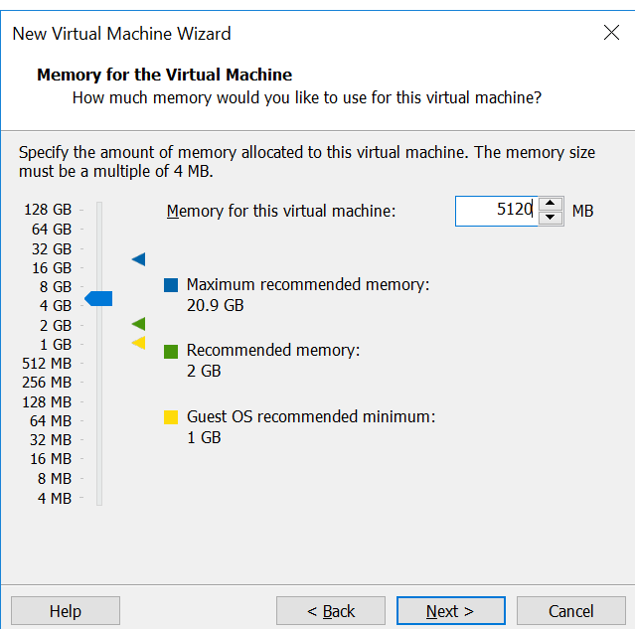

Assigned 120 GB Disk Size
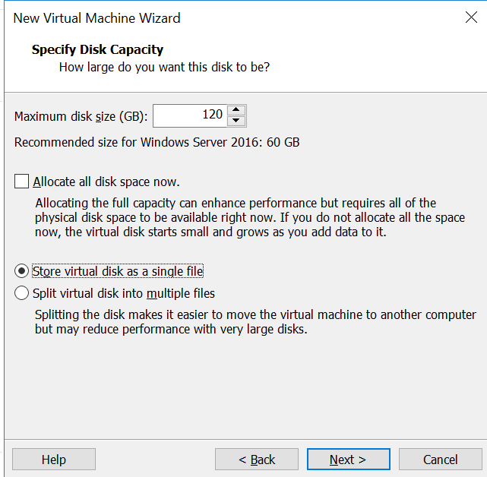
Verifying before creating VM
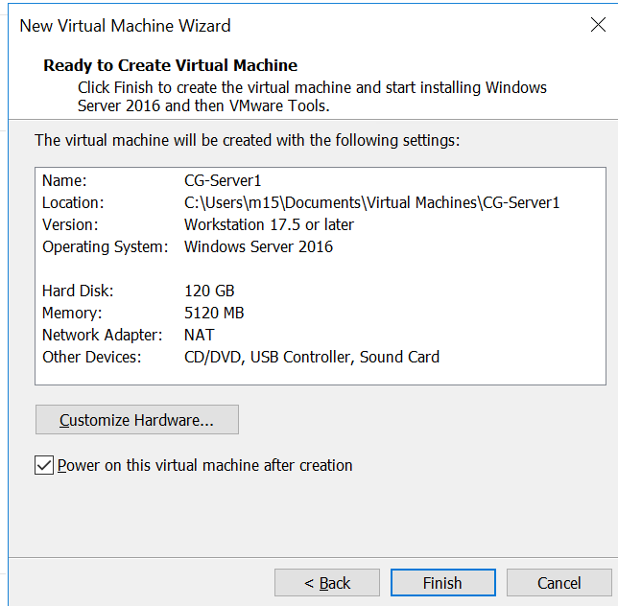
Selected Datacenter (KMS)
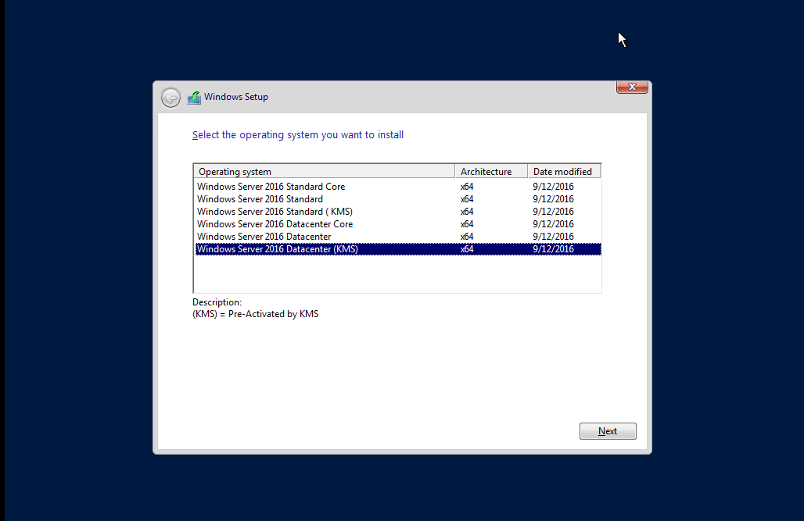

Assigning IP Address and other information
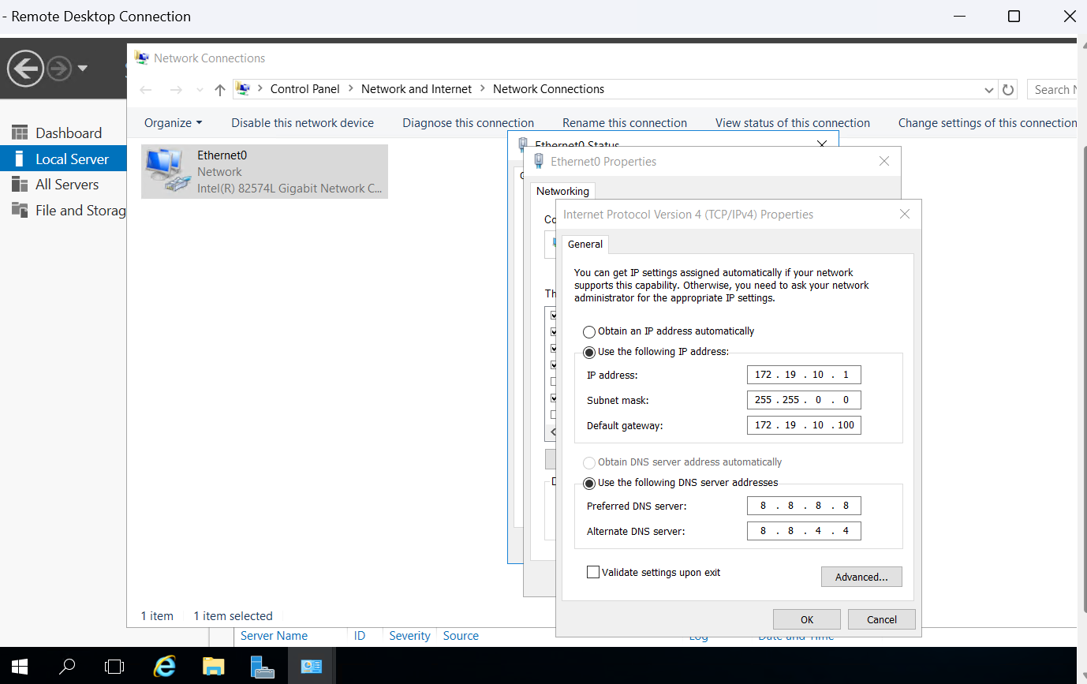
Verification of IP and other information
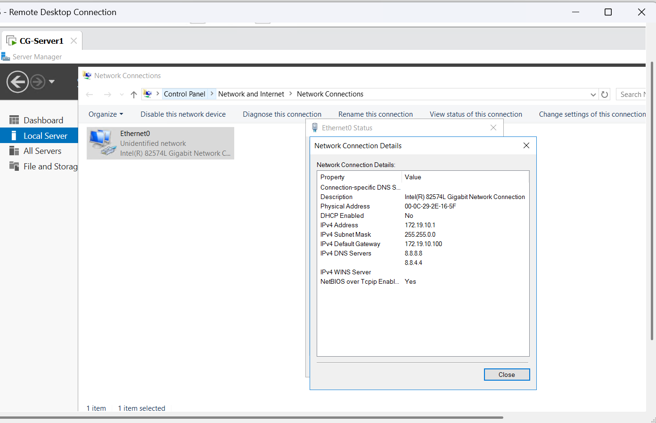
Verified using server manager:
