Report On

# Smart Rover Navigation: Obstacle Pathfinding and Crater Detection

Submitted in partial fulfillment of the requirements

of the degree of

# **Bachelor of Engineering**

by

**Nishant Tanaji Bhandigare (Roll no. 06)**

**Siddhesh Jondhale (Roll no. 63)**

**Supervisor**

**Mr. Sanket Patil**



## Department of Computer Engineering

**Vidyavardhini's College of Engineering & Technology**

## 

## (Affiliated to University of Mumbai)

## (2024-25)

**Vidyavardhini's College of Engineering & Technology**

**Department of Computer Engineering**

**CERTIFICATE**

This is to certify that the project entitled “**Smart Rover Navigation: Obstacle Pathfinding and Crater Detection**” is a bonafide work of “Nishant Tanaji Bhandigare(06), Siddhesh Jondhale(63)” submitted to the University of Mumbai in partial fulfillment of the requirement for the award of the degree of “Bachelor of Engineering” in “Computer Engineering”.

Prof. Sanket Patil

Guide

Dr. Megha Trivedi Dr. Rakesh Himte

Head of Department Principal

**Project Report on Approval for B.E.**

# This Mini Project entitled “**Smart Rover Navigation: Obstacle Pathfinding and Crater Detection”** by Nishant Tanaji Bhandigare(06), Siddhesh Jondhale(63)is approved for the degree of ‘**Bachelor of Engineering’** in in Semester VII of Fourth Year ‘**Computer Engineering’.**

Examiners:

1.________________________

2.________________________

Date:

Time:

**Declaration**

We declare that this written submission represents our ideas in our own words and where other's ideas or words have been included, we have adequately cited and referenced the original sources. We also declare that we have adhered to all principles of academic honesty and integrity and have not misrepresented or fabricated or falsified any idea/data/fact/source in my submission. We understand that any violation of the above will be cause for disciplinary action by the Institute and can also evoke penal action from the sources which have thus not been properly cited or from whom proper permission has not been taken when needed.

--------------------------

Nishant Bhandigare (06)

--------------------------

Siddhesh Jondhale (63)

Date:



Before presenting our project we want to thank some persons who have made great contributions in the completion of our project. First of all, we want to thank Prof. Sanket Patil, our guide for the project. We are thankful to our Principal Dr. Rakesh Himte Sir for providing different facilities. We also express our thankfulness to Dr. Megha Trivedi Ma’am our Head of the Department for help, support and their valuable time whenever required. We are thankful to all the faculty members of our project for giving their valuable suggestions, knowledge to us which help us throughout the project

--------------------------

Nishant Bhandigare (06)

--------------------------

Siddhesh Jondhale (63)

Date:

**Contents**

**Pg. No**

1. Introduction
   1. Problem Statement
   2. Aim & Objective
   3. Scope/Motivation
2. Literature Review
   1. Existing System
   2. Proposed System
3. Project Description

3.1 Modules

3.1.1. Data Acquisition and Preprocessing

3.1.2. Crater and Boulder Detection using Deep Learning

3.1.3. Feature Extraction and Information Attachment

3.1.4. Safe Rover Navigation Path Planning

3.2 Project Scheduling

3.3 Analysis

3.3.1. Functional Requirements

3.3.2.Non Functional Requirements

3.4 H/W and S/W Requirements

1. System Diagram
   1. System Architecture
   2. UML Diagram
   3. DFD Diagram
2. Implementation Methodology
3. Results
4. Conclusion
5. Plagiarism
6. References

**List of Figure**

## 1.Introduction

The exploration of the Moon has been one of humanity’s most ambitious scientific endeavors, with lunar missions playing a crucial role in advancing our understanding of the Moon's surface and geology. Among the numerous challenges faced by lunar missions is the identification and mapping of surface features like craters and boulders, which are critical for both scientific research and the safe landing and navigation of spacecraft and rovers. Detecting these features is especially important when planning landing zones, scientific exploration, and navigation routes, particularly in challenging terrains like the Moon's south pole.

Crater and boulder detection on the lunar surface is a key task in planetary science. Craters, formed by impacts over billions of years, offer insights into the Moon's geological history, while boulders provide clues about surface dynamics and regolith processes. Traditionally, identifying these features in high-resolution images has been a manual and time-consuming process. With the advent of large-scale lunar exploration programs such as India's Chandrayaan missions, automated detection techniques are increasingly important to process the vast amount of data generated. However, due to the varying sizes, shapes, and illumination conditions present in the Orbiter High-Resolution Camera (OHRC) images, accurately detecting craters and boulders poses significant challenges.

To address this, artificial intelligence (AI) and machine learning (ML) techniques offer a promising solution by automating the detection of surface features in an efficient and scalable way. In this project, we aim to develop a model capable of automatically detecting craters and boulders of various shapes and sizes from OHRC images, and attach relevant selenographic information such as position and size to the detected features. The detection results will be output as shapefiles containing polygonal boundary information, enabling accurate surface mapping and further scientific analysis.

In addition to crater and boulder detection, safe navigation for lunar rovers is another critical concern, particularly for missions targeting the Moon’s south pole, a region of scientific interest due to the presence of permanently shadowed areas and potential water ice deposits. The terrain, however, presents significant obstacles in the form of steep slopes, large craters, and scattered boulders. Planning a safe traverse path that avoids these obstacles is essential for the success of rover missions. Using topographic and optical data from Chandrayaan-2, we also aim to generate a safe 100-meter traverse route for a lunar rover starting from a designated landing site, incorporating scientifically significant stops for further investigation.

In this report, we present the methodology, implementation, and results of our automated crater and boulder detection system, along with the generation of a safe navigation path for lunar exploration. The approach leverages the latest advancements in deep learning and image processing, combined with selenographic analysis, to contribute to the ongoing efforts of lunar exploration.

## 1.1Problem Statement

The Moon’s surface is characterized by numerous craters and boulders, formed over billions of years by impacts from asteroids and other celestial bodies. These surface features are crucial for understanding the geological history of the Moon and for planning future lunar missions. However, accurately detecting and mapping these features from high-resolution images, such as those captured by the Orbiter High Resolution Camera (OHRC) on Chandrayaan-2, is a complex task due to several factors:

1. Diverse Shapes and Sizes: Craters and boulders vary significantly in size and shape, from large, well-defined craters to smaller, irregularly shaped boulders. Detecting such varied features in a single image requires advanced algorithms capable of handling this diversity.

2. Illumination Conditions: Lunar images captured by the OHRC often exhibit varying illumination conditions due to the Sun’s angle, which can cause shadows that obscure smaller features or distort the appearance of larger ones. This variation makes it difficult for traditional image processing techniques to consistently identify features.

3. Manual Detection Limitations: Manually identifying and annotating craters and boulders from high-resolution images is labor-intensive, time-consuming, and prone to human error, especially when processing large datasets. The need for an automated system that can efficiently detect these features is essential for enabling faster and more accurate analysis of the Moon's surface.

In addition, as missions focus increasingly on the lunar south pole—a region of great scientific interest due to its unique terrain and potential for water ice deposits—safe navigation becomes a critical challenge.

**1.2Aim and Objective**

The aim of this project is to develop an automated system that leverages artificial intelligence and machine learning techniques to detect craters and boulders of varying shapes and sizes from Orbiter High Resolution Camera (OHRC) images of the lunar surface. The system will also provide key selenographic information such as the position and diameter of the detected features. In addition, the project aims to generate a safe navigation path for a lunar rover on the Moon’s south pole, ensuring obstacle-free traversal while identifying scientifically significant stops along the route.

1. Crater and Boulder Detection:

- Design and implement an AI/ML model that can automatically detect craters and boulders from OHRC images, regardless of their shape, size, or illumination conditions.

- Ensure the model can handle diverse image conditions, including varying shadows and lighting.

- Attach relevant selenographic information, such as the position and diameter, to each detected feature.

- Output a polygonal shapefile containing the boundary information for each detected crater or boulder.

2. Selenoreferencing and Image Processing:

- Selenoreference the OHRC images using the auxiliary data provided, ensuring that the images are aligned with the lunar coordinate system.

- Preprocess the images by applying techniques like noise reduction, contrast enhancement, and edge detection to improve feature visibility.

3. Model Evaluation:

- Evaluate the model’s performance using appropriate metrics such as accuracy, precision, recall, and Intersection over Union (IoU) to measure the detection accuracy of craters and boulders.

- Compare the detected features with the actual craters/boulders present in the image to assess the model’s relevance and effectiveness.

5. Output and Visualization:

- Produce a polygonal shapefile or equivalent representation of the detected craters and boulders, along with their shape-size information and selenographic coordinates.

**1.3 Motivation**

Exploring the Moon's surface is critical for advancing scientific knowledge, enabling human and robotic exploration, and preparing for future space missions. The lunar surface holds valuable information about the history of the Solar System, as well as resources that could support future missions. However, the Moon's rugged and unpredictable terrain presents significant challenges, especially when it comes to safely navigating the surface and identifying key geological features such as craters and boulders.

Craters and boulders, formed by impacts over billions of years, provide valuable insights into the geological evolution of the Moon. The size, shape, and distribution of these features are crucial for understanding both the Moon’s history and its potential for future exploration. Traditional methods of manually detecting and mapping craters and boulders from high-resolution images are labor-intensive, slow, and prone to errors. With the increasing availability of high-resolution data from lunar missions such as Chandrayaan-2, there is a need for more efficient and scalable methods to analyze the surface.

Moreover, upcoming lunar missions, including those aimed at exploring the Moon’s south pole, require careful planning to ensure safe navigation of rovers and landers. The south pole is particularly interesting due to the potential presence of water ice in permanently shadowed regions, which is a key resource for future lunar exploration. However, this region also presents challenging terrain with steep slopes, large craters, and scattered boulders, making it difficult to plan safe rover traverses.

Automating the detection of surface features and the generation of safe navigation paths is essential to overcoming these challenges. Leveraging artificial intelligence (AI) and machine learning (ML) offers the potential to rapidly and accurately detect craters and boulders, while also planning navigation routes that avoid hazardous terrain. By doing so, AI/ML systems can enhance the safety and efficiency of future lunar missions, helping to unlock new scientific discoveries and pave the way for sustainable exploration.

This project is motivated by the desire to contribute to these efforts by developing an AI/ML-based system that can not only detect craters and boulders from Orbiter High Resolution Camera (OHRC) images but also generate a safe navigation route for a lunar rover in the challenging south polar region. Through this work, we aim to support future missions by providing tools for efficient lunar surface analysis and safe navigation, enabling both scientific exploration and potential resource utilization.

**2. Literature review**

The detection of lunar craters and boulders, as well as the planning of safe navigation routes for lunar rovers, has been an area of significant interest within planetary science and exploration. With the increasing volume of high-resolution imagery from lunar missions like Chandrayaan-2, researchers have been focusing on the development of automated methods using AI/ML techniques for surface feature detection and obstacle avoidance. This review explores the existing research in crater and boulder detection, the application of machine learning for image processing, and techniques for planning rover navigation paths.

1. Automated Detection of Lunar Craters and Boulders

Manual identification of craters and boulders on the Moon is a time-consuming task, especially given the scale and complexity of high-resolution imagery. Consequently, numerous approaches leveraging image processing and machine learning have been developed to automate this process. A pioneering study by Silburt et al. (2019) introduced a convolutional neural network (CNN) model for automatically detecting craters in planetary images. Their model was trained on lunar surface data and achieved high accuracy in identifying craters of varying sizes, demonstrating the potential of CNNs in feature detection tasks on planetary surfaces .

Expanding on this approach, Wang et al. (2020) employed a Mask R-CNN model to detect craters of diverse shapes and illumination conditions. This model not only identified craters but also provided boundary information, making it particularly suited for the polygonal shapefile output required in our project. Wang's work emphasized the importance of robust feature extraction, particularly under varying lighting conditions, which can create shadows that obscure smaller craters . This technique is directly applicable to the detection of boulders, which also exhibit irregular shapes and shadows.

Another notable contribution comes from Cohen et al. (2021), who focused on detecting boulders using digital terrain models (DTM) and optical imagery. Their method involved preprocessing the images to enhance the contrast of boulders and applying a gradient-based detection algorithm. The study showed that boulders could be identified even in complex terrains by combining optical imagery with topographic data . This research highlighted the importance of multi-source data integration, a technique that could also enhance the accuracy of our crater and boulder detection model.

2. Challenges in Lunar Image Processing

One of the primary challenges in crater and boulder detection is the variability in illumination conditions caused by the Sun’s position relative to the Moon's surface. This challenge has been addressed in several studies. Bandeira et al. (2012) developed an algorithm to detect craters in shadowed regions by enhancing image contrast and using edge detection techniques. Their study showed that applying advanced preprocessing techniques like histogram equalization and gradient-based filters can improve detection rates in challenging lighting conditions .

Similarly, Di et al. (2014) tackled the issue of illumination variation by developing a robust feature extraction method that incorporated texture analysis in addition to edge detection. This approach was effective in detecting small craters that are often missed by traditional methods, particularly when these features are partially hidden by shadows . These techniques underscore the need for preprocessing steps to improve the visibility of surface features before applying machine learning models.

3. Application of AI/ML in Planetary Image Processing

The use of machine learning for planetary image processing is rapidly evolving, with a focus on deep learning methods that can learn complex patterns from image data. Deep et al. (2020) developed a deep learning-based approach using a U-Net architecture for semantic segmentation of lunar images. Their model was trained to distinguish between different types of lunar terrain, including craters and boulders. The study highlighted the ability of U-Net to capture spatial dependencies and accurately segment irregular features like craters, even in noisy or incomplete data .

Moreover, Stepinski and Urbach (2009) applied a hybrid approach using machine learning combined with a rule-based system to detect craters. Their work was one of the first to introduce ML techniques for planetary surface analysis, showing that a combination of traditional methods and AI can significantly enhance detection accuracy. This hybrid approach could be valuable for incorporating domain-specific knowledge into our crater detection model .

4. Safe Navigation for Lunar Rovers

Navigating the lunar surface presents a unique set of challenges due to the rough and unpredictable terrain, particularly in regions like the south pole. Richards et al. (2020) proposed a method for planning safe navigation routes for lunar rovers using digital terrain models (DTMs). Their work focused on identifying obstacles such as craters and boulders and calculating optimal paths that avoid these hazards. They employed terrain slope analysis and obstacle avoidance algorithms to ensure the rover could traverse safely while maximizing scientific value by visiting key sites .

In a related study, Olson et al. (2017) developed a path-planning algorithm that considered both terrain obstacles and solar illumination conditions. Since lunar rovers are often solar-powered, navigating in shadowed regions can be risky. Their model incorporated real-time Sun position tracking and generated paths that maximized solar exposure while avoiding large obstacles . This approach is relevant to our project, which also requires the rover to navigate the south pole region, balancing safety and scientific exploration.

5. Conclusion from Literature

The literature provides a strong foundation for the development of automated crater and boulder detection systems, particularly through the use of machine learning and image processing techniques. Several studies demonstrate the effectiveness of CNN-based models for detecting surface features, even under challenging illumination conditions. Additionally, the integration of digital terrain models (DTMs) with optical data is shown to improve the accuracy of feature detection and navigation.

**2.1.Existing system**

Current methods for detecting craters and boulders on the lunar surface rely on a combination of manual annotation, traditional image processing techniques, and semi-automated algorithms. While some advancements have been made in automated detection, these systems still face several limitations:

1. Manual Identification: Historically, identifying craters and boulders in lunar images has been a largely manual process. Experts analyze high-resolution images and manually annotate features such as craters, boulders, and other geological formations. While this approach is accurate for specific areas, it is highly labor-intensive, time-consuming, and impractical for large datasets such as those produced by missions like Chandrayaan-2. Manual annotation also introduces the risk of human error and inconsistency across different datasets.

2. Traditional Image Processing: Some existing systems use classical image processing techniques, such as edge detection, thresholding, and morphological operations, to identify craters and boulders. For example, edge detection methods like the Canny and Sobel operators are used to outline craters based on image gradients. However, these methods struggle in complex terrains and under varying illumination conditions, where shadows and lighting can obscure or distort the appearance of surface features. Moreover, these methods require significant parameter tuning and are not adaptable to diverse terrain conditions across different regions of the Moon.

3. Semi-Automated Approaches: Semi-automated crater detection algorithms, such as the Hough Transform for circular feature detection, have been employed in some studies. These approaches are partially successful but are limited to detecting craters that exhibit near-perfect circular or elliptical shapes. They often fail in identifying irregularly shaped craters or boulders, particularly in regions with variable lighting conditions. Additionally, these methods do not integrate well with multi-sensor data, such as combining optical images with topographic data (DTM).

4. Navigation Path Planning: For lunar rover navigation, existing systems primarily rely on manual terrain analysis, where experts visually assess the terrain for obstacles such as craters, boulders, and steep slopes. Some path-planning algorithms based on digital terrain models (DTMs) exist, but they are typically designed for terrestrial environments or lack the level of automation required for large-scale lunar missions. These methods also do not consider real-time solar illumination conditions, which are crucial for solar-powered rovers on the Moon.

Limitations of the Existing System:

- Lack of full automation for crater and boulder detection.

- Difficulty in handling varying lighting conditions, shadows, and irregular feature shapes.

- Inefficiency in processing large datasets due to manual or semi-automated methods.

- Limited integration of multi-sensor data (e.g., optical and topographic data).

- Lack of automated and obstacle-aware path planning for lunar rovers in challenging terrains like the lunar south pole.

Proposed System

**2.2 Proposed System**

To overcome the limitations of existing systems, this project proposes a fully automated solution that integrates AI/ML techniques for detecting craters and boulders from high-resolution Orbiter High Resolution Camera (OHRC) images and generating safe navigation paths for lunar rovers. The proposed system will leverage deep learning models, multi-sensor data fusion, and advanced path-planning algorithms to provide an efficient, accurate, and scalable solution for lunar surface analysis.

1. Crater and Boulder Detection using AI/ML

- The proposed system will employ advanced deep learning techniques, such as convolutional neural networks (CNNs) and semantic segmentation models like U-Net or Mask R-CNN, to automatically detect craters and boulders of varying shapes, sizes, and under different lighting conditions.

- By training the model on annotated datasets of lunar surface images, the system will be able to detect both large and small craters, as well as irregularly shaped boulders, even in challenging illumination conditions.

- The model will output polygonal shapefiles containing the boundaries of detected craters and boulders, along with relevant selenographic information (e.g., position, diameter, and other dimensions).

- The system will also integrate digital terrain models (DTMs) with optical images to improve detection accuracy in regions where surface features may be difficult to discern through optical imagery alone.

2. Preprocessing and Selenoreferencing

- To account for varying illumination conditions and improve detection accuracy, the proposed system will incorporate advanced image preprocessing techniques such as histogram equalization, noise reduction, and contrast enhancement.

- The OHRC images will be selenoreferenced, meaning they will be aligned with lunar coordinates to ensure accurate mapping of craters and boulders to their selenographic positions on the Moon.

3. Evaluation Metrics

- The proposed system will be evaluated using metrics such as precision, recall, accuracy, and Intersection over Union (IoU) to assess the quality of crater and boulder detection. The system will be tested against manually annotated ground truth datasets to ensure high accuracy in detection.

- The system will also be tested in diverse terrain and lighting conditions to validate its robustness across different regions of the lunar surface.

4. Safe Rover Navigation Path Generation

- The proposed system will include an automated path-planning module that generates a safe navigation route for lunar rovers, particularly in the south pole region. This module will integrate data from Chandrayaan-2's Terrain Mapping Camera (TMC), Digital Terrain Models (DTMs), and Optical High-Resolution Camera (OHRC) to analyze the terrain and detect obstacles like craters, boulders, and steep slopes.

- The path-planning algorithm will calculate a minimum 100-meter safe navigation route, avoiding obstacles while incorporating scientific stops at key locations along the path.

- The rover path will consider solar illumination conditions to ensure that the solar-powered rover can avoid shadowed regions while maximizing its exposure to sunlight.

- A minimum of 10 scientifically significant stops will be marked along the rover’s traverse, and the proposed route will include detailed justifications for each stop.

5. Output and Visualization

- The output of the proposed system will include polygonal shapefiles of detected craters and boulders, annotated images/maps, and a rover navigation route marked with key stops and hazard-free paths.

- A detailed report will explain the rationale behind the chosen rover path, taking into account both safety and scientific objectives.

Key Advantages of the Proposed System:

- Full Automation: The system provides a fully automated workflow for detecting craters and boulders, removing the need for manual intervention.

- High Accuracy: By leveraging deep learning and multi-sensor data fusion, the system is expected to achieve high accuracy in feature detection and obstacle avoidance.

- Scalability: The system can efficiently process large datasets from lunar missions, making it suitable for future missions involving extensive surface analysis.

- Safe Navigation: The system ensures that lunar rovers can traverse safely in complex terrains like the south pole while maximizing scientific exploration.

**3. Project Description**

The goal of this project is to develop an automated system for the detection of craters and boulders on the lunar surface using image processing and deep learning techniques. In addition, the system will generate a safe navigation route for lunar rovers, particularly in the challenging terrain of the Moon’s south pole region, utilizing high-resolution images and digital terrain models (DTMs) from lunar missions such as Chandrayaan-2.

1. Crater and Boulder Detection

The first part of the project focuses on automating the detection of craters and boulders of varying shapes, sizes, and illumination conditions from Orbiter High Resolution Camera (OHRC) images. Traditional methods of manually identifying these features are not scalable, especially given the large volume of data generated by lunar missions. This project will leverage advanced artificial intelligence (AI) and machine learning (ML) techniques to automate the process.

A deep learning model, such as Mask R-CNN or U-Net, will be trained to detect both circular and irregularly shaped craters and boulders. The system will be robust against different illumination conditions, accounting for shadows and lighting variations that can obscure surface features. The model will output polygonal shapefiles of the detected craters and boulders, along with key attributes such as the selenographic position, diameter, and boundaries.

The detection process will also involve preprocessing steps to enhance image quality and contrast, including techniques such as histogram equalization and noise reduction. The detected features will be georeferenced to lunar coordinates, ensuring that their positions are accurately mapped for further analysis.

2. Rover Navigation Path Planning

The second part of the project focuses on developing a safe navigation route for a lunar rover, particularly in the south pole region of the Moon. This region presents significant challenges due to its rough terrain, steep slopes, large craters, and scattered boulders. Moreover, solar-powered rovers must avoid permanently shadowed areas to maintain a steady power supply.

The proposed system will use data from Chandrayaan-2’s Terrain Mapping Camera (TMC), Digital Terrain Models (DTMs), and Optical High-Resolution Camera (OHRC) to analyze the surface and identify obstacles like boulders and craters. The system will calculate a path that avoids these hazards, ensuring the rover can traverse a minimum distance of 100 meters while avoiding obstacles and rough terrain.

The path planning algorithm will also take into consideration solar illumination, ensuring that the rover avoids shadowed regions and maximizes sunlight exposure. In addition, the system will mark a minimum of 10 scientifically interesting stops along the path, where the rover can perform experiments or data collection. Each stop will be selected based on geological interest and accessibility, with detailed justifications provided for their inclusion in the navigation route.

3. Data Sources and Preprocessing

The primary dataset for this project will be high-resolution images from the OHRC instrument on the Chandrayaan-2 mission. These images are publicly available in PDS4 format. In addition, digital terrain models (DTMs) from the Terrain Mapping Camera (TMC) will be used to provide topographic data that complements the optical imagery. The combination of these data sources will improve the accuracy of crater and boulder detection and ensure that the generated rover paths account for both visual and topographic obstacles.

Before training the model, the images will undergo preprocessing to improve the quality of feature detection. This includes:

- Image enhancement: Using contrast adjustment, noise reduction, and histogram equalization to enhance image clarity and feature visibility.

- Selenoreferencing: Aligning the images with lunar coordinate systems to ensure accurate mapping of detected features.

- Dataset preparation: Annotating a subset of the OHRC images with ground truth data (manually marked craters and boulders) for model training and testing.

4. System Workflow

The overall workflow for the project consists of the following steps:

1. Data Acquisition: Downloading and preprocessing OHRC and TMC data from the Chandrayaan-2 mission.

2. Preprocessing: Applying contrast enhancement, noise reduction, and selenoreferencing to prepare the data for analysis.

3. Model Training: Training a deep learning model (such as Mask R-CNN or U-Net) on annotated OHRC images to detect craters and boulders.

4. Detection and Annotation: Automatically detecting craters and boulders, generating polygonal shapefiles, and attaching relevant selenographic information (e.g., diameter, location).

5. Path Planning: Using obstacle detection and terrain analysis to generate a 100-meter safe rover navigation path that avoids hazards and maximizes sunlight exposure.

6. Scientific Stop Identification: Marking at least 10 key scientific stops along the rover’s path for data collection and analysis.

7. Evaluation: Assessing the accuracy of crater/boulder detection using metrics like precision, recall, and Intersection over Union (IoU). Evaluating the rover path’s safety and scientific value.

5. Expected Outcomes

The main outputs of the project include:

- Crater and Boulder Detection: Polygonal shapefiles and detailed data on detected craters and boulders, including their size, location, and boundaries.

- Safe Rover Path: A safe and obstacle-free navigation route, extending at least 100 meters, with a minimum of 10 scientifically interesting stops marked along the path.

- Annotated Map: A visual representation of the rover’s path, with craters, boulders, and stops clearly marked for reference.

6. Evaluation and Validation

The detection model will be evaluated using standard metrics such as accuracy, precision, recall, and IoU. These metrics will be computed by comparing the model’s predictions to ground truth annotations in a test set. For the rover navigation system, the path will be evaluated based on obstacle avoidance, adherence to the required distance, and the inclusion of scientifically interesting stops. A successful system will generate paths that are both safe for the rover and scientifically valuable, minimizing the risk of hindrances such as craters and boulders.

7. Applications and Future Scope

This project has significant implications for future lunar exploration missions. By automating the detection of craters and boulders and generating safe navigation paths, the system can streamline mission planning, reduce human error, and improve the efficiency of surface exploration. The techniques developed in this project could be extended to other planetary bodies, such as Mars or asteroids, where surface analysis and navigation are critical for scientific exploration and resource utilization.

**3.1 Modules**

### 3.1.1. Data Acquisition and Preprocessing

### **Objective**: Gather and preprocess the necessary data to ensure it is suitable for model training and analysis.

### **Key Tasks**:

### **Data Downloading**: Retrieve OHRC images and Digital Terrain Models (DTMs) from publicly available datasets (e.g., Chandrayaan-2 mission data in PDS4 format).

### **Preprocessing**: Perform image enhancement techniques such as noise reduction, histogram equalization, and contrast adjustment to improve the visibility of surface features like craters and boulders.

### **Selenoreferencing**: Align the downloaded OHRC images with lunar coordinates using auxiliary information to ensure accurate mapping of detected features.

### **Dataset Preparation**: Annotate a subset of the dataset with ground truth (manually marked craters and boulders) for training and validation purposes.

### 3.1.2. Crater and Boulder Detection using Deep Learning

* **Objective**: Automatically detect craters and boulders of varying sizes and shapes from the preprocessed OHRC images.
* **Key Tasks**:
* **Model Selection**: Choose a deep learning model suitable for object detection and segmentation, such as Mask R-CNN or U-Net. These models are widely used for detecting and segmenting irregular objects in image data.
* **Training the Model**: Train the selected model using annotated images. The model will learn to identify both circular and irregularly shaped craters and boulders.
* **Testing and Validation**: Evaluate the model’s performance on a test set, using metrics like accuracy, precision, recall, and Intersection over Union (IoU) to quantify detection quality.
* **Prediction Output**: The model outputs polygonal shapefiles with boundaries of detected craters and boulders, along with relevant attributes such as size, position, and shape.

.

### 3.1.3. Feature Extraction and Information Attachment

### **Objective**: Attach relevant selenographic information (location, diameter, etc.) to each detected crater and boulder.

### **Key Tasks**:

### **Selenographic Position Calculation**: Compute the selenographic coordinates (latitude and longitude) of each detected feature, ensuring accurate placement on the lunar surface.

### **Size and Shape Analysis**: Measure the diameter, area, and perimeter of each detected crater or boulder, and attach this information to the output shapefile.

### **Shapefile Generation**: Generate a polygonal shapefile for each detected feature, incorporating boundary data and size-related attributes.

### 3.1.4. Safe Rover Navigation Path Planning

### **Objective**: Generate a safe and obstacle-free navigation path for a lunar rover, ensuring it avoids craters, boulders, and other obstacles while maintaining solar exposure.

### **Key Tasks**:

### **Obstacle Detection**: Use the detected craters and boulders to mark obstacles on the terrain, identifying regions that the rover should avoid.

### **Terrain Analysis**: Analyze the terrain using both OHRC images and Digital Terrain Models (DTMs) to assess surface roughness, slope steepness, and potential hazards.

### **Solar Illumination Analysis**: Incorporate solar illumination data to ensure the rover avoids shadowed areas and maximizes its exposure to sunlight, which is critical for solar-powered rovers.

### **Path Generation**: Develop an algorithm to calculate a 100-meter safe navigation path that avoids obstacles while incorporating scientifically interesting stops. The algorithm should generate a clear, efficient route based on the rover’s capabilities and the surface conditions.

## 3.2 Project Scheduling

This is the Gantt chart for the Project, outlining the key phases of development, from initial research and system design to model implementation, testing, and deployment. The chart helps track the progress and milestones across various stages such as the development of YOLO models and the creation of the user interface. Each phase is allocated specific start and end dates to ensure that the project remains on schedule and achieves timely completion, with room for testing and refinement before deployment.

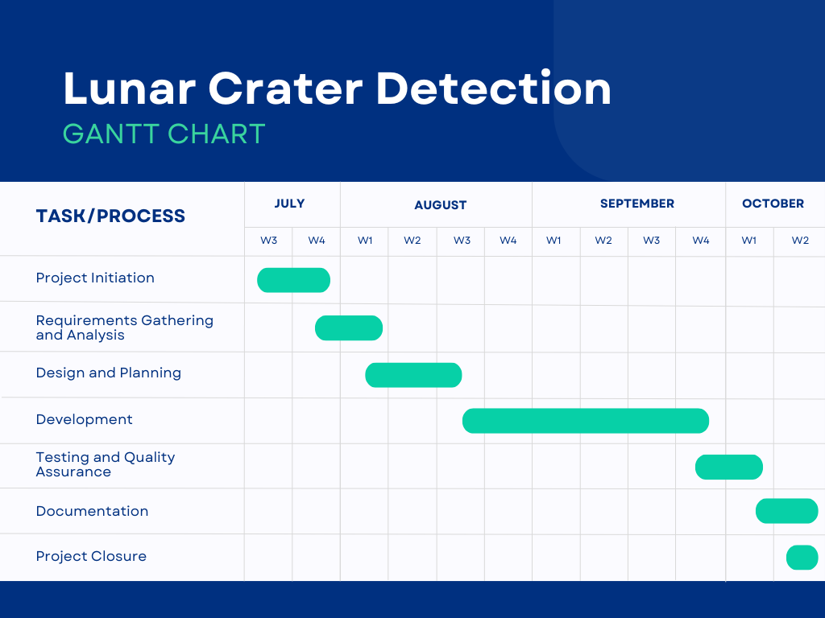

## 3.3 Analysis

The project aims to develop an automated system for detecting craters and boulders on the Moon’s surface using AI/ML techniques and generate a safe navigation path for lunar rovers. This analysis covers the technical strengths, challenges, and potential impacts of the project.

1. Technical Strengths

- Deep Learning in Image Processing: The use of advanced deep learning models like Mask R-CNN or U-Net enhances the system's ability to detect craters and boulders of various shapes and sizes, even under challenging illumination conditions. These models are robust and can handle complex, irregularly shaped objects, making them ideal for lunar surface analysis.

- Comprehensive Dataset: Leveraging publicly available datasets from Chandrayaan-2, including high-resolution optical imagery (OHRC) and digital terrain models (DTM), provides a rich data foundation. The variety in data types ensures the model can detect both visual and topographic features.

- Automation: Automating crater and boulder detection as well as rover navigation path planning streamlines the analysis process. This is crucial for large-scale lunar exploration projects, reducing the need for manual feature annotation and planning.

- Safe Navigation Planning: The incorporation of obstacle detection, terrain analysis, and solar illumination ensures that the rover’s path is optimized for both safety and scientific value, maximizing its operational efficiency.

2. Challenges

- Variability in Lunar Terrain: The lunar surface exhibits significant variability in terms of terrain and lighting, particularly in the south pole region where sunlight is sparse. The model must generalize well across different regions, which could require substantial training data and tuning.

- Data Preprocessing Complexity: Selenoreferencing, noise reduction, and other preprocessing tasks add complexity to the data preparation stage. Inaccurate preprocessing may affect the accuracy of crater/boulder detection.

- Balancing Safety and Scientific Value: Generating a path that avoids obstacles while maximizing solar exposure and incorporating scientific stops presents a multi-objective optimization challenge. The system must find a balance between safety and exploration efficiency, which may require iterative adjustments.

- Model Performance and Scalability: Training and deploying deep learning models on large datasets, such as OHRC images, requires significant computational resources. The model must be optimized for performance without sacrificing accuracy.

3. Impact and Applications

- Lunar Mission Efficiency: The project has the potential to significantly enhance the efficiency of lunar missions by automating crater and boulder detection, which is essential for mission planning, resource identification, and safe rover navigation.

- Scalability to Other Planetary Bodies: The techniques developed can be adapted for other planetary surfaces, such as Mars, where surface feature detection and safe navigation are equally important for exploration.

- Data-Driven Exploration: By automating the detection of craters and obstacles, the project enables more data-driven, real-time decision-making in space exploration. This could lead to more successful missions, with fewer risks and better scientific outcomes.

**3.3.1 Functional Requirement**

1. Crater and Boulder Detection: The system must automatically detect craters and boulders from OHRC images of varying shapes, sizes, and illumination conditions.

2. Feature Annotation: The system should provide selenographic position, size, and boundary details for each detected crater and boulder.

3. Rover Navigation Path Planning: The system should generate a safe 100-meter navigation path for a lunar rover, avoiding obstacles like craters and boulders.

4. Obstacle Detection: The system should identify obstacles based on detected craters and boulders, marking unsafe areas for rover traversal.

5. Scientific Stops Identification: The system must mark at least 10 scientifically relevant stops along the rover’s path.

6. Shapefile Output: The system should generate polygonal shapefiles with detected craters and boulders, containing relevant size and location information.

7. Solar Illumination Optimization: The rover path should consider sun exposure to maximize solar energy for the rover.

8. Visualization: The system must visually display detected features and the rover's planned path on a map.

**3.3.2 Non-Functional Requirements**

1. Accuracy: The detection of craters and boulders should have high precision and recall, ensuring minimal false positives and negatives.

2. Performance: The system should process large OHRC image datasets efficiently, optimizing for real-time or near-real-time analysis.

3. Scalability: The system should handle the addition of new datasets and be scalable for processing images of different lunar regions.

4. Robustness: The system must perform consistently across varying terrain conditions, lighting variations, and dataset quality.

5. Usability: The system should provide an intuitive interface for users to input data, view detected features, and analyze rover paths.

6. Reliability: The system should ensure minimal downtime and maintain accuracy and consistency throughout various lunar missions.

7. Security: The data used and processed, particularly from lunar missions, should be securely handled to prevent unauthorized access or loss.

8. Portability: The system should be portable across different computing environments, including cloud-based or local deployments.

## 3.4 Hardware and Software Requirements

**Hardware Requirements**

1. Processor: Multi-core CPU (Intel i7 or AMD Ryzen 7 or better) to handle large datasets and model training efficiently.

2. GPU: Dedicated GPU (NVIDIA RTX 3080 or higher) for deep learning model training and inference acceleration.

3. RAM: Minimum 32 GB to handle high-resolution image processing and model training tasks.

4. Storage: At least 1 TB SSD for fast data access and storage of large OHRC images and training datasets.

5. Display: High-resolution monitor for accurate visualization of lunar surface features and navigation paths.

6. Network: High-speed internet connection for downloading datasets and model updates, as well as cloud-based processing, if necessary.

**Software Requirements**

1. Operating System:

- Linux (Ubuntu preferred) or Windows 10/11 for compatibility with deep learning libraries.

2. Programming Language:

- Python 3.x for model development, data preprocessing, and integration of AI/ML frameworks.

3. Deep Learning Libraries:

- TensorFlow or PyTorch for building and training the deep learning models (e.g., Mask R-CNN, U-Net).

- Keras for high-level model design and training.

4. Image Processing Tools:

- OpenCV for image preprocessing, enhancement, and manipulation.

- GDAL (Geospatial Data Abstraction Library) for handling geographic information system (GIS) data and projections.

5. Geospatial Tools:

- QGIS or ArcGIS for visualizing lunar data, mapping craters/boulders, and generating shapefiles.

6. Dataset Tools:

- Tools for processing PDS4 format data from the Chandrayaan missions.

7. Integrated Development Environment (IDE):

- Visual Studio Code or PyCharm for writing and managing the codebase.

8. Version Control:

- Git for managing and tracking code changes.

9. Visualization Libraries:

- Matplotlib, Seaborn, or Plotly for visualizing the detected craters/boulders and rover navigation path.

10. Cloud Platform (Optional):

- AWS, Google Cloud, or Azure for scaling computation in case of large dataset processing or model training requiring additional computational resources.

## 4. System Design

The system for detecting craters and boulders on the Moon and planning rover navigation can be broken down into a layered architecture, consisting of various subsystems interacting with each other. Below is a high-level overview of the system design:

1. Data Acquisition Layer

- Input: OHRC images, DTM (Digital Terrain Models), and auxiliary data from the Chandrayaan mission (in PDS4 format).

- Components:

- Data Downloader: Downloads high-resolution images and terrain data.

- Preprocessing Unit: Enhances image quality through noise reduction, contrast adjustment, and selenoreferencing (aligning images with lunar coordinates).

- Dataset Storage: Manages and stores the raw and processed data for further use.

2. Feature Detection Layer

- Input: Preprocessed OHRC images and relevant metadata.

- Components:

- Deep Learning Model: A trained model (e.g., Mask R-CNN or U-Net) used to detect craters and boulders. It processes input images and identifies features regardless of shape or size.

- Feature Annotation Module: Adds selenographic coordinates, size, and boundary information to each detected feature.

- Shapefile Generator: Exports detected craters/boulders as shapefiles, containing all relevant metadata (e.g., diameter, location).

3. Navigation Path Planning Layer

- Input: Detected craters/boulders, terrain data, and auxiliary solar illumination data.

- Components:

- Obstacle Mapping: Marks craters, boulders, and other hazards that could obstruct the rover's path.

- Terrain Analysis: Analyzes slope, surface roughness, and topography using DTM data.

- Path Planning Algorithm: Computes a safe 100-meter navigation path, optimizing for solar illumination and avoiding obstacles. Incorporates scientifically valuable stops along the route.

- Scientific Stop Identification: Marks at least 10 scientifically significant stops for the rover along the path.

4. Evaluation and Feedback Layer

- Input: Detected features and planned navigation path.

- Components:

- Accuracy Module: Evaluates the crater/boulder detection accuracy using precision, recall, and IoU metrics.

- Path Validation: Ensures that the rover’s path avoids obstacles and maximizes safety, efficiency, and scientific exploration.

5. Visualization and User Interface Layer

- Input: Detected craters, boulders, and the planned rover path.

- Components:

- Map Visualization: Provides a visual representation of the lunar terrain, detected craters, boulders, and rover path with marked scientific stops.

- User Interface: Allows users to interact with the system, input data, view detected features, and assess the rover's proposed path.

**4.1 System Architecture**

**4.2 Class Diagram**

**4.3 DFD diagram**

## 5.Implementation methodology

The implementation of the crater and boulder detection system with lunar rover path planning can be divided into the following key phases:

1. Data Preprocessing

- Dataset Collection: Download OHRC and DTM datasets from Chandrayaan mission repositories in PDS4 format.

- Selenoreferencing: Align the images with lunar coordinates to ensure accurate localization of features.

- Image Enhancement: Apply noise reduction, contrast adjustment, and normalization techniques to improve image quality for model training.

2. Model Development

- Model Selection: Use a deep learning model like Mask R-CNN or U-Net for crater and boulder detection.

- Training Dataset Preparation: Manually label a subset of OHRC images to create ground truth annotations for craters and boulders.

- Model Training: Train the model on labeled images, optimizing for accuracy using precision, recall, and Intersection over Union (IoU) as metrics.

- Model Testing: Test the trained model on unseen OHRC images to ensure generalization across varying terrains and illumination conditions.

3. Feature Annotation

- Crater and Boulder Detection: Use the trained model to detect craters and boulders in test images.

- Annotation: Attach selenographic coordinates, boundary polygons, and size information to each detected feature.

- Shapefile Generation: Export the detected features as shapefiles for further analysis.

4. Navigation Path Planning

- Obstacle Mapping: Identify and mark craters, boulders, and terrain features that obstruct safe navigation.

- Path Planning Algorithm: Implement a path-planning algorithm that computes a safe 100-meter path, considering solar illumination and scientific stops.

- Scientific Stop Identification: Mark at least 10 scientifically significant stops along the planned rover path.

5. Evaluation

- Accuracy Assessment: Evaluate the model's performance using precision, recall, and IoU metrics for crater/boulder detection.

- Path Validation: Check the proposed rover path for safety, obstacle avoidance, and scientific value.

6. Visualization

- Map Visualization: Display the detected craters, boulders, and rover navigation path on a lunar surface map, allowing for user interaction.

- User Interface: Provide a simple UI for inputting images and visualizing outputs, including the shapefiles and rover path.

This step-by-step methodology ensures an organized, efficient, and scalable approach to developing the automated crater and boulder detection system with safe lunar navigation capabilities.

## 6. Result

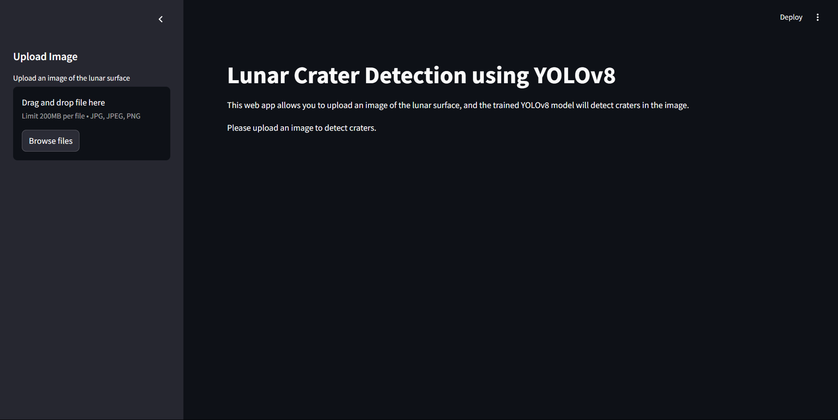

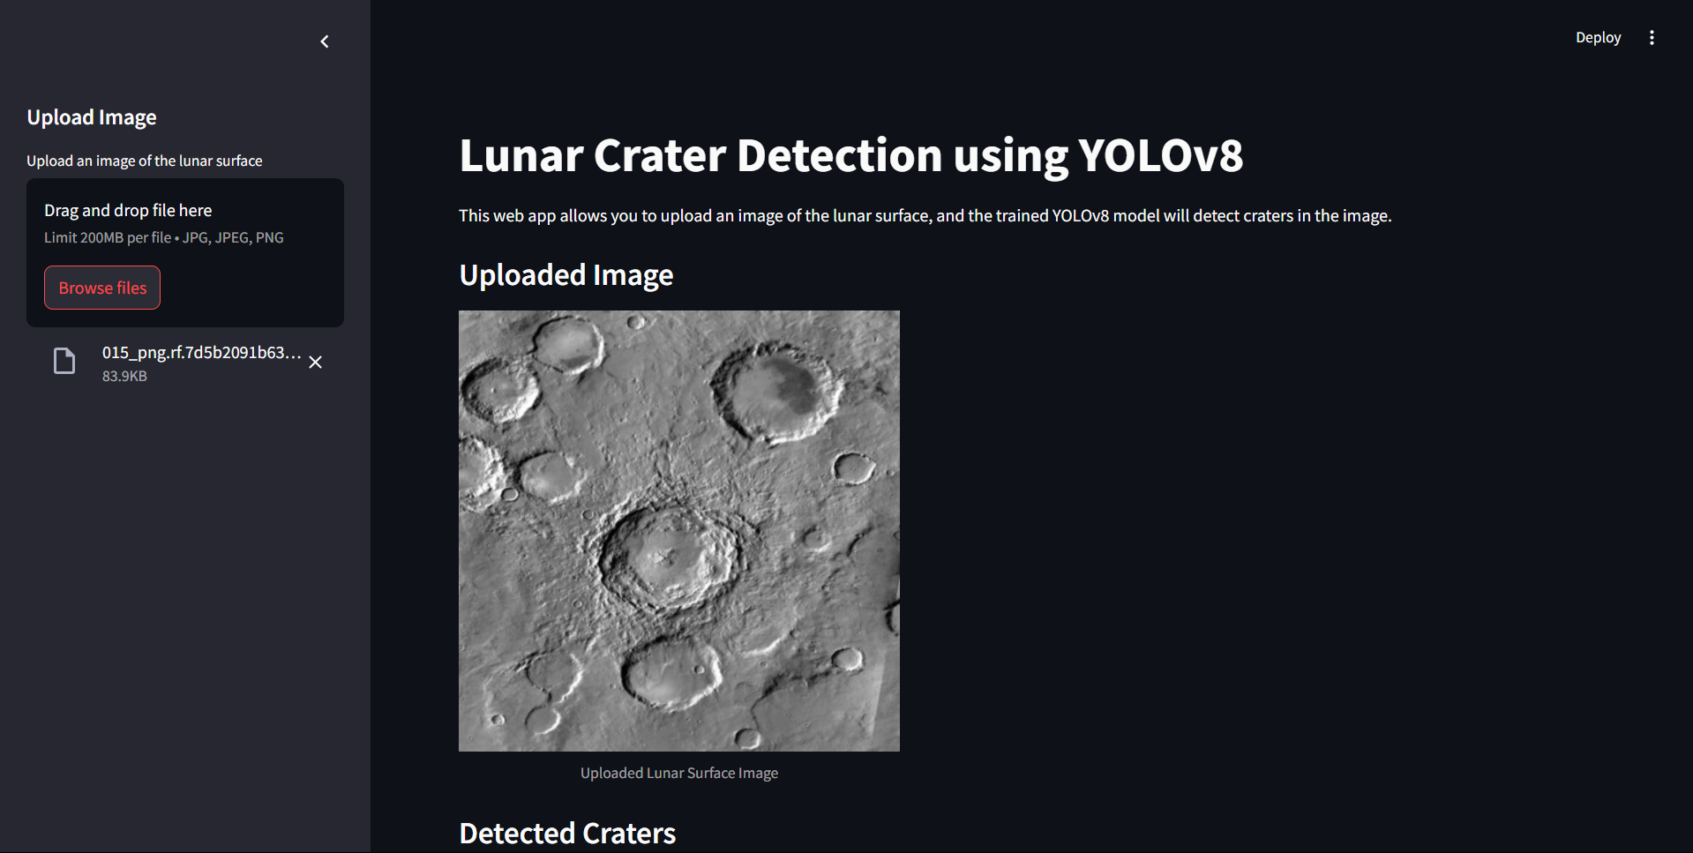

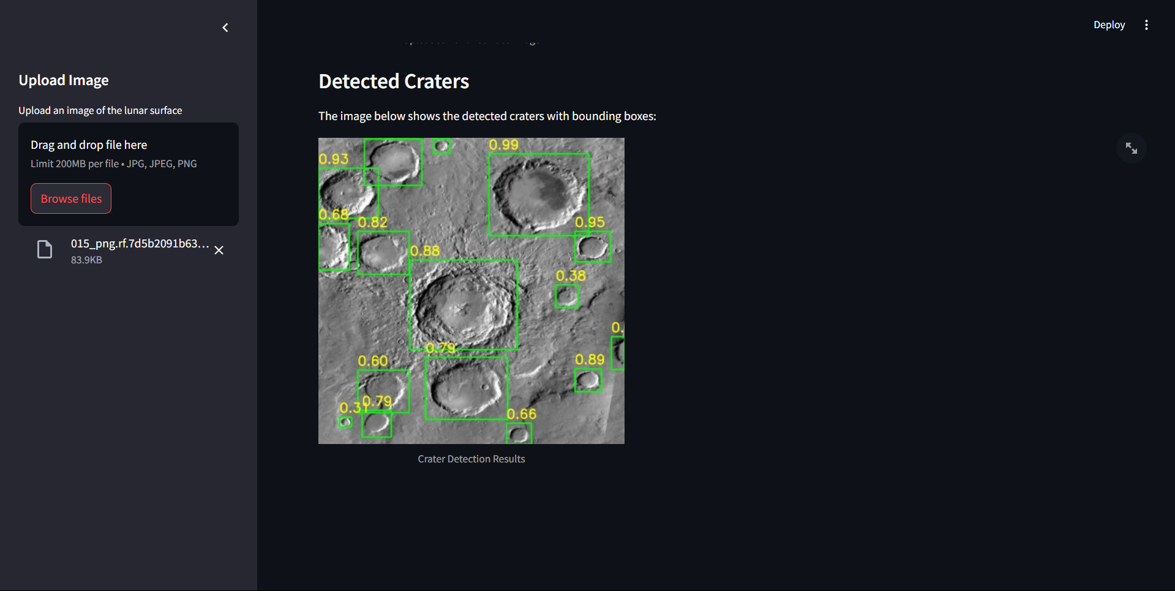

## 6. Conclusion

The project to automatically detect craters and boulders on the Moon’s surface using AI and deep learning, combined with the safe navigation path planning for a lunar rover, represents a significant advancement in lunar exploration technologies. By leveraging high-resolution OHRC data from the Chandrayaan mission and employing state-of-the-art image processing and machine learning techniques, the system can efficiently detect surface features regardless of shape, size, or illumination. This automation reduces the manual effort required for feature identification and enhances mission planning accuracy.

Moreover, the proposed path planning algorithm, incorporating obstacle avoidance and scientific stop identification, ensures safe and optimized rover navigation. The system’s modular design makes it scalable and adaptable to future lunar missions, and it can be extended to other planetary exploration tasks.

In summary, the successful implementation of this project will contribute to safer, more efficient lunar missions, offering valuable insights into surface features and enabling better mission outcomes through data-driven decision-making.

## 7. Plagiarism Report

## References

[1] **Silburt, A., Ali-Dib, M., Zhu, C., Marcus, P., Tamayo, D., & Miyamoto, H. (2019).** "Lunar crater identification via deep learning." *Icarus*, 317, 27-38.

[2] **Redmon, J., Divvala, S., Girshick, R., & Farhadi, A. (2016).** "You Only Look Once: Unified, Real-Time Object Detection." *Proceedings of the IEEE Conference on Computer Vision and Pattern Recognition (CVPR)*, 779-788.

[3] **Bochkovskiy, A., Wang, C. Y., & Liao, H. Y. M. (2020).** "YOLOv4: Optimal Speed and Accuracy of Object Detection." *arXiv preprint arXiv:2004.10934*.

[4] **Palafox, L., Ramrez, C., Hinojosa, S., Velarde, G., Barrón, C. A., & Bernal, J. (2021).** "Automatic lunar crater detection using transfer learning and convolutional neural networks." *Acta Astronautica*, 184, 58-66.

[5] **Zhu, X. X., Tuia, D., Mou, L., Xia, G.-S., Zhang, L., Xu, F., & Fraundorfer, F. (2017).** "Deep Learning in Remote Sensing: A Review." *IEEE Geoscience and Remote Sensing Magazine*, 5(4), 8-36.

[6] **Emami, P., Belgi, B., Lucchetti, A., Flahaut, J., & Souchay, J. (2021).** "Crater detection on Mars using convolutional neural networks and transfer learning." *Planetary and Space Science*, 203, 105296.

[7] **Wang, J., Zhang, Y., Zhou, H., Li, J., & Xu, S. (2019).** "A crater detection algorithm for the Chang'E mission based on deep learning." *Astrophysics and Space Science*, 364(8), 1-10.