
IILM UNIVERSITY, GREATER NOIDA
Department of Computer Science & Engineering (AI & ML)
INTERNSHIP REPORT
on
AI & Machine Learning Internship
Iris Flower Species Classification
& World Happiness Report — Exploratory Data Analysis

Submitted By | Nishant Deshwal
Enrollment Number | 25SCS1003004504
Program & Semester | B.Tech (AI & ML) — 3rd Semester
Organization | Pluto Academy
Internship Duration | 1 Month (Completed June 2026)
Certificate ID | PA-OL-AIML-2026-0292

Certificate of Internship Completion
The completion certificate issued by Pluto Academy for the AI & Machine Learning Internship is reproduced below for verification.
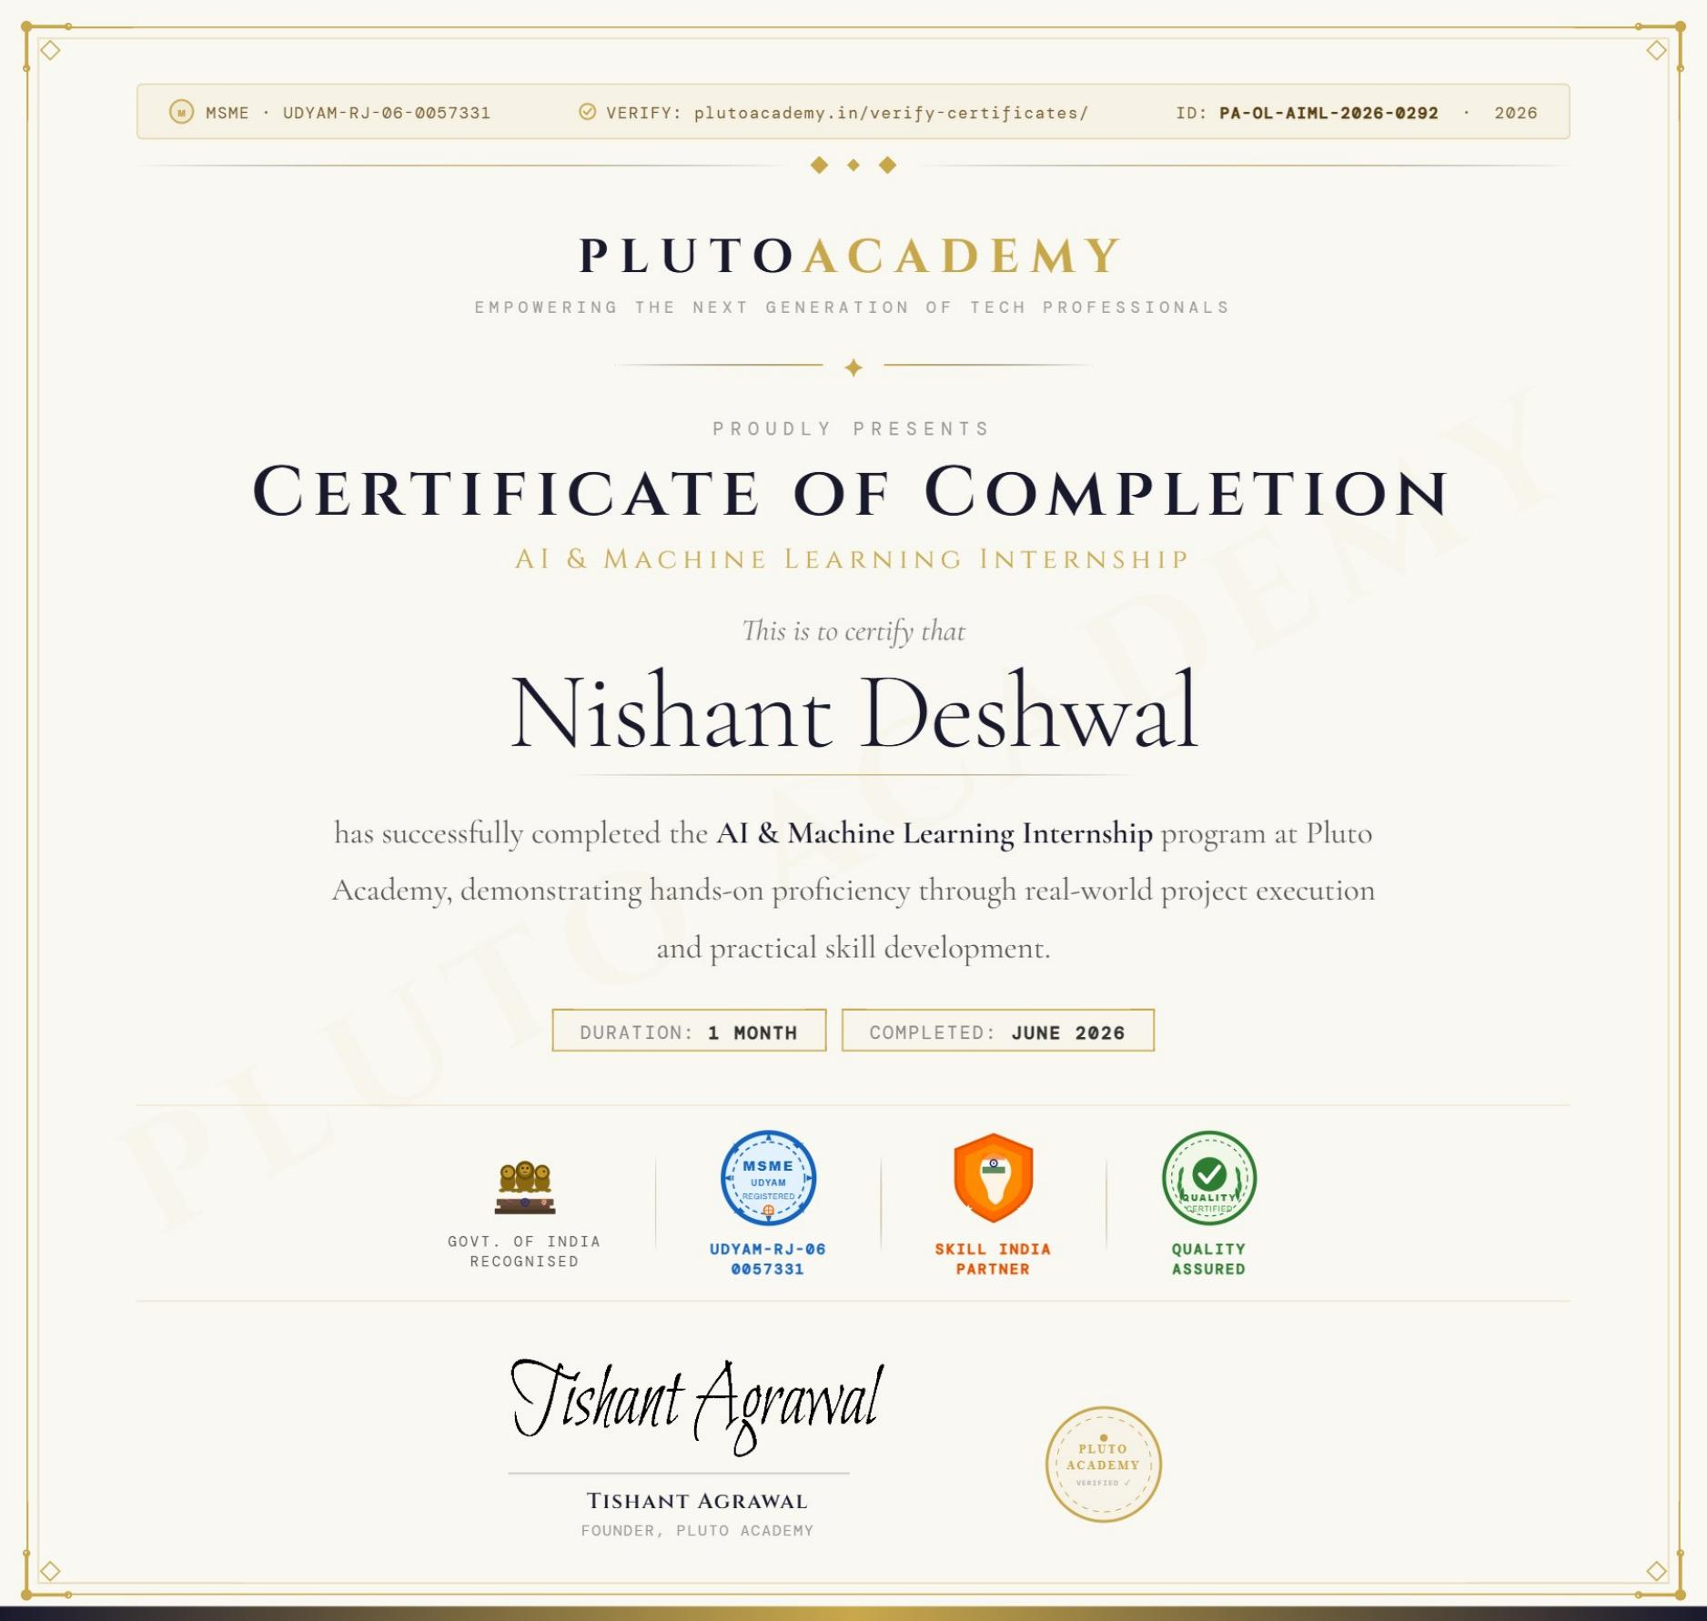
Fig. 0 — Certificate of Completion, Pluto Academy (ID: PA-OL-AIML-2026-0292)

Acknowledgement
I would like to express my sincere gratitude to Pluto Academy for providing me the opportunity to undertake this AI & Machine Learning internship. This hands-on, project-based experience allowed me to apply classroom concepts to real datasets and strengthen my practical understanding of the machine learning workflow.
I am thankful to Mr. Tishant Agrawal, Founder of Pluto Academy, and the mentoring team for their guidance throughout the program. I also thank the faculty of IILM University, Greater Noida, for their continued academic support that made this internship possible.
Finally, I extend my appreciation to my family and peers for their encouragement during this learning journey.

Table of Contents
1. Introduction 5
1.1 About the Organization — Pluto Academy 5
1.2 About the Internship Program 5
2. Objectives of the Internship 5
3. Tools & Technologies Used 5
4. Project 1: Iris Flower Species Classification 6
4.1 Introduction & Dataset 6
4.2 Methodology / Workflow 6
4.3 Exploratory Data Analysis 6
4.4 Model Building 8
4.5 Results & Evaluation 8
4.6 Conclusion 8
5. Project 2: World Happiness Report — EDA 9
5.1 Introduction & Dataset 9
5.2 Methodology / Workflow 9
5.3 Data Visualization 10
5.4 Correlation Analysis 11
5.5 Key Findings 12
5.6 Conclusion 12
6. Skills & Learning Outcomes 13
7. Conclusion 13
References 13

1. Introduction

1.1 About the Organization — Pluto Academy
Pluto Academy is a skills-training organization focused on empowering the next generation of tech professionals through hands-on, project-based learning in emerging technologies. The organization is MSME / Udyam registered (UDYAM-RJ-06-0057331), recognised as a Skill India partner, and delivers certified, quality-assured training programs.
The AI & Machine Learning Internship program is delivered as a one-month, project-driven track where interns apply core machine learning concepts to real-world datasets, building a practical, portfolio-ready foundation in data science.

1.2 About the Internship Program
Program Domain | Artificial Intelligence & Machine Learning
Duration | 1 Month
Completed On | June 2026
Certificate ID | PA-OL-AIML-2026-0292
Founder, Pluto Academy | Tishant Agrawal
Verification | plutoacademy.in/verify-certificates/
As part of the program, two applied machine learning projects were undertaken: a supervised classification project on the Iris flower dataset, and an exploratory data analysis (EDA) project on the World Happiness Report 2019 dataset. Both projects are documented in detail in the sections that follow.

2. Objectives of the Internship
- To apply supervised machine learning algorithms to a real classification problem end-to-end.
- To perform exploratory data analysis (EDA) and uncover patterns in real-world data.
- To build a complete data science workflow: loading, cleaning, visualizing, modeling, and evaluating.
- To compare multiple machine learning models using standard evaluation metrics.
- To translate data-driven insights into clear, presentable conclusions.
- To gain hands-on, portfolio-ready experience with industry-standard tools and libraries.

3. Tools & Technologies Used
Category | Tools / Libraries
Programming Language | Python
Data Handling | Pandas, NumPy
Machine Learning | Scikit-learn
Data Visualization | Matplotlib, Seaborn
Development Environment | Google Colab, Jupyter Notebook

4. Project 1: Iris Flower Species Classification

4.1 Introduction & Dataset
The Iris flower classification project is a classic supervised machine learning problem, where the goal is to classify flowers into one of three species — Setosa, Versicolor, and Virginica — based on four numeric features: sepal length, sepal width, petal length, and petal width. The dataset was loaded directly from Scikit-learn's built-in datasets module and converted into a Pandas DataFrame for analysis.
Property | Value
Total Samples | 150
Features | 4 (sepal & petal length/width, in cm)
Target Classes | 3 species (50 samples each)
Missing Values | 0

4.2 Methodology / Workflow
- Loaded the Iris dataset from Scikit-learn into a Pandas DataFrame.
- Reviewed the dataset structure, data types, and confirmed there were zero missing values.
- Visualized feature relationships across species using a Seaborn pairplot.
- Split the data into training (120 samples) and testing (30 samples) sets using an 80/20 split.
- Trained three classification models: Logistic Regression, K-Nearest Neighbors, and Random Forest.
- Evaluated and compared the models using accuracy scores and a confusion matrix.
from sklearn.datasets import load_iris
import pandas as pd
iris = load_iris()
df = pd.DataFrame(iris.data, columns=iris.feature_names)
df["species"] = iris.target

4.3 Exploratory Data Analysis
A Seaborn pairplot was used to visualize the relationships between all feature pairs, colored by species. The plot clearly shows that the Setosa species (0) is linearly separable from the other two species across nearly all feature combinations, while Versicolor (1) and Virginica (2) show some overlap, particularly in sepal measurements.
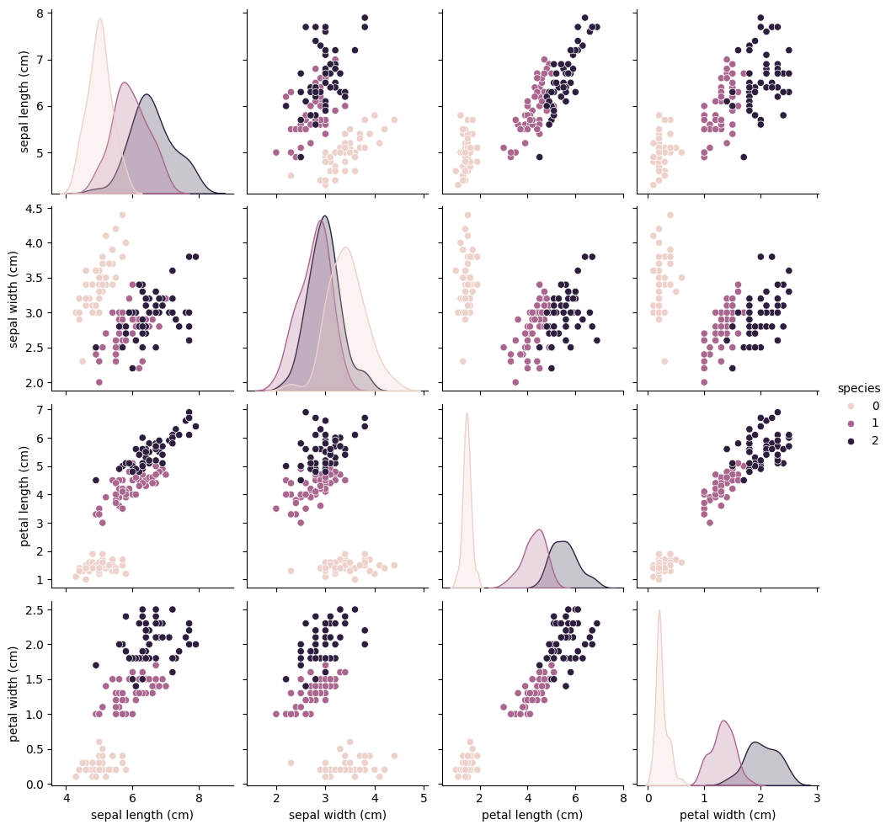
Fig. 1 — Pairplot of Iris features by species

4.4 Model Building
Three supervised classification algorithms were trained on the same training set and evaluated on the same held-out test set of 30 samples, allowing for a fair, like-for-like comparison of their performance.
from sklearn.linear_model import LogisticRegression
from sklearn.neighbors import KNeighborsClassifier
from sklearn.ensemble import RandomForestClassifier
lr = LogisticRegression(max_iter=200).fit(X_train, y_train)
knn = KNeighborsClassifier(n_neighbors=3).fit(X_train, y_train)
rf = RandomForestClassifier(n_estimators=100,
random_state=42).fit(X_train, y_train)

4.5 Results & Evaluation
Model | Test Accuracy
Logistic Regression | 100%
K-Nearest Neighbors (k = 3) | 100%
Random Forest (100 trees) | 100%
All three models achieved 100% accuracy on the 30-sample test set. The confusion matrix for the Random Forest model (representative of all three, given the identical accuracy) confirms zero misclassifications across all three species.
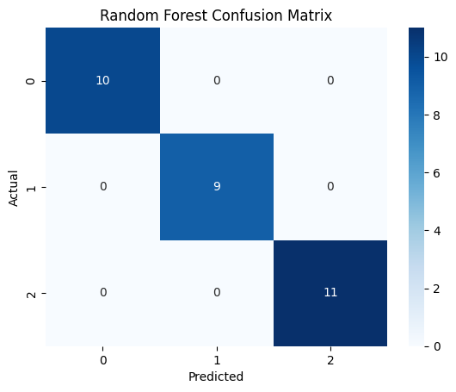
Fig. 2 — Random Forest confusion matrix on the test set

4.6 Conclusion
This project demonstrated the complete supervised machine learning workflow — from data loading and exploration to visualization, model training, and evaluation. The near-perfect separability of the Iris dataset, particularly along petal measurements, allowed all three models to achieve 100% test accuracy, confirming that the dataset is highly structured and well-suited to classification with simple, interpretable models.

5. Project 2: World Happiness Report — EDA

5.1 Introduction & Dataset
This project analyzes the World Happiness Report 2019 dataset to understand which socio-economic factors are most strongly related to happiness scores across countries. The dataset, extracted from a zipped archive of yearly reports, contains happiness scores and six contributing factors for 156 countries.
Property | Value
Countries Analyzed | 156
Data Columns | 9 (rank, country, score, 6 factors)
Report Year Studied | 2019
Missing Values | 0 (dataset was already clean)

5.2 Methodology / Workflow
- Extracted and loaded the 2019 World Happiness Report CSV file using Pandas.
- Checked for missing values and duplicates — the dataset required no major cleaning.
- Visualized the Top 10 and Bottom 10 happiest countries using bar charts.
- Plotted GDP per capita against happiness score to study their relationship.
- Built a correlation heatmap across all contributing factors.
- Ranked each factor by its correlation strength with the happiness score.
import pandas as pd
df = pd.read_csv("happiness_data/2019.csv")
print("Shape:", df.shape) # (156, 9)

5.3 Data Visualization
The Top 10 happiest countries in the 2019 report are led by Finland, Denmark, and Norway, with Nordic and Western European nations dominating the upper rankings. The Bottom 10 is led by South Sudan, the Central African Republic, and Afghanistan.
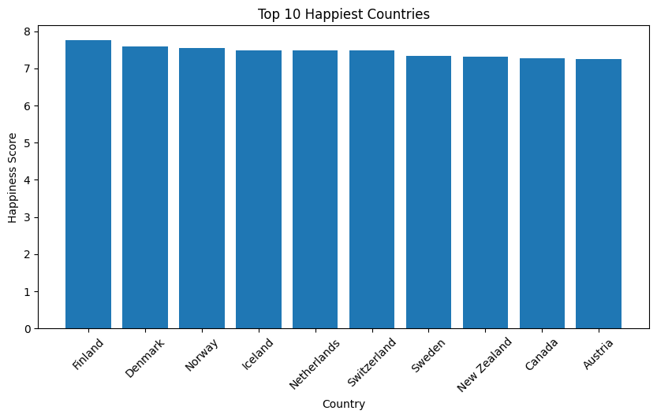
Fig. 3 — Top 10 happiest countries by score, 2019
A scatter plot of GDP per capita against happiness score shows a strong positive relationship — countries with a higher GDP per capita generally report higher happiness scores, though with some spread at the higher end.
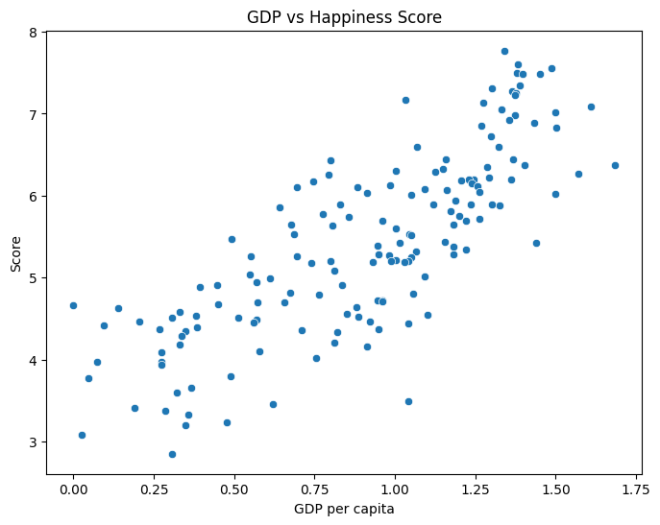
Fig. 4 — GDP per capita vs. happiness score

5.4 Correlation Analysis
A correlation heatmap across all numeric columns was generated to quantify how strongly each factor relates to the overall happiness score.
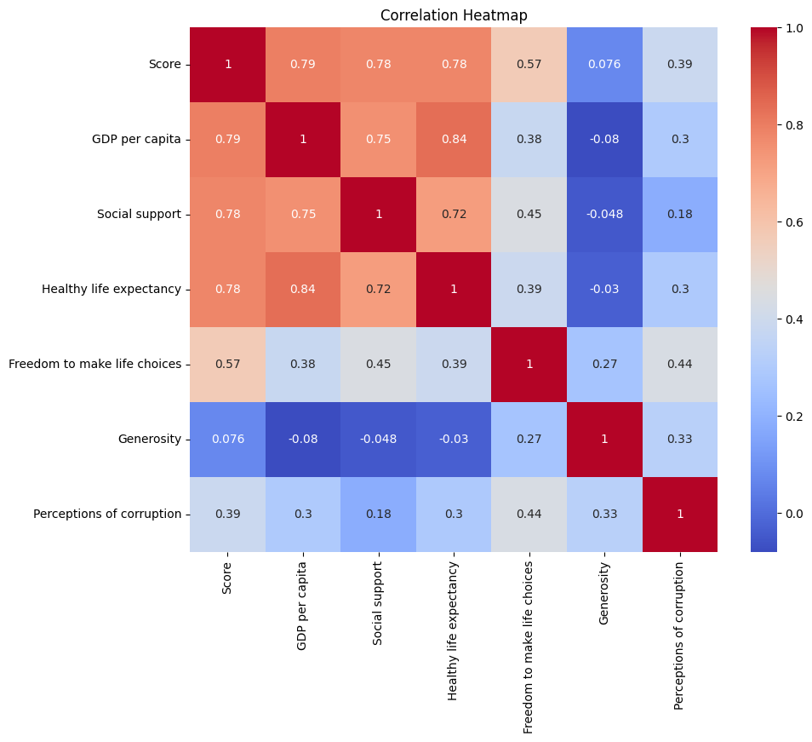
Fig. 5 — Correlation heatmap of happiness-report factors
Ranking each factor by its correlation with the happiness score makes the relative importance of each driver clear.
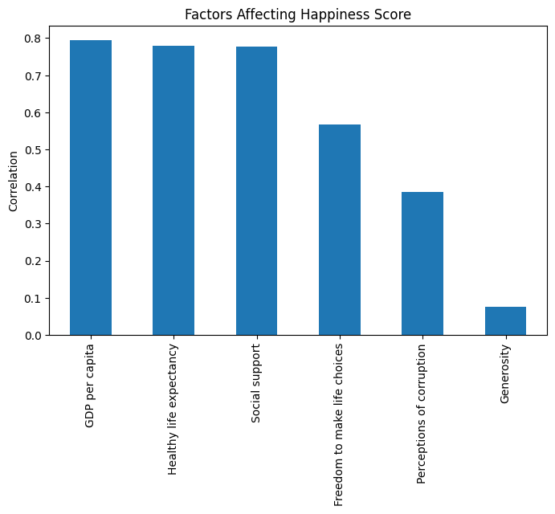
Fig. 6 — Correlation of each factor with the happiness score

5.5 Key Findings
Factor | Correlation with Score
GDP per Capita | 0.79
Healthy Life Expectancy | 0.78
Social Support | 0.78
Freedom to Make Life Choices | 0.57
Perceptions of Corruption | 0.39
Generosity | 0.08
- GDP per capita is the single strongest predictor of a country's happiness score.
- Healthy life expectancy and social support follow closely behind, each with a correlation above 0.75.
- Generosity shows almost no correlation with happiness scores, suggesting it plays a minimal role compared to economic and health-related factors.
- Finland, Denmark, and Norway topped the 2019 happiness rankings, consistent with their strong performance across GDP, health, and social support metrics.

5.6 Conclusion
The exploratory analysis confirms that economic prosperity, health, and social support are the dominant drivers of national happiness, while generosity has a comparatively negligible effect. These findings align with prior editions of the World Happiness Report and reinforce the value of EDA in surfacing actionable insights from raw survey data.

6. Skills & Learning Outcomes
- Python for Data Science — writing clean, reusable analysis code with Pandas and NumPy.
- Data Visualization — communicating patterns clearly using Matplotlib and Seaborn.
- Machine Learning Modeling — training and tuning classifiers with Scikit-learn.
- Model Evaluation — using accuracy scores and confusion matrices to validate results.
- Exploratory Data Analysis — framing the right questions before modeling begins.
- Professional Workflow — structuring, documenting, and presenting a data project end-to-end.

7. Conclusion
This one-month AI & Machine Learning internship at Pluto Academy provided valuable, hands-on exposure to the complete data science workflow. Through the Iris Flower Classification project, practical experience was gained in supervised learning, model comparison, and evaluation, achieving 100% test accuracy across three classifiers. Through the World Happiness Report EDA project, experience was gained in structured exploratory analysis, correlation-based reasoning, and communicating insights through visualization.
Together, these projects strengthened my practical grounding in Python-based data science and machine learning, and have laid a strong foundation for more advanced, real-world data science work ahead.

References
- Scikit-learn Iris Dataset Documentation — scikit-learn.org
- World Happiness Report 2019 — worldhappiness.report
- Pandas Documentation — pandas.pydata.org
- Seaborn Documentation — seaborn.pydata.org
- Pluto Academy — plutoacademy.in

