**Hashing :**

package hashing;

//@author Paddi

public class Hashing {

public static void main(String[] args) {

int col=0,i,j,x=0,k,y ;

int arr[]=new int[101] ;

for(i=0;i<20;i++)

{

for(j=0;j<=100;j++)

{

arr[j]=-1 ;

}

for(j=0;j<90;j++)

{

x=(int)(Math.random()*1000) ;

// System.out.println(x);

if(arr[x%101]==-1)

{

arr[x%101]=x ;

//System.out.println("yo");

}

else if(arr[x%101]!=-1)

{

y=x ;

k=1 ;

while(arr[y%101]!=-1)

{

y=(x%101+k*(11-(x%11)))%101 ; //double hashing

/*

y=(x%101+k*k)%101 //Quadratic Probing

y=(x%101+k)%101 //Linear Probing

*/

col++ ;

k++ ;

}

arr[y%101]=x ;

}

}

System.out.println(col);

}

System.out.println(col);

double avg=(double)((double)col/(double)20) ;

System.out.println(avg);

}

}

**OUTPUT:**

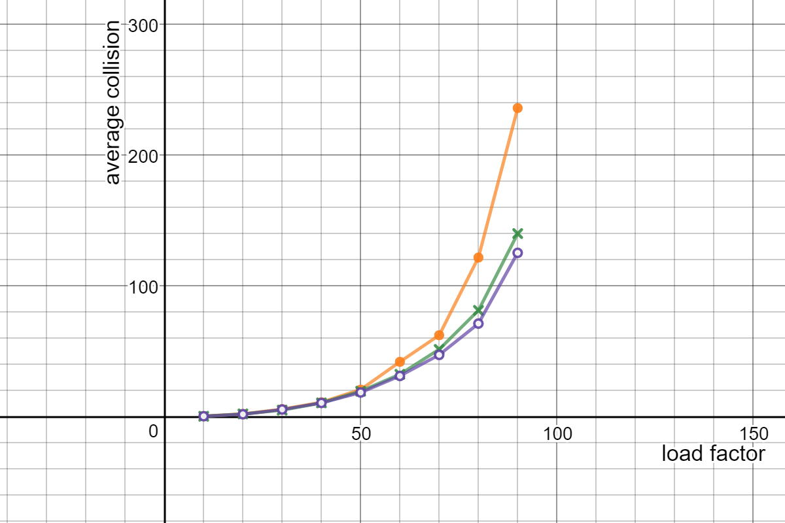

Orange Linear Probing

Green : Quadratic Probing

Purple: double Hashing

|  |  |  |  |
| --- | --- | --- | --- |
|  | Linear Hashing | Quadratic Hashing | Double Hashing |
| No. of Keys | Average collisions | Average collisions | Average collisions |
| 10 | 0.5 | 0.4 | 0.45 |
| 20 | 2.2 | 2.2 | 1.95 |
| 30 | 5.8 | 5.1 | 5.6 |
| 40 | 11.1 | 10.65 | 10.6 |
| 50 | 20.8 | 19.55 | 18.6 |
| 60 | 42.05 | 32.5 | 31.25 |
| 70 | 62.4 | 51.55 | 47.35 |
| 80 | 121.8 | 81.4 | 71.3 |
| 90 | 236.15 | 140.15 | 125.4 |