**Stock Predictor Website using**

**Machine Learning**

# Machine Learning Mini Project Report

Submitted in partial fulfillment of the requirements for the degree of

**Bachelor of Engineering (Computer Engineering)**

by:

|  |  |
| --- | --- |
| Nishant Patil | TU3F1920095 |
| Abhijit Zagade | TU3F1920096 |
| Priyam Soni | TU3F1920089 |

## Under the Guidance of Prof. Rohini Patil



**Department of Computer Engineering**

**TERNA ENGINEERING COLLEGE**

Nerul (W), Navi Mumbai 400706

## (University of Mumbai)

(2022-2023)



**TERNA ENGINEERING COLLEGE, NERUL, NAVI MUMBAI**

## Department of Computer Engineering

Academic Year 2022-23

CERTIFICATE

This is to certify that the Machine Learning mini project 2 A entitles **“Stock Predictor Website using Machine Learning”** is a bonafide work of

|  |  |
| --- | --- |
| **“Nishant Patil”** | **TU3F1920095** |
| **“Abhijit Zagade”** | **TU3F1920096** |
| **“Priyam Soni”** | **TU3F1920089** |

submitted to the University of Mumbai in partial fulfillment of the requirement for the award of the Bachelor of Engineering (Computer Engineering).

## Guide Head of Department Principal

**Approval Sheet**

# Project Report Approval

This Mini Project Report – an entitled “**Stock Predictor Website using Machine Learning**” by following students is approved for the degree of ***B.E. in "Computer Engineering"***.

## Submitted by:

|  |  |
| --- | --- |
| Nishant Patil | TU3F1920095 |
| Abhijit Zagade | TU3F1920096 |
| Priyam Soni | TU3F1920089 |

Examiners Name & Signature:

1. -

2. -

Date: Place:

# Declaration

We declare that this written submission represents our ideas in our own words and where others' ideas or words have been included, we have adequately cited and referenced the original sources. We also declare that we have adhered to all principles of academic honesty and integrity and have not misrepresented or fabricated or falsified any idea/data/fact/source in our submission. We understand that any violation of the above will be cause for disciplinary action by the Institute and can also evoke penal action from the sources which have thus not been properly cited or from whom proper permission has not been taken when needed.

|  |  |  |
| --- | --- | --- |
| Nishant Patil | TU3F1920095 | --------------------------- |
| Abhijit Zagade | TU3F1920096 |  |
| Priyam Soni | TU3F1920089 | --------------------------- |

Date:

Place:

**Table of Contents**

# Index

**TABLE OF CONTENTS**

|  |  |  |
| --- | --- | --- |
| **Sr. No.** | **Title** | **Page No.** |
|  | **Abstract** |  |
| Chapter 1 | Introduction |  |
| Chapter 2 | Problem Statement |  |
| Chapter 3 | Literature Survey |  |
| Chapter 4 | Objectives and scope |  |
| Chapter 5 | Proposed System |  |
| Chapter 6 | System Design |  |
| Chapter 7 | Implementation screenshot |  |
| Chapter 8 | Conclusion |  |
|  | Reference |  |

**`**

## ABSTRACT

Stock price forecasting is a popular and important topic in financial and academic studies. Share Market is an untidy place for predicting since there are no significant rules to estimate or predict the price of a share in the share market. Many methods like technical analysis, fundamental analysis, time series analysis, and statistical analysis, etc. are all used to attempt to predict the price in the share market but none of these methods are proved as a consistently acceptable prediction tool.

Exploration on the financial exchange has been a significant issue for analysts lately. Foreseeing the securities exchange pattern precisely will limit the danger and bring a greatest measure of benefit for every one of the partners. Any little changes in the framework can deliver compound mistakes in anticipating what's to be conducted in the framework. Hence, predicting the stock market trend accurately will minimize the risk and bring maximum amount of profit for all the stakeholders. During the last several years, a lot of studies have been done to predict stock market. Also in the course of the most recent couple of years, many machine learning calculations have been utilized trying to gauge stock costs. The forecast of stock market assists us with putting admirably in the financial exchange. The securities exchange is anticipated based on essential investigation and specialized examination.

We will attempt to implement, predict and analyze stock market prices. Machine Learning is very effective for the implementation of forecasting stock prices, returns, and stock modelling. With the help of statistical analysis, the relation between the selected factors and share price is formulated which can help in forecasting accurate results. Although, share market can never be predicted due to its vague domain, this report aims at applying the concept of prediction and analysis of data for forecasting the stock prices.

## CHAPTER 1 INTRODUCTION

Stock price forecasting is a popular and important topic in financial and academic studies. Share Market is an untidy place for predicting since there are no significant rules to estimate or predict the price of a share in the share market. Many methods like technical analysis, fundamental analysis, time series analysis, and statistical analysis, etc. are all used to attempt to predict the price in the share market but none of these methods are proved as a consistently acceptable prediction tool.

Is predicting stock prices using machine learning really an efficient choice? Investors take calculated guesses by analyzing data. They read the news, study the company history, industry trends and other lots of variables that go into making a prediction. The prevailing theories is that stock prices are totally random and unpredictable.

Forecasting Stock prices is not an easy task, the growth of the amount of stock data generated every day is difficult to predict. The price trend in the stock market is uncertain, and the valuable information hidden in the stock data is difficult to detect. For example, the price trend of stocks, profit trends, how to make a reasonable speculation on the price trend of stocks and profit trends is a major problem that needs to be solved at this stage.

The stock market appears in the news every day. You hear about it every time it reaches a new high or a new low. The rate of investment and business opportunities in the Stock market can increase if an efficient algorithm could be devised to predict the short term price of an individual stock. Previous methods of stock predictions involve the use of Artificial Neural Networks and Convolution Neural Networks which has an error loss at an average of 20%. In this project, we will see if there is a possibility of devising a model using Support Vector Regression algorithm which will predict stock price with a less percentage of error. And if the answer turns to be YES, we will also see how reliable and efficient will this model be.

Importing libraries and Dataset:

* Pandas is a useful library in data handling.
* Yfinance library used for downloading dataset.
* dash/Matplotlib are used for data visualization purpose.
* Sklearn – This module contains multiple libraries having pre-implemented functions to perform tasks from data preprocessing to model development and evaluation.

**System Features**

**Stock market prediction**

Stock price movements are in somewhat repetitive in nature in the time series of stock values. The

prediction feature of this system tries to predict the stock return in the time series value by

training Neural Network which involves producing an output and correcting the error.

**Market Analysis**

A detailed analysis of Stock market is presented to the user. The analysis contains the

performance of most of the listed companies for certain interval of days. The numbers and figures

are represented in graphs and plots in the form of line charts.

## CHAPTER 2 PROBLEM STATEMENT

Stock market is very vast and difficult to understand. It is considered too uncertain to be predictable due to huge fluctuation of the market. Stock market prediction task is interesting as well as divides researchers and academics into two groups, those who believe that we can devise mechanisms to predict the market and those who believe that the market is efficient and whenever new information comes up the market absorbs it by correcting itself, thus there is no space for prediction.

Investing in a good stock but at a bad time can have disastrous result, while investing in a stock at the right time can bear profits. Financial investors off today are facing this problem of trading as they do not properly understand as to which stocks to buy or which stocks to sell in order to get optimum result. So, the purposed project will reduce the problem with suitable accuracy faced in such real time scenario.

## CHAPTER 3 LITERATURE SURVEY

In the last few decades forecasting of stock returns has become an important field of research. In most of the cases the researchers had attempted to establish a linear relationship between the input macroeconomic variables and the stock returns. After the discovery of non-linearity in the stock market index returns; many literatures have come up in nonlinear statistical modeling of the stock returns, most of them required that the nonlinear model be specified before the estimation is done.

**Existing System**

**i.** Phichhang Ou and Hengshan Wang applied ten different data mining techniques to predict price movement of Hang Seng index of Hong Kong stock market. Quadratic discriminant analysis (QDA), Linear discriminant analysis (LDA), NaveBayes based on kernal estimation, K-nearest neighbor classification, neural network, Tree based classification, Support vector machine (SVM), Bayesian classification with Gaussian process, Logic model and Least squares support vector machine (LSSVM) are these ten methods. Among all these methods LS-SVM and SVM generate superior predictive performance. Mostly, SVM is better as compared to LS-SVM for in sample prediction. But in term of hit rate and error rate criteria LS-SVM is in turn better than SVM for out sample forecast.

**ii**. Binoy B. Nair, N.Mohana Dharini and V.P. Mohandas they proposed hybrid decision tree-neurofuzzy system for prediction of stock market. Automated stock market trend prediction system is proposed by using decision tree adaptive neuro-fuzzy hybrid system. They used different techniques like technical analysis and decision tree. First technical analysis which is generally used by stock traders for feature extraction and second decision tree for feature selection. By using technical analysis and decision tree which is used for the reduced datasets is then applied to the adaptive euro- fuzzy system for next day stock prediction. The tested their proposed system on four major international stock market. Their experimental results shows the proposed hybrid system produces much higher accuracy when compared to stand- alone decision tree based system and ANFIS based system without feature selection and dimensionality reduction. They propose above neuro-fuzzy system.

## CHAPTER 4 OBJECTIVE AND SCOPE

The ultimate goal of our applications is to Serve investors as a third party investment tool that uses Machine Learning algorithm and help them navigate in the fast-changing stock market. The project aims to introduce and democratize the latest machine learning technologies for investors. This application serves as a supplementary quantitative tool for investors to see the market at a

different perspective with the help of technology.

The project target is to create web application that analyses previous stock data of companies, and we will implement a model using Support Vector Regression algorithm which will predict stock price with a less percentage of error. These predicted and analyses data can be observed by individual to know the financial status of the companies and their comparisons. Company and industry can use it to breakdown their limitation and enhance their stock value. It can be very useful to even researchers, stock brokers, market makers, government, and general people.

**Scope**

The scope this project is to best predict the future prices of the stock which would benefit researchers, stock brokers, market makers, government, and general people. The main feature of this project is to generate an approximate forecasting output answer create a general idea of future values based on the previous data by generating a pattern. The scope of this project does not exceed more than a generalized suggestion tool.

## CHAPTER 5 PROPOSED SYSTEM

We will propose a single-page web application using Dash (a python framework), Developing this project idea using the Dash library (of Python), we can make dynamic plots of the financial data of a specific company and some machine learning models which will show company information (logo, registered name and description) and stock plots based on the stock code given by the given user.

Also, the ML model will enable the user to get predicted stock prices for the date inputted by the user. This web application can be applied to any company (whose stock code is available) of one's choosing.

This system named “Visualizing and forecasting stocks” is a web application that aims to forecast stock market value using Support Vector Regression (SVR) algorithm. This project is intended to solve the economic dilemma created in individuals that wants to invest in stock market.

## CHAPTER 6 SYSTEM DESIGN

As the problem of the prediction could be complex and lengthy, a series of actions and activities in the form of several phases was considered to break down the problem to conquer the complexity. It requires historic data of stock market in the project. So, it is necessary to have a trusted source having relevant and necessary data required for the prediction. We will be using yfinance (python library) as the main source of data. The yfinance python library aims to solve this problem by offering a reliable, threaded, and Pythonic way to download historical market data from Yahoo! finance. As mentions, through this project, we try to take advantage of Support Vector Regression (SVR) to address some interesting problems regarding stock market analysis.

Specially, stock market index prediction is done in this project. First, a set of past data is loaded and analyses; then, an SVR is modelled and trained for the problem model. Afterwards, similar past data are distinguished and used to predict future stock market values. Stock market data that are used in this assignment are the data from NASDAQ, is a stock market index that includes almost all stocks of the companies that trade on the Nasdaq. Most are technology and internetrelated, but there are financial, consumer, biotech, and industrial companies as well.

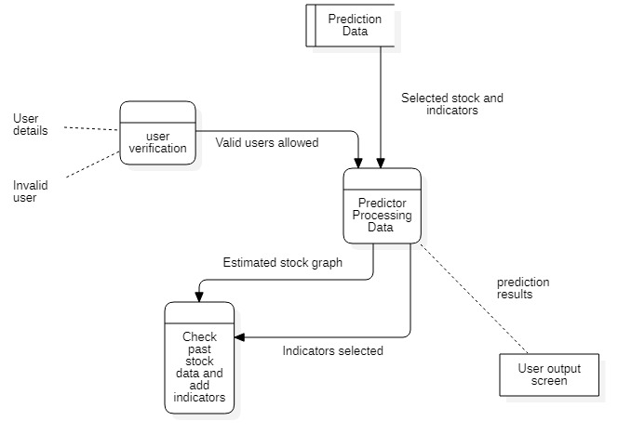

## CHAPTER 7 IMPLEMENTATION

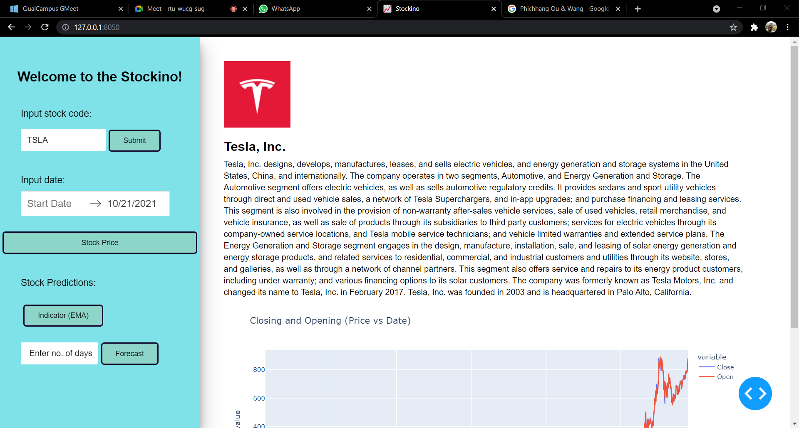

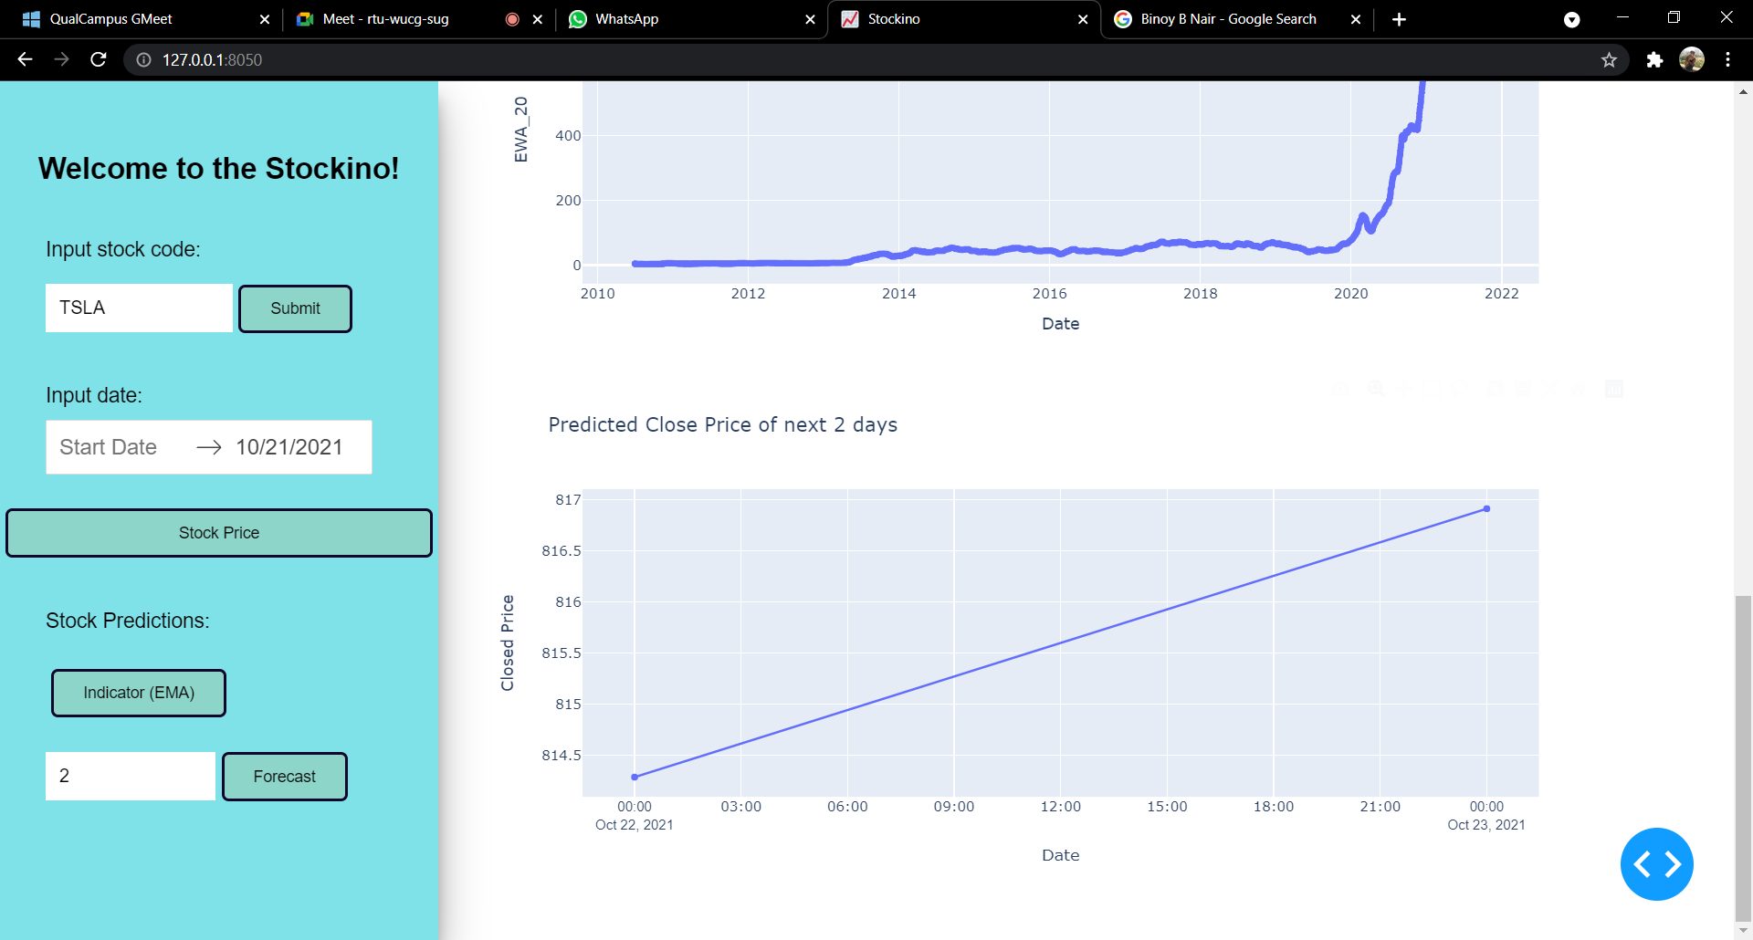

## CHAPTER 8 CONCLUSION

Use of recently introduced machine learning techniques in the prediction of stocks have yielded promising results and thereby marked the use of them in profitable exchange schemes. It has led to the conclusion that it is possible to predict stock market with more accuracy and efficiency using machine learning techniques. In the future, the stock market prediction system can be further improved by utilizing a much bigger dataset than the one being utilized currently.

This would help to increase the accuracy of our prediction models. Furthermore, other models of Machine Learning could also be studied to check for the accuracy rate resulted by them. It is possible to predict stock market with more accuracy and efficiency using machine learning techniques In the future, the stock market prediction system can be further improved by utilizing a much bigger dataset than the one being utilized currently.

## REFERENCES

• Website Name: Analytics Vidya

Access to: [https://www.analyticsvidhya.com/blog/2020/03/support-vector- regression-tutorialformachine- learning/](https://www.analyticsvidhya.com/blog/2020/03/support-vector-%20regression-tutorialformachine-%20learning/)

• Website Name: Slide Share

Access to: <https://www.slideshare.net/anilsth91/stock-market-analysis-and-prediction>

• Author Name: Phayung Meesad

P. Meesad and R. I. Rasel, "Predicting stock market price using support vector regression,"

2013 International Conference on Informatics, Electronics and Vision (ICIEV), 2013, pp. 1-6, doi:

10.1109/ICIEV.2013.6572570.

performance.URL: <https://ieeexplore.ieee.org/stamp/stamp.jsp?tp=&arnumber=6572570&isnumber=6572523>

• Website Name: Investopedia

Access to: <https://www.investopedia.com/terms/e/ema.asp>