**90Course Learning Outcomes:**

Upon completion of this assignment, you should be able to:

|  |  |  |
| --- | --- | --- |
| CLO1 | Explain the essential concepts, principles, strategies, and theories relating to Information Technology application development using C language. | Final Exam |
| CLO2 | Demonstrate the ability to program a C solution. | Practical Assessment |
| **CLO3** | **Construct C solutions for a range of Information Technology related problems.** | **Group Assignment** |

1. **ASSIGNMENT DESCRIPTION**

**Hotel Management System**

Managing a hotel involves handling reservations, check-ins, check-outs, room management, and billing. Your task is to design and develop a Hotel Management System to streamline these processes. The system will cater to four distinct user roles and must encompass the following requirements.

**Roles and Functionalities**

**Administrator**

* Login and logout from the system.
* Register new users (hotel staff, customers) into the system.
* Manage existing users by updating their account status.
* Manage the hotel rooms by adding, updating, or removing room details.

**Hotel Staff**

* Login and logout from the system.
* Manage room reservations.
* Check-in and check-out guests.
* View room availability and booking history.

**Customer**

* Login and logout from the system.
* Search for available rooms.
* Make and cancel reservations.
* View reservation history and current bookings.

**Guest**

* View room availability.
* Search for room details and rates.

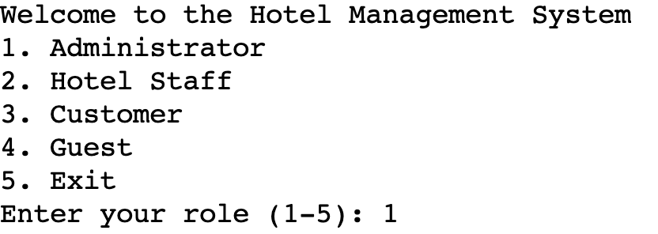 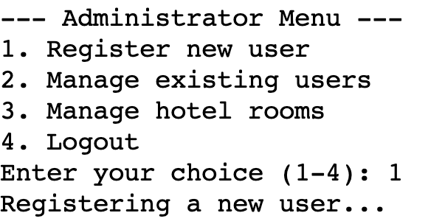

Figure 1: Example of system menu

Figure 1 shows an example of the application login screen and administrator menu for the Hotel Management System. The application should include, but is not limited to, the functionalities listed in the menu.

You are required to form a **group of 4 students** to design, implement, test, and document the Hotel Management System. Use your creativity to design and develop the system. You are encouraged

to review any existing Hotel Management System available on the market and add any suitable additional features on top of the basic requirements provided.

1. **REQUIREMENTS**
2. You are required to carry out extra research for your system and document any logical assumptions you made after the research.
3. Your program should use symbolic constants where appropriate. Validations need to be included to ensure the accuracy of the system. State any assumptions that you make under each function.
4. You are required to store all data ina textfile.
5. You are expected to use control structures, functions, array, pointers, structures, unions, and files in your program. Your program must embrace modular programming technique and should be menu driven. Functions of similar operations can be grouped (or kept alone) and stored as separate C files. Header files are to be stored separately as .h files.
6. You may include any extra features which you may feel relevant and that add value to the system.
7. There should be no need for graphics (user interface) in your program, as what is being assessed, is your programming skill not the interface design.
8. You should include the good programming practice such as comments, variable naming conventions and indentation**.**
9. In a situation where a student:
   * + ***Failed to attempt the assignment demonstration, overall marks awarded for the assignment will be based on the documentation and design components only with a maximum 40 marks.***
     + ***Found to be involved in plagiarism, the offence will be dealt in accordance with APU regulations on plagiarism.***
10. You are required to use portable ANSI C programming language to implement the solution. Use of any other language like C++/Java etc. is not allowed. Global variable is not allowed.
11. Results of a comprehensive testing is to be included in your document in the form of Input/Output screenshots with sufficient explanation. The tests conducted shall take into consideration of all valid inputs and negative test cases.
12. **DELIVERABLES**

You are required to submit:

1. A softcopy of the program coded in C – submitted in Moodle. The program should include the following:

* Basic C concepts such as displaying and reading of text, variables, and assignment of values, comments – to explain various parts of the program, etc.
* Intermediate C concepts such as control structures – selection and iteration control structures, use of arrays – single / double scripted, string.
* Advanced C concepts such as functions – programmer defined and library functions, pointers, structures, unions, linked list and files.
* Any other features of C that has not been covered.

1. A documentation of the system, that incorporates basic documentation standards such as header and footer, page numbering and which includes

* Cover page
* Table of contents
* Introduction and assumptions
* Design of the program – using pseudocode **or** flowchart – which adheres to the requirements provided above
* Explain the concepts implemented in your solution with code snippet from your solution.
* Additional features which have been incorporated in the solution in terms of design and C codes (sample segment of source code from the system created)
* Sample outputs when the program is executed with some explanation of the outputs / sections of the program
* Conclusion
* References –American Psychological Association (APA) style
* Workload matrix

1. Files to be uploaded to Moodle (ONLY FOLLOWING 3 FILES):
   1. **Documentation file** (.pdf)
   2. **Program / Source files** (.c files), **Header files** (.h files) and **text file** (archived as single .zip or .rar file)
2. Submission

* All three files to be uploaded to Moodle
* Refer to the Moodle for the assignment deadline.

1. **ASSESSMENT CRITERIA**
2. CLO3: Design solution (Pseudocode or Flowchart) 20%

Detailed, logical and application of appropriate idea.

1. CLO3: Coding / Implementation 40%

Appropriate application of C concepts (from basic to advance), good solution implemented with validation and met all the requirements with additional features.

1. CLO3: Documentation 20%

Overall standard and layout, explanation of concepts applied, Input/Output screen capture, assumptions and etc.

1. CLO3: Demonstration and Q&A 20%

Know how to execute and able to trace the system as well as answer the questions posted based on the assignment submitted during presentation

1. **PERFORMANCE CRITERIA**

Distinction (75% and above)

This grade will be assigned to work which meets all requirements stated in the question. The program runs smoothly when executed. There is clear evidence and application of C concepts up to advanced level. The program solution is unique with excellent coding styles and validation. The program implemented maps completely against the design (pseudocode or flowchart) as seen in the documentation. The design of the solution varies in styles and has unique logic with hardly any errors / omissions. The documentation does not have any missing components. Sample outputs documented have clear explanation. All work is referenced according to APA Referencing convention. Student must be able to provide excellent explanation of the codes and work done, show additional concepts / new ideas used in the solution, able to answer all questions posed with accurate / logical answers / explanation provided with sound arguments and clear discussion. Overall, an excellent piece of work submitted.

Credit (65%-74%)

This grade will be assigned to work which of good standard and meets most of the requirements stated in the question. The program runs smoothly when executed. There is clear evidence and application of C concepts up to at least intermediate level. The program solution is unique with good coding styles and validation. The program implemented maps well against the design (pseudocode or flowchart) as seen in the documentation. The design of the solution varies in styles and has unique logic with minor errors / omissions. The documentation does not have any missing components. Sample outputs documented with some explanation. All work is referenced according to APA Referencing convention but with some minor errors / omissions. Student must be able to provide good explanation of the codes and work done, answer most questions posed with mostly accurate / logical answers / explanation. Overall, a good assignment submitted.

Pass (50%-64%)

This grade will be assigned to work which meets at least half of the basic requirements (approximately 50%) stated in the questions. The program runs smoothly when executed. There is clear evidence and application of C concepts at basic level. The program solution is common with basic coding styles and validation. The program implemented somewhat maps with the design (pseudocode or flowchart) as seen in the documentation. The design of the solution is average in terms of logic and style with some errors / omissions. The documentation has some missing components. Sample outputs documented but without any explanation. Did some referencing but not according to APA Referencing convention and with some minor errors / omissions. Student must be able to explain some codes and work done and able to answer some questions posed with some accurate / logical answers / explanation. Overall, an average piece of work submitted.

Fail (Below 50%)

This grade will be assigned to work which achieved less than half of the requirements stated in the question. The program is able to compile but not able to execute or with major error. The program solution has only basic coding styles with no validation. The program solution has little or no mapping with the design. The design of the solution has major / obvious errors / omissions. The documentation has some missing essential components. No referencing. Student is barely able to explain the codes / work done and answer given on the questions posed but with mostly inaccurate / illogical answers / explanation. Overall, a poor piece of work submitted.