Experiment 1 – Question 1
Title: Reverse an Array
Algorithm:
- Create a temporary array of same size.
- Copy elements from original array in reverse order.
- Copy the temporary array back to the original array.
Output:
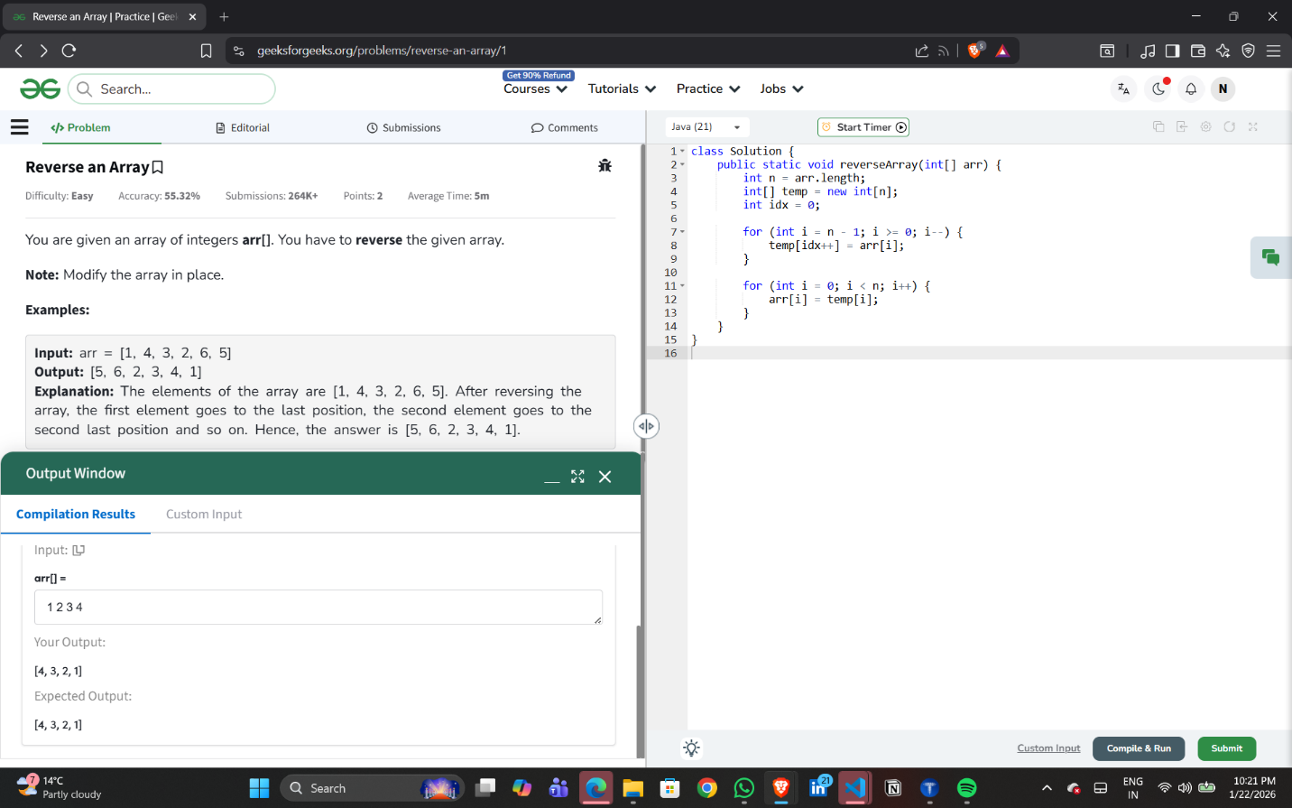

Experiment 1 – Question 2
Title: Find Minimum and Maximum in an Array
Algorithm:
- 1. Initialize min and max as first element.
- 2. Traverse the array.
- 3. Update min and max.
- 4. Return result.
Output:
