

Tribhuvan University Faculty of Humanities and Social Science

A PROJECT PROPOSAL ON

FUTSAL BOOKING SYSTEM

Submitted to

Department of Computer Application

Nepal Mega College

In partial fulfillment of the requirements for the Bachelors in Computer Application

Submitted by

Nishant Dahal (Roll No: 16)

Rohan Magar (Roll No: 19)

June, 2026
Contents

1. Introduction 1
2. Problem Statement 1
3. Objective 1
4. Methodology 1
a. Requirement Identification 1
i) Study of existing system 1
ii) Requirement Collection 2
iii) Functional Requirements 2
iv) Non-Functional Requirements 2
b. Feasibility Study 2
i) Technical Feasibility 2
ii) Operational Feasibility 3
iii) Economic Feasibility 3
c. High Level Design of System 3
i) Flowchart for User 3
ii) Flowchart for Admin 6
iii) Use Case Diagram 7
d. Methodology of proposed system 8
i) Waterfall Model 8
5. GANTT chart 9
6. Expected Outcomes 10
7. References 11

Introduction
Futsal has become increasingly popular in urban areas, leading to a high demand for court bookings, especially during peak hours and weekends. Many users such as players, team organizers, and small groups often book multiple time slots across different venues or manage bookings for different teams. However, handling multiple bookings manually, checking availability across various futsal courts, and keeping track of schedules can be confusing and time-consuming.
The proposed Futsal Booking Ssystem aims to solve these problems by providing a single platform with three user roles: Player, Manager, and Admin. Players can book court slots and manage their bookings, managers can add and manage their own courts, confirm and cancel bookings, and track payments, and the admin can manage users, grounds, and all bookings from one place. This makes the entire booking process simpler, faster, and more organized. [1] [2] [3]

Problem Statement
Currently, players, court managers, and administrators who use futsal court booking systems face several challenges:
- Managing multiple bookings across different futsal venues
- Checking court availability manually for different time slots
- Booking slots separately for each team or session
- Keeping track of booking history and schedules
- Handling last-minute changes or cancellations
- Managing information across multiple teams, venues, and user roles such as players, managers, and administrators [4] [5] [6]

Objective
- To enable players to book single or multiple futsal court slots online efficiently.
- To provide a platform for managing multiple teams, courts, and bookings in one system.
- To display real-time court availability information for accurate booking decisions.
- To maintain and track booking history and records systematically.
- To provide managers and administrators with tools to manage courts, users, and booking records effectively. [4] [5] [7]

4. Methodology

a. Requirement Identification

i) Study of existing system
Currently, futsal bookings are managed using phone calls, messaging apps, or manual registers. Some venues also rely on basic online scheduling tools or social media pages. In addition, existing sports court management platforms such as Playo, Skedda, CourtReserve, and Book My Court are used in some regions to handle court reservations and scheduling digitally. However, these methods and platforms often still lead to confusion, lack of real-time updates, and difficulty in tracking bookings across multiple users and time slots.
There is no centralized system that efficiently manages multiple bookings, team schedules, and booking history in a structured and fully integrated way. [8] [9] [7] [10]

ii) Requirement Collection
Requirements are collected through:
- Observation of existing futsal booking practices
- Discussions with futsal players and venue owners
- Analysis of current scheduling methods
- Study of sports facility management workflows

iii) Functional Requirements
- User registration and login with role-based access control for Player, Manager, and Admin
- Court and slot booking management
- Team and schedule management
- Booking history tracking
- Role-based dashboards for managers and administrators to manage courts, bookings, and users
- Notifications and booking updates

iv) Non-Functional Requirements
- User-friendly interface
- Data security and privacy
- High reliability and availability
- Scalability for multiple venues
- Maintainability and easy updates

b. Feasibility Study

i) Technical Feasibility
The system is technically feasible because it can be developed using readily available technologies and resources without requiring advanced hardware or complex infrastructure. The development tools and technologies are widely used, reliable, and well-supported, making implementation straightforward and manageable.

The project can be developed using:
- Frontend: HTML, CSS, JavaScript
- Backend: PHP
- Database: MySQL
These technologies are commonly used in web development and are suitable for building an efficient and reliable academic-level project.

ii) Operational Feasibility
The system is operationally feasible because it is simple and easy to use in real-world situations. Its user-friendly design enables futsal players, organizers and administrators to operate it without technical difficulty. A clear interface and well-structured features allow users to quickly adapt and manage bookings and schedules efficiently. [8] [9] [7] [10]

iii) Economic Feasibility
The system is economically feasible because it is developed using open-source freely available technologies, which significantly reduce development and licensing costs. Minimal hardware requirements and low maintenance expenses further help keep the overall budget within reasonable limits. As a result, the system can be implemented and operated cost-effectively while fulfilling all required functionalities.

c. High Level Design of System

i) Flowchart for User
The following figure shows the user flowchart for the Futsal Booking System. The user must log in to access the system. After successful login, the user is directed to the dashboard where they can view courts and make bookings.

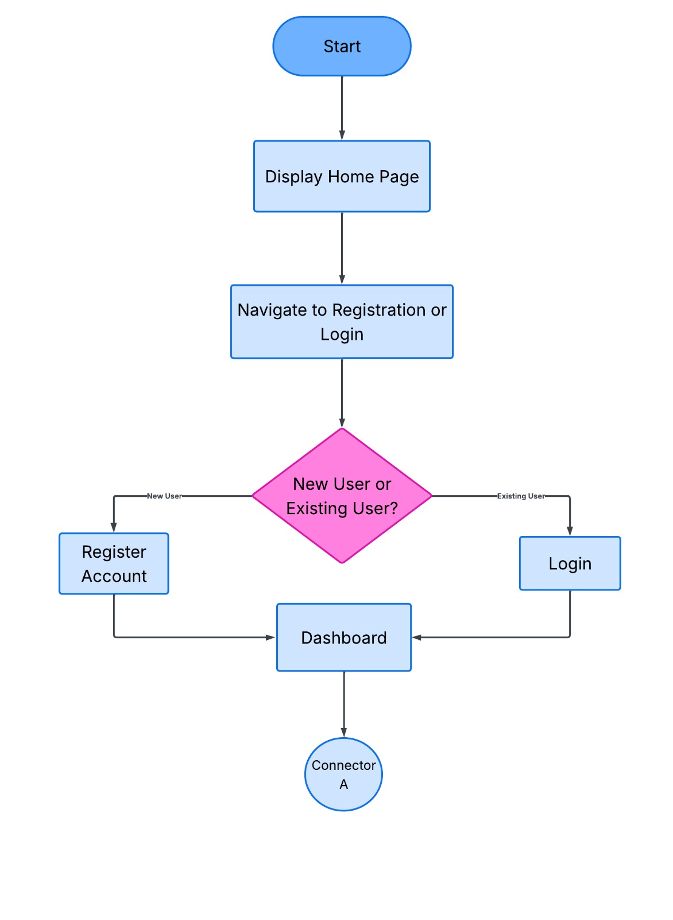

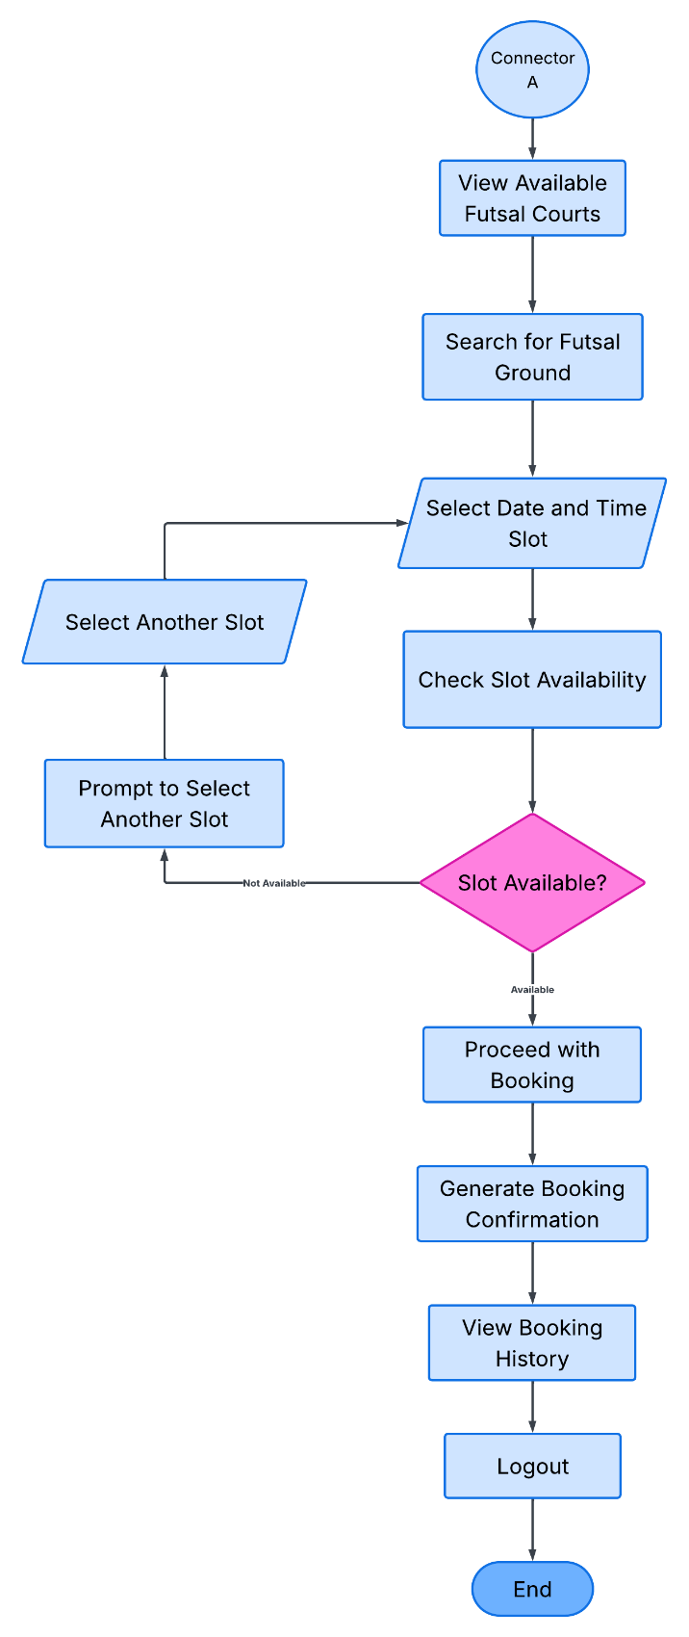

Figure 1: System Flowchart for User

ii) Flowchart for Admin
The following figure shows the admin flowchart for the Futsal Booking System. The admin must log in to access the system. After successful login, the admin is directed to the dashboard where they can manage courts, view booking records, manage users, generate reports, and perform other administrative tasks.
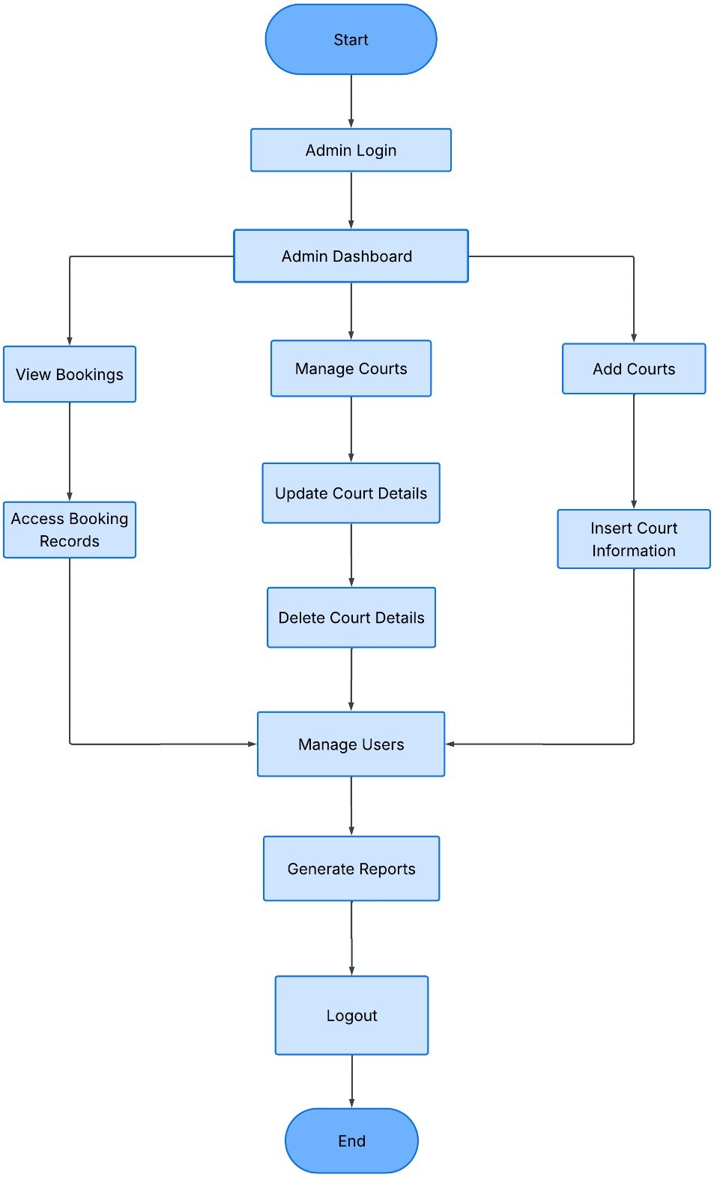

Figure 2: System Flowchart for Admin

iii) Use Case Diagram
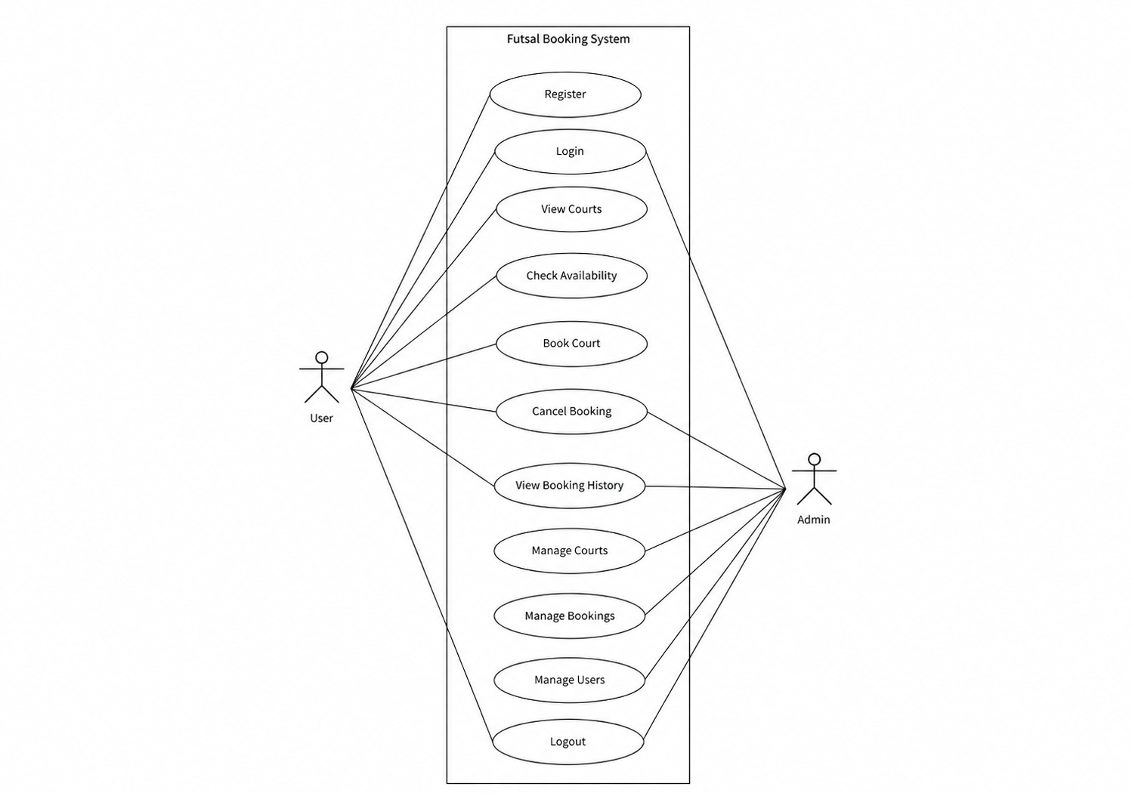

Figure 3: Use Case Diagram for Futsal Booking System

The use case diagram for the Futsal Booking System represents the interaction between the system and its three actors: User, Manager, and Admin. The User can register, log in, view available courts, check availability, book courts, cancel bookings, and view booking history. The Manager can log in, add and manage their own courts, confirm and cancel bookings, and track payments. The Admin can log in, manage all users, manage grounds, view and confirm bookings, and generate reports. The diagram also shows authentication as a shared function between all three actors.

d. Methodology of proposed system

i) Waterfall Model
The project is developed using the Waterfall Model, where each phase is completed fully before moving on to the next. It starts with gathering requirements, followed by system design, implementation, testing, deployment, and finally maintenance with ongoing improvements. This approach works well because the requirements are clear from the beginning and the project timeline is fixed.
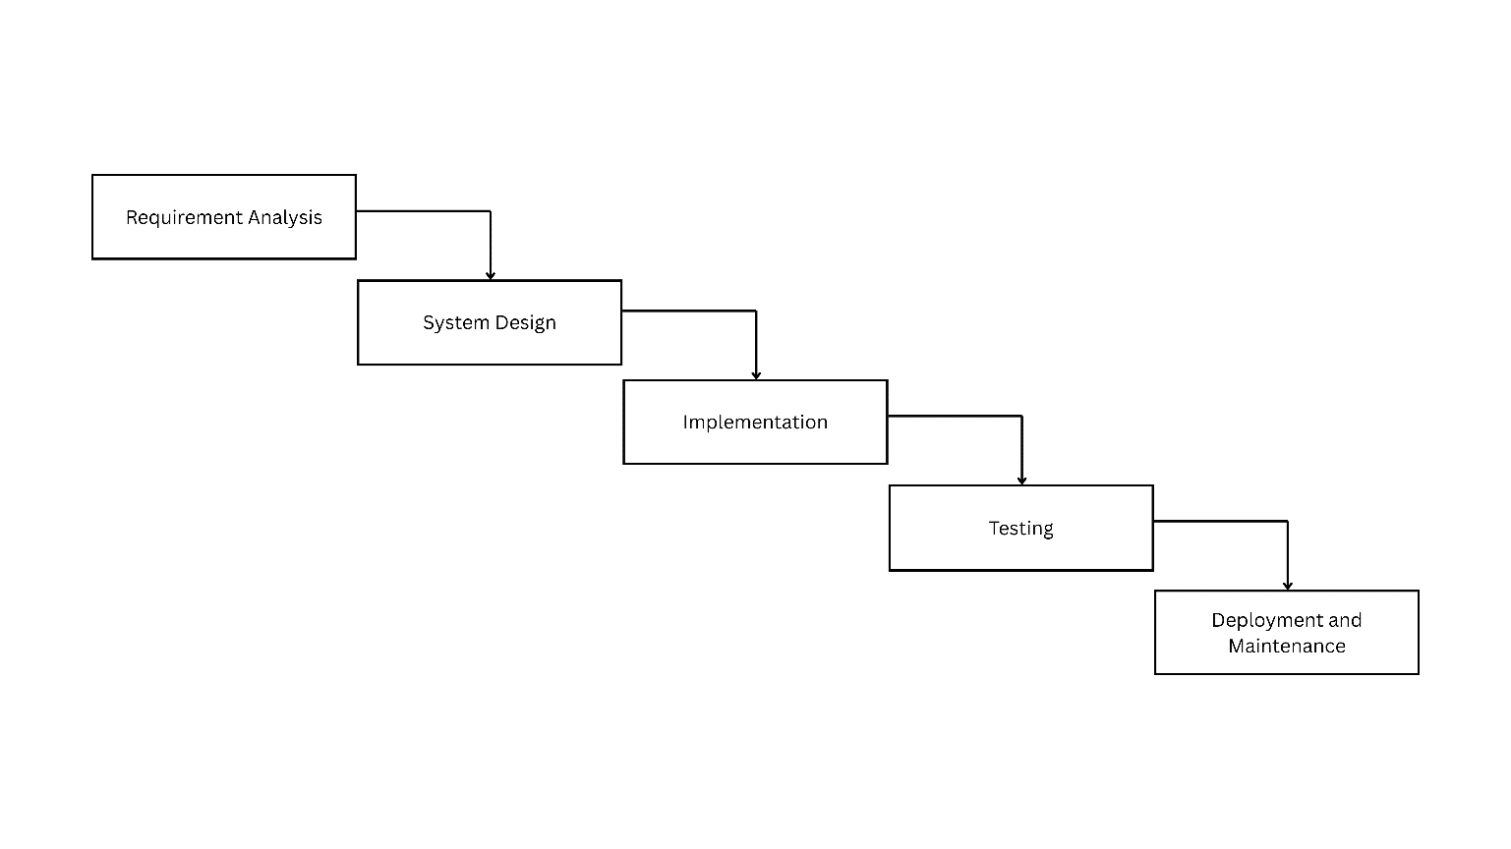

Figure 4: Waterfall model

GANTT chart
The Gantt chart illustrates the timeline and sequence of activities involved in the development of the Futsal Booking System. It serves as a project planning tool to allocate tasks, monitor progress, and ensure that the project is completed within the scheduled timeframe. The chart covers major phases including requirement analysis, system design, database development, module implementation, testing, and documentation.
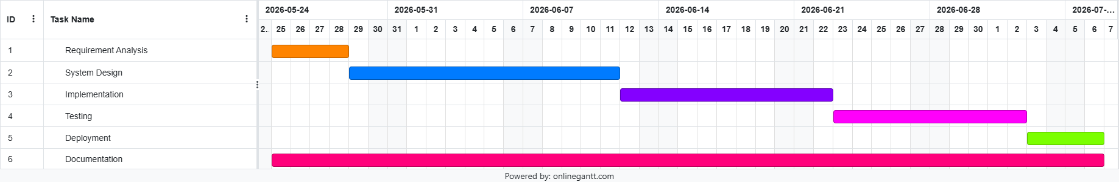

Figure 5: GANTT chart for the project

Expected Outcomes
The proposed system will provide an efficient and user-friendly platform for managing futsal court bookings and schedules. It will allow players to view court availability, reserve time slots, and track booking history, while managers and administrators manage courts, users, and records through a centralized system.
The platform will reduce manual booking efforts, minimize scheduling conflicts, improve data organization, and provide managers and administrators with better control over their courts, users, and booking management.
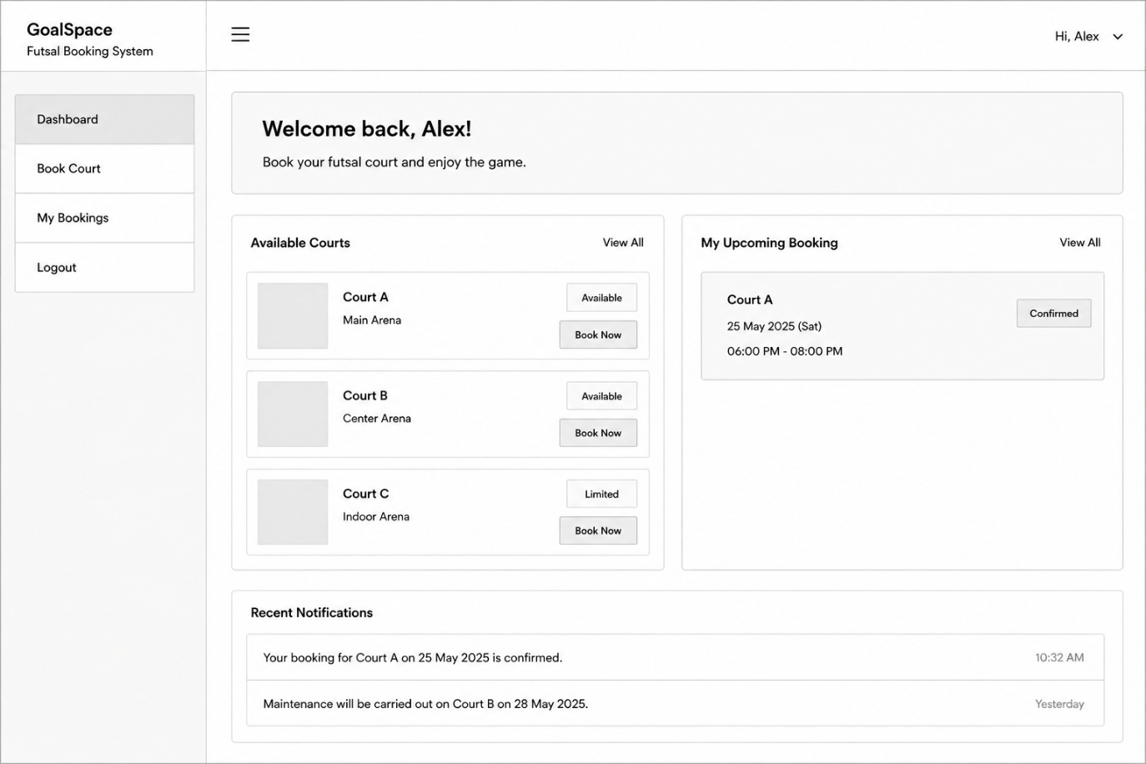

Figure 6: Wireframe of the proposed system

References

[1] | M. C. G. &. S. F. Beato, "Physical Demands of Futsal: A Review," Journal of Sports Medicine and Physical Fitness, vol. 56(4), p. 428–432, 2016.
[2] | V. H. Ronald Engler, Futsal: Technique, Tactics, Training, Meyer & Meyer Sport, 2010.
[3] | P. Sturgess, Futsal: Training, Technique and Tactics, Bloomsbury Sport, 2017.
[4] | J. F. G. J. S. V. Jeffrey A. Hoffer, Modern Systems Analysis and Design, Pearson, 2019.
[5] | B. H. W. D. T. Alan Dennis, Systems Analysis and Design: An Object-Oriented Approach with UML, Wiley, 2020.
[6] | J. P. L. Kenneth C. Laudon, Management Information Systems: Managing the Digital Firm, Pearson, 2022.
[7] | J. B. Karl E. Wiegers, Software Requirements, Microsoft Press, 2013.
[8] | B. R. M. Roger S. Pressman, Software Engineering: A Practitioner’s Approach, McGraw-Hill Education, 2020.
[9] | I. Sommerville, Software Engineering, Pearson, 2016.
[10] | I. S. Gerald Kotonya, Requirements Engineering: Processes and Techniques, Wiley, 1998.

