Technical Test:
=====================================================================================
- List view: Shows a list of all the tickets.
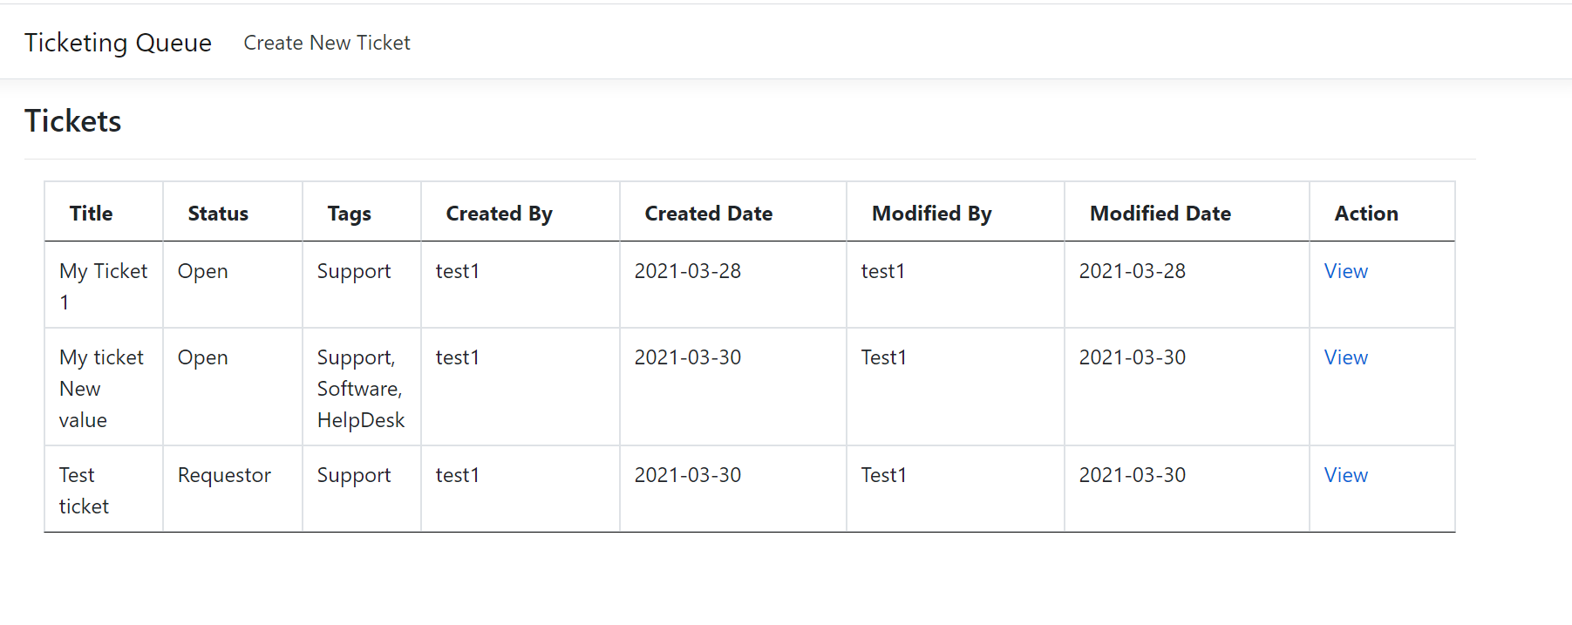
- Create a new ticket: User can create a ticket by using the form below.
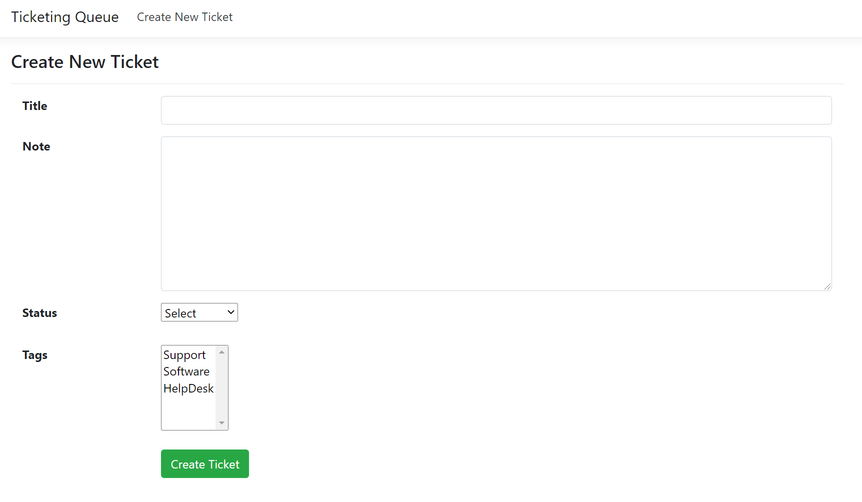

- Edit Ticket: User can edit the ticket based on ticket ID.

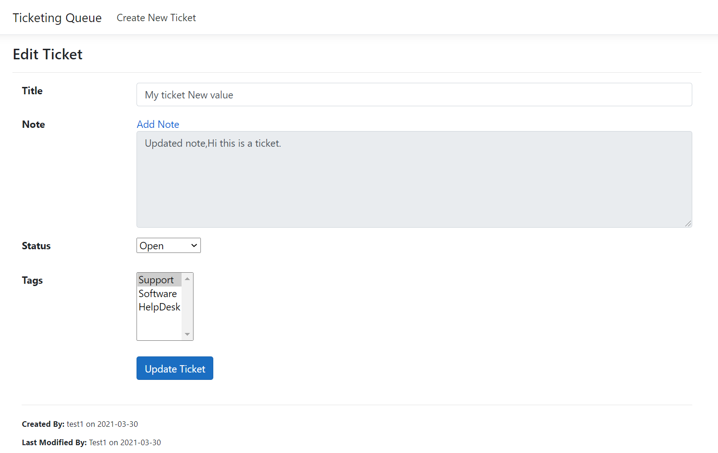

- Add Note in Edit View: User can add a note to an existing ticket.

