**Q. How React works? How Virtual-DOM works in React?**

React creates a virtual DOM. When state changes in a component it firstly runs a “diffing” algorithm, which identifies what has changed in the virtual DOM. The second step is reconciliation, where it updates the DOM with the results of diff.

The HTML DOM is always tree-structured — which is allowed by the structure of HTML document. The DOM trees are huge nowadays because of large apps. Since we are more and more pushed towards dynamic web apps (Single Page Applications — SPAs), we need to modify the DOM tree incessantly and a lot. And this is a real performance and development pain.

The Virtual DOM is an abstraction of the HTML DOM. It is lightweight and detached from the browser-specific implementation details. It is not invented by React but it uses it and provides it for free. ReactElements lives in the virtual DOM. They make the basic nodes here. Once we defined the elements, ReactElements can be render into the "real" DOM.

Whenever a ReactComponent is changing the state, diff algorithm in React runs and identifies what has changed. And then it updates the DOM with the results of diff. The point is - it’s done faster than it would be in the regular DOM.

**Q. What is JSX?**

JSX is a syntax extension to JavaScript and comes with the full power of JavaScript. JSX produces React “elements”. You can embed any JavaScript expression in JSX by wrapping it in curly braces. After compilation, JSX expressions become regular JavaScript objects. This means that you can use JSX inside of if statements and for loops, assign it to variables, accept it as arguments, and return it from functions. Eventhough React does not require JSX, it is the recommended way of describing our UI in React app.

For example, below is the syntax for a basic element in React with JSX and its equivalent without it.

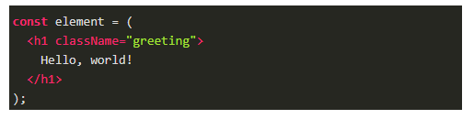

Equivalent of the above using React.createElement

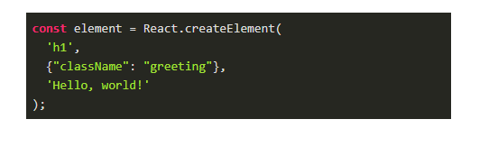

**Q. What is ReactDOM and what is the difference between ReactDOM and React?**

Prior to v0.14, all ReactDOM functionality was part of React. But later, React and ReactDOM were split into two different libraries.

As the name implies, ReactDOM is the glue between React and the DOM. Often, we will only use it for one single thing: mounting with ReactDOM. Another useful feature of ReactDOM is ReactDOM.findDOMNode() which we can use to gain direct access to a DOM element.

**Q. What is the difference between state and props?**

The state is a data structure that starts with a default value when a Component mounts. It may be mutated across time, mostly as a result of user events.

Props (short for properties) are a Component’s configuration. Props are how components talk to each other. They are received from above component and immutable as far as the Component receiving them is concerned. A Component cannot change its props, but it is responsible for putting together the props of its child Components. Props do not have to just be data — callback functions may be passed in as props.

Props and State do similar things but are used in different ways. The majority of our components will probably be stateless. Props are used to pass data from parent to child or by the component itself. They are immutable and thus will not be changed. State is used for mutable data, or data that will change. This is particularly useful for user input.

**Q. What are controlled components?**

In HTML, form elements such as <input>, <textarea>, and <select> typically maintain their own state and update it based on user input. When a user submits a form the values from the aforementioned elements are sent with the form. With React it works differently. The component containing the form will keep track of the value of the input in it's state and will re-render the component each time the callback function e.g. onChange is fired as the state will be updated. A form element whose value is controlled by React in this way is called a "controlled component".

**Q. What is create-react-app?**

create-react-app is the official CLI (Command Line Interface) for React to create React apps with no build configuration.

We don’t need to install or configure tools like Webpack or Babel. They are preconfigured and hidden so that we can focus on the code. We can install easily just like any other node modules. Then it is just one command to start the React project.