<https://javaconceptoftheday.com/java-string-interview-questions-and-answers>

<https://www.geeksforgeeks.org/strings-in-java/>

Strings in Java are Objects that are backed internally by a char array. Since arrays are immutable(cannot grow), Strings are immutable as well. Whenever a change to a String is made, an entirely new String is created.

**Memory allotment of String**

Whenever a String Object is created, two objects will be created-

1. One in the Heap Area
2. One in the String constant pool

**String object reference always points to heap area object.**

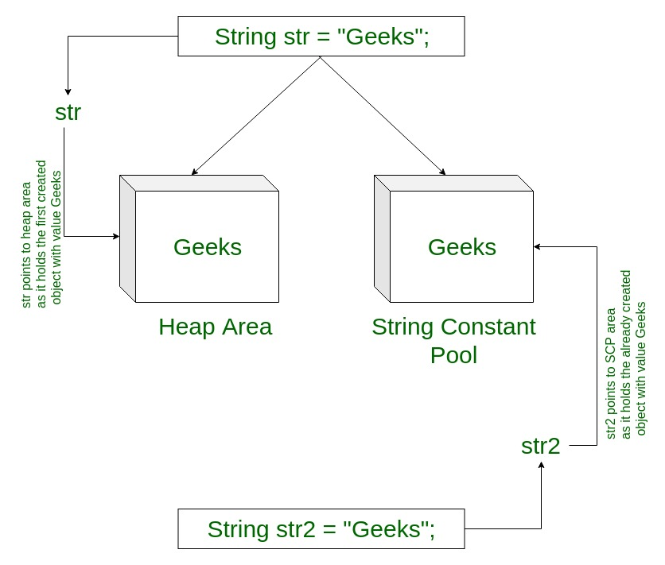

**Immutable means – object cannot be changed. It is like a constant. If we change value of String, then new object will be created.**