Software as a Service | SaaS

SaaS is also known as "**On-Demand Software**". It is a software distribution model in which services are hosted by a cloud service provider. These services are available to end-users over the internet so, the end-users do not need to install any software on their devices to access these services.

887.1K

122

Difference between JDK, JRE, and JVM

There are the following services provided by SaaS providers -

**Business Services** - SaaS Provider provides various business services to start-up the business. The SaaS business services include **ERP** (Enterprise Resource Planning), **CRM** (Customer Relationship Management), **billing**, and **sales**.

**Document Management** - SaaS document management is a software application offered by a third party (SaaS providers) to create, manage, and track electronic documents.

**Example:** Slack, Samepage, Box, and Zoho Forms.

**Social Networks** - As we all know, social networking sites are used by the general public, so social networking service providers use SaaS for their convenience and handle the general public's information.

**Mail Services** - To handle the unpredictable number of users and load on e-mail services, many e-mail providers offering their services using SaaS.

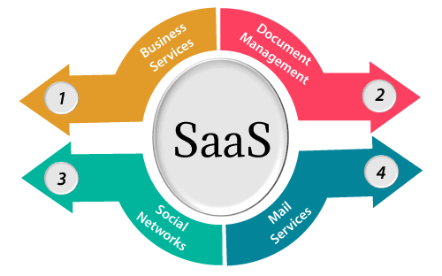

Advantages of SaaS cloud computing layer

**1) SaaS is easy to buy**

SaaS pricing is based on a monthly fee or annual fee subscription, so it allows organizations to access business functionality at a low cost, which is less than licensed applications.

Unlike traditional software, which is sold as a licensed based with an up-front cost (and often an optional ongoing support fee), SaaS providers are generally pricing the applications using a subscription fee, most commonly a monthly or annually fee.

**2. One to Many**

SaaS services are offered as a one-to-many model means a single instance of the application is shared by multiple users.

**3. Less hardware required for SaaS**

The software is hosted remotely, so organizations do not need to invest in additional hardware.

**4. Low maintenance required for SaaS**

Software as a service removes the need for installation, set-up, and daily maintenance for the organizations. The initial set-up cost for SaaS is typically less than the enterprise software. SaaS vendors are pricing their applications based on some usage parameters, such as a number of users using the application. So SaaS does easy to monitor and automatic updates.

**5. No special software or hardware versions required**

All users will have the same version of the software and typically access it through the web browser. SaaS reduces IT support costs by outsourcing hardware and software maintenance and support to the IaaS provider.

**6. Multidevice support**

SaaS services can be accessed from any device such as desktops, laptops, tablets, phones, and thin clients.

**7. API Integration**

SaaS services easily integrate with other software or services through standard APIs.

**8. No client-side installation**

SaaS services are accessed directly from the service provider using the internet connection, so do not need to require any software installation.

Disadvantages of SaaS cloud computing layer

**1) Security**

Actually, data is stored in the cloud, so security may be an issue for some users. However, cloud computing is not more secure than in-house deployment.

**2) Latency issue**

Since data and applications are stored in the cloud at a variable distance from the end-user, there is a possibility that there may be greater latency when interacting with the application compared to local deployment. Therefore, the SaaS model is not suitable for applications whose demand response time is in milliseconds.

**3) Total Dependency on Internet**

Without an internet connection, most SaaS applications are not usable.

**4) Switching between SaaS vendors is difficult**

Switching SaaS vendors involves the difficult and slow task of transferring the very large data files over the internet and then converting and importing them into another SaaS also.

Popular SaaS Providers

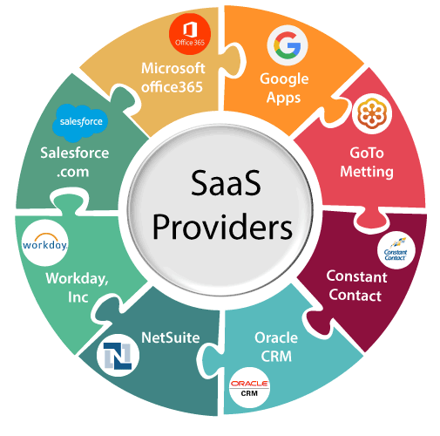

The below table shows some popular SaaS providers and services that are provided by them -

|  |  |
| --- | --- |
| **Provider** | **Services** |
| Salseforce.com | On-demand CRM solutions |
| Microsoft Office 365 | Online office suite |
| Google Apps | Gmail, Google Calendar, Docs, and sites |
| NetSuite | ERP, accounting, order management, CRM, Professionals Services Automation (PSA), and e-commerce applications. |
| GoToMeeting | Online meeting and video-conferencing software |
| Constant Contact | E-mail marketing, online survey, and event marketing |
| Oracle CRM | CRM applications |
| Workday, Inc | Human capital management, payroll, and financial management. |