<https://hsvphry.org.in/Pages/EstateOffice>

Estate Office

The single window service is being provided in all the Estate offices where the applicant can submit his/her application relating to HSVP work at the counter. An acknowledgement receipt is issued on receipt of application indicating the date when the final reply will be given and in case of rejection of the application the reason for rejection is also mentioned on the receipt.

   8.     Transfer Of Application

HSVP allows transfer the property from one owner to another owner. If the conveyance deed is done and all dues are cleared then HSVP charges administrative charges of Rs.5000/- for transfer of the property otherwise transfer fee is charged by HSVP at the rate fixed from time to time. Transfer is allowed in case of Residential/ Commercial/ Nursing Homes (Auction). Transfer of residential/ commercial plots wherein either full payment has already been made or laid down schedule of payment of installments is over or Construction is complete (i.e. OC issued), which ever is earlier, shall be allowed only through execution of conveyance deed/ sale deed. However, in other case, wherein full payment of the plot has not so far been made and the schedule of payment of installments is not yet over, a maximum of four transfers shall be allowed before final payment. The rate of transfer fee depends on the zone potential of the urban estate in which the plot lies.

To transfer a residential property in Haryana Shehri Vikas Pradhikaran (HSVP), you'll need to apply for a transfer permission letter and provide the following documents:

* **Property documents**:
* **Identity proof**: Applicant's identity proof, such as a voter card, driving license, Aadhar card, or PAN card
* **Witness identity proof**: Identity proof of the witness
* **Digital photograph**: Digital photograph of the building or plot
* **NOC from DTP**: NOC from DTP if the area is notified under 7(A) of the HDRUA Act 1975

How to take transfer permission in HUDA ( Through Allottee)

1. Log in to the HUDA website at:

**<https://www.hsvphry.org.in/>**

1. Create your User ID and Password by filling out the relevant details.
2. After logging in you will be redirected to the Home Page. Search for the option 'Apply Online Application’.
3. Go to the option ‘Transfer Permission Letter ( Through Allottee).
4. Choose the ‘Appointment Time Slot’.
5. Choose ‘Building Constructed as ‘Yes’ or ‘No’ and enter the further details.
6. Fill in information about ‘Proposed Applicant/ Transferee’.
7. Choose ‘Yes’ to ‘ Add Transferee Joint Holder Details’.
8. Tap on ‘Proceed’ and go to the payment gateway.
9. After making the payment you will get your Online application receipt.

* **Sale deed**: Proof of the sale and transfer of ownership from the seller to the buyer
* **Identity proof**: Proof of identity for both parties
* **Property tax receipts**: Property tax receipts up to the current year
* **No Objection Certificate (NOC)**: If applicable
* **Encumbrance certificate**: Proof that the property is free from any encumbrances
* **Court decree**: An affidavit or declaration that no court case is pending
* **Chain of ownership**: Proof of the chain of ownership
* **Allotment letter**: Allotment letter or re-allotment letter from any government or semi-government department

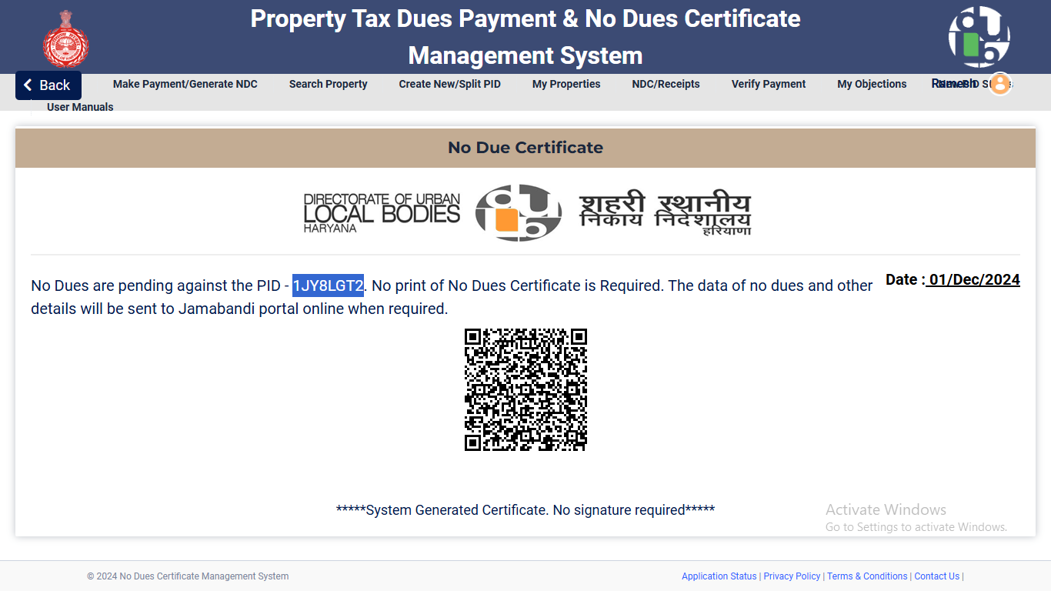

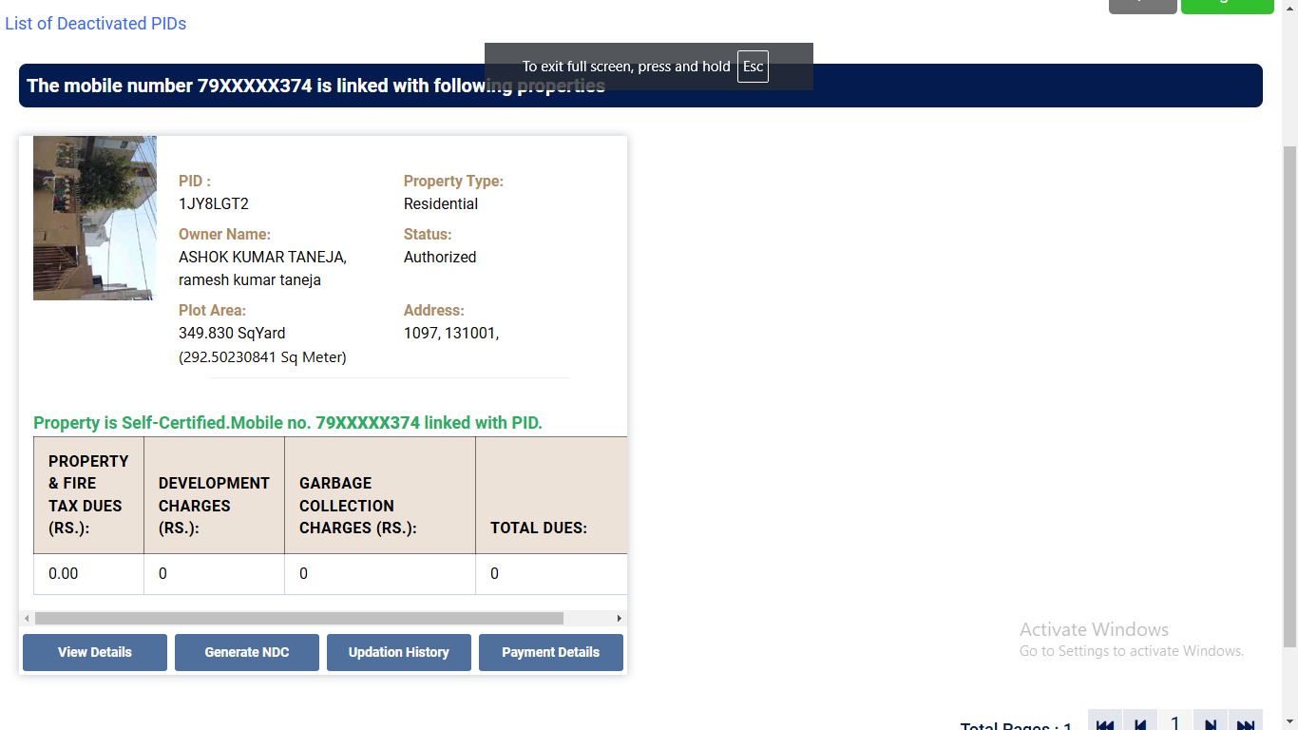

AFFIDAVIT

I,

do hereby solemnly affirm and declare as under:-

1. That I am sole and absolute owner and allottee of residential Plot No. , Sector , Urban Estate Panchkula, Measuring _Sq.Mtrs. duly allotted to me by the Estate Officer, HUDA, Panchkula, on free hold basis.
2. That I have sold/transferred the said Plot to Sh.

as per Sale Agreement duly signed and executed by me with the above Said purchasers

and have received the entire consideration /transfer value in full and final settlement as per the said deed of Sale Agreement.

1. That I have executed and signed one Indemnity Bond in favour of HUDA duly got attested by me from the Magistrate Ist class for the Transfer of the said Plot in favour of the above said purchasers and have also signed other required papers for transfer of ownership in the names of the said Purchasers.
2. That I shall present myself personally in the office of the Estate Officer, HUDA, Panchkula or before the other appropriate authority to submit the signed Indemnity Bond and the affidavit of the transferees for the final transfer of the said plot in favour of the above said purchasers and my responsibility and my the transfer of the said Plot in favour of the said purchasers finally in the record of the Estate Officer, HUDA Panchkula.

Contd…2..

-2-

1. That I shall never back out of the said transaction and shall be fully bound with the terms & conditions of the instrument of agreement duly signed by me and shall also never cancel or revoke the Indemnity Bond so executed by me for Estate Officer, HUDA Panchkula.
2. That I have delivered the actual , physical and vacant possession of the said plot to the said purchasers and have also handed over all the relevant papers/documents relating to the ownership of the said Plot to the said purchasers including the allotment letter and receipts of payments etc.etc. for the reference and record of the said purchasers/ transfers.
3. That I shall sign & execute any such papers/documents relating to the transfer of ownership of the said Plot in favour of the said purchasers/ transfers at any later stage without any demand, delay and hesitation, if any, such necessity arises later on at the request and the cost of the said purchasers.
4. That the above bargain has been done by me with my full sense, with a sound and stable mind, without any undue pressure, coercion, force or fraud as per deed of agreement which has been duly signed & executed by me after clearly and expressly understanding all its terms & conditions.
5. That none of my legal heirs shall have any legal right, claim or interests in the above mentioned plot during my life time and/or after my death.
6. That from today onwards, the said purchasers have become the actual owners of the said plot (subject to the balance installments of the said plot) and now I am only benami owner of the same till the ownership of the said plot actually transferred in the names of the said purchasers or in the name/s of their nominee/s

Place: Dated:

Deponent.

Verification :

Verified that the above contents of this affidavit are true and correct to My knowledge and belief and nothing has been concealed there in. No Part of it is false and incorrect.

Deponent.

INDEMNITY BOND

This Indemnity Bond is executed at Panchkula, on this

of , 2009 by

WHEREAS the executant is desirous of getting property bearing residential Plot No. , Sector , Urban Estate Panchkula, measuring Mtrs. Transferred in the names of

AND WHEREAS the Estate Officer, HUDA, urban Estate Panchkula, has Asked the executant to furnish this Indemnity Bond for the same .

NOW THIS INDEMNITY BOND WITNESSETH AS FOLLOWS

1. That the said transfer which is sought in the names of Sh

is a friendly transfer and, in case, the Haryana Urban Development Authority

would suffer any loss on account of this transfer in their names, the executant, his properties and his persons shall be liable to make good the loss which may be sustained by the HUDA or its employees on account of this transfer.

1. That the legal heirs and successors of the executant shall also be liable to make good the loss, if any , suffered by HUDA.

Contd…2…

-2-

1. That, in case, any legal heirs or other persons shall make any claim regarding this plot, the litigation of the same will be defended by the executant and the loss suffered by HUDA will also be made good by the executant

and his properties and person.

IN THE PRESENCE of the following witnesses this Indemnity Bond is Signed at Panchkula, on the day, month and year mentioned above.

WITNESSES:-

Witness No. 1

EXECUTANT.

Witness No. 2

AFFIDAVIT BY THE TRANSFEREES

We,

do hereby solemnly affirm and declare as under:-

1. That we accept the allotment of residential Plot No. , Sector , Urban Estate Panchkula, measuring Sq.Mtrs. inclusive of incidental Space allotted, if any.
2. That we further undertake to make payment of all the outstanding dues or such amount as may be due or become liable/due against this plot at any later stage.
3. That we accept the terms & conditions relating to the allotment of Plot and

of incidental open space, if any, and shall abide by the provisions of HUDA Act, 1977, and the rules/regulations applicable thereunder and amended from time to time.

1. That we shall not use the plot for purposes, other than for which it has been allotted.
2. That we shall pay the interest on the delayed payment of installment/ enhanced compensation, as per policy of the authority, decided from time to time .
3. That we shall not raise any dispute in respect of the interest paid by the transferor in respect of the delay payment of instalment/enhanced compensation/ possession interest in respect of the plot/building, as per policy of the authority, decided from time to time.

Place:

Dated:

# Verification :

Deponent.

Verified that the above contents of this affidavit are true and correct to My knowledge and belief and nothing has been concealed therein.No Part of it is false and incorrect.

# Deponent.

AFFIDAVIT

I,

do hereby solemnly affirm and declare as under:-

1. That I am sole and absolute owner and allottee of residential Plot No.

, Sector , Urban Estate Panchkula,Measuring

Sq.Mtrs. duly allotted to me by the Estate Officer, HUDA, Panchkula, on instalments and free hold basis, and the said plot is free from All sorts of encumbrances and attachments till to-date.

1. That there is no dispute/litigation or Court Case, pending in any Court of Law against the above said plot.
2. That I have not obtained any loan against my above said plot and the same is free from mortgage till to-date.
3. That my latest specimen signatures are as under:-

i ii iii

Place:

Dated:

# Verification :

Deponent.

Verified that the above contents of this affidavit are true and correct to My knowledge and belief and nothing has been concealed therein.No Part of it is false and incorrect.

# Deponent.

SALE AGREEMENT

ON NON JUDICIAL STAMP PAPERS WORTH Rs. /-

This Deed of Sale Agreement is made at on this

Day of 200 ;

BETWEEN

(hereinafter referred to as the seller which term shall where the context so admits include

his heirs, assigns, executors, successors, legal representatives, administrative and administrators) of the one part .

AND

(hereinafter referred to as the Purchaser which term shall where the context so admits

include theirs, assigns, executors, successors, legal representatives, administrative and administrators) of the other part.

AND WHEREAS the seller is sole and absolute owner and allottee of residential Plot No. , Sector , Urban Estates Panchkula, Plot measuring

Sq.Mtrs. duly allotted to him on free hold basis by the Estate Officer, HUDA, Panchkula and the said plot is free from all sorts of encumbrances i.e. sale gift, mortgage, claims, charges into any sale agreement prior to this agreement in respect of above said plot.

AND WHEREAS the said seller is interested in the sale of his above said plot and has agreed with the said purchasers for the absolute sale of said plot in favour of the purchasers and the purchasers have also agreed to purchase the same and both the parties have agreed with each other on the following terms and conditions:-

Contd..2..

-2-

NOW THIS DEED FURTHER WITNESSETH AS UNDER

1. That the total sale price of the said free hold residential plot has been fixed at Rs. /- (Rupees

Only)

1. That the said purchasers have paid to the said seller a sum of Rs. /(Rupees

Only) vide

as full and final payment against the said Plot for which amount the said seller

hereby acknowledges the receipt in the presence of the marginal witnesses.

1. That now from today the said purchasers shall be responsible to pay the balance price/instalments of the said plot to the Estate Officer, HUDA, Panchkula and to construct the building on the said plot within stipulated period. In case, purchasers fails to do so then the purchasers shall have to face all such consequences and the seller shall not be responsible for the same at any later stage.
2. That the said seller has delivered the actual and physical vacant possession of the said plot to the said Purchasers and has also handed over all the concerned papers and documents of the said plot (subject to the balance payment of the said plot).
3. That the said seller has executed an Indemnity Bond in favour of the purchasers/Govt.for the transfer of the said plot in the names of the purchasers and seller shall not withdraw the same at any later stage. In case the said seller does so and backs out from this bargain then the said seller shall be liable to refund to the said purchasers three times of the amount received by him today

Contd..3..

-3-

plus three time of the amount to be paid by the purchasers to the Govt.against the said plot plus three times of the cost of construction/damages, if any, without any hesitation and delay. In case the said purchasers shall have right to get the sale effected through court of law under specific relief act.

1. That the said seller hereby further agrees and undertakes to save harmless and to keep indemnified the said Purchasers from and against all losses, claims or damages (If any due to sale of said plot only) from time to time and to execute and to sign all such papers and documents regarding the transfer of ownership of said property only (if such necessary arises at any later stage) on the request and cost of the Purchasers without any hesitation, permission, demand and delay.
2. That this deed of sale agreement is made in duplicate. Original will be kept by the purchasers and copy thereof by the said seller for his records and ready reference.

IN WITNESS WHEREOF both the parties have set their hands on this deed at on the day, month and year mentioned above in the presence of the witnesses.

# WITNESS No.1 SELLER.

WITNESSNO.2 PURCHASER.

RECEIPT

Received a sum of Rs. /-(Rupees

Only)vide

from Sh.

as full and final payment against the absolute sale of my residential Plot

No. ,Sector ,Urban Estate Panchkula ,Plo measuring

Sq.Mtrs. which I have sold to them as per terms and conditions of this sale Agreement in the presence of the witnesses.

Dated:-

WITNESS NO. 1 :

SELLER.

WITNESS NO. 2 :

To

The Estate Officer, HUDA, Panchkula.

Sub: Transfer of residential Plot No. ,Sector , Urban Estate Panchkula, Measuring Sq.Mtrs.

Sir,

With reference to your Letter No. , Dated / /2009, I hereby enclose the following documents:-

1. Indemnity Bond.
2. Affidavit by the Transferees.
3. Original Permission Letter.
4. Original Allotment Letter.
5. Affidavit by the Transferor.
6. Identification Proofs of Transferor/Transferees.

It is therefore requested that the aforesaid Plot may kindly be transferred in the Names of Sh.

, at the earliest and oblige.

Thanking you,

Yours Faithfully, Dated: / /2009.