Assignment No: 1

Code:
BFS:
#include <iostream>
#include <vector>
#include <queue>
#include <omp.h>
using namespace std;

int main() {
int n, e;
cout << "Enter number of vertices: ";
cin >> n;

cout << "Enter number of edges: ";
cin >> e;

vector<vector<int>> graph(n);
cout << "Enter edges (u v):\n";
for (int i = 0; i < e; i++) {
int u, v;
cin >> u >> v;
graph[u].push_back(v);
graph[v].push_back(u);
}

int start;
cout << "Enter starting node: ";
cin >> start;

vector<bool> visited(n, false);
queue<int> q;

visited[start] = true;
q.push(start);

cout << "Parallel BFS Traversal: ";

while (!q.empty()) {
int size = q.size();

#pragma omp parallel for
for (int i = 0; i < size; i++) {
int node;

#pragma omp critical
{
node = q.front();
q.pop();
cout << node << " ";
}

for (int nbr : graph[node]) {
#pragma omp critical
{
if (!visited[nbr]) {
visited[nbr] = true;
q.push(nbr);
}
}
}
}
}
return 0;
}

OUTPUT:
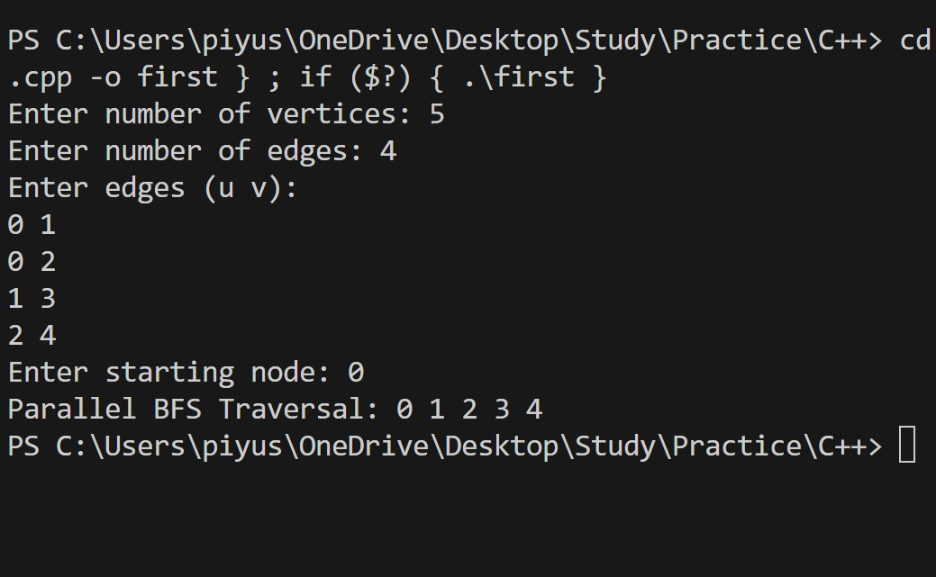

DFS:
#include <iostream>
#include <vector>
#include <omp.h>
using namespace std;

void dfs(int node, vector<vector<int>> &graph, vector<bool> &visited) {
#pragma omp critical
{
if (visited[node]) return;
visited[node] = true;
cout << node << " ";
}

#pragma omp parallel for
for (int i = 0; i < graph[node].size(); i++) {
int nbr = graph[node][i];
if (!visited[nbr]) {
#pragma omp task
dfs(nbr, graph, visited);
}
}
}

int main() {
int n, e;
cout << "Enter number of vertices: ";
cin >> n;

cout << "Enter number of edges: ";
cin >> e;

vector<vector<int>> graph(n);
cout << "Enter edges (u v):\n";
for (int i = 0; i < e; i++) {
int u, v;
cin >> u >> v;
graph[u].push_back(v);
graph[v].push_back(u);
}

int start;
cout << "Enter starting node: ";
cin >> start;

vector<bool> visited(n, false);

cout << "Parallel DFS Traversal: ";

#pragma omp parallel
{
#pragma omp single
dfs(start, graph, visited);
}

return 0;
}

OUTPUT:
