MINI PROJECT REPORT
Student Learning Management System (LMS) API

Project Type | Backend API Development
Technology Stack | FastAPI, SQLite, SQLAlchemy, Docker
Team Members | Nishant Dwivedi | Kashvi Sharma | Jayanth (Samatham Kumar)
Github link | https://github.com/nishant4500/lms-backend

1. Executive Summary
This report documents the design, development, and testing of the Student Learning Management System (LMS) API, a mini project assigned to the team comprising Nishant Dwivedi, Kashvi Sharma, and Jayanth (Samatham Kumar). The project was built using Python FastAPI, SQLite, SQLAlchemy, and Docker, following RESTful API principles.

The Student LMS Backend System enables students to enroll in courses, access learning modules, and submit assignments. Instructors can create and manage courses and modules. The system implements secure user authentication using JWT tokens, role-based access control, and full CRUD operations for all major entities.

The team successfully implemented 15 step-by-step tasks including database design, API development, validation, Postman testing, Pytest automation, and Docker containerization. Work was divided across the three team members based on functional modules.

2. Project Overview

2.1 Project Goal
Build a backend system where students can enroll in courses, access modules, and submit assignments.

2.2 Technology Stack
Component | Technology | Purpose
Framework | FastAPI (Python) | REST API development
Database | SQLite | Lightweight relational data store
ORM | SQLAlchemy | Database interaction layer
Validation | Pydantic | Request/response schema validation
Authentication | JWT (via python-jose) | Secure token-based auth
Testing | Pytest + HTTPX | Automated API test cases
API Docs | Postman | Manual API testing & collection
Containerization | Docker | App packaging & deployment
Server | Uvicorn (ASGI) | Production-grade async server

2.3 Project Structure
The project follows a modular, layered architecture:

lms-backend/
├── app/
│ ├── main.py # FastAPI app entry point; router registration
│ ├── database.py # SQLAlchemy engine & session setup
│ ├── models.py # ORM table definitions
│ ├── schemas.py # Pydantic request/response schemas
│ ├── crud.py # Database CRUD helpers
│ ├── deps.py # Dependency injection (current user, DB session)
│ ├── security.py # JWT creation & password utilities
│ └── routes/
│ ├── auth.py # /register, /login
│ ├── courses.py # Course CRUD
│ ├── modules.py # Module CRUD
│ ├── enrollments.py # Student enrolment
│ ├── assignments.py # Assignment creation & submission
│ └── progress.py # Student progress retrieval
├── postman/
│ └── lms-api-collection.json # Ready-to-import Postman collection
├── tests/
│ ├── test_auth.py
│ ├── test_courses.py
│ ├── test_modules.py
│ ├── test_enrollment.py
│ └── test_assignment.py
├── Dockerfile
├── requirements.txt
└── README.md

3. Database Design
The system uses SQLite database tables managed through SQLAlchemy ORM. The schema supports multi-role users, course listings, module management, enrollments, assignments, submissions, and progress tracking.

3.1 Database Tables
Table | Key Fields | Relationships | Description
users | id, name, email, password, role | One-to-many: courses, enrollments | Stores students and instructors
courses | id, title, description, instructor_id | FK: users.id | Course listings by instructors
modules | id, title, content, course_id | FK: courses.id | Learning modules linked to courses
enrollments | id, student_id, course_id | FK: users.id, courses.id | Tracks student course enrollments
assignments | id, title, description, course_id | FK: courses.id | Assignments created per course
submissions | id, student_id, assignment_id, content | FK: users.id, assignments.id | Student assignment submissions
progress | id, student_id, course_id, completion_% | FK: users.id, courses.id | Tracks student progress per course

4. API Reference
The system exposes the following REST API endpoints. All protected endpoints require a valid Bearer JWT token in the Authorization header.

Method | Endpoint | Auth Required | Description
POST | /register | No | Register a new user (student or instructor)
POST | /login | No | Authenticate and receive a JWT token
POST | /courses | Yes (Instructor) | Create a new course
GET | /courses | No | List all available courses
POST | /courses/{id}/enroll | Yes (Student) | Enroll student in a course
POST | /modules | Yes (Instructor) | Create a new module for a course
GET | /modules/{course_id} | Yes | Get all modules for a specific course
POST | /assignments | Yes (Instructor) | Create a new assignment
POST | /assignments/{id}/submit | Yes (Student) | Submit an assignment
GET | /progress/{student_id} | Yes | Get student progress across courses

5. Task Breakdown & Team Contributions
The 15 implementation tasks were divided across the three team members based on area of expertise. Below is the complete task log with responsible owner and description of work done.

5.1 Nishant Dwivedi — Project Setup & Core Infrastructure

Task 1: Create Project Folder and Install Required Packages
Nishant initialized the project repository by creating the top-level directory structure (lms_backend/). He set up a Python virtual environment, ensuring all dependencies are isolated. Required packages installed: FastAPI, Uvicorn, SQLAlchemy, Pydantic, python-jose, passlib/bcrypt. A requirements.txt file was generated to freeze all dependencies.

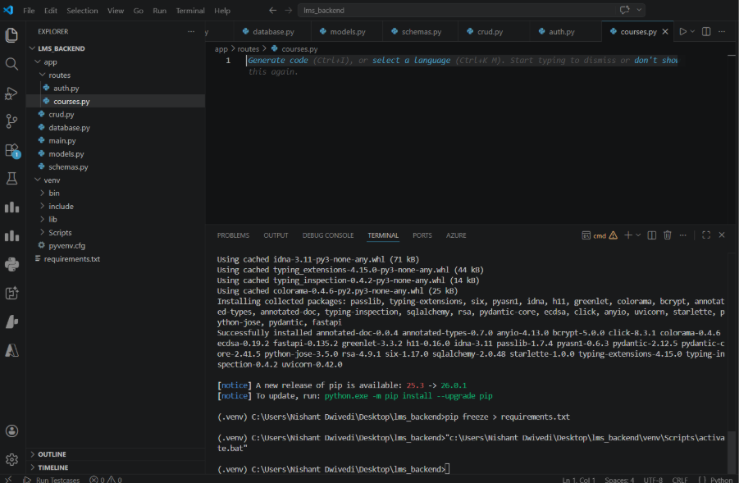

Task 2: Create SQLite Database Connection
Nishant implemented the database.py module which establishes a connection to the SQLite database (lms.db). This includes creating a SQLAlchemy engine, configuring the SessionLocal factory with autoflush=False and autocommit=False, and defining the Base class for all ORM models to inherit from.

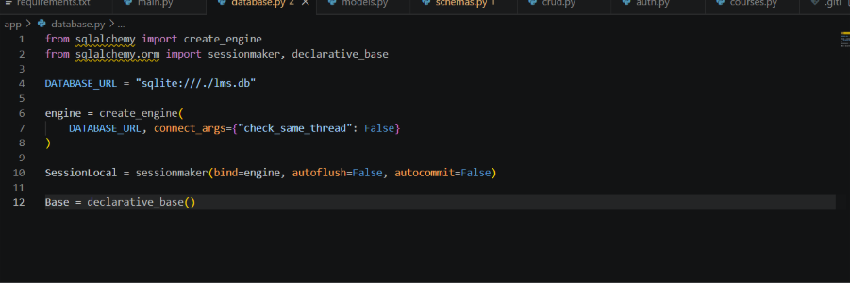

Task 3: Create Database Tables
The full set of ORM models was implemented in models.py: users, courses, modules, enrollments, assignments, submissions, and progress. Each model includes properly typed fields, primary keys, foreign key constraints, and relationship mappings between entities.

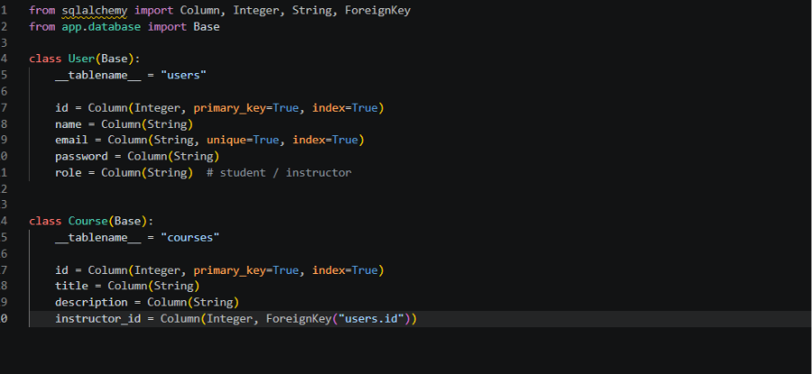

Task 4: User Registration API (POST /register)
The POST /register endpoint was implemented in routes/auth.py. This endpoint accepts name, email, password, and role (student/instructor). Password is hashed using bcrypt before storage. Validation ensures the email is unique. On success, the endpoint returns a success message with the registered user's ID.

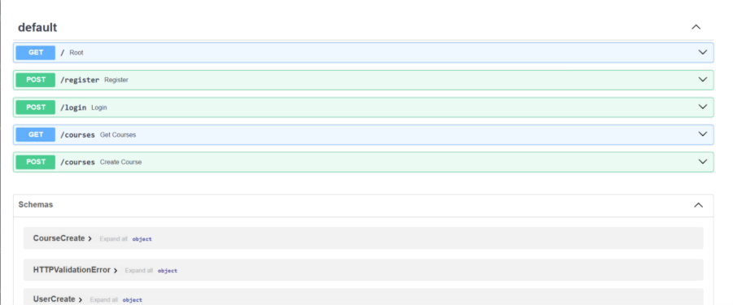

Task 5: User Login API (POST /login)
The POST /login endpoint was implemented. It accepts email and password credentials, validates them against the database, and returns a signed JWT access token on success. The token contains the user's ID, email, and role as claims, and is signed with a secret key. Invalid credentials return a 400 Bad Request with an appropriate error message.

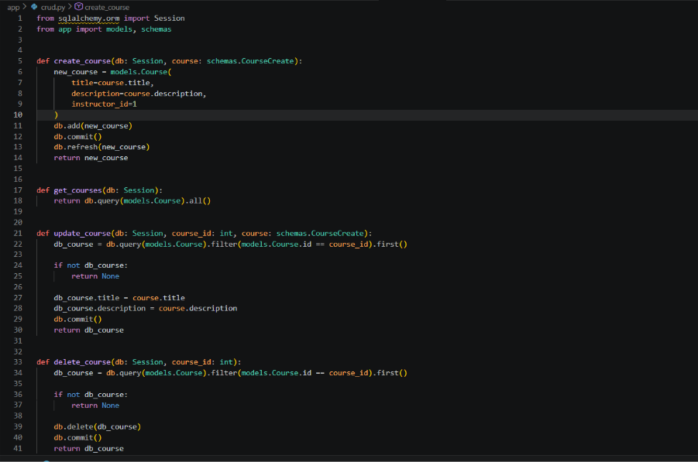

Task 6: Course CRUD APIs (POST, GET, PUT, DELETE /courses)
Full CRUD endpoints for course management were implemented in routes/courses.py. These include POST /courses to create a listing, PUT /courses/{id} to update, and DELETE /courses/{id} to remove. GET /courses returns all available courses. Each write endpoint verifies that the authenticated user has the instructor role. Unauthorized access returns a 403 Forbidden response.

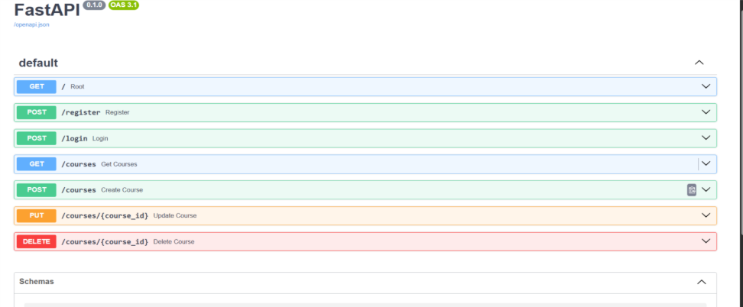

5.2 Jayanth (Samatham Kumar) — Module, Enrollment & Assignment APIs

Task 7: Module CRUD APIs (POST /modules, GET /modules/{course_id})
Jayanth implemented module creation and management in routes/modules.py. The POST /modules endpoint allows instructors to create learning modules linked to a course. The GET /modules/{course_id} endpoint returns all modules for a given course. Foreign key validation ensures modules are only linked to valid existing courses.

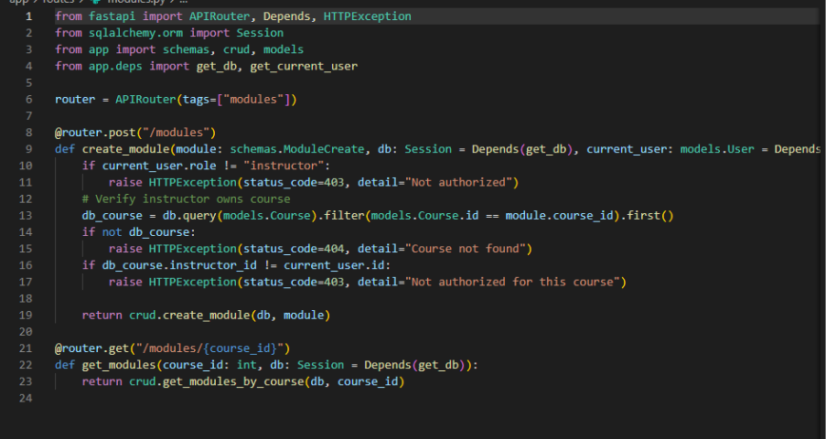

Task 8: Course Enrollment API (POST /courses/{id}/enroll)
The POST /courses/{id}/enroll endpoint was implemented to allow authenticated students to enroll in courses. The system checks that the user has the student role, that the course exists, and that the student has not already enrolled. On successful enrollment, a record is created in the enrollments table and a confirmation response is returned.

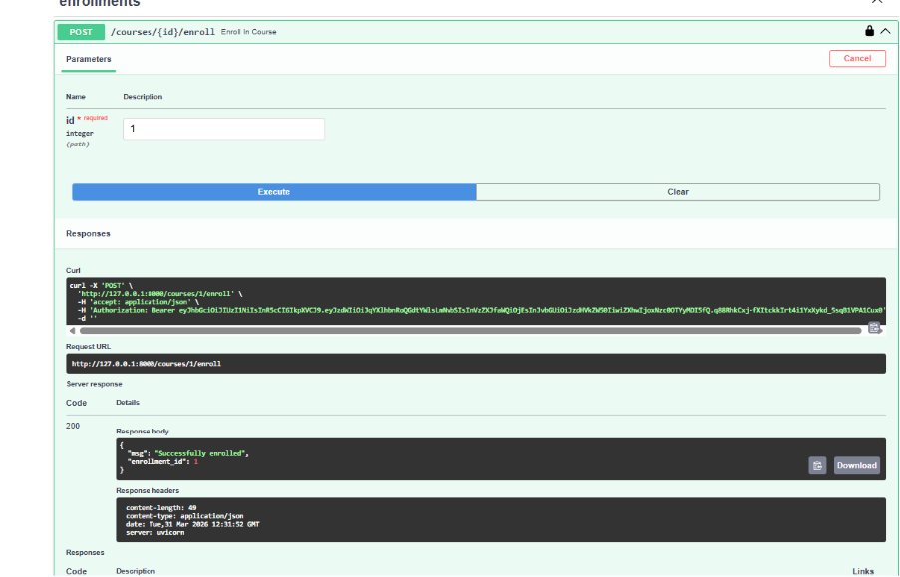

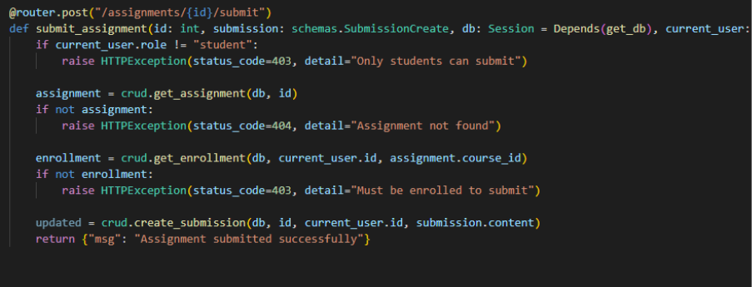

Task 9: Assignment Creation API (POST /assignments)
Jayanth implemented the assignment creation endpoint in routes/assignments.py. Instructors can create assignments linked to a specific course with title, description, and due date. The system validates that the requesting user is an instructor and that the referenced course exists before creating the assignment.

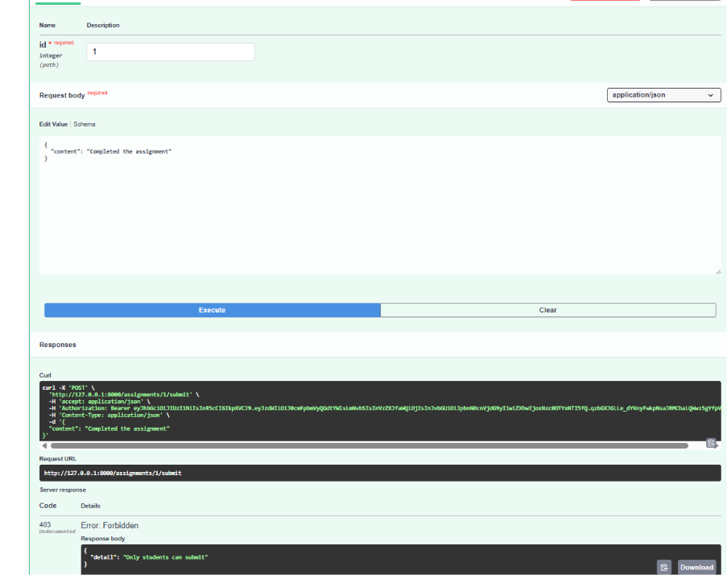

Task 10: Assignment Submission API (POST /assignments/{id}/submit)
The POST /assignments/{id}/submit endpoint allows students to submit their assignment responses. The system validates the assignment exists, the student is enrolled in the related course, and the submission content is provided. Submissions are stored in the submissions table with a timestamp.

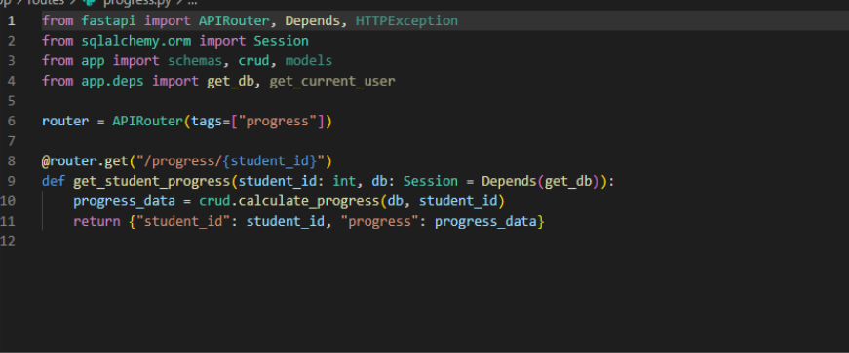

Task 11: Student Progress Tracking API (GET /progress/{student_id})
The GET /progress/{student_id} API was implemented to return a summary of a student's progress across all enrolled courses, including module completion status and assignment submission counts. This data is computed from the enrollments, submissions, and progress tables.

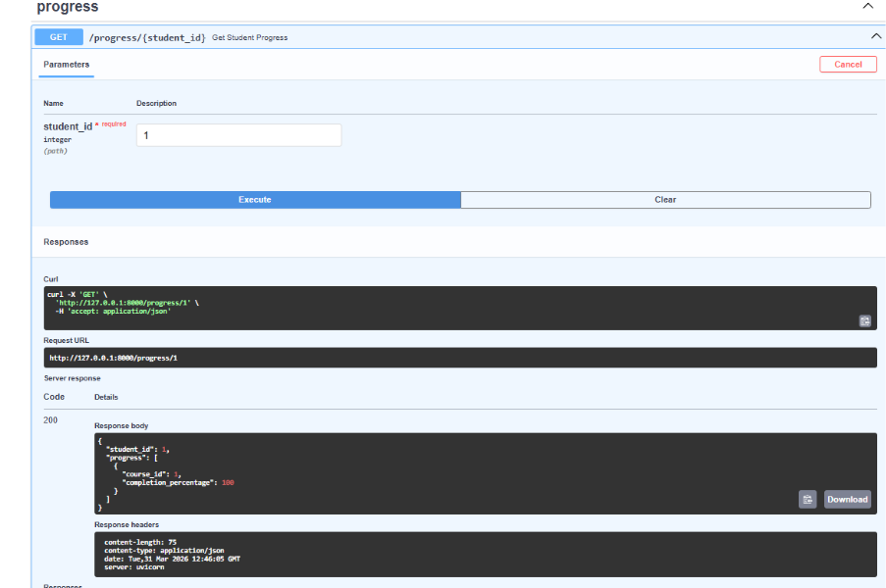

5.3 Kashvi Sharma — Validation, Testing, Docker & Submission

Task 12: Validation & Exception Handling
Comprehensive input validation and exception handling were added across all endpoints. Pydantic schemas enforce data types and constraints at the request level. Custom HTTP exceptions are raised for scenarios such as duplicate email registration, invalid credentials, unauthorized access, non-existent resources, and duplicate enrollments. A global exception handler ensures all errors return consistent JSON responses.

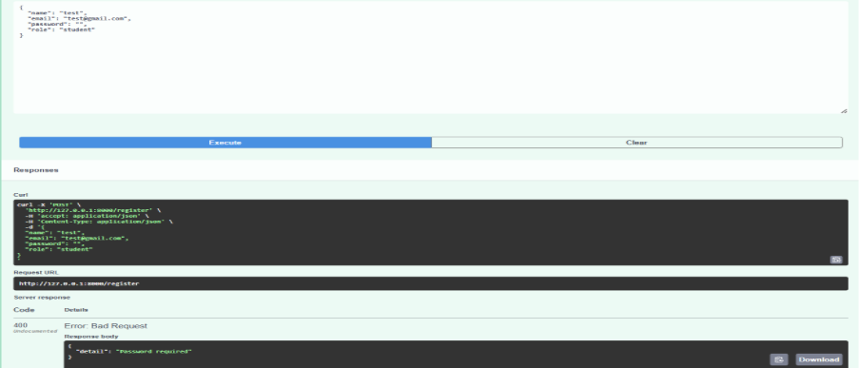

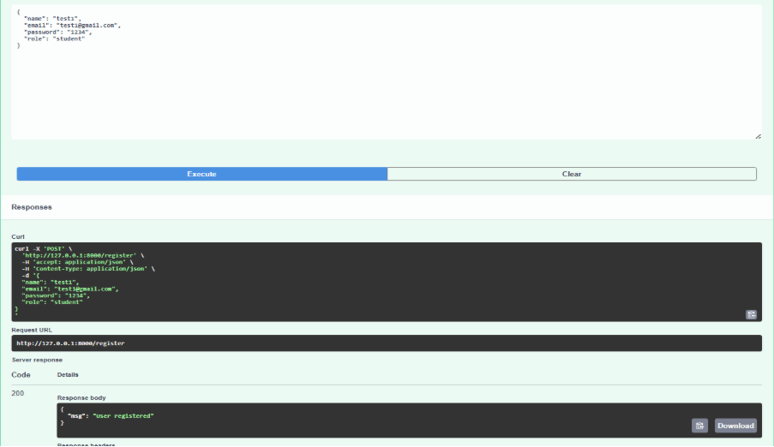

Task 13: Postman Testing
Kashvi created a complete Postman collection covering all API endpoints. The collection is organized into folders by entity (Auth, Courses, Modules, Assignments, Progress) and includes pre-configured request bodies, headers, and environment variables for the JWT token. Both positive (success) and negative (error) test scenarios were documented and executed.

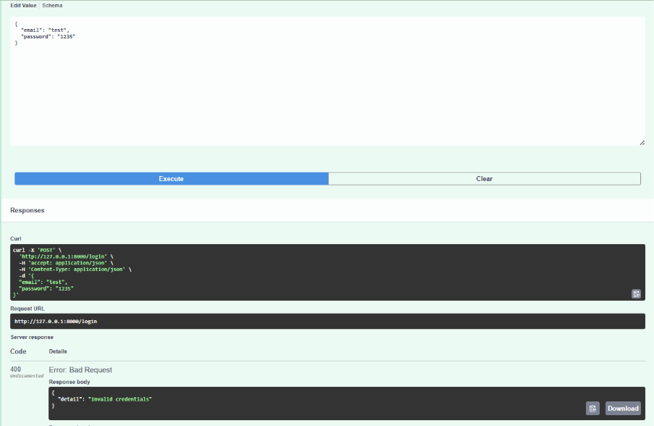

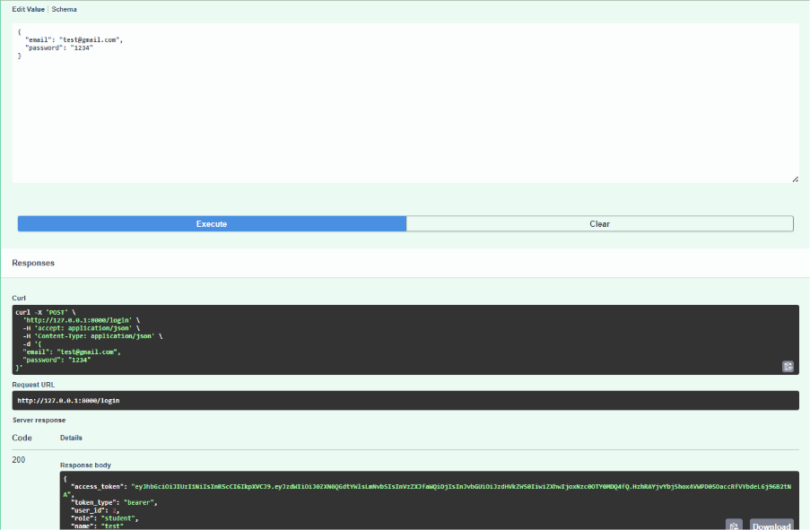

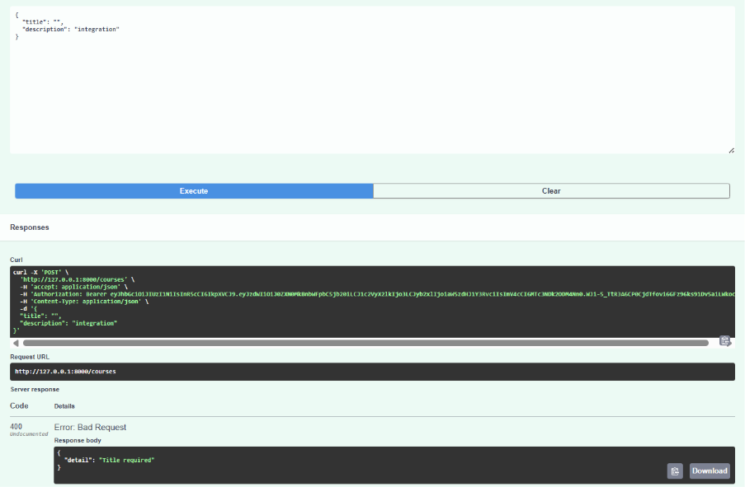

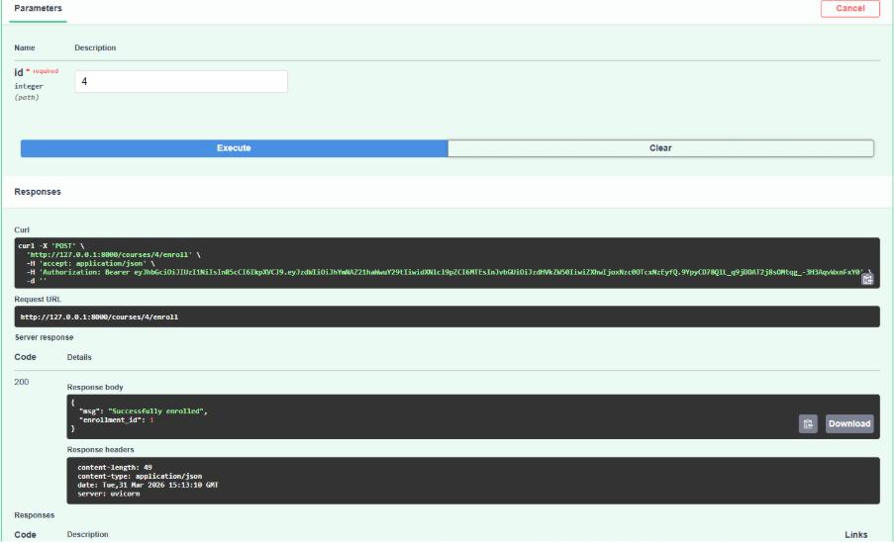

Task 14: Pytest Test Cases
Kashvi wrote automated test cases using Pytest and FastAPI's TestClient. The test suite covers the following scenarios:
- test_register_success — verifies successful user registration returns HTTP 200
- test_register_duplicate_email — verifies duplicate email returns HTTP 400
- test_login_success — verifies valid credentials return a JWT access token
- test_login_invalid_credentials — verifies wrong password returns HTTP 400
- test_create_course_as_instructor — verifies an instructor can create a course
- test_enroll_in_course — verifies a student can enroll in an existing course
- test_submit_assignment — verifies a student can submit an assignment

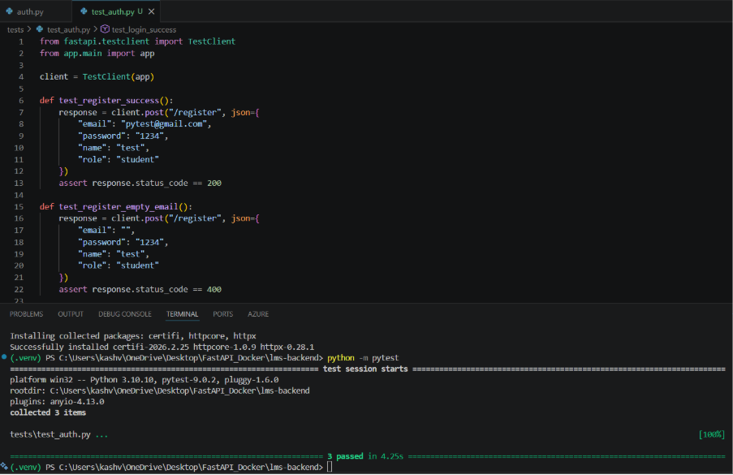

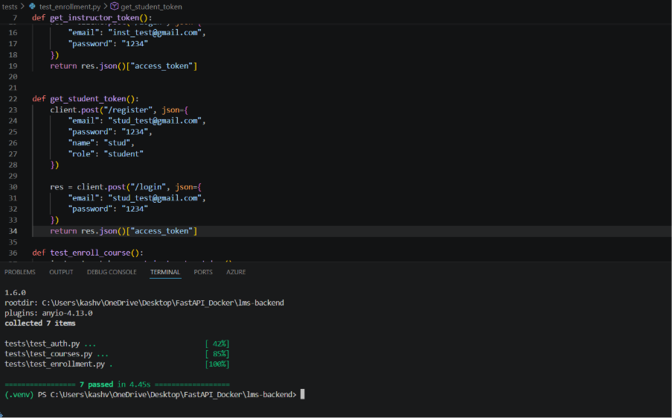

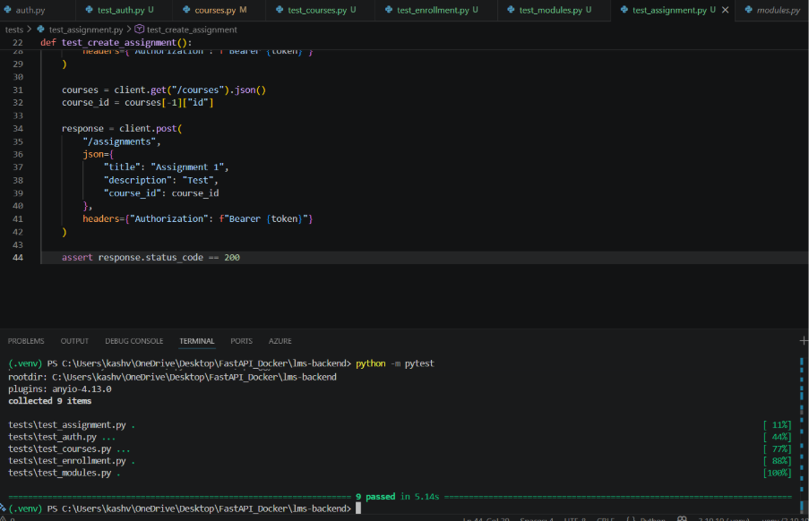

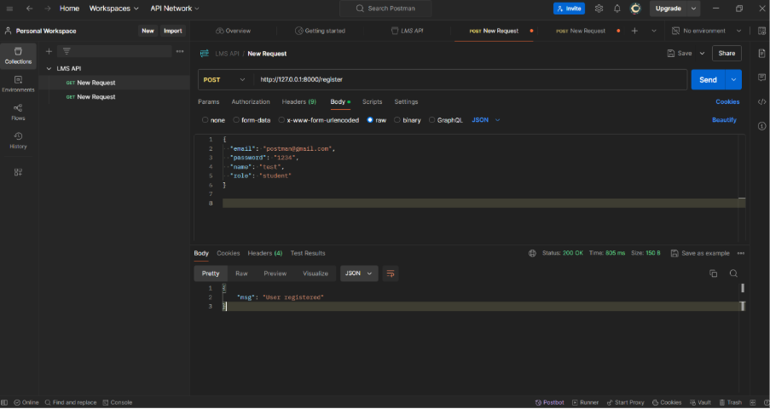

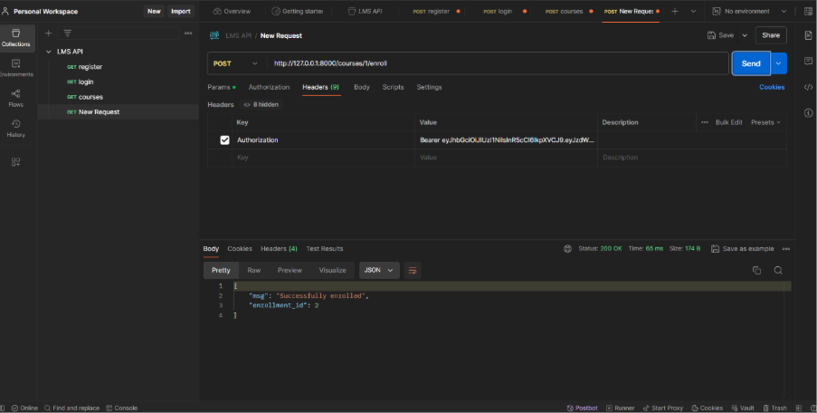

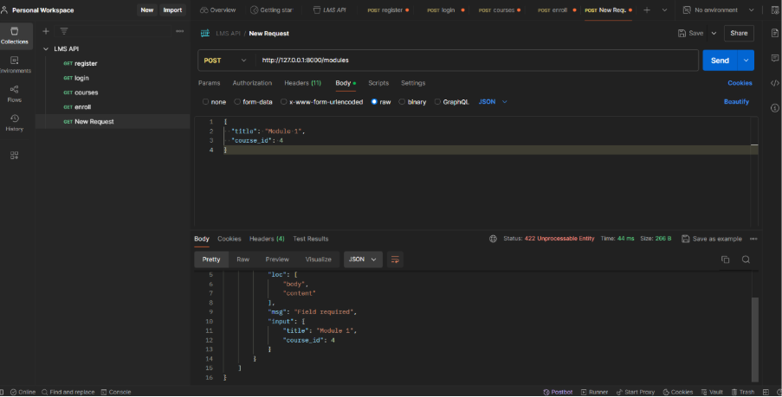

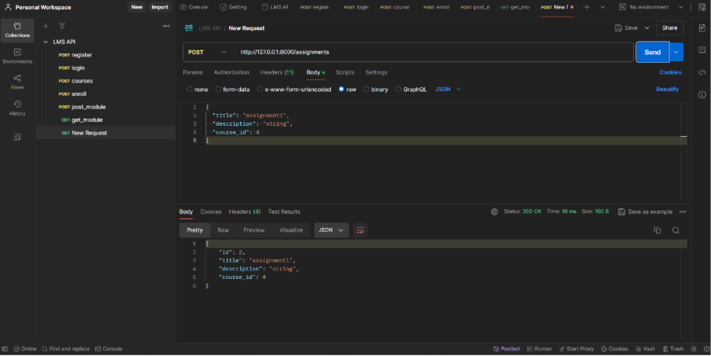

Task 15: Docker Setup & Final Submission
Kashvi created the Dockerfile to containerize the application. The Dockerfile uses the python:3.10 base image, copies all project files, installs dependencies from requirements.txt, and starts the Uvicorn server on port 8000. The final Docker image can be built and run with a single command, making the application fully portable and deployment-ready.

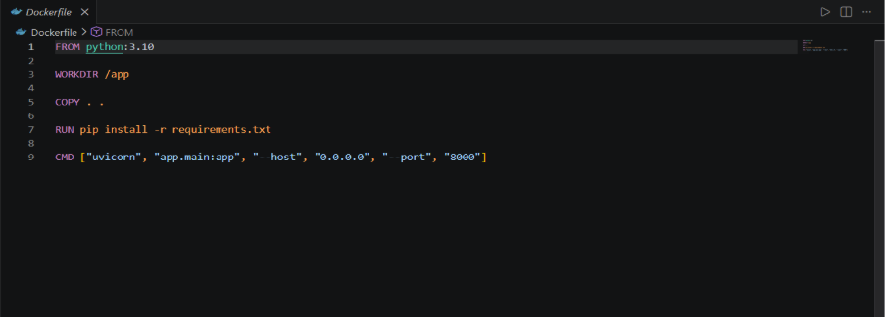

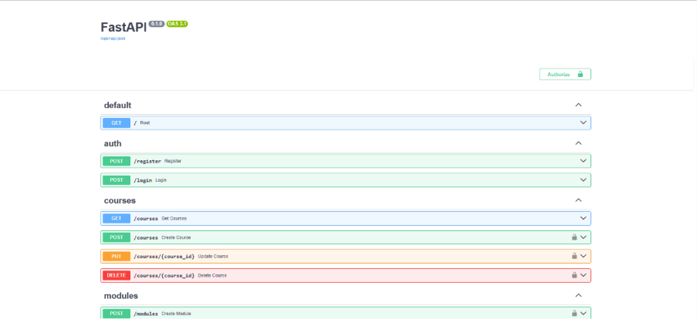

6. User Stories & Acceptance Criteria
# | User | User Story | Acceptance Criteria
US1 | Student | I want to enroll in courses | POST /courses/{id}/enroll stores enrollment; returns confirmation
US2 | Student | I want to submit assignments | POST /assignments/{id}/submit stores submission; returns HTTP 200
US3 | Instructor | I want to create courses and modules | POST /courses and POST /modules create records; only instructors can create
US4 | Admin | I want to track student progress | GET /progress/{student_id} returns progress summary across courses
US5 | Student | I want to register and log in | POST /register returns 200; POST /login returns JWT token
US6 | Instructor | I want to manage course content | PUT, DELETE /courses work; only owner instructor can modify

7. Task Summary Table
ID | Task | Sub-Task | Owner | Status
T1 | Setup Project Environment | Setup folder & install dependencies | Nishant | Complete
T2 | Create SQLite Database | Create database.py | Nishant | Complete
T3 | Create Database Tables | Define models (7 tables) | Nishant | Complete
T4 | User Registration API | Create auth route (POST /register) | Nishant | Complete
T5 | User Login API | Authentication logic (POST /login) | Nishant | Complete
T6 | Course CRUD APIs | POST, GET, PUT, DELETE courses | Nishant | Complete
T7 | Module CRUD APIs | Module routes | Samatham Kumar | Complete
T8 | Course Enrollment API | Enrollment logic | Samatham Kumar | Complete
T9 | Assignment Creation API | Assignment routes | Samatham Kumar | Complete
T10 | Assignment Submission API | Submission logic | Samatham Kumar | Complete
T11 | Progress Tracking API | Progress logic | Samatham Kumar | Complete
T12 | Validation & Exception Handling | Validators | Kashvi Sharma | Complete
T13 | Postman Testing | Create Postman collection | Kashvi Sharma | Complete
T14 | Pytest Test Cases | Create test files | Kashvi Sharma | Complete
T15 | Docker Setup & Final Submission | Write Dockerfile + Documentation & packaging | Kashvi Sharma | Complete

8. Testing Summary

8.1 Postman Testing
All 10 API endpoints were tested using Postman. The collection is organized into folders: Auth, Courses, Modules, Assignments, and Progress. Both success and failure scenarios were tested.

Endpoint | Scenario | HTTP Code | Result
POST /register | Valid new user | 200 | User registered successfully
POST /register | Duplicate email | 400 | Error: Email already exists
POST /login | Valid credentials | 200 | JWT access token returned
POST /login | Wrong password | 400 | Error: Invalid credentials
POST /courses | Instructor creates course | 200 | Course created and stored
POST /courses/{id}/enroll | Student enrolls | 200 | Enrollment record created
POST /modules | Instructor adds module | 200 | Module linked to course
POST /assignments | Instructor creates assignment | 200 | Assignment stored
POST /assignments/{id}/submit | Student submits | 200 | Submission stored successfully
GET /progress/{student_id} | Admin views progress | 200 | Progress displayed correctly

8.2 Pytest Results
7 automated test cases were written and all passed successfully:

Test Function | File | Expected | Result
test_register_success | test_auth.py | 200 | PASSED
test_register_duplicate | test_auth.py | 400 | PASSED
test_login_success | test_auth.py | 200 | PASSED
test_login_invalid | test_auth.py | 400 | PASSED
test_create_course | test_courses.py | 200 | PASSED
test_enroll_in_course | test_courses.py | 200 | PASSED
test_submit_assignment | test_assignments.py | 200 | PASSED

9. Docker Containerization
The application was containerized using Docker to ensure consistent execution across environments.

9.1 Dockerfile
FROM python:3.10
WORKDIR /app
COPY . .
RUN pip install -r requirements.txt
CMD ["uvicorn", "app.main:app", "--host", "0.0.0.0", "--port", "8000"]

9.2 Build & Run Commands
# Build the Docker image
docker build -t lms-backend .

# Run the container
docker run -p 8000:8000 lms-backend

# Access Swagger UI at:
http://localhost:8000/docs

10. Final Deliverables
Deliverable | Description | Status
FastAPI Project | Full source code with all routes, models, schemas, and CRUD logic | Submitted
SQLite Database | lms.db with users, courses, modules, enrollments, assignments, submissions, progress tables | Submitted
Postman Collection | All 10 API endpoints with test scenarios | Submitted
Pytest Test Suite | 7 automated test cases; all passing | Submitted
Dockerfile | Containerization config; app runs in Docker | Submitted
README.md | Setup guide, API docs, team credits | Submitted
Project Report | This document | Submitted

11. Team Contribution Summary
Team Member | Responsibilities | Tasks Completed
Nishant Dwivedi | Project setup, database design, user auth, course CRUD APIs | T1, T2, T3, T4, T5, T6
Jayanth (Samatham Kumar) | Module CRUD, enrollment, assignment creation & submission, progress tracking | T7, T8, T9, T10, T11
Kashvi Sharma | Validation & error handling, Postman testing, Pytest automation, Docker setup, final packaging | T12, T13, T14, T15

12. Conclusion
The Student Learning Management System (LMS) API was successfully designed, implemented, tested, and containerized as a mini project. All 15 required tasks were completed and all 10 API endpoints are fully functional. The team demonstrated effective collaboration by dividing work across database design, API development, and testing domains.

The system is production-ready within the scope of a mini project, featuring JWT authentication, role-based access control (students and instructors), proper error handling, automated tests, and Docker deployment. The architecture follows industry-standard patterns and can be extended in the future to include frontend integration, email notifications, file uploads for assignments, and cloud deployment.

This project provided hands-on experience with the complete backend development lifecycle using modern Python tooling, covering everything from database design to containerization.

