ASSIGNMENT 3: APPLY DIMENSIONALITY REDUCTION USING PCA

1. Aim and Practical Objectives
The main goal of this practical is to learn how to reduce the number of input features in a dataset using Principal Component Analysis (PCA) while keeping as much useful information as possible.
- Apply PCA to a high-dimensional dataset and study the explained variance of each component.
- Decide how many components to keep using the scree plot and cumulative variance.
- Visualise high-dimensional data in two dimensions.
- Compare classifier accuracy on original features and on PCA-reduced features.

2. Theory

2.1 The curse of dimensionality
Modern data sets often have tens or thousands of features. As the number of features grows, the data become sparse in the feature space, distances between points become less meaningful, models need more samples to generalise, training becomes slower and the risk of overfitting increases. These problems are known as the curse of dimensionality. Dimensionality reduction addresses them by representing the data with fewer variables while keeping as much useful information as possible.
There are two approaches. Feature selection keeps a subset of the original features. Feature extraction creates new features as combinations of the original ones; PCA is the best-known feature extraction method.

2.2 Principal Component Analysis
PCA is an unsupervised, linear technique that transforms the original, possibly correlated, features into a new set of uncorrelated variables called principal components. The components are new axes in the feature space: the first principal component (PC1) is the direction along which the data vary the most; PC2 is the direction with the next largest variance that is perpendicular (orthogonal) to PC1; and so on. The components are ordered by the amount of variance they capture, so keeping the first few preserves most of the information.

2.3 Mathematical steps of PCA
- Step 1, standardise: transform each feature to z = (x − μ) / σ so that all features have mean 0 and standard deviation 1.
- Step 2, covariance matrix: compute C = ZᵀZ / (n − 1), which shows how every pair of features varies together.
- Step 3, eigen-decomposition: solve C v = λ v. The eigenvectors v are the directions of the principal components and the eigenvalues λ are the variances along those directions.
- Step 4, sort and select: arrange the eigenvectors by decreasing eigenvalue and keep the first k.
- Step 5, project: form the matrix W of the k chosen eigenvectors and compute the reduced data Z_new = Z · W.
Explained variance ratio of PCᵢ = λᵢ / (λ₁ + λ₂ + … + λₚ)
In practice, software computes PCA with the singular value decomposition (SVD) of the data matrix, which gives the same result and is numerically more stable.

2.4 Choosing the number of components
- Cumulative explained variance: keep enough components to reach a target such as 90% or 95% of the total variance.
- Scree plot: plot the variance of each component and keep the components before the curve flattens (the elbow).
- Kaiser criterion: keep components with an eigenvalue greater than 1 (for standardised data).
- Model performance: choose the smallest number of components that gives acceptable accuracy on a validation set.

2.5 Properties and importance of scaling
The principal components are orthogonal (uncorrelated) with each other, ordered by variance, and each is a linear combination of the original features; the weights of this combination are called loadings and show which original features contribute to a component. PCA is sensitive to the scale of the features: a feature measured in large units would dominate the first component, so standardisation is essential. The data used to fit the scaler and the PCA must come from the training set only, to avoid data leakage.
The reconstruction error (the difference between the original data and the data rebuilt from the kept components) shows how much information was lost.

2.6 Advantages, limitations and applications
Advantages | Limitations
Removes correlation between features | Components are hard to interpret in real-world terms
Reduces storage and training time | Only captures linear relationships (kernel PCA, t-SNE or UMAP handle non-linear)
Reduces noise and overfitting | Assumes that high variance means high information
Allows 2D / 3D visualisation | Sensitive to scaling and outliers

PCA is widely used for data visualisation, noise removal, image compression, speeding up machine-learning models, face recognition (eigenfaces), genetics and finance (for example, summarising many correlated stock returns).

2.8 Worked example: PCA with two features
Suppose two standardised features have a correlation of 0.8, so the covariance matrix is C = [[1, 0.8], [0.8, 1]]. Solving C v = λ v gives:
Component | Eigenvalue (variance) | Eigenvector (direction) | Explained variance
PC1 | 1.8 | (1/√2)(1, 1) | 1.8 / 2.0 = 90%
PC2 | 0.2 | (1/√2)(1, −1) | 0.2 / 2.0 = 10%

PC1 points along the diagonal where both features increase together; it keeps 90% of the information. The point (1, 1) has PC1 score (1 + 1)/√2 = 1.414 and PC2 score 0, and the point (1, −1) has PC1 score 0 and PC2 score 1.414. If only PC1 is kept, the two features are replaced by a single feature and only 10% of the variance is lost. The stronger the correlation between the original features, the more PCA can compress them.

3. Dataset Description
The Digits dataset from scikit-learn (UCI): 1797 images of handwritten digits 0 to 9, each 8 x 8 pixels, giving 64 numeric features per sample. The data was split 70% train / 30% test (stratified) and standardised using the training set only, so no information leaks from the test set.

4. Procedure
Standardise the pixels; fit PCA on the training set; calculate the variance explained by each component and the number of components needed for 80, 90, 95 and 99% variance; project the data to 2D; train Logistic Regression on the original 64 features and on 2, 10, 20 and 30 principal components and compare test accuracy.

5. Observations and Results

5.1 Explained variance
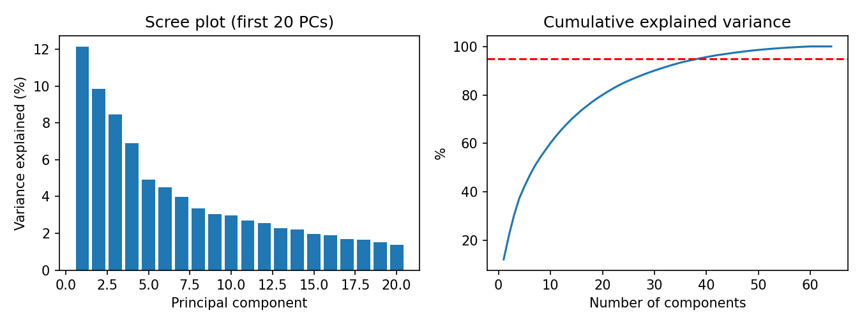
Figure 1: Scree plot (left) and cumulative explained variance (right); the red line marks 95%
Variance retained | Components needed | Reduction in features
80% | 20 | 69%
90% | 30 | 53%
95% | 39 | 39%
99% | 53 | 17%
Table 1: Number of principal components needed to retain a given share of the variance
The first component explains only 12.13% of the variance and the second 9.84%, so the first two together keep just 21.97%. 39 of the 64 components are enough to keep 95% of the information.

5.2 Effect on classification accuracy
Model input | Features | Test_accuracy | Train_time_s
Original (64 features) | 64 | 0.981 | 0.021
PCA (2 components) | 2 | 0.528 | 0.023
PCA (10 components) | 10 | 0.880 | 0.030
PCA (20 components) | 20 | 0.946 | 0.023
PCA (30 components) | 30 | 0.948 | 0.021
Table 2: Logistic Regression test accuracy using original features and PCA components

5.3 Two-dimensional projection
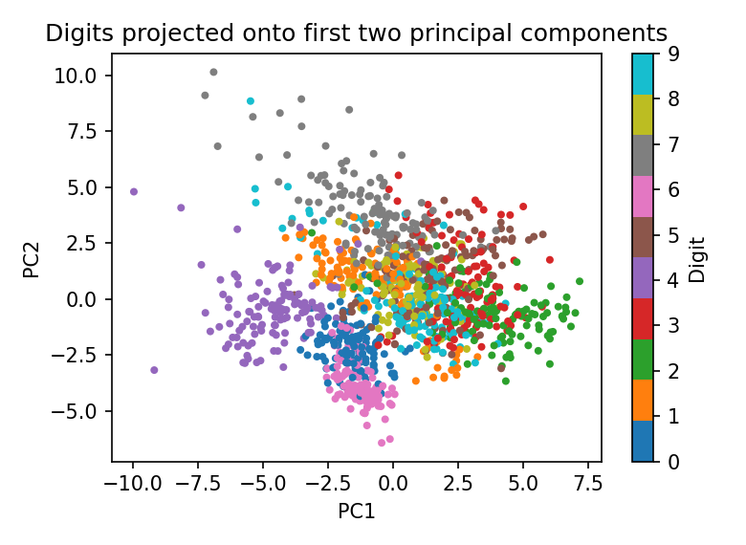
Figure 2: Digits on PC1 and PC2. Some digits form groups but many overlap.
- Accuracy on the original 64 features is 98.15%. With 30 components (53% fewer features) it is 94.81%; with 20 components it is 94.63%.
- With only 2 components accuracy drops to 52.78%, so a 2D plot is good for visualisation but loses too much information for classification.
- Training time is tiny for this small dataset, so the benefit of PCA here is simplicity and visualisation rather than speed.

5.4 Summary of key findings
Finding | Evidence from the output
Variance of first two components | PC1 = 12.13%, PC2 = 9.84%, together 21.97%
Components for 95% of variance | 39 of 64 (a 39% reduction in features)
Accuracy with all 64 features | 98.15% (Logistic Regression)
Accuracy with 30 / 20 components | 94.81% / 94.63%
Accuracy with 2 components | 52.78%: too much information is lost for classification
Table: Summary of the main findings of this practical

6. Python Source Code Implementation
The complete Python code used for this practical is given below:

import numpy as np
import pandas as pd
import time
import matplotlib.pyplot as plt
from sklearn.datasets import load_digits
from sklearn.preprocessing import StandardScaler
from sklearn.decomposition import PCA
from sklearn.model_selection import train_test_split
from sklearn.linear_model import LogisticRegression
from sklearn.metrics import accuracy_score

# ------------------------------------------------------------------------
# 1. Load and standardise the data
# ------------------------------------------------------------------------
digits = load_digits()
X, y = digits.data, digits.target
X_train, X_test, y_train, y_test = train_test_split(
X, y, test_size=0.3, random_state=42, stratify=y)
scaler = StandardScaler().fit(X_train)
Xtr, Xte = scaler.transform(X_train), scaler.transform(X_test)
print("=== DATASET OVERVIEW ===")
print("Samples:", X.shape[0], "| Original features (pixels):", X.shape[1])

# ------------------------------------------------------------------------
# 2. Fit PCA and study explained variance
# ------------------------------------------------------------------------
pca = PCA().fit(Xtr)
cum = np.cumsum(pca.explained_variance_ratio_)
print("\n=== EXPLAINED VARIANCE ===")
for i in range(5):
print(f"PC{i+1}: {pca.explained_variance_ratio_[i]*100:5.2f}%")
for target in (0.80, 0.90, 0.95, 0.99):
print(f"Components needed for {target*100:.0f}% variance: {np.argmax(cum >= target) + 1}")

# ------------------------------------------------------------------------
# 3. Model accuracy: original features vs PCA-reduced features
# ------------------------------------------------------------------------
rows = []
t0 = time.time()
clf = LogisticRegression(max_iter=2000).fit(Xtr, y_train)
rows.append(["Original (64 features)", 64, accuracy_score(y_test, clf.predict(Xte)),
time.time() - t0])
for n_comp in (2, 10, 20, 30):
p = PCA(n_components=n_comp).fit(Xtr)
t0 = time.time()
clf = LogisticRegression(max_iter=2000).fit(p.transform(Xtr), y_train)
acc = accuracy_score(y_test, clf.predict(p.transform(Xte)))
rows.append([f"PCA ({n_comp} components)", n_comp, acc, time.time() - t0])

result = pd.DataFrame(rows, columns=["Model input", "Features", "Test_accuracy", "Train_time_s"])
print("\n=== LOGISTIC REGRESSION: ORIGINAL vs PCA ===")
print(result.round(4).to_string(index=False))

# ------------------------------------------------------------------------
# 4. Visualisation
# ------------------------------------------------------------------------
fig, axs = plt.subplots(1, 2, figsize=(9, 3.4))
axs[0].bar(range(1, 21), pca.explained_variance_ratio_[:20] * 100)
axs[0].set_title("Scree plot (first 20 PCs)"); axs[0].set_xlabel("Principal component")
axs[0].set_ylabel("Variance explained (%)")
axs[1].plot(range(1, 65), cum * 100); axs[1].axhline(95, color="red", ls="--")
axs[1].set_title("Cumulative explained variance"); axs[1].set_xlabel("Number of components")
axs[1].set_ylabel("%")
plt.tight_layout(); plt.savefig("fig1.png", dpi=150); plt.close()

Z = PCA(n_components=2).fit_transform(Xtr)
plt.figure(figsize=(5.2, 3.8))
sc = plt.scatter(Z[:, 0], Z[:, 1], c=y_train, cmap="tab10", s=8)
plt.colorbar(sc, label="Digit"); plt.xlabel("PC1"); plt.ylabel("PC2")
plt.title("Digits projected onto first two principal components")
plt.tight_layout(); plt.savefig("fig2.png", dpi=150); plt.close()

7. Execution Output
The output obtained on executing the script (Section 5 is based on it):

=== DATASET OVERVIEW ===
Samples: 1797 | Original features (pixels): 64

=== EXPLAINED VARIANCE ===
PC1: 12.13%
PC2: 9.84%
PC3: 8.47%
PC4: 6.92%
PC5: 4.92%
Components needed for 80% variance: 20
Components needed for 90% variance: 30
Components needed for 95% variance: 39
Components needed for 99% variance: 53

=== LOGISTIC REGRESSION: ORIGINAL vs PCA ===
Model input Features Test_accuracy Train_time_s
Original (64 features) 64 0.9815 0.0210
PCA (2 components) 2 0.5278 0.0233
PCA (10 components) 10 0.8796 0.0297
PCA (20 components) 20 0.9463 0.0226
PCA (30 components) 30 0.9481 0.0212

8. Interpretation and Conclusion
- PCA reduced the 64 pixel features to a smaller set of uncorrelated components. About 39 components keep 95% of the variance, and 20 to 30 components already give 94 to 95% accuracy compared with 98% on all features.
- There is a trade-off between dimensionality and accuracy: fewer components give simpler models but lose information. The number of components should be chosen from the scree plot and the accuracy required.
- Two components are suitable for visualisation only.
- Limitations: PCA is linear and the components are hard to interpret; accuracy was measured with only one classifier and one split.
- Future scope: compare with kernel PCA, t-SNE or UMAP, use cross-validation to choose the number of components, and apply PCA to a larger image data set.

9. Key Terms and Definitions
Term | Meaning
Principal component | A new axis, a linear combination of the original features, along which the data vary as much as possible
Eigenvector | Direction of a principal component
Eigenvalue | Amount of variance along an eigenvector
Explained variance ratio | Fraction of the total variance captured by one component
Scree plot | Plot of the variance of each component, used to decide how many to keep
Standardisation | Rescaling features to mean 0 and standard deviation 1 before PCA
Curse of dimensionality | Problems (sparsity, overfitting, cost) that grow with the number of features
Reference: Alpaydin, E. and Kaynak, C. Optical Recognition of Handwritten Digits Data Set, UCI Machine Learning Repository.

