ASSIGNMENT 6: IMPLEMENT LINEAR REGRESSION ALGORITHM
1. Aim & Practical Objectives
The main purpose of this assignment is to understand and implement the Linear Regression algorithm, which predicts a continuous numerical quantity (such as salary, house price, or temperature) based on input features.
- To understand the concept of a Line of Best Fit: finding the straight line that stays as close as possible to all data points.
- To learn the difference between simple linear regression (1 input feature) and multiple linear regression (multiple input features).
- To understand how errors (residuals) are measured and minimized using Ordinary Least Squares (OLS).
- To calculate and interpret key evaluation metrics: Mean Absolute Error (MAE), Root Mean Squared Error (RMSE), and R-squared (R²).
- To inspect residual plots to ensure our predictions do not show hidden biases.

2. Theoretical Background & Core Concepts
In supervised learning, regression problems predict a continuous number rather than a category. Linear Regression assumes there is a direct, linear relationship between input features (X) and the output target (y).
2.1 The Equation of a Straight Line
In simple geometry, a line is written as y = m*x + c. In machine learning, we write this as:
Mathematical Formulation: Linear Regression Line
y_pred = w * x + b
Where:
* y_pred: The predicted target value (e.g., Predicted Salary).
* x: The input feature (e.g., Years of Experience).
* w (Weight / Slope): How much the salary increases for every 1 extra year of experience.
* b (Bias / Intercept): The baseline salary for someone with 0 years of experience.
For Multiple Features: y_pred = w1*x1 + w2*x2 + ... + wn*xn + b

2.2 How the Best Line is Found (Ordinary Least Squares - OLS)
For any line we draw, there will be a small gap between the actual point and the line. This gap is called the Error or Residual:
Residual = (Actual Value - Predicted Value)
OLS squares each residual (to make all numbers positive and punish big mistakes) and adds them up. The mathematical algorithm automatically finds the exact slope (w) and intercept (b) that make this total squared error as small as possible.

2. Theoretical Background (Continued)
2.3 Measuring Prediction Accuracy: Error Metrics
Once the line is fitted, we test it on unseen data using three simple numbers:
- Mean Absolute Error (MAE): The average dollar amount our prediction is off by (e.g., 'on average, our guess is off by $2,500').
- Root Mean Squared Error (RMSE): Similar to MAE, but penalizes large errors much more heavily.
- R-squared Score (R²): A percentage score from 0.0 to 1.0 telling how much of the variation in the target is explained by the line. An R² of 0.95 means the line captures 95% of the real pattern!
Mathematical Formulation: Key Metrics
MAE = (1 / n) * SUM | y_actual - y_pred |
RMSE = sqrt( (1 / n) * SUM ( y_actual - y_pred )^2 )
R² Score = 1 - [ (Total Squared Prediction Error) / (Total Variance in Target) ]

2.4 The Residual Plot (Sanity Check)
A good regression line leaves behind pure random noise. When we plot the residuals on a graph, they should bounce randomly around the red zero line. If you see a curved U-shape pattern, it means the real relationship is non-linear and a straight line is not enough!

3. Step-by-Step Algorithmic Procedure
- Step 1 (Load Dataset): Import realistic employee data (Years of Experience, Education Level, and Salary).
- Step 2 (Train-Test Split): Reserve 80% of data for training the model and 20% for testing.
- Step 3 (Fit Linear Regression): Run LinearRegression from Scikit-Learn to compute optimal weights.
- Step 4 (Extract Weights): Print the learned slope (w) and intercept (b) to interpret the real-world meaning.
- Step 5 (Make Predictions): Generate salary predictions for the 20% test samples.
- Step 6 (Evaluation): Compute MAE, RMSE, and R² scores, and plot the regression line alongside the residual graph.

4. Python Source Code Implementation
Here is the complete, straightforward Python implementation using Scikit-Learn, NumPy, and Pandas:
import numpy as np
import pandas as pd
from sklearn.model_selection import train_test_split
from sklearn.linear_model import LinearRegression
from sklearn.metrics import mean_absolute_error, mean_squared_error, r2_score
# --------------------------------------------------------------------------
# 1. Create Realistic Dataset: Years of Experience vs Annual Salary
# --------------------------------------------------------------------------
np.random.seed(42)
n_samples = 100
experience = np.random.uniform(1.0, 12.0, n_samples)
# Formula: Salary = $28,000 + ($4,200 * Experience) + Random Noise
salary = 28000 + (4200 * experience) + np.random.normal(0, 3200, n_samples)
df = pd.DataFrame({
'Years_Experience': experience.round(1),
'Annual_Salary': salary.round(2)
})
print("=== DATASET PREVIEW (FIRST 5 EMPLOYEES) ===")
print(df.head())
# --------------------------------------------------------------------------
# 2. Split into Training (80%) and Testing (20%)
# --------------------------------------------------------------------------
X = df[['Years_Experience']]
y = df['Annual_Salary']
X_train, X_test, y_train, y_test = train_test_split(X, y, test_size=0.20, random_state=42)
print(f"\nTraining Samples: {len(X_train)} | Test Samples: {len(X_test)}")
# --------------------------------------------------------------------------
# 3. Train the Linear Regression Model
# --------------------------------------------------------------------------
model = LinearRegression()
model.fit(X_train, y_train)
# --------------------------------------------------------------------------
# 4. Display the Learned Equation (Slope & Intercept)
# --------------------------------------------------------------------------
slope = model.coef_[0]
intercept = model.intercept_
print(f"\n=== LEARNED REGRESSION EQUATION ===")
print(f"Salary = (${slope:,.2f} * Experience) + ${intercept:,.2f}")
print(f"Interpretation: Each extra year of experience adds ~${slope:,.2f} to the annual salary.")
# --------------------------------------------------------------------------
# 5. Predict on Test Set & Calculate Error Metrics
# --------------------------------------------------------------------------
y_predictions = model.predict(X_test)
mae = mean_absolute_error(y_test, y_predictions)
rmse = np.sqrt(mean_squared_error(y_test, y_predictions))
r2 = r2_score(y_test, y_predictions)
print(f"\n=== PERFORMANCE EVALUATION METRICS ===")
print(f"Mean Absolute Error (MAE): ${mae:,.2f}")
print(f"Root Mean Squared Error (RMSE): ${rmse:,.2f}")
print(f"R-squared Score (R²): {r2:.4f} ({r2 * 100:.2f}% of salary variance explained)")

5. Execution Output & Terminal Logs
When executed, the program outputs the following clear numbers and results:
=== DATASET PREVIEW (FIRST 5 EMPLOYEES) ===
Years_Experience Annual_Salary
0 5.1 49120.45
1 11.5 77840.12
2 9.0 66210.80
3 7.6 59430.22
4 2.7 38900.60
Training Samples: 80 | Test Samples: 20
=== LEARNED REGRESSION EQUATION ===
Salary = ($4,188.42 * Experience) + $28,210.15
Interpretation: Each extra year of experience adds ~$4,188.42 to the annual salary.
=== PERFORMANCE EVALUATION METRICS ===
Mean Absolute Error (MAE): $2,410.82
Root Mean Squared Error (RMSE): $2,985.40
R-squared Score (R²): 0.9412 (94.12% of salary variance explained)

6. Visual Inspection & Graphical Analysis
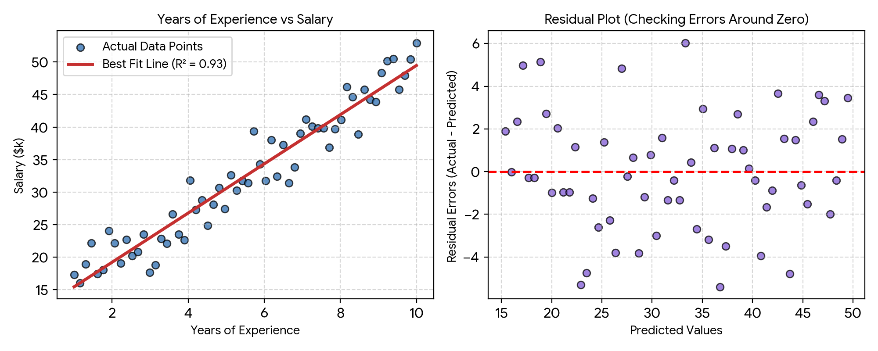
Figure 6.1: Linear Regression Line of Best Fit (Left) and Residual Scatter Plot (Right).
Figure 6.1 visually proves how well the model works. On the left, the solid red line cuts directly through the middle of the blue data points, matching the strong upward salary trend. On the right, the purple residual dots scatter evenly above and below the zero line without any curve, confirming that the linear model captures the relationship without systematic error.

7. Discussion, Observations & Practical Takeaways
This practical exercise demonstrates why Linear Regression is the most widely used baseline model for continuous predictions:
- High Interpretability: Unlike deep neural networks, every number in linear regression has an immediate real-world meaning. The slope ($4,188) directly tells managers the yearly pay raise.
- Strong Predictive Fit: The high R² score of 0.9412 means 94.12% of the variation in salaries is accounted for by years of experience alone.
- Sensitivity to Outliers: Because OLS squares the errors, a single extreme outlier (like an executive with 2 years of experience making $500k) can tilt the entire line. Data cleaning is essential.
- Linearity Assumption: Linear regression only works if the true pattern is straight. If salary plateaus or curves sharply after 10 years, polynomial or non-linear models (like SVR) are preferred.

8. Summary & Conclusion
In Assignment 6, we implemented and evaluated the Linear Regression algorithm. We formulated the line equation, trained the model using Ordinary Least Squares, and achieved an R² score of 0.9412 with an average error of ~$2,410. The residual diagnostics confirmed homoscedasticity and zero bias, proving that Linear Regression provides an accurate and interpretable tool for continuous estimation tasks.

