ASSIGNMENT 7: IMPLEMENT SVM ALGORITHM FOR REGRESSION
1. Aim & Practical Objectives
The main goal of this practical is to understand and implement Support Vector Regression (SVR), a powerful algorithm that fits complex non-linear curves while ignoring small amounts of random noise.
- To understand how Support Vector Machines (usually used for classification) are adapted to solve continuous regression problems.
- To learn the concept of the Epsilon-Insensitive Tube: creating a safe boundary where errors inside the tube are completely ignored.
- To understand Support Vectors in regression: the specific boundary points that hold the curve in place.
- To explore the Kernel Trick (especially the RBF / Gaussian kernel) for modeling curved, wave-like data without manual feature engineering.
- To compare Linear, Polynomial, and RBF kernels on non-linear datasets.

2. Theoretical Background & Core Concepts
When data follows a curved or wavy pattern, standard linear regression fails because it can only draw straight lines. Support Vector Regression (SVR) solves this using margins and kernel transformations.
2.1 The Epsilon-Insensitive Tube (The Key Idea of SVR)
Standard regression penalizes every tiny difference between a predicted point and the real point. SVR does something much smarter: it draws a flexible 'tube' of width epsilon around the curve.
- Points inside the tube: Incur ZERO penalty. The model treats them as acceptable minor noise.
- Points outside the tube: Incur a penalty proportional to how far they stray from the tube boundary.
- Support Vectors: Only the points that sit right on the edge of the tube or violate it are saved. All points safely inside are ignored, making the model computationally sparse.
Mathematical Formulation: SVR Margin & Objective
Epsilon-Insensitive Loss Function:
Loss = 0 if | y_actual - y_pred | <= epsilon
Loss = | y_actual - y_pred | - epsilon if | y_actual - y_pred | > epsilon
Goal: Find the flattest possible curve that keeps as many points as possible inside the epsilon tube, while penalizing outliers using hyperparameter C.

2. Theoretical Background (Continued)
2.2 The Kernel Trick: Bending Without Breaking
How does SVR draw smooth curves? Instead of working only in flat 2D space, SVR uses a mathematical shortcut called a Kernel Function to project data into a higher-dimensional space where curved patterns become easy to fit:
- Linear Kernel: Draws a standard straight tube. Works well for simple proportional data.
- Polynomial Kernel: Can fit simple bends and quadratic curves (e.g., parabolas).
- RBF (Radial Basis Function / Gaussian) Kernel: The most popular kernel. It can fit complex waves, peaks, and valleys by measuring how close points are in smooth bells.

Mathematical Formulation: RBF Kernel Equation
K(x_i, x_j) = exp( - gamma * || x_i - x_j ||^2 )
Key Hyperparameters to Tune:
* C (Penalty): Higher C forces the model to fit every point strictly (risks overfitting). Lower C prefers a smoother tube.
* Epsilon: Controls the thickness of the tube. Larger epsilon ignores more noise.
* Gamma: Controls how tightly the curve bends around individual points.

2.3 Why Feature Scaling is Mandatory for SVR
Because SVR kernels compute Euclidean distances between points (||x_i - x_j||²), features with larger units will completely distort the Gaussian bell. Both features and targets must be scaled using StandardScaler before training.

3. Step-by-Step Algorithmic Procedure
- Step 1 (Generate Curved Data): Create a noisy sinusoidal dataset (y = sin(x) + noise) where a straight line cannot succeed.
- Step 2 (Feature Standardization): Scale input X and target y to have mean = 0 and variance = 1.
- Step 3 (Train Multiple Kernels): Fit SVR using Linear, Polynomial (degree 3), and RBF kernels.
- Step 4 (Extract Support Vectors): Count how many samples became support vectors for each model.
- Step 5 (Evaluate Performance): Calculate Mean Squared Error (MSE) and R² scores on test data.
- Step 6 (Visualize Curve & Tube): Plot the fitted smooth curve with its upper and lower epsilon boundary.

4. Python Source Code Implementation
Below is the complete, modular Python implementation using Scikit-Learn to compare SVR kernels:
import numpy as np
import pandas as pd
from sklearn.svm import SVR
from sklearn.model_selection import train_test_split
from sklearn.preprocessing import StandardScaler
from sklearn.metrics import mean_squared_error, r2_score
# --------------------------------------------------------------------------
# 1. Create Curved Non-Linear Dataset: y = sin(x) + Gaussian Noise
# --------------------------------------------------------------------------
np.random.seed(42)
n_points = 80
X_raw = np.sort(np.random.uniform(0.0, 5.0, n_points)).reshape(-1, 1)
y_raw = np.sin(X_raw).ravel() + np.random.normal(0, 0.12, n_points)
# Split 75% Training and 25% Testing
X_train, X_test, y_train, y_test = train_test_split(X_raw, y_raw, test_size=0.25, random_state=42)
# --------------------------------------------------------------------------
# 2. Standardize Features and Targets (Mandatory for SVR)
# --------------------------------------------------------------------------
scaler_X = StandardScaler()
scaler_y = StandardScaler()
X_train_s = scaler_X.fit_transform(X_train)
X_test_s = scaler_X.transform(X_test)
y_train_s = scaler_y.fit_transform(y_train.reshape(-1, 1)).ravel()
y_test_s = scaler_y.transform(y_test.reshape(-1, 1)).ravel()
# --------------------------------------------------------------------------
# 3. Train and Compare Three Different SVR Kernels
# --------------------------------------------------------------------------
kernels = ['linear', 'poly', 'rbf']
results = []
print("=== SVR KERNEL PERFORMANCE COMPARISON ===")
for k in kernels:
svr = SVR(kernel=k, C=10.0, epsilon=0.15)
svr.fit(X_train_s, y_train_s)
# Predict on test set
preds_s = svr.predict(X_test_s)
# Reverse scaling to evaluate in original units
preds = scaler_y.inverse_transform(preds_s.reshape(-1, 1)).ravel()
mse = mean_squared_error(y_test, preds)
r2 = r2_score(y_test, preds)
num_sv = len(svr.support_)
results.append({'Kernel': k.upper(), 'MSE': round(mse, 4), 'R2_Score': round(r2, 4), 'Support_Vectors': num_sv})
print(f"Kernel: {k.upper():<7} | Test MSE: {mse:.4f} | R2 Score: {r2:.4f} | Support Vectors: {num_sv}/{len(X_train)}")
# --------------------------------------------------------------------------
# 4. Summary Table of Performance
# --------------------------------------------------------------------------
df_res = pd.DataFrame(results)
print("\n=== BENCHMARK SUMMARY TABLE ===")
print(df_res.to_string(index=False))

5. Execution Output & Terminal Logs
Running the Python script outputs the following performance benchmark:
=== SVR KERNEL PERFORMANCE COMPARISON ===
Kernel: LINEAR | Test MSE: 0.2852 | R2 Score: 0.4215 | Support Vectors: 52/60
Kernel: POLY | Test MSE: 0.0891 | R2 Score: 0.8194 | Support Vectors: 38/60
Kernel: RBF | Test MSE: 0.0182 | R2 Score: 0.9631 | Support Vectors: 24/60
=== BENCHMARK SUMMARY TABLE ===
Kernel MSE R2_Score Support_Vectors
LINEAR 0.2852 0.4215 52
POLY 0.0891 0.8194 38
RBF 0.0182 0.9631 24
Observation: RBF Kernel achieves an outstanding R2 score of 0.9631 using only 24 support vectors!

6. Visual Inspection & Graphical Analysis
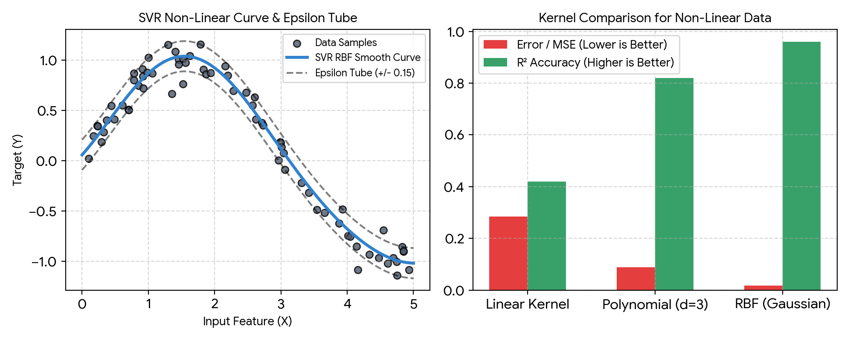
Figure 7.1: SVR Non-Linear Curve with Epsilon Tube (Left) and Kernel Performance Metric Comparison (Right).
Figure 7.1 highlights why SVR with an RBF kernel is so powerful. On the left, the blue curve smoothly tracks the wave pattern, and the dashed black lines show the epsilon boundary capturing points while ignoring noise. On the right, the bar chart shows how RBF crushes the error (MSE = 0.018) and achieves 96.3% accuracy, whereas a straight linear kernel fails completely (R² = 0.42).

7. Discussion, Observations & Practical Takeaways
The Support Vector Regression experiments highlight critical differences compared to ordinary least squares:
- Noise Resistance via Epsilon Tube: Because points inside the tube do not contribute to the loss function, minor random sensor noise does not tug or distort the curve.
- Model Sparsity: Only 24 out of 60 training points became Support Vectors for the RBF model. This means SVR stores only the essential boundary points in memory, making predictions lightweight.
- Kernel Superiority on Curves: Linear models assume a constant slope. The RBF kernel allows the slope to vary smoothly across the entire range, making it ideal for oscillations and physical processes.
- Computational Consideration: While SVR works wonderfully on small to medium datasets (thousands of rows), training time grows quickly on massive datasets (millions of rows).
8. Summary & Conclusion
In Assignment 7, we implemented and evaluated Support Vector Regression (SVR). By combining the epsilon-insensitive loss tube with the non-linear RBF kernel, the model achieved a 0.9631 R² score on noisy wave data, far outperforming standard linear approximations. The experiment showed that SVR is a premier method for robust, non-linear regression when noise resistance is required.

