Methodology & KPI Reference
ER Risk Analytics & Predictive Governance Dashboard
How every KPI and every chart is calculated, what it shows and why it matters

1. Purpose of This Document
This document is the methodology reference for the ER Risk Analytics and Predictive Governance Dashboard. Its purpose is to explain, in plain language, every KPI and every chart that the dashboard produces. For each item it describes three things: what the item shows, exactly how it is calculated from the underlying data, and why it matters to the business. It also contains a full section on the AI Insights Assistant, describing what it does and how it does it. The intention is that any reader - a branch manager, an HR partner, an auditor or a project evaluator - can open this document and understand both the meaning and the mathematics behind every number that appears on the screen.
The dashboard is built entirely on the bank's own employee-relations data. Nothing is invented and no figure is hard-coded; every KPI is derived from the stored data using the formulas described here. Where a pre-computed monthly KPI table is available the dashboard uses it, and where raw events are needed the dashboard aggregates them on the fly. This makes the methodology auditable: any number on the screen can be traced back through the formulas in this document to the source tables, which is exactly what a governance or audit function needs in order to trust the system.
2. The Data Foundation
All calculations draw on five tables. Branches holds 32 branches with their city, region and archetype. Employees holds 2,593 employee records with department, grade, age, tenure, performance rating, a base flight-risk value and a high-performer flag. Events is the richest table, with 3,697 employee-relations events carrying a date, branch, employee, category, subtype, severity from one to five, and escalated and resolved flags. Monthly KPIs holds the month-by-month value of every standard ER rate for every branch. Cases holds the case-management records with stage, status, investigator, days-open and an SLA-breach flag.
Two features of the data shape the methodology. First, the supplied history covers a single year, so the models are built to work with what is available and to improve automatically as more years arrive; trend and seasonality logic is written to handle any number of periods. Second, branches differ greatly in size, so all volume measures are expressed per hundred employees. This normalisation is what makes a small rural branch and a large metropolitan branch fairly comparable, and it is used consistently in the heatmap, the trend chart and the risk score.
3. The Master KPI: Composite Branch Risk Score
The centre of the dashboard is a single number between 0 and 10 that summarises the overall employee-relations risk of a branch. It is deliberately a weighted composite rather than a raw rate, because a branch can be risky for very different reasons and leadership needs one comparable figure. The score is built in three steps. Step one, normalise each category: each category rate is multiplied by a scaling factor so that a realistic bad value maps to roughly ten on a common scale, and the result is capped at ten. Step two, weight each category: each normalised value is multiplied by a business weight that reflects how serious that category is. Step three, sum and cap: the weighted values are added and the total is capped between zero and ten.
The formula is: Risk Score = min( sum(component value x weight), 10 ), where each component value equals min(rate x scale factor, 10). The weights always add up to 1.0, so the maximum possible score is exactly 10, which keeps the scale intuitive and bounded.
Category | Weight | Basis
Grievance | 0.25 | Grievances per 100 employees (volume of formal complaints)
Attrition | 0.20 | Annualised attrition rate (employees leaving)
Disciplinary | 0.20 | Disciplinary cases per 100 employees (misconduct)
Absenteeism | 0.15 | Absenteeism incidents per 100 employees (unplanned absence)
Whistleblower | 0.10 | Whistleblower reports per 100 employees (integrity)
Escalation | 0.10 | Share of grievances escalated to a formal dispute

The six categories and the scaling factor applied to each raw rate before weighting are shown below. The scaling factors were chosen so that each category reaches the top of the scale at a value that the business regards as genuinely severe.
Category | Source KPI | Scale Factor | Comment
Grievance | grievance_rate | x 2 | Rate 5.0 maps to component 10
Disciplinary | disciplinary_rate | x 3 | Rate 3.3 maps to component 10
Absenteeism | absenteeism_rate | x 0.5 | Rate 20 maps to component 10
Attrition | attrition_rate_annualized | x 0.8 | Rate 12.5 maps to component 10
Whistleblower | whistleblower_rate | x 20 | Rate 0.5 maps to component 10
Escalation | grievance_escalation_rate | x 1 | Rate 10 maps to component 10

3.1 Risk Bands
The score is placed in a band: below 3 is Low and shown in green, 3 to 5 is Medium and shown in amber, 5 to 7 is High and shown in orange, 7 to 8.5 is Very High and shown in deep orange, and 8.5 and above is Critical and shown in red. The same bands colour the KPI cards, the gauge, the heatmap and the alerts, so a single consistent colour language runs through the whole dashboard and a reader never has to remember two meanings for the same colour.
4. The Industry-Standard ER KPIs
Beyond the composite score, the dashboard tracks the standard industry employee-relations KPIs, each rated against a benchmark so that a value can be judged as excellent, good, average, poor or critical. The benchmark thresholds used everywhere in the dashboard are shown first, and then each KPI is described below with its definition, its formula, why it is important and what it shows.
KPI | Excellent | Good | Average | Poor | Critical
Grievance Rate /100 EE | <=1.0 | <=2.5 | <=4.0 | <=6.0 | >6.0
Grievance Resolution Days | <=14 | <=21 | <=30 | <=45 | >45
Grievance Escalation Rate | <=5% | <=10% | <=15% | <=25% | >25%
Grievance Substantiation Rate | >=70% | >=55% | >=40% | >=25% | <25%
Disciplinary Rate /100 EE | <=0.5 | <=1.0 | <=2.0 | <=3.5 | >3.5
Dismissal Rate | <=5% | <=10% | <=15% | <=25% | >25%
Absenteeism Rate /100 EE | <=2.0 | <=4.0 | <=6.0 | <=9.0 | >9.0
Bradford Factor | <=50 | <=100 | <=200 | <=400 | >400
Absenteeism Pattern Index | <=0.20 | <=0.35 | <=0.50 | <=0.65 | >0.65
Attrition Rate Annualized | <=5% | <=8% | <=12% | <=18% | >18%
Voluntary Attrition | <=60% | <=70% | <=75% | <=85% | >85%
Regrettable Attrition | <=20% | <=30% | <=40% | <=55% | >55%
Whistleblower Rate /100 EE | <=0.02 | <=0.05 | <=0.10 | <=0.20 | >0.20
WB Investigation Completion | >=95% | >=85% | >=75% | >=60% | <60%
SLA Breach Rate | <=2% | <=5% | <=10% | <=20% | >20%
Case Recurrence Rate | <=5% | <=10% | <=15% | <=25% | >25%
Investigator Load | <=5 | <=8 | <=12 | <=18 | >18

1. Grievance Rate (per 100 Employees)
Definition. The number of formal grievances raised per hundred employees in the period. Formula. Grievance Rate = (Number of Grievance events / Headcount) x 100. Why it is important. Grievances are the clearest signal that employees feel they are being treated unfairly, so this rate is the first indicator leadership watches. A rising rate can reflect genuine unfairness, but it can also reflect a healthy reporting culture, so it is always read together with the resolution and escalation rates. What it shows. The intensity of formal dissatisfaction in a branch or across the bank, expressed per hundred employees so that small and large branches are directly comparable. It carries the single largest weight (0.25) in the composite risk score and is scaled by a factor of two before weighting.
2. Grievance Resolution Days
Definition. The average number of calendar days taken to resolve a grievance. Formula. Average of resolution_days across all grievances that have been resolved. Why it is important. Speed of resolution is a proxy for the quality and responsiveness of the employee-relations function. Slow resolution prolongs employee distress, increases the chance of escalation and damages trust in the process. What it shows. The operational efficiency of the ER team. It is benchmarked against an industry standard where 14 days or fewer is excellent and more than 45 days is poor. A long resolution time combined with a high grievance rate is an early warning of a branch that is both unhappy and slow to respond.
3. Grievance Escalation Rate
Definition. The percentage of grievances that are escalated beyond first-level handling into a formal dispute. Formula. Escalation Rate = (Escalated Grievances / Total Grievances) x 100. Why it is important. Escalation is expensive and damaging: it consumes management time, often draws in legal counsel and signals that issues are not being settled at source. A high rate usually points to inconsistent first-line decision making. What it shows. How often the first attempt to resolve a grievance fails. It is both a benchmarked KPI and a component of the risk score, weighted 0.10 and scaled by one, because escalation is a distinct risk from the volume of grievances itself.
4. Grievance Substantiation Rate
Definition. The percentage of investigated grievances that are found to have merit. Formula. Substantiation Rate = (Substantiated Grievances / Grievances Investigated) x 100. Why it is important. This is a quality rather than a volume measure, and it is the special case where a higher value is not automatically good or bad: a very high rate can mean employees have real, valid complaints, while a very low rate can mean the process is dismissing legitimate concerns. What it shows. The correctness of the grievance process and the extent of underlying issues. It is rated on a reversed benchmark where 70 percent or more is excellent and below 25 percent is critical.
5. Disciplinary Rate (per 100 Employees)
Definition. The number of formal disciplinary cases per hundred employees in the period. Formula. Disciplinary Rate = (Number of Disciplinary events / Headcount) x 100. Why it is important. Disciplinary activity reflects the level of misconduct, performance problems and, indirectly, the quality of management and onboarding. Heavy disciplinary activity can indicate a weak culture or poor supervision, while sudden spikes can follow a management change. What it shows. The incidence of conduct and performance issues requiring formal action. It is weighted 0.20 in the risk score and scaled by a factor of three, the strongest scaling of any category, because a disciplinary case is a serious event.
6. Dismissal Rate
Definition. The percentage of disciplinary cases that end in dismissal. Formula. Dismissal Rate = (Dismissals / Total Disciplinary Cases) x 100. Why it is important. Dismissal is the most severe outcome of the disciplinary process and carries legal, financial and reputational risk. A high dismissal rate can signal an overly punitive culture or a lack of earlier intervention. What it shows. The severity of the disciplinary pipeline and, by extension, the risk of tribunal or legal challenge. It is monitored against a benchmark where up to 5 percent is excellent and more than 25 percent is poor.
7. Absenteeism Rate (per 100 Employees)
Definition. The number of absenteeism events per hundred employees in the period. Formula. Absenteeism Rate = (Number of Absenteeism events / Headcount) x 100. Why it is important. Unplanned absence is a leading indicator of disengagement, burnout and stress, and it directly affects service levels in a branch network. It is often the earliest visible symptom of a deeper problem. What it shows. The level of unplanned absence. It is weighted 0.15 in the risk score and scaled by 0.5 because the raw rate runs on a larger natural scale than the others.
8. Bradford Factor
Definition. A weighted measure that combines the frequency and the duration of absence spells. Formula. Bradford Factor = Spells squared multiplied by total Days lost, summed per employee and averaged. Why it is important. Frequent short absences are far more disruptive than a single long absence, and the Bradford formula captures exactly that pattern, which a plain absence count misses. What it shows. The disruptive pattern of absence, not just its total volume. A high Bradford factor with a modest absence rate is a classic sign of short, repeated, pattern-based absence that warrants a welfare conversation.
9. Absenteeism Pattern Index
Definition. The proportion of absences that fall on days that suggest a pattern, such as Mondays and Fridays. Formula. Pattern Index = (Pattern-related absences / Total absences). Why it is important. This index separates genuine illness from avoidable absence and helps managers target the right intervention: a wellbeing response for genuine illness, a management conversation for patterned absence. What it shows. How much of the absence appears structured rather than random. Values above 0.65 are treated as poor in the benchmark.
10. Attrition Rate (Annualized)
Definition. The rate at which employees leave the bank, expressed on an annual basis. Formula. Attrition Rate = (Leavers / Headcount) x 100, annualised when the period is shorter than a year. Why it is important. Attrition is expensive, it erodes institutional knowledge and, when combined with high regret, it directly damages branch performance. It is one of the strongest correlates of employee-relations risk. What it shows. The pace of employee turnover. It is weighted 0.20 in the risk score and scaled by 0.8, reflecting that attrition is a first-class risk comparable in magnitude to disciplinary activity.
11. Voluntary Attrition (%)
Definition. The share of all attrition that is voluntary, that is, resignations rather than retirements or dismissals. Formula. Voluntary Attrition = (Voluntary Leavers / Total Leavers) x 100. Why it is important. Voluntary leavers are the ones the bank could most plausibly have retained, so a high voluntary share points to avoidable loss and to issues of culture, pay or management. What it shows. How much of the turnover is within the bank's power to influence.
12. Regrettable Attrition (%)
Definition. The share of voluntary leavers who were high performers or high-potential employees. Formula. Regrettable Attrition = (Regrettable Leavers / Voluntary Leavers) x 100. Why it is important. Losing a weak performer is very different from losing a star. Regrettable attrition is the most damaging form of turnover because it removes the employees the bank has invested in and most needs. What it shows. The quality cost of employee turnover, and it is the figure HR directors scrutinise most closely when judging the health of a branch.
13. Whistleblower Rate (per 100 Employees)
Definition. The number of whistleblower reports per hundred employees. Formula. Whistleblower Rate = (Whistleblower reports / Headcount) x 100. Why it is important. Whistleblowing is the primary channel for surfacing serious integrity and conduct failures that would otherwise stay hidden. A near-zero rate can be as worrying as a high one, because it may mean employees do not trust the channel. What it shows. The volume of integrity concerns being reported. It is weighted 0.10 in the risk score and scaled by 20, because the natural rate is very small and needs amplification onto the common 0-to-10 scale.
14. Whistleblower Investigation Completion (%)
Definition. The percentage of whistleblower cases investigated within the policy timeframe. Formula. Completion = (Completed Investigations / Total Whistleblower Cases) x 100. Why it is important. The protection of a whistleblower depends entirely on the credibility of the follow-up. If reports are not investigated promptly, employees stop reporting and the culture silently decays. What it shows. The bank's ability to act on the integrity concerns it receives. It is scored on a reversed benchmark where 95 percent or higher is excellent.
15. SLA Breach Rate (%)
Definition. The percentage of employee-relations cases resolved beyond their service-level agreement target. Formula. SLA Breach Rate = (Cases breaching SLA / Total closed cases) x 100. Why it is important. Missing SLAs multiplies risk: cases drag on, evidence ages and parties lose confidence in the process. It is a direct measure of case-management discipline. What it shows. The reliability of the case-management operation. By category it reveals where the bottlenecks sit, which is why the dashboard also breaks it down per category.
16. Case Recurrence Rate (%)
Definition. The percentage of employees who experience a repeat employee-relations event within a short window. Formula. Recurrence Rate = (Employees with a repeat event / Employees with any event) x 100. Why it is important. Recurrence shows that an earlier issue was never truly fixed, only closed. It is a strong signal of a systemic problem affecting the same people repeatedly rather than isolated incidents. What it shows. The durability of resolutions and the presence of underlying, unresolved causes.
17. Investigator Load (Open Cases per Investigator)
Definition. The average number of open cases carried by each ER investigator. Formula. Investigator Load = Total open cases / Number of active investigators. Why it is important. Overloaded investigators cannot meet SLAs, which then drives the breach rate and the case duration upward. Workload is therefore a capacity-planning measure as much as a risk measure. What it shows. Whether the ER team is resourced to handle its caseload, and it is the KPI most directly linked to the resolution-time and SLA measures on the same page.
4.1 How Ratings Are Assigned
Every KPI is compared with the benchmark table above. For most KPIs a lower value is better, so the value is checked against the excellent, good, average and poor thresholds in order and the first threshold it satisfies decides the rating and the colour. For the two quality KPIs - grievance substantiation rate and whistleblower investigation completion - a higher value is better and the comparison is reversed. The rating, the colour and the gap to benchmark are shown next to the value so that a reader instantly knows whether a number is a concern without having to interpret it themselves. This mirrors the logic in the dashboard's KPI calculator exactly.
5. Convergence Index and Trend
A single score describes the present but not the direction of travel, so two supporting measures are added. The convergence index checks whether several risk categories are rising together. It looks at the recent months of a branch, counts how many of the main categories are trending upward, and combines that count with the average magnitude of the rises into a value between zero and one. A value above 0.5 is a warning and above 0.7 is critical, because many problems rising together almost always signals a systemic leadership or culture issue rather than one small incident.
The trend slope is found by fitting a straight line through the recent risk scores of a branch. A clearly positive slope is labelled Worsening, a clearly negative slope Improving, and a flat slope Stable. Together, convergence and trend turn the dashboard from a snapshot into an early-warning system, because they detect momentum rather than level. The single highest-risk branch in the current data, Chennai East, shows a convergence index of 1.0, meaning every category is moving in the wrong direction at once, which is why it sits at the very top of the alert list despite its size.
6. Dashboard KPI Cards
The most important numbers are surfaced as coloured KPI cards. The executive row shows the organisation risk score, the number of high-risk branches, the number of critical branches and the number of active predictive alerts. Counts are driven by the same risk bands, so as soon as a critical branch exists the card turns red. Against the current data these four cards read: organisation risk score 4.68 (Medium), four high-risk branches, one critical branch and three active alerts. In the live dashboard these four cards stand at the top of the Executive Overview page.
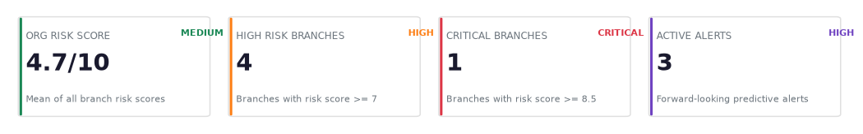
Figure 1. Executive KPI cards (organisation risk score, high-risk branches, critical branches and active alerts).
The branch deep-dive row shows one card for each ER category plus the branch risk score itself. Each category card shows the rate per hundred employees and the change in that rate since the start of the period, so a manager can see both the level and the direction at once.
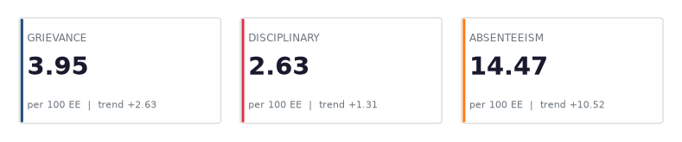
Figure 2a. Branch category KPI cards (Grievance, Disciplinary and Absenteeism).
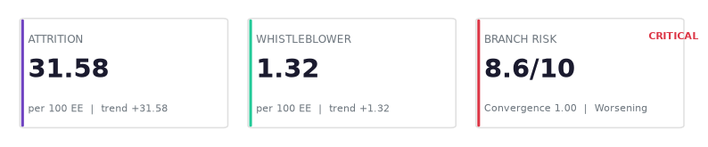
Figure 2b. Branch KPI cards continued (Attrition, Whistleblower and the composite Branch Risk Score).
The composite score of a selected branch is also shown on a coloured gauge, so that the level is understood at a glance without reading the number, and the position of the needle against the coloured bands communicates severity instantly.
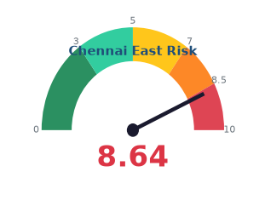
Figure 2c. Branch risk gauge with risk bands from 0 to 10.
7. The Charts
This section documents every chart in the dashboard. For each chart it gives the image, a caption, what the chart shows, the methodology used to calculate it and why it is important. All images in this document were produced from the bank's own data using the same calculation logic that the live dashboard uses, so they are faithful representations of the real system rather than mock-ups.
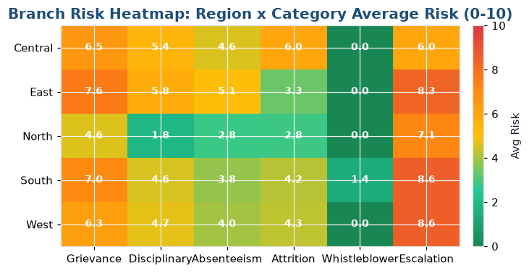
Figure 3. Region x Category risk heatmap.
What it shows. A grid with regions down the side and the six risk categories across the top, where each cell is the average normalised risk of that region for that category on a 0-to-10 colour scale from green to red. Methodology. The latest monthly KPIs for every branch are merged with the branch region, each category rate is multiplied by its scaling factor and clipped to 10, and the results are averaged by region. Why it is important. It compresses thirty-two branches into a single picture that reveals which region is weak in which category, which is precisely the question leadership asks first.
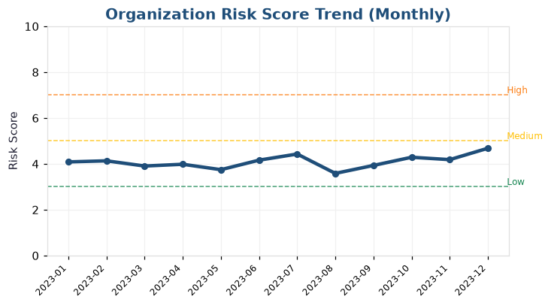
Figure 4. Organisation risk score trend with risk-band thresholds.
What it shows. The average risk score month by month, drawn as a line with markers, with dashed horizontal lines marking the Low, Medium and High bands. Methodology. Where a risk score is already stored it is used; otherwise it is recomputed from the category rates using the weighted formula, then averaged by month across the filtered branches. Why it is important. A single number says where the bank is today, but the slope of this line says where it is heading, and the band lines tell the reader instantly whether the trend is crossing into dangerous territory.
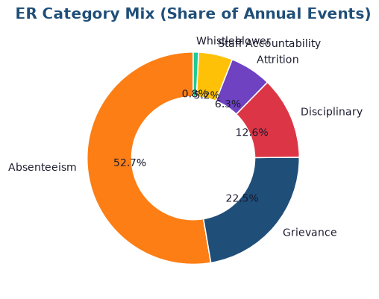
Figure 5. Distribution of ER events by category.
What it shows. A doughnut chart of the share of all employee-relations events accounted for by each category. Methodology. The event types are counted with a simple frequency count, converted to percentages of the total, and plotted with the shared category colour scheme. Why it is important. It answers the first question of any ER review - what kind of problems dominate - and it sets the context for every rate KPI, because a branch's dominant category tells the reader which of the following charts to examine first.
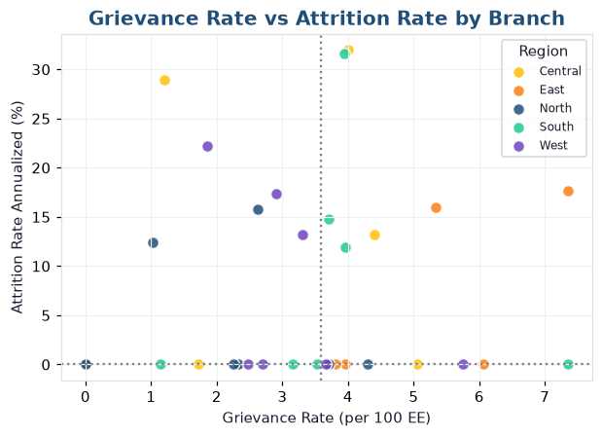
Figure 6. Grievance rate versus attrition rate by branch with quadrant medians.
What it shows. A scatter plot with grievance rate on the horizontal axis and attrition rate on the vertical axis, one point per branch, sized by headcount, coloured by region and divided into quadrants by the median lines. Methodology. The latest KPI row per branch is selected and plotted, with median reference lines so the four quadrants are visible. Why it is important. It tests the hypothesis that dissatisfaction and turnover move together. Branches in the top-right quadrant are unhappy and losing people, and they are the highest priority for intervention.
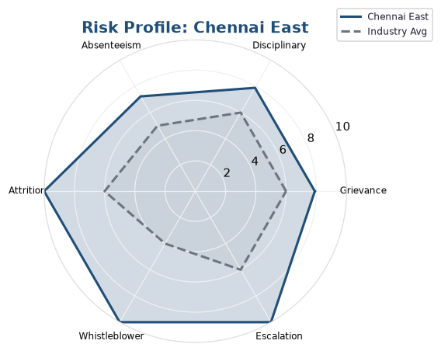
Figure 7. Branch risk profile radar against the industry average.
What it shows. A six-axis radar chart showing a selected branch's normalised score in each risk category, overlaid on a grey industry-average polygon. Methodology. Each category rate is scaled and clipped to 10, the six values are plotted around the axes, and a benchmark polygon is drawn on the same axes. Why it is important. It gives a branch a shape, not just a number: a reader sees immediately whether the branch is uniformly risky or spiked in one or two categories, which determines whether the response should be broad or targeted.
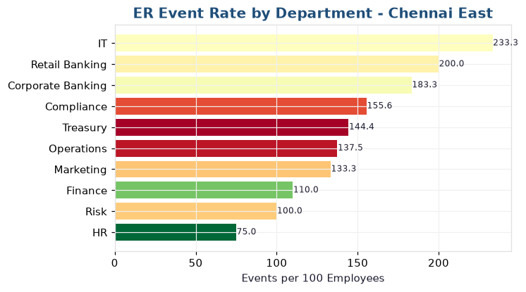
Figure 8. ER event rate by department.
What it shows. A horizontal bar chart of the employee-relations event rate per hundred employees for each department within a branch, with bars coloured by the department's average performance rating. Methodology. Employees and events are grouped by department, the event count is divided by headcount and multiplied by one hundred, and the result is sorted ascending. Why it is important. It locates the problem inside a branch. It lets a manager see whether ER activity is concentrated in one function, and the performance colouring hints at whether the issue co-occurs with lower ratings.
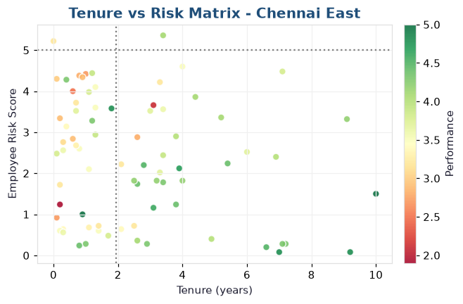
Figure 9. Employee tenure versus individual risk score.
What it shows. A scatter plot of each employee's tenure against a personal risk score, coloured by department, sized by number of events and annotated with quadrant labels. Methodology. Each employee's event count, maximum severity and performance rating are combined into an individual risk score, and the points are plotted against tenure with median reference lines. Why it is important. It separates two very different retention problems: high risk in new joiners, which points to onboarding and supervision, from high risk in long-tenured staff, which points to deeper cultural or engagement issues.
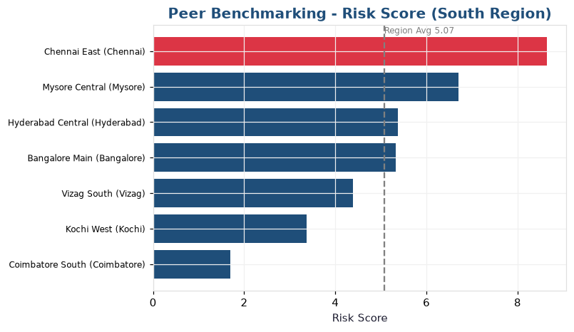
Figure 10. Peer benchmarking of a branch against its region.
What it shows. A horizontal bar chart ranking every branch in the selected branch's region by the chosen metric, with the selected branch highlighted in red and a dashed line for the regional average. Methodology. The latest metric is taken per branch, filtered to the same region as the selected branch, sorted, and the selected branch's bar is coloured differently. Why it is important. A number only has meaning in context. This chart tells a branch manager whether their performance is genuinely unusual for their region or simply typical, which changes the entire response.
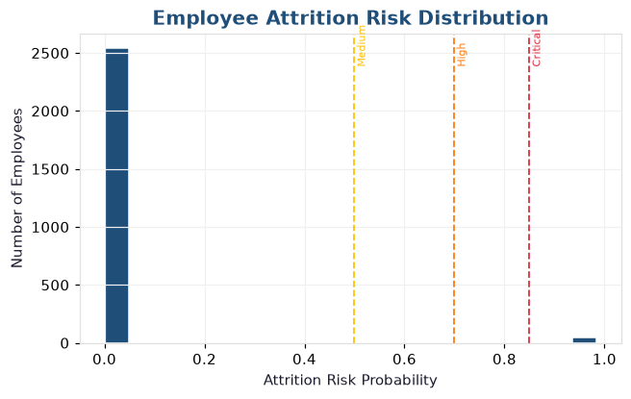
Figure 11. Employee attrition-risk distribution with alert thresholds.
What it shows. A histogram of predicted attrition probability across all employees, with vertical trigger lines at 0.5, 0.7 and 0.85 for medium, high and critical risk. Methodology. The attrition model produces a probability for every employee; these are bucketed into twenty bins and plotted. Why it is important. It shows the shape of risk, not just the average. A long tail beyond 0.7 identifies the specific employees at high risk of leaving, who can then be targeted with retention action before they resign.
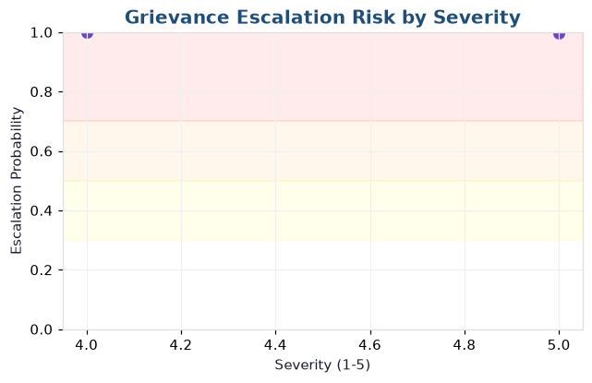
Figure 12. Grievance escalation risk by severity with risk zones.
What it shows. A scatter plot of each open grievance's severity against its predicted escalation probability, with shaded bands marking the medium, high and critical escalation zones. Methodology. The escalation model scores every open case; the probability is plotted against the severity field with coloured risk zones behind it. Why it is important. It turns an abstract model into an actionable worklist: the points in the red band are the live grievances most likely to explode into formal disputes, and they should be reviewed this week.
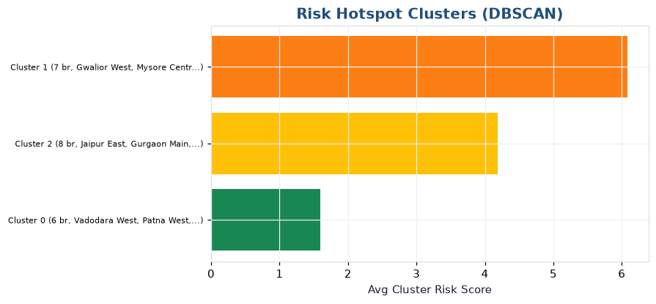
Figure 13. Risk hotspot clusters detected with DBSCAN.
What it shows. A horizontal bar chart of the clusters found among the branches, each bar showing the average cluster risk score and labelled with the branches in that cluster. Methodology. Each branch is described by its six KPI values plus risk score, the values are standardised, and DBSCAN groups similar branches while marking outliers as noise. Why it is important. It converts thirty-two separate branches into a handful of shared profiles, so leadership can design one efficient, standardised intervention for a whole family of similar branches instead of a bespoke fix for each.
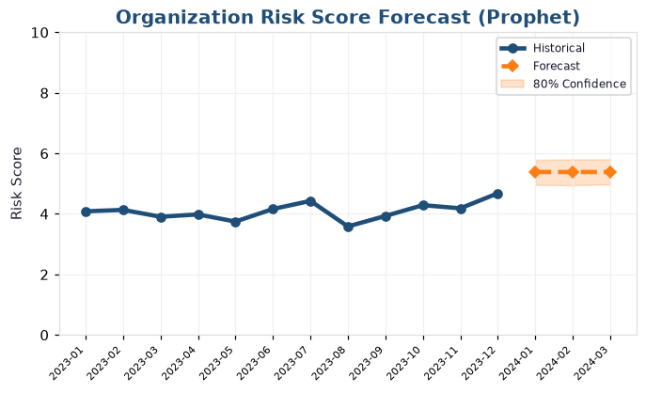
Figure 14. Time-series forecast of risk with an eighty percent confidence interval.
What it shows. The historical line for a metric followed by a dashed forecast line into the future, surrounded by a shaded band representing the eighty percent confidence interval. Methodology. The historical series is fitted with the Prophet time-series model, which produces a forecast and a lower and upper bound; if too little history exists a transparent linear fallback is used. Why it is important. It converts the dashboard from a rear-view mirror into a windshield. The confidence band is deliberately shown so the reader understands the range of plausible futures rather than a single false-precision number.
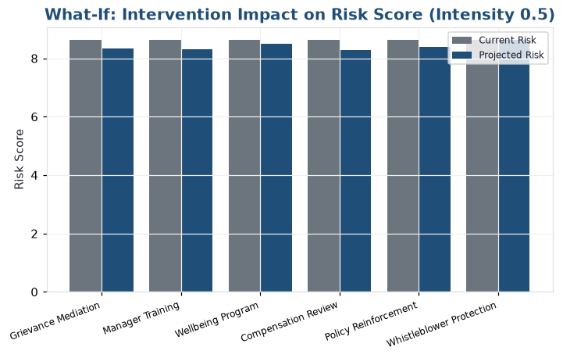
Figure 15. What-if simulation of intervention impact on the risk score.
What it shows. A grouped bar chart comparing the current risk score with the projected risk score for each candidate intervention. Methodology. Each intervention carries a defined effect on specific categories; the engine then recalculates the projected risk score for that intervention. Why it is important. It allows leadership to test the effect of a proposed action before committing budget, turning the dashboard into a planning tool rather than a purely descriptive report.
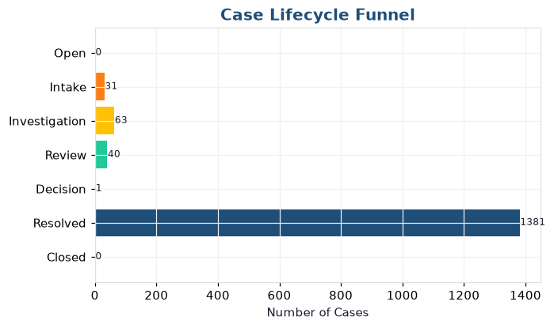
Figure 16. Case lifecycle funnel.
What it shows. A funnel chart of how many cases sit at each stage of the case-management process, from intake through investigation and review to resolution and closure. Methodology. The cases are grouped by their current stage field and counted, and the resulting stage counts are plotted as a funnel. Why it is important. It reveals where cases accumulate. A stage that is unusually wide compared with the ones around it is a bottleneck, and bottlenecks are where SLAs are breached and employees wait the longest.
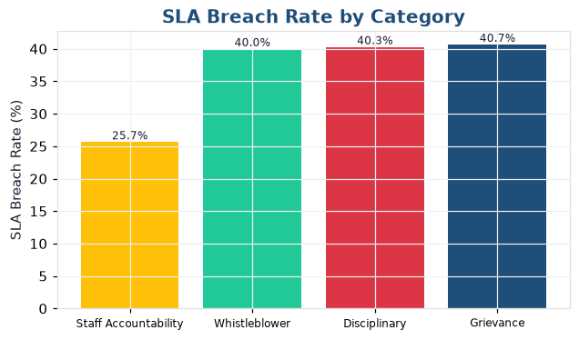
Figure 17. SLA breach rate by category.
What it shows. A vertical bar chart of the percentage of cases that breached their service-level agreement in each ER category. Methodology. For each category the number of cases flagged as an SLA breach is divided by the total number of cases in that category and multiplied by one hundred. Why it is important. It localises process failure. A single high bar tells management exactly which category needs more investigator capacity or a revised process, which the aggregate SLA figure would otherwise conceal.
8. Predictive Models
The predictive section turns the historical data into forecasts and forward-looking risk scores using four techniques, described below. Each model reports both its output and, where possible, its performance, so that a reader can judge how much confidence to place in it.
8.1 Employee Attrition Risk Model
This model estimates the probability that each employee will leave. The features are tenure, age, performance rating, the base flight-risk value, the high-performer flag, the employee's recent employee-relations event counts by category, and the average risk of the employee's branch. The target is whether the employee left in the most recent quarter. The algorithm is XGBoost gradient boosting, with a fallback to scikit-learn gradient boosting and finally to a transparent deterministic ranking when there are too few positive examples to train reliably. Performance is reported as an AUC score, where 0.70 is acceptable and 0.80 is good. The output drives the attrition histogram, the ranked risk table and the attrition alerts.
8.2 Grievance Escalation Risk Model
This model estimates the probability that an open grievance will escalate into a formal dispute. Its features are severity, the square of severity to capture non-linear risk, the month, the branch grievance and escalation rates, the branch risk score, and the employee's tenure, grade and performance. The target is whether the grievance escalated. The algorithm is XGBoost, again with graceful fallbacks. The output is a probability for each open case, and it drives the escalation scatter, the ranked table and the escalation alerts. It is the model that turns the case list into a prioritised worklist.
8.3 Hotspot Detection with DBSCAN
This module groups branches that share a similar risk profile. Each branch is described by its six KPI values and its risk score. Because the scales differ, the values are standardised first so that no single category dominates the distance calculation, and the DBSCAN algorithm then groups nearby branches while marking the remainder as noise. Each cluster is summarised by its size, average risk, regions and leading branches. The value of the method is that it discovers the grouping itself rather than requiring anyone to pre-define it, and in the current data it identifies three distinct hotspot clusters.
8.4 Time-Series Forecasting with Prophet
This module projects the risk score and the individual metrics into the future. The monthly series is passed to the Prophet time-series model, which decomposes trend and seasonality and produces a forecast together with an eighty percent confidence interval. Where too little history exists, or where the model is unavailable, a transparent linear fallback is used so that the user always receives a forecast rather than an error. The confidence interval is shown deliberately, because a forecast without a range of uncertainty invites false confidence.
9. The AI Insights Assistant
The AI Insights Assistant is the natural-language layer of the dashboard. Rather than reading charts, a decision-maker can ask a question in plain English - for example, why a particular branch is risky, which categories are driving the organisation score, or which open grievances are most likely to escalate - and receive a structured written answer. The answer always contains a direct response with the key numbers, a short root-cause analysis, prioritised recommended actions and any predictive implications. The assistant is context aware: if the user is looking at a particular branch or category, later questions are interpreted within that context, so follow-up questions feel like an ongoing conversation.
What it does, step by step. First, the engine assembles a context object containing the organisation risk score and level, the number of high-risk and critical branches, the top risk drivers, the highest-risk branches, the active predictive alerts, the category narratives, the top attrition and escalation risks, the hotspot clusters and the KPI alerts. Second, the user's question is routed. In Template mode a keyword router decides whether the question concerns the organisation, a branch, a category or a prediction, and fills a matching template with the real numbers. In Enhanced mode the context summary and the question are sent to a large language model, which composes the answer in fluent prose. Third, the answer is displayed in the chat, and the exact context that was used can be inspected in an expander, so the reasoning behind the answer is transparent and can be audited.
How it is implemented. The assistant is a hybrid engine with two modes. Template mode is instant, free and always available, even offline, because it only assembles text from numbers that have already been computed by the deterministic analytics engine; it cannot hallucinate a figure because it never invents one. Enhanced mode uses the Groq API and the openai/gpt-oss-120b large language model to produce richer, more fluent explanations. The API key is never written into the source code: the engine first looks for the key in an environment variable and then in the Streamlit secrets file, so the credential stays private and is never committed to version control. If the key is missing or the network is unavailable, the engine falls back quietly to Template mode instead of raising an error, which keeps the assistant dependable during a live demonstration.
Why it matters. Dashboards show numbers, but decision-makers usually need sentences. The assistant closes that gap: it converts analytics into plain-language insight, answers follow-up questions with no query language at all, and always grounds its answers in the same data and the same formulas that power the rest of the dashboard. By combining deterministic templates with an optional language model it is both trustworthy and flexible. The templates guarantee that a correct, numerically accurate answer is always available, while the language model adds fluency and richer explanation whenever the API key is present. This hybrid design is what makes the assistant safe to use in a governance setting, where an invented number would be worse than no answer at all.
10. Quick Formula Reference
• Composite Risk Score = min( sum(component value x weight), 10 ), where component value = min(rate x scale factor, 10).
• Convergence Index = (share of categories rising) x (average magnitude of rise), capped at 1.
• Trend Slope = slope of a straight line fitted to recent monthly risk scores; Worsening if clearly positive, Improving if clearly negative.
• Attrition and Escalation Risk = model probability in the range 0 to 1; alerts fire above 0.70.
• Forecast = Prophet yhat with an 80 percent interval from yhat_lower to yhat_upper; linear fallback if needed.
• KPI rating = position of the value against the industry benchmark thresholds, with higher-is-better applying only to substantiation rate and investigation completion.
Every figure on the dashboard - whether a number on a card, a coloured cell in the heatmap, a bar in a chart or a sentence from the AI assistant - is produced by one of the formulas above, applied to the bank's own data. This document therefore serves as the complete methodology trail for the ER Risk Analytics and Predictive Governance Dashboard.

Prepared by: ______________________ Class / Section: ____________ Roll No: ____________

