
Toshiba

Title: Bulk Loader User Guide

Copyright: © Copyright 2015 Landis+Gyr Ltd.

Classification: FOR INTERNAL USE ONLY
[FOR INTERNAL USE ONLY/ EXTERNAL USE/ CUSTOMER COPY]

Validity: The electronic file is the official version and supersedes any printed copy

Disclaimer: THIS DOCUMENT CONTAINS INFORMATION OF LANDIS+GYR GROUP AND

MAY ONLY BE VIEWED BY AUTHORIZED PERSONS.

Revision History

Date | Revision | Description | Author
28/04/2015 | 1.0 | Initial Draft | Narinder Mittal
6/11/2015 | 1.1 | Modified | Ramesh Prasad

 | Table of Contents
1 | Introduction .......................................................................................................................................... |  | 4
2 | Pre- requisites ....................................................................................................................................... |  | 4
3 | Pre-Load Steps ...................................................................................................................................... |  | 4
4 | Bulk Loading Steps ................................................................................................................................ |  | 7
5 | Verification Steps ................................................................................................................................ |  | 13
6 | Recovery Steps .................................................................................................................................... |  | 13
 | 6.1 | Delete Scripts .............................................................................................................................. | 13
 | 6.2 | DB Restore .................................................................................................................................. | 13
7 | FAQs and Troubleshooting – ............................................................................................................... |  | 13

1 Introduction

The scope of this document is to provide guidance in loading endpoints via bulk loader for M2M and SBS.

- Pre- requisites

- Sqlloader

- Remote connectivity of SQL Server on SPU SIM machine is up.

- Pre-Load Steps

    - All the components (CC, DLMS, SBS, M2M, NetSimulator, NMS and SPU SIM) are installed.

    - DB Backup –

      - Take Command Centre database backup. Ask DBA

      - Take SPUSIM database backup for below 2 files:

SPUSIMUIONLAT

SPUSIMUIONLAT_log

In case something goes wrong we can replace existing database with backups.

- Stop Simulator - Sender Service , Listener Service, Request Handler and Packet Generator Services

- Please make sure you have correct seq number:

CentralServices:

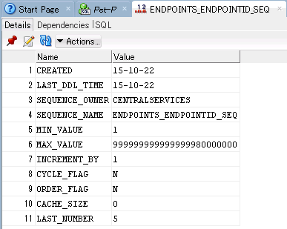

CentralServices DB has 4 endpoints and next Sequence would be 5.

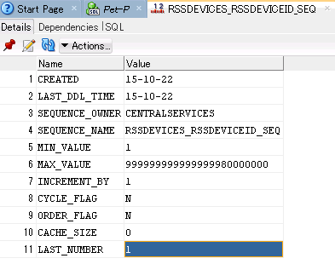

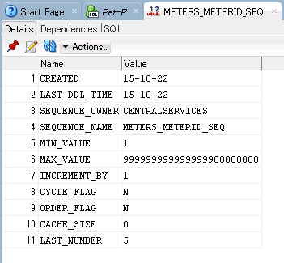

CentralServices DB has 4 meters and next Sequence would be 5.

DLMSADAPTER:

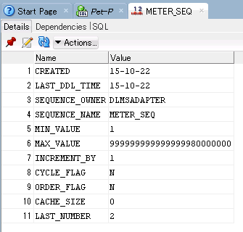
It should be less than or equal to max endpoint in CentralServices database.

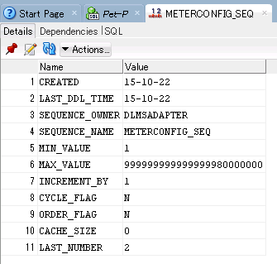
It should be less than or equal to max endpoint in Central Services database.

M2MAdapter

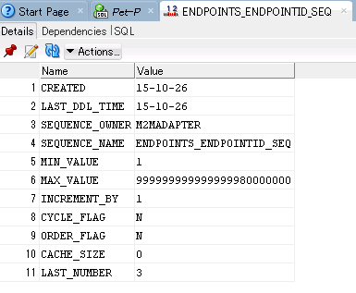
It should be less than or equal to max endpoint in Central Services database.

SBSAdapter
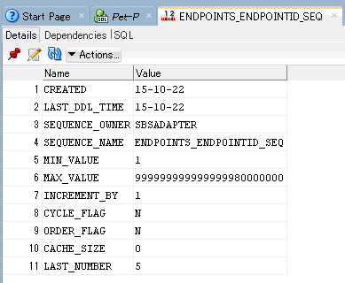
It should be less than or equal to max endpoint in Central Services database.

- Create Trigger using below query (Please make sure this trigger is dropped after successful bulk load):

create or replace TRIGGER KeyCache.TI_ChangeDateFormat
AFTER LOGON ON KeyCache.SCHEMA
DECLARE username VARCHAR2(30);
BEGIN
username := SYS_CONTEXT('USERENV','SESSION_USER');

IF username = UPPER('KeyCache') THEN
DBMS_SESSION.SET_NLS('NLS_COMP','LINGUISTIC');
DBMS_SESSION.SET_NLS('NLS_SORT','BINARY_CI');
DBMS_SESSION.SET_NLS('NLS_DATE_FORMAT','''MM/DD/YYYY HH24:MI:SS''');
DBMS_SESSION.SET_NLS('NLS_TIMESTAMP_FORMAT','''MM/DD/YYYY HH24:MI:SS.FF3''');
END IF;
END;

- CC web Server changes – This is required because LGECCCryptoService in app server is configured to exposed thru named pipe since it is used by security service which is on the same machine. But since bulk loader can be on individual machines, it needs to directly consume LGECCCryptoService and then a http endpoint is needed in that service.

Open <Web Server>TS2\Web\RSAeServiceHost\web.config and add below subtag in <binding> tag

<basicHttpBinding>

<binding name="BasicHttpBinding_ICryptoService" > <security mode="None">

</security>

</binding>

</basicHttpBinding>

……

……

Add highlighted text in existing tag: <services>

<service name="LandisGyr.CommandCenter.Cryptography.LGECC.LGECCCryptoService"> <endpoint

address=""

binding="netNamedPipeBinding"

bindingConfiguration="namedPipeBinding" contract="LandisGyr.Cryptography.Services.ICryptoService" />

<endpoint address="" binding="basicHttpBinding" bindingConfiguration="BasicHttpBinding_ICryptoService" contract=" LandisGyr.Cryptography.Services.ICryptoService " />

</service>

</services>

- Enable SQL Server Remote Connectivity on SPU SIM machine a. Open SQL Server Configuration Manager
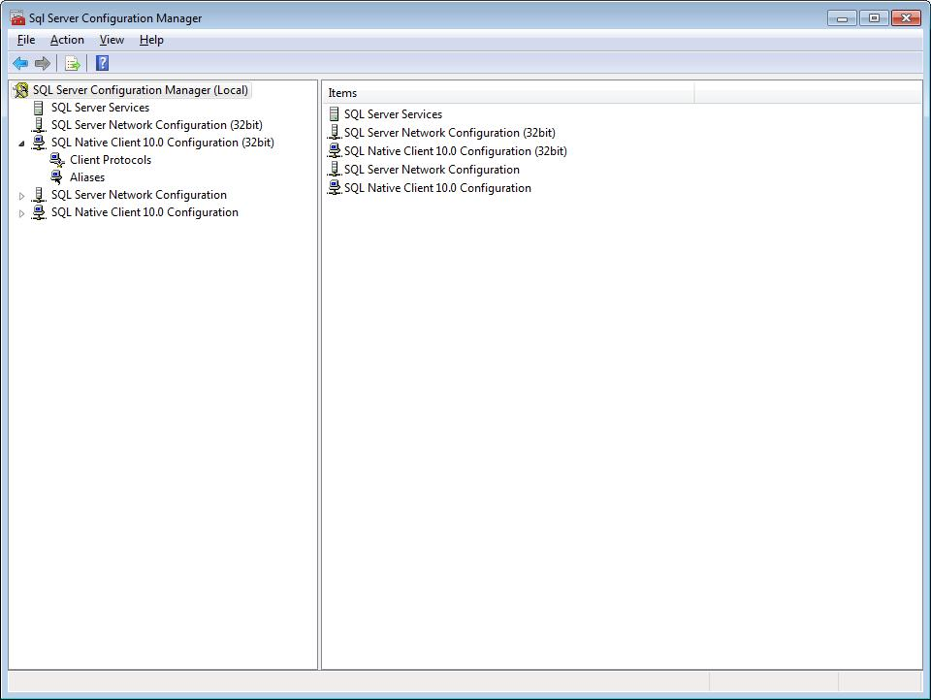

- Check the SQL Server Services to verify that all services are up and running

- Verify that Client protocols are enabled for all Configurations

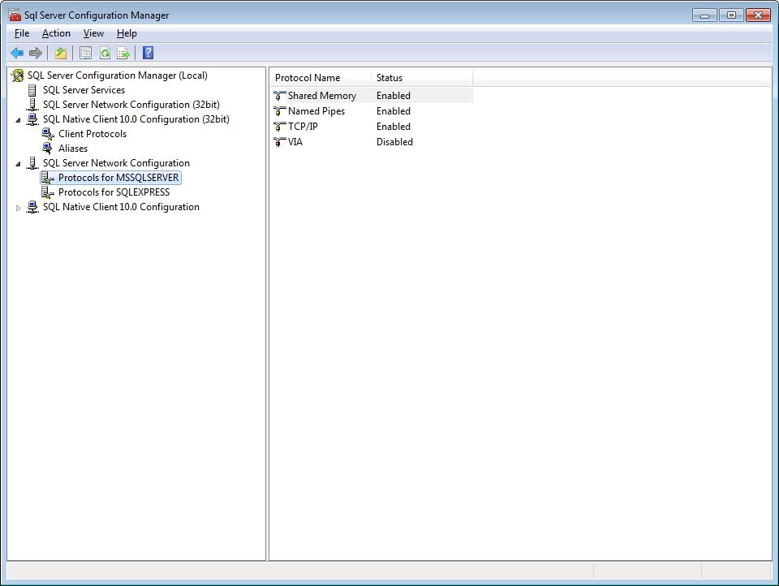

- Generate Kep and Kdk as follow

  - Make sure that “LandisGyr.Simulation.Tools.Utilities.exe.cofig” at location ‘BulkLoader\Utilities’ has following highlighted URL correctly set-

<client>

<endpoint address="http://<CCPrimaryAppServerIP>/RSAServiceHost/LGECCCryptoServ ice.svc"

binding="basicHttpBinding" bindingConfiguration="BasicHttpBinding_ICryptoService"

contract="LGECC.ICryptoService" name="BasicHttpBinding_ICryptoService" /> </client>

  - Go to path ‘BulkLoader\Utilities’ and open ‘BulkLoader\LandisGyr.Simulation.Tools.Utilities.exe’. Following window will open

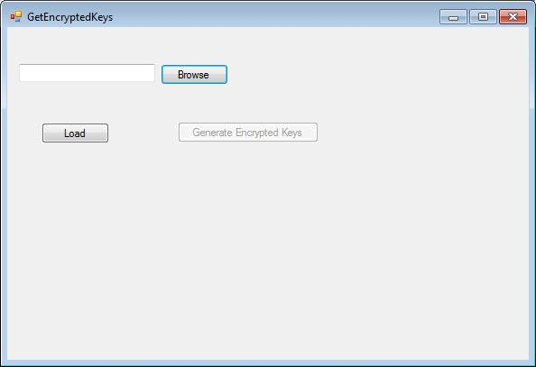

  - Browse for the LoaderSettings.xml at ‘BulkLoader\Utilities\LoaderSettingFiles’ and then load.

  - Click ‘Generate Encrypted Keys’ button and file ‘EncryptedKeys.xml’ will be generated at location ‘BulkLoader\Utilities’. Verify that keys are present in this file.

- Stop TS2 Service on all the app servers. This is mandatory to stop processing any packets during the bulk upload.

- Bulk Loading Steps

  - Open application ‘BulkLoader/BulkLoader.exe’.Following window will open.

  - Welcome Screen – Verify that command center and GSIS version mentioned here are compatible.

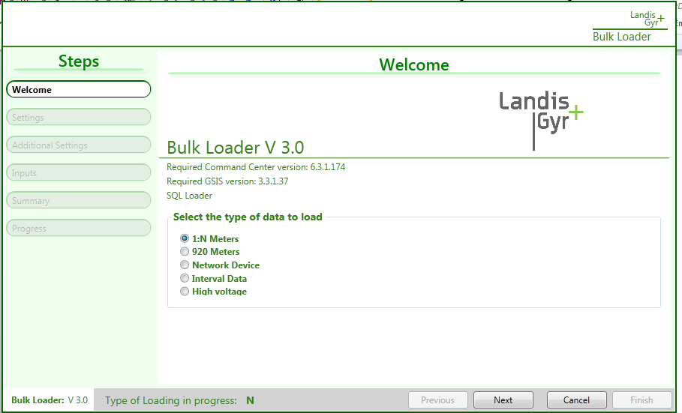

- Type of Data to Load:
Select type of data you want to load.
- Type of Adapter/Layer to be Loaded(NEW SCREEN):
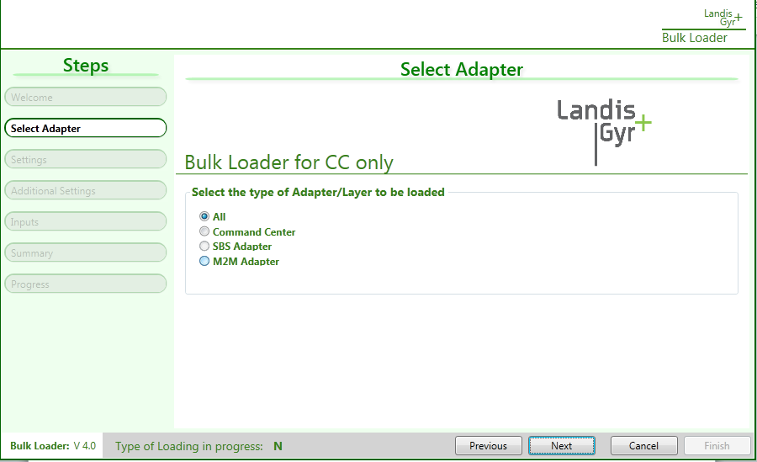
Select Layers in which you want data to be inserted.
Tepco japan would need to click “ALL” radio button always for their use.

1: N Meters

- Settings Screen - Click Next and you will get Settings Screen window. Input the connection details for CC, M2M, KeyCache, DLMS and SPU Sim databases. Change the location to store the clean scripts that will be generated as part of bulk loading. Click ‘Test Connection’.
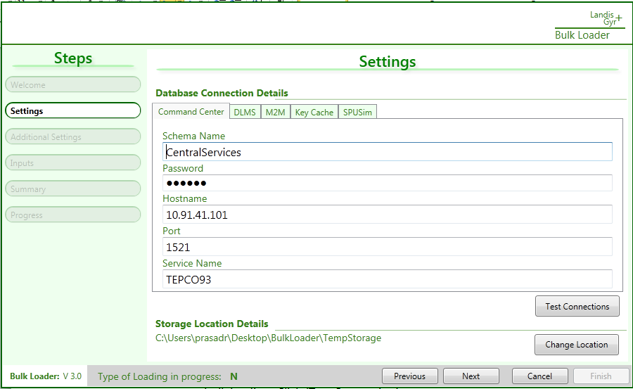

If connections are successful, ‘Next’ button is enabled. Click Next to proceed

- Additional Settings Screen - Additional Settings Screen will open when next button is clicked. Here is the description of each field

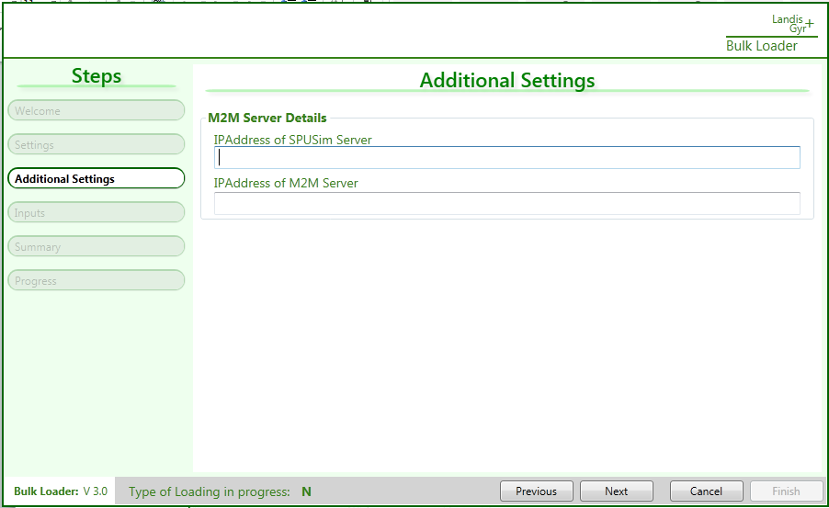

M2M

  - IPAddress of SPU Sim – IP Address of SPU SIm machine that will be used for M2M.

  - IPAddress of M2M – IP Adresss of M2M machine which will be used by SPU Sim to route any outbound traffic for command responses and push packets in case of M2M.

Click ‘Next’ to proceed.

- Inputs Screen – Inputs Screen will have following UI inputs.
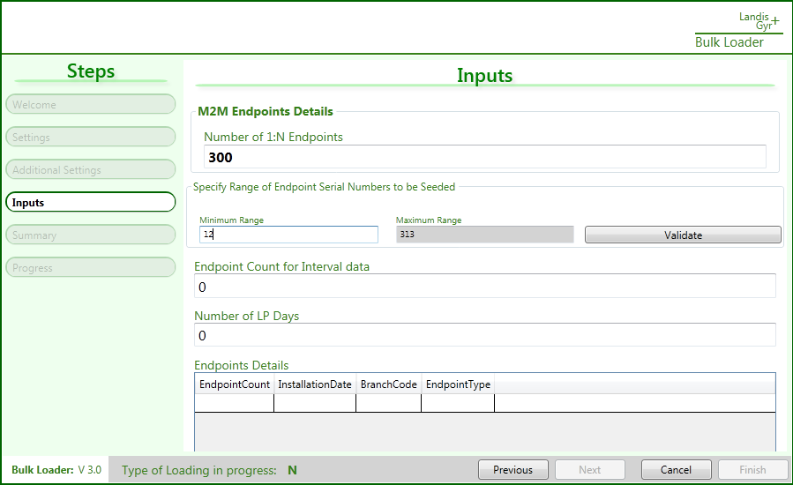
- Number of 1:N Meters - Please note that at time either provide 1:N meters.
- Specify Range of Serial Numbers to be seeded – Get unused range of serial numbers from centralservices’s endpoints table that will be bulk loaded. Click the ‘Validate’ button to verify that range is valid. Once the range is valid, ‘Next’ button is enabled.
- Endpoint Count for Interval Data – No of endpoint for which we want to send interval data. Leave it 0 as of now.

- Number of LP Days. – Please leave it 0 as of now.

- Summary Screen – Summary Screen will display the endpoints ids range that will be generated as part of bulk upload. Required seeding to bulk upload will be done.
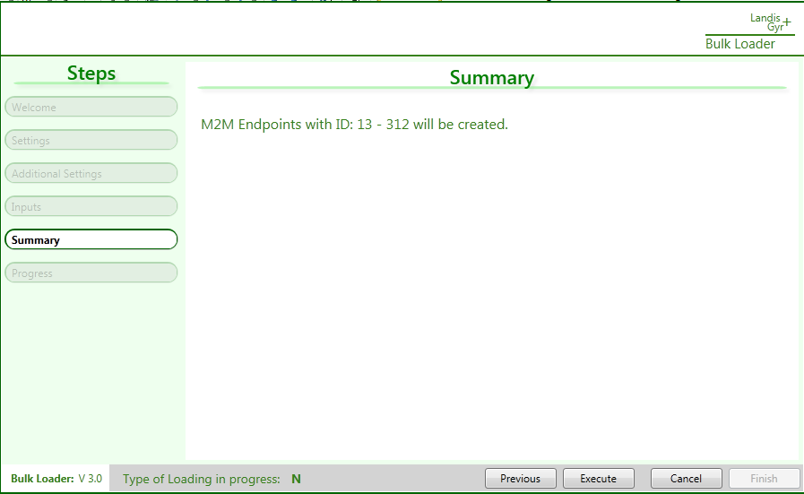
- Progress Screen - Progress will be visible in the window. Once bulk loading is done,
‘Finish’ button will be enabled.

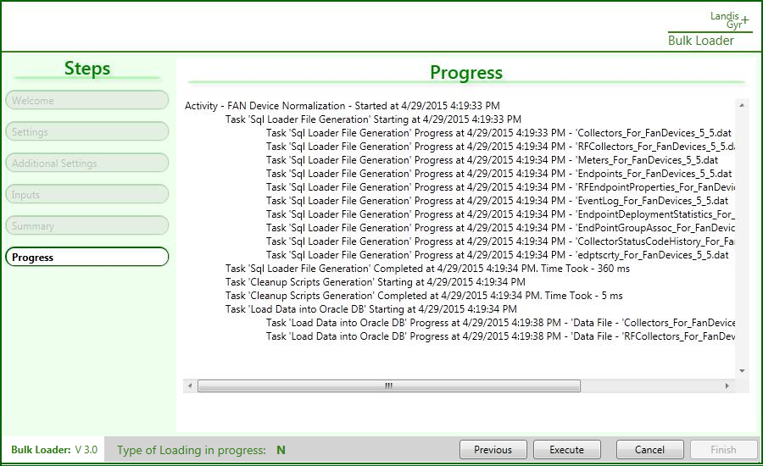

HV Meters
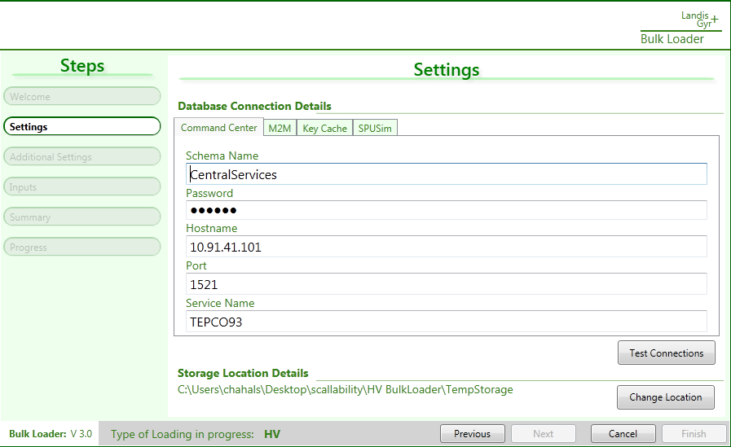
- Settings Screen - Click Next and you will get Settings Screen window. Input the connection details for CC, M2M, KeyCache and SPU Sim databases. Change the location to store the clean scripts that will be generated as part of bulk loading. Click ‘Test Connection’.

If connections are successful, ‘Next’ button is enabled. Click Next to proceed

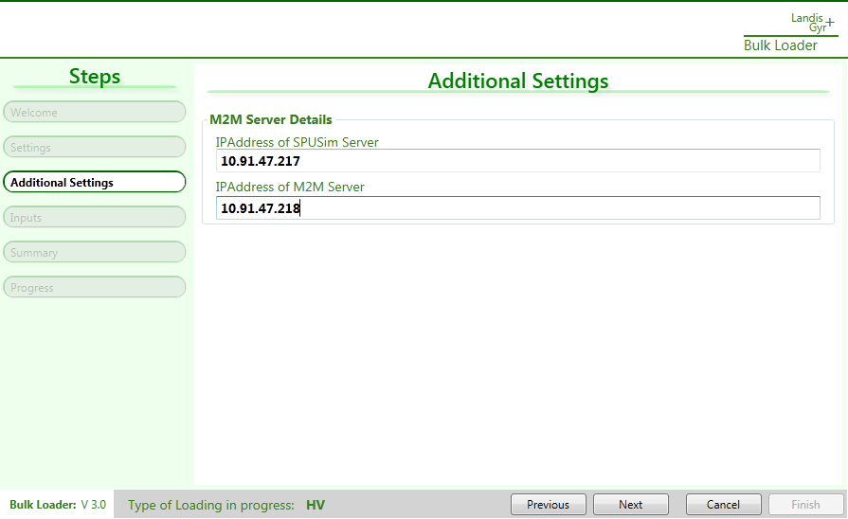
- Additional Settings Screen - Additional Settings Screen will open when next button is clicked.

Here is the description of each field.
M2M

    - IPAddress of SPU Sim – IP Address of SPU SIm machine that will be used for M2M.

    - IPAddress of M2M – IP Adresss of M2M machine which will be used by SPU Sim to route any outbound traffic for command responses and push packets in case of M2M.

Click ‘Next’ to proceed.
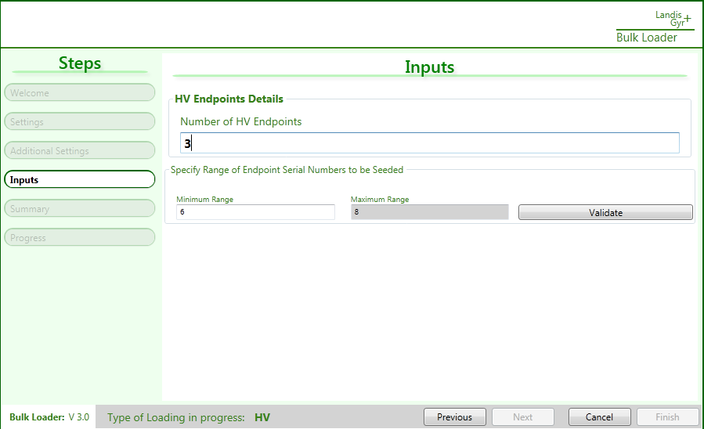
- Inputs Screen – Inputs Screen will have following UI inputs.

- Number of 1:N Meters - Please note that at time either provide 1:N meters.
- Specify Range of Serial Numbers to be seeded – Get unused range of serial numbers from centralservices’s endpoints table that will be bulk loaded. Click the ‘Validate’ button to verify that range is valid. Once the range is valid, ‘Next’ button is enabled.
- Endpoint Count for Interval Data – No of endpoint for which we want to send interval data. Leave it 0 as of now.

- Number of LP Days. – Please leave it 0 as of now.

- Summary Screen – Summary Screen will display the endpoints ids range that will be generated as part of bulk upload. Required seeding to bulk upload will be done.
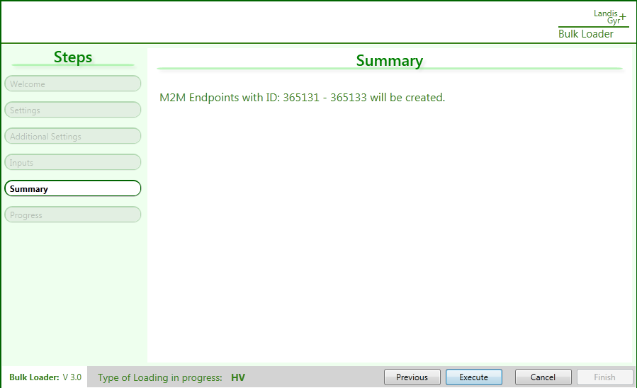

- Progress Screen - Progress will be visible in the window. Once bulk loading is done,
‘Finish’ button will be enabled.
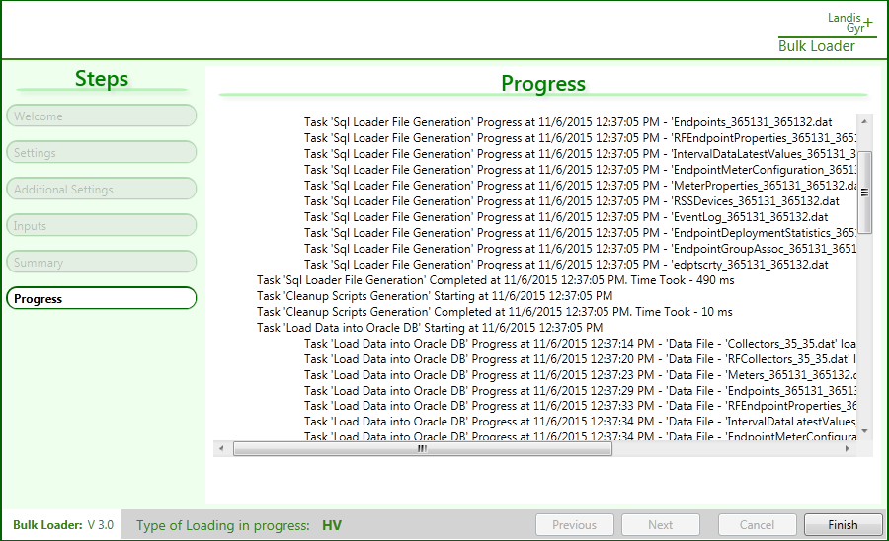

920 Meters

- Settings Screen - Click Next and you will get Settings Screen window. Input the connection details for CC, SBS, KeyCache, DLMS and SPU Sim databases. Change the location to store the clean scripts that will be generated as part of bulk loading. Click ‘Test Connection’.
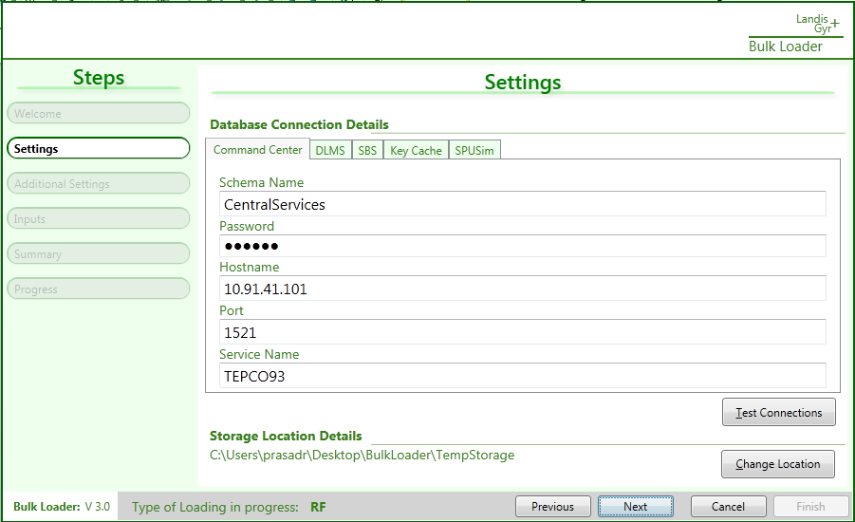
If connections are successful, ‘Next’ button is enabled. Click Next to proceed
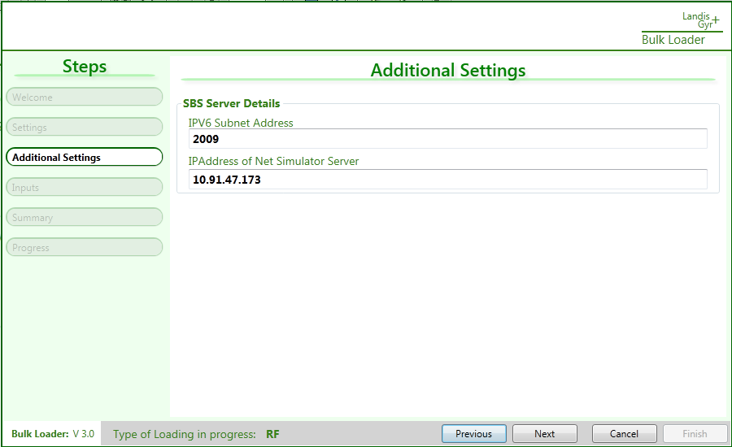
- Additional Settings Screen - Additional Settings Screen will open when next button is clicked. Here is the description of each field
SBS

  - IPV6 Subnet Address - SBS IPV6 Subnet Address which will be used by Bulk Loader to generate the IP Address for endpoints.

  - IPAddress of Net Simulator – IP Address of Net Simulator which will be used by SPU Sim to to route any outbound traffic for command responses and push packets in case of SBS.

Click ‘Next’ to proceed.
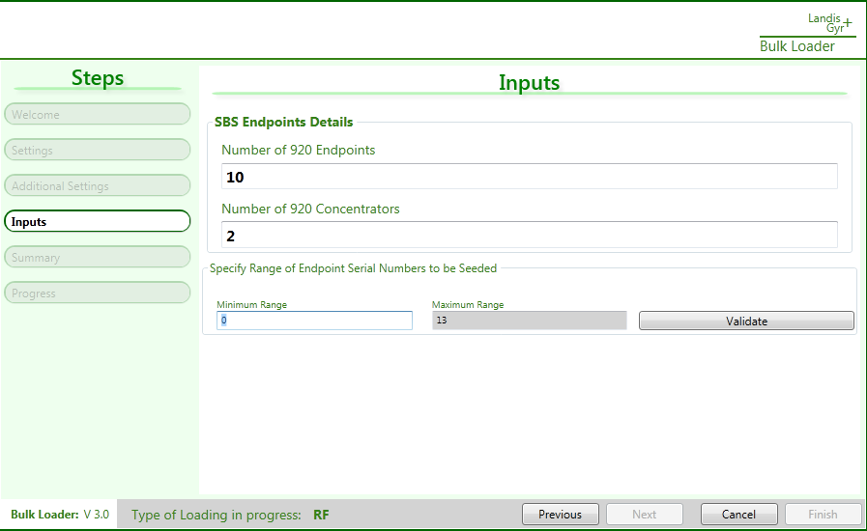
- Inputs Screen – Inputs Screen will have following UI inputs.

  - Number of 920 Meters - Please note that at time either provide 1:N meters or 920 meters and keep the other value 0.

  - Number of 920 Concentrators – It should non-zero if loading 920 endpoints.

  - Specify Range of Serial Numbers to be seeded – Get unused range of serial numbers from centralservices’s endpoints table that will be bulk loaded. Click the ‘Validate’ button to verify that range is valid. Once the range is valid, ‘Next’ button is enabled.

Click ‘Next’ button to proceed.

- Summary Screen – Summary Screen will display the collector ids and endpoints ids range that will be generated as part of bulk upload. Required seeding to bulk upload will be done.
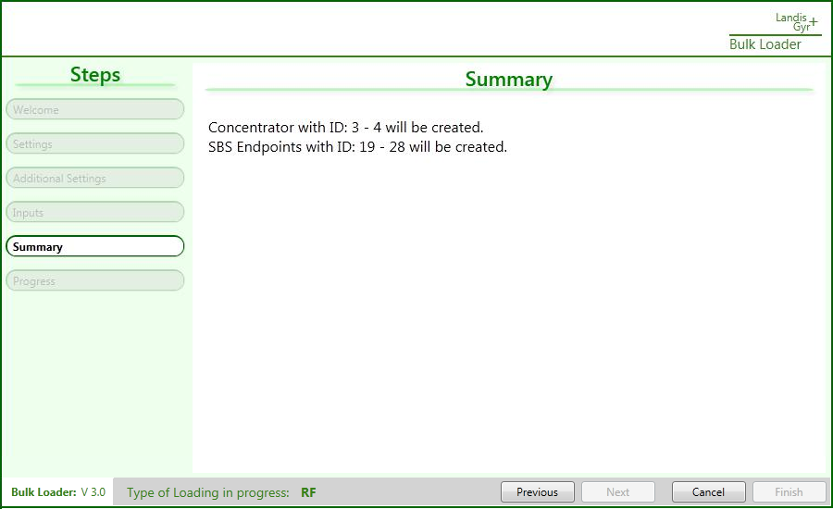

Click ‘Execute’ to start bulk loading.

- Progress Screen - Progress will be visible in the window. Once bulk loading is done,

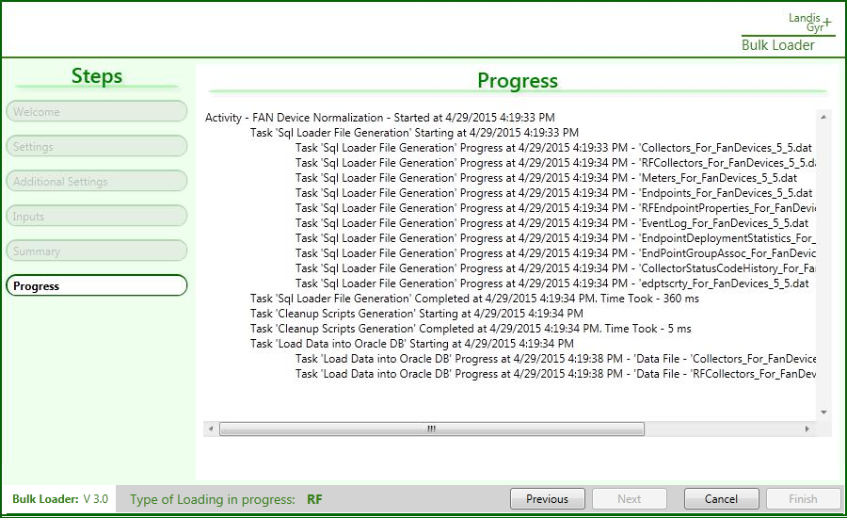
‘Finish’ button will be enabled.

- Verification Steps

  - Start all the SPU Sim services.

  - Start the TS2 services on all the app servers.

  - Verify that count of records in following tables

    - Centralservices.Endpoints

    - CentralServices.Collectors

    - DLMSAdapter.Meters

    - M2MAdapter.Endpoints

    - SBSAdapter.Endpoints

    - SBSAdapter.Collectors

  - Verify that endpoints are visible on CC UI and they are responding to commands

  - Verify that interval push are getting recorded for the endpoints.

  - Drop the trigger when bulk load is successful using below script:

drop trigger KeyCache.TI_ChangeDateFormat;
commit;

- Recovery Steps

If there is any failure during the bulk upload process, we have following ways to recover from it

- Delete Scripts

  - Please get the delete scripts from storage location specified in ‘Settings Screen’. Scripts for all CC, SBS, M2M, DLMS, SPU SIM and KeyCache will be present in their respective folders,

- DB Restore

  - If there is any issue in recovery with delete scripts, then please ask DBA to restore to DB backups taken at start of process.

- FAQs and Troubleshooting –

  - Please ensure that bulk loader is compatible with the CC schema.

  - Getting below while bulk loading –
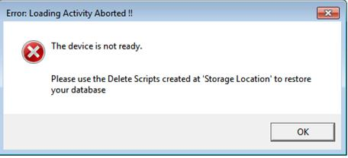

This error usually appears since path is not configured on machine where bulk loading is being performed.

Solution – Path shown in the screenshot below needs to changed.
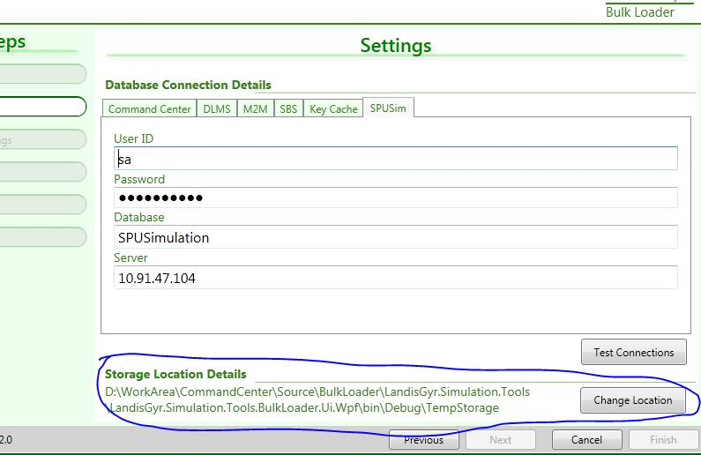

In case error still persists, perform the recovery steps.

