**Project/Assignment 3**

**Virtual Machines and Virtual Clusters**

**Team Member**

Surya Prakash Singh (2014H112186P)

Nishant Kumar (2014H112193P)

**1. Basic Architecture**

**1.1 Introduction**

The following figure depicts basic architecture of our model. We have used KVM as a hypervisor. Libvirt api to handle virtual machine and used open-v-switch to create a virtual bridge.

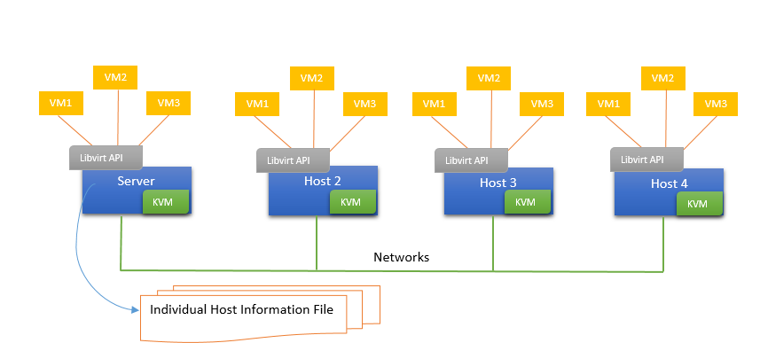

**1.2 Network Architecture**

We have used open-v-switch in order to create a virtual bridge. We have used following commands to create a virtual bridge.

Ovs-vsctl add-br br0 //this command will create a virtual bridge with name br0

Ovs-vsctl add-port br0 eth0 //this command will link the eth0 to bridge br0

Ifconfig eth0 0 //to remove ip from eht0

Dhclient br0

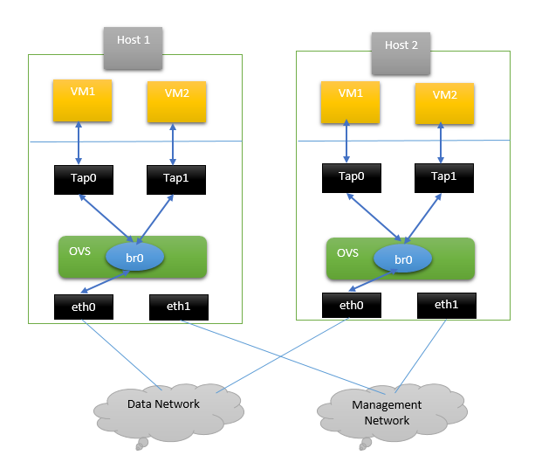

**1.3 Overall Working**

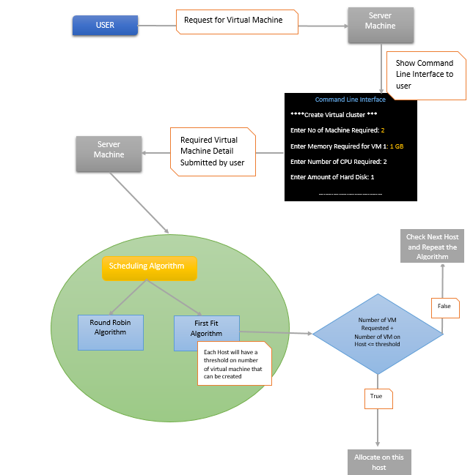

**2. References**

1. <http://libvirt.org/html/index.html>

2. <https://www.youtube.com/watch?v=rYW7kQRyUvA>

3.[http://git.openvswitch.org/cgibin/gitweb.cgi?p=openvswitch;a=blob_plain;f=INSTALL.Libvirt;hb=HEAD](http://git.openvswitch.org/cgi-bin/gitweb.cgi?p=openvswitch;a=blob_plain;f=INSTALL.Libvirt;hb=HEAD)