REPORT:-

Questions :-

**1.**What category(part) of the state of India spend most on healthcare

2.how has the expenditure changes over the passing years (2015-2018)

**3.**What are the difference variations in expenditure of the following criteria in different states :-

i) Family welfare expenditure on health by Urban Family Welfare Services ( UFWS )

ii)Family welfare expenditure on health by Rural Family Welfare Services ( UFWS )

iii) Family welfare expenditure on health by Mother and Child Health ( MCH )

which states spends the most on :- Miscellaneous family welfare expenditure on health and Family welfare expenditure on health by Mother and Child Health ( MCH )

**4.**Whichstates spend the most on healthcare with respective to their size and population in rural and urban areas

5.How Medical and public expenditure on health by Medical Education, Research & Training varies yearly in different states

Part1:- Data Selection





The data we have selected is of national health profile , and the csv files selected are :-

1.Public Expenditure on health by components across states

2.State wise distribution of sub-centres, primary health centres, community health centres (CHC) & health and wellness centres (HWC)

Part 2:-Visualisation

1.Data importation and establish relationship

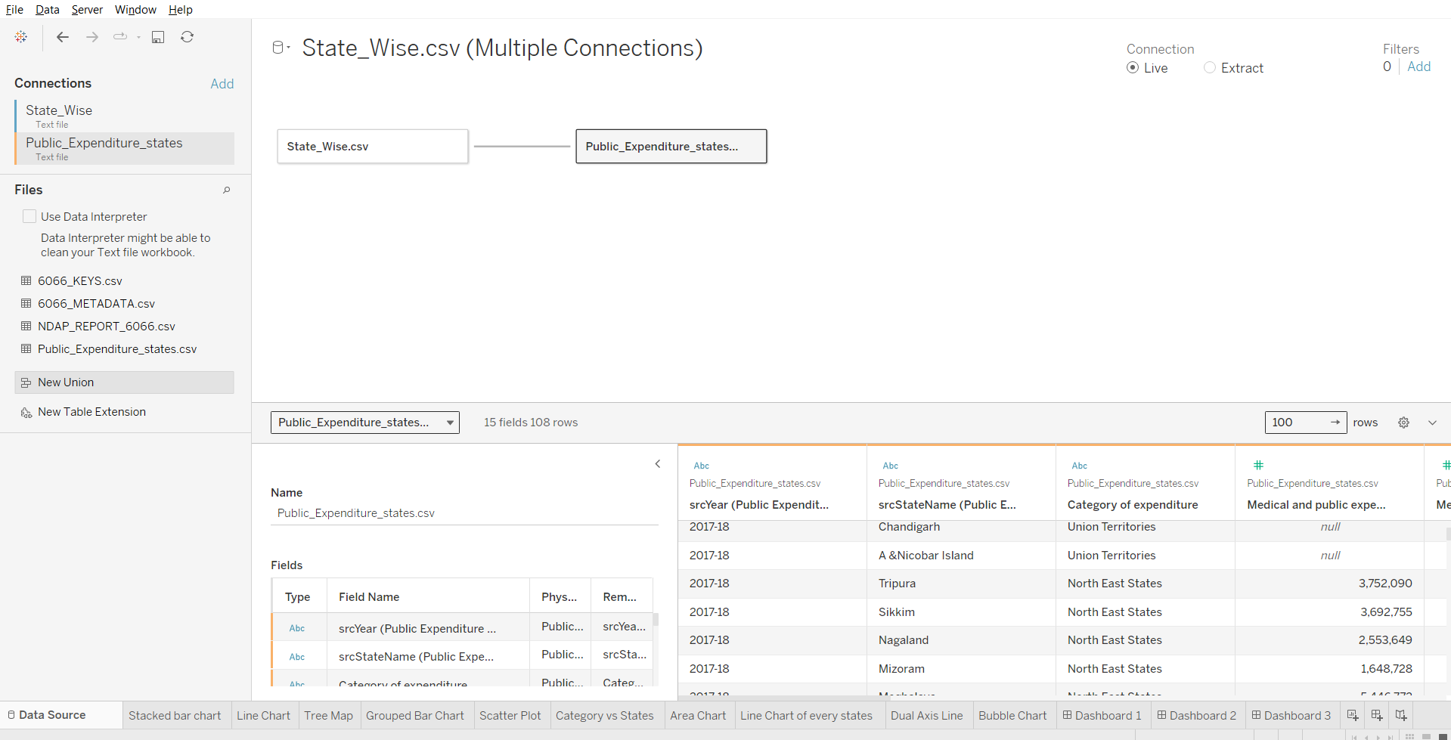

2.Stacked Bar Chart

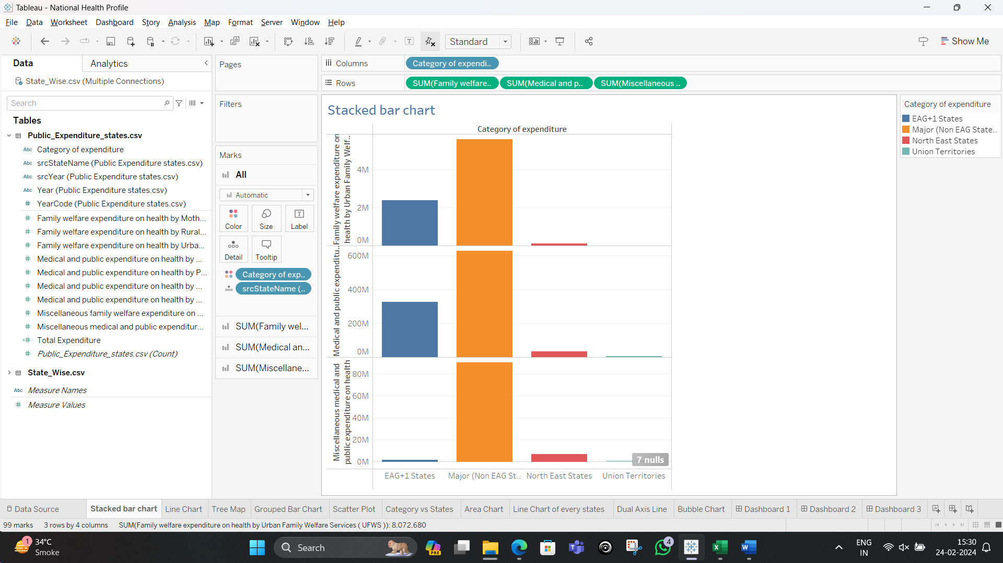

3.Line Chart

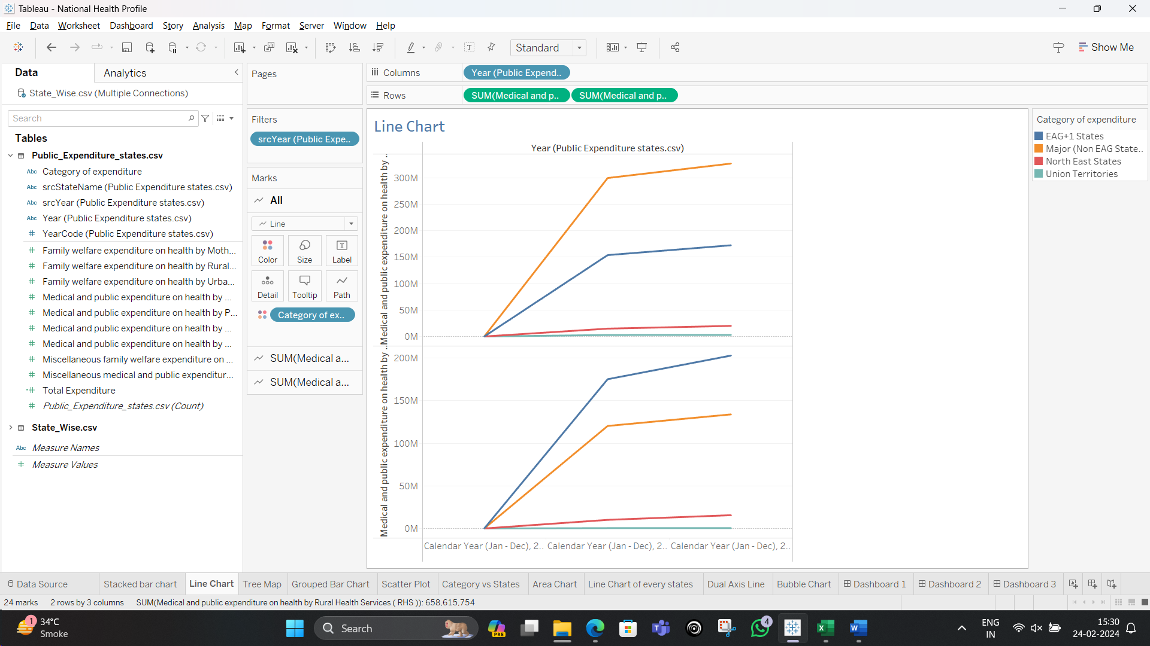

4.Tree Map

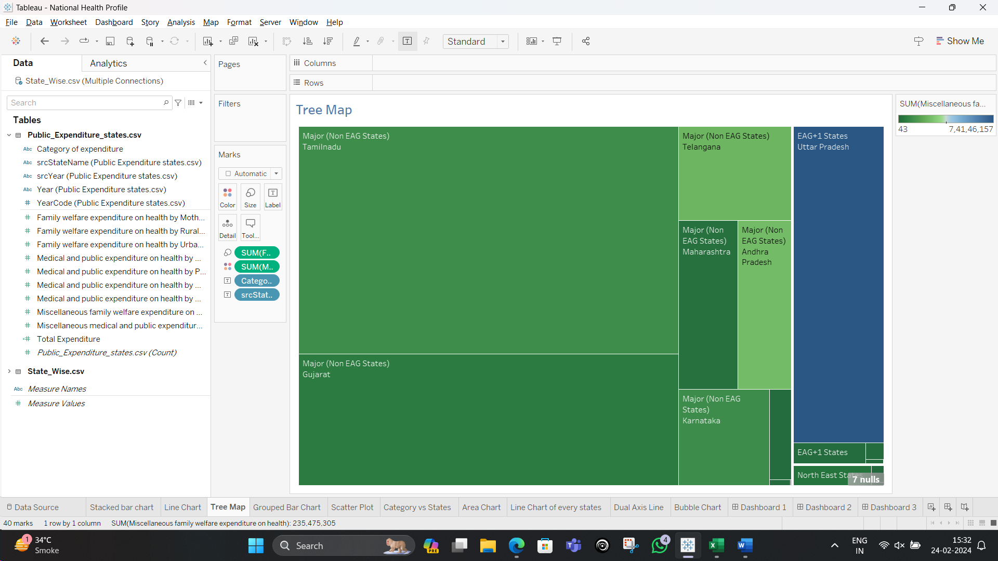

5.Grouped Bar Chart

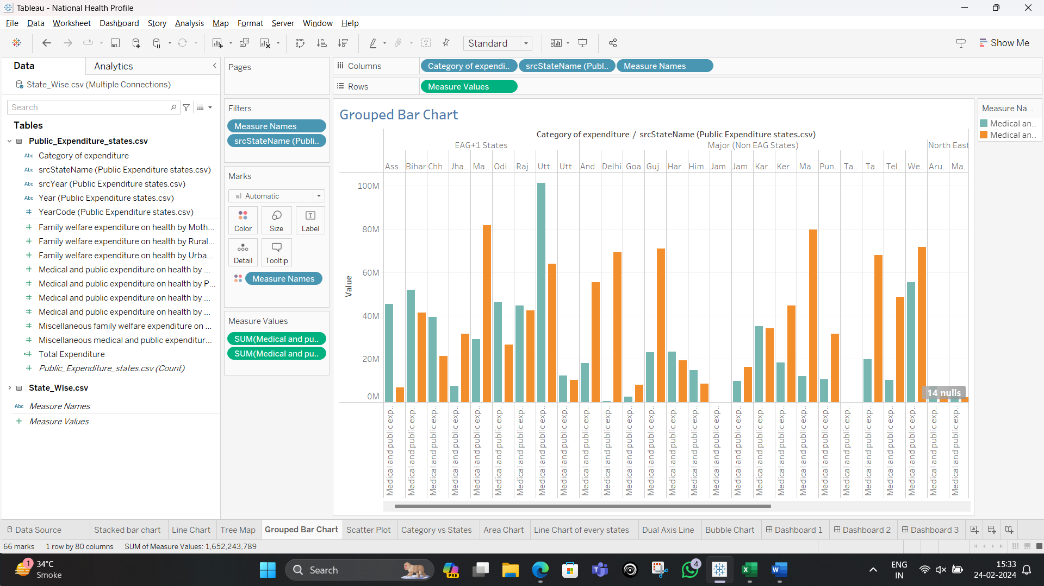

6.Scatter Plot

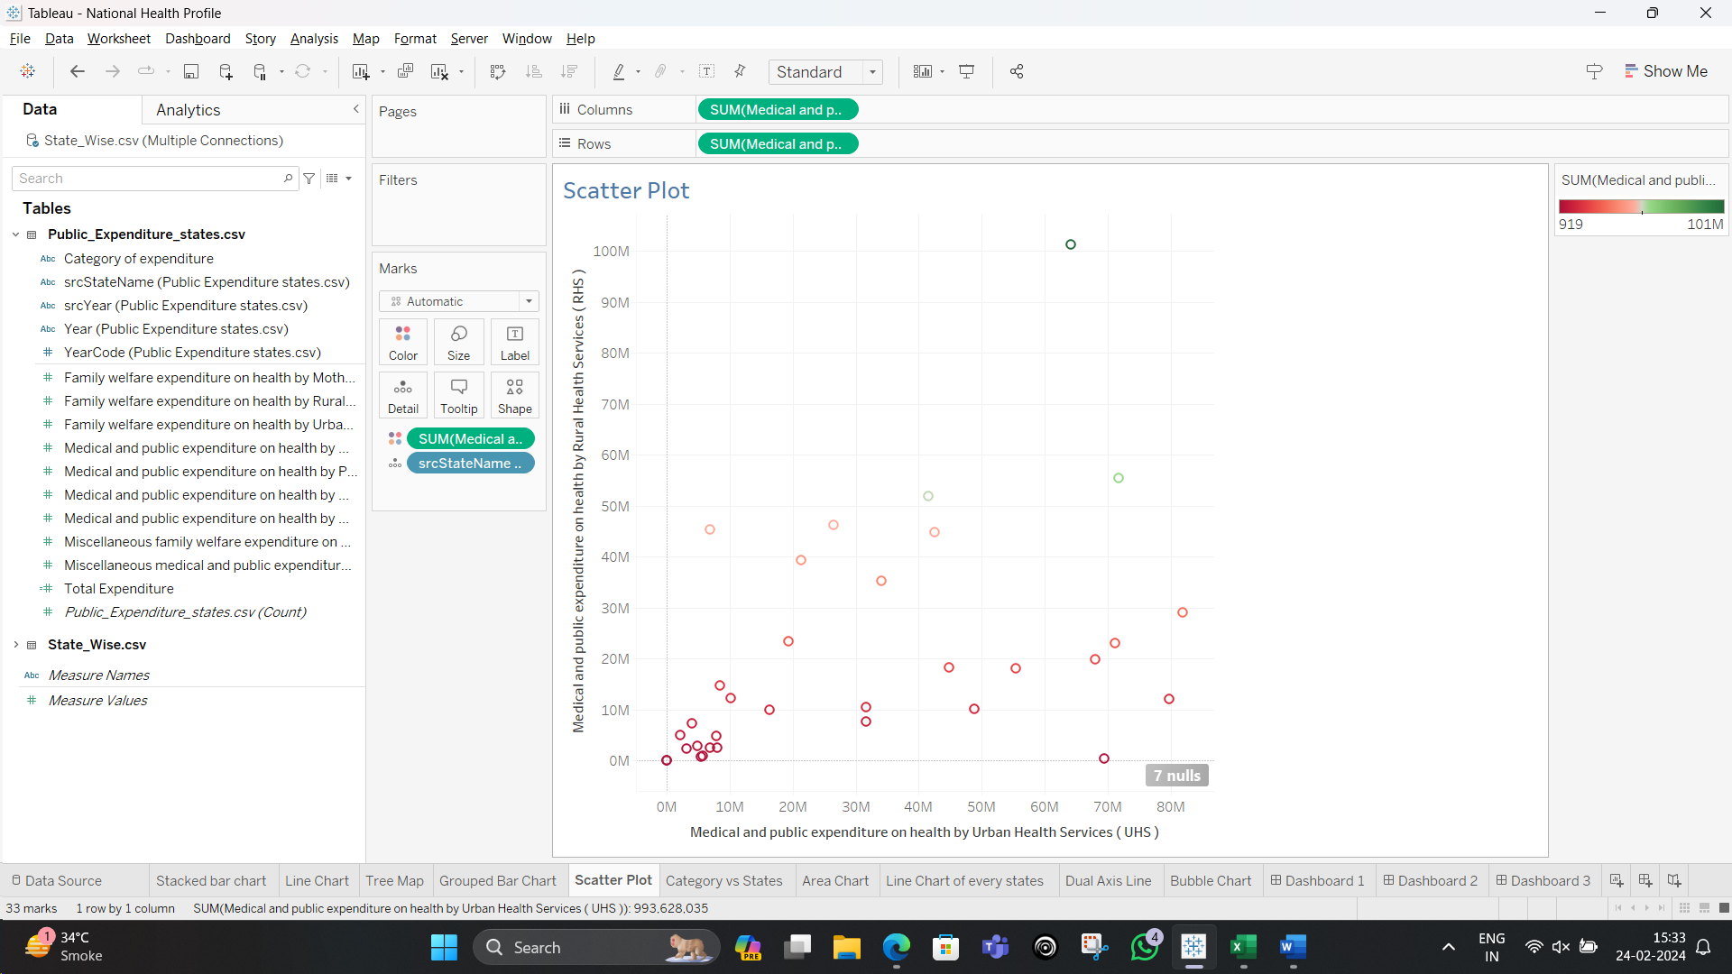

7.Horizontal Grouped Bar Graph

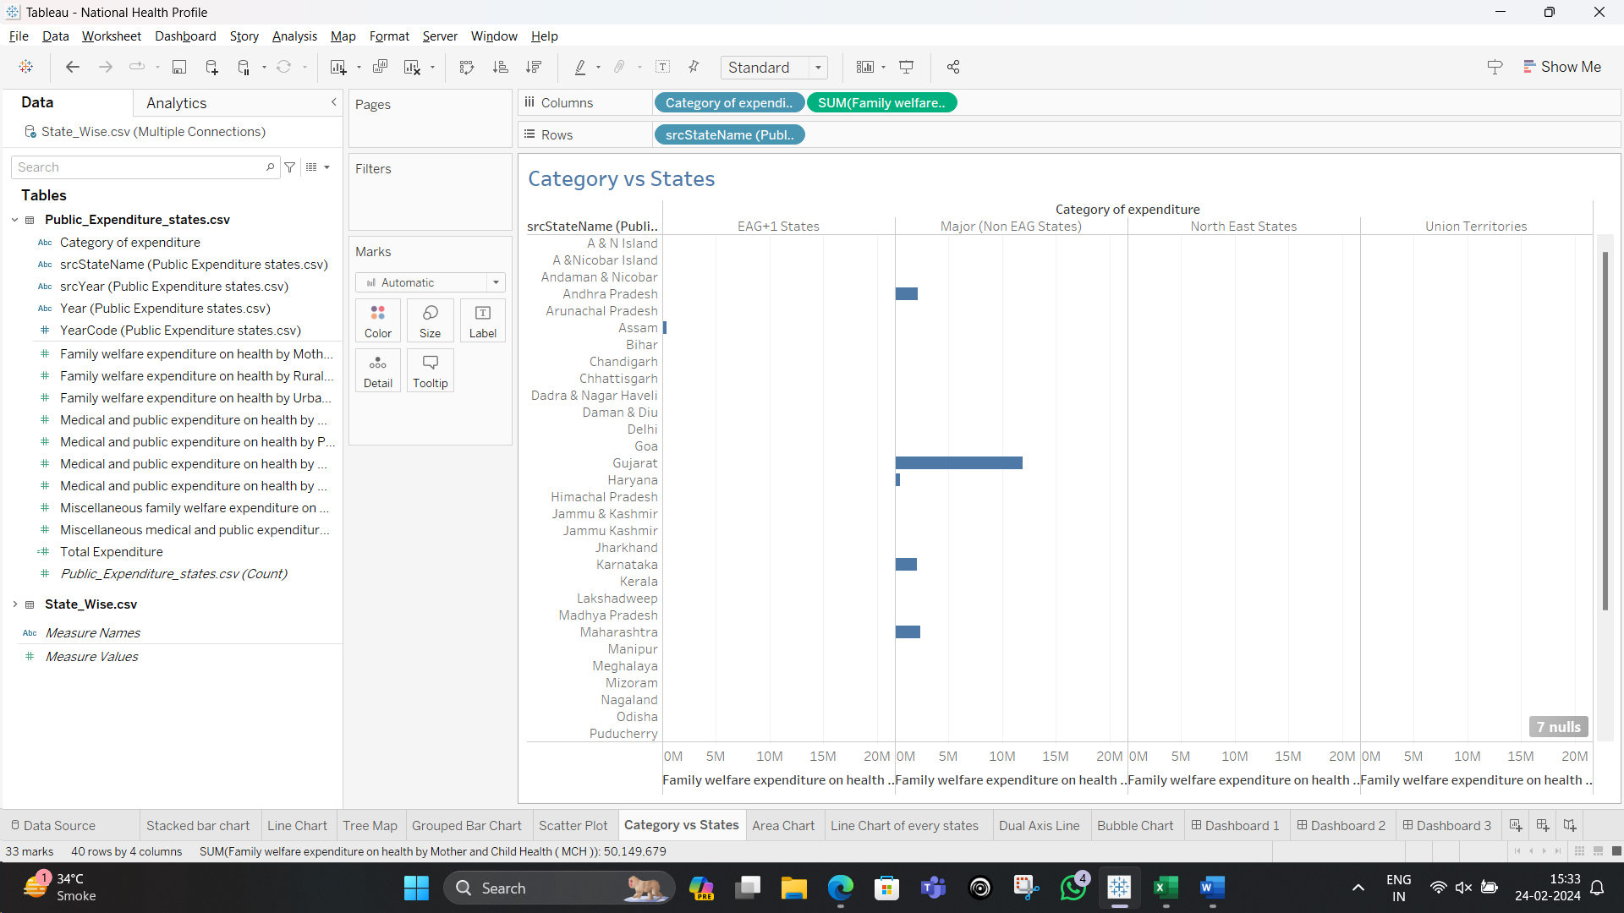

8.Area Chart

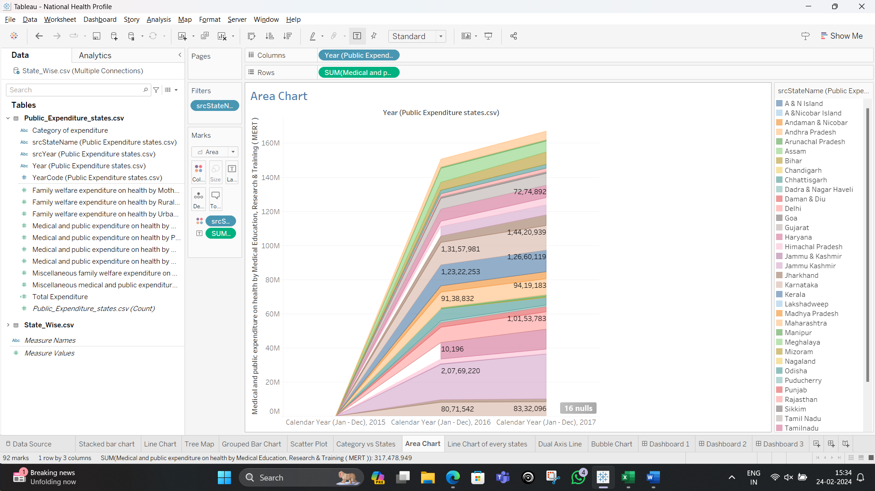

9.Line Chart of different states

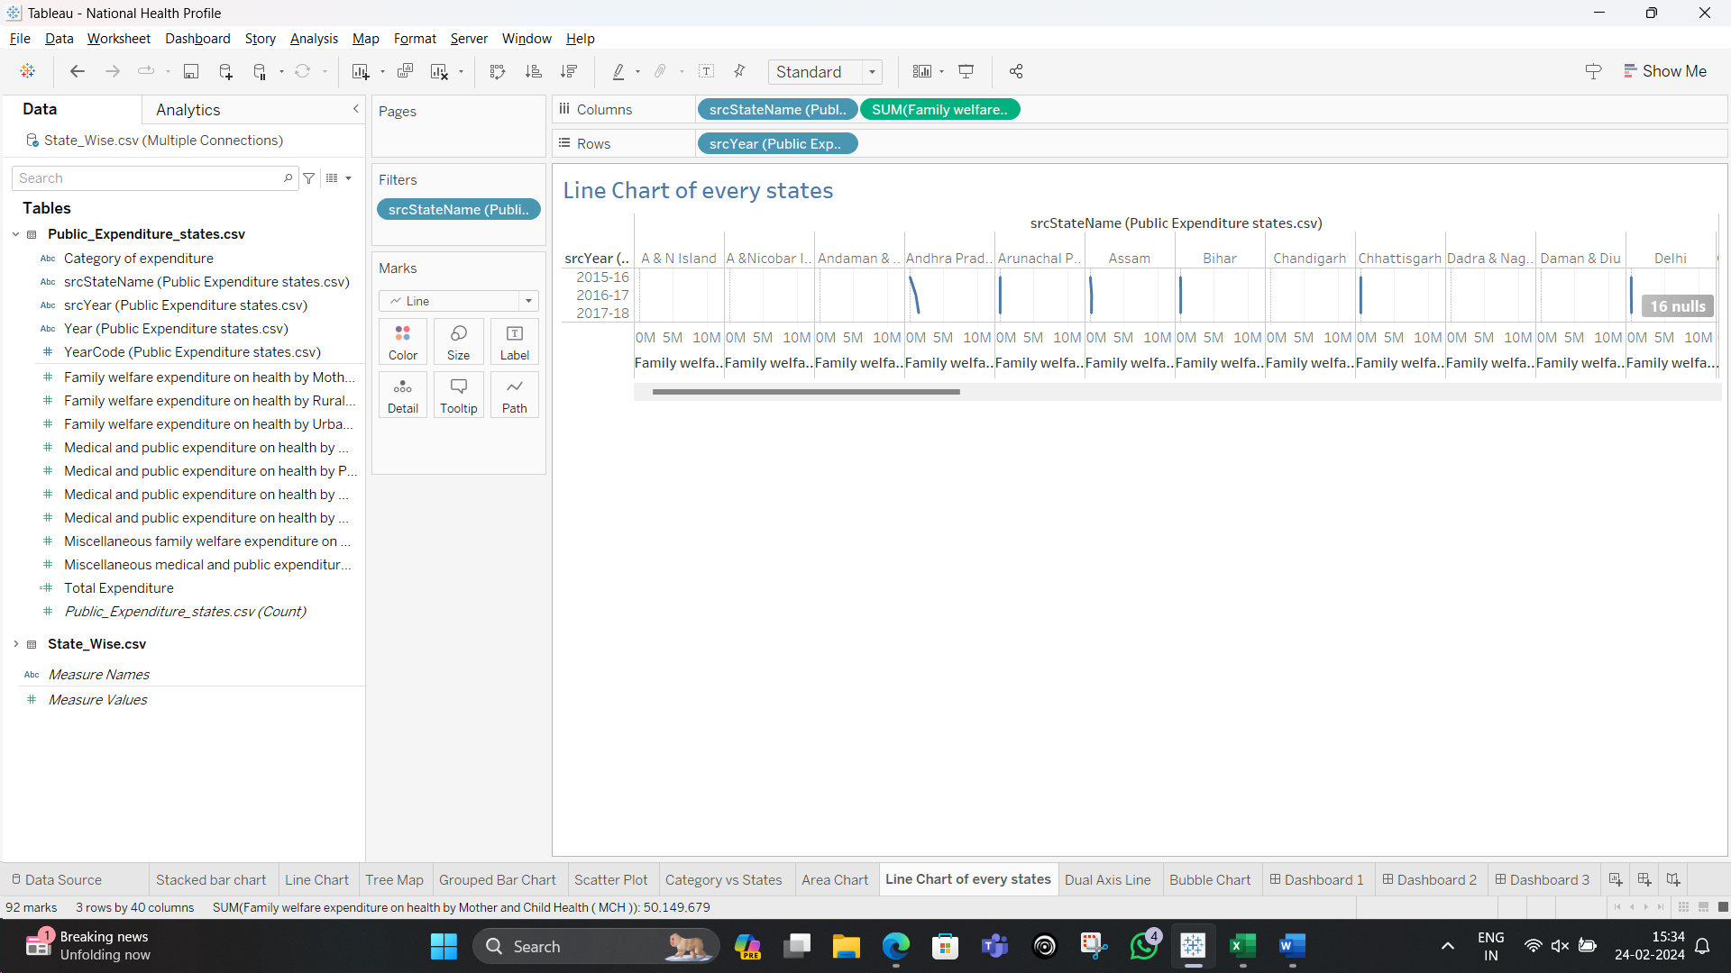

10.Dual Axis Line Chart

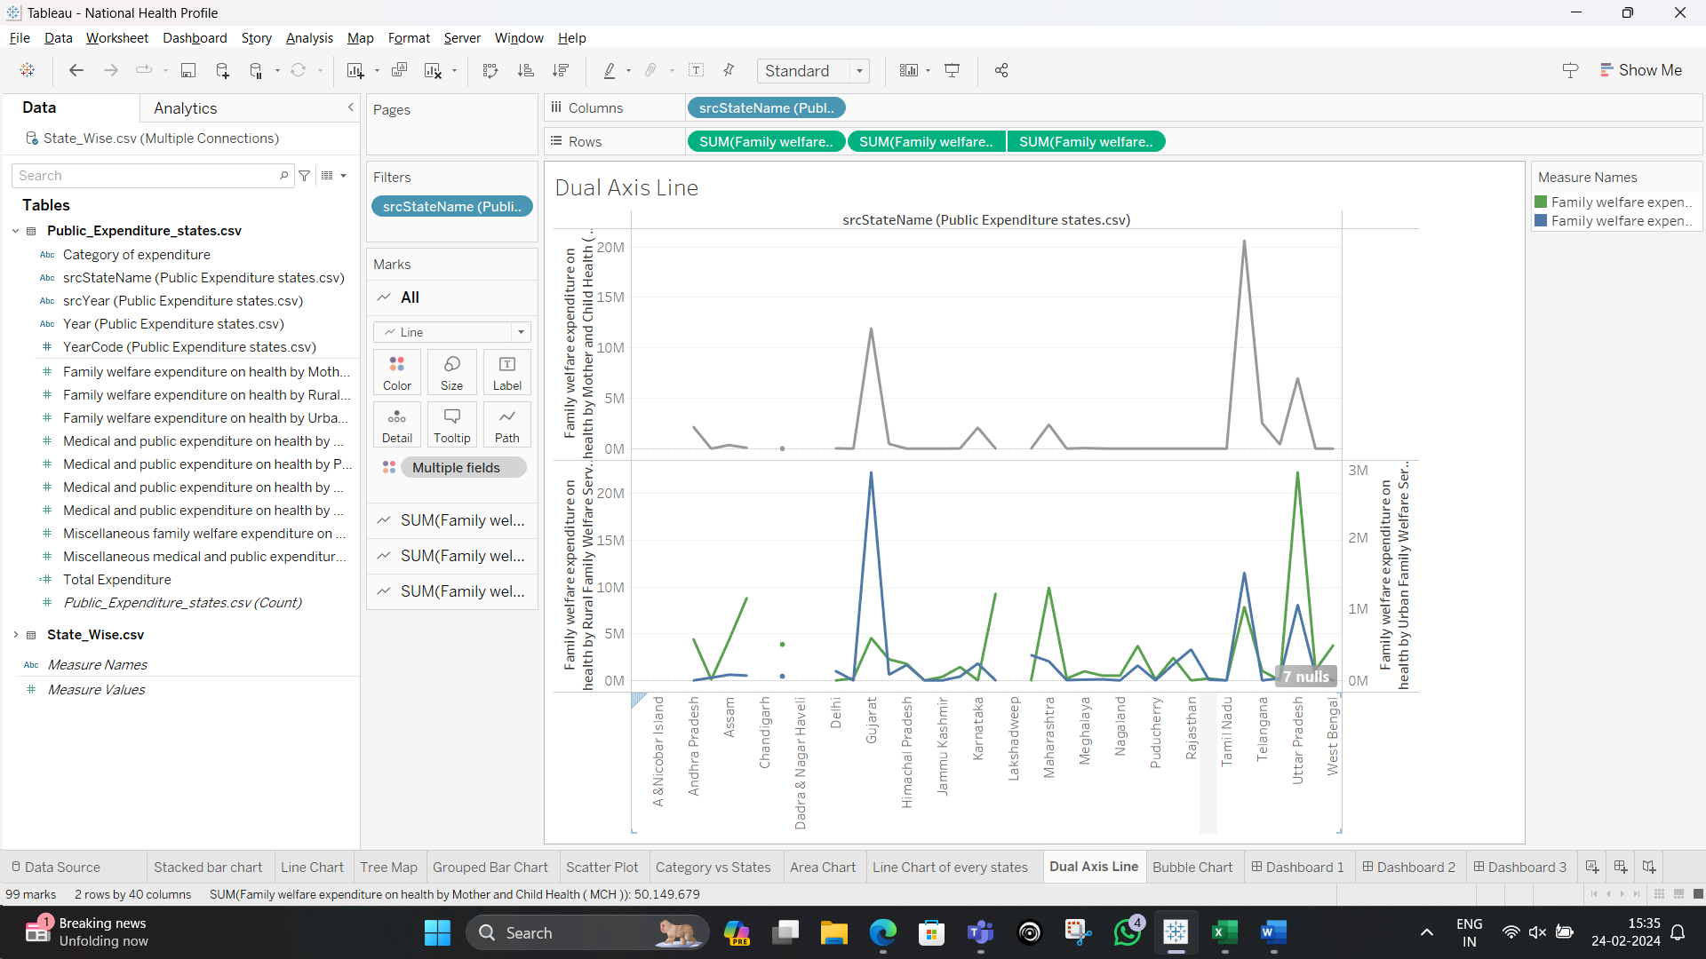

11.Bubble Chart

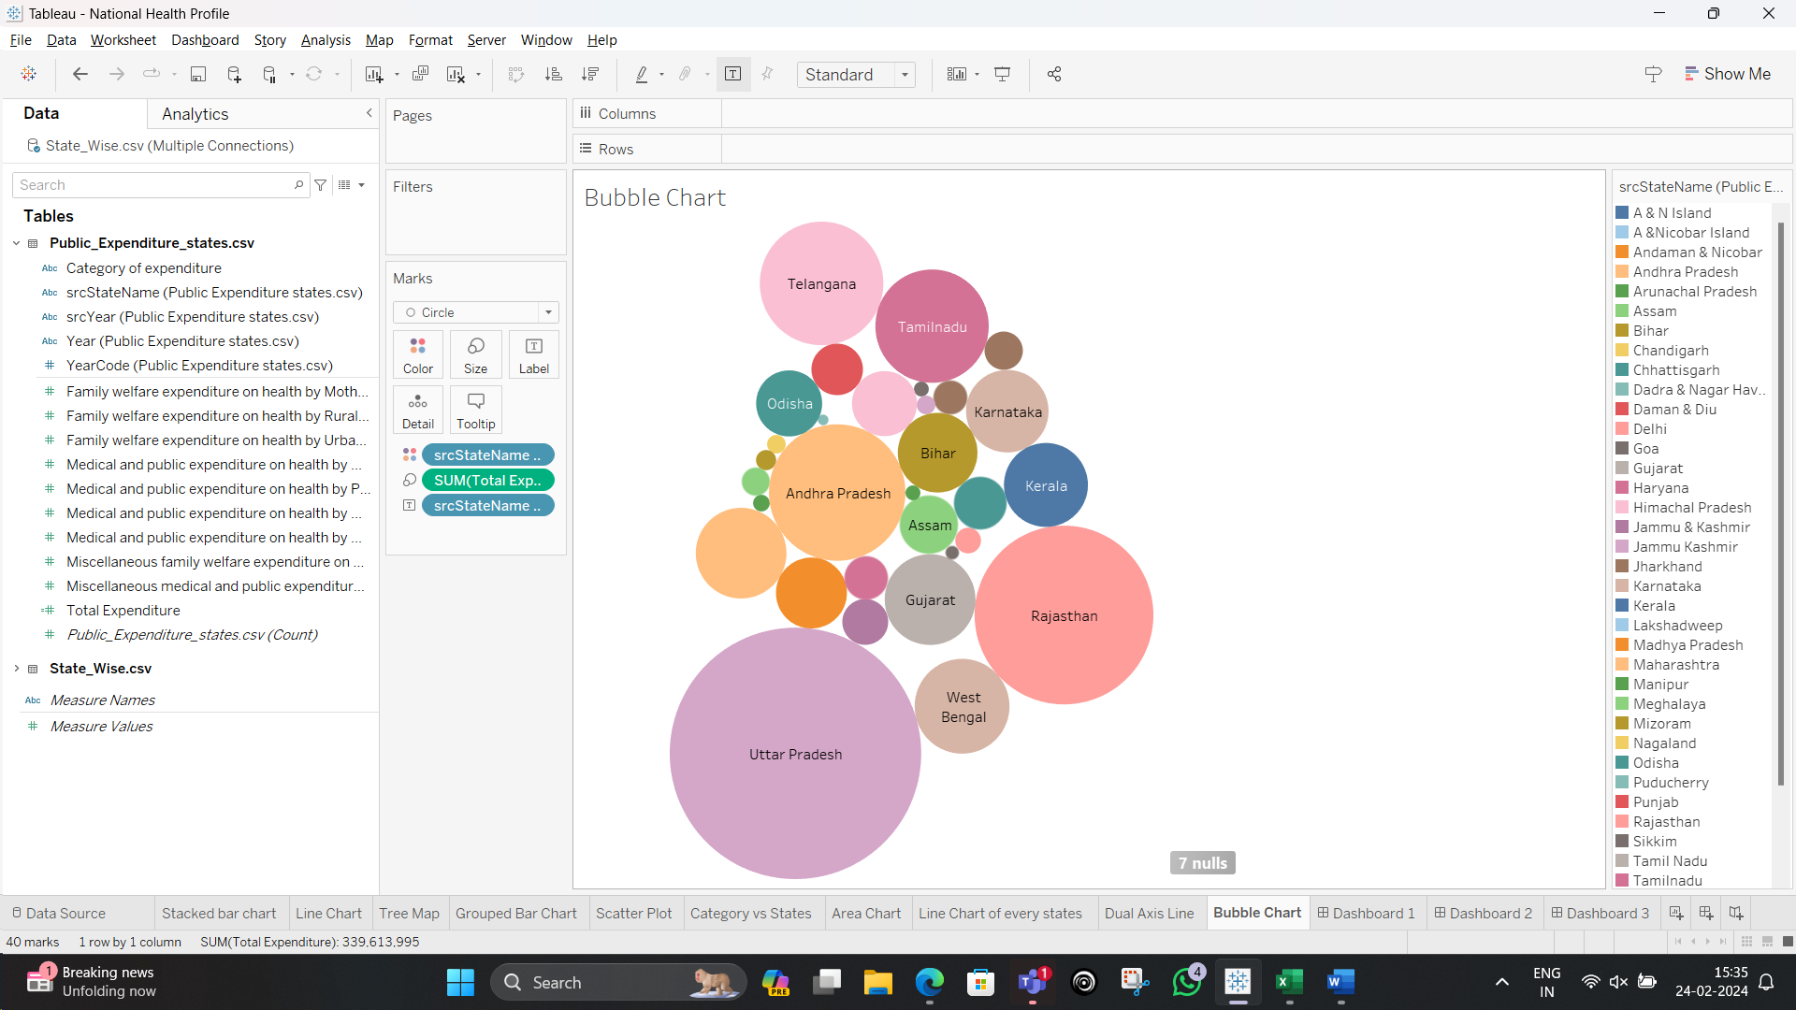

Dashboards

1.Comparative analysis of health expenditure categories across states

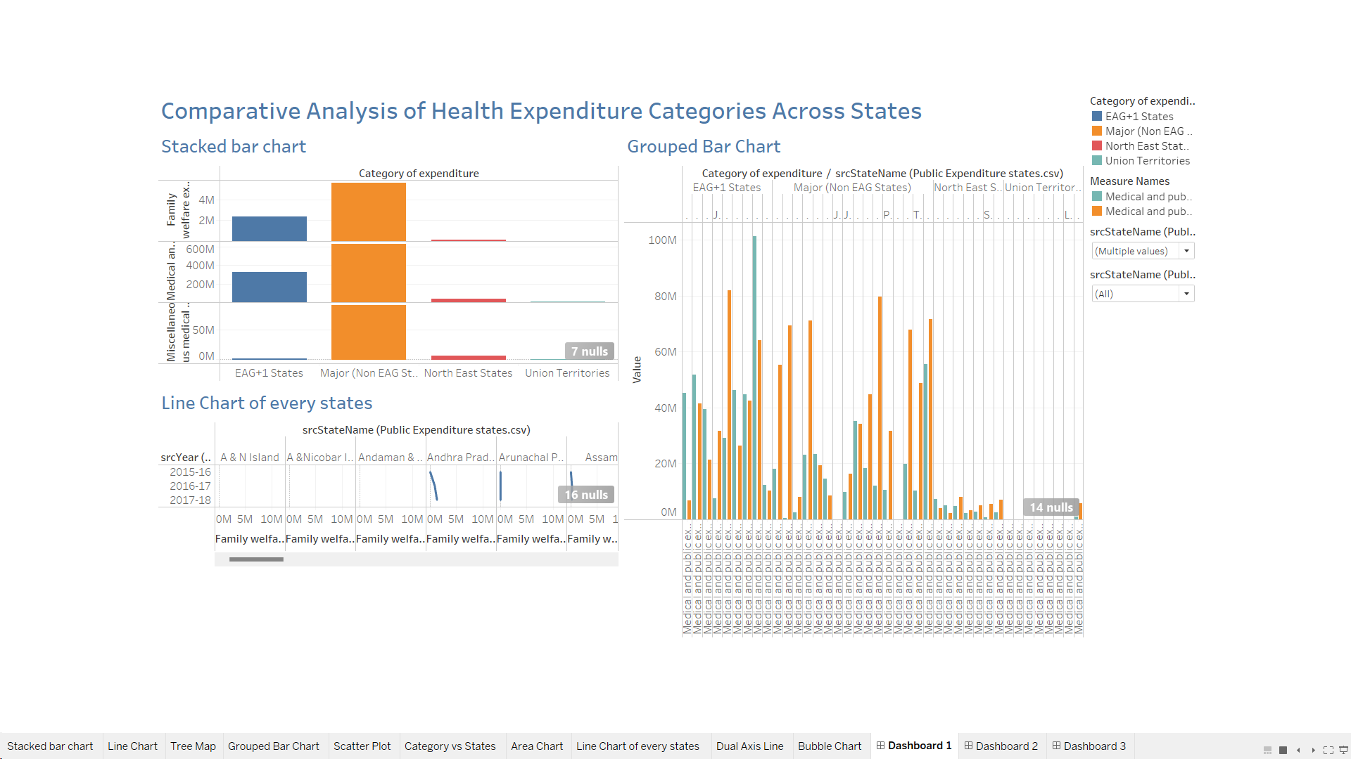

2.Insights into health financing state by state over time

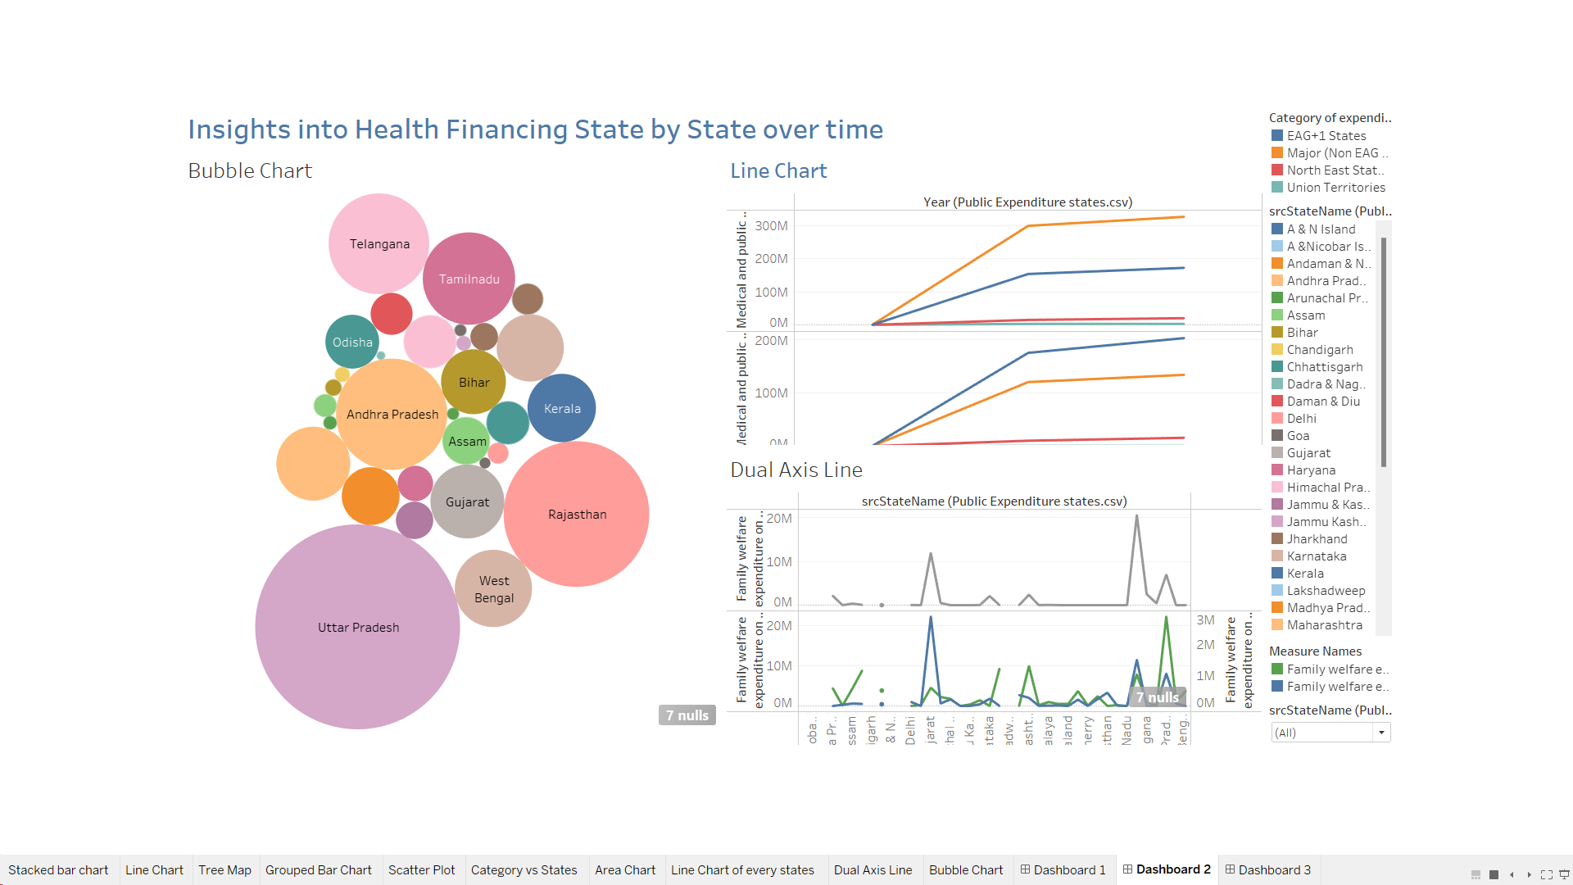

3.Visualizing state health expenditure

