PROJECT REPORT
ON
BANK MANAGEMENT SYSTEM
A Core Java Based Project

Submitted in partial fulfillment of the requirements for the BCA programme

Submitted By
Nishant
BCA – 3rd Year
R.V. Higher Education and Technical Institute

Project Guide
Rahul Sharma

Academic Session: 2026

CERTIFICATE
This is to certify that Nishant, a student of BCA 3rd Year at R.V. Higher Education and Technical Institute, has successfully completed the project entitled “Bank Management System” using Core Java.
The project has been completed as part of the academic requirements of the BCA programme. The work presented in this report is based on the implementation and testing performed by the student.

Project Guide: Rahul Sharma
Student Name: Nishant
Course: BCA

Signature of Project Guide: ____________________
Signature of HOD: ______________________________
Date: ____________________

DECLARATION
I, Nishant, hereby declare that the project report entitled “Bank Management System” is my academic project developed using Core Java. The project has been prepared for educational purposes as part of my BCA programme.
I have made reasonable efforts to understand, implement and test the features described in this report.

Student Name: Nishant
Signature: ____________________
Date: ____________________

ACKNOWLEDGEMENT
I would like to express my sincere gratitude to my project guide, Rahul Sharma, for guidance and support during the development of this project.
I also thank R.V. Higher Education and Technical Institute for providing the academic environment and resources required to complete this project.
Finally, I am thankful to everyone who supported me directly or indirectly during the preparation, coding and testing of the Bank Management System.

ABSTRACT
The Bank Management System is a simple console-based application developed using Core Java. The main purpose of the project is to demonstrate how basic banking operations can be implemented through programming.
The system allows a user to enter account information, maintain an account balance, deposit money, withdraw money, check the balance and view account details. A menu-driven interface makes the application easy to operate.
The project demonstrates practical use of Java concepts such as variables, classes, objects, methods, Scanner input, conditional statements and arithmetic operations. The application was tested using sample banking transactions and the core functions worked successfully.

TABLE OF CONTENTS
S. No. | Chapter / Section
1 | Introduction
2 | Objectives
3 | Problem Statement
4 | Scope of the Project
5 | System Requirements
6 | Technologies Used
7 | System Design / Modules
8 | Implementation and Coding
9 | Testing and Results
10 | Advantages
11 | Limitations
12 | Future Scope
13 | Conclusion
14 | Bibliography

1. INTRODUCTION
Banking applications are commonly used to manage customer accounts and transactions. This project presents a basic Bank Management System that demonstrates the core logic required for simple banking operations.
The application is developed in Core Java and uses a console-based menu. It is intended as a BCA academic project and focuses on understanding programming logic rather than real-world banking security.

2. OBJECTIVES
• Create a simple banking application using Core Java.
• Provide a menu-driven interface.
• Allow deposit and withdrawal operations.
• Display the current account balance.
• Display basic account details.
• Demonstrate practical application of Core Java concepts.

3. PROBLEM STATEMENT
Manual handling of basic account operations can be time-consuming and prone to calculation errors. The project aims to provide a small computerized system that performs basic account calculations and displays transaction results clearly.

4. SCOPE OF THE PROJECT
The current version is suitable for academic demonstration and supports basic single-account operations. It can later be extended to support multiple users, database storage, transaction history, authentication and a web interface.

5. SYSTEM REQUIREMENTS

Hardware Requirements
• Computer or laptop/Android-compatible Java development environment as applicable
• Minimum 2 GB RAM recommended
• Basic storage for source files and project documentation

Software Requirements
• Java Development Kit (JDK)
• Java-compatible IDE or compiler
• Operating system capable of running Java

6. TECHNOLOGIES USED
• Programming Language: Java
• Programming Concepts: Core Java and Object-Oriented Programming
• Input/Output: Scanner and console output
• Application Type: Console-based application

7. SYSTEM DESIGN / MODULES
• Account Setup – accepts the user's name and initial deposit.
• Deposit Module – adds a valid deposit amount to the balance.
• Withdrawal Module – subtracts a valid amount when sufficient balance is available.
• Balance Module – displays the current balance.
• Account Details Module – displays basic account information.
• Exit Module – closes the application.

8. IMPLEMENTATION AND CODING
The following code represents the main structure of the Core Java application. The complete source code can be maintained separately as the project source file.
import java.util.Scanner;
public class BankManagementSystem {
static Scanner sc = new Scanner(System.in);
static String name;
static double balance;
public static void main(String[] args) {
System.out.print("Enter Name: ");
name = sc.nextLine();
System.out.print("Enter Initial Deposit: ");
balance = sc.nextDouble();
// Menu-driven banking operations
// Deposit, Withdrawal, Balance,
// Account Details and Exit
}
}

Important Operations
Deposit: balance = balance + amount
Withdrawal: balance = balance - amount, after checking that the requested amount does not exceed the available balance.
Balance Check: displays the current value stored in the balance variable.

9. TESTING AND RESULTS
The application was tested with sample input values to verify the basic banking operations.
Test Case | Input / Action | Expected Result | Status
1 | Name = Nishant | Name accepted | Pass
2 | Initial Deposit = ₹2000 | Balance = ₹2000 | Pass
3 | Check Balance | ₹2000 displayed | Pass
4 | Withdraw ₹1000 | Withdrawal successful | Pass
5 | Check Balance after withdrawal | ₹1000 displayed | Pass

Testing Screenshot
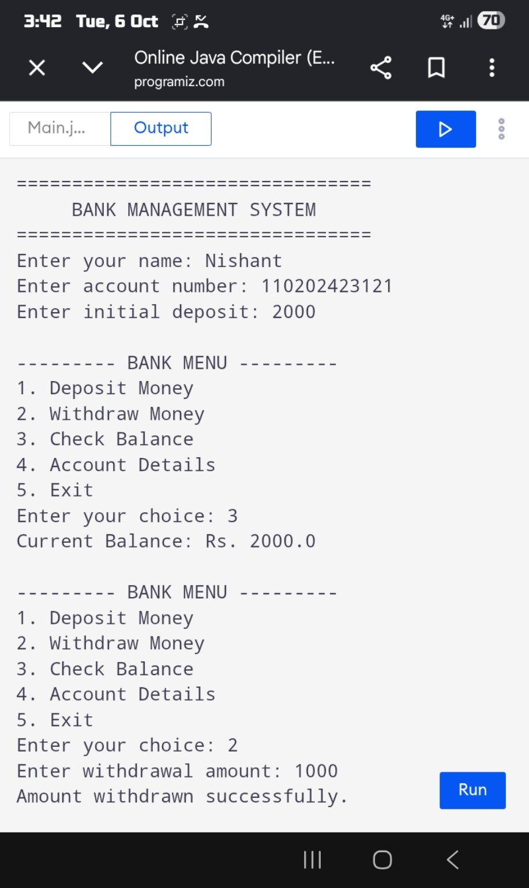
The screenshot above shows the successful execution of the program and the tested banking transactions.

10. ADVANTAGES
• Simple and easy to operate.
• Demonstrates important Core Java concepts.
• Performs basic calculations automatically.
• Easy to modify and extend.
• Suitable for academic demonstration.

11. LIMITATIONS
• Current version is console-based.
• No permanent database storage.
• Basic version does not include user authentication.
• Designed for educational use, not real banking transactions.

12. FUTURE SCOPE
• Add MySQL database using JDBC.
• Create Java Servlet/JSP web interface.
• Add login and authentication.
• Add transaction history.
• Support multiple customer accounts.
• Deploy the web version online.

13. CONCLUSION
The Bank Management System successfully demonstrates the implementation of basic banking operations using Core Java. The project provides account setup, deposit, withdrawal, balance checking and account information features through a menu-driven interface.
Testing confirmed that the main operations work correctly with the sample transactions used in the project. The system also provides a foundation for future development into a database-driven and web-based application.

14. BIBLIOGRAPHY
• Java programming concepts and classroom notes.
• Oracle Java documentation and standard Java API references.
• Core Java textbooks and learning materials.
• Project implementation and testing performed by the student.

PROJECT SUBMISSION DETAILS
Project: Bank Management System
Student: Nishant
Course: BCA – 3rd Year
Institute: R.V. Higher Education and Technical Institute
Guide: Rahul Sharma

— END OF REPORT —

