Air Quality Monitoring System Using IoT

Mr. Lakshay[1], Mr. Nitin yadav[2], Mr. Nishant kumar[3]

[1, 2, 3] students , Apex Institute of Technology , Chandigarh University

Abstract:

**The rapid change in the earth’s atmosphere, global warming, rise in green house gases etc, the credit for all of which goes to pollution. Pollution in not new, but has surely made a great impact in the recent times. Air pollution today is not just limited to the towns and cities it has spread its wings everywhere. Pollution has several severe problems associated with it. The major problem being the deteriorating health of humans. Pollutants like CFCs, CO2, NOx, CS4 etc. are the most intoxicating gases one can breathe. To keep an eye on the air**

**quality index, several products have made. IoT has revolutionized the way we look at these devices. Works like data collection, exchange of data have become a lot easier. IoT infused pollution controlling devices also help us to figure out the source problem quick and efficiently. In this review paper we discuss about the already existing solutions to a problem like pollution, and we talk about the infusion of this new technology IoT and how it shows real improvement in the results if used correctly.**

***Keywords: Air Pollution, Sensors, Edge Computing, Geo-Map Location, Depleting particulates***

# Introduction

Today we denote the growth of a nation by its rapid growth in industrialization and urbanization. With new factories and buildings setting up in each corner of the city, pollution has become a major issue. Construction sites, factories, vehicles are just some of the main causes behind air pollution.

Though we know that pollution is not something new, it has existed from the earliest epoch of humankind, but in the recent times it has reached alarming levels. If we could talk about the situation of air pollution 50 years ago, we could only talk about vehicles and deforestation. But, in today’s 21st century the range has grown much bigger. Hence, the monitoring of the

air quality index is highly needed as it has close relations with the human health.

There are many devices that have been invented to monitor the different air pollutants present in the atmosphere. These devices monitor the air and give us a read on the air quality index, and the different gases present in the environment. Herein lies the problem, though we get to know about the air quality indices and the atmospheric composition, we cannot precisely locate the source problem. What we have with us is mere outcome of the surrounding, without any further knowledge about the problem nor the solution to it.

To revise this problem, we use a new technology buzz that is IoT. IoT or Internetof Things is any appliance, or device that is embedded with electricity, network and sensors that allow exchange and analysis of data on a large scale. People cultivated this property and rendered it into these Air monitoring systems to ease the collection of enormous amounts of data. The properties of the Internet of Things, such as an ultra-large network of things, device and network level heterogeneity, and massive quantities of events generated spontaneously by these things, will make expansion of diverse applications and services extremely difficult. Middleware, in general, will make the development process easier by coordinating the actions of heterogeneous data and networking equipment and facilitating interoperability between different software and systems. A lot of suggestions for IoT middleware have surfaced in recent months. Wireless sensor networks (WSN), a critical component of IoT, were the focus of these concepts

This is where IoT comes to the rescue. Devising an air pollution monitoring system using IoT not only gives us a detailed report of the air quality index bur also points to actual whereabouts of the problem. This helps us to get to the problem a lot quicker and find a solution much easily. The IoT device uses different kinds of sensors to monitor different gases and pollutants. These give us very precise results and allows us with real-time air monitoring. Using IoT makes collection and exchange of data really and easy to manipulate. While the internet of things is still in its infancy, it has solved many problems so far and has declared itself a success in the industrial world and well as in homes.

This paper is a review on how IoT has revolutionized the game of air quality measuring devices, to what scale the devices which have been created this far are working, and how to improve those designs to make a better working model which will help mankind move a step forward in reducing air pollution.

# Literature Review:

Monika Singh used IOT for proposing Air pollution Monitoring System in August 2019. The system consists of different kind of sensors that consist of MQ135 and MQ6 gas sensor for sensing different kind of gases present in environment [2]. Design includes LCD, Wi-Fi module, buzzer and Arduino. Arduino is a microcontroller where all connections take place. Using Wi- Fi module, it provides internet connection between hardware and sensors which finally by taking the data of air pollution show it on LCD.

Nitin Sadashiv Desai invented a system for monitoring air pollution using Beagle bone interface in 2017 [3]. It also includes different sensors such as noise sensor, carbon dioxide [CO2] and carbon monoxide [CO]. Analog pin of beagle bone was used for reading analog output. Using SQL python data from sensors is uploaded on Azure cloud. All the data i.e., stored is stored in the form of .csv file and the data day by day uploaded on the cloud.

Poonam Pal in October 2017 designed an Air Monitoring System using Arduino. It uses MQ135 sensor which is used for measuring different kinds of dangerous gases [4]. The sensor gives the output in form of voltage and converted in PPM using microcontroller Arduino. Later using Wi-fi module the whole process is connected to internet and later the data is shown on LCD in PPM. If the output is below 1000 PPM it indicates fresh air and if the air quality is above 1000 PPM the buzzer will start beeping and poor air will be shown on LCD.

Chourey proposed an IOT based air pollution monitoring system which is designed using MQ135, MQ7 and DHT11 gas sensor and esp32 [7]. Esp32 module is used for showing the information on ThinkSpeak web server. Later the buzzer will help us to notify whether the air quality drops or is well.

Saiye in 2020 designed an air quality detection and monitoring system which uses wireless sensor network for monitoring air quality in various places while also producing real-time data and information can be retrieved via smartphones, tablets and internet compatible device. [6] Designed system includes Arduino Uno, a WIFI module, and a MQ135 gas sensor for monitoring air quality and for recording the data and providing continuous bandwidth.

Rajat Sankhe in 2017 used carbon sensor for sensing the pollutants or the carbon particles in the air and it also detects the level of pollutants in air and gives the output in form of analog signal [5]. The Arduino give the output in digital form and converted into analog form. The data is displayed over LCD and if the air quality crosses the certain limit set by the user the

buzzer starts beeping. GPRS module is also used in this so that is continuously display the location where the air quality is low or where the sensor is detecting poor air quality.

Yamunathangam developed an IOT based air quality monitoring system using various gas sensors like MQ135, MQ6 and GPS sensors [8]. These all sensors are connected via Arduino. All the data recorded is collected in Thing Speak interface for further processing. All the result were viewed in graphical format. Further matlab analysis used for calculating average pollution and the result is shown android app. Later it will also show the location where the air quality is low and also influence the audience which all contaminants play major role in poor quality of air and how to prevent from them.

Harsh Gupta in 2019 presented an IOT based Air Pollution Monitoring System which consists of sensors that were to constantly monitor the Temperature, Humidity, Carbon Monoxide, Smoke, LPG, PM2.5 and PM10 levels in the atmosphere [1]. In their work, a one-way communication between Thing Speak, an open-source cloud platform, and an Android Application has been developed. Raspberry Pi has been used as a gateway to interface the hardware system. Once the firebase API was included in Android or iOS App, firebase features like Analytics, Authentication, Storage, Messaging, Hosting, Crash reporting, Real-time Database etc. were used. The Graphs were plotted in Thing Speak according to the sensors data received and the same were visualized in an Android App in a tabular format.

Sunil Mahesh Pattar in 2018 designed an IoT-based Air Pollution Monitoring System can be used to monitor the air quality over the internet using a web server [9]. It can also trigger an alarm when the air quality drops below a certain level, which means when there is a sufficient number of harmful gases such as CO2, smoke, alcohol, benzene, and NH3 gas in the atmosphere. The air quality can be displayed in PPM on

the LCD and on the website so that it can be easily monitored. One can use their computer or smartphone to monitor the air pollutants in this IoT project. the level of pollution has increased due to population growth, increased vehicle use, industrialization, and urbanization. This has negative consequences on human health by directly impacting the health of those who are exposed to it.

# Problem Formulation and Solutions Offered:

* 1. Problems:

In this paper we not only tackle the problem of air pollution, but we also in brief discuss about the various pre-existing solutions. The devices used earlier have worked well so far in reporting an approximate information about the air pollution index. But this is not sufficient.

Our focus is on the problem that these devices though inform us about the composition of the different gases in the atmosphere, they by no way show us how to eradicate it. The problem also lies with accessibility of the products. These pre- existing devices are mostly used by industries as a mandatory pollution control checklist. We all know this by now that pollution is not caused by industries alone. The pre-existing solutions do not make any profound difference on the grass root level. To make a difference it needs a refined tuning and correct implementation.

If we dig a little more into it, we find that the pre-existing solutions due to its built-in

nature for industries could not be used as a home appliance. It is also not very cost effective because of a lot of different sensors used in the same device to make it multipurpose which is not useful considering that each environmental composition has its own needs. Also, these devices have really complex connections which make it very hard to use by a common man.

Our review paper majorly covers the topic of the limits to the pre-existing solutions vs the advantages of using IoT in air pollution controlling devices.

* 1. Solutions:

In recent years we have seen IoT to rise and shine and show the wonderful advantages it has. IoT infused devices have many precedence.

* + 1. They not only show us a precise measurement of the air quality index it also shows us the main
    2. problem source in that surrounding that is generating the poor air quality.
    3. Using IoT devices also help with another major issue that is the exchange of huge amounts of data can be made really easy and simple. We can store data and compare it results in the future to have clear view of the growth in the environment.
    4. IoT devices use different sensors that to monitor different gases present around. This is helpful because now these devices can be used in our homes too, that specific sensors fit for that surrounding.
    5. r major advantage of IoT enabled devices over any other air pollution measuring device is the user-friendly nature, that does not require any extra knowledge and can be used by a layman.
    6. IoT devices also help us with real time monitoring and geo-map location, which help us in tracking down the source problem really quickly.

The features mentioned above are some of the main reasons why we think that use of IoT has really changed the game for devices used to detect pollution.

# 4. Prompt Technology:

We will now discuss in detail the design of these IoT enabled Air Pollution Monitoring device and the different kinds of sensors it uses.

1. Hardware selection: It is particularly important to select the appropriate hardware for the desired output of the device. Chosen hardware should not be awfully expensive and bulky. It should be pocket friendly, eco-friendly, easy to access and use.

There are various sensors and hardware to choose from for the best result according to our needs:

* 1. Arduino UNO: Arduino Uno is a microcontroller board based on the ATmega328P. It has 14 digital input/output pins 6 analog inputs, a16 MHz quartz crystal, a USB Connection, power jack, an ICSP

header and a reset button as shown in Fig. 1.

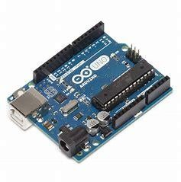

Fig 1.

* 1. MQ135 sensor: - The MQ135 sensor can sense NH3, NOx, alcohol, Benzene, smoke, CO2 and some other gases. It gives the output in form of voltage levels. Fig 2.

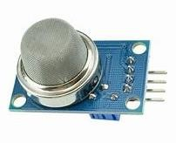

Fig 2.

3.) WIFI Module (ESP8266): - The

ESP8266 is a low-cost Wi-Fi chip with full TCP/IP stack and MCU (microcontroller unit) capability. It runs on 3.3V and gives our system access to Wi-Fi or internet. Fig 2.2 shows Wi-Fi Module (ESP8266). There are many WIFI modules similar to ESP8266 such as ESP32 or NODE MCU etc. Fig 3.

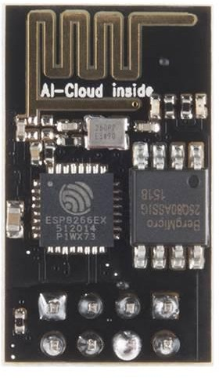

Fig 3

4.) Buzzer: - A Buzzer or beeper is an audio signalling device. Whenever the air pollution goes above the threshold level the Buzzer starts beeping indicating Danger. Fig 4.

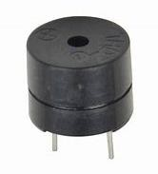Fig 4.

* + 1. LCD (Liquid Crystal Display): - This is a basic (16x2) 16 character by 2-line display. Black text on green background. It is used to indicate the Air and Humidity in PPM. Fig 5.

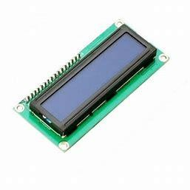

Fig 5.

* + 1. GSM Module: - GSM Module is used to establish communication between a computer and a GSM system. Global System for Mobile communication (GSM) is an architecture used for mobile communication. Fig 6.

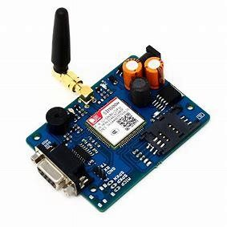

Fig 6.

* + 1. LPG Sensor: - MQ-6 sensor is a simple-to-use liquefied petroleum gas (LPG) sensor, suitable for sensing LPG (composed of mostly propane and butane) concentrations in the air. The MQ-6 can detect gas concentrations anywhere from 200 to 10000ppm. Fig 7.

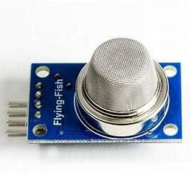

Fig 7.

* + 1. Temperature Sensor: - The LM35 is precision integrated-circuit temperature sensor, whose output voltage is linearly proportional to the Celsius (Centigrade) temperature. It can be used with single power supplies, or with plus and minus supplies. Fig 8.

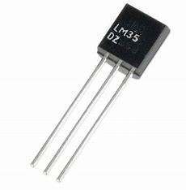

Fig 8.

* + 1. Humidity Sensor: - The humidity sensor is of capacitive type, comprising on chip signal conditioner. However, it is mounted on the PCB, which also consists of other stages employed to make sensor rather smarter. The PCB consists of CMOS timers to pulse the sensor to provide output voltage. Fig 9.

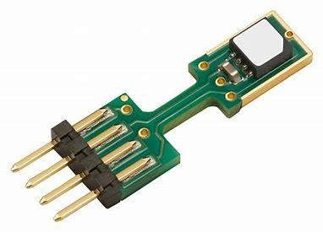

Fig 9.

1. Cost Estimation of the project: For making of the project, we should calculate the estimate budget of the project, as per the pricing on the online websites for electronic components, Similarly, we have formulated a cost estimation of Rs 2000 for this project.
2. Circuit: Figuring out the best circuit for better results and efficient way to use our device is also a very crucial step for this research paper. Circuit should not be overly complicated, so that any individual could easily look at any malfunction and solve them on their own.
3. Data transfer and access: Presence of all the harmful gases in PPM (parts per million), pressure and temperature of the room should be well measured and transferred to the user through GSM on the regular interval of time on their mobile phones.
4. Defining output: There are many IOT based pollution monitoring system in the world whose output is to just alarm the user of the device but just alarming does not help us in reducing the pollution of the environment. The most favourable output of the device can be restricting the use of the machines or activities which are responsible for the pollution until the air quality index reaches to the normal level (below 350ppm)

# Result and Conclusion:

We can confidently say now that, using IoT devices in controlling air pollution is a definite smarter way to see effective results in a shorter span of time.

As a result, we can say that using robotics in IoT enabled air controlling devices is a sure shot way of eradicating pollution to a larger extent. We have already discussed the various ways it can help us. Though it might cost a little on the higher end but can be proven to be very useful.

Using IoT in controlling air pollution can help us in depleting the particulates present in the air. These will help us in reducing smog, help people in living a healthier life and defend us from causing severe air borne diseases.

The analysis of IoT-assisted air pollution monitoring systems' findings shows that, despite advancements, a number of technological issues still need to be resolved before these systems can perform to their full potential. The validity of the data gathered by inexpensive sensors is the first problem. To provide accurate and dependable data, it is crucial to confirm the sensors utilised, their positioning, and their long-term maintenance. The second issue is the significant reliance

on cloud platforms for computation and storage, which can be solved by implementing edge computing to increase bandwidth and decrease latency. The third difficulty is to establish common communication standards in order to address interoperability problems. This will make it simpler to collect and process data across several systems. Secure communication between devices, gateways, and clouds is the fourth difficulty. For the acquired data to remain accurate, safe, and verified data transmission is essential. Future systems with solutions to these problems could perform better, be more effective, and be more accurate. Real- time IoT-based air pollution monitoring can advance and provide more accurate results by validating cheap sensors, adopting edge computing, creating communication standards, and ensuring safe data transmission. These developments would improve air pollution monitoring's overall effectiveness and accuracy, which would ultimately improve environmental management and public health.

# Acknowledgement:

This paper and the research behind it would not have been possible without the exceptional support of our supervisor, Dr. Sonal Rattan. Her enthusiasm, knowledge and exacting attention to detail have been an inspiration and kept our work on track from our first encounter in

Microprocessor & Microcontroller class to the final draft of this paper. We want to express our gratitude to Dr. Shweta and Dr. Namit Chawla, our Panelists at Chandigarh University for looking over our transcriptions and answered with unfailing patience numerous questions about the

IEEE format and structure of the review paper. We greatly appreciate the help from Dr. Aman Kaushik, Head of Department of AIT CSE, University Institute of Engineering, Chandigarh University, who gave us the opportunity to work on such special project, which would really be helpful for the decades to come. We are also

grateful for the insightful comments offered by the anonymous peer reviewers on Research Gate. The generosity and expertise of one and all have improved this study in innumerable ways and saved us from many errors; those that inevitably remain are entirely our own responsibility.

# References:

[1.] Harsh Gupta, Dhananjay Bhardwaj, Himanshu Agrawal, Vinay Anand Tikkiwal, Arun Kumar,(2019)‘An IoT Based Air Pollution Monitoring System for Smart Cities’, ICSETS.

[2.] Monika Singh, Misha Kumari,

Pradeep Kumar Chauhan, (2019) ‘IoT Based Air Pollution Monitoring System using Arduino’, International Research Journal of Engineering and Technology, IRJET.

[3.] Nitin Sadashiv Desai, John Sahaya RaniAlex, (2017)‘IoT based air pollution monitoring and predictor system on Beagle Bone Black’, International Conference on Nextgen Electronic Technologies, ICNET.

[4.] Poonam Pal, Ritik Gupta, Sanjana Tiwari, Ashutosh Sharma, (2017) ‘IoT-based air pollution monitoring system using Arduino’, International Research Journal of and Technology IRJET.

[5.] Rajat Sankhe, Pravin Shirodkar,

Avinash Nangare, Abhishek Yadav, Gauri Salunkhe (2017) ‘Iot Based Air and Sound Pollution Monitoring System’, International Journal of Engineering Research & Technology IJERT.

[6.] Saiye, Y.D. and Ajose-Ismail, B.M., 2020. IoT Based Air Quality Detection and Monitoring System. International Journal of Research and Innovation in Applied Science, 5(7), pp.66- 68

[7.] Chourey, P., Soni, K., Singh,

N.J. and Agarwal, R., 2022. IoT-Sodar Network for Airshed Management Planning. IETE Journal of Research, pp.1- 15.

[8.] Yamunathangam, K. Pritheka,

P. Varuna, (2018) ‘IoT Enabled Air Pollution Monitoring and Awareness Creation System’, International Journal of Recent Technology and Engineering, IRJET.

[9.] Mohesh, P.S. and Rajendra, P.B., A survey Paper on Air Pollution Monitoring using IOT. IJARIIE-ISSN (O), 4

[10.] Park J., Oh Y., Byun H. H. and Kim C. K. Low Cost Fine-Grained Air Quality Monitoring System Using LoRa WAN. 2019 International Conference on Information Networking (ICOIN), 2019, pp. 439-441.

[11.] Nakjuatong N., Mingkhwan

A. and Boonrawd P. Design of Particulate Matter Monitoring based on NB-IoT. 2021 25th International Computer Science and Engineering Conference (ICSEC), 2021, pp. 372-376.

1. Miletiev R., Iontchev E. and Yordanov R. Indoor particulate matter (PM) monitoring and analysis. 2019 27th National Conference with International Participation (TELECOM), 2019, pp. 23- 26.
2. Dhingra S., Madda R. B., Gandomi A. H., Patan R. and Daneshmand

M. Internet of Things Mobile–Air Pollution Monitoring System (IoT-Mobair). In IEEE Internet of Things Journal, June 2019, vol. 6, no. 3, pp. 5577-5584.

1. Swamy S. N. and Kota S. R. An Empirical Study on System Level Aspects of Internet of Things (IoT). In IEEE Access, 2020, vol. 8, pp. 188082-188134.
2. Su K., Li J. and Fu H. Smart city and the applications. 2011 International Conference on Electronics, Communications and Control (ICECC), 2011, pp. 1028-1031.
3. Yassine S., Kadry S. and Sicilia

M. Measuring learning outcomes effectively in smart learning environments. 2016 Smart Solutions for Future Cities, 2016, pp. 1-5.