**Manually found errors:**

1. String request = br.readLine();

The readLine() have no error handling for NullPointException

We can use try and catch to fix that:

String request = "";

**try** {

/* read the HTTP request from the client */

request = br.readLine();

}**catch** (NullPointerException e) {

System.***out***.println(e);

}

1. **private** **static** ServerSocket *dServerSocket*;

Defining a static variable is not a good practice because if we have multiple instances of a variable and it is changed at one spot, it will affect all the objects where it was used.

**Tool choices and version**:

Tool 1- Spotbugs

Version- This is the first released version of the Lesser GPL. It also counts

as the successor of the GNU Library Public License, version 2, hence

the version number 2.1

Tool 2- SonarLint

Version- 4.0.1.2990

**Tool Invocation Process:**

Spotbugs:

1. First I downloaded the zip file for Spotbugs

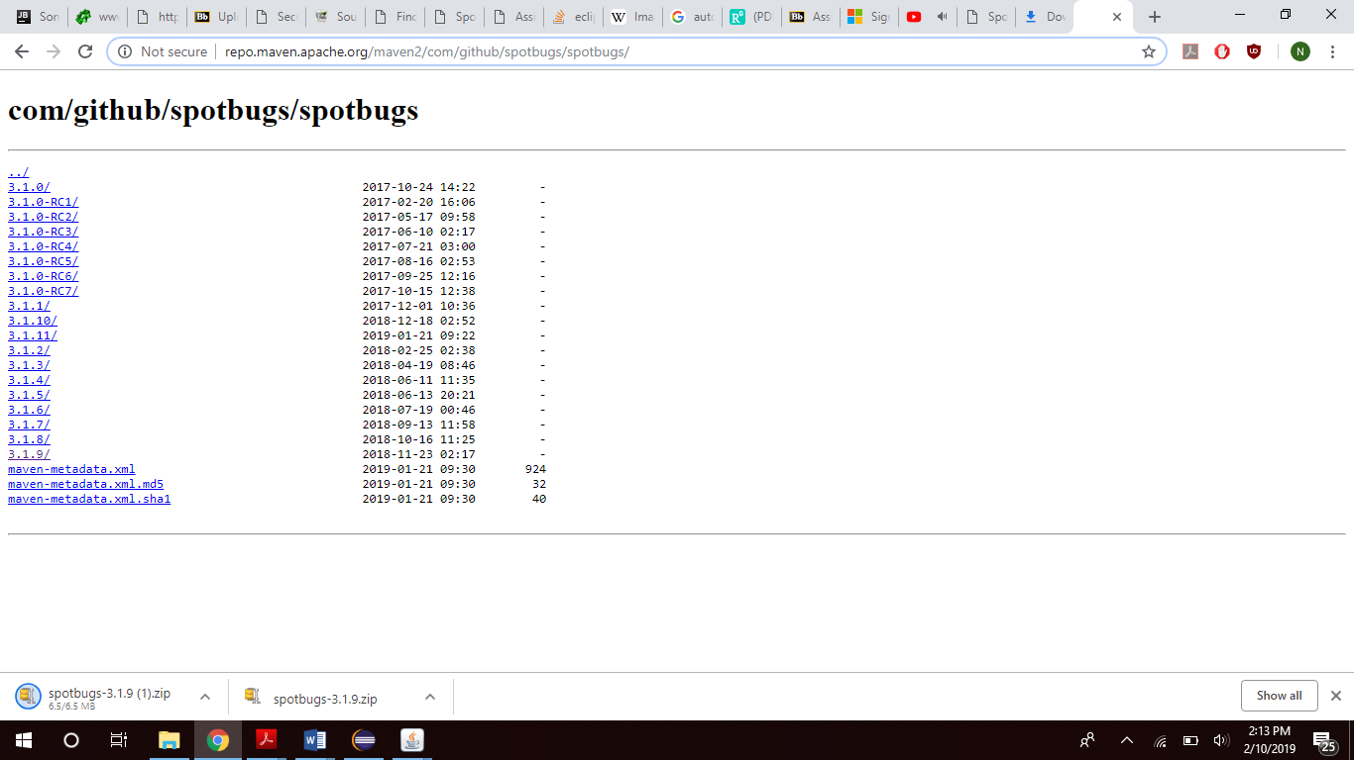

1. Then unzip the downloaded zip file and in the bin folder there is a bat file.

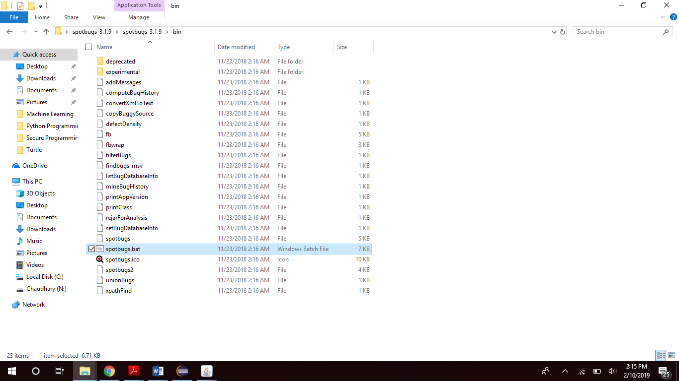

1. Run the bat file, it will open the Spotbugs tool

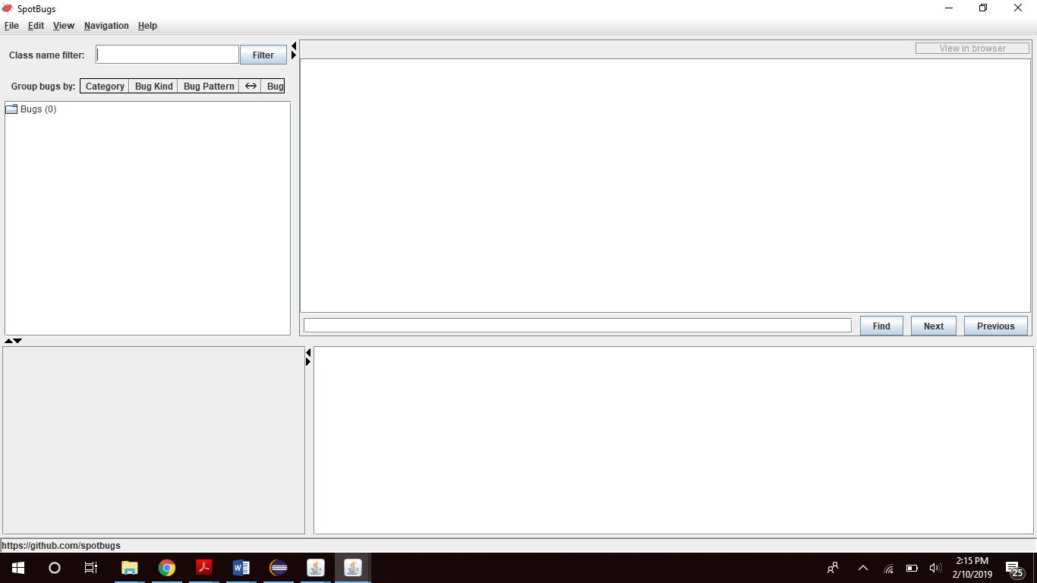

1. In the end click on New Project and give the address of that file to run it in Spotbugs

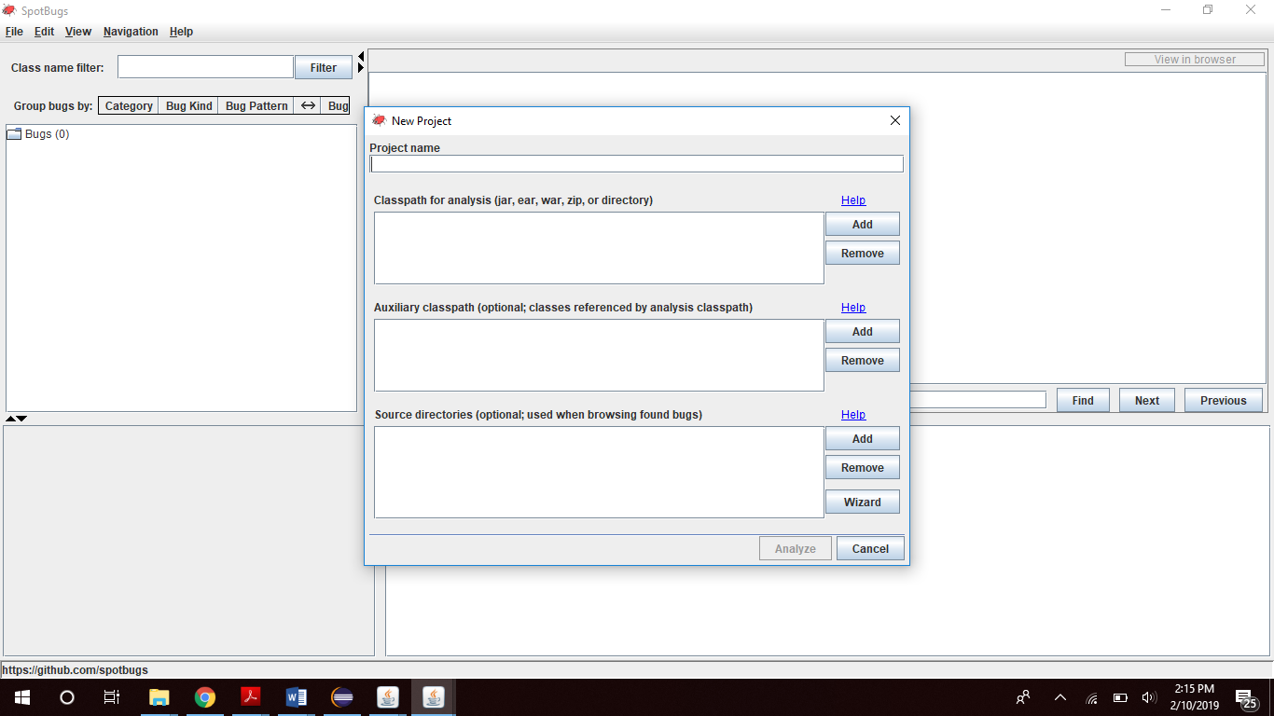

* Then after analyzing the file it will show the bugs.

Sonarlint:

1. Go to Eclipse Marketplace

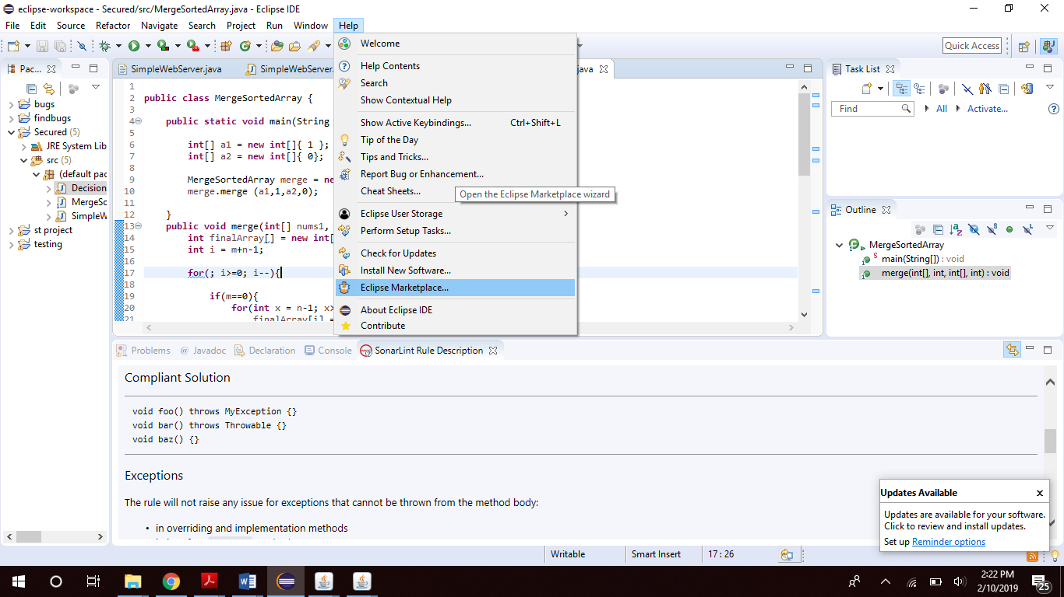

1. Find SonarLint and click on Install. The plugin will be installed, restart Eclipse once the installation is complete.

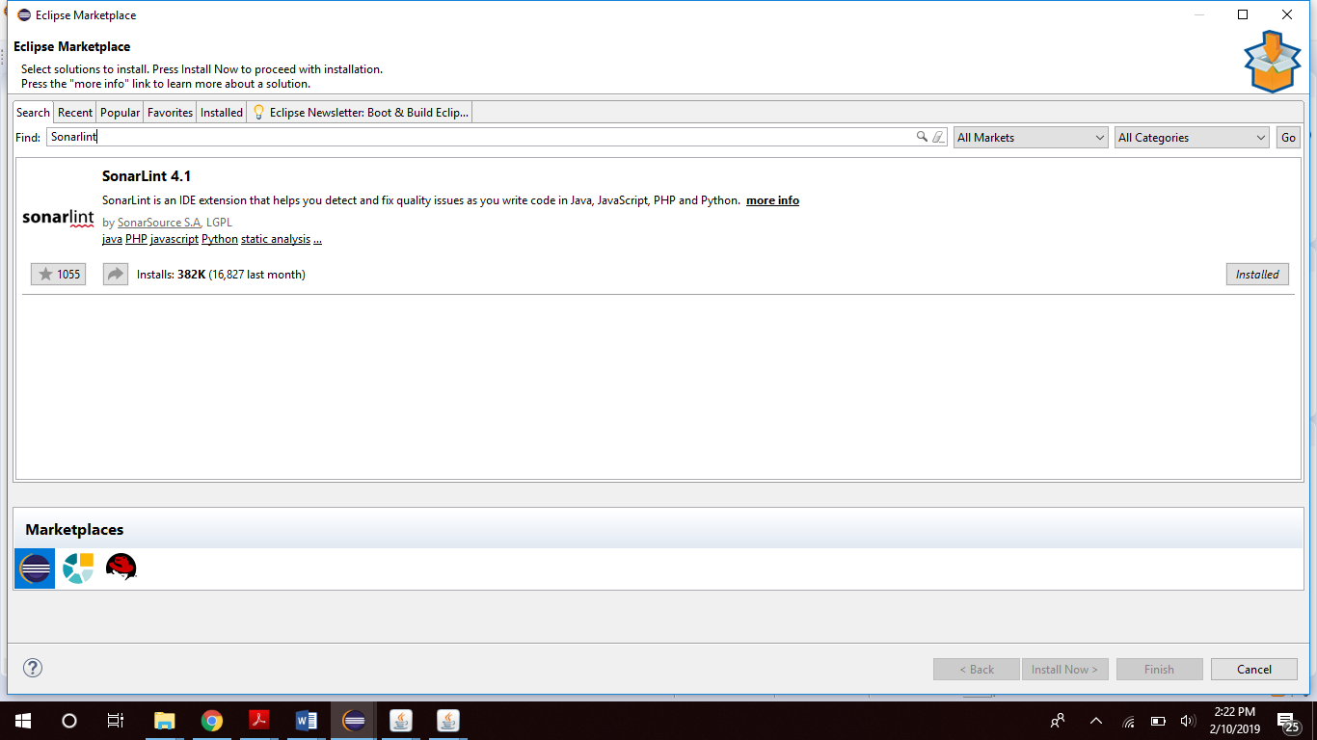

* Spotbugs and SonarLint analyse source code
* The category of both the tools is:
* Style checking
* Program verification
* Bug finding
* Security review